
INTERNATIONAL MARKETING PRINCIPLES AND PRACTICES
Starbucks Corporation
UK and India

Student Name: Debashish Biswas
Student ID:2425482

Module Name: International Marketing: Principles and Practices

Module Code: LCMB7026

Lecturer’s Name: Tushara Balendran

EXECUTIVE SUMMARY

Starbucks is a global coffee brand, but it does not use the same strategy everywhere. This assignment compares how Starbucks markets itself in the UK and in India. It looks at the macro-environment using PESTLE and Hofstede’s Dimensions, and then compares segmentation, targeting, positioning and the 7Ps (product, price, place, promotion, people, process and physical evidence) in both countries.
The report shows that the UK is a mature, high-cost, highly regulated market, where Starbucks focuses on premium pricing, strong digital loyalty, sustainability messages and convenience through many store formats. In India, Starbucks is still growing. It uses local flavours, smaller cup sizes, “premium but affordable” pricing, and UPI-based digital payments to attract young, urban middle-class consumers.
Performance data shows strong brand equity and digital engagement in both markets, but profits are under pressure: from high costs in the UK and from rapid expansion and price sensitivity in India. The assignment also reviews ethical issues, including tax and packaging in the UK and social inclusion and environmental claims in India. It ends with recommendations to improve value and transparency in the UK, focus on profitable growth and localisation in India, and share best practices between both markets.

TABLE OF CONTENTS
EXECUTIVE SUMMARY i
TABLE OF CONTENTS ii
INTRODUCTION 1
BRAND OVERVIEW 1
OPERATIONS IN THE UK & INDIA 2
COMPARISON OF THE SOCIO-CULTURAL CONTEXT OF THE UK AND INDIA 3
PESTLE ANALYSIS 3
POLITICAL 3
ECONOMIC 4
SOCIAL 5
CULTURAL ANALYSIS USING HOFSTEDE’S DIMENSIONS 6
COMPARISON OF BRAND’S STP STRATEGIES IN THE UK AND INDIA 10
SEGMENTATION 10
TARGETING 12
POSITIONING 14
COMPARISON OF MARKETING MIX STRATEGIES IN THE UK AND INDIA 16
PRODUCT 16
PRICE 17
PLACE (DISTRIBUTION & LOCATION) 18
PROMOTION 18
PEOPLE 19
PROCESS 19
PHYSICAL EVIDENCE 20
EVALUATION OF MARKETING STRATEGY PERFORMANCE 21
PERFORMANCE IN THE UK 21
PERFORMANCE IN INDIA 22
COMPARATIVE EVALUATION 23
EVALUATION OF MARKETING ETHICS PRACTICES 23
ETHICAL PRACTICES IN THE UK 23
ETHICAL PRACTICES IN INDIA 24
COMPARATIVE ASSESSMENT 24
RECOMMENDATIONS AND CONCLUSION 24
RECOMMENDATIONS 24
CONCLUSION 25
REFERENCES 27

INTRODUCTION
Starbucks is the world’s largest coffeehouse chain, operating 40,199 outlets in 87 countries and with global revenue of USD 36.2 billion (Starbucks Corporation, 2025; SEC, 2025). This study assesses Starbucks global marketing strategy in the UK and India, two of its key markets, to understand how this company is adapted towards different macro-environments, STP strategies, marketing mix and overall marketing performances of the company. Therefore, first the report provides an in-depth overview of the brand and its entry and scale in the selected two countries. After that the paper conduct macro environment analysis using PESTLE framework to understand key differences in policy, economy, society, technology, law, and environment that shape marketing strategies in the UK and India. The report then compares STP strategies to understand how the company segments, targets, and positions its brand in the UK and India. Next, the report contrasts the 7Ps (product, price, place, promotion, people, process, physical evidence) with evidence from offers, pricing tiers, formats, and campaigns (Starbucks Corporation, 2025). Finally the paper evaluates the performance of Starbucks in the selected counters based on sales, store counts, market share, and engagement metrics to understand if the marketing strategies are effective. The paper also reviews marketing ethics, including labelling, data, and sustainability claims and finally offers practical recommendations for stronger localisation, digital loyalty, and sustainable growth.

BRAND OVERVIEW
Starbucks Corporation is a leading global specialty coffee retailer and roaster, founded in Seattle, USA in 1971 (Starbucks, 2024). It has grown into a major international brand with presence across more than 87 countries, operating over 40,199 stores globally (52 % company operated, 48 % licensed; Figure 1) as of end of FY 2024 (Starbucks Corporation, 2025).
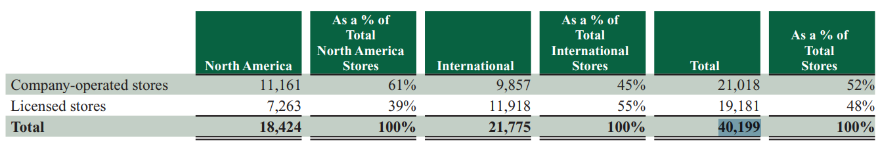
FIGURE 1: TOTAL NUMBER OF STORES
(SOURCE: STARBUCKS CORPORATION, 2025)
Starbucks’ offerings include espresso-based drinks, brewed coffee, tea beverages, cold blended drinks (e.g. Frappuccino®), food items (pastries, sandwiches, snacks), and merchandise/retail packaged coffee (Starbucks Corporation, 2025). Additionally, Starbucks has expanded into consumer-packaged goods (CPG) channels through licensing (e.g., via its Global Coffee Alliance with Nestlé) and reserve/experiential formats (Starbucks Reserve®) (Starbucks Corporation, 2025).
In FY 2024, Starbucks reported consolidated net revenues of USD 36.2 billion, representing a 1 % increase over the prior year and Starbucks’ international (non-U.S.) operations remain a critical growth region, though international comparable store sales declined 9% in Q4 FY 2024 (SEC, 2025). When it comes to its strategy for expanding internationally, Starbucks uses a mix of company-owned and licensed or joint venture (JV) operations. It also uses several store designs, such as drive-thru, delivery, pick-up, and smaller urban sizes, depending on how the local market works (Starbucks Corporation, 2025). Starbucks regularly enters new areas through joint ventures or licensing to lower risk and take use of the distribution power of local partners. For instance, Starbucks came to India through a 50:50 joint venture with Tata (Fischer & Roy, 2019).
TABLE 1: STARBUCKS — GLOBAL HEADLINE METRICS (FY2020–FY2024)
(SOURCE: SELF-CREATED)
The company has a strong presence around the world, a premium brand image, and a strong dedication to quality in important regions. Starbucks stays ahead of other big coffeehouse chains by offering a wide range of products, using new technologies, and putting a lot of emphasis on the customer experience (The Brand Hopper, 2023).

OPERATIONS IN THE UK & INDIA
Starbucks entered the UK market in 1998, opening its first store on King’s Road in London. By 2023, Starbucks UK operated 1,168 stores (354 company-operated, 814 licensed) across the country (Flanagan, 2024). In 2023 the revenue of the company from UK was £547.7m and it continues expansion, aiming to add ~100 new stores (Starbucks, 2024a). In the UK, one distinctive adaptation is Starbucks’ leadership in plant-based milk policies — e.g., removal of plant-milk surcharge, campaigns to make non-dairy milk the default (Buxton, 2022). In the UK, Starbucks competes predominantly with Costa Coffee (ranked No. 1 in UK coffee chains), as well as Caffè Nero and other independent café chains (Tea&Coffee, 2025). Caffè Nero is a major UK-based chain with over 1,000 locations in Europe (including the UK) and operates espresso, tea, and food offerings similar to Starbucks (Jessica, 2025)
Starbucks entered India in October 2012 via a JV with Tata Consumer Products (formerly Tata Global Beverages), with its first store opening at Horniman Circle, Mumbai (Starbucks, 2022). As of October 2024, Tata Starbucks operates 457+ outlets across more than 70 cities in India (The Economic Times, 2024) and planned to Accelerate Growth to 1,000 Stores BY 2028 (Starbucks, 2024b). Starbucks India adapts its menu heavily — offering Indian favourites such as Masala Chai, Filter Coffee, and localized food items (e.g., paneer wraps) to appeal to Indian consumer tastes (Hindustan Times, 2022). In India, Starbucks faces competition from well-established domestic chains such as Café Coffee Day (CCD) (historically widespread) and Barista, as well as newer specialty/ artisanal chains like Blue Tokai and Third Wave Coffee Roasters (Pocket Option, 2025).

COMPARISON OF THE SOCIO-CULTURAL CONTEXT OF THE UK AND INDIA

PESTLE ANALYSIS
PESTEL framework developed by (Aguilar, 1967) is used to understand how macro-economic and socio-cultural conductions influence Starbucks’ marketing decisions of Starbucks in the selected two countries.

POLITICAL
The UK’s tax–wage policy mix raises operating costs for hospitality. From 1 April 2025, the main Corporation Tax rate is 25% (profits >£250k) with a 19% small-profits rate (≤£50k) (Gov.UK, 2025). The National Living Wage (age 21+) also rises to £12.21/hour from April 2025 (Gov.UK, 2025a). Together, these measures pressure store-level margins and can necessitate menu price adjustments and productivity initiatives (e.g., order-ahead, smaller formats).
In India, policy is comparatively supportive of expansion but shapes pricing. Restaurant GST is 5% without input tax credit (ITC) (standard for standalone restaurants), which limits cost offsets; certain “specified premises” (e.g., higher-tariff hotels) can charge 18% with ITC (NACIN, 2025). For retail formats, single-brand retail trading (SBRT) allows 100% FDI (automatic) but requires 30% local sourcing where foreign investment exceeds 51% (Acharya, 2025). Therefore, Starbucks adopted menu engineering to protect margins under 5% GST, and continued localization in merchandise/packaging supply to align with SBRT norms (Fischer & Roy, 2019).
TABLE 2: POLITICAL – WHICH MARKET IS MORE FAVOURABLE FOR STARBUCKS?

So, it is found that in UK higher payroll/tax costs pressure menu pricing; stricter platform/safety rules affect social, influencer and youth targeting. While India’s GST regime lowers sticker shock, stable market-entry/expansion rules; local sourcing can support “Made-in-India” narratives in merchandising/packaging. Hence, Starbucks should emphasize operational efficiency and mix management in the UK while leveraging India’s policy stability and localization signals in brand storytelling.

ECONOMIC
In UK the inflation has eased but remains above target Consumer price inflation CPI(H) ~4.0% (Aug 2025); the IMF projects UK CPI ~3.4% in 2025 and GDP growth ~1.3%, implying persistent price sensitivity (IMF, 2025). Unemployment edged up to 4.8% (ONS, 2025). Payment habits are highly cashless: ~4 in 10 UK payments were contactless in 2023, and monthly contactless volumes continue to rise in 2025—favouring app-led promotions and loyalty (UK Finance, 2025). So, in Uk lingering inflation impacts price sensitivity; very high contactless/mobile-wallet usage makes app-led loyalty and digital payments table stakes.
In India macroeconomic momentum is stronger. IMF (2025a) projects real GDP +6.6% (2025) and CPI ~2.8%; official CPI prints fell to around 1.5% in Sep 2025, creating room for rate cuts (Ohri, 2025). UPI is the dominant payment rail: 19.63 billion transactions in Sep 2025 (value ₹24.90 lakh crore) (The Economic times, 2025). The broader demand expansion with extremely high digital-payment adoption supports Starbucks’ app-first and micro-offer strategy.
TABLE 3: ECONOMIC – WHICH MARKET IS MORE FAVOURABLE FOR STARBUCKS?
The discussion shows that price elasticity is tighter in the UK; India offers volume growth with digital payments scale. Starbucks should prioritize value tiers and bundles in the UK and frequency-building UPI promotions in India.

SOCIAL
In UK a mature café culture intersects with strong health-conscious trends and high social-media engagement with strong use of Instagram/TikTok among UK adults (e.g., Instagram used by ~76% of adult mobile users in 2024 (Baker, 2025)); these support seasonal innovation and plant-based positioning—provided claims comply with advertising rules. Contactless and mobile usage patterns reinforce digital engagement for loyalty and CRM.
TABLE 4: SOCIAL – WHICH MARKET IS MORE FAVOURABLE FOR STARBUCKS?
India is a youthful, urbanising base and rising middle-class incomes underpin café adoption. Local taste preferences (tea culture, spice profiles) have already driven Starbucks’ Masala Chai / Filter Coffee adaptations and regionally relevant food. Influencer discovery is mainstream but must comply with ASCI disclosure (ASCI, n.d.). There is a strong scope for youth-targeted, mobile-first campaigns, localized menus (e.g., masala chai/filter coffee) and regional festivals activations.
So, the UK rewards health/ethics-led brand cues; India rewards local taste + youth culture activations. Starbucks should keep UK comms on wellness/sustainability and India comms on local flavours, value, and creator-led discovery (with compliant disclosures).

CULTURAL ANALYSIS USING HOFSTEDE’S DIMENSIONS
While PESTLE provides a structural overview of external factors, Hofstede’s cultural framework (Hofstede, 1980) adds insight into how national values shape Starbucks’ marketing and consumer engagement in the UK and India.
TABLE 5: HOFSTEDE’S CULTURAL COMPARISON BETWEEN THE UK AND INDIA
According to Hofstede's cultural model, Starbucks’ UK-based marketing leverages on individualism, ethics and digital identity expression whereas its Indian counterpart succeeds with community inclusiveness, aspiration and trust-centric localization.
In general, the company is working across two diametric macro and cultural contexts. The UK market is characterized by high operating costs, strict regulation and a culture of equality, ethics and sustainability. In this, success hinges on operational productivity, digital engagement and trustworthy ethical leadership. India, on the other hand, is defined by fast growing economy, young consumers and a collectivist society that values value for money, familiarity and more importantly – social connection. Starbucks’ secret is local innovation, cultural inclusion and digital access.
TECHNOLOGICAL
In Uk Network quality enables rich digital experiences. According to Ofcom (2025) 62% of UK landmass has 5G and strong 4G/5G availability across 92–96% premises. This broad 5G/premises coverage enables rich media, video, and real-time offers; supports order-ahead, delivery, and location-based promotions.
India also have strong Technological infrastructure 984 million broadband subscribers (Parul, 2025) and 50% 5G coverage and 4G/5G coverage and broadband subscriptions keep expanding (PIB, 2025); Also, according to the Telecom Regulatory Authority of India (TRAI) there is a mass adoption and reliability for order-ahead, loyalty, and QR based payment (TRAI, 2025). Combined with UPI, Starbucks can drive mobile-first CX, QR offers, and loyalty accrual at scale.
TABLE 6: TECHNOLOGICAL – WHICH MARKET IS MORE FAVOURABLE FOR STARBUCKS?
So, both markets support high-bandwidth mobile journeys; India’s payments rails are more unified at national scale, suggesting deeper UPI-native experimentation (cashback stacks, bank-partner offers).
LEGAL / REGULATORY
In UK, Calorie labelling is mandatory for businesses with ≥250 employees (Colombet et al., 2024), allergen labelling for PPDS (“Natasha’s Law”) requires full ingredients with highlighted allergens (FSA, 2021). Influencer and ad claims are governed by the ASA/CAP Code; data uses must meet UK GDPR/ICO expectations (ASA, 2025). Soft Drinks Industry Levy and other health policy instruments also shape recipe and promotion choices. Therefore, Starbucks must ensure menus C packaging must show calories and allergens; influencer campaigns need conspicuous labels; high-sugar drinks incur SDIL—drives recipe reformulation and promotion mix towards lower-sugar options.
TABLE 7: LEGAL / REGULATORY – WHICH MARKET IS MORE FAVOURABLE FOR STARBUCKS?
In India, FSSAI menu labelling requires chains with a central licence or ≥10 outlets to display calories and serving size (FSSAI, 2021); India enforces a ≤2% industrial trans-fat limit across foods (FSSAI, 2021). DPDP Act 2023 is the data-protection law, with Draft Rules (2025) detailing consent and children’s data (Lexology, 2025); ASCI 2023 influencer guidelines require conspicuous “Ad/Sponsored” labels, with a 2025 scorecard showing frequent non-compliance—raising enforcement risks (Legally Flawless, 2023). Therefore, Starbucks must embed calorie labelling in menus/boards/apps, DPDP-ready consent, and ASCI-compliant disclosures.
ENVIRONMENTAL
In UK regulation raises packaging costs and mandates design change. The Plastic Packaging Tax (£223.69/tonne) and emerging EPR requirements increase costs; bans cover several single-use plastic items (Gov.UK, 2021). The UK’s legally binding net-zero 2050 framework and falling GHG emissions create reputational incentives for lower-carbon operations, reusables, and recycling claims—if credible (Uk Parliament, 2025).

TABLE 8: ENVIRONMENTAL – WHICH MARKET IS MORE FAVOURABLE FOR STARBUCKS?

Whine in India, since July 2022, a nationwide ban on identified single-use plastic items (e.g., cutlery, straws, stirrers, plates, cups) is in force; plastic EPR is operational via CPCB’s national portal (UKHI, 2025). India’s Nationally Determined Contribution commits to -45% emissions intensity by 2030 and ~50% installed power capacity from non-fossil by 2030; 2025 reporting indicates the 50% capacity milestone has been reached early, although generation remains coal-heavy (Pandey, 2025) so green-power procurement may be available but grid emissions remain material. Therefore, Starbucks should scale reusable cup incentives, EPR compliance, and renewables procurement messaging with caution about actual footprint changes.

FIGURE 2: PESTEL ANALYSIS OF STARBUCKS
(SOURCE: SELF-CREATED)
In general, the PESTLE analysis demonstrates that Starbucks works in two completely different macro-environment. The UK has high operating costs, rigorous rules, and health-conscious customers, which means that companies need to be efficient and environmentally friendly. India, on the other hand, has a fast-growing economy, young consumers, and new digital technologies, thus prices need to be low and products need to be adapted to the local market. Starbucks needs to find a balance between cost management and ethical leadership in the UK and local innovation and digital engagement in India. Both of these initiatives should fit under the company's global purpose of sustainable and inclusive growth.
Together, the PESTLE and Hofstede discussion demonstrates that Starbucks has to strike a balance between costs discipline and trust-building with ethical stakeholders in mature markets such as United Kingdom v/s localised responses and community focused growth in the emerging market such as India — all under its global philosophy of sustainable and inclusive growth.

COMPARISON OF BRAND’S STP STRATEGIES IN THE UK AND INDIA
This section compares how Starbucks segments, targets, and positions itself in the UK and in India in order to understand how each market’s environment shapes Starbucks’ approach.

SEGMENTATION
Starbucks divides its markets by multiple bases such as demographic, geographic, psychographic and behavioural. Demographically, Starbucks is known to cater to people from both sexes (males & females) and between the ages of 22-60; these include urbanites with relatively high income, as well as college students and younger work force urban professionals (Start.io, 2022). From a geographic perspective, the brand focuses on high pedestrian traffic urban and suburban locations which include central business districts, malls, transit hubs and university areas (Start.io, 2022). Psychographically, Starbucks does connect with those people who like to identify themselves and link a good life with the consumption of coffee (Hodgson 2024). Behaviourally, Starbucks divides by loyalty (heavy vs light), digital interaction (app users vs in store purchasers) and willingness to adopt new seasonal or limited time products (Shastri, 2025).
In order to deepen the psychographic view, Starbucks’ customer base in both countries can also be interpreted through the VALS (Values, Attitudes and Lifestyles) framework, which groups consumers based on their motivations, resources, and lifestyle orientations. In the UK, Starbucks primarily attracts Experiencers, Achievers and Innovators. Experiencers are young, social and trend-sensitive consumers who enjoy seasonal drinks and use coffee shops as lifestyle spaces; Achievers are busy professionals who value convenience, quality and reliability, and therefore gravitate towards Starbucks’ consistent service and digital ordering convenience; Innovators are higher-resource consumers who respond to ethical cues, sustainability initiatives and premium formats such as Starbucks Reserve.
In India, Starbucks’ core psychographic clusters tilt more towards Strivers, Experiencers and Achievers. Strivers are aspirational, status-conscious consumers who see Starbucks as a symbol of global lifestyle that is “premium-accessible”; Experiencers are young, urban and socially oriented, using Starbucks for socialising, “hanging out” and trying localised drinks such as Masala Chai and Filter Coffee; Achievers in India are emerging middle-class professionals who place value on hygiene, consistency and digital convenience, and appreciate app-based ordering and UPI payments. These VALS-based segments are then prioritised differently in each market’s targeting strategy, as discussed below.
TABLE 9: VALS-BASED PSYCHOGRAPHIC SEGMENTATION OF STARBUCKS CUSTOMERS IN THE UK AND INDIA
In the UK, the segmentation therefore skews more towards urban professionals and students for whom convenience, speed and digital are critical. The widespread use of contactless and mobile wallets in the UK is further supporting behavioural segmentation linked to digital usage (Tovar, 2024).

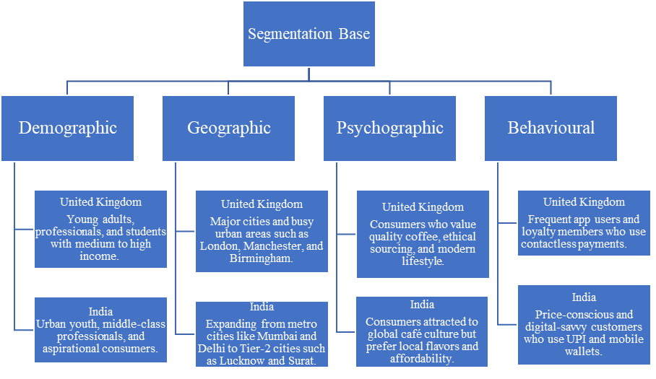
FIGURE 3: SEGMENTATION BASE OF STARBUCKS
(SOURCE: SELF-CREATED)
In India, on the other hand, Starbucks targets more than just the urban premium niche. It also targets middle-class people who want to be like them and people who are price-sensitive, especially in Tier-2 cities. Starbucks India offers Masala Chai, Filter Coffee, and smaller cup versions to meet local tastes and reach more customers (Shastri, 2025). So, though both markets target urban, middle-class consumers, India's market include more social, economic, and taste categories.
Starbucks targets each country depending on market maturity and customer behaviour. Starbucks UK prioritises high-value customers. These customers use the service frequently, are online, and are willing to pay more for consistency, convenience, and brand experience (Tovar, 2024).

TARGETING
Starbucks' targeting in each country based on how mature the market is and how customers act. Starbucks UK targets clients, who use their service a lot, active online users and willing to pay extra for brand experience (Tovar, 2024). This targeting strategy is supported by the fact that mobile payments and contactless transactions are so common in the UK (57% of adults use them) (UK Finance, 2025). In the midst of tough competition from veteran chains such as Costa and Caffè Nero, Starbucks focuses on strengthening relationships with its loyal customers via app-based rewards, seasonal innovation and Ethical positioning (e.g. plant-based milk parity) (Tovar, 2024).
In India, Starbucks is focused towards growing a demographic of young urban middle class professionals and aspiring consumers (Fischer & Roy, 2019). The firm’s approach to add 1,000 stores by 2028 also suggests that it is expanding beyond premium metro markets and into emerging markets (Starbucks, 2024b). Its changes to products and packaging (lower sizes, local flavours) are meant to attract more price-conscious or first-time café users in India's changing coffee culture (Shastri, 2025). Starbucks India is concentrating only on the B2C retail growth by establishing its brand and customer base before exploring B2B segments (Suri, 2025). The “going desi” initiative (Masala Chai, Filter Coffee) is directly targeted towards Indian taste seekers who might otherwise go in for local tea or filter coffee shops (Gairola, 2024).
TABLE 10: TARGETING STRATEGY
Overall, Starbucks mainly uses a differentiated targeting strategy in both the UK and India, while also applying concentrated targeting to specific high-potential niches in each market rather than an undifferentiated mass-market approach.

POSITIONING
In the UK and India, Starbucks presents itself as a high presented as premium but accessible international brand of coffee balancing international standard and local preparedness (Hodgson, 2024).
In the UK, Starbucks operates at a high level with a price premium above the mainstream coffee shops of Costa Coffee and Caffè Nero but below that of artisanal independents such as Caravan Coffee Roasters and Taylor St. Baristas (see Figure 6) (Merkelijkheid, n.d.). The company’s move to ditch the surcharge for plant-based alternative milks, as well broadens its image of a socially responsible and eco-friendly brand, a good fit with the UK market being one that overwhelmingly values sustainability and inclusivity (Buxton, 2022; Hodgson, 2024).
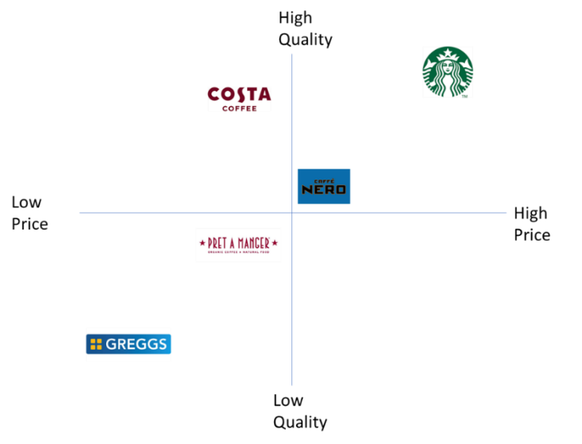
FIGURE 6: PERCEPTUAL MAP — UK MARKET (PRICE VS QUALITY)
(SOURCE: SELF-CREATED)
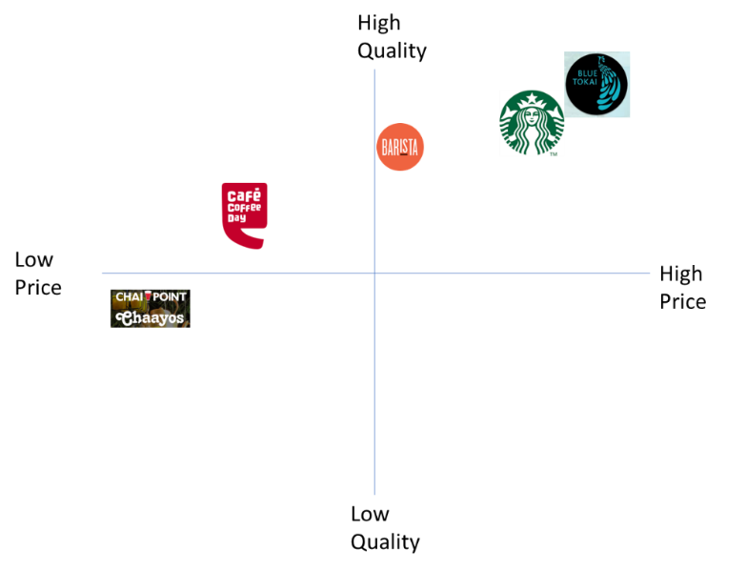
FIGURE 7: PERCEPTUAL MAP — INDIA MARKET (PRICE VS QUALITY)
(SOURCE: SELF-CREATED)
Instead, in India, Starbucks remain a premium-accessible café brand maintaining the global standard for consistency and quality with some local cues weaved in to appeal to mass audience more effectively (Gairola, 2024). Starbucks’ prices for coffee in India are higher than local cafés but not extremely high justifying the branding, space and digital convenience. As Figure 7 shows, Starbucks India is positioned as middle-upper indicates to the company’s brand promise of ‘highest product quality’ and ‘aspirational brand experience at accessible price point’ for Indian emerging urban middle class. It fuses the global café philosophy with traditional Indian motifs in menu, packaging and promotional imagery (Fischer & Roy, 2019). The “going desi” product line is a critical aspect to create its local connect without diluting its premium brand perception (Gairola, 2024).
TABLE 11: COMPARISON OF STARBUCKS’ POSITIONING IN THE UK AND INDIA

Dimension | Similar positioning | UK – distinct | India – distinct
Overall brand | Premium yet accessible international coffeehouse. | Global, ethical premium chain in a mature market. | Aspirational global brand for emerging middle class.
Price–quality tier | Above low-priced local cafés/fast food. | Above Costa/Caffè Nero, below artisanal independents (“everyday premium”). | Above local cafés, below luxury venues (“premium-accessible”).
Functional benefits | Quality coffee, reliable service, comfortable cafés. | Focus on convenience, speed and digital ease for busy professionals. | Focus on quality plus social hangout space for young urban customers.
Emotional benefits | Linked to lifestyle, comfort and status. | Strong ethics and sustainability image (e.g. plant-based parity). | Strong aspiration and modern lifestyle image with global–local blend.
Cultural adaptation | Global Starbucks identity with local adjustment. | Light localisation, mostly ethical messaging and minor product tweaks. | Deeper localisation via “going desi” items, Indian motifs and festivals.
Visual / symbolic cues | Shared logo, store design and branded packaging. | Modern, minimalist, sustainability-themed décor. | Mix of global design with Indian art, local materials and Tata linkage.
Overall, Starbucks is positioned as a premium yet accessible international brand in both the UK and India, but the UK stresses ethical and digital sophistication, while India stresses aspiration, localisation and cultural connection.

COMPARISON OF MARKETING MIX STRATEGIES IN THE UK AND INDIA
In this section, the implementation of 7Ps of marketing mix by Starbucks in UK and India will be compared. How Starbucks adopted general strategies and adopted new strategies based on the diverse macro-environments and consumer markets.

PRODUCT
In the UK, Starbucks has a consistent global product line of espresso drinks, teas, iced products and light snacks with very mild localisation—such as adding seasonal flavours or some variety in terms of size (Starbucks UK, 2025; Starbucks Corporation, 2025). It focuses on premium 100% Arabica beans, merchandise and “At Home” offering to maintain brand integrity and provide an interconnected experience across different channels (Starbucks Corporation, 2025).
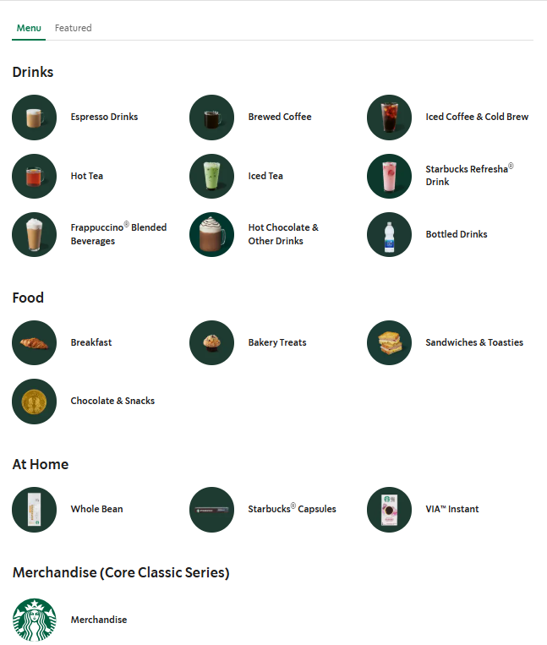
FIGURE 8: PRODUCTS IN THE UK MARKET
(SOURCE: STARBUCKS UK, 2025)
While localisation is the driving force of it in India. The Tata partnership incorporates Indian flavours – Masala Chai, Filter Coffee, Jaggery Cloud Latte and local snacks; as well as vegetarian and non-dairy products (Hindustan Times, 2022; Fischer & Roy, 2019). Localised cup sizes and Tata coffee result in lower-cost products that resonate with local cultures (Starbucksin, 2025).
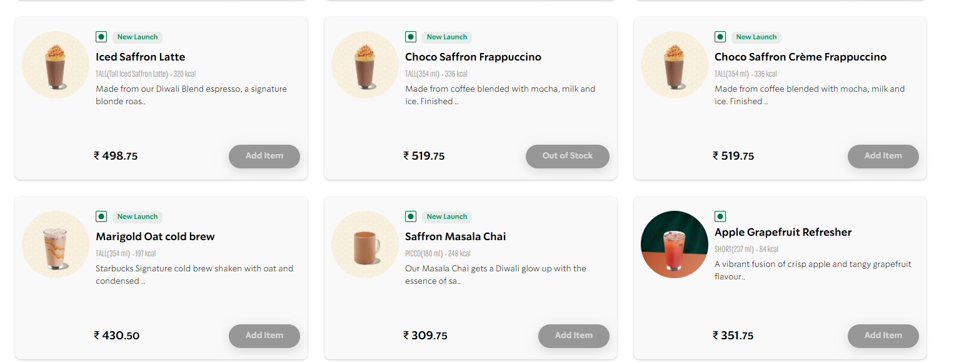
FIGURE 9: PRODUCTS IN THE INDIA
(SOURCE: STARBUCKSIN, 2025)
So, the UK emphasises the need for global consistency and brand authenticity on one hand, while India demonstrates a balance between international standardisation and local tailoring to enrich cultural relevance.

PRICE
Starbucks' prices match its high-end image; however price vary depending on the local market. For example; in the UK, a latte costs between £3.50 and £4.50. Though the price is high its customers are willing to pay for convenience and brand image (Alagar, 2025; Tea&Coffee, 2025).
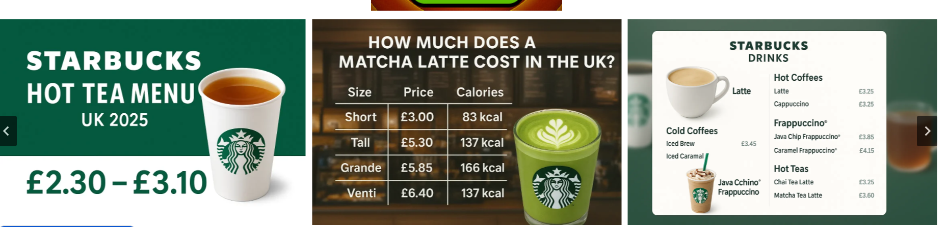
FIGURE 10: PRICING IN THE UK MARKET
(SOURCE: STARBUCKS-MENUE, 2025)
Prices in India range from ₹215 to ₹355, which is higher than general café shop price but still affordable for middle-class people (Shastri, 2025; Aniket, 2025). Small portions and entry-level drinks helps it to keep low prices compared to global market to attract customers (Fischer & Roy, 2019).
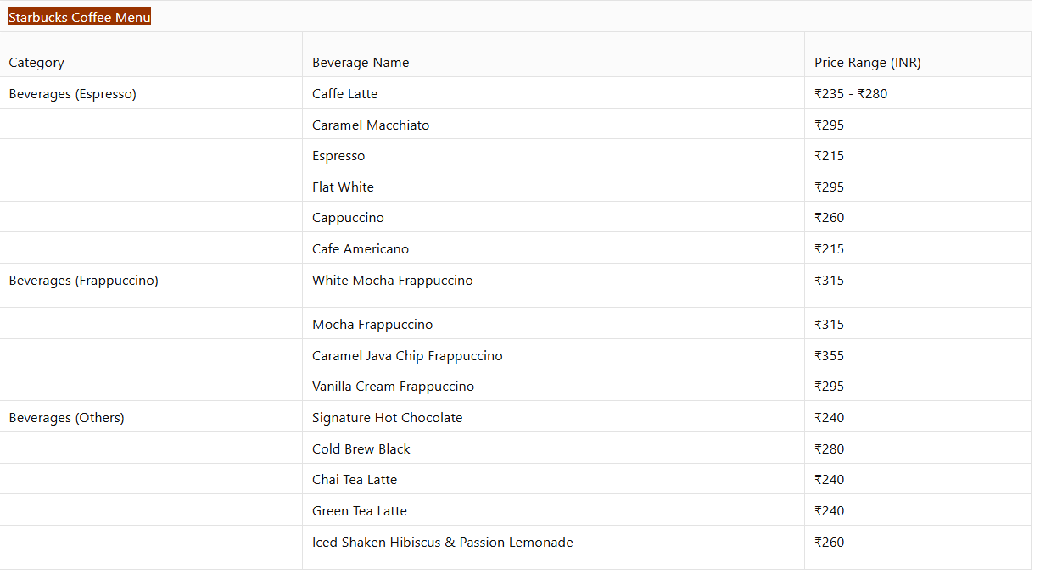
FIGURE 11: PRICING IN INDIA
(SOURCE: Aniket, 2025)
Overall, in the UK, it uses price as a sign of prestige and quality, while India uses a "premium-accessible" method to find a balance between want and price.

PLACE (DISTRIBUTION & LOCATION)
Starbucks has different ways of getting its products to its two main markets. In the UK, the corporation has a lot of high-street shopfronts, drive-thrus, and pick-up-only locations that combine with digital ordering and delivery apps to make things easier in a competitive coffee industry (Flanagan, 2024; Starbucks UK, 2024). This strategy anchors ease of access and digital convenience for time-constrained urban consumers.?On the other hand, Tata Starbucks in India is still developing its market with more than 457 stores present across 70 cities, focusing on metro and Tier-2 market expansion rather than saturation (Starbucks, 2024b). The Indian strategy seeks penetration and scale to develop on the new-to-market customers whereas the UK model is about proximity, convenience and technologies to cater an established set of markets.

PROMOTION
The focus of promotions is different in two counties. Campaigns in the UK focus on sustainability, loyalty integration, and digital involvement. While ads emphasise ethical sourcing and environment aims, the Starbucks Rewards app drives seasonal promotions and tailored incentives (Starbucks UK, 2024; Buxton, 2022). Premium experiences and eco-conscious principles are in line with social media marketing (Baker, 2025).
In India, storytelling skews tow local culture and aspiration. Such advertising campaign like “It Starts With Your Name”, festive promotions (Diwali, Holi) use regional currency motifs and influencers to reach and connect with urbanites degenerating youth (Gairola, 2024; Shastri, 2025). The ASCI compliant influencer alliances offer regional adage with mass digital metric (ASCI, n.d.). Thus UK foregrounds loyalty and ethics, whereas India foregrounds cultural prism and emotional connection.

PEOPLE
Starbucks refers to employees as “partners” in both markets showing an inclusive culture. In UK the strategy is to keep skilled labour at a lower cost for training and be digitally integrated to be able to maintain the quality of services under labour pressure (Starbucks UK, 2024).
In India, Tata Starbucks focuses on inclusiveness and developing talent and also moving towards gender parity with apprentice programmes that lead to increasing female representation (ESG News, 2024; Starbucks Careers India, 2025).
The UK is thus seeking efficiency and consistency, while in India, the company uses human capital to ensure its brand narrative of equality and opportunity.

PROCESS
In the United Kingdom, they don’t have to invest so much money into speed of service; process innovation in the shape of mobile order-ahead app payments and pick-up shelves are all built into the customer journey (Starbucks, 2025a).
In India there is a first-time café visit process and digital-store experience involving half digital, half in store. The UPI-based payments and loyalty integration are rapidly expanding, demanding flexible operations and on-boarding for new markets (TRAI, 2025; The Economic Times, 2025).
Both markets deploy the same digital backbone, though, in UK it is optimized for throughput while in India it is about scale and access.

PHYSICAL EVIDENCE
The design of the store and the sensory signals show what Starbucks stands for. In the UK, modern design, clear menu boards, and decor that promotes sustainability are all popular for a modern, high-end look (Starbucks UK, 2024).
Stores in India mix global styles with local workmanship. For example, Mumbai's flagship shop uses Indian art, materials from the region, and Tata branding (The Brand Hopper, 2023; Fischer & Roy, 2019). "Local roots, global brand" is what the packaging and visual merchandising show.
In short, the UK focusses on brand consistency and digital sophistication, while India combines localisation and authenticity to build emotional devotion.
TABLE 12: STARBUCKS’ MARKETING MIX (7PS) STRATEGIES IN THE UK AND INDIA
The analysis demonstrates that Starbucks has a constant premium identity and is able to change each part of the marketing mix as needed. The UK shows that it is digitally mature and has improved operations, while India shows that it can quickly grow and integrate cultures. Both of these things support Starbucks' approach of "global consistency, local relevance."

EVALUATION OF MARKETING STRATEGY PERFORMANCE

PERFORMANCE IN THE UK
In a highly competitive coffee shop industry, Starbucks' UK marketing approach exhibits excellent digital engagement and operational maturity. Starbucks UK's FY2023 revenue was £547.7 million, up 21.9% from the year before, and its operating profit was £21.7 million (Starbucks, 2024a). With 1,168 locations, its network increased coverage and brand awareness (Flanagan, 2024). The Starbucks Rewards scheme more than doubled its number of active users from 600,000 to 1.2 million in just 90 days after evidence the implementation of digital loyalty (Starbucks, 2024a). Roughly 40% of global sales are through digital coupons, indicating the significance of mobile-convenience with customised promotions (Su, 2025).
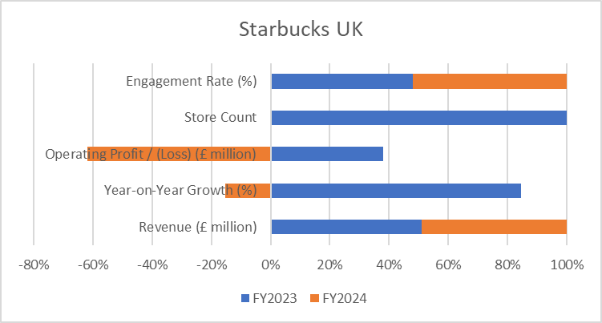
FIGURE 12: STARBUCKS UK – KEY MARKETING PERFORMANCE INDICATORS
While inflated prices, ubiquitous locations and feel-good sustainability narratives could all be working for Starbucks in keeping that aspirational status alive. It makes sense given the UK consumer’s ethical and environmental values, that campaigns would now eradicate the surcharge for plant-based milk and promote reusable cups (Buxton, 2022; Hodgson, 2024). However, FY2024 had seen a downward turn in financial performance, with a turnover of £525.6 million and pre-tax losses of £35.2 million (Walton, 2025). The overall demand situation remained firm but escalating labour, energy and supply costs eroded margins. The problem occurs when cost control tilts too far toward retaining or increasing value with a brand. Overall, Starbucks’ UK model is working to keep loyalty and digital engagement but will need to drive operational efficiencies to ensure profitability in a high-cost market.

PERFORMANCE IN INDIA
Starbucks is still in the process of growing and establishing its brand in India. It was a 50:50 joint venture with Tata Consumer Products and made ₹1,218 crore (about US$143 million) in sales in FY2024, which was a 12% increase from the previous year (The Economic Times, 2025). The network grew to 479 outlets in 80 locations, and there are plans to treble this number to 1,000 by 2028 (Starbucks, 2024b). India's approach to attract middle-class and young people includes offering premium accessible prices, digital loyalty programs, and new menu items that are specific to each region (Shastri, 2025).
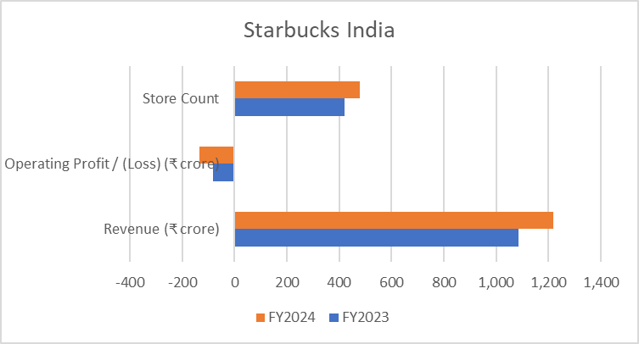
FIGURE 13: STARBUCKS INDIA – KEY MARKETING PERFORMANCE INDICATORS
Tata Starbucks lost ₹135.7 crore despite doubling sales due to rising operating expenses and consumer price awareness (The Economic Times, 2025). Digital marketing is effective, as evidenced by their 17.8 million Instagram followers and 0.8-1% interaction rate (Digital Scholar, 2024). Cultural Connection and Brand Goals Festival collaborations #StarbucksIndia and ads have raised brand aspirations and cultural connection (Gairola, 2024). Starbucks India has maintained its locality in a foreign café industry by serving region-specific beverages, running smaller retail shops, and delivering UPI-based payment solutions to a loyal and tech-savvy consumer base.
India prioritises long-term equity over short-term profitability. The brand's marketing mix (product, pricing, and local promotion) enables it to penetrate a rapidly evolving coffee culture market.

COMPARATIVE EVALUATION
The analysis shows that success of the company is dependent on market maturity and adaptation. Digital interaction and product localisation help Starbucks differentiate apart in both areas. The UK shows how to be efficient in a competitive market, while India shows how to flourish and interact with various cultures. They demonstrate that established markets value operational discipline and new markets cultural adaptability. Starbucks must balance these factors to remain global leader. It must employ the UK's advanced digital and ethical frameworks and promote India's demographic advantage and local innovation.

EVALUATION OF MARKETING ETHICS PRACTICES
The ethical factor on Starbucks marketing mix is an important part of its global brand. The company makes a public pledge to buy 100% of its coffee from the C.A.F.E. Practices programme which guarantees compliance with social, environmental and economic standards (Starbucks, 2024c). This demonstrates its wider Corporate Social Responsibility (CSR) configuration and corresponding with the Triple Bottom Line ethos - people, planet and profit. This work also aligns with the UN Sustainable Development Goals (SDGs.), notably SDG 8 (Decent Work), SDG 12 (Responsible Consumption) and SDG 13(Climate Action).

ETHICAL PRACTICES IN THE UK
The UK’s greatest ethical furores concern Starbucks’ tax techniques. With an income of £548 million in FY2023, the company paid just £7.2 million in corporation tax after moving £40.4m royalties to its American parent (Neate, 2024). While these transfers are not illegal under tax law, critics suggest that they do not align with Starbucks ethical corporate identity and its responsibilities to local stakeholders (Campbell 2016). From the perspective of stakeholder theory and distributive justice, this raises issues of fairness: consumers pay a premium for locally produced properties whilst the amount they contribute to local taxes seems miniscule.
To address environmental ethics, it’s been reported that Starbucks UK has released cold drink cups that include 10–20% less plastic and incentives have been introduced to move towards the use of reusable cups (Ko, 2024; Janberg, 2024). Single-use packaging is still widely used, though, and the company is accused of greenwashing when its sustainability promises are out of line with quantifiable results. This conflict draws attention to the discrepancy between Starbucks' claims of sustainability and its actual environmental effects.

ETHICAL PRACTICES IN INDIA
In India, ethical focus is around social inclusion and environmental responsibility. The initiative jointly managed by Tata Starbucks Embracing Gender and Preparing for Success program, which is a part of the partnership SDG 4 (Quality Education) and SDG 5 (Gender Equality)’s action plans in CSR activity(Tata Consumer Products, 2019). These initiatives have helped to elevate Starbucks’ local image as a diversified employer in an industry still formalising: the service sector.
According to India's national plastic-ban regulations, Tata Starbucks also promised to fully switch to recyclable and compostable packaging by 2019 (Tata Consumer Products, 2019). Takeaway culture and a lack of recycling facilities, however, impede those objectives (UKHI, 2025; Pandey, 2025). Therefore, if the company's environmental marketing claims are not supported by transparent waste-management reporting, they may be exaggerated.

COMPARATIVE ASSESSMENT
Starbucks UK receives higher ethical criticism for tax transparency and dubious claims on packaging, and Starbucks India is making better progress in social inclusion but suffering more with environmental issues. So much so, they must ensure their sustainability cues and CSR (corporate social responsibility) is credible, measurable and locally relevant. Independent verification of impacts and standardised reporting in all markets would also strengthen confidence. Ultimately, the long-term brand reputation of Starbucks relies on transforming its values – tax fairness, inclusivity and care for the environment - from marketing slogans into tangible action grounded in evidence on a market-by-market basis.

RECOMMENDATIONS AND CONCLUSION

RECOMMENDATIONS
Reflecting on the findings of the study following recommendations are provided;
First, in the UK, Starbucks needs a more relevant value proposition without diluting premium position. Retailers can no longer rely solely on bundling the past with reward currencies or offering a blanket discount, as there are still persistent cost pressures and slowing growth that require more sophisticated “value ladders” like off-peak bundles, smaller size formats and targeted discounts for rewards members rather than homogenous price slashes. Meanwhile, continued optimisation of store formats (more pick-up, drive-thru and smaller square-footage stores) can preserve margins in a high-wage, high-rent environment as well. In order to lessen concerns of "green-washing" and to strengthen trust, Starbucks should also strengthen evidence-based sustainability marketing by tying its plant-based promotions, reusable incentives, and packaging modifications to open impact data. Its ethical brand narrative would be strengthened by increased tax transparency and evident local community investment, especially in light of the continuous criticism of tax procedures.
Second, Starbucks should put profitable growth ahead of sheer scale in India. Tighter control over unit economics, cautious site selection in Tier-2 cities, and more scalable shop forms (kiosks, small outlets) to reduce fixed costs should all be part of the expansion to 1,000 stores by 2028. While preserving iconic products as margin drivers, the brand should keep developing its "premium-accessible" posture through micro-priced entry items, regional festival menus, and smaller cup sizes.
On the digital front, Starbucks can make use of UPI’s penetration as well as India’s social media culture by developing heavier UPI-linked loyalty journeys, bank collaborations and hyper-local influencer programmes without comprising on ASCI and DPDP regulations. Third, in both markets Starbucks ought to move forward with credible circularity initiatives — on reusable cup schemes, take-back points and local recycling partnerships — that match up its ethical claims with visible practice.
Cross-market learning is also recommended. UK-style robust sustainability reporting and menu-labelling schemes can be adapted for India so too India’s festival-based “going desi” localisation, and the youth-driven digital playbooks could form a selective basis for campaigning in UK cities with large south Asian and multicultural consumer bases.

CONCLUSION
Overall, the analysis demonstrates that Starbucks runs a consistent worldwide scale-up template (premium), yet fine-tunes its STP strategies and 7Ps to two vastly different contexts: the UK, which is mature, expensive, and heavily regulated, and India, which is young, growing quickly, and very digital. In the UK, Starbucks’ strategy has delivered strong brand presence, high digital loyalty and historically solid profitability, yet is increasingly exposed to inflation, wage growth and ethical scrutiny over tax and sustainability. In India, marketing focus is quick growing, through store openings, activity on social media, and a connection to the culture. However, high expenses of expansion and price-sensitive demand make it hard to make money.
The future success of Starbucks’ international marketing will depend on its ability to balance cost discipline and ethical leadership in mature markets with localisation-led, digitally enabled growth in emerging ones. By tightening value and efficiency in the UK, deepening profitable localisation in India and ensuring that ethical commitments are backed by transparent actions, Starbucks can strengthen both its commercial performance and its credibility as a responsible global brand.

REFERENCES
Acharya, M. (2025) Single brand retail trading. ClearTax. Available at: https://cleartax.in/s/single-brand-retail-trading (Accessed: 18 October 2025).
Advertising Standards Authority (ASA) (2025) Recognising ads: Social media and influencer marketing. Available at: https://www.asa.org.uk/advice-online/recognising-ads-social-media.html (Accessed: 18 October 2025).
Advertising Standards Council of India (ASCI) (n.d.) Guidelines for influencer advertising in digital media. Available at: https://www.ascionline.in/wp-content/uploads/2023/08/GUIDELINES-FOR-INFLUENCER-ADVERTISING-IN-DIGITAL-MEDIA.pdf (Accessed: 18 October 2025).
Aguilar, F.J. (1967) Scanning the business environment. New York: Macmillan.
Alagar, R. (2025) Starbucks marketing strategy: the case study. Skill Floor. Available at: https://skillfloor.com/blog/starbucks-marketing-strategy-case-study (Accessed: 9 November 2025).
Aniket (2025) Starbucks coffee price in India: see affordable coffee, coupons. Magicpin Blog. Available at: https://magicpin.in/blog/starbucks-coffee-price/ (Accessed: 9 November 2025).
Baker, N. (2025) UK mobile phone statistics, 2025. Uswitch. Available at: https://www.uswitch.com/mobiles/studies/mobile-statistics/ (Accessed: 18 October 2025).
Buxton, A. (2022) ‘Starbucks ditches vegan milk surcharge in all UK stores after Switch4Good spoof campaign’, Green Queen, 12 January. Available at: https://www.greenqueen.com.hk/starbucks-uk-drops-plant-milk-surcharge/ (Accessed: 18 October 2025).
Colombet, Z., Robinson, E., Kypridemos, C., Jones, A. and O’Flaherty, M. (2024) ‘Effect of calorie labelling in the out-of-home food sector on adult obesity prevalence, cardiovascular mortality, and social inequalities in England: a modelling study’, The Lancet Public Health, 9(3), pp. e178–e185.
Digital Scholar (2024) Case study on Starbucks’s digital marketing strategies – which you didn’t hear before!. Available at: https://digitalscholar.in/starbucks-digital-marketing-strategies/ (Accessed: 9 November 2025).
ESG News (2024) Tata Starbucks aims for 1,000 stores in India by 2028, doubling employment. Available at: https://esgnews.com/tata-starbucks-aims-for-1000-stores-in-india-by-2028-doubling-employment/ (Accessed: 9 November 2025).
Fischer, D. and Roy, K. (2019) ‘Market entry in India: The curious case of Starbucks’, Rutgers Business Review, 4(2), pp. 112–127.
Flanagan, R. (2024) ‘Starbucks to open another 100 stores in the UK – see full list of first 19 locations’, Mirror, 8 February. Available at: https://www.mirror.co.uk/money/starbucks-open-another-100-stores-32467599 (Accessed: 18 October 2025).
Food Safety and Standards Authority of India (FSSAI) (2021) Food Safety and Standards (Labelling and Display) Regulations, 2020. Available at: https://www.fssai.gov.in/upload/uploadfiles/files/Compendium_Labelling_Display_23_09_2021.pdf (Accessed: 18 October 2025).
Food Standards Agency (FSA) (2021) Introduction to allergen labelling for PPDS food. Available at: https://www.food.gov.uk/business-guidance/introduction-to-allergen-labelling-changes-ppds (Accessed: 18 October 2025).
Gairola, S. (2024) ‘Crafting a coffee empire: Starbucks’ rise in the Indian market – case study of Starbucks phenomenon in India’, International Journal of Innovative Research in Technology (IJIRT), 11(3), ISSN 2349-6002.
Gov.UK (2021) Plastic Packaging Tax: Steps to take. Available at: https://www.gov.uk/guidance/check-if-you-need-to-register-for-plastic-packaging-tax (Accessed: 18 October 2025).
Gov.UK (2025) Corporation tax rates and allowances. Available at: https://www.gov.uk/government/publications/rates-and-allowances-corporation-tax/rates-and-allowances-corporation-tax (Accessed: 18 October 2025).
Gov.UK (2025a) National Minimum Wage and National Living Wage rates. Available at: https://www.gov.uk/national-minimum-wage-rates (Accessed: 18 October 2025).
Hindustan Times (2022) ‘Starbucks to go desi, include masala chai, filter coffee to menu’, Hindustan Times, 30 July. Available at: https://www.hindustantimes.com/business/starbucks-to-go-desi-include-masala-chai-filter-coffee-to-menu-101657545358973.html (Accessed: 18 October 2025).
Hodgson, S. (2024) Starbucks brand positioning strategy, segmentation, targeting, and marketing. Brand Fabrik. Available at: https://fabrikbrands.com/branding-matters/brand-strategy/starbucks-positioning-strategy-starbucks-brand-position-strategy (Accessed: 18 October 2025).
Hofstede, G. (1980) Culture’s consequences: International differences in work-related values. Beverly Hills, CA: Sage.
International Monetary Fund (IMF) (2025) At a glance: United Kingdom. Available at: https://www.imf.org/en/Countries/GBR (Accessed: 18 October 2025).
International Monetary Fund (IMF) (2025a) World economic outlook, October 2025: Navigating low inflation. Washington, DC: IMF. Available at: https://www.imf.org/en/Publications/WEO/Issues/2025/10/14/world-economic-outlook-october-2025 (Accessed: 18 October 2025).
Janberg, W. (2024) The environmental cost of coffee: Starbucks’ plastic dilemma. ReportLinker. Available at: https://www.reportlinker.com/article/5981 (Accessed: 9 November 2025).
Jessica (2025) Caffè Nero Group. UK Startup Blog. Available at: https://directory.ukstartupblog.co.uk/caffe-nero-group/ (Accessed: 18 October 2025).
Ko, M. (2024) New, more sustainable Starbucks cold cups are made with up to 20 percent less plastic. Starbucks Stories & News. Available at: https://about.starbucks.com/stories/2024/new-more-sustainable-starbucks-cold-cups-are-made-with-up-to-20-percent-less-plastic/ (Accessed: 9 November 2025).
Legally Flawless (2023) ‘Influencer marketing and the fashion industry – The legal implications’, Legally Flawless, 12 November. Available at: https://legallyflawless.in/influencer-marketing-fashion-industry-the-legal-implications/ (Accessed: 18 October 2025).
Lexology (2025) Draft Digital Personal Data Protection (DPDP) Rules, 2025: A legal critique. Available at: https://www.lexology.com/library/detail.aspx?g=53f9ca14-e8b8-4891-a4b4-f2a4cc5a3abe (Accessed: 18 October 2025).
Merkelijkheid (n.d.) Starbucks positioning: Trendy coffee brand or ditchwater? Available at: https://merkelijkheid.nl/en/positioning/starbucks (Accessed: 18 October 2025).
National Academy of Customs, Indirect Taxes and Narcotics (NACIN) (2025) Handbook for GST Officers (August 2025). Available at: https://nacin.gov.in/Documents/e-Books/GST%20Handbook%203rd%20Edition%20-%20August%202025%20-%20NACIN%20Visakhapatnam.pdf (Accessed: 18 October 2025).
Ofcom (2025) Connected Nations update: Spring 2025. Available at: https://www.ofcom.org.uk/phones-and-broadband/coverage-and-speeds/connected-nations-update-spring-2025 (Accessed: 18 October 2025).
Office for National Statistics (ONS) (2025) Employment in the UK: October 2025. Available at: https://www.ons.gov.uk/employmentandlabourmarket/peopleinwork/employmentandemployeetypes/bulletins/employmentintheuk/october2025 (Accessed: 18 October 2025).
Ohri, N. (2025) ‘India’s retail inflation slows to eight-year low in September, leaving room for rate cut’, Reuters, 13 October. Available at: https://www.reuters.com/world/india/indias-retail-inflation-slows-154-september-2025-10-13/ (Accessed: 18 October 2025).
Ooh Magazine (2025) Starbucks UK sees 4% decline in sales for 2024 financial year. Available at: https://www.oohmagazine.co.uk/story.php?s=2025-04-08-starbucks-uk-sees-4-decline-in-sales-for-2024-financial-year (Accessed: 9 November 2025).
Pandey, K. (2025) ‘India achieves 50% non-fossil power capacity five years ahead of target’, Mongabay India, 10 July. Available at: https://india.mongabay.com/short-article/2025/07/india-achieves-50-non-fossil-power-capacity-five-years-ahead-of-target/ (Accessed: 18 October 2025).
Parul (2025) ‘India’s broadband users cross 984 million in July’, SME Futures, 6 August. Available at: https://smefutures.com/indias-broadband-users-cross-984-million-in-july/ (Accessed: 18 October 2025).
PocketOption (2025) Starbucks competitors in India: Market dynamics and key players. Available at: https://pocketoption.com/blog/en/interesting/reviews/starbucks-competitors-in-india/ (Accessed: 18 October 2025).
Press Information Bureau (PIB) (2025) Indian Telecom Services Performance Indicator Report for the quarter April–June 2025. Available at: https://www.pib.gov.in/PressReleasePage.aspx?PRID=2163330 (Accessed: 18 October 2025).
Shastri, A. (2025) Brewing the Starbucks marketing strategy: A complete guide. IIDE. Available at: https://iide.co/case-studies/starbucks-marketing-strategy (Accessed: 18 October 2025).
Starbucks (2012) Starbucks opens spectacular flagship store in Mumbai, honoring the dynamic culture of India. Available at: https://stories.starbucks.com/asia/stories/2012/starbucks-opens-spectacular-flagship-store-in-mumbai-honoring-the-dynamic-c/ (Accessed: 9 November 2025).
Starbucks (2022) Top 10 things to know about Starbucks 10 years in India. Available at: https://stories.starbucks.com/asia/stories/2022/top-10-things-to-know-about-starbucks-10-years-in-india/ (Accessed: 18 October 2025).
Starbucks (2024) Starbucks reports Q4 and full fiscal year 2024 results. Starbucks Financial Newsroom. Available at: https://investor.starbucks.com (Accessed: 18 October 2025).
Starbucks (2024a) Starbucks files UK and EMEA accounts for the fiscal year ended October 2023. Available at: https://stories.starbucks.com/emea/stories/2024/starbucks-files-uk-and-emea-accounts-for-the-fiscal-year-ended-october-2023/ (Accessed: 18 October 2025).
Starbucks (2024b) Tata Starbucks to accelerate growth to 1,000 stores, double employment in India by 2028. Available at: https://about.starbucks.com/press/2024/tata-starbucks-to-accelerate-growth-to-1000-stores-double-employment-in-india-by-2028/ (Accessed: 18 October 2025).
Starbucks (2024c) C.A.F.E. Practices: Starbucks approach to ethically sourcing coffee. Available at: https://about.starbucks.com/press/2024/cafe-practices-starbucks-approach-to-ethically-sourcing-coffee/ (Accessed: 9 November 2025).
Starbucks (2025a) A store for everyone. Available at: https://www.starbucks.com/stores-and-ordering/ (Accessed: 9 November 2025).
Starbucks (2025b) Download our app today and join Starbucks® Rewards. Available at: https://www.starbucks.co.uk/app (Accessed: 9 November 2025).
Starbucks Careers (2025) Benefits & perks. Available at: https://careers.starbucks.com/benefits/ (Accessed: 9 November 2025).
Starbucks Careers India (2025) Careers at Starbucks. Available at: https://careers.starbucks.in/job/Vadodara-Apprentice/579986210/ (Accessed: 9 November 2025).
Starbucks Corporation (2024) Starbucks reports Q4 and full fiscal year 2024 results. Available at: https://investor.starbucks.com/news/financial-releases/news-details/2024/Starbucks-Reports-Q4-and-Full-Fiscal-Year-2024-Results/default.aspx (Accessed: 18 October 2025).
Starbucks Corporation (2025) Starbucks fiscal 2024 annual report. Available at: https://s203.q4cdn.com/326826266/files/doc_financials/2024/ar/Starbucks-Fiscal-2024-Annual-Report.pdf (Accessed: 18 October 2025).
Starbucks IN (2025) Drinks. Available at: https://www.starbucks.in/ordering (Accessed: 9 November 2025).
Starbucks UK (2024) Order ahead to get ahead. Available at: https://www.starbucks.co.uk/article/381/order-ahead-to-get-ahead (Accessed: 9 November 2025).
Starbucks UK (2025) Menu. Available at: https://www.starbucks.co.uk/menu (Accessed: 9 November 2025).
Starbucks-Menu (2025) Starbucks menu with prices UK. Available at: https://starbucks-menu.co.uk/ (Accessed: 9 November 2025).
Start.io (2022) Who is Starbucks’ target market? Customer characteristics and marketing strategy analysis. Available at: https://www.start.io/blog/starbucks-target-market-customer-characteristics-marketing-strategy (Accessed: 18 October 2025).
Su, I. (2025) Starbucks Rewards: a loyalty program case study. LoyaltyLion. Available at: https://loyaltylion.com/blog/scale-success-story-starbucks-rewards-program (Accessed: 9 November 2025).
Suri, M. (2025) Starbucks business model and growth strategy. GrowthX. Available at: https://growthx.club/blog/starbucks-business-model (Accessed: 18 October 2025).
Tata Consumer Products (2019) Tata Starbucks reiterates commitment towards environmental sustainability. Available at: https://www.tataconsumer.com/news/tata-starbucks-reiterates-commitment-towards-environmental-sustainability (Accessed: 9 November 2025).
Tea & Coffee Trade Journal (2025) ‘Costa Coffee takes top spot as the UK’s favourite coffee chain’, Tea & Coffee Trade Journal, 3 February. Available at: https://www.teaandcoffee.net/news/36131/costa-coffee-uks-favourite-according-to-world-coffee-portal/ (Accessed: 18 October 2025).
Telecom Regulatory Authority of India (TRAI) (2025) Telecom subscriptions reports. Available at: https://www.trai.gov.in/release-publication/reports/telecom-subscriptions-reports (Accessed: 18 October 2025).
The Brand Hopper (2023) Marketing strategies and marketing mix of Starbucks Coffee. Available at: https://thebrandhopper.com/2023/07/06/marketing-strategies-and-marketing-mix-of-starbucks/ (Accessed: 18 October 2025).
The Economic Times (2025) ‘Starbucks India losses surge 65% in FY25, sales grow 5%’, The Economic Times. Available at: https://economictimes.indiatimes.com/industry/cons-products/food/starbucks-india-losses-surge-65-in-fy25-sales-grow-5/articleshow/121398481.cms (Accessed: 9 November 2025).
The Economic Times (2025) ‘UPI crosses 20 billion transactions in August, records ₹24.85 lakh crore value’, The Economic Times, 2 September. Available at: https://economictimes.indiatimes.com/industry/banking/finance/banking/upi-crosses-20-billion-transactions-in-august-records-24-85-lakh-crore-value/articleshow/123633627.cms (Accessed: 18 October 2025).
The Guardian (2024) ‘Starbucks paid £7.2m in UK corporation tax despite gross profit of £149m’, The Guardian, 5 April. Available at: https://www.theguardian.com/business/2024/apr/05/starbucks-paid-7-point-2m-in-uk-corporation-tax-despite-gross-profit-of-149m (Accessed: 9 November 2025).
Tovar, D. (2024) Digital marketing: What is Starbucks’ marketing strategy? Blue Cactus UK. Available at: https://www.blucactus.uk/starbucks-marketing-strategy (Accessed: 18 October 2025).
U.S. Securities and Exchange Commission (SEC) (2025) Starbucks reports Q4 and full fiscal year 2024 results. Available at: https://www.sec.gov/Archives/edgar/data/829224/000082922424000051/sbux-9292024xexhibit991.htm (Accessed: 18 October 2025).
UK Finance (2025) Over half of UK adults now use mobile wallets. Available at: https://www.ukfinance.org.uk/news-and-insight/press-release/over-half-uk-adults-now-use-mobile-wallets (Accessed: 18 October 2025).
UK Parliament (2025) The UK’s plans and progress to reach net zero by 2050. House of Commons Library Research Briefing CBP-9888. Available at: https://commonslibrary.parliament.uk/research-briefings/cbp-9888/ (Accessed: 18 October 2025).
UKHI (2025) Single-use plastic ban in India: 2025 update. Available at: https://ukhi.org/single-use-plastic-ban-in-india-2025-update/ (Accessed: 18 October 2025).
Walton, J. (2025) ‘Coffee shop chain records large loss across its UK locations for the last financial year, after achieving profit before tax of £16.9m in the previous year’, Foodservice Equipment Journal. Available at: https://www.foodserviceequipmentjournal.com/starbucks-uk-sees-35m-pre-tax-loss-in-2024/ (Accessed: 9 November 2025).

