NAME: Deirdre Gould
ENROLE NUMBER: 1809630
MODULE TITLE: Generating Business Data and Analysis
BMSP4004
ASSIGNMENT: 1

Introduction
What is an Information system? It is a software which helps you organise and analyse data, a set of consistent components that work together to collect, process, store and distribute information to help decision making, coordination, control, analysis, and visualisation in an organisation. It is made up of five components, hardware, software, database, network and people. The components mix together to perform input, process, output, feedback, and control. Hardware consists of input/output device processor operating system and media devices. “The first large-scale mechanical information system was Herman Hollerith`s census tabulator. Invented in time to process the 1890 U.S. census, Hollerith`s machine represented a major step in automation, as well as an inspiration to develop computerised information systems” (Zwass, 2019).
Business and organisations rely on information systems to carry out and manage their operations as well as their customers, suppliers, financial accounts, manage human resources, and to compete in the marketplace. People rely on information system for internet-based in their every day life socialising, banking, study, shopping, and entertainment.
The three main kinds of information systems that would serve different organisational needs are, operational-level systems, management-level, and strategic-level. Major types of systems, Transaction Processing Systems (TPS) has a large database and a lot of concurrent users that execute database transactions, banking, credit card processing, stock market, supermarket checkout. Management Information Systems (MIS), Decision-Support Systems has a high-level data for complex and decisions. (DSS), Executive Support Systems (ESS).
“A database is less expensive and comes with a lot of benefits, it helps to build a better relationship with the existing customers and search for new ones. Here is a list of advantages:
- Building better customer relationship (via newsletters, business emails)
- Sell complementary products
- To make customers aware of special offers
- To tell them about new services and products
- To send offers to specific groups
- Results are evident because you can consider the returns
- It`s very useful in direct marketing” (Charis, 2017).
Data Modelling
“A data model-a collection of concepts that can be used to describe the structure of a database-provides the necessary means to achieve this abstraction. By structure of a database we mean the data types, relationships, and constraints that should hold on the data. Most data model also include a set of basic operations for specifying retrievals and updates on the database.” (Navathe, 2000). Data modelling is usually the first step in database design the data structures in a table for the database which helps to reduce unnecessary columns. Therefore, it provides a framework for data to be used in information system. If a data model is used constantly across systems, then compatibility of data can be achieved. The same data structures are used to store, and access data then different applications can share data seamlessly. The primary goal of using data model is to ensure that all data objects required by the database are accurately represented.
Flat-File Database
Flat database cannot represent complex relationships between entities. It is a simple database system using a single table in which all records are stored as a single row of data, that are separated by delimiters. It is a uniform format, with no structures for indexing or recognising relationships between entities. They are created for small, simple databases like a mobile phone contact list.

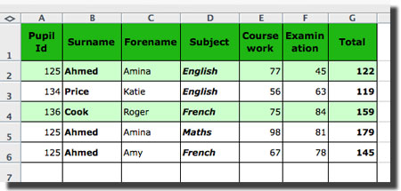 (database, 2004)
Spreadsheet file data table is the flat-file database with easy single field input.
Relational Database
A relational database contains multiple tables of data that relate to each other through different key fields. “The relational model was first introduced by Ted Codd of IBM Research in 1970 in a classic paper (Codd1970), and attracted immediate attention due to its simplicity and mathematical foundations. The model uses the concept of a mathematical relation-which looks somewhat like a table of values-as its basic building block and has its theoretical basis in set theory and first order predicate logic.” (Navathe, 2000).

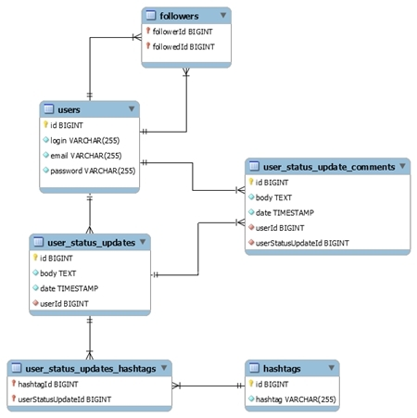 (Plechawska-Wojcik, 2017)
No two databases are alike the database design is more like art than science as you need to analysis all the information. By gathering the information, you can then define the objective of the database and how to store it by diving the data into subject tables. Choose one column or more as the primary key, which will identify each of the rows. In the relational model a table cannot contain duplicate rows, as that will create uncertainties in retrieval. To ensure individuality each table should have a column or columns called primary key that uniquely identifies every records of the table, example county code will be used as a primary key. Also, county English, county welsh, town code, town name. The primary key should not change if you do you will have to change all its references, or everything will get lost.
A database containing independent and unrelated tables serves little purpose which is the flat-line database to make it into a relational database is defined between the relationship of the tables. Designing the relational database to identify the relationships among the table can be done with:
- One-to-many; a record in table 1 has no more than one matching record in table 2 design two tables, one to store information `town name` and the other `county name`.
- many-to-many; a record in table 1 can have more than one matching information in table 2, table 2 has one information matching in table 1; design another table to store information `venue`.

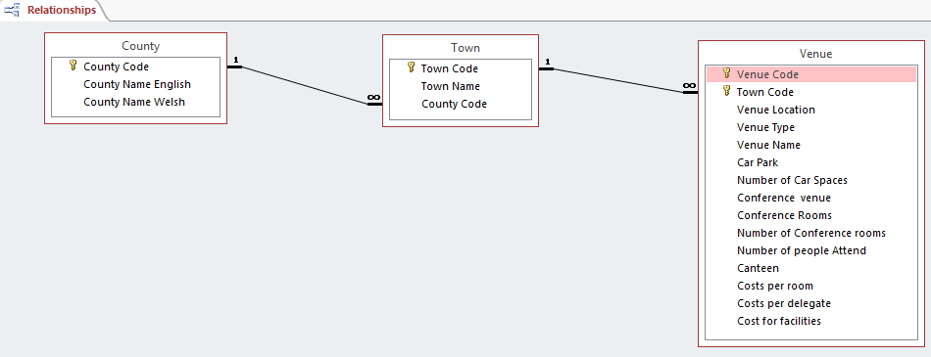 (Mullins, 2018)

- one-to-one; if limited on columns inside a table one-to-one relationship can be split into two tables of data.
Having chosen appropriate data for each column refine by adding more columns if needed creating a new table for possible data or splitting a large table into two smaller tables. The town code key in the venue is called a foreign key, whereas the venue code is a primary key. The primary key allows each row in a table to be uniquely identified and ensures that no duplicate row exist, and no null values are entered.
“A foreign key is a field (or collection of fields) in one table that uniquely identifies a row of another table or the same table. The foreign key is defined in a second table but refers to the primary key in the first table”. (foreign key, n.d.).
Conclusion:
A very important part of running a business is database management tracking and organising, for better inventory. Database manages a huge amount of data and helps users to perform more than one task at any one time. Using one software application businesses can operate a more efficiently. The types of data that are easily managed are payroll, employee records, student information, project management, accounting, library books and inventory. Information is useful for a company to know about its present performance, assessing and making plans for the further operations. Without database all these tasks would have to be done manually which is time consuming. Database can structure and categorise to suit the needs of the organisations. Where the database is entered specific users can access daily and multiple if given access also operate the system at the same time.
A very effective marketing strategy today is the email a lot of money is made from business email listings. A business email list helps to convert the audience into targets. Another way database is good for businesses is marketing, a database builds up customer profile which helps in more targeted marketing. The designing is important as there needs to be a balance between usefulness and simplicity. A database is of no importance if it is not updated. Extra fields are useful to add information later.
Advantages of databases are basically a lot quicker less time consuming more compact, easily updated, and its in one place for easy access. The dis advantages are security and integrity can be compromised, additional hardware maybe required which adds to costs and administrators.

