Task One - Professional, ethical, and inclusive behaviours.

Define the term professional and explain what it means to be a ‘people professional.’ (AC 1.1)
According to Gerald (2023) Most professionals must adhere to rigid rules of conduct. (Gerald ,2023) This is also agreed by Indeed (2021) Professionals have often been well-educated individuals who have received a significant amount of training and schooling. You can enter a wide range of various career paths as a professional. (Indeed Editorial Team,2021) According to Accaglobal (2019), professionalism is demonstrated by someone who knows when to challenge and when to conform, in addition to when to lead and when to work as a team. (https://www.accaglobal.com)
A rigid code of conduct is expected from most professionals, according to Gerald (2023). The statement is also strongly supported by Indeed (2021): Professionals often have a high level of education and training. It is possible for professionals to pursue a wide variety of careers. In fact, Accaglobal (2019) says professionalism is the ability to challenge, conform and lead at the right times, in addition to the ability to work together and act as a team. (https://www.accaglobal.com)
Through effective people interventions, human resource professionals support the organisation's vision and goals. Organisations are made up of people, one of their roles is to enable the people within to flourish both individually and collectively. As described by CIPD (2021) The people profession is uniquely placed to drive positive change in the world of work by understanding, communicating, and unlocking the value of an organisation’s people, the profession enables sustainable business outcomes which benefit all. (“Why work in the people profession? | CIPD”) (CIPD,2021)
HR professionals are responsible for supporting the organisational vision, goals, and values through effective people interventions. Organisations are made up of people, and enabling individuals and organisations to flourish is one of their responsibilities. A person's role is unique in enabling sustainable business outcomes, both for an organisation and its employees, based on the profession's understanding, communication, and unlocking of a people's value, according to CIPD (2021). (“Why work in the people profession? | CIPD”) (CIPD,2021)
According to Hurst (2021) Human resources specialists play a crucial role in the business world, and having one on your team would be quite advantageous for any company. HR specialists have a crucial role in resolving conflicts and promoting company values in addition to dealing with business, strategy, planning, and development. Employees are people with human emotions at the end of the day. There are some circumstances that call for the intervention of a person who is emotionally intelligent and is familiar with all workplace agreements, laws, and regulations. (Hurst,2021)
In the business world, HR specialists play a key role, and any company would benefit from having one on its team. As well as handling business, strategy, planning, and development, HR specialists need to resolve conflicts and promote company values. At the end of the day, employees are human beings with emotions. Some circumstances might require the intervention of someone with a high degree of emotional intelligence and familiarity with all legal, regulatory, and workplace agreements. (Hurst, 2021)

Explore how the role of a people professional (either a generalist or a particular specialist) is evolving and the priorities this raises for continuing professional development (CPD) (AC 3.1)
The CIPD asserts that Several techniques still used by HR departments were initially created for hierarchical, top-down systems. With a new generation of leaders that have grown up in an open, tech-driven world and have had an experience that is much more "consumer-like," we are heading towards smaller, self-empowered teams. Because of this, Hr should be more focused on "empowering managers, providing them tools to work with one another and really grasp technology and data." Since the days of the "personnel" function, the people profession has advanced significantly. Technology will keep developing, and there will always be chances we can take advantage of to better position ourselves for the digital future. (Prasad)
CIPD believes that some of the HR methodologies still in use were originally developed to accommodate hierarchical, top-down systems. In the coming years, we will see a shift towards smaller, self-empowered teams thanks to the new generation of leaders who grew up in an open, tech-driven world. Therefore, HR should emphasize "empowering managers, providing them with tools to accomplish their goals, and helping them grasp technology and data." Compared to traditional HR, the "people" profession has advanced significantly. Our position in the digital future will continually improve as technology advances. (Prasad, 2019)
CIPD (2030) describes the demand for agility and change, presents a genuine opportunity for human resources professionals to fully participate in company strategy and drive necessary change in organisational design and development. Given the complexity of our organisations, this will entail increased cross-functional collaboration and business partnering: It will be essential to develop extraordinary adaptability, openness, and persuasiveness. CIPD (People Profession 2030 a Collective View of Future Trends)
A genuine opportunity for human resources professionals to actively participate in business strategy and drive critical change in organisational design and development is presented by CIPD (2020), which describes the desire for agility and transformation. This will require more cross-functional collaboration and business partnering due to the complexity of our organisations; it will be crucial to cultivate exceptional agility, transparency, and persuasiveness. CIPD (People Profession 2030 a Collaborative Vision of Future Trends) (People Profession 2030 a Collective View of Future Trends)
According to Dessler (2019) although onboarding, recruitment, and training are still the responsibilities of modern HR professionals, their jobs have expanded to include more strategic duties. While the concept of an employee lifecycle has enlarged our understanding of human resources, HR professionals' responsibilities now encompass the whole employee lifecycle, from the initial hiring date to the worker's termination date. Most of HR's previous duties, including conducting performance reviews and offering training and development programmes, are covered under this strategy. The emphasis now is on taking a more cooperative approach. In contrast to the past, HR is now sitting at the leadership table to help determine the company's direction and make strategic decisions. (Dessler,2019)
Although onboarding, recruitment, and training are still the tasks of contemporary HR professionals, Dessler (2019) claims that their positions have evolved to incorporate more improve management. Although the idea of an employee lifecycle has broadened our knowledge of human resources, HR professionals' duties now span the whole employee lifetime, from the time of the employee's original hire to the time of their termination. This plan covers most HR's prior responsibilities, including conducting performance appraisal and providing training and development opportunities. The current focus is on adopting a more consultative approach. Unlike in the past, HR is now a member of senior team, engaging in the development of business plan. (Dessler,2019)

Discuss the concept of ‘ethical values,’ and how at least three ethical values that you hold personally, impact (or could impact) on your work as a people professional. (AC 1.2)
CIPD (2019) describe ethical values as the moral compass we use to navigate through life and make decisions is provided by ethical principles. Every corporation has the chance to shape its ethical culture and inspire its employees to act and conduct ethically. The culture of an organisation may influence people's behaviour, and research has shown that ethical leadership perceptions have a favourable effect on employees' ethical behaviour. (CIPD, “Ethics at Work: An Employer’s Guide | Guide”) We distinguish between corporate values and ethical values (such as honesty, fairness, integrity, trustworthiness, and respect). Company values are what the firm will provide, while ethical values are how those business values will be fulfilled. (Institute of Business Ethics)
Trust, honesty, and integrity (Baker,2021) are three of the most important qualities to me personally. The more open I am with others, whether it is a member of my family, a teammate, or anyone else, the more they will trust me. If people are aware of my honesty and integrity, they will not need to question what I have to offer or search for the reasons behind my actions. (Gonsalves, 2012) The three most important qualities I value are trust, honesty, and integrity (Baker,2021). I will gain trust from others if I am open with them, whether they are family members, teammates, or anyone else. The truth and integrity of who I am will make people less likely to question what I can offer or question the reasons for what I do. (Gonsalves, 2012)
I have come to realise that no matter how disappointed I believe someone will get when I tell them anything the harsh truth, they will be a thousand times more disappointed when they discovered that I had lied to them. They are aware that I am a trustworthy individual who keeps my word. Alternate strategies of speaking lies and half-truths, will erode trust and can hurt any relationship over the long term. (Andreski,2020) I want to be known as a person of honesty and integrity so that my colleagues, family, and friends will not have to doubt what I say or wonder what my true intentions are. Honesty is a quality I possess. Sincerity helps me uphold my moral convictions, which is crucial to me in my profession. One way that honesty shows through in my work every day is by being reasonable and transparent in my communication and decision making. (Andreski,2020). I ensure that I am ethical and do the right thing by having strong moral principles. Integrity is the ability to stay committed to one's beliefs even when faced with a challenging situation. As a people professional I stand by my beliefs when making decisions to help guide my team. For example, I have a moral obligation to help support managers to eliminate emotions from the disciplinary process when making decisions in the best interest of the company and the colleague to ensure everyone is treated fairly and equally. A leader who stays consistent in their beliefs gives employees confidence in their decision, which leads to stability within an organisation. (Team, 2022)
I would like to be known as the kind of person who acts on what they say they will do. The results of lack of integrity, honesty, and trustworthiness would most definitely hurt my reputation since people would find it hard to believe in me. It is essential to establish a reputation as the kind of person who keeps their word. Due to my lack of integrity, honesty, and reliability, others would find it difficult to believe in me. This would surely damage my reputation and make it more difficult for me to challenge others' morals, which now makes up a sizeable portion of my role. As a professional in the human relations field, I would become untrustworthy and lose respect from others. Integrity, honesty, and trust improve the workplace. When I earn my colleagues' trust, by leading by example I provide the groundwork for strong business ethics and doing the right thing, creating an open workplace where my colleagues and managers may speak freely and comfortably, this has helped enhance managers' capacity for constant communication, relationship development, and the display of values to retain staff and expertise within the company. (DecisionWise,2018)

Explain why it is essential for people professionals to contribute confidently to discussions, and ways of doing this that are (AC 1.3):
An essential aspect of HR's job is employee communication. A company's culture, employee engagement, and productivity are all influenced by effective internal communication, which also helps to build trust inside the company. (CIPD, “Employee Communication | Factsheets | CIPD”) It is essential to consider a variety of persuasive tactics and strategies to give an engaging and informed opinion to a conversation.
According to Mills (2017) Understanding depends on communication being clear. Poor communication will leave your audience will become confused if your message is confusing, and you will not achieve your goals. In meetings, things like these frequently occur. The goal of meetings is to produce meeting deliverables, such as choices, action items, or consensus, which can advance a business or initiative. Whatever message you communicate, whether during a presentation or on a conference call, should consider the desires and requirements of your audience by outlining a distinct benefit or outlining a specific course of action. (Mills,2017)
When the message you wish to discuss is fully informed, your audience will comprehend exactly what you are trying to convey. It is important that your thesis is reinforced by factual material that includes numbers and figures to stop the audience from inventing scenarios. The entire goal of your conversation will be unsuccessful if you are lacking information. Knowing when and where things will happen must be a key focus. Sharing based on information makes sense. The language is sequential, logical, and organised. (Indeed) The impact of changes on employees and where the organisation is going can often be difficult for senior leaders to communicate clearly. It can also be difficult for managers to communicate effectively with their teams due to a lack of skills, confidence, and time. CIPD (“Employee Communication | Factsheets | CIPD”) The essential point should be clearly connected, and the flow should be consistent. Having engaging discussions with your colleagues can help both of you in several ways, including, you can show your colleagues your excellent qualities, such as composure, honesty, open-mindedness, and dependability, by participating in communication with them. It is not only about what you say in a discussion; it is also about how you listen. Professional relationships can be established through meaningful discussions at work. While virtual communication channels like emails and phone calls can also build these connections, in-person interactions may result in more interesting discussions or deeper interpersonal relationships. (Indeed) Establishing connections with others is essential to successfully completing all these tasks knowing what they think, what they worry about, and how they wish to interact with them using the best possible methods (CIPD, 2022c).

Discuss when and how to raise concerns when issues such as organisational policies or leadership approaches conflict with ethical values or legislation. (AC 1.4)
According to ACAS (2020) If you are experiencing issues at work, you should first attempt raising them informally with your manager. If you are a member of a trade union, you can speak with a representative. Explain the issue and what you believe ought to happen. The method of tackling the issue needs to be collaborative. You should be able to describe the issue to your management. You should pay attention to what they have to say as well. If you are unable to come to a resolution you can formally raise the matter, this is known as a grievance. (ACAS)
As described by GOV (2011) If you report specific wrongdoing as a worker, you are considered a whistle-blower. You must reveal misbehaviour that is in the public interest. This implies that it must have an impact on others. You have the right to voice your concern at any time on an incident that has already occurred, is currently occurring, or you suspect will happen soon. (GOV.UK,2011) Employers, workers, trade unions, and the public all recognise the need of "whistleblowing," or bringing up workplace issues that are in the best interests of all people. It is important for individuals to feel comfortable and heard when expressing issues. Treating colleagues with dignity, respect, and compassion is an essential part of positive people management, and encouraging whistleblowing by taking an open-minded stance helps advance the principles of truthfulness and openness. With this strategy, the culture is altered, and the provision of exceptional care, colleague wellbeing, and safety are accepted as "the way we do things around here." (“Whistleblowing or Raising Concerns at Work”)
The Public Interest Disclosure Act of 1998 (OPSI; which went into effect in 1999, established a policy to give employees who report wrongdoings they really believe to be true strong protection from being dismissed or subjected to other sanctions. It empowers employees who report misconduct to file a complaint with an employment tribunal if they are fired or experience any other kind of retaliation as a result. Workers who are not employees may file a claim for harm if their contracts are terminated because they made a protected disclosure, but only employees may file a claim for unfair dismissal. (GOV.UK, “Governance Guide - Public Interest Disclosure | Department for Communities”)
Provide a robust argument for ethical people practice that is supported by academic theory and details both the business and human benefits of people at work feeling included, valued, and fairly treated. (AC 2.1)
Gordon (2022) States employee treatment at work affects their motivation, contentment, performance, and commitment. The factors that support this are explained by Herzberg's two-factor theory of motivation. Motivators and hygiene are the two main categories into which the items are divided. Growth, progress, meaningful work, and recognition are some of the motivators. With participation in decision-making, employees feel valued and included, and rewards that are appropriate result in improved performance, motivation, and satisfaction. They are distinguished by a protracted term of employment with the organisation. Employee well-being is improved by treating them equally and valuing them despite their differences, which also helps to improve performance and employee happiness. (Gordon,2022)
Several factors affect the motivation and commitment of employees at work according to Gordon (2022). According to Herzberg's two-factor theory of motivation, this phenomenon is supported by two factors. In general, the items can be categorized into two categories: motivators and hygiene. In addition to growth, progress, meaningful work, and recognition, there are many other motivating factors. Involvement in decision-making leads to a sense of belonging and appreciation, and rewarding employees appropriately results in an increase in performance, motivation, and satisfaction. An employee who has been with the organisation for a lengthy period distinguishes them from others. It is also possible to improve performance and employee happiness by treating employees equally and valuing them regardless of their differences. (Gordon,2022)
For an employee to feel truly valued and motivated, they must feel like they belong. Belonging is what allows them to be themselves without fear of punishment or different treatment -- and it has a significant impact on their performance. It's still important to focus on diversity and inclusion, but without a sense of belonging, they won't suffice. To improve employee engagement and psychological safety, belonging is a crucial component. An environment that fosters collaboration and problem solving even triggers different brain responses. (Huppert, 2017)
Herzberg's Two Component Theory of Motivation teaches us that organisations and leaders must first get the fundamentals correct. The person will not become content unless they have successfully given them access to the fundamental hygiene factors. (Nickerson,2021)
Maslow's motivation theory, often known as Maslow's hierarchy of needs, is a theoretical framework that describes the numerous motivations that humans experience. Because theory can be applied to the workplace, it has gained popularity among intellectuals and business executives. This approach can be applied by managers to inspire staff, boost job happiness, and develop self-actualized workers. They are our fundamental issues, and they are what drive us most. You cannot expect your team to be motivated to do anything other than try to meet their physiological demands if you cannot provide for their needs. (McLeod, 2021)
Engagement in the workplace contributes to a company's success. High-engagement teams are 23% more likely to be profitable, and teams in the top 20% are 81% less likely to be absenteeism-prone, and 43% less likely to be turnover-prone. A sense of belonging at work increases job performance by 56%. Productivity increases when workers are supported, happy, and free to be themselves. (Herbert, 2021)
It's crucial to meet the safety requirements of the workforce if you want to keep them comfortable and happy. This involves offering a secure work atmosphere free from intimidation, bullying, or risk posed by the surrounding physical environment. (Hartzell,2021) In the job, it's critical to strike a healthy and fruitful balance between personal and professional obligations. Promoting worker motivation through social inclusion and interaction is an excellent idea. (Cherry,2022) Offering employees more duties can help them feel valued, important, and respected, which is another effective strategy to raise their self-esteem. (Wilson,2020) Employees may perform to the best of their abilities and attain their full potential at work with the assistance of managers and team leaders. (Wilson,2020)
Drawing on your own or a hypothetical example of providing a people practice solution to meet a particular need or introducing a new policy or initiative, describe:
- Strategies for designing the solution/initiative so that it will be inclusive
- Strategies for checking that, when in practice, the solution/initiative engages and meets the needs of all those it is aimed at. (AC 2.2)
When implementing the new colleague food menu following the closure of the staff canteen, I went about gathering insights from managers and colleagues over several weeks and across different working patterns. I held forums (Having a say on what matters, 2018), engagement sessions and feedback forms, before agreeing on the best solution to implement. As a result, colleagues had the chance to ask questions and make frank comments about what they thought would not work or what might work better. I was able to compile all the information that was crucial to my colleagues, which enabled me to think about what would be best for both the organisation and them. This gave the colleagues a chance to influence the plan's design.
I presented to my colleagues the justification for the change, how the most recent modifications would affect them personally, and how the change would be implemented throughout the company. It was crucial that colleagues were reassured that hot meals would still be provided to them throughout their shifts but at a reduced cost of 70% and that the meals would now be served from the customer café.
As the policies changed (People Policies, 2023), I made sure they were fully informed. Before the formal shift occurred, it was crucial to have early colleague contact strategies for designing the solution/initiative so that it was inclusive to all those affected. I was already able to learn from investigating other organisations what was functioning effectively elsewhere because we were one of the last organisations to apply this change to the colleagues.
It was crucial to maintain listening groups and forum Your say meetings (Having a say on what matters, 2018), with the management team and colleagues after the change to make sure the change had been implemented fully. I could also look through store data to confirm how many people were using the new colleague menu to determine the level of engagement. It was encouraging to learn that following a successful launch, colleagues' cafe takings were exceeding the goal, and the cafe's LFL total was rising week by week.

Task Two – Professional Development
Activity 1 (A.C 2.3, AC 3.2) Using a range of information, including feedback from other, assess your practice against the FIVE CIPD Profession Map core behaviours listed below. The 5 core behaviours (all to be selected at associate level) are:
- Ethical Practice
- Professional Courage and Influence
- Valuing People
- Working Inclusively
- Passion for Learning
To evaluate myself against the Five CIPD Profession Map Core Behaviours at Associate Level: Ethical Practice, Professional Courage and Influence, Valuing People, Working Inclusively, and a Passion for Learning, I was able to fill out this information by asking for feedback from my Line Manager, Business Partner, and Work colleagues. My performance reviews have also helped me to learn what people think are my strengths and areas for improvement. I thought anonymous colleague insight polls were a fantastic tool for getting feedback because they helped to remove any barriers for the colleagues completing the survey and gave me a true image of how other people viewed my behaviours. I was able to determine which Professional Map Core Behaviours needed the most attention after completing the self-assessment, what I would need to do to accomplish this, and suggested resources that were available to me.
Self-Evaluation
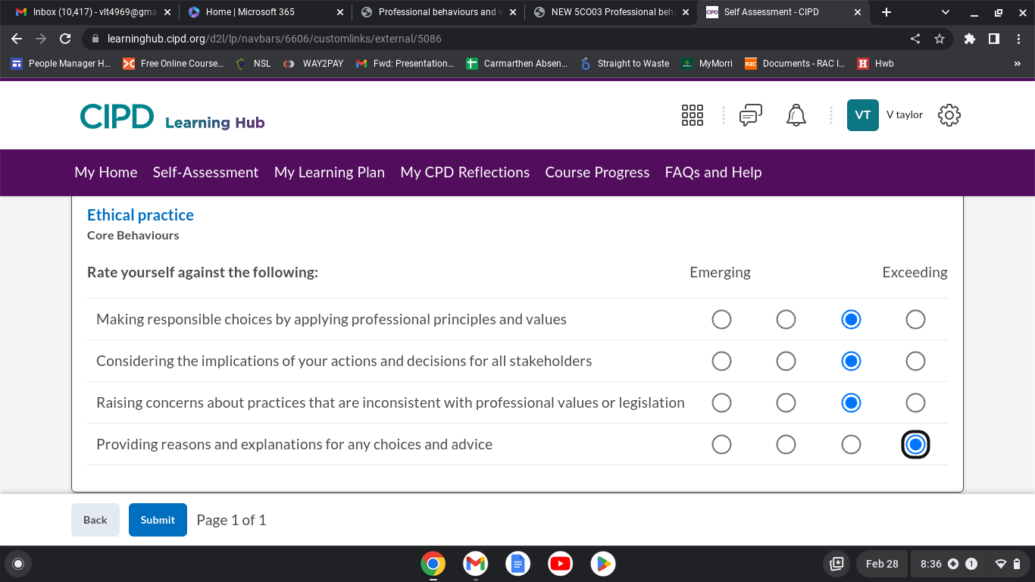

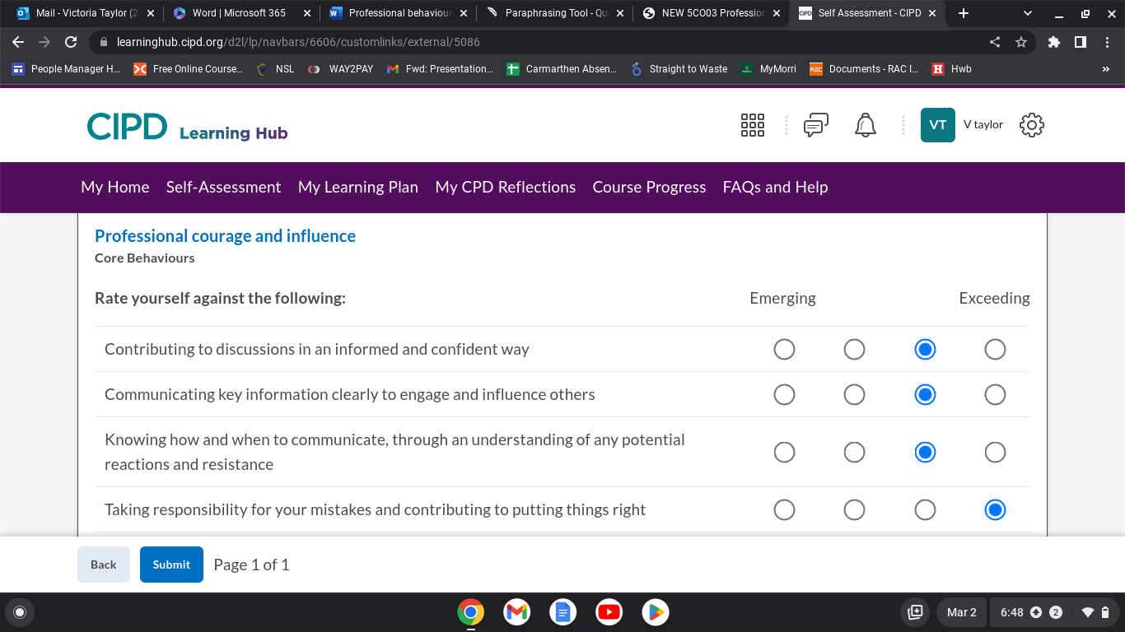

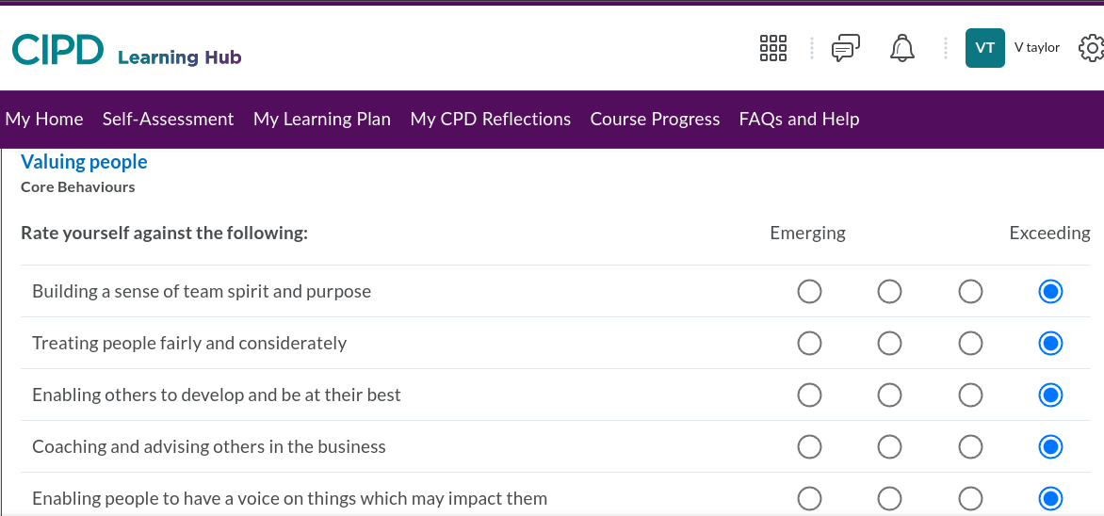

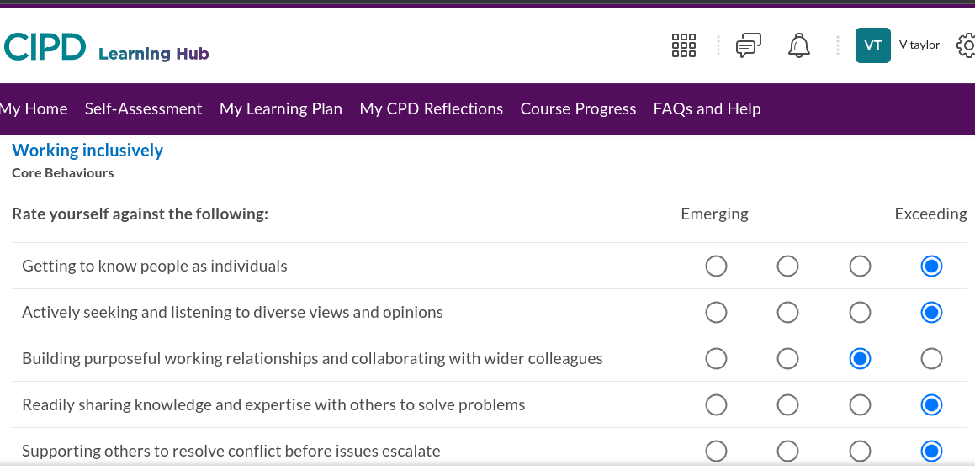

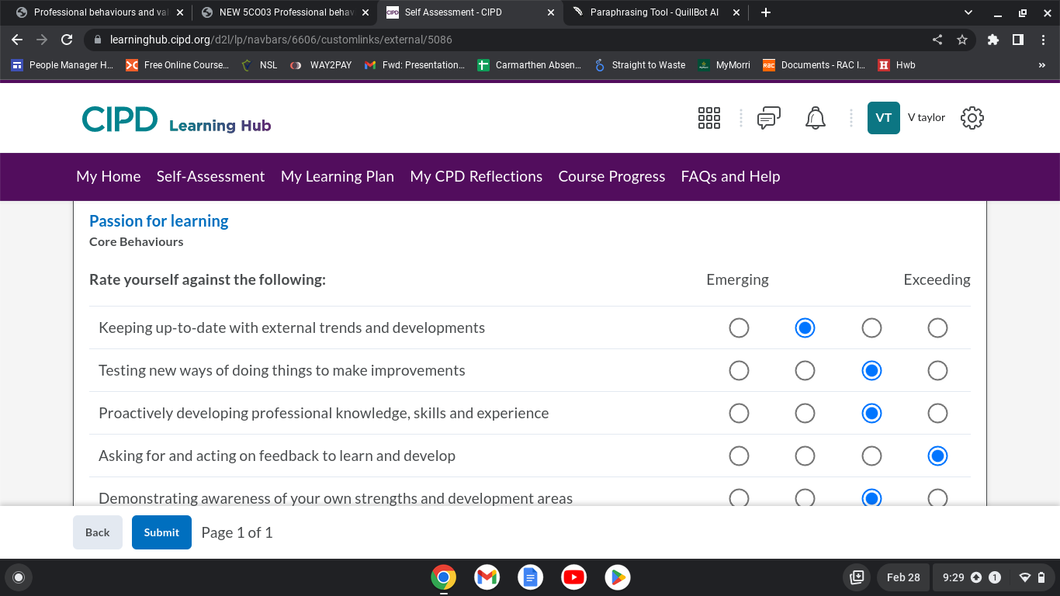
ACTIVITY 2 (AC 3.3) Having identified your main development needs in relation to these 5 areas, formulate appropriate development activities to meet these needs and add these to your professional development/learning plan.
Based on my self-evaluation, I've used the data to create my own training plan, which includes the things I need to work on, and the steps I'll take to get there. I am a kinesthetics learner, thus I like to practise what I learn. I like learning by doing. For me, better comprehension requires having a physical experience. (Indeed Editorial Team, “Guide to Kinesthetic Learning: Definition, Benefits and Careers | Indeed.com”) For the next nine months, I will use this strategy to enhance my skills and reinforce my ethical practise behaviours.
The aspect I believe needs improving the most is Developing my passion for learning to support me in my new position is something I need to take a more proactive approach. to help Developing my own knowledge and experiences since doing so will help me stay on the forefront of change, information, and new practises. Therefore, keeping myself up to date with external trends and developments provide me space for development, and make me feel more empowered to enable me to collaborate better with the wider business. To achieve my personal growth, I have started setting aside time each day for reading, unstructured research, and professional advancement in work-related matters. In my daily commute, podcasts have replaced the radio. I have made plans to attend future seminars and development days in addition to enrolling in additional E-learning courses offered by my organisation.
My line manager has observed that I struggle To improve confidence to communicate at meetings and that I become more uncomfortable in communicating key information. To improve this and feel more at ease, I have started offering to facilitate weekly meetings. I am going to team up with a manager who engaging through communication so I can get guidance. To improve how engaging I am I will also ask for feedback and ask questions to clarify peoples understanding. I will also make a point of to practise in front of a mirror and speaking aloud prior to the day. I am going to start watching TED presentations to improve my ability to engage with the audience. I will reassess my performance in these five crucial areas to see where I can make additions.

ACTIVITY 3 (AC 3.4) A key element of CPD is reflecting on the impact of our learning, so that we can make further decisions about how to progress. Select 3 formal or informal development activities you have undertaken over the last 12 months and reflect on how each of these activities has impacted your behaviour and performance.
My continual professional development initiatives have improved my performance and behaviour. They are provided in the PDF attachment of my CPD reflections.
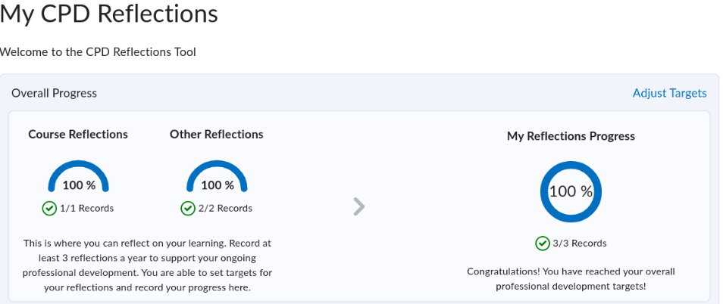
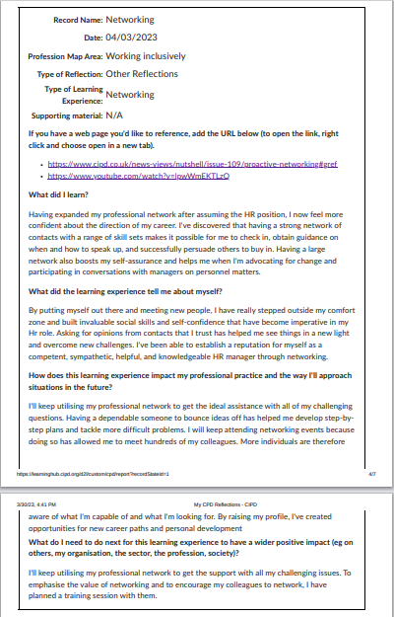

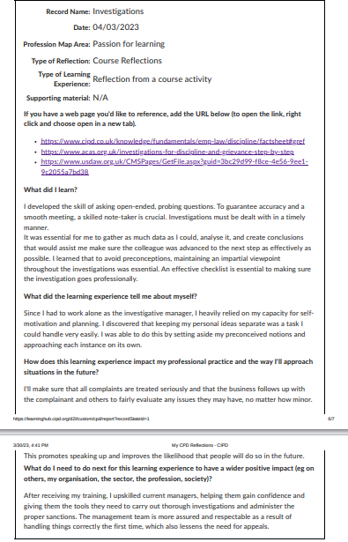

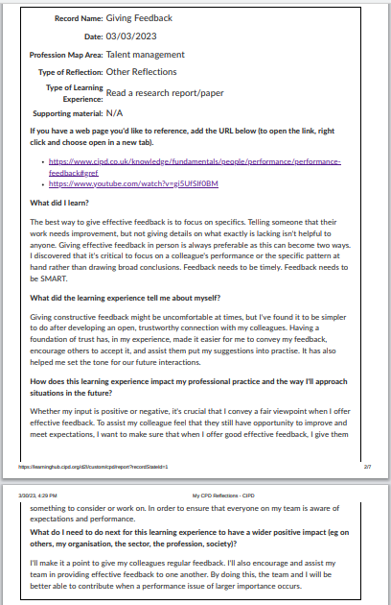

Bibliography
ACAS. “How to Raise a Problem at Work | Acas.” Acas.org.uk, 2020, www.acas.org.uk/how-to-raise-a-problem-at-work. Accessed 17 Feb. 2023.
Andreski, Luke. “Ethics in the Workplace: The Renewal of Trust.” HRZone, 17 June 2020, www.hrzone.com/lead/culture/ethics-in-the-workplace-the-renewal-of-trust. Accessed 10 Mar. 2023.
Baker, Colin. “The 8 Ethical Values Needed in Business.” Leaders.com, 9 Aug. 2021, leaders.com/articles/company-culture/ethical-values/. Accessed 10 Mar. 2023.
Bonde, Sheila, and Paul Firenze. “A Framework for Making Ethical Decisions.” Brown University, Brown University, May 2013, www.brown.edu/academics/science-and-technology-studies/framework-making-ethical-decisions. Accessed 17 Feb. 2023.
CIPD. “Employee Communication | Factsheets | CIPD.” CIPD, 12 Aug. 2022, www.cipd.co.uk/knowledge/fundamentals/relations/communication/factsheet. Accessed 16 Feb. 2023.
---. “Employee Communication | Factsheets | CIPD.” CIPD, 12 Aug. 2022, www.cipd.co.uk/knowledge/fundamentals/relations/communication/factsheet. Accessed 5 Apr. 2023.

CIPD (2022c). New Profession Map | CIPD Profession Map. [online] CIPD
Profession for the Future. Available at: https://peopleprofession.cipd.org/profession-
map [Accessed 5 April. 2023].

---. “Ethical Practice | CIPD Profession Map.” CIPD People Profession, 2021, peopleprofession.cipd.org/profession-map/core-behaviours/ethical-practice#gref. Accessed 20 Feb. 2023.
---. “Ethics at Work: An Employer’s Guide | Guide.” CIPD, 31 Oct. 2019, www.cipd.co.uk/knowledge/culture/ethics/ethics-work-guide#gref. Accessed 4 Feb. 2023.
---. People Profession 2030 a Collective View of Future Trends. CIPD, Nov. 2020.
---. “Why Work in the People Profession?” CIPD, 2021, www.cipd.co.uk/careers/why-work#gref. Accessed 4 Feb. 2023.
DecisionWise. “What Do Honesty, Integrity, and Trust Mean in Leadership?” DecisionWise, 12 June 2018, decision-wise.com/resources/articles/what-does-honesty-integrity-and-trust-mean-in-leadership/. Accessed 10 Mar. 2023.
Dessler, Wendy. “How the Role of HR Professionals Is Evolving.” Cayenne Consulting, 14 Sept. 2019, www.caycon.com/blog/how-the-role-of-hr-professionals-is-evolving. Accessed 21 Feb. 2023.
gerald, j. “Professional.” Wikipedia, 17 Jan. 2023, en.wikipedia.org/wiki/Professional#:~:text=A%20professional%20is%20a%20member. Accessed 4 Feb. 2023.
Gonsalves, Kelly. “5 Reasons to Be Honest in Love.” Mindbodygreen, 12 Aug. 2012, www.mindbodygreen.com/articles/why-honesty-in-a-relationship-is-so-important#:~:text=Honesty%20is%20the%20foundation%20for. Accessed 5 Apr. 2023.
gordon, jason. “Herzburg’s Two-Factor Theory (Hygiene Theory) - Explained.” The Business Professor, LLC, 8 Apr. 2022, thebusinessprofessor.com/en_US/management-leadership-organizational-behavior/herzburg-two-factor-theory-defined. Accessed 20 Feb. 2023.
GOV.UK. “Governance Guide - Public Interest Disclosure | Department for Communities.” Communities, 30 July 2015, www.communities-ni.gov.uk/governance-guide-public-interest-disclosure#:~:text=The%20Public%20Interest%20Disclosure%20Act. Accessed 17 Feb. 2023.
---. “Whistleblowing for Employees.” GOV.UK, 13 Dec. 2011, www.gov.uk/whistleblowing. Accessed 17 Feb. 2023.
Hartzell, Sherri. “The Needs Theory: Motivating Employees with Maslow’s Hierarchy of Needs - Video & Lesson Transcript | Study.com.” Study.com, 2021, study.com/academy/lesson/the-needs-theory-motivating-employees-with-maslows-hierarchy-of-needs.html. Accessed 21 Feb. 2023.
Having a say on what matters. (2018). Available at: https://www.morrisons-corporate.com/globalassets/corporatesite/corporate-responsibility/annual-report/colleagues.pdf [Accessed 21 Feb. 2023].
Herbert, cecelia. “Belonging: The New Top Driver of Employee Engagement in 2021.” Qualtrics, 10 Dec. 2020, www.qualtrics.com/blog/belonging-at-work/. Accessed 5 Apr. 2023.
https ://www.accaglobal.com, ACCA. “What It Means to Be Professional | ACCA Global.” Accaglobal.com, 2019, www.accaglobal.com/an/en/student/sa/features/being-professional.html. Accessed 4 Feb. 2023.
Huppert, Maxwell. “Employees Share What Gives Them a Sense of Belonging at Work.” Www.linkedin.com, 25 Oct. 2017, www.linkedin.com/business/talent/blog/talent-engagement/employees-share-what-gives-them-sense-of-belonging-at-work. Accessed 5 Apr. 2023.
Hurst, Joel. “What It Means to Be a HR Professional.” Real Business, 8 July 2021, realbusiness.co.uk/what-it-means-to-be-an-hr-professional. Accessed 4 Feb. 2023.
Indeed. “13 Ways to Start a Conversation (with Examples).” Indeed Career Guide, Dec. 2019, www.indeed.com/career-advice/career-development/how-to-start-a-conversation.
Indeed Editorial Team. “Guide to Kinesthetic Learning: Definition, Benefits and Careers | Indeed.com.” Www.indeed.com, 6 Oct. 2021, www.indeed.com/career-advice/career-development/kinesthetic-learning. Accessed 30 Mar. 2023.

Indeed Editorial Team. “What Is a Professional? (Definition, Standards and Types).” Indeed Career Guide, 25 Oct. 2021, ie.indeed.com/career-advice/career-development/what-is-professional. Accessed 4 Feb. 2023.
Institute of Business Ethics. “Purpose, Ethical Values, Culture & Behaviours.” Www.ibe.org.uk, 2022, www.ibe.org.uk/knowledge-hub/ibe-business-ethics-framework/purpose-ethicalvalues-culturebehaviour.html. Accessed 4 Feb. 2023.
McLeod, Saul. “Maslow’s Hierarchy of Needs.” Simply Psychology, 4 Apr. 2022, www.simplypsychology.org/maslow.html. Accessed 21 Feb. 2023.
Mills, G. Riley. “Council Post: Mastering the Five C’s of Influential Communication.” Forbes, 17 May 2017, www.forbes.com/sites/forbescoachescouncil/2017/05/05/mastering-the-five-cs-of-influential-communication/?sh=61b7745021b6. Accessed 16 Feb. 2023.
Nickerson, Charlotte. “Herzberg’s Motivation Theory (Two-Factor Theory).” Simply Psychology, 16 Nov. 2021, www.simplypsychology.org/herzbergs-two-factor-theory.html. Accessed 20 Feb. 2023.
People policies (2023). Available at https://sites.google.com/morrisonsplc.co.uk/my-handbook-retail-2-nps/my-people-policies. Accessed 21 Feb. 2023.
Prasad, Sarah. “Head Resourcing - What Is the Future for the “People Profession”?” Www.headresourcing.com, 2019, www.headresourcing.com/blog/2019/04/what-is-the-future-for-the-people-profession?source=google.com. Accessed 21 Feb. 2023.
Sharp, Rachel. “HR Magazine - Ethics and HR.” HR Magazine, 16 Apr. 2019, www.hrmagazine.co.uk/content/features/ethics-and-hr/. Accessed 20 Feb. 2023.
“Whistleblowing or Raising Concerns at Work.” Www.proceduresonline.com, 10 Nov. 2020, www.proceduresonline.com/swcpp/cornwall_scilly/p_whistleblowing.html. Accessed 17 Feb. 2023.
Wikipedia Contributors. “Maslow’s Hierarchy of Needs.” Wikipedia, Wikimedia Foundation, 21 Feb. 2019, en.wikipedia.org/wiki/Maslow%27s_hierarchy_of_needs. Accessed 21 Feb. 2023.
Wilson, Graham. “Maslow’s Theory of Motivation: Driving Your Teams to Success.” Www.thesuccessfactory.co.uk, 2020, www.thesuccessfactory.co.uk/blog/maslows-theory-of-motivation-driving-your-teams-to-success. Accessed 21 Feb. 2023.

Appendix (A.C 2.3)



