1944 Butler Act
Rebuild and reform of the education system after WW2-
According to (UK Prliment,n.d.) .’The plans for post war education in Britan aimed to remove the inequalities which remind in the system. The proportion of ‘free places’ at grammar schools in England and Wales increased from almost a third between 1913 and 1937. However, when power children were offered places, parents often had to turn them down owing extras coast involved. The education act of 1944 was steered through parliament by the education minister, R.A. Butler’.
The act led to the establishment of the tripartite system of grammar schools, technical schools, and secondary modern schools, although in practise very few technical schools were created. (Sharpe,2019).
(Sharpe,2019) Staes that during 1943 he famously spent a fateful weekend at chequers where, after a lot of debate and argument, he succeeded in persuading Churchill to support his radical proposals for a fundamental reform of schooling. In time the 1944 act came to be known as the butler act.
(UK Parliament.n.d.) recommended in a report by Sir William Spens in 1938. Children would be allocated on the basis of an examination at the age of 11, known as the ‘11plus’. This was intended to provide equal opportunities for children of all backgrounds.

(3D eye,2014)
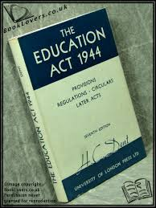
Why is this seen as a contested issue?
I believe that all children deserve the same opportunities, an exam-based opinion cannot determine the full potential of a child. This act was in places for equal opportunities. This cannot reasonably be interpreted as providing equal opportunities. According to (wjec,n.d.) It implies that the 11 plus exam was a socially divers and highly controversial election procedure. Secondary modern schools became the ‘inferior’ partner offering little. In the way of opportunities to children. Many children were classified as non- academics as grammar schools could only take about 20% of children.
Grammer schools were given more government spending than secondary moderns and therefore students who attended those schools benefited from greater resource (wjec,n.d.). I believe this does not appear to reflect principles of equal opportunities.
Free compulsory and organised education-
‘In 1944, R.A.Butler introduced the education act, also known as the butler act, the main idea behind the act was equality of opportunity. It aimed to allow children within the working class to progress as far as they could without being restricted by the demand of having to pay expensive fees.
With the act came a three-level education system the tripartite system included three different types of schools: technical, Grammer and secondary modern This was decided after children at the age of 11 took an exam known as the 11 plus. ‘ (wjec,n.d.)
The main body of this scrap book will examine in detail how the 1944 butler act was a contested issue; I will be discussing this critically. I intended to discuss the butler act before hand and after. And overall research that is interesting. Using different sources to support my research and own opinions on this topic.
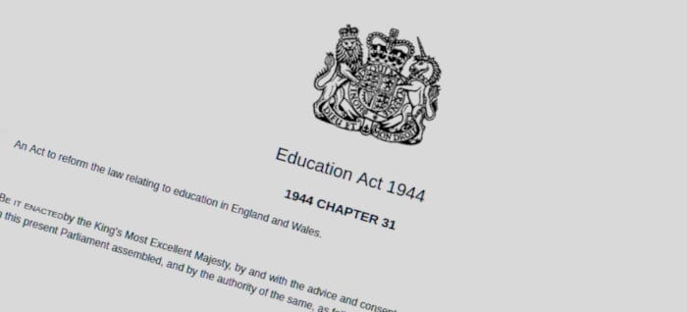

(BBC history,n.d.)
Did the churches control the schools?
‘A major problem facing the butler act at the time was persuading the churches to support his plans. They controlled a large number of schools. He also allowed them to determine the nature of their schools’ daily acts of worship and their syllabuses for religious instruction, but with pt out of any parents who might want it. The act said nothing about the curriculum to be tought-exept with regard to religious education, which was the only compulsory subject prescribed.’ Sharpe (2019) research from discoverysocity,(2014) shows that Religious foundations were expected to contribute financially to the capital coasts of these schools. This demonstrates to me that church’s had control over schools I believe this could of caused tension between state and church.

(resolven distric news,2022)
(education otherwise,n.d.)
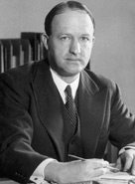

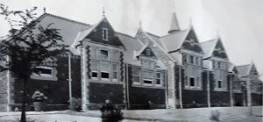
The tripartite system-
The tripartite model of schooling was not a success, overall, around 20 per cent of children attended grammar schools and 5 per cent technical schools. Thus, 75 per cent of 11–15-year-olds attended schools which provided no formal qualifications. Pupils at secondary modern schools preformed less well than other pupils. Yet across LEAs there was a considerable variation in the proportion of children having access to grammar schools. (the British academy,2019). The act led to the establishment of the tripartite system of grammar schools, technical schools and secondary modern schools, although in practise very few technical schools were created. (wjec,n.d.) indicates that grammar schools were given far more government spending than secondary moderns and therefore students who attended those schools beneficiated from greater resources.

Leading up to and after the butler act-
(the British academey,2019) states that ‘In 1938 around 80 percent of children left school at 14. most of these attended an all-age elementary school and less than 1 percent of each cohort attended university. One driver of the new legislation was the desire for social reform, to build a ‘new Jerusalem’ to rise from the ashes of a Britan broken by the second world war. Another was the reality of evacuation. Evacuation mixed up in British class system like never before as children from the working class entered the homes of the better off who in turn began to give greater support to reform.’
‘Prior to the introduction of the 1944 butler act, progress of reform has been prolonged. The fisher education act of 1918 didn’t essentially thrive in implementing a school leaving age of 14. The 1936 education act was exacted but not effective, churches resisted the extension of state control over their schools’. (the British academey,2019).
Conclusion-
While the 1944 butler act made a significant impact on changing education by offering free education and hughering the school leaving age. I still firmly believe that this act is a contested issue that when deeply researched can be seen as problematic. Opportunities given by the butler act can be seen as unequal due to the different support systems different children had during the time of the 11 plus. Highering the mark for girls demonstrated how this was not based of all academic ability and setting girls to tougher standards, creating a divide between children. This system reinforced class division rather than creating equal opportunities. Children’s future should not of been determind by this.
Contested issues with the 1944 butler act-
The act can be deemed us unfair opportunities according to (easy sociology,2025) ‘conflict theorists have pointed out that while the act intended to expand opportunities, it also reproduced certain form of inequality. Through the tripartite system. Grammer schools, which often emphasized academic rigor, tended to attract children from middle-class backgrounds who had recourses and family support to pass the 11-plus exam.’ I believe that the background of your family’s place in society contributed a large amount to children going to Grammer, technical or secondary modern schools, as stated that middle class children had access to greater recourses compared to children how came from working or lower-class background didn’t not have access to the same support when taking this exam. Easy sociology, (2025) says that the act. Inadvertently contributed to a dual-tiered system, perpetuating social satisfaction rather than eliminating it.
Thompson, (2014) Agrees that most secondary modern schools were full of working class children reinforcing the argument that middle class children had move of an advantage when taking the 11 plus exam and being accepted into grammar schools. In this research it is also highlighted that many teacher, students, parents and even students saw children who failed the 11+ as failures. Many children leaving school without qualifications. Thompson, (2014). This emphasises the point of people believing the exam was unfair. When the overall purpose of the 1944 butler act was for equality.
Evidence from Haggar,(2019) supports the idea that it was called into question on the grounds that some children might be unable to do themselves justice because of “examination nerves”: that the tests might contain cultural biases; that some children might be given greater opportunities to practise IQ tests because they were in higher streams of primary schools and/or because they had private coaching practise could be shown to improve IQ test performance very significantly.
It is found that girls were likely to score considerably higher marks in the 11+, so much so that it a considered necessary to set the pass mark higher for girls than for boys to prevent girls from gaining a disproportionate share of grammar school. Places. Policy marker claimed that girls had developed more quickly and that boys would soon catch up. Haggar (2019). this was not stated in the act however they wanted equal numbers of boys and girls. I believe this is setting girls to a tougher standard and is not purely based on academic ability. As Haggar, (2019) stated I firmly agree with the statement that it is doubtful also weather children can be classified as “academic”, “technical” or “practical”. I believe that the human ability is far more complex that three fixed categories especially at the young age of 11 years old.
Welsh not-
The Welsh not was a wooden token given to children caught speaking Welsh in 19-century schools. It was often accompanied by corporal punishment and is Widley thought to have been responsible for the decline of the Welsh language. Teachers believed that their main duty was to teach English to the children. (johns,2024).
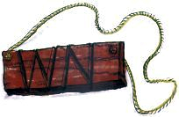

Welsh not

(steres,2021)

Issues surrounding the Welsh not-
As stated by (johnes, 2024.p3), the Welsh not was real and many children were physically and psychologically punished at school for speaking Welsh. This did, in some ways, contribute to the fortunes of the language. There were real concerns that Welsh was in danger of dying, despite the national revival. (johnes, 2024.p7). research from (maggie,2024), says that this stigmatizing marker wasn’t just a temporary punishment; it symbolized humiliation. Worse, the wearer would pass it on to the next child they overheard speaking Welsh, creating a ripple effect of blame and shame thought the classroom. I believe that this would have been harmful to children creating a dived taking away from the learning of other areas of school. At the end of the day, the student still wearing the Welsh not would often face further punishment, such as physical reprimands of detention. This practise wasn’t just about enforcing discipline; it was about eradicating the Welsh language from the future generations (maggie,2024). Resulting in physical and long term emotional harm.
(walesonline,n.d.)
(woods,2021)
Outline-
In the main body of my scrap book, I will be discussing in more detail how the Welsh not impacted the future generations in Wales, the 1847 blue book. I will also be talking about how the Welsh not is a contested issue using research to support it.
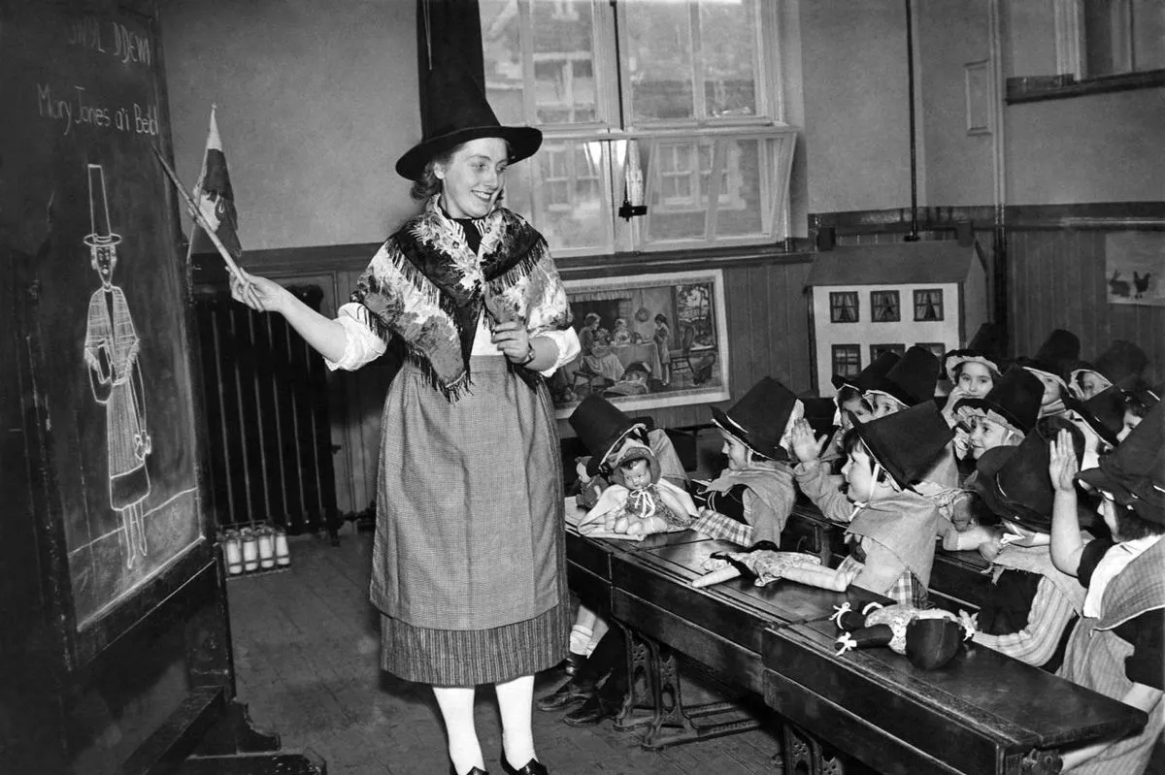
Consequences of the Welsh not-
Findings from (johnes, 2024.p8) Staes that one 1890 reference to the Welsh not in schools in the past said it was little wonder that Welsh had lost ground when the machinery of the state schools was driving it to perdition. In 1891, a census question was asked for the first time in Wales about what languages people spoke. It revelled that 45 per cent of the population were now unable to speak Welsh. A decade later, the figure had risen to more than 55 per cent.’ I believe that this valuates the point of this detrimental issue caused Welsh people to lose touch with their culture not being able to speak the language of their country. As found in research by (Welsh language commissiones,2021) says that results show that 17.8% of the population in Wales can speak Welsh.
Future of the Welsh language-
(Golley slater,2020), emphasises the point that speaking Welsh wasn’t passed down to new generations in fear that it would be detrimental to the future careers and work opportunities. According to (rowlands,2024) the Welsh language became simplified and anglicised, to make it easier to learn. A Welsh speaker of 100 years ago would hardly recognise Welsh “as she is spoke today”. This suggests that the origin of the Welsh language was tainted by the wesh not taking away from the culture and language for future generations indicating that people may feel out of touch with how the language should be spoken as it may of become more English-influenced. As it also Staes by (Rowlands,2024) that this simplification has gone too far. (maggie,2024) Reinforces the idea that the policy reflected a broader effort by authorities to promote English as the superior language. (johnes,2024.p3) says one historian summed up that ‘over the years the Welsh not became and, in much popular memory remains, the ultimate symbol of coercion of the Welsh people by an alien, colonial power intent on the subjugation of a nations language and, by implication, its soul.
Why is the Welsh not a contested issue-
According to (johnes, 2024.p12) in 1962, Saunders Lewis made an iconic radio speech on the history and future of the Welsh language. Although he did not mention the Welsh not, he did perpetuate the idea that education policy had deliberately tried to kill the language. A 2012 popular history of Wales, for example, claimed that the blue books states that ‘anyone caught speaking Welsh were to be severely punished.’(johnes, 2024.p13). (maggie,20240 emphzises the cultural impact the Welsh not had stating while the Welsh not may seem like a small, outdated relic of the past, its legacy is significant. It represents not just the repression of a language, but the systematic targeting of an entire cultural identity.
(maggie,2024) suggests in 1847, the infamous blue books report-a government- commissioned study of Welsh education-characterized the Welsh language and culture as barriers to progress. The report even branded Welsh communities as lacking in ambition and morality, igniting a storm of outrage among Welsh speakers. I firmly believe that the Welsh not reinforced a separation between Wales and England as it stated “igniting a storm of outrage among Welsh speakers’ (maggie,2024). Following that statement (johnes,2024.p3) says that present day understanding of the relationships between Wales and England have also shaped popular views of the Welsh not. Those who feel Wales has been mistreated or oppressed by rule from London are likely to see the Welsh not as another example of that relationship.
A statement found in (johnes,2024.p1) states that teachers’ forced children to only speak the little of the language they had learned from books or picked up from others. But the result of his treatment, and not being able to understand his teachers, was that he hated school and was unable to sleep. He argued that such experiences made children look upon everyone who spoke English as a natural enemy.’ This research gave more validation to the point that it made a detrimental impact to children in all aspects of life creating a divide between them and taking focus off learning due to lack of understanding of the English language.

Conclusion-
In conclusion I firmly believe that the Welsh not is a powerful symbol of the wider attempts to suppress the Welsh language and culture. This had a detrimental impact on children at the time physically and emotionally, affecting all aspects of life creating deep divisions between England and Wales. The Welsh not had a huge impact on the future generations restricting them from their culture and not being able to speak the language of their country as the Welsh speaker decrees over the years. Understanding these issues highlights the importance of recognising how polices and reinforcements in schools and shape people.
(carradice,2011)

1847 education reports blue books-
Research found from (davies,2021) shares that the Welsh language was identified early in the reports as an issue: “my district exhibits the phenomenon of a peculiar language isolating the mass from the upper proportion of society” it was described as “a language of the old-fashioned agriculture, of theology, and of simple rustic life”
Referance list-
BBC History, (n.d.) richard austen butler (1902-1982). Available at: https://www.bbc.co.uk/history/historic_figures/butler_rab.shtml
Carradice,P. (2011) the treason of the blue books. Available at: https://www.bbc.co.uk/webarchive/https%3A%2F%2Fwww.bbc.co.uk%2Fblogs%2Fwales%2Fentries%2F72d77f69-72a7-3626-9c19-469c91f45753
Davies,G. (2021) the ‘treason of the blue books’ as they relate to prembrey and burry port. Available at: https://pembreyburryportheritage.co.uk/the-treason-of-the-blue-books
discoversociety, (2014) schools, religious education and the law. Available at: https://archive.discoversociety.org/2014/07/01/schools-religious-education-and-the-law/
education otherwise, (n.d.) history. Available at: https://www.educationotherwise.org/history/
easy sociology, (2025) the education act 1944. Available at: https://easysociology.com/sociology-of-law/the-education-act-1944/
Golley slater (2020) understanding welsh language laws. Available at: https://www.golleyslater.com/news-and-insights/understanding-welsh-language-laws/
Haggar,R. (2019) from tripartite to comprehensive secondary education. Available at: https://earlhamsociologypages.uk/from-tripartite-to-comprehensive-secondary-education/
Johnes,M. (2024) Welsh not elementary education and the anglicisation of nineteenth century Wales
Maggie, (2024) the history and cultural impact of the welsh not. Available at: https://www.walespast.com/the-history-and-cultural-impact-of-the-welsh-not/?utm_source=copilot.com
Resolven distric news, (2022). The history of neath grammer school for girls. Available at: https://resolvendistrictnews.co.uk/the-history-of-neath-grammar-school-for-girls/
Rowlands,R. (2024) welsh,not:the ‘survival’ of the welsh language. Available at: https://bylines.cymru/arts-and-culture/welsh-language/
Sharpe, K. (2019) the 1944 education act was a lan mark law- but lets reconsider the privlages it granted to religion. Available at: https://www.secularism.org.uk/opinion/2019/12/the-1944-education-act-was-a-landmark-law-but-lets-reconsider-the-privileges-it-granted-to-religion
Steres,T. (2021) 5 reasons why welsh pride never dies. Available: https://reddragonamerica.org/news-%26-updates/f/5-reasons-why-welsh-pride-never-dies
the brithish academy, (2019). Childhood policy milestones. Available at: https://www.thebritishacademy.ac.uk/documents/225/The-British-Academy-Childhood-Policy-Milestones-Chronologies.pdf
Thompson,C.H. (2014). Strengths and weaknesses of the triprties system. Available at: https://sociologytwynham.com/2014/12/12/strengths-and-weaknesses-of-tripartite-system/
UK Parliament (n.d.) the education act of 1944. Available at: https://www.parliament.uk/about/living-heritage/transformingsociety/livinglearning/school/overview/educationact1944/
Welsh language commissioner, (2021) 2021 census. Available at: https://www.welshlanguagecommissioner.wales/policy-and-research/the-position-of-the-welsh-language/2021-census#:~:text=The%202021%20Census%20results%20show,has%20been%20decreasing%20since%202001.
Woods,S. (2021) welsh not still alive and well. Available at: https://www.slwoods.co.uk/?p=8758
WJEC, (n.d.) rebuilding the country after 1945. Available at: https://blended-learning.resources.wjec.co.uk/en/bl20-21_1-21/2/1
3D eye, (2014) the butler education act: 70 years on. Available at: https://3diassociates.wordpress.com/2014/04/23/the-butler-education-act-70-years-on/

I acknowledge that the use of copilot (copilot.com) between January 7th and 18th to help my research and check my work. I used the prompts.
- Following the assignment brief please guidelines giving me a better structure for my work.
- Please summarise this website for me
- Please check the following text for correct academic wording and feedback on how I can improve.
I confirm I have not presented any AI generated text as my own work. I confirm I have copies of my drafts, notes and other recourses I used before, and after the use of AI tools which may be asked to provide as evidence.

