A Research Proposal
for

Alternative cost-effective solutions for storage and use of surplus photovoltaic energy in domestic microgeneration systems

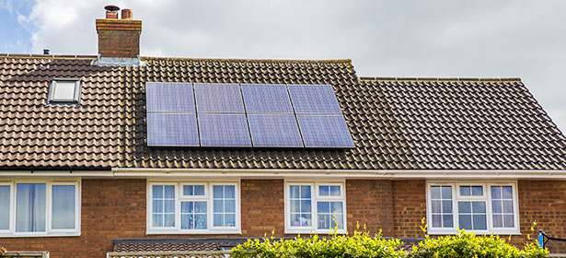

Derek Lockhart

Electrical and Electronic Engineering

Mr Gareth Jones Dr Nik Whitehead

M5X01051

Table of Contents
Para Title Page

1. Introduction and Background 4
1.1 Industrial Context 5
1.2 Literature Review 5
1.3 Aims and Objectives 8
1.4 Conclusion 8
2. Research and Development 9
2.1 Philosophy 9
2.2 Approach 9

2.3 Strategy 10
2.3.1 Survey 10
2.3.2 Case Study 11
2.3.3 Hardware / Software Development 12
2.4 Generalisability, Reliability and Validity. 13
2.4.1 Generalisability 13
2.4.2 Reliability 13
2.4.3 Validity 14
2.5 Development 14
2.6 Conclusion 15
3. Resources and Planning 16
3.1 Resources 16
3.2 Planning 17
3.3 Ethics and Law 19
3.3.1 GDPR 19
3.3.2 Ethics 19
4. Conclusion 19
5. References 20

Table of Figures
Figure Title Page
1 Project Gantt Chart 1
2 Gantt Chart Task List 11
3 Project Mind Map 22

1. Introduction
Microgeneration is now a popular method of reducing the cost of utilities[1]. Due to the makeup of the Government backed Feed In Tariff (FIT) scheme, owners of microgeneration systems are paid for supplying electricity to the grid based on the assumption that 50% of the generated power will be used by the system owner and 50% will be exported to the National Grid[2]. It should be noted that this division is assumed and is not metered.
The power produced by any solar array is at maximum during the day [3] when, coincidentally, home occupiers particularly the author tend to be engaged elsewhere[4], thereby the period during which a typical Solar PV system is at peak efficiency also happens to be the period during which the energy is harvested the least for the home owner.
Therefore, the possibility of maximising the use of this power by storing the excess produced during the day will increase the benefit of the system to the system owner.
Several commercial solutions are available to store surplus solar power, however these solutions incur a significant installation cost [5] and are life limited, this cost incursion effectively makes the ‘free’ solar power the home owner desires to collect no longer free. Typical costs for the installation of a Powerwall system are over £7000 [6] with a warranty period of 10 years[7]. This is in comparison to the case study household with an annual electricity bill of under £700.

1.1 Industrial Context
The issue of storing surplus micro generated electricity is an evolving market that the industrial and commercial sectors. REF. There are major manufacturers investigating this concept, with the Tesla Powerwall® product being a market leader with a prominent public footprint. Further manufacturers are developing energy diverters, these devices can switch excess energy to specific devices.

1.2 Background Literature
The UK Government Feed-In Tariff scheme [2] defines the current benefits available, among others, to domestic microgeneration system owners. These benefits state that systems below 30kW are not metered for their actual export. This allows domestic producers to make best use of their surplus energy as they see fit without financial penalty. Cherrington et al [8] also demonstrate that the scheme has decreased its payments since its inception, with homeowners guaranteed to keep the sign on rate for 20 yrs. The benefit from these systems is designed to repay the homeowners investment within 8 yrs., and therefore Feed-In Tariff eligible systems, which by their very nature, are grid tied systems, to make the technology economically viable. This is in contrast to the findings of Ghaith, Epplin and Frazier [9] who investigated the economics of domestic solar electricity in the United States, which despite a huge number of incentive policy’s [10], who find systems that are tied to the grid are still not economically effective when compared to those systems that configured as stand-alone.

The Electricity Journals 2015 article [11] “Tesla's New Battery: The Future Is on the Wall” spoke volumes on the perceived future of economical microgeneration. The system uses Lithium-Ion batteries and is primarily aimed at the storage of excess solar generation.

Davis and Hiralal [12] carried out a study of the through day consumption of electricity in UK households, they also compared the consumption data to the charge and discharge cycles of the Tesla Powerwall. The costs of the installation are variable depending on market forces, also the vagaries of the weather dependency would seem to question the ability to these systems to provide solar power collection to sufficiently offset their costs.
Li et al [13] investigates the electrical effectiveness of different battery technologies for use in rechargeable solar storage systems. They find that although the current battery technologies available are promising they do have weaknesses in their application that affects their cost effectiveness.
John, Hale and Selvam [14] investigated the properties of concrete as a thermal storage medium for solar power, although the study was focused on industrial sized applications it showed promising results that may be applicable to domestic microgeneration.
Rodríguez-Hidalgo [15] et al investigated the advantages of storing surplus solar energy in domestic hot water. This research was focused on the size of water tank when compared to solar installation size for maximum efficiency, this research was primarily focused on a large scale multi occupancy residential mode though it does provide a rational example of modes of storage other than rechargeable battery.

Seddegh et al [16] investigated using different mediums to store heat energy prior to recovery. This would seem to be a comprehensive investigation into mediums beyond simply water of concrete and focuses on means of effectively preheating water for domestic use. This paper shows the effectiveness of latent heat storage due to the higher energy density possible in the materials used.
Charron and Athienitis carried out research into the specifications and technology required for solar fitted homes that would have a net zero (NESH) energy requirement. Although many of the design considerations are based around preconstruction and therefore beyond the scope of this project, they make valued comment of the efficiency of low power direct heating of thermal mass within the domestic setting, this would seem to offer the option of using the low power rating of excess solar energy to directly heat a thermal mass.
Mahela and Shaik [17] carried out a review of grid connected solar systems, they explain clearly the methodology of detecting the phase difference between voltage and current as a means of discriminating between the import and export of domestic power. This would allow calculation of the extent of the power available to be utilised in ways this research project will seek to identify.

1.3 Aims and Objectives

The aim of this paper will be to
Investigate the cost of energy storage methods and attempt to suggest methods worthy of investigation that will recover this energy for a lower price point to the home owner.
This will be done through the following objectives:
- Evaluate the solar energy storage solutions available.
- Analyse the cost per unit of current solar energy storage solutions.
- Investigate possible alternative solar energy solutions.
- Identify the costs to the home owner for each alternative solution.
- Examine methods of detecting excess power.
- Investigate methods of diverting only excess power.
- Develop possible ‘Smart Home’ solutions.
1.4 Conclusion
It would seem therefore that there is potential to explore possible means of utilising excess solar generated power that are comparable in economic effectiveness to a commercial battery storage system. This would require investigation into methods of detecting and redirecting this energy. The financial cost of systems of installing storage systems must also be included.
Therefore, at the completion of this paper the author aims to be able to suggest cost efficient and practical methods of recovering surplus solar energy and methods of integrating this into currently available smart home devices, these objectives will be completed in accordance with the timescales laid out in the project plan shown in Figure 1.

2. Research and Development Methods
This section shall seek to justify the research philosophy and strategies to be used in the research project. Further the methods of data collection and possible paths for the future development. Finally, this section will identify the methods to be used to analyse the data that is captured and compare these to the aims and objectives set out.
2.1 Philosophy
This research project will take a Phenomenological philosophy to the research. Hallet [18], citing Åkerlind [19] and Saljo [20] defines a method to allow views to be formed from a number of ideas and is a method of defining rather than confirming a theory. This will allow the researcher to define the advantages of solar PV storage and its methods
A Positivist philosophy to this research would be less advantages, Ittner [21], discusses the cause and effect analysis of positivist research, Schrag [22] would seem to concur, and suggests that positivist research also looks for cause and this is analogous to causal medical treatment having an effect on symptoms. This is mechanistic and is therefore possibly subject to oversimplification of a complex problem.
2.2 Approach
This research will use a deductive approach to this research. Wilson [23] states that a deductive approach is one where an existing theory is tested to check its validity, since this project is based on the authors theory that surplus solar energy could be stored and recovered more economically than with the use of commercial battery systems, then this theory is testable using a deductive process. This deductive approach would seem more suitable for this research than an Inductive approach. Babbie [24] finds that an inductive approach is the opposite of the deductive, such that instead of a theory being tested and the outcome observed, the inductive approach observes the outcome and posits a theory to match the observed results. In this case a theory is already in hand and therefore the deductive approach is appropriate.
2.3 Strategy
The research suggested will use three strategies to develop outcomes. The strategies chosen will be, Survey, Case Study and Software/Hardware Development.
2.3.1 Survey
The survey chosen will be aimed at potential customers of the project outcome. Check and Schutt [25] stated that a survey is “ the collection of information from a sample of individuals through their responses to questions”. Ponto [26], finds that research strategies offer varied options to collect data, and can be used to collect data quantitatively and qualitatively.
Babbie[24] defines quantitative research as that which compares and statistically analyses data from polls and questionnaires, or by the statistical manipulation of data. Walliman [27] would seem to agree finding that statistical data analysis is a byword for quantitative data analysis. This is opposed to qualitative research which Shank [28], cited by Ospina [29] defines as “a form of systematic empirical inquiry into meaning”. Walliman [27] also finds that in qualitative research the concepts and the processes can be less defined at the outset and are effectively generated as the research cycle is completed through methods such as interview and observation. Therefore, qualitative data is that which forms from the collation of opinion that can then allow quantitative research to quantify the data using statistical methods.
Within the scope of this project the qualitative research is initially from the authors idea that excess solar power could be more economically recovered, this could be confirmed through further qualitative research as a reasonable hypothesis or alter the research to a different hypothesis, this would lead to a quantitative analysis that may, or may not, lead to confirmation.
2.3.2 Case study
This case study will use data generated by a single domestic microgeneration system. The energy data captured will be two-fold, first the energy generated by the 3.445kW domestic system, this data will show the energy available throughout the day every day over a single year. Secondly, using data from the energy purchased by the same household over the same period will allow an accurate model to be created for that household’s solar energy surplus. Starman [30], argues that although case studies are generally thought of as qualitative in nature they do have a quantitative element in them, Starman was advocating their use in the educational environment. Runeson et al [31] also found that the primary data in a case study is qualitative, though due to the explorative nature of case studies they must remain flexible enough to adapt the data collection should unforeseen data points be found. Therefore, although the primary data in this case study is quantitative it shall be analysed according to the qualitative research theory suggested.

2.3.3 Software hardware development
The project will look to develop hardware and software along several lines of enquiry. Some or all of these lines could become hardware and software development areas.
1. The solutions currently available would seem to be well developed and may provide insight into development of other solutions. If this is the case the literature review may provide this.
2. The proposal of alternative solutions will provide the purpose for any hardware development and its intrinsic software.
3. The methods of determining the real time excess power will require a hardware and software solution.
4. The option of developing software solutions to integrate into smart home appliances will also involve software

McLeod, MacDonell and Doolin [32] explain that the history of the software development process is fraught with failed projects, some through their inability to keep pace with technological development and can be found to be out of date before release. Others due to a lack of qualitative research found that the products were not customer focused or customer friendly. Ralph [33] focuses on the difference between the rational and the empirical design paradigms, and finds that the different paradigms can produce problems in the development of engineering solutions. Examples being that a project team who are not part of setting the goals of the project will restrict the flexibility of the development of the program.
2.4 These research methods must be subjected to the rules of Generalisability, Reliability and Validity.

2.4.1 Salkind [34] finds that generalisability is the ability of a research sample to be proven as a true representative sample of a target population. If research is not generalisable then it is not fit for the purpose intended and indeed could be considered invalid.

The case study is based on the data available from 3.445kW Domestic solar array. This falls within the average size solar installations installed in the UK of 3 - 4 kW [35]. The case study array is fitted to a domestic dwelling dated from circa 1930, this fits well into range of dwellings studied by Moran and Sukumar [36], who used the metric of kWh (installed) against kW produced in arrays fitted to older dwellings, and found an average of 634 to 915. This compares well with the case study in question which has an average kWh/kWp of 870 over the previous 4 years. The case study domestic situation is also fairly typical for the UK a 3 Bedroom semi-detached family home with 5 occupants[37][38].

2.4.2 Holt and walker [39] define reliability as “ the consistency with which something is measured” and would seem analogous to any scientific method in that it should be repeatable. Salkind [34] would seem to agree and defines high reliability research as highly predictable with consistent results. Within this project, although the power values change daily according to weather as well as seasonally the efficiency results should be reliably consistent for any given power production level, the research may find that below a distinct production level the efficiency of a proposed system may become uneconomical, the question will the stand if this would equally apply to a commercial system.

2.4.3 Cohen and Manion [40] refine validity into internal and external, internal validity is ensuring that the research itself does not have a causal effect on the outcomes found. This seems to agree with Roe and Just [41] who define internal validity as ensuring that effects found in research are the actual results of a defined cause and not a result of the research. External validity is whether the found effects are applicable to a larger population, therefore if the sample is a true reflection on the population as a whole then the research will be externally valid[41][40].
In respect of this research the data should be valid internally if the relationships between solar generation, home occupancy and storage potential are as expected. The research will also be externally valid if the data from the household involved is truly representative of a significant section of the population.
Morse et al [42] find that the usage of reliability and validity remain prominent in European academics, whereas they have been replaced in north American research circles with criteria such as significance, relevance and impact.

2.5 Development
Following the completion of objectives 1-4 the project will move onto a prototype phase for objective 5. The anticipated prototypes will meet the needs of objectives 5 & 6 to find and prove concepts for the detection and diversion of excess power. Objective 7 seeks to find a software or app solution that will allow integration with smart home devices given a successful research phase.

Analysis of the results will be based on straight cost comparison of the systems found and investigated. These costs will include purchase and installation, maintenance and end of warranty replacement, thereby giving the cost of any energy recouped.
Once basic function has been developed and proven the project will use feature driven development.
Feature driven development is an incremental development process particularly used in software, where the capability of a system is incrementally increased feature by feature in and enduring cycle[43].

2.6 Conclusion
This project will use a phenomenological philosophy and a deductive approach. This combination will allow flexibility in that the ideas that develop through the philosophy will be checked for validity through the approach. The strategies chosen of survey, case study and hardware/software development will similarly complement each other. The survey of home owners could confirm the authors theory on the use of surplus solar PV could be commonplace, the subsequent case study will provide a baseline that will prove the effectiveness of the subsequently developed hardware and software solutions. Given that the case study is through data from the authors own home the question of impartiality must be vigorously monitored. The hardware and software solution must also be relevant to any potential customer and focused on their needs rather than focused specifically on the authors.

3. Resources and Planning
3.1 Resources
Jugdev and Marthur [44] define resources as those identifiable requirements to enable project completion. Lock [45] similarly defines a resource as any asset required for work on a project, including, but not limited to personnel, IT equipment, software packages, data, funding, academic reference material and laboratory hardware. The resources used within this research project will come from various sources.
Data:
Solar panel generation data from a 3-bed semi-detached house
Electricity consumption data from dwelling smart meters.
Installation costs and recovery data from commercial suppliers
Literature
UWTSD Library (Online)
Personnel
Author as main researcher
UWTSD Staff as required (John Young, Gareth Jones)
Hardware
Domestic Solar panel installation
Electronics Lab and associated equipment
Software
Proteus software package
Microsoft Project software package
3.2 Planning
The project will be managed with the aid of Microsoft Project software package. Microsoft Project is a software package designed to integrate all aspects of project management and graphically display them to simplify time and task management and deconfliction[46]. Data entry on the package is normally centred around the Gantt chart. A Gantt chart is a graphical representation of project tasks timescales and dependencies and were first created in the early 20th century [47].
3.2.1 Gantt
Using the Microsoft Project software, a Gantt chart has been created of the main project tasks and their projected timescales. The Gantt chart for this proposed project can be seen below in Figure 1.

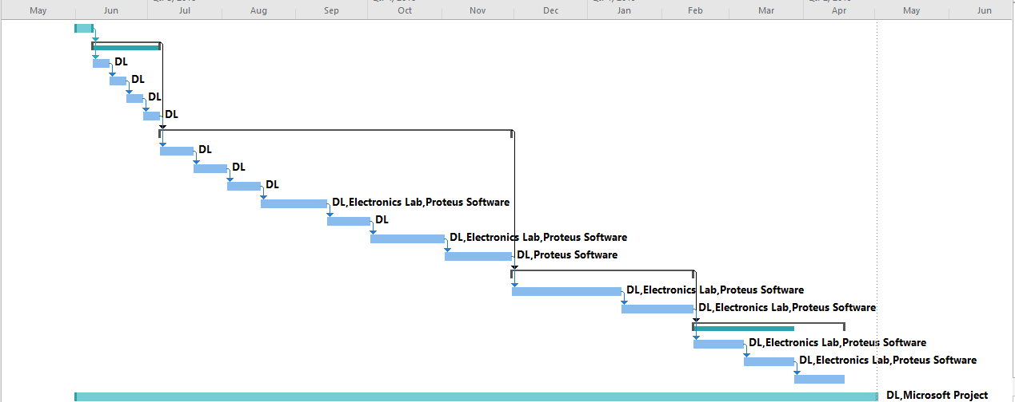
Figure 1 Project Gantt Chart
It can be seen in Figure 1 that the project is projected to take 11 months to complete. This projection is purely an estimate and relies on the assumption that a significant proportion of the research and initial data analysis can be completed before the beginning of the first term in September. Should the start date for the 1st term cause the project date to slip then the task list that can be seen in Figure 2 will be adjusted to suit, e.g. Tasks 11 & 12 may be swapped.
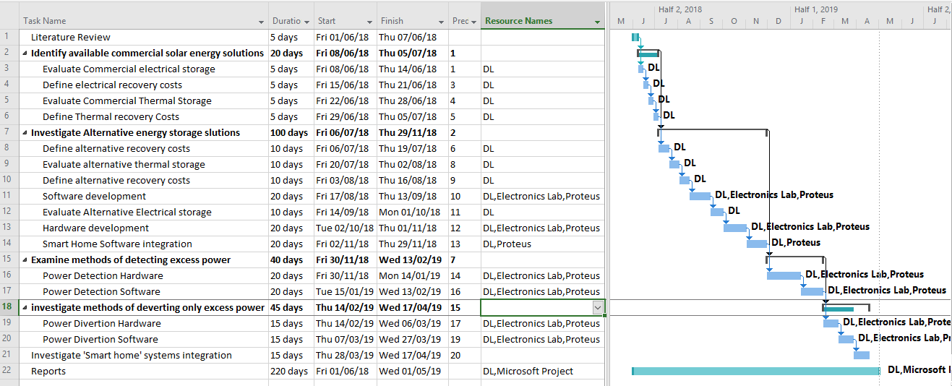
Figure 2 Gantt Chart Task List
3.2.2 Mind Map
Ming and Caixia [48] describe a mind map as a graphical method of generating and organising project thoughts and ideas into key words and phrases. These words and phrases can then be generated into work streams. Brinkman [49] further explains that mind maps generate information in a similar way to the brain, such that one thought will create a link or thought to another, once generated mind maps can look artistic in nature. Thoughts begin on the map begin at a central general point and radiate outwards becoming more succinct. A Mind map was used to generate initial trains of thought on this project, this initial mind map became the source of the Gantt chart task list and therefore is the initial source of the project workstream. The mind map for this project can be seen in Figure 3 Appendix 1.

3.3 Ethics and Law
This project will be completed to meet the appropriated legal and university requirements. This includes GDPR and Ethics.
3.3.1 GDPR
Any data recouped from the survey will be anonymous and no personal data will be held. The personal data resulting from access to solar generation and electricity usage is the authors own property and will be anonymised prior to submission.
3.3.2 Ethics
This proposed research project will be submitted to the University to seek approval from the Ethics committee. The research will be conducted in accordance with the UWTSD Research Ethics and Integrity Code of Practice and the British Computer Society Code of Ethics. The appropriate ethics form is attached in appendix 2.
4. Conclusion

This project will use the allocated resources to investigate, evaluate and produce alternative solutions for the use of surplus solar generated electrical power. The Phenomenological and deductive methods of research will be supported by the use of a survey and a case study which will generate and confirm data for a hardware and software development strategy. The project will be managed to ensure correct resource use and efficient time and task management that will be supported by a project management software package. The resulting product suggestions will be proven to be price competitive against commercial battery storage solutions.

5. References

[1] P. Balcombe, “Energy from microgeneration: sustainability and perceptions in the UK,” 2014.
[2] UK Government, “Feed-in tariffs: get money for generating your own electricity - GOV.UK,” gov.uk, 2016. [Online]. Available: https://www.gov.uk/feed-in-tariffs. [Accessed: 25-Apr-2018].
[3] F. Rodríguez, A. Fleetwood, A. Galarza, and L. Fontán, “Predicting solar energy generation through artificial neural networks using weather forecasts for microgrid control,” Renew. Energy, vol. 126, pp. 855–864, Oct. 2018.
[4] A. Ingle, M. Moezzi, L. Lutzenhiser, and R. Diamond, “Better home energy audit modelling: incorporating inhabitant behaviours,” Build. Res. Inf., vol. 42, no. 4, pp. 409–421, Jul. 2014.
[5] C. Truong, M. Naumann, R. Karl, M. Müller, A. Jossen, and H. Hesse, “Economics of Residential Photovoltaic Battery Systems in Germany: The Case of Tesla’s Powerwall,” Batteries, vol. 2, no. 2, p. 14, May 2016.
[6] Tesla, “Powerwall | The Tesla Home Battery,” Tesla, 2018. [Online]. Available: https://www.tesla.com/en_GB/powerwall. [Accessed: 02-May-2018].
[7] Telsa, “Tesla Powerwall Warranty (European Warranty Region),” 2017.
[8] R. Cherrington, V. Goodship, A. Longfield, and K. Kirwan, “The feed-in tariff in the UK: A case study focus on domestic photovoltaic systems,” Renew. Energy, vol. 50, pp. 421–426, Feb. 2013.
[9] A. F. Ghaith, F. M. Epplin, and R. S. Frazier, “Economics of grid-tied household solar panel systems versus grid-only electricity,” Renew. Sustain. Energy Rev., vol. 76, pp. 407–424, Sep. 2017.
[10] US Department of Energy, “Database of State Incentives for Renewables &amp; Efficiency® - DSIRE,” Database of State Incentives for Renewables & Efficiency, 2018. [Online]. Available: http://www.dsireusa.org/. [Accessed: 25-Apr-2018].
[11] “Tesla’s New Battery: The Future Is on the Wall,” Electr. J., vol. 28, no. 6, pp. 1–4, Jul. 2015.
[12] M. J. M. Davis and P. Hiralal, “Batteries as a Service: A New Look at Electricity Peak Demand Management for Houses in the UK,” Procedia Eng., vol. 145, pp. 1448–1455, Jan. 2016.
[13] Q. Li, Y. Liu, S. Guo, and H. Zhou, “Solar energy storage in the rechargeable batteries,” Nano Today, vol. 16, pp. 46–60, Oct. 2017.
[14] E. John, M. Hale, and P. Selvam, “Concrete as a thermal energy storage medium for thermocline solar energy storage systems,” Sol. Energy, vol. 96, pp. 194–204, Oct. 2013.
[15] M. C. Rodríguez-Hidalgo, P. A. Rodríguez-Aumente, A. Lecuona, M. Legrand, and R. Ventas, “Domestic hot water consumption vs. solar thermal energy storage: The optimum size of the storage tank,” Appl. Energy, vol. 97, pp. 897–906, Sep. 2012.
[16] S. Seddegh, X. Wang, A. D. Henderson, and Z. Xing, “Solar domestic hot water systems using latent heat energy storage medium: A review,” Renew. Sustain. Energy Rev., vol. 49, pp. 517–533, Sep. 2015.
[17] O. P. Mahela and A. G. Shaik, “Comprehensive overview of grid interfaced solar photovoltaic systems,” Renew. Sustain. Energy Rev., vol. 68, pp. 316–332, Feb. 2017.
[18] F. Hallett, “The postgraduate student experience of study support: a phenomenographic analysis,” Stud. High. Educ., vol. 35, no. 2, pp. 225–238, Mar. 2010.
[19] G. S. Åkerlind, “Variation and commonality in phenomenographic research methods,” High. Educ. Res. Dev., vol. 24, no. 4, pp. 321–334, Nov. 2005.
[20] R. Säljö, “Talk as Data and Practice — a critical look at phenomenographic inquiry and the appeal to experience,” High. Educ. Res. Dev., vol. 16, no. 2, pp. 173–190, Jun. 1997.
[21] C. D. Ittner, “Strengthening causal inferences in positivist field studies,” Accounting, Organ. Soc., vol. 39, no. 7, pp. 545–549, Oct. 2014.
[22] F. Schrag, “In Defense of Positivist Research Paradigms,” Educ. Res., vol. 21, no. 5, p. 5, Jun. 1992.
[23] J. (Jonathan S. Wilson, Essentials of business research : a guide to doing your research project. Sage Publications, 2010.
[24] E. R. Babbie, The practice of social research. Wadsworth Pub. Co, 1998.
[25] J. W. Check and R. K. Schutt, Research methods in education. Sage Publications, 2012.
[26] J. Ponto, “Understanding and Evaluating Survey Research.,” J. Adv. Pract. Oncol., vol. 6, no. 2, pp. 168–71, 2015.
[27] N. Walliman, Research methods : the basics. Routledge, 2011.
[28] G. D. Shank, Qualitative research : a personal skills approach. Pearson Merrill Prentice Hall, 2006.
[29] S. Ospina and R. F. Wagner, “Qualitative Research,” Encycl. Leadersh. , 2004.
[30] A. B. Starman, “The case study as a type of qualitative research.: EBSCOhost,” J. Contemp. Educ. Stud., vol. 1, no. 1, pp. 28–44, 2013.
[31] P. Runeson, Case study research in software engineering : guidelines and examples. Wiley, 2012.
[32] L. McLeod, S. G. MacDonell, and B. Doolin, “Qualitative research on software development: a longitudinal case study methodology,” Empir. Softw. Eng., vol. 16, no. 4, pp. 430–459, Aug. 2011.
[33] P. Ralph, “The two paradigms of software development research,” Sci. Comput. Program., vol. 156, pp. 68–89, May 2018.
[34] N. J. Salkind, Exploring research. Pearson, 2012.
[35] The eco experts, “Solar Panel Output - How Much Electricity Do They Produce?,” Solar Panel Electricity Power Output, 2018. [Online]. Available: https://www.theecoexperts.co.uk/solar-panels/electricity-power-output. [Accessed: 29-Apr-2018].
[36] F. Moran and S. Natarajan, “PV in historic dwellings: The potential to reduce domestic CO 2 emissions,” J. Build. Eng., vol. 3, pp. 70–78, 2015.
[37] Office for National Statistics, “Families and Households - Office for National Statistics,” 2017.
[38] Office for National Statistics, “CT0621_2011 Census - Tenure num bedrooms accomm type sex of HRP age of HRP - 2011 Census merged LAs EW - Office for National Statistics,” 2011.
[39] N. Holt and I. Walker, Research with people : theory, plans and practicals. Palgrave Macmillan, 2009.
[40] L. Cohen and L. Manion, Research methods in education. Routhledge, 1994.
[41] B. E. Roe and D. R. Just, “Internal and External Validity in Economics Research: Tradeoffs between Experiments, Field Experiments, Natural Experiments, and Field Data,” Am. J. Agric. Econ., vol. 91, no. 5, pp. 1266–1271, Dec. 2009.
[42] J. M. Morse, M. Barrett, M. Mayan, K. Olson, and J. Spiers, “Verification Strategies for Establishing Reliability and Validity in Qualitative Research,” Int. J. Qual. Methods, vol. 1, no. 2, 2002.
[43] M. Rychl and P. Tichá, “A Tool for Supporting Feature-Driven Development.”
[44] K. Jugdev and G. Mathur, “Classifying project management resources by complexity and leverage,” Int. J. Manag. Proj. Bus., vol. 5, no. 1, pp. 105–124, Jan. 2012.
[45] D. Lock, Project management. Gower, 2007.
[46] B. Biafore, Successful project management : applying best practices and real-world techniques with Microsoft Project. O’Reilly Media, 2011.
[47] P. P. Kumar, “Effective Use of Gantt Chart for Managing Large Scale Projects,” Cost Eng., vol. 47, no. 7, 2005.
[48] L. Ning and W. Caixia, “A Study on Constructing On-line Seminar Based on the Mind Map.”
[49] A. Brinkman, “Mind mapping as a tool in mathematics education - ProQuest,” Math. Teach., vol. 96, no. 2, pp. 96–101, 2003.

Appendix 1
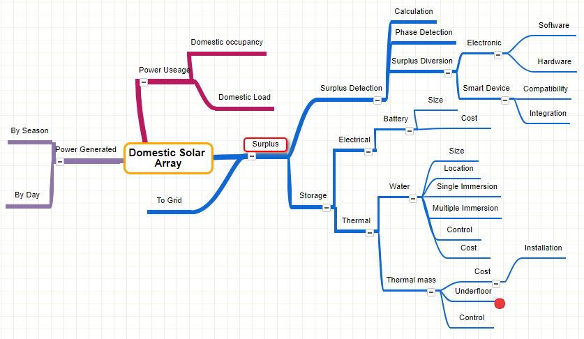
Figure 3 Project Mind Map

Appendix 2

