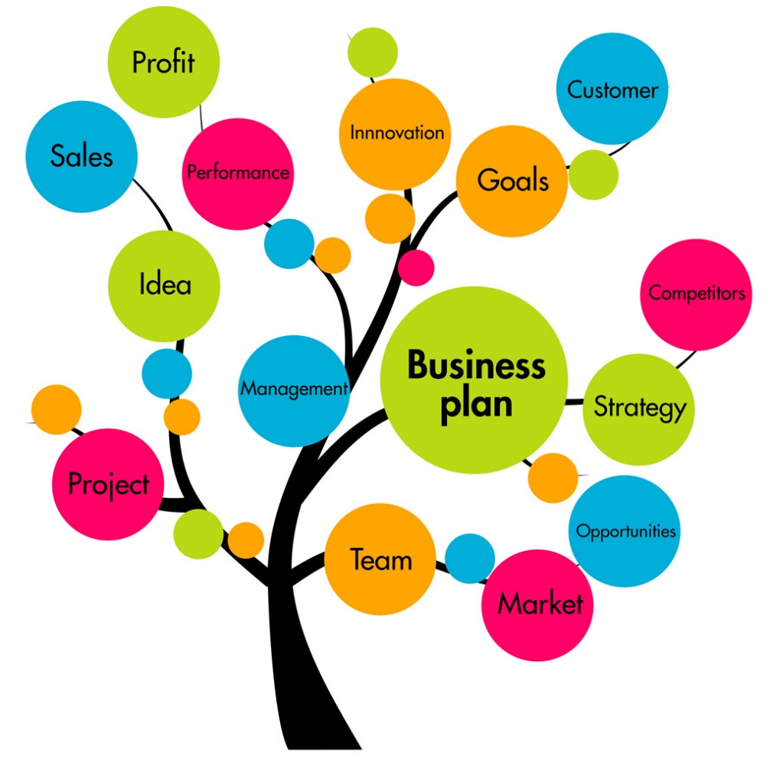

Celia McClelland
1813622
M4X01917 BUSINESS FOR SKILLS
Dale Clark

Introduction
This report investigates the factors that influence my desires in life by keeping my goals in sight. By having a plan, it helps me focus by mapping my future and what successes I aim to achieve. By making the correct decisions it helps preventing me from taking a back step if I find things getting challenging.
Therefore to help me create and solve an action plan I have chosen to use the SWOT and PDP analysis. The SWOT analysis will help me to distinguish and analyse the crucial issues I have that could affect me reaching my objective. The PDP analysis will help me develop a career plan, it will help me to organise and identify an action plan for my future goals.
ANAYLSIS
The SWOT and PDP both have their benefits and limitations.
 | Limitations | Benefits
SWOT Analysis | - It doesn’t help provide a solution  - Does not offer you any alternative decisions, but it can generate a lot of alternatives but will make you struggle on picking a solution  - Can create an information over load , which not all the information is relevant . | - acknowledge yourself as an individual  - understand your weaknesses, how to address them into strengths  - acknowledge threats  - understand the opportunities that can be offered  - enhance my strengths  - to develop my goals and strategies so I will be able to achieve them.
PDP Analysis | - can always change  - career path can always change  - not aware of the updates on the education required | - identify my personal development  - identify my academic progress  - identify the different opportunities ahead  - able to monitor and review my progress  - be aware of the continuing development of my chosen profession


On your left is the famous sir alan suagr , he is an international buisness man , who uses SWOT & PDP for his buisnesses
Alan Sugar founded the company and is still the managing director of the company, forty years on. Over the years, Amstrad has had to change its product mix but has retained a solid position in the market place
(Essay UK, 2019)

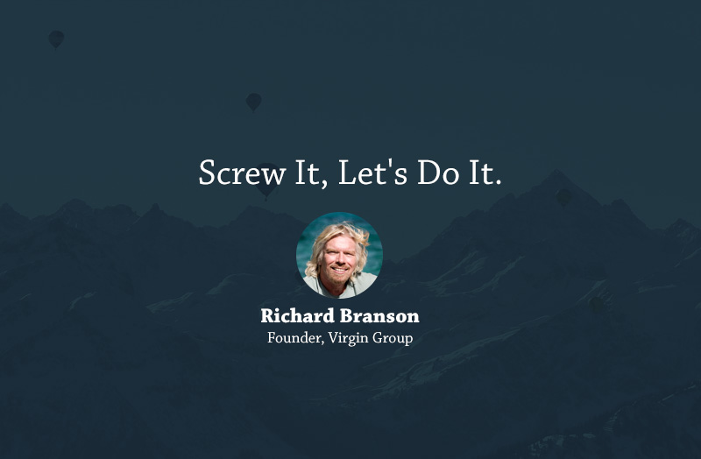
ON YOUR LEFT IS RICHARD BRANSON , WHICH BUISNESS MOTO IS WRITTEN DOWN BELOW AS YOU CAN VISUALISE HE WOULDN’T USE A SWOT PLAN OR PDP , BUT STILL HAS MADE A SUCESSFUL BUISNESS ”
“Screw it lets do it .”
(Laurinavicius.T.2016).

PDP
Definition - Personal development planning for you to create an action plan so you can plan goal settings, as well as identifying and reflexing on yourself.
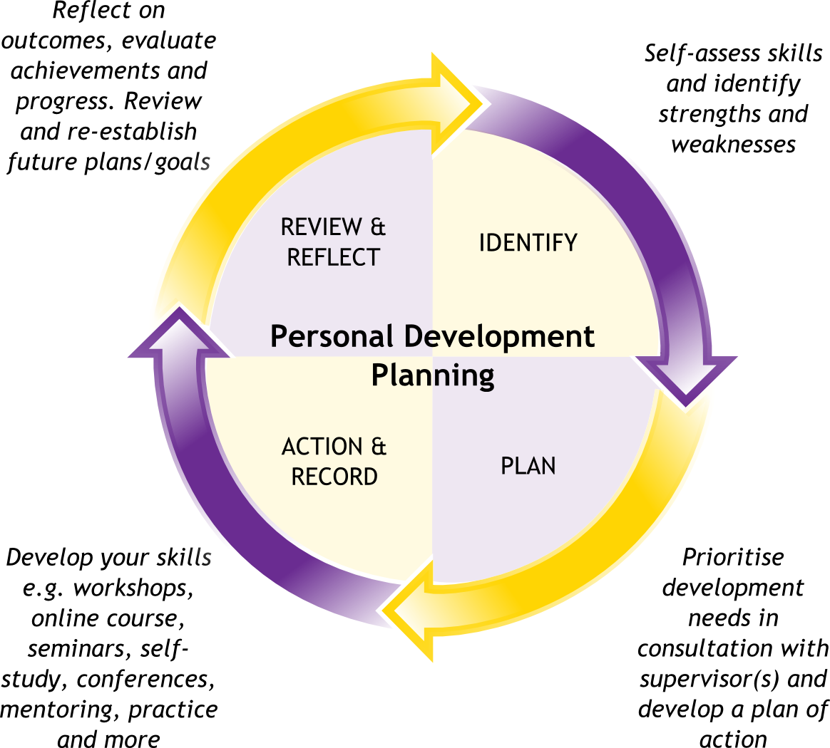

GOAL | OBJECTIVE | EVIDENCE | DEADLINE
Improve my presenting skills | Spend 1 hour researching on presenting skills (PC , Books) | Delivering presentation/ conferences , looking at role models such a Sir Alan sugar on what advice helped make there career a success | Each week
Writing structure | Read journal articles,reports and books | Write a written report on each information source I have read | Every week
 | Research literature and writing structure examples | Write example pieces of information | Every week
Communication skills | Attends debates and conferences | Participate in the debates and take notes on how each individuals communicates | Every 2 weeks
Controlling my  emotions | Try and do emotion exercises by researching on the internet and reading books | Try and act out scene to see how well I can control my emotions | Every week
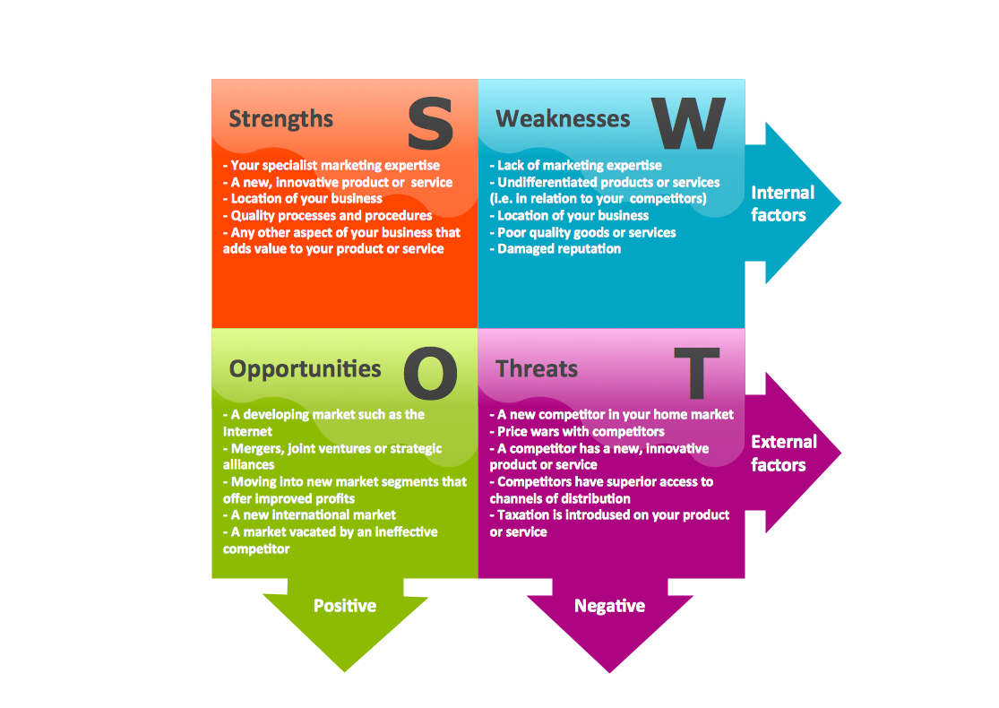
SWOT
Definition – Divide information into segments so it is easier to analyse the your strengths, weaknesses, opportunities and threats so you can reach your goal.

Strengths | - Euphuistic learner,  - Passionate about debates, Good listener,  - Interacting with individuals, research
Weaknesses | - Writing structure  - Exams  - Confidence,  - Getting my point across  - Time-keeping
Opportunities | - University  - Research skills,  - Extending my knowledge on the hospitality market, work experience at hotels abroad doing wedding fayre,  - Learning a new language
Threats | - My daughter and family life  - Health  - Not being update with the latest technology

Goals

 | MY GOALS FOR THE NEXT 5 YEARS
GOALS  - Expand the family business further afield. (Tied with a bow wedding fayres events)  - Be fluent in another language  - Be a good manager | PLAN  - Encouraging brides to meet the faces behind independent local businesses which can caterers to the bridals needs  - Meeting the needs of the bride  - Studying international hotel management influences my career goal as it teaches me many skills on being an entrepreneur, Once I finish this degree I am aim to meet with the directors of the hotels to introduce my business idea proposal  - Sign up to a class to learn multiple languages  - Work experience at the Marriott Hotel  - Presenting in conferences / university
OPPORTUNITIES  - Traveling the world, and learn how they operate their business by doing work experience  - Be trusted to run a business on my own  - Update knowledge on latest trends | THREATS  - Loss of money  - Business proposal gets rejected  - Brexit  - Lack of confidence

Conclusion
By entailing my passion in area which I have had 8 years' experience in has moulded me into a person who I am today. It makes me determined to achieve my goals as I have watched this business flourish into a successful business which has so much potential and is based on family dreams which I aspire to see blossom even more to leave a legacy behind which will never be a dying trade. The skills I have learnt from being a part of this experience has shown me nothing is ever to little; it never has an ending. There are areas I need to improve on, but they will come in time from more experience and research. My inspiration comes from my mother who has put hour and knowledge to see this business develop which she has been a brilliant mentor and role model, I aspire to determined and strong willed as she is to see my action plan develop.
By analysing myself performance on the SWOT and PDP analysis it helps me develop myself as an individual. Through experience of working every day journeys I can turn my weakness into strengths and my opportunities to become reality. However, I would be unrealistic if I was to say I won't have any weakness' in life time, it all takes time to improve yourself as individual. It will help me identify my targets which will make me a successful business woman. Long as I am focused, I will be able to analyse myself to make room for improvement and set new goals when I have completed this one in the next 5 years.
References
Essay UK, 2019,Swot Analysis for Sir Alan Sugar's Amstrad. Available from: <http://www.essay.uk.com/guides/swot-analyses/amstad-swot-analysis.php> [12-02-19].
Laurinavicius.T. (2016). Top 20 Inspirational Business Quotes from Famous Founders. Available: https://despreneur.com/top-20-most-inspiring-quotes-from-world-business-icons/. Last accessed 12th Feb 2019.

Bartels .J. (2013). What is a Personal Development Plan?. Available: http://www.smartselfdevelopmentplan.com/what-is-a-personal-development-plan. Last accessed 12th Feb 2019.
Danca.A. (2013). SWOT Analysis . SWOT Analysis . 1 (1), p.1.

