Databases and application development
Cai Perry (2304939)
University of Wales Trinity Saint David
  - Coursework Part B – SQL Database

Contents
Abstract 2
Planning 2
Entity Relationship Diagram 2
Table structures 3
Test Data 3
Implementation 5
Tables 5
Rollback scenario 7
Performance Tuning Enhancement 7

Abstract
This document will contain evidence of my planning and implementation of a back-end SQL database according to the guidelines of the scenario AdventureWorks Cycles. This project aims to create a relational database for this company, featuring the management and storage of products, orders and customer/employee data. Through the use of foreign keys I have demonstrated that tables share information whilst also being able to capture specific attributes such as bike type, employee name and date of order.
I have also further demonstrated my understanding through the use of queries later in the project, testing my database and the information within it. This project serves as a foundation system that can suit a starting bike business, ensuring an organized workflow and order system for both the employees and customers.

Planning

Entity Relationship Diagram
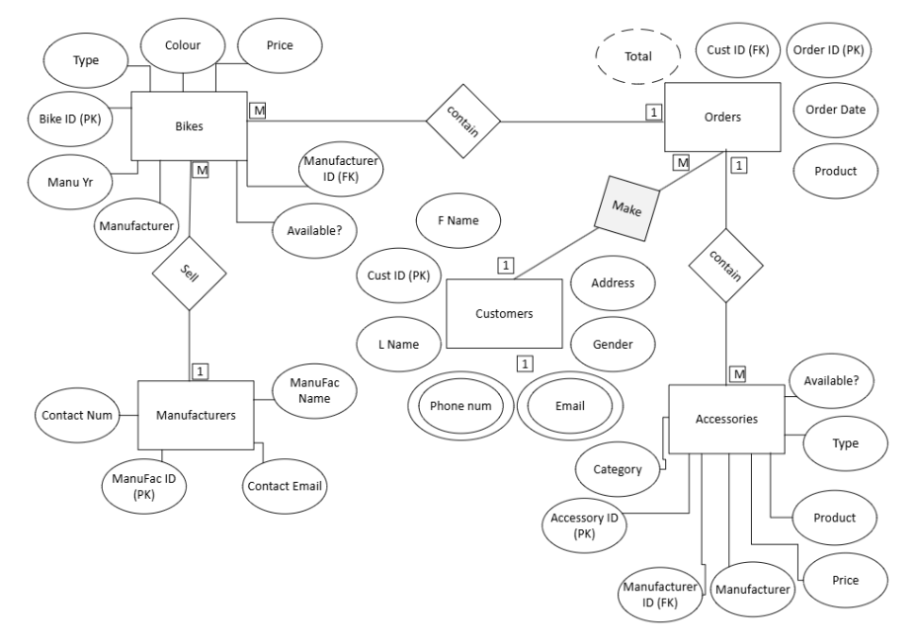
The entity relationship diagram shows the tables, attributes and relationships. Here you are able to view the types of relationships between entities. Some attributes like phone number have multiple ovals around it, this means that the attribute can have multiple values, for example, the same customer can have two or more emails that they use to order. On the orders table, the total attribute is surrounded by a dotted line. This means that it can be derived from other fields, in this case it would be the price of each item on the order added together.

Table structures
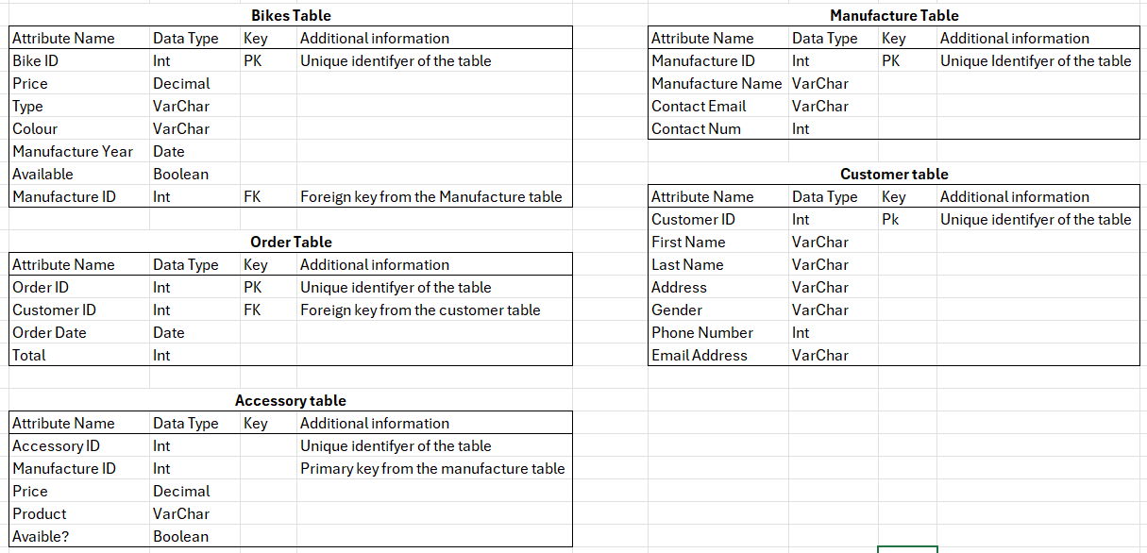
Using the layout from the entity relationship diagram, I created tables that I will use for my database. Here I have included the attribute name, the data type that they will be in SQL, if the attribute is a key and any other additional information about that attribute.

Test Data
The test data are records which have been created to be input into the database so that I can test that the tables can hold data, and that the correct data has been input into the correct place within the database. These false records are also used to determine whether my queries and transactions work too.
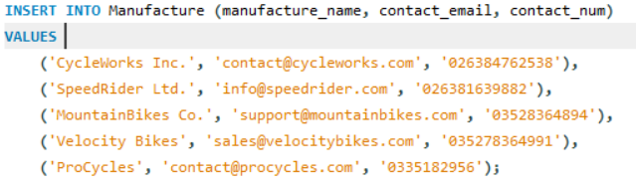
This is my test data for the manufactures table.
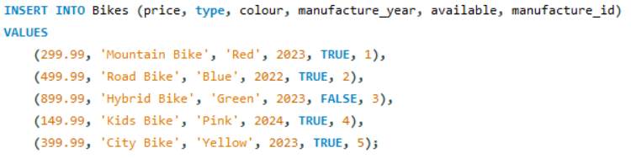
This is the test data for the bikes table.
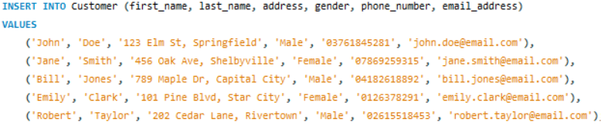
This is my test data for the customer table
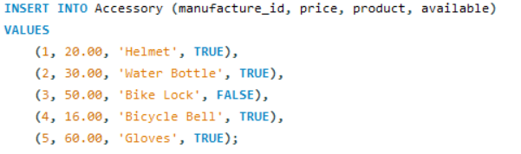
This is the test data for the accessory table.
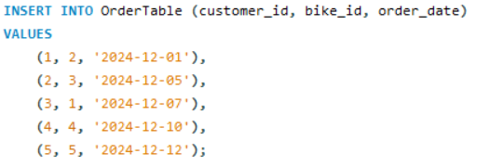
This is the test data for the order table
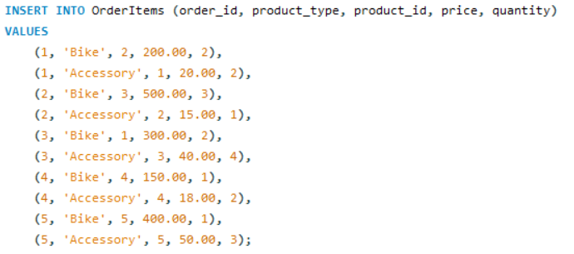
This is the test data for the item order table handling records for both bikes and accessories.

Implementation
In the implementation section of this project, I have used the planning layout I have designed to create the code for the database, this includes the table structures, test data, queries and transactions.

Tables
These are the 6 tables I have in the database, these will serve as the foundation and where the data a will later input will be stored.
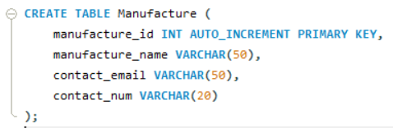
This is the manufacture table; it stores the information for the bike manufactures.
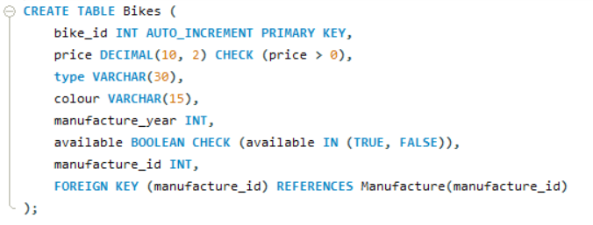
This is the bikes table; it stores all the information for the bikes. I have the manufacture ID here as a foreign key so that the user can see which manufactures made the bike, and have check constraints on the price, making sure that it’s not negative, and that the bike is either set as true or false for the Boolean value.
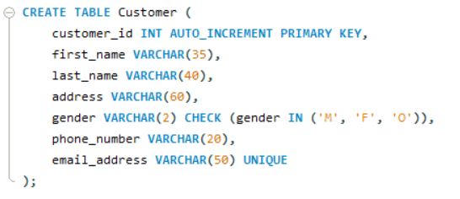
This is the customer table; it stores the information for the customers. I have made the email address field unique, and have a check constraint on the gender, making sure it can only be set to Male, Female or Other.
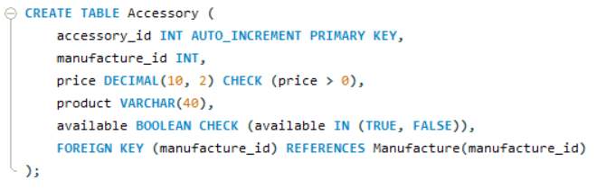
This is the accessory table. Similar to the bikes table, it holds information for the accessories for the bikes. Here I have a price check to make sure the price is at a value above zero, in order to not mess with the calculations that I test later. I also have a check on the Boolean value, just to make sure that it is either set to true or false.
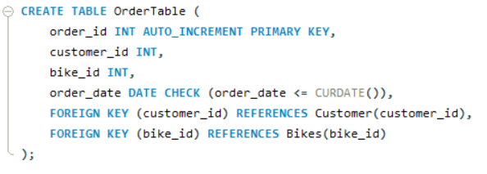
This is the first order table “OrderTable”. This table handles all of the general order details, such as the bike, and customer id, and the date of order. I also have a date check to make sure the date of order input is either equal to or before today’s date.
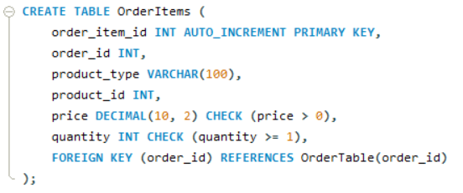
The last table, order items, handles the item in an order. The primary reason for having two tables is to avoid data redundancy and make sure all tables remain in 3nf. If I were to implement all of the information into one table, there would be attributes that don’t only depend on the primary key.

Rollback scenario
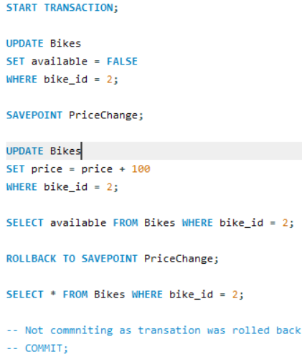
This is the transaction I have implemented to show what would happen if a price would change on a bike that didn’t exist or wasn’t available. At the top I change the bike id ‘2’ to false, then select a save point. I then update the price of bike id ‘2’ by adding £100. In the next line where I select all bikes under ‘2’, there should be none, so then the transaction was rolled back to the save point, as a bikes price shouldn’t be updated if there is no bike to price. Commit is commented out, as in a real scenario, if the price was to be updated, it could be if the bike was available. This statement could be improved with multiple if statements to avoid hard coding one outcome into the transaction.

Performance Tuning Enhancement
In this section, I have made queries for information that I believe would be regularly searched for and executed within the database. This is to streamline data retrieval. There are five key queries which I believe will be the most beneficial to the data I have created.
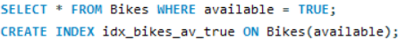
The first one, will select all bikes that are available, so that when searching the user won’t have to manually look through the available column to see which ones are and aren’t available. I have used an index for this as it filters the bikes table through the available column. The addition of an index will speed up this process when the table eventually grows larger and there are more records to sort through.
The second one takes all orders made by a specific customer, so the user can see all of the orders done by one person. This number is customer 3 at the moment but can be swapped for any customer on the database. I have again implemented an index onto this query too as the query similarly filters the OrderTable by customer id so adding an index int the customer id attribute would speed up searches, especially if the user decided to add an ‘and’ function to search for multiple customers orders at the same time.
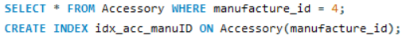
This query retrieves all bikes from a certain manufacturer, in this case it is manufacturer ‘4’ but can be changed upon the user’s request. Similarly to the previous query, I have also implemented an index because it searches from the accessory table to the manufacture id column, so an index would again speed up the search process as the database grows.
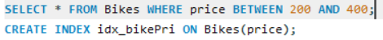
The fourth query searches for bikes priced between £200 and £400. These numbers can be changed to anything with the use of the between function, getting all records in between a specified higher and lower value. An index is also necessary in this because it searched for a column via a table, so to prevent a slower, full table scan, it narrows down the search to only the information it needs to complete the query.
The final query is a composite index as it sorts through two constraints, that being the manufacture Id and whether the accessory is available. Here another index would be required as it again searches through two columns so an index would be most effective here as there are multiple constraints. The constraints can also be changed to any manufacturer ID, and the availability to false. To avoid any data duplication or unnecessary complication, this database is under the assumption that the manufacturers listed produce both bike and accessories. There is no manufacturer who does only one or the other.
All of my queries listed use an index. This was because in this case they have all benefitted from one being implemented. However, there are queries this database could use that doesn’t necessarily benefit from an index. An example of such a query would simply be:
This is because this query retrieves all the records from the bikes table regardless, so putting in an index wouldn’t do anything to streamline the query. The reason why I haven’t included a query like this is because it just shows the whole bike table. Another query that wouldn’t require an index would be:
This is because the manufacture year will no doubt have many repeating values, because there are many different bikes made in the same year.so in cases where there is a lack of variation between the records, an index may not be helpful, especially since this database will have rotating stock since customers can place orders. If this were to act as an archive of bikes so the years were much more varied, it may benefit to have an index for this query, but in this case it isn’t needed.

