PROFESSIONAL CAREER DEVELOPMENT

MY PLAN IN 2000 WORDS

Gabriella Lombardi Hoyos 2010001
Husam Alharahsheh
BMSW4005

TABLE OF CONTENTS

- Introduction.

- Lifeline.

- Self-evaluation.

  - Motivation.

  - SWOT Analysis.

  - Smart Objectives.

  - Johari Window theory.

- Academic, Professional and Personal expectations.

- Where and who I want to be in 5 years?

- Conclusion.

- References

Introduction

I am Gabriella Lombardi Hoyos. I have 20 years old, and I born in Italy. But I do not speak Italian. The reason is because my parents decided to move to Spain when I was 1 year old.

I grow up in Spain, but I always had a Latin culture at home, as my partners are from Colombia.

I lived in Spain until my sixteen years old. Then I moved to Colombia for two years. I went back to Spain when I was 19 years old, because I did not like to live in Colombia. I was Studying Business Administrative.

But since I arrived back to the airport in Spain…. I felt like that was not my place.

I decided to come to London only two weeks for holidays. But I really enjoy the crazy live here and I looked the way to stay without my mother’s help.

In these year and eight months I worked as an Au Pair, as a waitress, as a host, as a cashier, as a kitchen, in a warehouse, as a cleaner and now I am learning to become a barista/bartender.

In this country I started to learn not only about a new country and his culture, also, about myself, what I want, where I want to go and in who I want to become one day.

For all of these I pass for a big process with fights, happiness, disappointments, crazy things, adventures, love, meet new people in my life who helped me to be who I am today, and a lot of more things.

I was a kid who only was leaving day by day, trying to only go out with friends. One day I wake up, during the first quarantine and I realized that was not the life that I really want to leave. So, I decided to change. I done it. In that moment I applied to start the university, I started to learn how to take care of myself, because no one else is going to do it for me.

And now I think I done it well. Not in the best way that I will had done it, but yes to had help my family and have given them a roof where to go. I feel proud of myself in a lot of ways.

To try to understand my life I am going to place a little draw of high and low points of my life. With a table specifying what happened in that years.

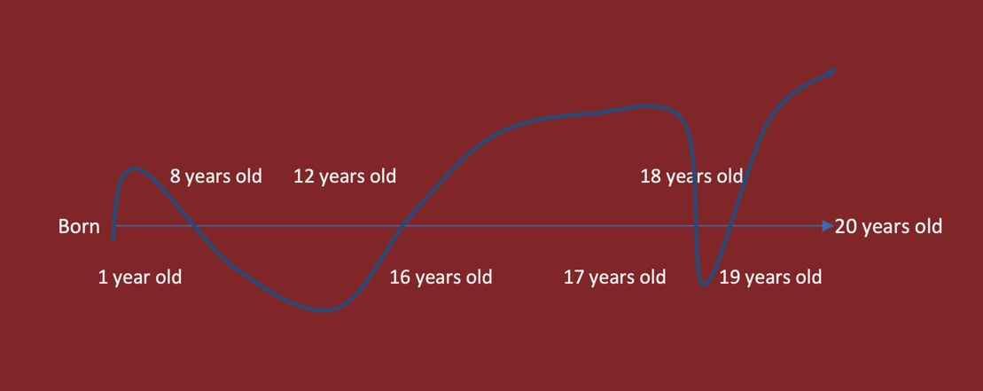

Age range | High points | Low points
1 year old | I moved to live in Spain.
8 years old |  | Separation of my parents.
12 years old |  | My father disappeared.
16 years old | I moved to live in Colombia.
17 years old | I finished Bachelor.
18 years old | I started my first job.  I go back to live in Spain.  I went to London, only for “Holydays” and then I decided to stay. | My fiend dies.  My great grandmother dies.
19 years old | I started my second job.  I fall in love.  I start the university.  I helped my brother to came and live with me.  I started to do savings and pay phone and internet contracts (I feel old).
20 years old | I start renting a whole apartment.  I helped my mum to came and have somewhere to stay.

Now, to continue with this personal report and mostly analysis…. I want to do a self-evaluation review. Where I will describe my past, my present and my future, always been totally sincere and honest.
When I was a child, I used to have everything, but I decided to get my own things. That’s the reason that I moved to London.

In the gap between nineteen and tweeny years old I learned that I need to have self-motivation for everything. No one is going to push me. And no one supposed to do it.

So, I started to write in a paper all the things that I want to do, my goals. Later own I separate them in different groups and times.

I decided to choose things that will make me grow, not only as a professional, also as a person.

Every morning when I wake up, I repeat to myself…...” you need to enjoy your life as if there will not be one tomorrow. But always thinking that all your actions have a consequence. So, make sure you do what you want but always thinking in the future”.

I think that the best think is learn about yourself. If you do not know your own, you can not love or enjoy in the same way the life, friends, family, etc.

The first steep is to write your own SWOT Analysis, because with this you can learn more about you. And this is mine:

Strengths | Weaknesses | Opportunities | Threats
- I am veery good in my job. Because I am working in what I want.  - I am a professionalism and strong work ethic person  - I am very organizing  - I can work under pressure  - I am an honest person | - Poor communication skills  - I have a strong character  - Sometimes I am a bite shy  - I have a strong compulsive need to do things quickly and remove them from my “to do list”. I am impatient | - At work they are giving me the opportunity to grow up giving me more important things to do | - I feel like I am blocked in my personal life  - I am trying to place too many things in my life. And to be honest…. I do not know who I am trying to become.

Always remember that this is analysis will change all the time, because we are in constantly changes.

Later own you can find your Smart Objectives. Mines are:

- Go to work by bicycle. It is one hour to go to work and go back home. I do it four days in a week.

- Wake up early. Are you constantly feeling short of time? Set a intention to wake up as early as five am in the morning every day; you’ll have at least an hour extra to do the things you love earlier than the day’s job starts off evolved.

- Organize all the important things of my house, like the bills, buy new staff for leave better.

- Improve my time management skills.

Also, I think you can use the Johari Window theory. For me fill this part of the work is too difficult. But I am going to leave it done. This is mine:

x | Known to self | Not known to self
Know to others | Open  Adaptable  Friendly  Sensible  Confident  Observant  Inpatient  Negative  Confident  Honest | Blind spot  Powerful  Intelligent  Brave
Not known to others | Hidden  Shy  Energetic  Irresponsible | Unknow  Nervous  Independent  Spontaneous

To be honest for my professional career I am working hard to urge a far better position in my workplace. I started as a waitress and now I am working as a bartender and waitresses at the identical time. I am always trying to provide the most effective of me to the corporate, so therein way they see that I am interesting to enhance my knowledge and to became as a manager in the future.

All the time you’ll learn something new. Which is what I am doing during this moment. I did not study something specific to be able to become a bartender, a manager, eighter the boss of a restaurant. But I prefer this country because it does not matter if you do not have the knowledge, your colleges will facilitate your and teach you all the new things.

I am a realistic person and when I want something I fight for it, until I get it. That’s the way I got my position behind the bar. I always find the way to have what I want.

My academic goal is to finish my career. I do not know if I am going to work of these. But I know this is something that I want to learn. And I am placing all energy on it to get it. The reason of this is because I am too young in this moment to work in an office. I like to always be running and doing a lot of things.

For my personal expectation is hard to explain. I thought I do not know what I want to do in my life, who I want to become when I grow up, where I want to be when I get older……But in these last two months…. all my life had done a three hundred and sixty degrees turn.

In this moment I am leaving my live in a way that I do not like…. what way is it? You will ask yourself. Leaving it day by day. Because I am feeling a big whole inside me that does not allow me to continue with my live. To be that impaction person who always try to do something new and curios girl that all the time was asking question for everything, for the only reason to learn something new. I fell that my light is off in this moment.

But as I already said, I need to live my life and always think in the future.

I see myself in five years living in my very own apartment, working in something that I prefer, in an office. Because I will fight to work in and where I would like.

I would prefer to sleep in a unique country. I am only looking something with a beach near, only for a pair of years.

I see myself working an amount of 40 hours per week. Because I will have an office schedule and I will get an honest rate payment. So, I will be able to do not must work over that if I want.

In five years, I might prefer to have a leadership position. Why? Because I will have finished my studies and in that way, I will be able to have my own workers in charge. As in the book of Organizational Behaviour is wrote…. I will have the knowledge of a leadership qualities like: ‘leading and managing changes”. Also, I will have the experience of working in hospitality as a manager.

To be honest I wish to have the choice if I would like to work from home or at the office.

The reason is that during this way if I would like to travel, I can do it and continue working at the same time.

I am aiming to work for a private business and in other side I will have some own business and I will continue studying. Why? Because in this life all the persons can steal you everything, but never your knowledge.

I am planning to grow in my existent career in this moment, but at the same time to take some other classes of different things. Couse knowledge is freedom.

To get what I want I will have to spend a lot of time. What I learned is that if you want something, fight for it, does not matter the longest it takes.

To conclude with my report and my plan, I want to get focus in…. we only have one life in this world. So, just life and learn about all those small, medium, and big things that you do all your days.

I will get my goals because I am going to work hard on them. To see back one day and feel proud of myself.

I know that the journey will not be easy. But nothing in this life is simple.

References

Organizational Behaviour PDF eBook 9th Edition, David Buchanan, and Andrzej Huczynski.

Moodle, Professional Career Development, BMSW4005.

Organizational Behaviour PDF eBook 9th Edition, David Buchanan, and Andrzej Huczynski.

HUAT AH. (2016). Self-reflection (using analysis from the Johari Window model). [online] Available at: https://huatzailee.wordpress.com/2016/08/08/self-reflection-using-analysis-from-the-johari-window-model/

ROLE PLAY -Job Interview



