Module Title: Psychology in Health and Social Care.
Module Number: LCHS.4010_LON.
Assignment No: ASSIGNMENT 2
Student Name: Adriana Ilona Rana-Ryng.
Student ID: 2430426
Lecturer’s Name: Muhammad Aliyu.

Context : Setting - Old people living in a dementia care home/nursing home.

Home care/Nursing home care.

Nursing homes offer a comprehensive package of inpatient, professional support for people with dementia in 24-hours, along with a specialized theoretical and modeling approach, medical care related to the progressive decline of cognitive, memory, and motor functions in people with dementia. These services include prevention, routine, stability, dignity, respect, and support in maintaining independence. A safe and friendly environment and a holistic approach in care homes support autonomy and engagement in social activities and activities, where isolation is a significant problem for people with dementia today. Activities such as occupational or physio-therapy, Interaction with others improve a person's functionality, memory, behavior, and motor skills while maintaining their dignity, promoting respect and understanding.
A personalized care plan helps individuals in a care center manage their needs and shortcomings, maintain routine and independence. Residents are often confused, emotionally disturbed, disoriented, and have difficulty communicating, which reduces their quality of life (Alzheimer's Society, 2023). Care in a care home for people with dementia is essential and focuses on the patient's, profiles them, identifies meaning in life, regulates stress, and maintains a sense of belonging. Building a bond between staff and the patient is essential, taking into account their life history, preferences, needs, and values, is fundamental (Kitwood, 1997).

Daily Life in Care Home Dementia Setting includes.

- Support for staying active: These include activities to reduce anxiety or confusion, maintain strength and independence as dementia progresses (intellectual and physical activities prevent dementia). These therapies improve emotional well-being by stimulating cognitive function (Brookere Hatman, 2016).
- Constant health monitoring: medical interventions, and administration, dressing, hygiene, nutrition,nursing.
- Specialized medical infrastructure and equipment with qualified staff.
- Security and stability: a safe environment that reduces behavioral disorders and anxiety. Minimizing risks such as escape, falls, and fire. A closed, stimulating environment in which the person moves safely among staff and fellow residents.
- Meeting complex needs: as dementia progresses, the person becomes dependent on third parties, leading to the conclusion that nursing homes are a better and safer alternative than home care.
- Routine and structure: a predictable daily schedule, meals tailored by dietitians, sleep and activity at consistent times, reduces confusion and lets the person know they are in control of their day.
- Nursing home staff: professional, continuously trim and skilled, perform a very important function, build trust through respect, use validation techniques, therapy, mentoring, encouragement and support, organize daily schedules and routines, monitor and eliminate problems, implement interventions, treat symptoms in residents, and fulfill many other important functions.
- Relief for family caregivers: Caregivers for dementia experience physical and emotional strain, lack professional training, knowledge and skills, specialized equipment, and financial resources, the ability to ensure safety/comfort. Due to existential responsibilities, daily activities, and obligations, there is a chronic lack of time and respite from focused care/ attention. By entrusting their loved one to professional care home, families can focus on their lives without stress, anxiety, rest, and recharge, supporting their loved one in a specialized and supportive environment. They can also engage in their well-being and enhance their well-being through online visits and contacts.

Mental health practices in supporting people with dementia in care homes.

Dementia, a neurological disease, impairs memory, cognitive function, and behavior. This phenomenon affects millions of people aged 65 and older. Global population aging leads to an increasing demand for health and social care. Therefore, professionals in these settings should be familiar with psychological theories that approach human development, life needs, and health behaviors, as this is essential to providing effective and targeted care. This report examines two important theories: Erikson's Theories of Psychological Development and Bandura's Social Learning Theory. By assessing their application in residential care for older adults with dementia, examples can be found that demonstrate the importance of supporting residents and critically discussing advanced strategies for specialized services.

Introduction to two psychological theories.

Eric Ericsson's Theory :

The Psychological Development Program guides a person through eight stages of life, each of which represents a conflict. The final stage, Integrity vs. Despair (65+), leads to reflection on life, a search for meaning and acceptance, and integration with death. Despair and Failure represent patterns of regret, remorse, and unfulfillment in life, while fear leads to catastrophe (Ericsson 1982).
In older people with dementia, cognitive function deteriorates due to memory loss and disorientation, making life more difficult.
By supporting these individuals socially, we preserve their financial dignity and meaning in life. Every professional should incorporate Ericsson's theory into their practice, as it is relevant and focuses on older people and their life development.

Albert Bandura's theory of behavior:

Theory monitoring involves learning, imitation, and social modeling (Bandura 1977). Learning occurs through experience and observation of others. The theory is based on self-efficacy (Bandura 1997). People with dementia struggle with fluency and complex tasks, but they evoke and imitate behaviors when they are exploited or influenced by their environment.
These are role models, routines, reinforcement and shaping behaviors that promote well-being, as pointed out by Bandura's Theory.

Practical Application of Psychological Theory and Methods in the Context of Healthcare and Social care.

Erikson's theory and practical application:

- Remission therapy, which utilizes images, music, historical narratives, encourages reflection to build social integrity. It utilizes affirmation of one's identity and life experiences, reduces loss, promotes acceptance by the environment and peers ( Coleman 2005).
- Meaningful Activities: Adding direction to the daily routine, like gardening, art, religious practice, can enhance a sense of self-esteem and belonging, and alleviate feelings of despair.
- End-of-Life Care: Specialized support from staff can support residents, validate experiences, reduce anxiety, and promote acceptance.

Challenges:

- Due to cognitive impairment, verbal communication is limited, which makes reminiscences difficult.
- Traumatic events can cause emotional stress,
- Due to staff shortages, there is limited time to personalise.

Strategies:

- Multi-neuronal sounds like music, smells or tactile objects are used to stimulate sensory perception and memories supported ( Woodsi in,2018)
- Trained, empathetic trauma-informed care staff builds a positive relationship between needs and the care services provided.
- Help from family members in a reminiscence session that ensures continuity of bonds and emotional support.

Practical and methodological Applications of Bandura's Social Learning Theory.

- Staff modeling behaviors through calm, respectful behavior to prevent resident aggression – the Four Frames Principle.
- Group activities, such as singing, exercise, or art classes, strengthen social bonds through observation and imitation of peers.
- Positive reinforcement, such as small gifts and rewards, encourage residents to participate in activities, reduce social withdrawal and isolation.

Challenges:

- Older adults with advanced dementia struggle with challenging tasks.
- Reducing negative patterns that can irritate nursing home residents and provoke aggression.
- Difficult-to-achieve cohesion and conflict within teams require specific, targeted solutions.

Strategies:

Breaking down tasks:

- Into smaller, more manageable steps using a step-by-step approach.
- Continuous staff training with positive modeling and reinforcement.
- Common procedures established in advance help reduce confusion and anxiety (Kitwood,1997).

Examples in practice:

- Rooms of memories: decoration from the 50s - 70s, which help support the stage of integrity included in Erikson's theory.
- Music therapy in group residents, imitating singing, observing the scenery for improving their well-being, mood, and social integration, as Bandura's theory suggests.
- Peer mentoring, for example, allows older adults with mild dementia to model others' behavior by participating in meals with individuals with advanced dementia.
- Staff modeling involves calmly responding to aggressive behavior, which limits its escalations, or alternative behaviour.
Such examples demonstrate how theory can be used and how it finds practical application by connecting abstract concepts with real-world interventions.

Biological and environmental factors in home care settings.

Biological factors are key to caregiving needs, demonstrating the variability of health with age, including cognitive and adaptive impairments, mood swings, and chronic stress.
Environmental factors are shaped by social learning and psychosocial support at different ages, through emotional adaptations and social interactions, the physical environment, and the quality of care.
Erikson's "Integrity vs. Despair" Theory emphasizes the importance of a supportive environment for maintaining dignity in the face of biological changes.

Bandura's Social Learning Theory posits that through observation and reinforcement, self-efficacy can be achieved and problems can be solved. Positive modeling builds self-efficacy, while negative modeling causes stress.

Two theories demonstrate that biological limitations and the supportive environment can impact the quality of life of a nursing home resident with dementia. They emphasize the need for holistic care that addresses physical health and psychological resilience.

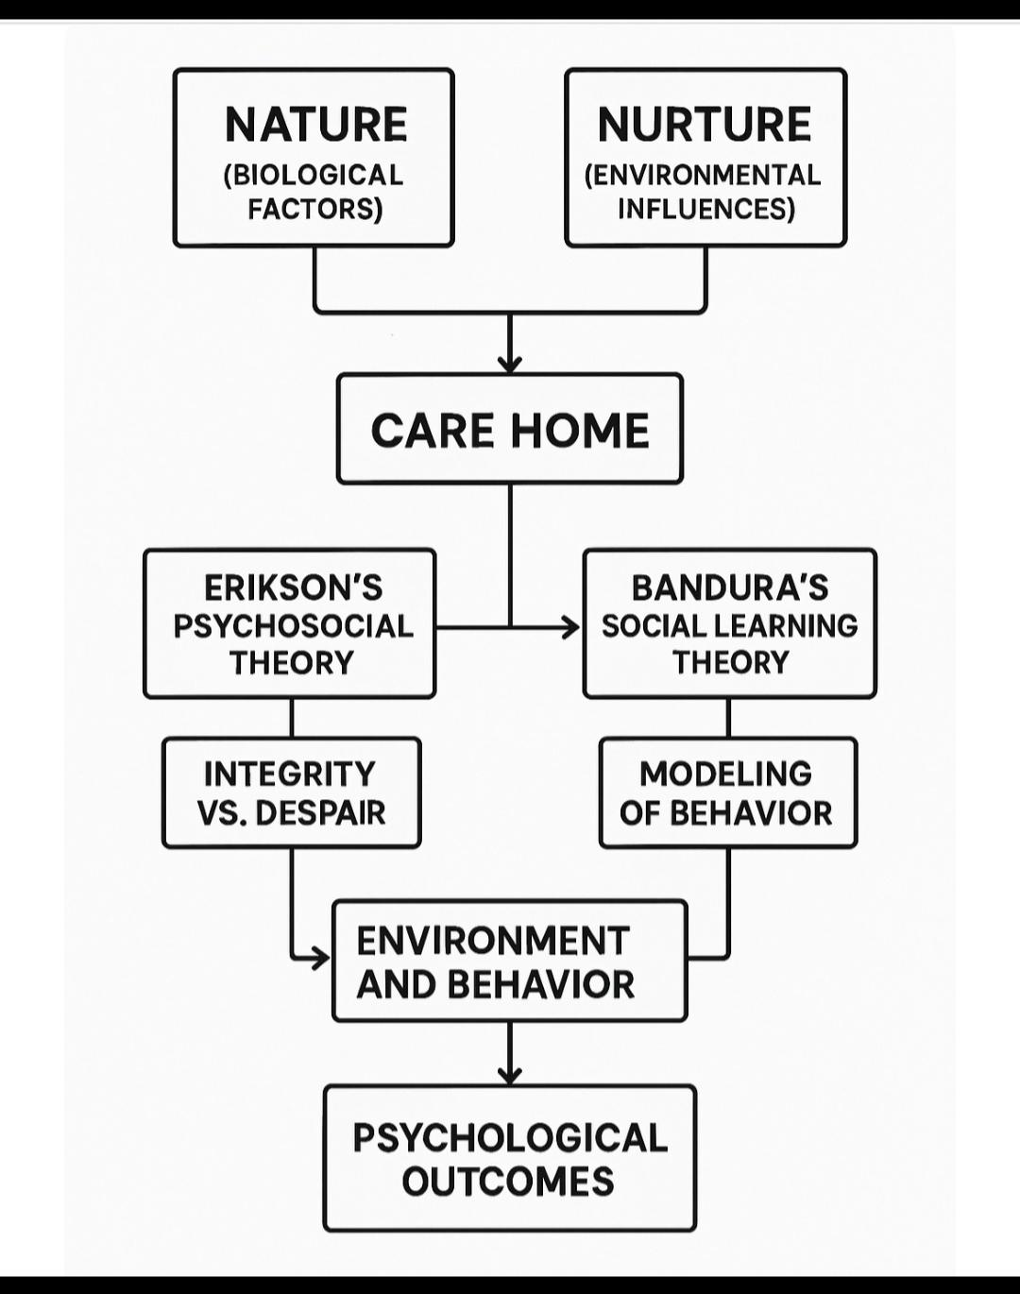

Critical evaluation.

Erikson's theory offers a developmental perspective and emphasizes understanding meaning and identity. However, it simplifies the concept of late adulthood and the stage of integrity. Dementia disrupts this theory and may not lead to adaptation.
Bandura's theory presents behavioral strategies and observable learning, but it also does not account for cognitive decline. The only tools we can use are imitation, small acts that can improve well-being in old age.
Two theories complement each other. Erikson's theory understands the person and their existential needs, while Bandura's theory presents practical, integrated behavioral strategies that support the emotional and behavioral development of older people and the care of people with dementia.

Conclusions.

Health and social care professionals in residential care with dementia should integrate psychological theory with practice models to appropriately support older adults, and staff should receive professional training.
Erikson's Psychosocial Theory emphasizes the importance of personal dignity, while Bandura's Social Learning Theory emphasizes the role of modeling and reinforcing appropriate behaviors. Cognitive impairments and personal deficits are the primary concerns, while strategic remission therapy provides positive reinforcement. Targeted procedures streamline care, and critical and creative application of these theories can improve older adults' psychological well-being, integrity, dignity, and social connectedness.

Reference.

•Alzheimer’s Society Annual conference 2023.
https://www.alzint.org/news-events/events/alzheimers-society-annual-conference-2022/
•Bandura, A.(1977) Social Learning Theory. Englewood Cliffs, NJ:Prentice Hall.
•Bandura,A.(1997) Self-Efficacy: The Exercise of Control. New York: Freeman.
•Coleman, P.G. (2005) ‘Uses of reminiscence: Functions and benefits’, Aging and Mental Health, 9(4), pp.291-294.
•Erickson,E.H. (1982) The Life Cycle Completed. New York: Norton.
•Kitwood,T. (1997) Dementia Reconsidered: The Person Comes First. Buckingham: Open University Press.
•Sabat,S.R. (2001). The Experience of Alzheimer’s Disease: Life Through a Tangled Veil. Oxford: Blackwell.
Woods,B., •O’Philbin,L., at all (2018). ‘Reminiscence therapy for dementia’, Cochrane Database of Systematic Reviews, Issue 3, Art. No.: CD001120.

