

Creating a distance measurement device using ultrasonic transducers

By Luke Evans (P134201)

Supervisor: Stephen Mosey
Second Marker: Gareth Jones

Project submitted as part of the requirements for the award of B.Eng. (Hons) Computer Systems and Electronics

April 27th 2017

Declaration FORM AND FORM OF CONSENT
DECLARATION

I, ............................................(FULL NAME)………………………………… declare that I am the sole author of this Project; that all references cited have been consulted; that I have conducted all work of which this is a record, and that the finished work lies within the prescribed word limits.

This work has not previously been accepted as part of any other degree submission.

Signed: .............................................

Date: ...............................................

FORM OF CONSENT

I ............................................(FULL NAME)………………………………… hereby consent that my Project, submitted in candidature for the B.Eng. Computer Systems and Electronics degree, if successful, may be made available for inter-library loan or photocopying (subject to the law of copyright), and that the title and abstract may be made available to outside organisations.

Signed: .............................................

Date: ...............................................

Abstract
The overall aims and objectives of this project are to design and create an ultrasonic measurement device (or tape measure) using transducers to oscillate a signal at around 40KHz to be bounced off an obstacle (such as walls and other hard surfaces) to be received and the time taken will be measured and converted into a specific unit of measurement (such as centimetres or inches) using a Liquid Crystal Display (LCD) to display the measurement. The device will be battery powered using around 9V to allow more portability and different battery types will be used to detect the differences in power and how long the device will last.
The idea of this project was due to many building firms and carpenters still using physical tape measures to measure what they need where these can be more accurate they can also be fiddley and harder to use. The prototype will be intended to be as simple as placing on the floor and powering on which is easier to use than the physical ones bought in DIY stores.
The circuit for the prototype will be created using specific software such as Proteus to digitally find the components needed and connect them all up to see if the circuit is fully operational before creating the physical prototype itself. The prototype will use a PIC microcontroller to oscillate the signal and to convert the time taken into the unit of measurement which the data will be compiled onto the microcontroller using software such as CCS compiler.
Research will be taken to better understand how these systems perform and will be noted in the report. The research will come in many forms such as reading from specific websites based on the subject, reading from books and journals also based on the subject. All of this research will be put together and read from to allow a benefit to learning how to create the device for the project.

Table of Contents
1. Abstract 3
2. Introduction 5
2.1 Aims and Objectives 5
2.2 Further Chapters in the project 6
2.3 Gantt Chart 6
3. Project Research 7
3.1 Internet Website 7
3.1.1 What is ultrasound? 7
3.1.2 What is Piezoelectricity? 8
3.1.3 Ultrasonic Transducer 9
3.1.4 Similar products on the market currently 12
3.2 Online Journals 15
3.2.1 Development of ultrasonic standard transducers in the frequency range 1 MHz - 10 MHz [11] 15
3.2.2 Design & Development of Smart Ultrasonic Distance Measuring Device [12] 16
3.2.3 Interfacing PIC Microcontrollers [13] 19
4. Prototype Development and Implementation 20
4.1 Block Diagram 20
4.2 Flow Chart 21
4.3 Labcenter Proteus 23
5. Project Testing and Results 26
5.1 Project Photo’s 26
6. Evaluation on the project 30
Conclusion 31
Bibliography 32
Appendix 33

Introduction

Human ears can hear sound waves that vibrate in the range from about 20 times a second (a deep rumbling noise) to about 20,000 times a second (a high-pitched whistling) based on Hz which is a measurement of how often the sound vibrates in this case 20KHz and 20Hz respectively are the minimum and maximum values a human ear can hear [1]. In some cases, different ages of people can hear different sound values, for example children can hear from 18KHz to 20KHz whereas middle aged adults will hear around 14-16 KHz and the elderly will hear much less (at around 12 – 14KHz).
In the case of this project sound wave values of 40KHz will be used to create a device that will use this signal size to create a distance measurement device using ultrasound.

Aims and Objectives
The aim of this project is to design and create an ultrasonic distance measurement device (or tape measure) that transmits and receives 40Khz of ultrasound to bounce off an obstacle (for example a wall of skirting board) to measure the time of flight and convert such time of flight (using complex CCS code) into centimetres or inches.
The objectives to get this aim are as follows:
- Research into specific project areas needed for the project for example ultrasound and how it works and can be measured, ultrasonic devices themselves where different devices are checked to see how each perform and which would be best for the project (with a final device being picked) and researching familiar devices that are already created that are on the market for inspiration and to try and include some different elements to improve such devices
- The device will be designed using the software Proteus where the components that are needed to solve the problem and finally output as expected are added onto the software where the device can be simulated and checked if performing correctly before the device is created physically.
- The device will need to have code written on the PIC micro controller that will be included on the device to be able to perform as intended, this code will be written on the Proteus software to further check if the device is working as intended before created physically, when the device design is finally finalized the components will be implemented onto a bread board and the code which was created will be implemented onto the micro controller by using a PIC start kit and the software CCS compiler to compile the code onto the PIC itself.
- Testing will be needed to check if the device is performing correctly and given the right values the device will be moved by different distances (for example from 30 cm to 120cm) and a ruler or a regular tape measure will be used to check if the distances being displayed on the LCD display are correct and the device is a success.

Further Chapters in the project
This project will cover further chapters where different aspects of the project are covered these chapters are as follows:
- Project research where many different types of research will be taken to have a further understanding and a massive aid to the design and creation of the device and aid with the report itself.
- Prototype development and implementation where the designs of the project and the physical device itself will be shown to allow the reader to have a full understanding and aspect of the project.
- Project Testing and Results where the project will be tested using different distances and different materials to check how the device performs and if it is performing as the design intends.
- Evaluation on the project where the project is checked to see if everything was done as intended on subjects such as what conclusions were drawn from the data used for the project was the data correct to the research, were the objectives and aims met and overall was the project success.
- Conclusion of the entire project where the project is concluded and if there were any further improvements could have been added to the device.

Gantt Chart
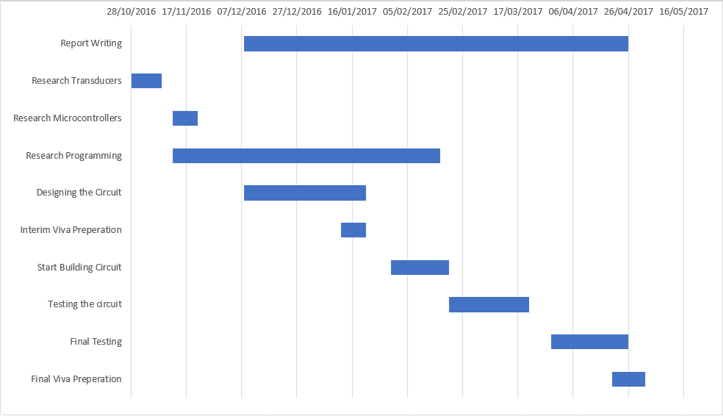
Above is the Gantt chart used for the entire project it gives an idea of how long the entire project will last and the dates in which every part of the assignment take place. For example, the report takes most of the year as it needs that long to be written, the research also takes a while as a lot was taken throughout the project.

Project Research

This section of the report is where the research that was used for the exact knowledge and know-how for the project is shown. The research that was found was read and used in different forms to have different aspects to help in the project these were such as using the internet to find information from well-known scholars and professors on websites where the information will be used to get more of an understanding of the problem at hand (in this case ultrasound etc.) this will be then cited for later use. Books can be read (found from the university library or other such libraries. These books can be analysed for information helping on all the subjects needed for the project to be a success. These are a few examples of such ways of getting research needed for the project to be a success.
The specific subjects of research that were used are shown below:

Internet Website
This sub section displays information that can be used to aid in the development for the project which is found from different websites found on the internet this information is below:

What is ultrasound?
As stated in the introduction and from the website http://www.explainthatstuff.com/ultrasound.html [2] We as human’s can hear specific sound waves that can vibrate in the range from about 20 times a second (which is known to be like a deep rumbling noise) to about 20,000 times a second (known to be like a high-pitched whistling). (As stated earlier children can generally hear higher-pitched sounds than their parents at around 18-20KHz where adults tend to hear around 15-18KHz give or take, because the ability to hear higher such frequencies worsens as the human ear ages.) Sounds that are perceived have a frequency ranging from 20hz – 20,000Hz (20KHz). The unit for sound is known as a hertz it is a measurement of how often something vibrates and 1 Hz is equal to one vibration per second. When measuring the human voice, it is known that the human voice makes sounds ranging from 100hz (or around 400hz) to around 4000Hz depending on how high or low (or loud) a voice is.
Some animals have a greater range of sound frequencies compared to the human ear these animals are as follows: Bats, dogs and dolphins these animals hear in a range past 20KHz that we as humans can hear for example per the website from the independent hearing professionals (or IHP) dogs and cats have a hearing range of around 46KHz to 50KHz so this device would be heard by such animals and may have an adverse effect near them as this is an extremely high pitched sound. However, bats have a hearing range limit at around 120KHz which is much higher than the limit this device will perform at. Dolphins have a similar limit to bats at 130KHz. [3] Sounds like this (with frequencies beyond the range of human hearing) are such known examples of ultrasound which is what the project is based upon.

What is Piezoelectricity?
According to the website http://www.explainthatstuff.com/piezoelectricity.html [4] Piezoelectricity can be used to turn the sound energy in your voice (or other such methods like using transducers) into electrical signals. In such examples using a microphone where the sound would be converted into electrical signals that your computer could interpret. Also, a gramophone would have been using piezoelectricity to read the sounds from the LP vinyl records for sale back in the 1960’s and onwards.
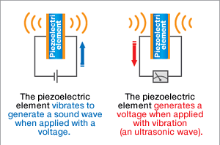

[5]
Example of how using a piezoelectric crystal the element vibrates to generate the 40KHz sound needed for the project device to perform correctly.
Piezoelectric crystals are electrically neutral: the atoms inside the crystals may not be symmetrically arranged, however their electrical charges are a perfect balance: a positive charge in one side cancels out a negative charge nearby at the other side. However, if a crystal is squeezed or stretched it can deform the structure of the crystal, pushing some of the atoms closer together (or further apart) ruining the balance of positive and negative in the structure, and causing problematic net electrical charges to appear. This effect is a problem throughout the whole structure so net positive and negative charges appear on outer region of the crystal.
The reverse-piezoelectric effect occurs in an opposite way. If a voltage is created across a piezoelectric crystal the process is subjecting the atoms inside it to "electrical pressure." The atoms must move to rebalance themselves, this is what causes piezoelectric crystals to deform When a voltage is put across the crystal’s atoms.
“In ultrasound equipment, a piezoelectric transducer converts electrical energy into extremely rapid mechanical vibrations—so fast, in fact, that it makes sounds, but ones too high-pitched for our ears to hear. These ultrasound vibrations can be used for scanning, cleaning, and all kinds of other things”. [4]

“In a quartz clock or watch, the reverse-piezoelectric effect is used to keep time very precisely. Electrical energy from a battery is fed into a crystal to make it oscillate thousands of times a second. The watch then uses an electronic circuit to turn that into slower, once-per-second beats that a tiny motor and some precision gears use to drive the second, minute, and hour hands around the clock-face.”
“Piezoelectricity is also used, much more crudely, in spark lighters for gas stoves and barbecues. Press a lighter switch and you'll hear a clicking sound and see sparks appear. What you're doing, when you press the switch, is squeezing a piezoelectric crystal, generating a voltage, and making a spark fly across a small gap.”

Ultrasonic Transducer
The website http://arduino-info.wikispaces.com/Ultrasonic+Distance+Sensor [6] states: The Ultrasonic Sensor is a small device (normally attached to a mother device however can be sold on its own) that sends out a high-frequency sound pulse (at 40KHz) which then the time of flight (which is how long it takes for the echo of the sound to reflect off an obstacle) is constantly sending out until the signal is received. The sensor has 2 openings on its front. One opening transmits ultrasonic waves, the other receives them.

The speed of sound is described as approximately 341 meters (1100 feet) per second. The ultrasonic sensor uses this information along with the time difference between transmitting and receiving the ultrasound wave pulse to determine the distance to an object.
The mathematic equation of how the device performs is below:

Distance = Time x Speed of Sound divided by 2 (where time is divided by 2 due to sending and receiving.

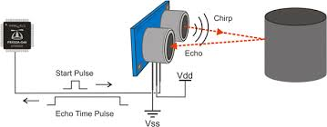[6]
An image of a basic description of how an ultrasonic transducer performs where the ultrasound signal being sent from the transducer module is being rebound off of the object shown and being received into the receiver part of the module, all of then eventually gets sent back to the microcontroller at the left. .

Using ultrasonic transducers has many different uses some of these are as follows:
- Measurement of dynamically changing diameters, the use of this for example when factories (or some shops perhaps) have something on a roller (for example wall paper) the ultrasonic transducer can detect the distance received from bouncing off the wallpaper to detect how much of it remains.

[6]

Example image of such measurement where the transducer Is measuring the distance it’s use would be in a factory environment where specific measurements are measured using the transducer and once it has the right amount it sends data and tells the machine to cut the item for example. .
- Measurement of dynamically changing heights, the use of this method for example where in factories the transducer can detect if something is being stacked the limit of which the stacked items can get until overflow, this is successful due to the transducer checking the distance by transmitting the signal and timing the seconds it takes for the signal to receive. The higher the stack the quicker it takes for the signal to receive.
[6]
Example image of such measurement again, where the transducer is measuring the distance taken between the transducer and the stack being raised (used in factories and other such places where if the stack of items that are being packed in the factory environment gets too high there would be serious damage and problems for the machines themselves.
- Measurement of dynamically changing depths, the example use of this method is where in again factories or water treatment facilities the transducer can check the depth of a pipe (or a huge amount in a vat) by sending the sound signal and checking the time taken to receive (like the above method) this method however can be harder to achieve due to the sound travelling through the water.

[6]

Example image of the method where the transducer is sending the signal to check the depth of water where in the factory environment the transducer will check how much liquid is in the barrel for example. This will stop the liquid from overflowing as the transducer will measure the exact distance needed to stop the overflow from happening.
The datasheet for the transducer that will be used in the project (known as the PING 28015) is shown as on the website http://users.ece.utexas.edu/~valvano/Datasheets/PingDocs.pdf. [7].
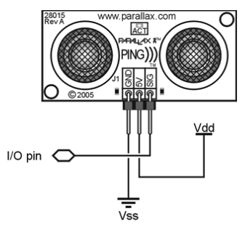
The transducer has a range of 2cm up to 3m (which is all that is needed for what it is designed for) it also requires 3-5 volts of voltage (due to only powering the transducer and the microcontroller part of the device). The transducer is also using TTL (transistor-transistor logic) for the pulse itself.
Image from the website of the transducer module itself. Showing the differences of the three pins (where one is for grounding the signal, one is for the five-volt input voltage and the last one is the signal itself (I/O pin coming from the microcontroller) As this is a module it allows the use of both transmitter and transceiver (where other such transducers can be separate) The module fits easily into a solderless breadboard or can be easily soldered onto a printed circuit board.

[7]

Similar products on the market currently
This section of the research covers the different products that are already made and currently for sale. The products are noted below with a final table to compare each one found.
60ft Ultrasonic Tape Measure with Laser: [8]

Not much is said about this device, comparing it to the specifications of the project at least. This device uses a laser guider which allows extra aid when measuring the distance (where the project device does not include a laser) where the project device has a limit of 3m this already for sale device has a limit of 60 feet (due to have the aid from the laser) The LCD display is backlit meaning it can be used in darker areas (the project device does not include this), however it uses the same 40KHz ultrasound signal. Unlike the project the device uses a 9V battery meaning it needs more than the device being created (which uses 5V) this extra power is more than likely needed for the laser and the backlit LCD screen. The price of the item is around £12 which is a reasonable amount for the amount it can do.
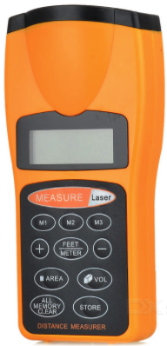

Image of the device itself, where it has a plethora of buttons to allow different distances (which can be seen as feet and meter with plus and minus buttons to accompany it)

[8]

Ultrasonic Distance Meter with Laser Pointer: [9]

This device is like the last in the sense in that it includes a laser pointer however this device is slightly different for example has a different limit it can perform this time it can perform up to 50 feet (which is less than the last device by 10 feet) however this device has the same LCD screen except this one isn’t backlit (which makes it more difficult to use in darker places). Like the last device it uses the same 40KHz ultrasound signal to perform (with the help of the laser).
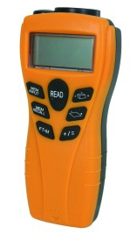

Image of the device itself, similar in looks to the last one however the buttons implemented on the device have different uses, these are changing metric and imperial units, calculating squared and cubed numbers (when it gets the distance) and including a “Mem” button to memorise the last distance found.

[9]

Out of all the devices this one is the most basic however it is the cheapest out of the ones that were found overall.

Titan MK715 Laser Distance Measurer: [10]
Again, this device performs similarly to the last two shown however it does have differences for example the performing limit is at 15m (which is a lot less than the previous two, being 60 feet against 15m which is around 49 feet). The device includes a different kind of screen having a colourised backlit LCD which is slightly larger than the previous devices. The device is powered by 2 AAA batteries (which is around 3v) a huge amount less than the previous devices and slightly less than the project device. The device still uses a laser and the same 40KHz ultrasound signal like the last devices.
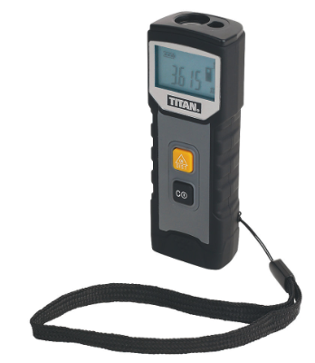
Image of the device itself, has a different style to the other devices previously for example it is a different colour and has a slight thinner and smaller build to it. The device only includes two buttons (on and reset) which is a difference to the last ones shown. As it can’t convert numbers or change the unit of measurement like some of the other unit’s out there.

[10]

Device | Performing Distance | Power Consumed | Laser included for aid? | Ultrasound limit | Price
Project Device | 3m (or around 9.8 feet) | 5V | No | 40KHz | N/A
60ft Ultrasonic Tape Measure with Laser | 60 feet | 9V | Yes | 40KHz | £11.38
Ultrasonic Distance Meter with Laser Pointer | 50 feet | 9V | Yes | 40KHz | £9.99
Titan MK715 Laser Distance Measurer | 15m (or around 49 feet) | Around 3V | Yes | 40KHz | £19.99
This is a table comparing each of the devices found online against the device being created for this project. Prices, distance and other such subjects are compared to check which would be the best to use. From looking the second device found would be the best to purchase (if needed be) due to have a useful distance and it is the cheapest out of the three (however this is comparing if one were to purchase a device). From looking at the said devices they are indeed quite like the project creation, they all have the same 40KHz signal and similar distances. The project being less due to the module.

Online Journals
In this sub-section of the report the journals (and other such published information) that were found online (such as using the university’s library online search engine) are read and the information gathered from such will be shown below:

Development of ultrasonic standard transducers in the frequency range 1 MHz - 10 MHz [11]
From reading this specific journal (created in 1986) it can be seen transducers have changed over the years (compared to the type being used in the project) the changes are known as:
In the first iteration of transducer prototypes, the component quartz discs were supported by three small noses on the end, there was a gap between the quartz disc and the housing being sealed by a casting resin. This iteration of transducer was unsuccessful. The sealing wasn’t robust and when the investigation of the radiated sound field was taken the holographic interferometry revealed a disturbance of the rotational field symmetry (this was due to the three noses that were added originally)
In the second iteration of transducer prototypes, the problem from the last iteration was solved in a better way. The Quartz discs had a special type of electrode configuration (known as "coaxial") these were then used. This allowed a stronger connection between the housing and the disc itself and allowed a better vibration decoupling. Because of the design of the electrode the vibration is restricted to the disc's central part.
In this design, the rear electrode is surrounded by an electrode ring which is wrapped around the rim of the quartz disc. Hence, the ring is at the same electric potential as the front electrode of the device. The disc can be firmly supported by means of a clamp of circular symmetry in the rim zone.
This generations iteration has three types of transducer which differs in the gap width between the rear, inner electrode and the electrode ring. The sound field as investigated by holographic interferometry exhibited better symmetry compared to the last iterations of transducers over the years. The transducer with the largest gap width, namely 2.5 mm, having the highest Q factors, particularly in the overtones.
This above online journal shows that the said internals of different types of transducers have seemingly changed over the last few decades (from around the 1970’s until now), the transducer being used in the project is like the above however the material the transducer is made from is silicone.

Design & Development of Smart Ultrasonic Distance Measuring Device [12]
This journal that has been found (created in the Department of ECE MVN University situated in Haryana, India) has the same experimental project as this project in question. They are creating a distance measurement device using a similar ultrasonic transducer module with a 7-segment display showing the distance.
The different sections of this journal (that have been noted) are shown below:
Transmitter
The transmitter consists of a transistor which amplifies the 40KHz pulse generated by the microcontroller (in the project being created a PIC 16F887 is used). The ultrasonic transducer which is used as a transmitter is being driven by a specific inverting buffer. A set of three parallel inverters are used to increase the transmitted power needed to drive the device in question. “The output of this set of parallel inverters are given as input to another set of parallel inverters. The output of both parallel inverters is given as input to the two terminals of the ultrasonic transducer at the transmitting end. One of the input given to the terminal of the transducer is the positive going pulse and the other terminal is given 180 phase shift of the same input.” This is done to increase the transmitted power. Thus, the ultrasonic transducer at the transmitting end generates a 40KHz pulse which hits the target receives to the transceiver to be converted.
Transceiver
The reflected signal from the target is picked up by the transceiver. The signal received by the transceiver is very weak and is amplified through various stages of amplifier (in the case of this project being created the amplifier circuit is implemented onto the PING 28015 module). The output of the amplifier is filtered and then given to a specific pin of the microcontroller (in the case of this academic exercise the pin used for output is pin 14 (or RA6) which is an analogue comparator, pin 13 (or RA7) is another terminal of the microcontroller to have a similar output. For displaying a digit on segment display the microcontroller provides segment data using complex code and display enable signal in a time multiplexed mode. A switch is used here to reset the microcontroller which drives the reset signal through a set of capacitor and resistor. The arrival of the signal from the target makes the microcontroller high which is sensed by the microcontroller. “Hence the timer is read and the 16-bit number is divided from the velocity of sound to obtain the four-digit number. This four-digit number is displayed on the seven-segment display which indicates the distance of target. sound to obtain the four-digit number. This four-digit number is displayed on the seven-segment display which indicates the distance of target.”

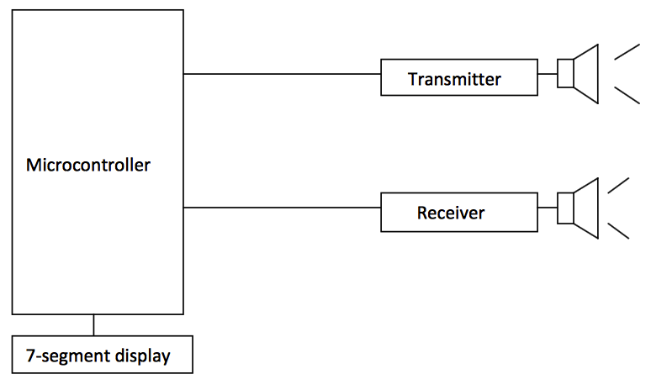
From reading the journal a basic schematic diagram was found this diagram shows how the device will perform by displaying that the transmitter and receiver are connected to the microcontroller (with each having their own pin, where the device being created in this project will have three pins one for signal, and the others for power and ground as seen earlier) with an output (the 7-segment display) where the distance will be shown (in centimetres.) [12]
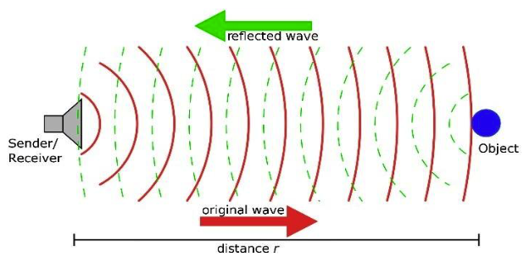
Basic understanding of how the transducer performs showing how the original ultrasound signal or “ultrasound wave” reflects off an object and becomes “reflected wave” which then gets received by the transceiver which will be converted using the microcontroller by using code from Proteus.. [12]

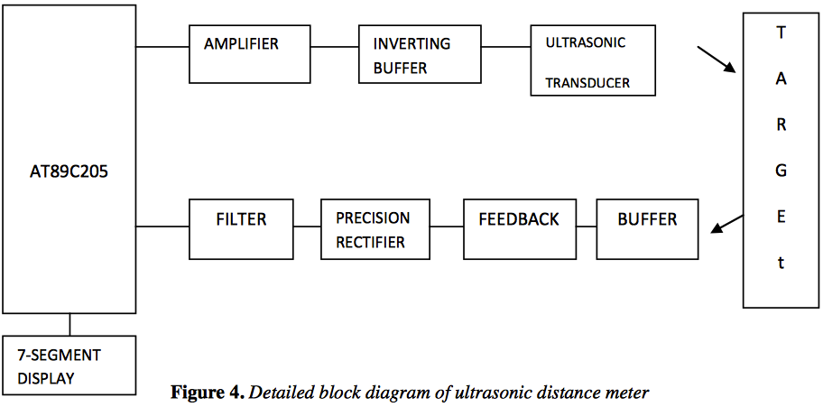
Block diagram showing how the device will perform where the microcontroller (in this case it’s known as an AT89C205) will first send a signal through the amplifier then through an inverting buffer (due to the signal loss) which will get sent through the transducer to reflect off the target to be received firstly through the buffer which then will go through the feedback loop and precision rectifier. After all this the signal, will go through a filter (as after the received signal is returned there is a huge loss on the signal so it needs boosting). The signal then gets sent back to the microcontroller which will convert the time taken to receive into the unit of measurement (in this case they used centimetres) this will be displayed on the LCD. [12]
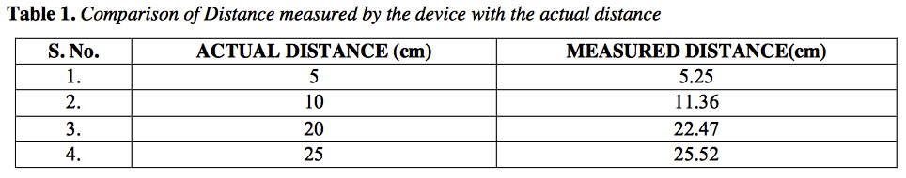
This table above shows the project they had created has been a marginal success. This is due to not having an exact distance (as can be seen above from 5cm the measured distance is 5.25cm) this is normal for a “home-made” device as an exact distance cannot be found due to the loss in signal previously. This makes the project a success as the measured distances are give or take very like the intended amount. [12]
This journal has the most information needed to aid in the creation in the project as it is almost identical to what is intended out of this project (the only differences are slight component changes like the microcontroller and the transducer itself as they use single transducers which would mean they need extra components on the device as filters etc aren’t included with the transducers like the one being used in this project.
The journal’s project was low cost compared to buying a device that does it all for you, however a device being purchased may have a better leniency towards getting the correct value.

Interfacing PIC Microcontrollers [13]
This journal has been found where it gives information on PIC microcontrollers. The information found is shown below:
“PIC Software is stored in non-volatile memory. The source code is written on a PC host using a text editor or the edit window in MPLAB (the standard development system), assembled and downloaded to the chip. The entry-level development system hardware normally used until recently consists of a host PC and programing unit, connected via a serial link. The PC runs MPLAB, and when the program is written and assembled, it is downloaded by placing the chip in programing unit connected to a PC COM (RS232) port. The chip is programed via pins RB6 (clock) and RB7 (data). The programing unit supplied by Microchip is called PICSTART Plus. It has a zero-insertion force socket in which the chip is placed, and contains another PIC within to handle the programing. The firmware in the programmer control chip can be updated in line with the updates of the development system itself, because new microcontroller unit (MCU) types are added continuously to the range.” – Journal Publisher Summary at the top of the page.

The above statement gives information on how to create and implement the software onto the pic microcontroller. The method is very similar to how the device will be created for the project MPLAB isn’t used however Proteus is used instead (being a similar software) To implement the software onto the PIC CCS compiler is used using the same PIC Start Plus peripheral where the microcontroller is placed and the source code is added.

Microcontrollers contain all the components required for a processor system all in the same place, The CPU (central processing unit), memory (RAM), and input/output (I/O) are all included in the same PIC microcontroller. A device therefore can be built using one microcontroller and a few other components such as displays and other interfacing circuits (such as filters or amplifiers for example).

Microcontrollers are known to be complex meaning observation is hugely necessary in the way the hardware and software (from the CCS compiler) perform together. All microcontrollers work in a similar way meaning all Microcontrollers need the same amount of care. For example, slight changes in code will completely stop the device from performing, if too much voltage is put through the PIC (most require around five volts) the PIC will completely burn out and will be dead. “The PIC 16F877 has a good range of features and that allows most of the essential techniques to be explained”. The PIC has a set of serial ports (SPI Ports) built in that are used to transfer data to and from other devices, as well as analogue inputs.

The microcontroller only provides a limited amount of current: about 20 mA in the case of PIC, and even less for standard microprocessor ports. Therefore, to drive an output device that needs more current than the above current, a specific amplifier or switch will be required. From this, current drivers and switches that can be purchased today are derived from the same semi-conductor technology that is the basis of the transistor being used.

Prototype Development and Implementation
This section of the report is where the design of the device is shown, such as the design using Proteus where a simulation of the device can be created where the components connect to the microcontroller and the other such parts of the device, also the diagrams and charts that aid in creating the device are shown. The different aspects of the design are as follows:

Block Diagram
This subsection of the report is where the block diagram that’s created for aid of designing the device itself, the diagram will show how the device will intend to perform. The diagram is shown below:
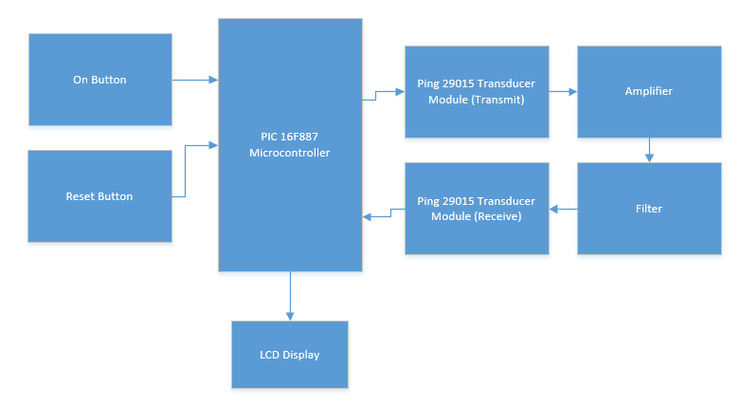
As can be seen the on button and reset button connect to the microcontroller, as they require code from the microcontroller to perform. The PIC sends signal to the transducer firstly for the transmitter which goes through an amplifier (which is part of the module itself), once this happens the signal will get received (providing it rebounds from an obstacle) which will go through a filter (again in the module) the signal will need to be filtered in order to convert the sound into voltage. The received signal then gets sent back to the pic which initiates the LCD display (using the same code from before) to display the measurement intended. This is how the device is intended to perform by using the components included.

Flow Chart
This subsection of the report is where the flow chart that is created for the aid in designing the project device. The chart explains how the device will perform using the specific method of flow charts. The flow chart is explained below:
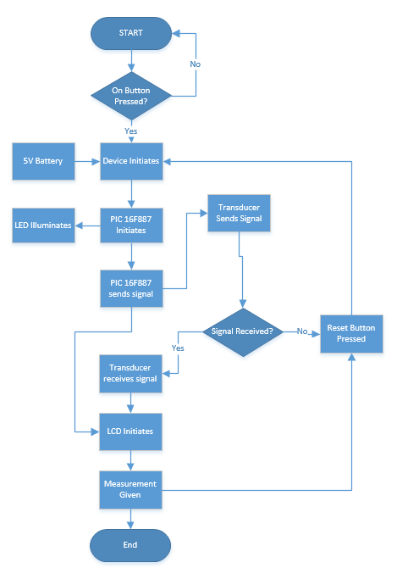

As above the flow chart for the device is shown, it works by the following structure:
- On button pressed, where if the user chooses not to press the on button then the chart restarts as nothing has happened. If the user presses the on button the device initiates.
- A 5V battery is added to the device as it needs power to perform as intended, after which the PIC microcontroller initiates. Which makes the LED illuminate (to show the user the device has initiated).
- The PIC sends a signal to the transducer which once happens the transducer sends a signal. If the signal has been received (bounced off an obstacle and received by the transducer) then transducer has received the signal. If the signal hasn’t been received, then the reset button is pressed which resets the device and re-initiates.
- Once the LCD has been initiated the measurement is given (in centimetres) which will be like the actual distance. Once this has been done the user will press the reset button and start again. This also ends the process and the flow chart ends.

Labcenter Proteus
This subsection of the report is where the design of the device (schematic diagram) is created and shown with each iteration of the design being shown and explained. The beauty of this software is that a huge number of different components are included (with even the allowance of creating slight versions of components that aren’t part of the software (as is seen in the designs), also the software allows complete simulation of the circuits that are created meaning the device created can be checked before being made physically. The designs from Proteus (in the different updated versions it is in) are shown in full below:
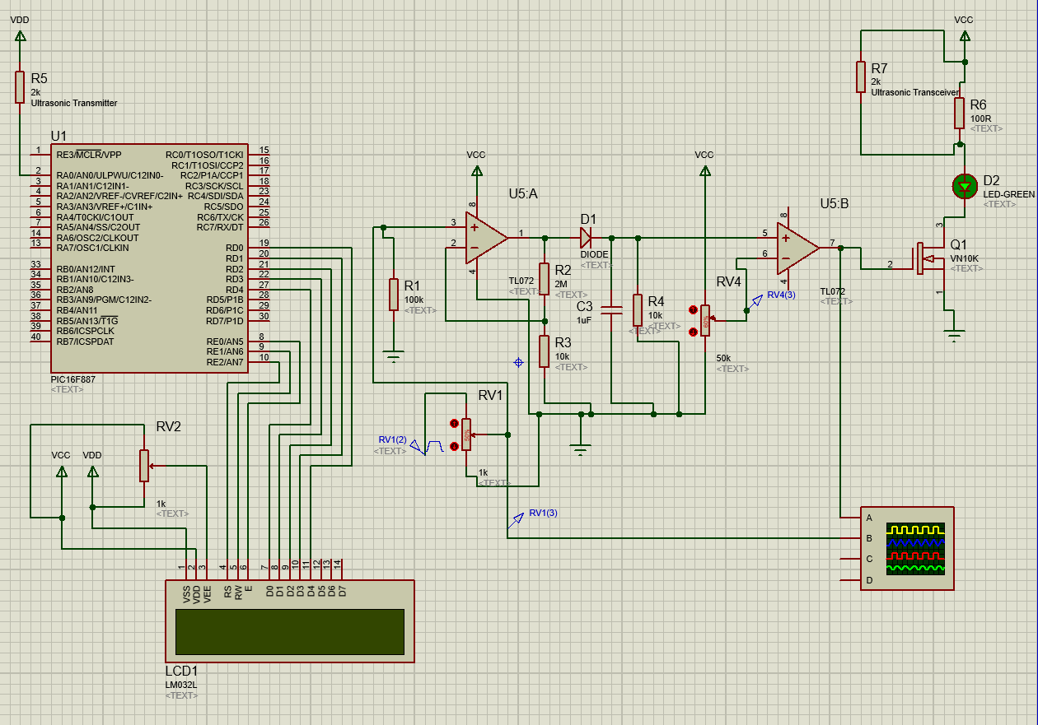
Original Circuit (October 2016 – December 2016)

The original circuit is shown above, where the transducers are separate and the circuit itself (where the amplifiers and filters are also separate (this is due to the amplifier circuit being a circuit with regular resistors and capacitors etc and the transducers being separate components as said). It also has other components needed for the device to perform correctly.

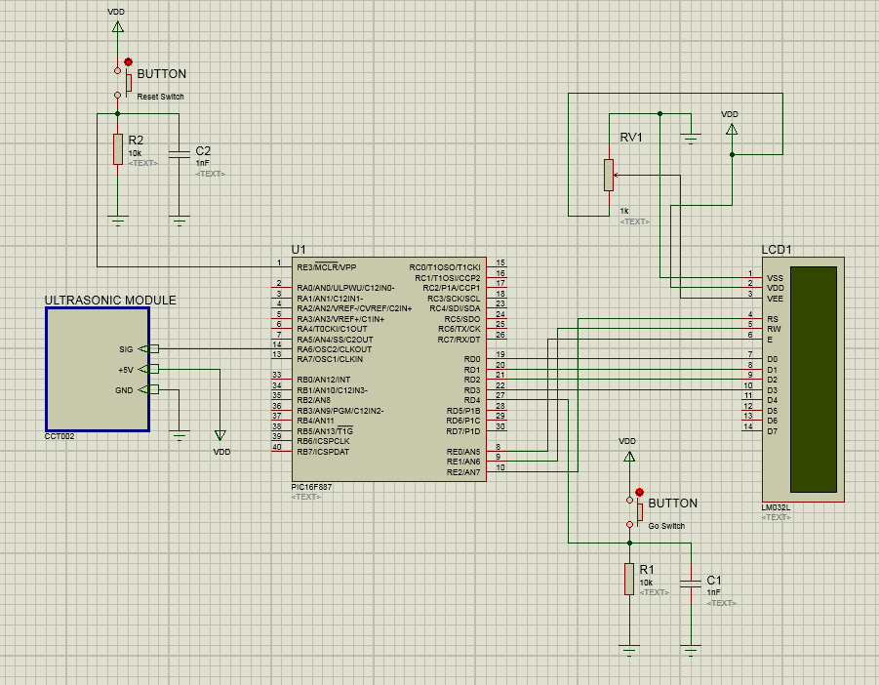
Updated Circuit (December 2016 – January 2017)

The circuit has been updated in the sense that the circuit has been completely removed and has all been added by changing the separate transducers to a transducer module (which includes a micro amplifier and filter to do the entire process of the removed circuit for a huge fraction of the size which allows more room for the circuit once it has been created fully. It’s also more simple to create and better to use).

More Updated Circuit (January 2017 – March 2017)
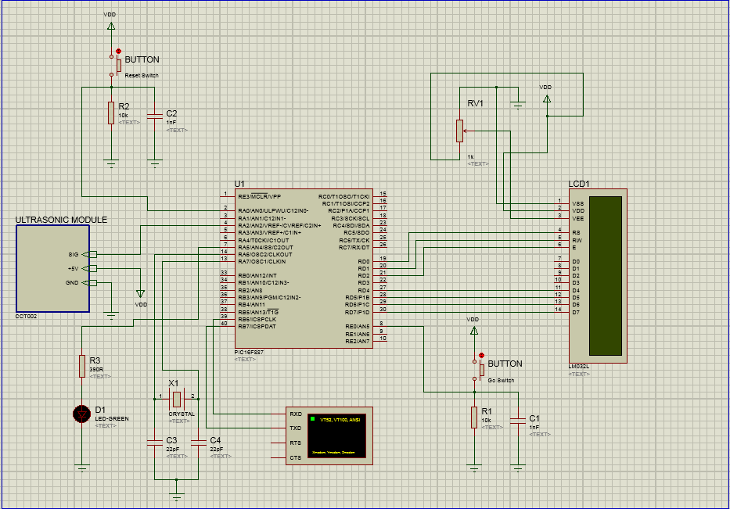
This circuit is the same as the above updated circuit however the PIC microcontroller requires a clock to perform, so a quartz crystal clock is added to allow the use of the clock for the PIC. The LED is also added to allow the user to know the entire device has initialised.

Project Testing and Results
In this section of the report the testing of the device that was created for the project is written, this testing section will include:
- Photos of the device itself showing the components in the right place on the bread board (being in the same place as the Proteus simulation)
- Testing proof that the device performs as intended (with correct measurements where the correct measurement will be compared with the device measurement to see if there is much of a difference and if the project is a complete success (opposed to being similar but not the exact values)
- The results of each test will be charted in a table for comparison reasons.

Project Photo’s
This subsection is where the photos taken of the created device on a breadboard. Each of the photos taken are below:

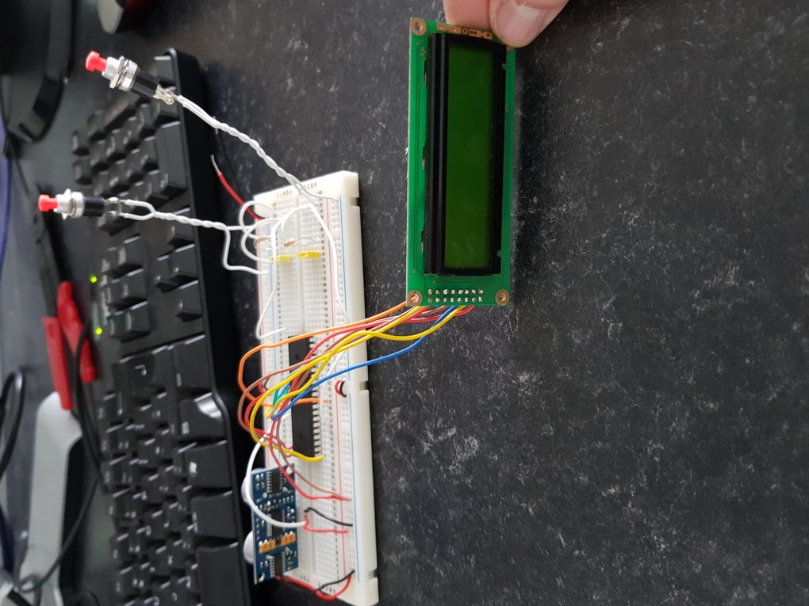
Image of the device taken (from the front) where the LCD screen can be seen connected to the PIC 16F877 microcontroller using the pins D0 to D7 (using 8 wires) these are digital pins that allow the PIC to send digital signals to the LCD. The rear of the Ping 28015 ultrasound module can also be seen where the filters and amplifiers (in tiny form) for the circuit are located.
At this point the device is unconnected to power.

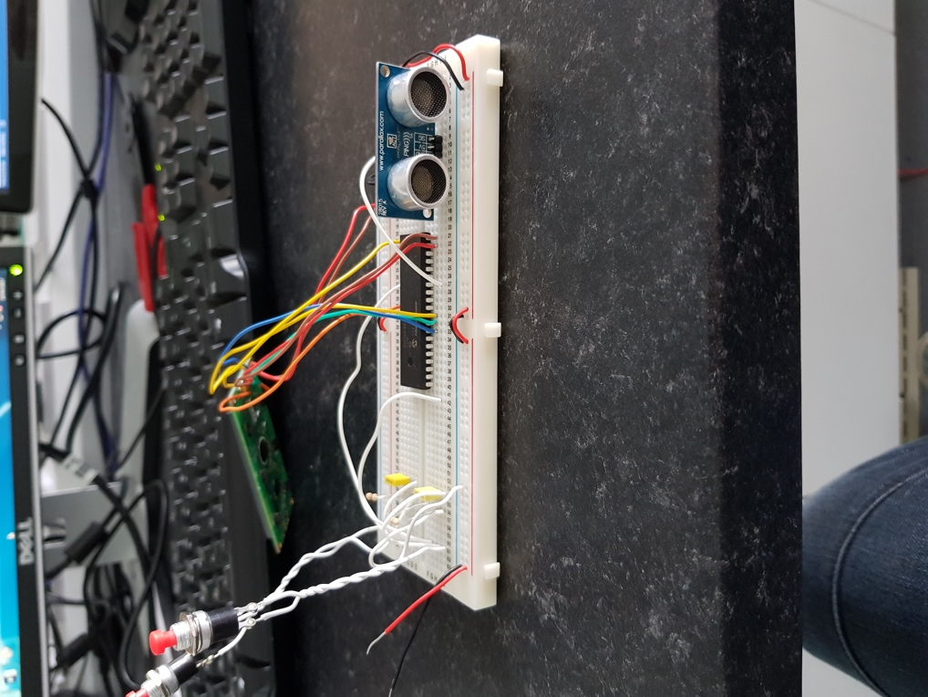
Rear view of the device where the main component can be seen, the Ping 28015 ultrasonic transducer module, where the transmitter and transducer (the main component besides the microcontroller) is located. The transmitter and transceiver are either side of each other and will transmit the signal in a cone like direction towards an obstacle where the signal will be received and converted through the PIC 16F887 and will display on the LCD display. The power and ground cables for the device are also located at the lower left of the breadboard.

A more zoomed in look at the ultrasonic transducer module, where the company name and website are shown with the product name. The three pins that are connected to the breadboard are seen on the photo are as follows:
- GND – where the component will need to be grounded (the ground on this has a wire connected to the ground rail on the bread board.
- 5V – the power wire, where the device takes in power. In this case the pin is connected to a wire which connects to the bread board’s power rail.
- SIG – The signal pin, this pin is where the signal (in both output signal and input signal) connects to the device. The pin connects to a wire which connects to the A2 pin on the PIC 16F887.
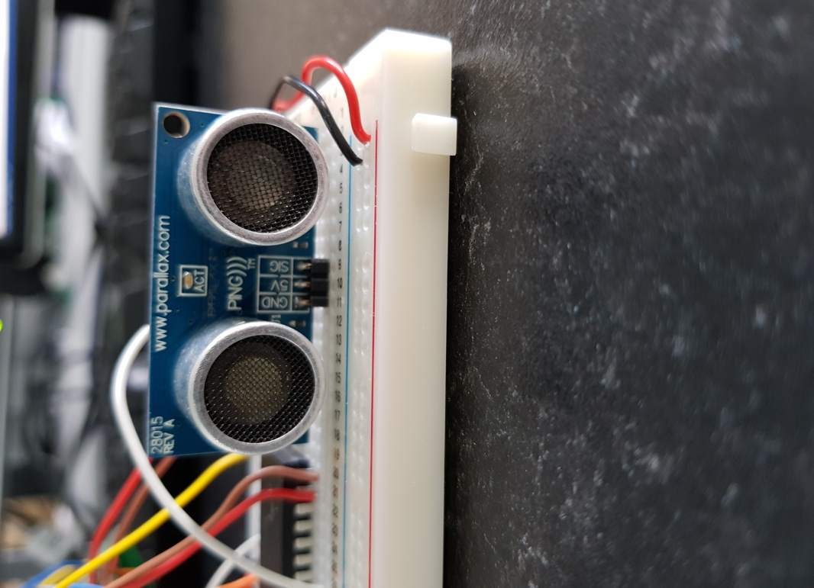

A close-up image of the PIC 16F887 where the name can be seen (along with the company logo stamped on the bottom). As can be seen many wires are connected to it these are from the LCD screen, where each wire is needed for different purposes for the LCD such as, the data used to display the measurement. The other wires that can be seen are the power and ground wires (from the power and ground rails on the bread board) and the other wire is the one that connects to the ultrasonic transducer module which is the wire that sends the data from the PIC to the module itself.
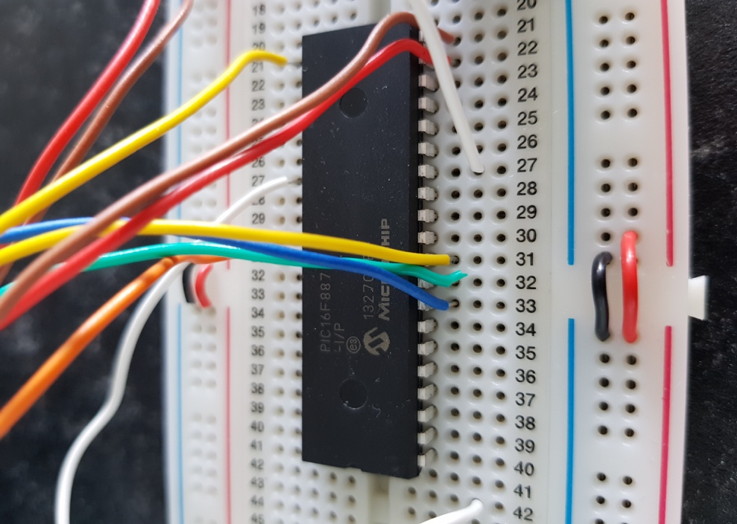

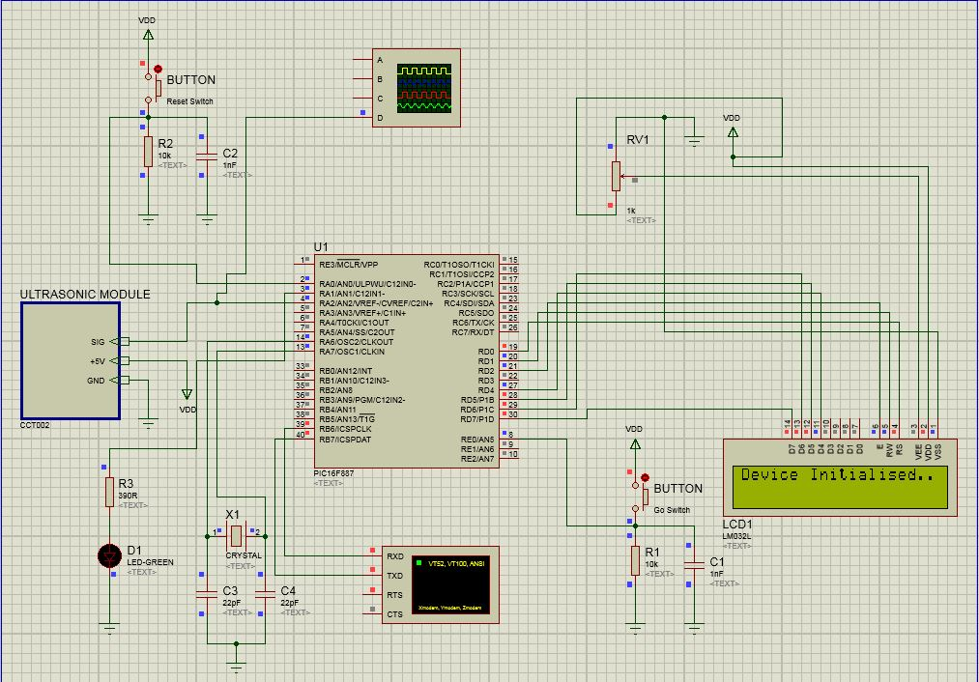

Screenshot of the device on Proteus where the LCD display has been flipped to be able to read what is on the display itself (otherwise the letters look distorted) which is displaying the text “Device Initialised..” this is due to the code written onto the PIC using the CCS compiler software and Proteus (see appendix for code.) this is able to be done due to the simulation giving the device the power needed to run.
As the device wasn’t performing as it was intended (as seen in the aims and objectives above) there are no more screenshots to add on this section of the report.

Evaluation on the project
Overall the project was partially successful, the device was designed on Proteus and created using specific components. The project research aided with the project, for example there was a similar project that gave great ideas that helped in the creation of the design.
The research that was found online and in journals etc was useful in creating this project, each of the subjects that needed research were found and aided towards the creation of the circuit design and eventually the fully created prototype.
The objectives were partially met as the device was created but not performing as correctly as it should. The device was created on Proteus and then the components were added onto a breadboard however, the program code was incorrect in some way as the device couldn’t send out the signal as intended, the only thing the device could do was alert the user it has initialised.
The aim was also not met as the device wasn’t fully created as intended to be, if more time had been given the device would have been fully created.
In future if possible the device would be created as intended where it can perform by pressing a button and receiving a signal and reset by also pressing a separate button however also have added improvements such as:
- A button that allows the user to change the unit of measurement for the user (change from centimetres to inches etc.)
- Rechargeable battery where the user can charge the device to be able to use it wherever they need it.
- A suitable case would be a useful addition to allow the user to have the device in a well defended place which would be comfortable to hold and have an eye-catching look to make it user friendly.
If possible these improvements would be added to the device if enough time was given. Unlike the devices found online which don’t feature the button to change the unit of measurement or rechargeable batteries (the ones found online only featured regular batteries which is costly)

Conclusion

In conclusion, the project was unsuccessful due to the device not performing as it was intended to, however the device did have some amount of use where if given power the LCD would tell the user that it has initialised. If more time was possible the device may had been fully created and performing as intended. The research that was found had a huge impact on creating the prototype itself (on both simulation and physical) as the different subjects that were found online were exactly what was needed to create this device.
The code used was written for the project device to perform was written incorrectly using Proteus as the device hadn’t sent out the 40 KHz signal or receive it. This was due to the code not being written right. (this code is seen in the appendix section at a later part of the report.)

Bibliograpy

[1] | E. T. Stuff, “www.explainthatstuff.com,” 16 December 2016. [Online]. Available: http://www.explainthatstuff.com/ultrasound.html. [Accessed 09 January 2017].
[2] | C. Woodford, “Ultrasound,” 2008. [Online]. Available: http://www.explainthatstuff.com/ultrasound.html. [Accessed 12 April 2017].
[3] | Independant Hearing Professionals, “The Hearing Ranges of Animals – Which Animals Hear Best?,” [Online]. Available: http://www.myihp.co.uk/animal-hearing-ranges/. [Accessed 12 April 2017].
[4] | C. Woodford, “Piezoelectricity,” 2016 July 20. [Online]. Available: http://www.explainthatstuff.com/piezoelectricity.html. [Accessed 13 April 2017].
[5] | NIHON DEMPA KOGYO CO., LTD., “Basic principle of medical ultrasonic probes (transducer),” [Online]. Available: http://www.ndk.com/en/sensor/ultrasonic/basic02.html. [Accessed 14 April 2017].
[6] | Arduino-Info.wikispaces.com, “Understanding the Science Behind the Ultrasonic Distance Sensor,” [Online]. Available: http://arduino-info.wikispaces.com/Ultrasonic+Distance+Sensor. [Accessed 14 April 2017].
[7] | Parallax, “PING))) Ultrasonic Distance Sensor,” [Online]. Available: http://users.ece.utexas.edu/~valvano/Datasheets/PingDocs.pdf. [Accessed 14 April 2017].
[8] | DealExtreme, “60ft Ultrasonic Tape Measure With Laser,” [Online]. Available: http://www.dx.com/p/60ft-ultrasonic-tape-measure-with-laser-pointer-2153#.WPYHXhiZMb0. [Accessed 15 April 2017].
[9] | Maplin Electronics, “Ultrasonic Distance Meter with Laser Pointer,” [Online]. Available: http://www.maplin.co.uk/p/ultrasonic-distance-meter-with-laser-pointer-n70cx. [Accessed 2015 April 2017].
[10] | Screw Fix, “Titan MK715 Laser Distance Measurer,” [Online]. Available: http://www.screwfix.com/p/titan-mk715-laser-distance-measurer/5151P?kpid=5151P&cm_mmc=Google-_-Product%2520Listing%2520Ads-_-Sales%2520Tracking-_-sales%2520tracking%2520url&gclid=Cj0KEQjw8tbHBRC6rLS024qYjtEBEiQA7wIDeTkaVrslknmTT9PWMn32g-UzDJb4HMEyxbW6Vjix0GgaAoPV8P8HAQ&gclsrc=aw.ds&dclid=CKTw2ZaNrtMCFSEe0wod1MMCDw#product_additional_details_container. [Accessed 15 April 2017].
[11] | Κ. B. G. L. K. BRENDEL, “Development of ultrasonic standard transducers in the frequency range 1 MHz - 10 MHz,” Development of ultrasonic standard transducers in the frequency range 1 MHz - 10 MHz, p. 11 and 12, 1986.
[12] | M. S. D. S. K. L. Dr. Rajeev Matan, “Design & Development of Smart Ultrasonic Distance Measuring Device,” Design & Development of Smart Ultrasonic Distance Measuring Device, pp. 20-23.
[13] | M. Bates, “PIC Hardware,” 2006. [Online]. Available: http://www.sciencedirect.com/science/article/pii/B9780750680288500036. [Accessed 20 April 2017].

Appendix
This section is where the code used for the circuit is located, the code is below:
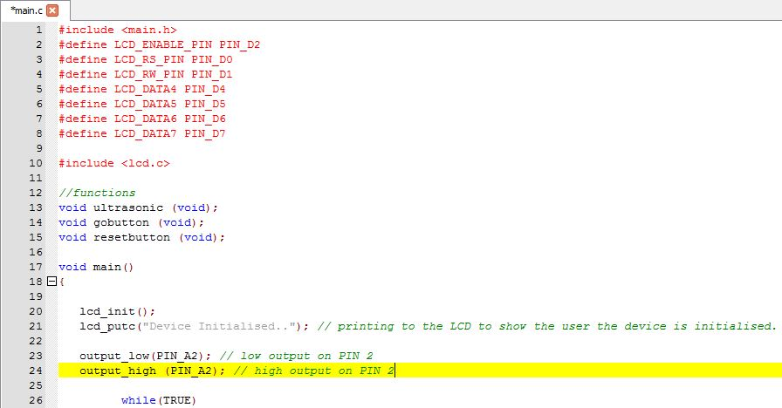
The beginning part of the code where the LCD is defined and the data pins are enabled for the LCD screen. The device will display the text “Device Initialised..” when connected to power.
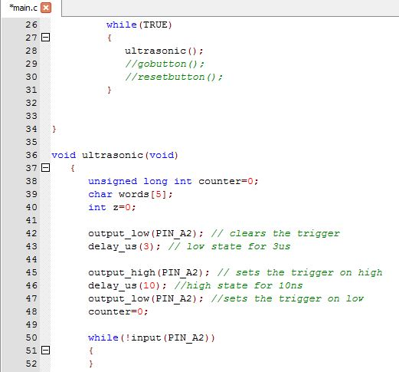
The next part of the code where the trigger is set to try and send out the ultrasound signal to be received.
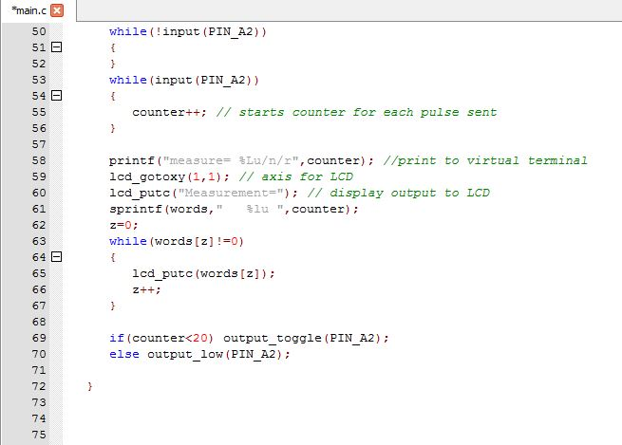
The code where the LCD display produces the measurement after the signal has been received.
Each of the lines of code that was written had an incorrect part somewhere as the code that was written on Proteus for the device was unsuccessful in having the device prove it can work properly and perform correctly as intended.

