Student Name: Ana-Maria Savulescu
Student ID no.: 2208665
Lecturer Name: Chris Wilkin



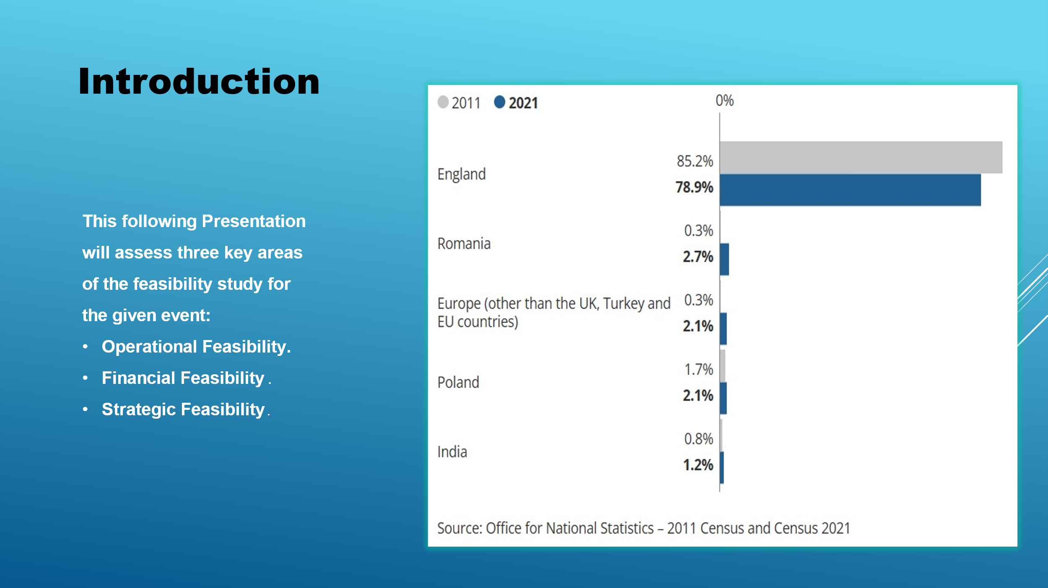
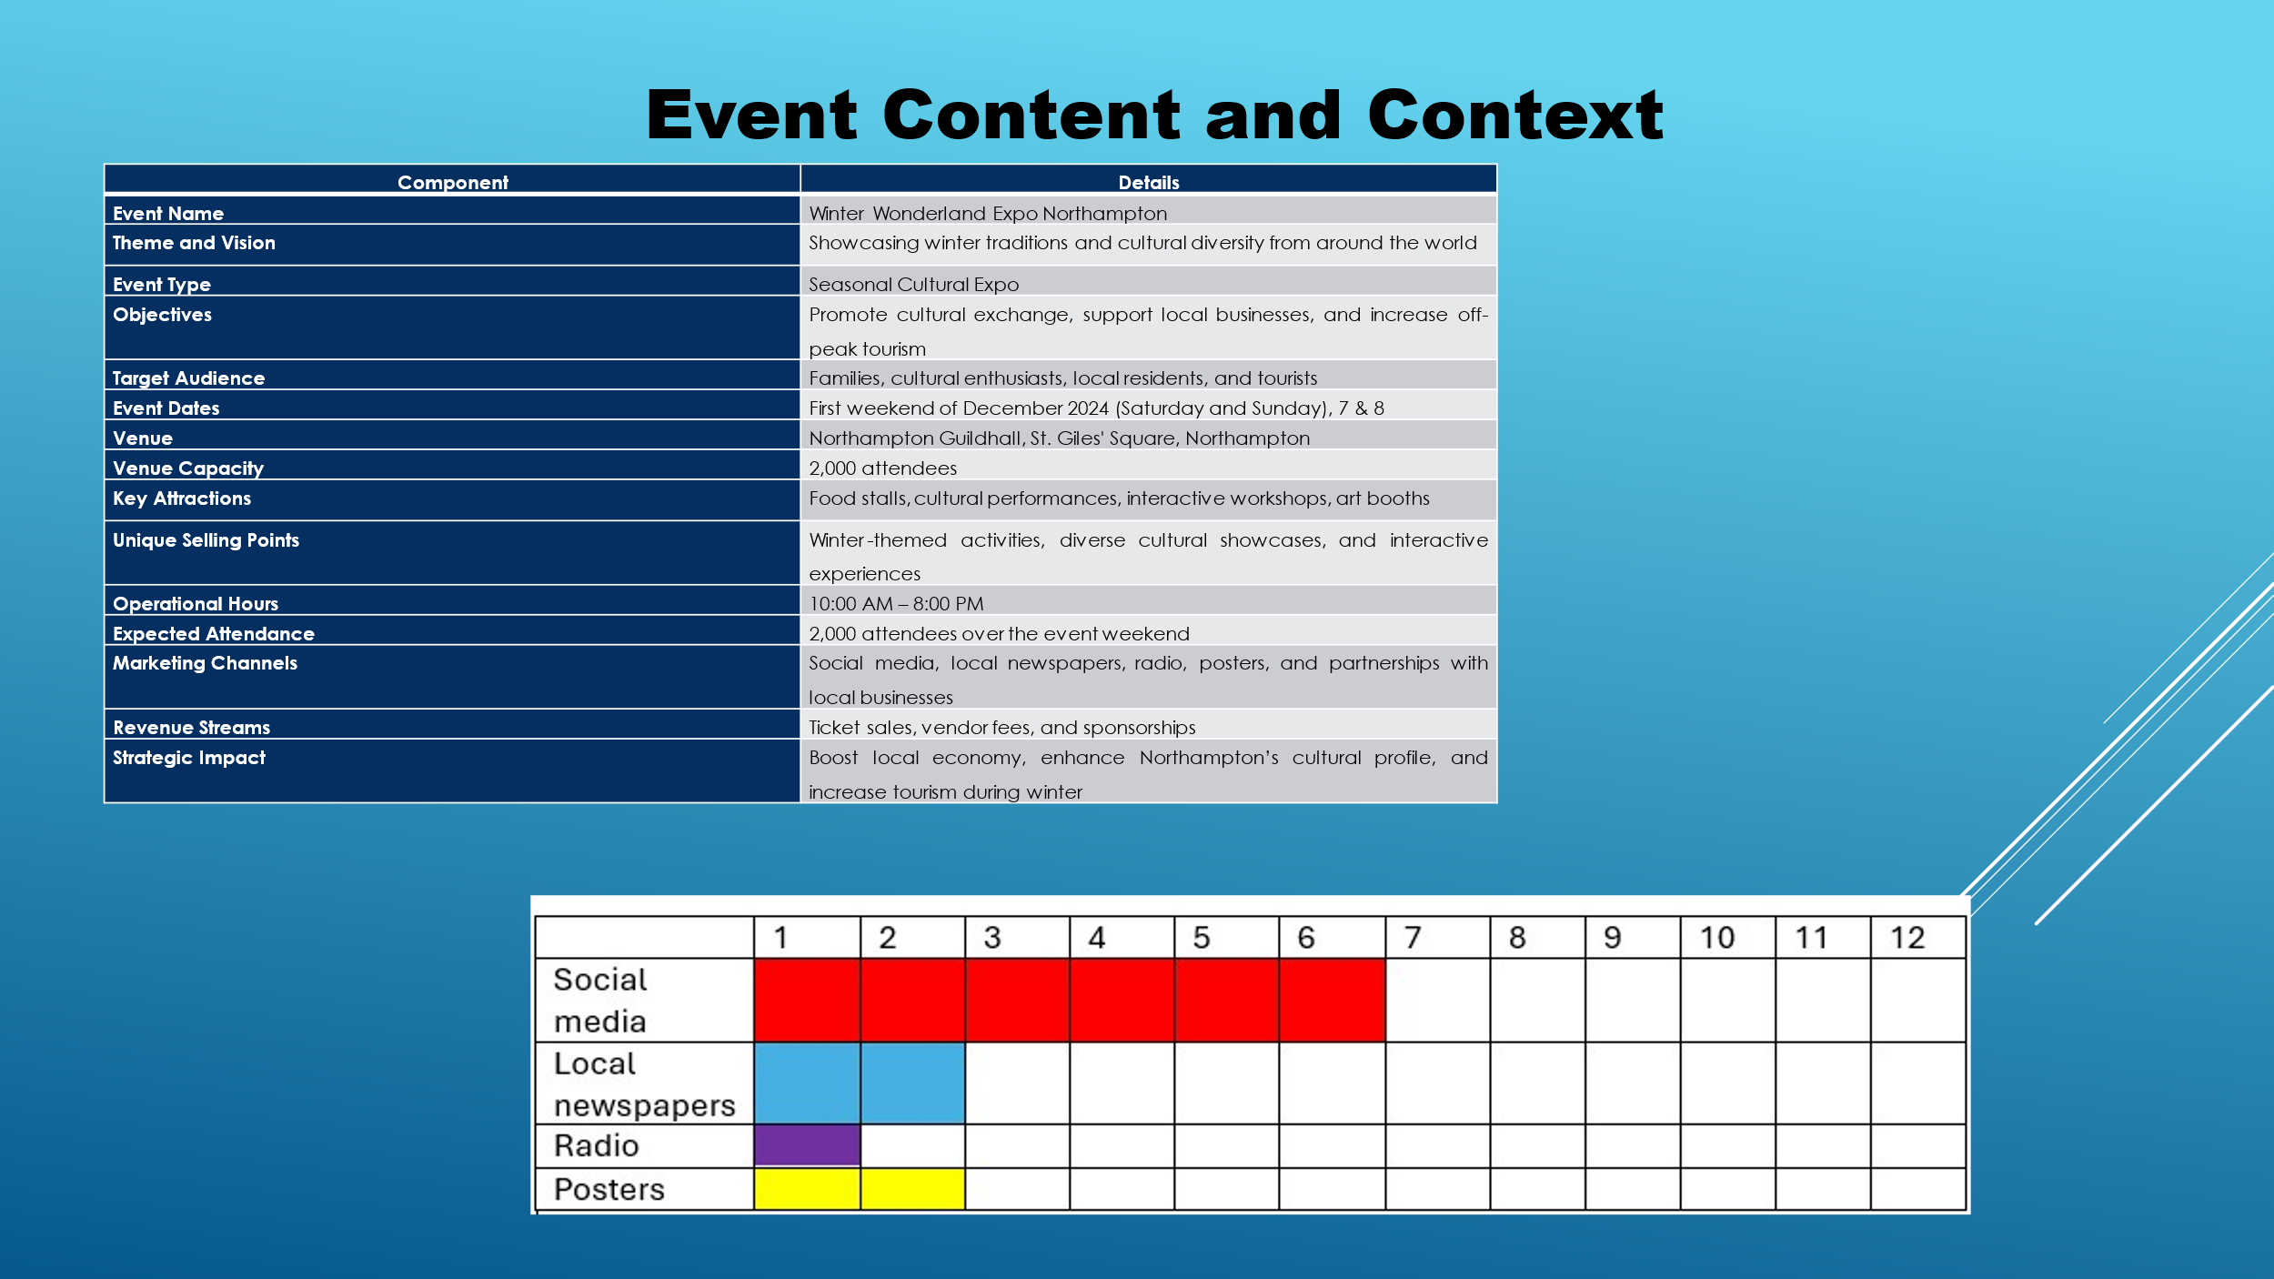

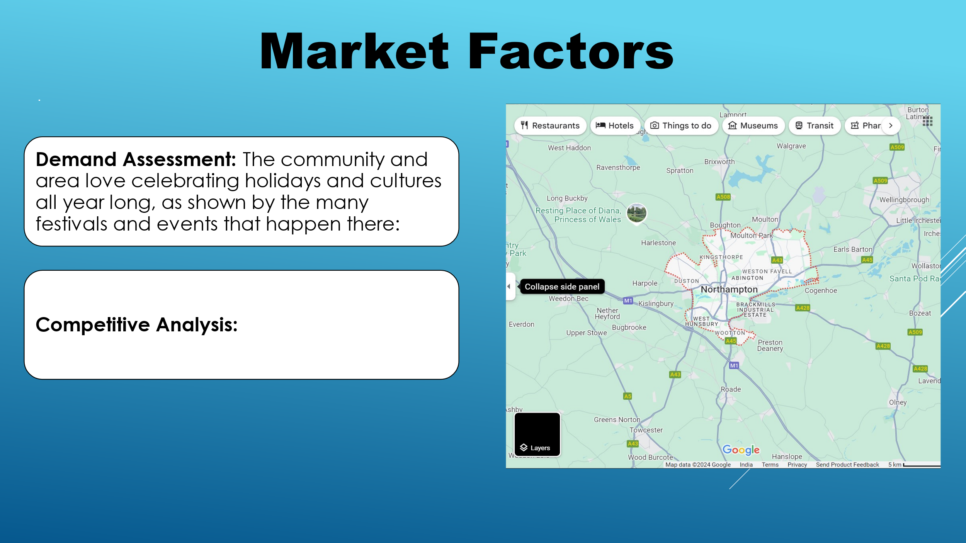
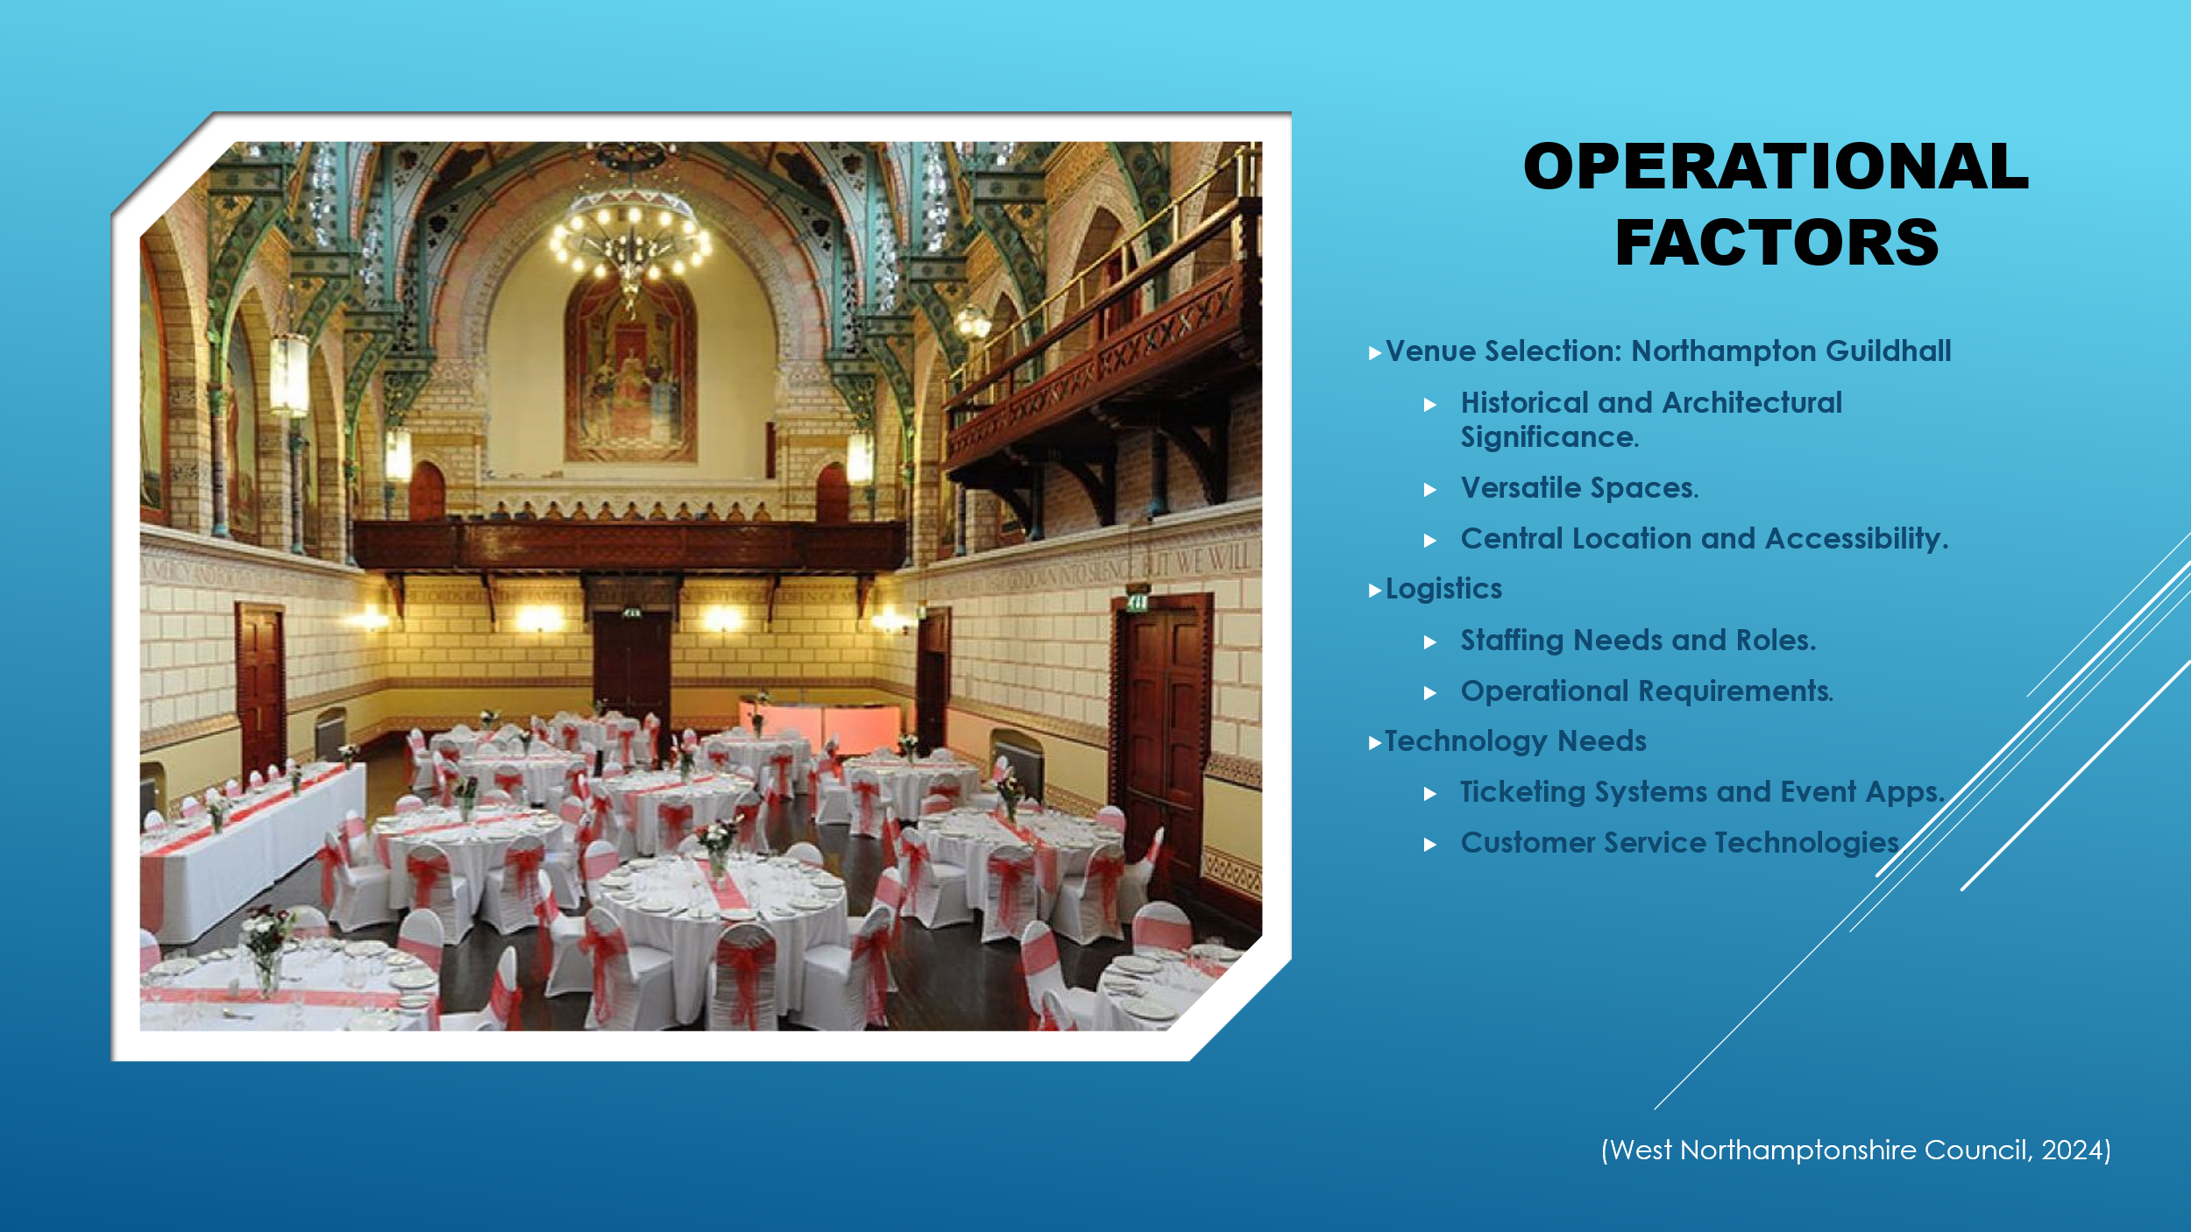

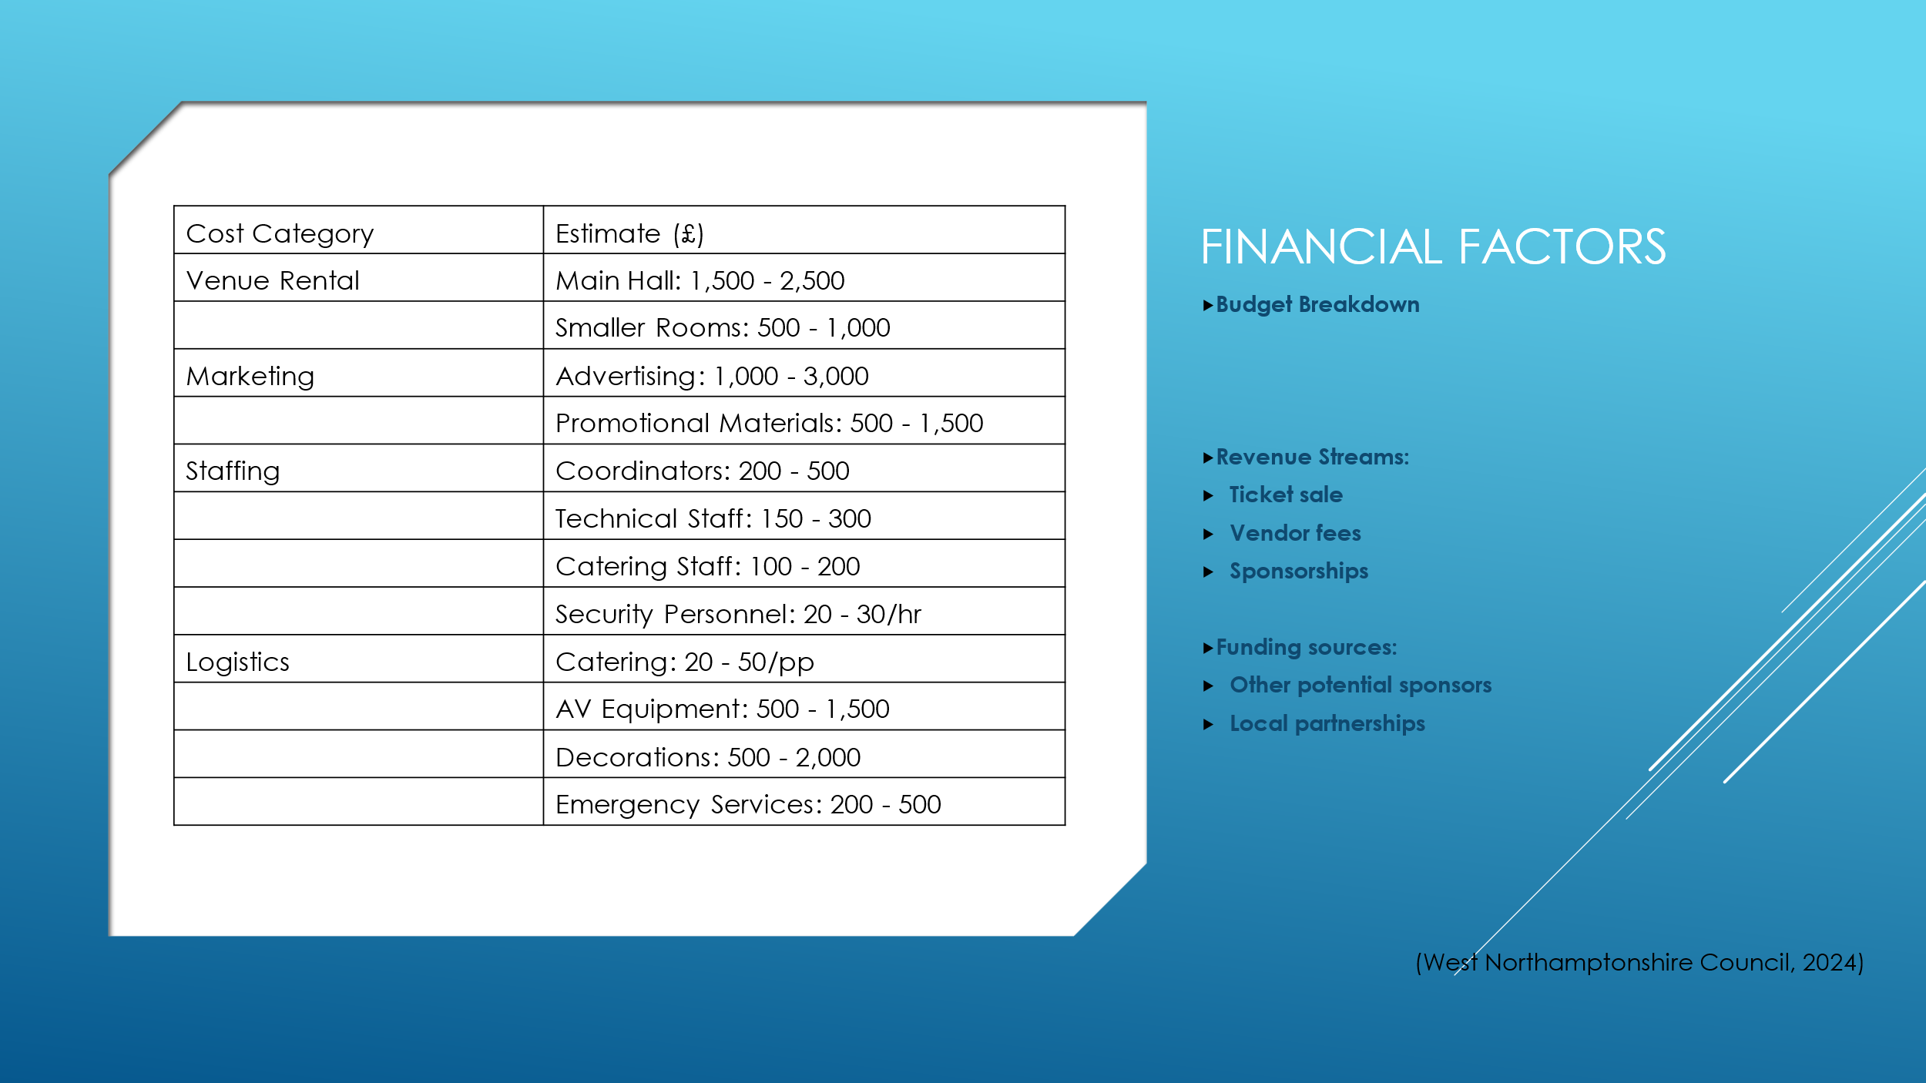
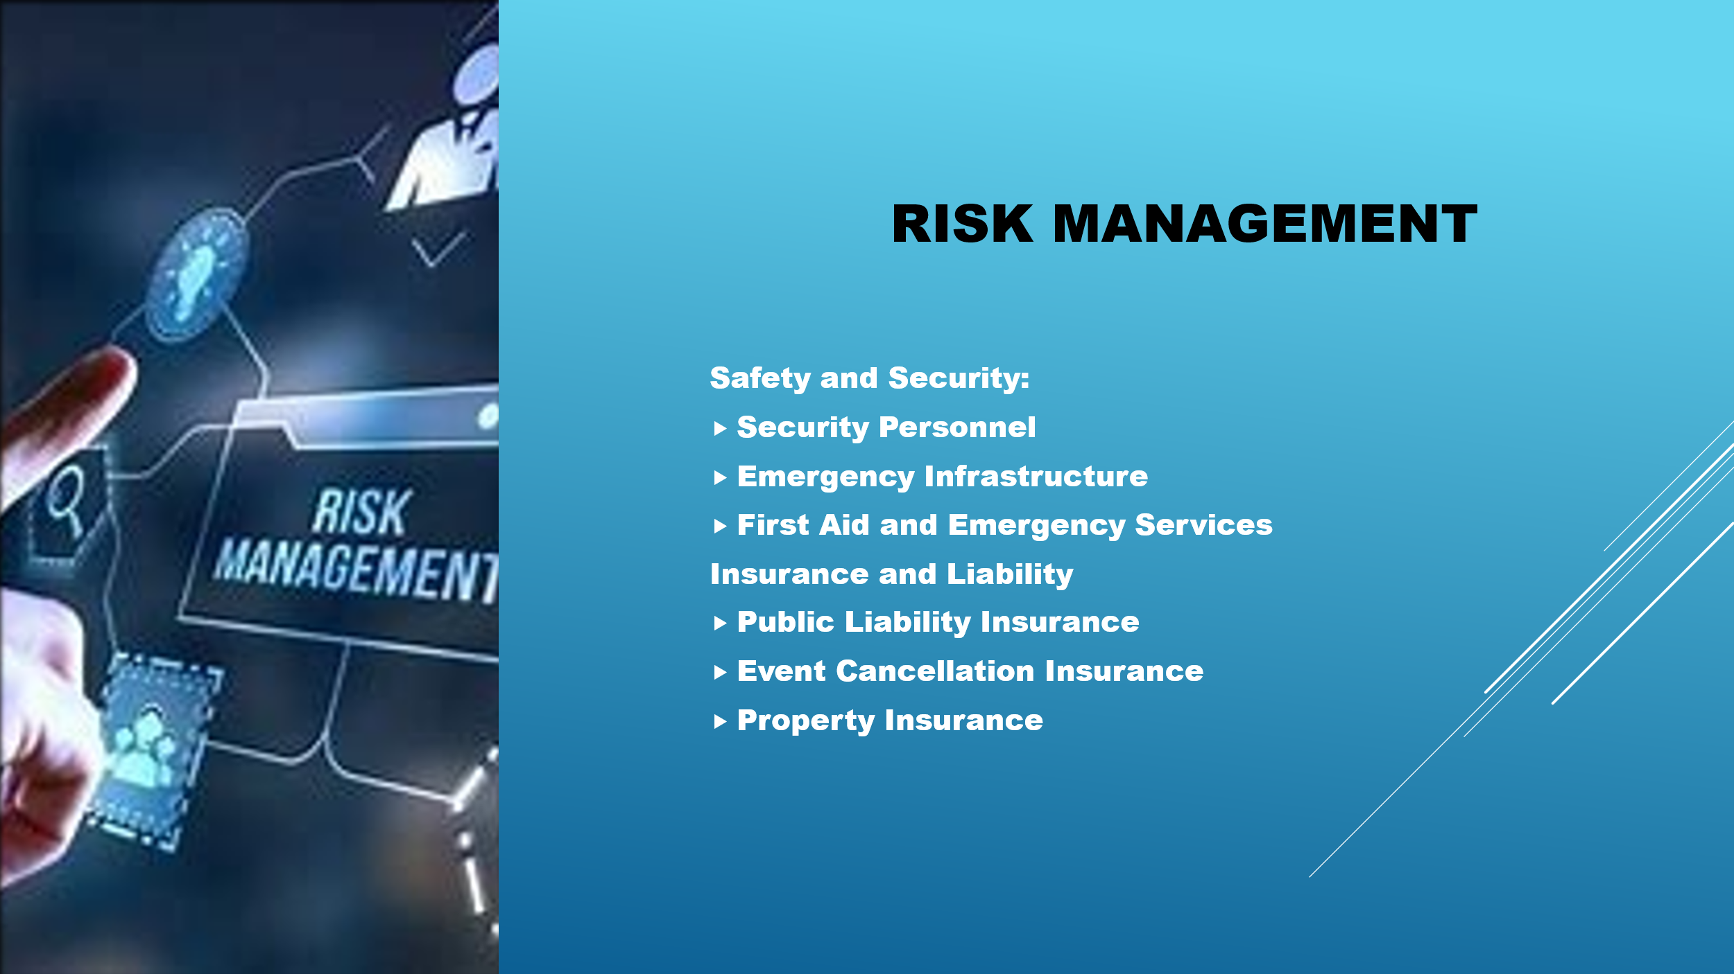





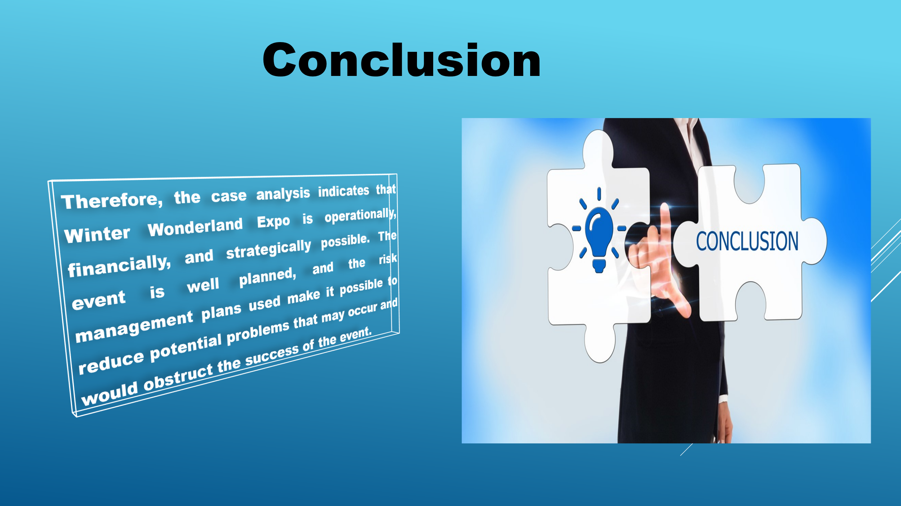

REFERENCES
Allen, J., Harris, R. and Jago, L. (2021) Festival & special event management Johnny Allen, Robert Harris, Leo Jago. Milton, QLD: John Wiley and Sons Australia.
Ansuini, T.M. (2022) Event planning: Understanding the process through gained experience and research a project in Creative Studies. Buffalo, NY: SUNY Buffalo State University.
Arif, B. et al. (2024) ‘The impact of third party funds, loan to deposit ratio and capital adequacy ratio on return on assets’, Jurnal Ilmiah Manajemen Kesatuan, 12(4), pp. 1137–1146.
BABATUNDE, B.O. et al. (2023) ‘Building Effective Marketing Partners: A tactical tool to achieve customer retention in the face of strong competitors’, Izvestiya Journal of the University of Economics – Varna, 67(3), pp. 171–181.
Bladen, C. et al. (2023) Events management: An introduction. London: Routledge, Taylor & Francis Group.
Brown, A.E. and Pappas, N. (2021) ‘Added value and music events: A festivalgoer perspective’, Annals of Leisure Research, 26(1), pp. 117–139.
Charles, J. (2020) Party & Wedding Marquees, Julia Charles Event Management. Available at: https://www.juliacharleseventmanagement.co.uk/venue-decoration-hire/marquee-hire/party-wedding-marquees/ (Accessed: 09 October 2024).
Daw, M. (2023) The Essential Intel for this year’s Winter wonderland, Evening Standard. Available at: https://www.standard.co.uk/going-out/attractions/winter-wonderland-2023-opening-times-ticket-prices-food-drink-b1124574.html (Accessed: 09 October 2024).
Eventbrite (2022) How much does it really cost to host an event?, Eventbrite Blog. Available at: https://www.eventbrite.co.uk/blog/much-really-cost-run-event-ds00/?msockid=0e91f1a3779c6f9214eee5c976576eb9 (Accessed: 09 October 2024).
Google (2024) Northampton, Google maps. Available at: https://www.google.co.uk/maps/@52.2602916,-0.9338222,10z?entry=ttu&g_ep=EgoyMDI0MTAwNS4yIKXMDSoASAFQAw%3D%3D (Accessed: 09 October 2024).
Irawan, N. et al. (2022) ‘Environmental management and stakeholder roles in Sustainable Tourism Development: A feasibility study’, IOP Conference Series: Earth and Environmental Science, 1108(1), p. 012068.
Kharouf, H. et al. (2020) ‘Understanding online event experience: The importance of communication, engagement and interaction’, Journal of Business Research, 121, pp. 735–746.
Keywave Media Solutions (2024) What’s on in and around Northamptonshire, Visit Northamptonshire in the heart of the UK. Available at: https://visitnorthamptonshire.co.uk/whats-on/ (Accessed: 09 October 2024).
Lee-Smith, A., Eun, J. and Strauss, S. (2024) ‘Events and gatherings’, Beginning Korean, pp. 92–112.
Leung, R. (2022) ‘Development of information and communication technology: From e-tourism to smart tourism’, Handbook of e-Tourism, pp. 23–55.
Mair, J. and Smith, A. (2022) ‘Events and sustainability: Why making events more sustainable is not enough’, Events and Sustainability, pp. 1–17.
Nadda, V., Arnott, I. and Sealy, W. (2020) Legal, safety, and environmental challenges for event management: Emerging research and opportunities. Hershey, PA: IGI Global, Business Science Reference.
Office for National Statistics (2022) How life has changed in North Northamptonshire: Census 2021. Available at: https://www.ons.gov.uk/visualisations/censusareachanges/E06000061/ (Accessed: 08 October 2024).
Wadhwa, V. (2024) Event goals and objectives - 5 step guide with examples, Airmeet. Available at: https://www.airmeet.com/hub/blog/virtual-event-goals-objectives-planning/ (Accessed: 14 October 2024).
West Northamptonshire Council (2024a) Meetings and corporate events at the guildhall: West northamptonshire council, Meetings and corporate events at the Guildhall | West Northamptonshire Council. Available at: https://www.westnorthants.gov.uk/commercial/northampton-guildhall/meetings-and-corporate-events-guildhall (Accessed: 09 October 2024).
West Northamptonshire Council (2024b) Northampton Guildhall, West Northamptonshire Council. Available at: https://www.westnorthants.gov.uk/commercial/northampton-guildhall (Accessed: 09 October 2024).
Wong, R., Morris, K. and Masys, A.J. (2023) ‘Exercises to support safety and security’, Advanced Sciences and Technologies for Security Applications, pp. 127–139.

