Geraint Davies
2003381
BSc Architecture
History & Theory (M4X01975)
Paul Harries
Coursework 2 – Fallingwater Analysis

Historical Context
Appointed the ‘Best work ever produced by an American architect’ by the American Institute of Architects in 1991, and arguably one of the most inspirational buildings constructed in the 20th century, Frank Lloyd Wright’s Fallingwater is a constructive phenomenon that facilitated to introduce the modern movement of architecture. The recognition and success achieved by Fallingwater originates not only from the aesthetics of the building but also the harmony created through the natural landscape of Bear Run, Pennsylvania, that surrounds Fallingwater, as the structure perfectly embodies Frank Lloyd Wright’s principles of organic architecture, and the tranquil cohesion of nature and architecture. Frank Lloyd Wright completed the design of Fallingwater in 1935, and with the collaboration of the structural design team composing of Mendel Glickman and William Peters, the construction of Fallingwater began in 1936 and spanned over the duration of 1 year pending its completion in 1937. Despite its current public use, Fallingwater was originally intended as a holiday home for Edgar Kaufmann and his family, who appointed Frank Lloyd Wright, for the design in 1935. However, in 1963, after several years of private use, Edgar jr. donated Fallingwater and the 1,500 acres of surrounding land of Bear Run to the Western Pennsylvania Conservancy, who opened it up to the public, with annual attendance on a global scale as people congregate to see the innovative inspiration tat is Fallingwater. (Western Pennsylvania Concervancy, 2021)
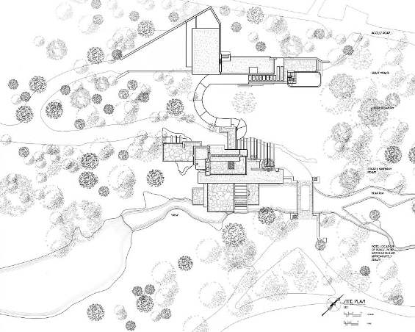
Historic American Buildings Survey (1990)

Plan & Structure
The structural design of Fallingwater uses a large centralised open plan living room that allows the building’s interior to open up to the natural landscape as through the use of limited vertical obstructions allows the client to feel connected to the natural environment from within the comfort of the living room. Moreover, the design of the building necessitates that the structure is of a minimal height as not to appear displaced or to contrast the natural environment, despite being taller than the previous buildings of Frank Lloyd Wright. Furthermore, the design emphasizes the aesthetic of the large cantilevers to draw the eye of the viewer to the horizontal characteristics of the building that act and mimic the surrounding natural landscape. The structure of Fallingwater consists of tiered layers that each enhance the verticality of the building, whilst simultaneously contrasting the large vertical cantilevers used within the design of the building, this is a key feature seen in Wright’s work with buildings such as Taliesin in 1959. As seen through the elevation of Fallingwater, the north section of the structure acts as a focal point for the tiered design, with each floor decreasing in size. This strategy was used by Frank Lloyd Wright to reduce the overall load of the structure that was carried through the masonry walls and concrete bolsters. However, since the construction of Fallingwater in 1937, the building has been under scrutiny for major structural flaws, with the building requiring restoration and further structural support. Once construction had completed the building instantly became victim to flaws within the design as despite the load of the cantilevers being combated by the tiered north elevation of the structure, the unequal distribution of weight led to large cracks along the cantilevers which began to descend at its furthermost point. Additionally, the structural instability of Fallingwater was further heightened with the realisation of structural design member, Mendel Glickman, that the negative reinforcement of the building was neglected to be installed, a mistake that caused to question the structural safety of Fallingwater and resulted in restoration and the addition of reinforcements to secure the building. (Silman, 2000)
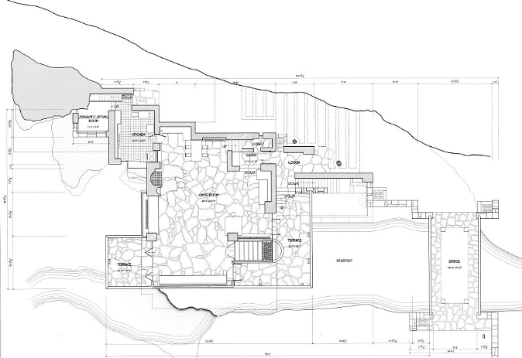
Historic American Buildings Survey (1990)
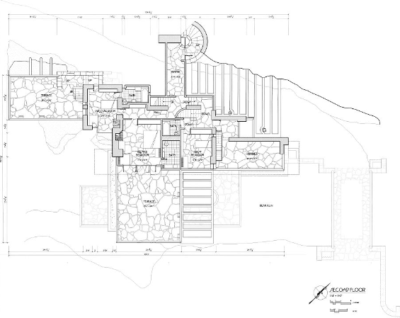
Historic American Buildings Survey (1990)
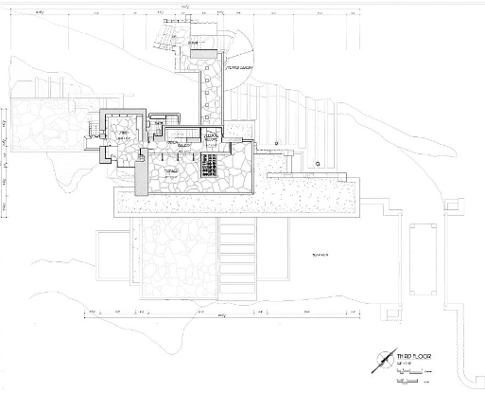
Historic American Buildings Survey (1990)
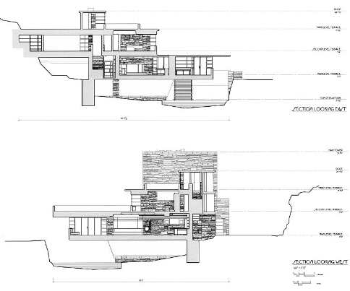
Historic American Buildings Survey (1990)

Materials & Lighting
One aspect of Fallingwater that contributed to the success of the building is the use of materiality and how it causes the building to unify with the surroundings. The structure of Fallingwater can be simplified into the use of four materials, reinforced concrete, steel, glass and sandstone, as the use of a limited range of materials allows the building to achieve an enhanced connection to the surrounding landscape, as well as becoming an exemplary representation for Frank Lloyd Wright’s principle of organic architecture. In addition to this, reinforced concrete was chosen for Fallingwater, due to the high strength to weight ratio as it is used for the cantilever which, a material which in theory, had been structurally stable for the large overhanging stretches. Furthermore, the scenic location of Fallingwater creates an imperative for the surrounding landscape to be seen with the frequent use of large steel windows that provide views to scenery of Bear Run. The regular use of windows permits the interior to be fused with the surrounding wildlife and allow the client to feel connected with nature from the comfort of their living room. In addition to this, the large roof to ceiling stretches of glass allows the interior to be flooded with sunlight, thus enhancing the open concept of the design and softening the stark rugged stone aesthetic. Moreover, the design of Fallingwater has a series of intricate and subtle details throughout the house, a singular display of this, is the use of modest windows that control the reverberation of the waterfall, on which the house is situated. Therefore, this highlights the extreme detail used by Frank Lloyd Wright within the design of the house and that each facet of the structure had a specific intention. (Weebly, 2015)
Ideas and Theories Underpinning the Design
The work of frank Lloyd Wright aided the emergence of the modern movement for global architecture as the innovative design of Fallingwater was ahead of its time. The site and location of the structure are two fundamental driving points for the pioneering design of Fallingwater as the secluded surrounding of Bear Run, Pennsylvania, combined with Frank Lloyd Wright’s principles of organic architecture led to the use and emphasis on horizontal cantilevers that would replicate the topography of the site. Furthermore, despite wright’s views and attempted disassociation with the traditional style and emerging modern design led by architects such as Walter Gropius, Mies Van Der Rohe and Le Corbusier parallels can be drawn between Fallingwater and the work of architects at the time. (Lind, 2010) In 1928 Rudolf Schindler erected the Wolfe House consisting of large tiered cantilevered balconies, with the building emerging from the surrounding landscape. Arguably, the use of cantilevers and the way in which Fallingwater is integrated into the scenery of Bear Run, is echoing the similar characteristics implemented only year prior in the Wolfe House. Contrastingly, despite the similarities between features of Fallingwater and other architectural designs during this period, Fallingwater was unique in the materials used within the structure. The trademark cantilevered balconies of the design are constructed from reinforced concrete, a material which was not traditionally used within the construction of private housing. However, it was the innovative use of the reinforced concrete that caused the building’s cantilevers to crack and bend under the large load, creating the need for structural reinforcements to ensure the safety of the client. (Weisberg, 2011)
Conclusion
Overall, Frank Lloyd Wright’s Fallingwater is an astonishing achievement that was a fundamental structure to the development of the modern era of architecture. The building epitomizes his organic method of architectural design, and it was through the use of this new style of architecture that allows audiences today to be captivated by the cohesion between the natural beauty of the scenery of Bear Run, Pennsylvania and the phenomenal structure that is Fallingwater. The landscape of the site was one of the most influential aspects to Wright’s design as rock ledges of the waterfall and the natural characteristics of the scenery inspired the low elevations and prominent horizontal cantilevers that mimic the surrounding environment to create an aesthetic unity between Fallingwater and the scenery of the landscape. However, external influences such as Schindler’s Wolfe building can be seen to be echoed through the design of Fallingwater with large overhanging cantilevers and a connection to natural environment used within both designs. Despite this, it is the innovative features, for example, the use of reinforced concrete and the precarious detail seen through the sound manipulation of windows that set Fallingwater apart from other designs at the time and why it was voted the ‘Best work ever produced by an American architect’ by the American Institute of Architects in 1991. Therefore, it can be concluded that Frank Lloyd Wright’s unwillingness to follow the conventual and emerging methods of architecture as well as his principles of organic architecture were the driving force behind the unique design of Fallingwater and led to his undisputable reputation as a founder behind the modern architecture that we see before us today.

Historic American Building Survey. (1990). First Floor Plan – Fallingwater, State Route 381 Available at: First Floor Plan - Fallingwater, State Route 381 (Stewart Township), Ohiopyle, Fayette County, PA | Library of Congress (loc.gov) (accessed: 10 April 2021)
Historic American Building Survey. (1990). Second Floor Plan – Fallingwater, State Route 381 Available at: Second Floor Plan - Fallingwater, State Route 381 (Stewart Township), Ohiopyle, Fayette County, PA | Library of Congress (loc.gov) (accessed: 10 April 2021)
Historic American Building Survey. (1990). Section – Fallingwater, State Route 381 Available at: Sections - Fallingwater, State Route 381 (Stewart Township), Ohiopyle, Fayette County, PA | Library of Congress (loc.gov) (accessed: 10 April 2021)
Historic American Building Survey. (1990). Site Plan– Fallingwater, State Route 381 Available at: Site Plan - Fallingwater, State Route 381 (Stewart Township), Ohiopyle, Fayette County, PA | Library of Congress (loc.gov) (accessed: 10 April 2021)
Historic American Building Survey. (1990). Third Floor Plan – Fallingwater, State Route 381 Available at: Third Floor Plan - Fallingwater, State Route 381 (Stewart Township), Ohiopyle, Fayette County, PA | Library of Congress (loc.gov) (accessed: 10 April 2021)
Lind, C., 2010. Frank Lloyd Wright's Fallingwater. 1st ed. San Francisco: Pomegranate Artbooks.
Silman, R., 2000. The Plan to Save Fallingwater. Scientific American, 283(3), pp. 88-95.
Weebly, 2015. Fallingwater. [Online]
Available at: https://fallingwaterproject.weebly.com/about.html
[Accessed 9th April 2021].
Weisberg, R. W., 2011. Frank Lloyd Wright's Fallingwater: A Case Study in Inside-the-box Creativity. Creativity Research Journal, 23(4), pp. 296-312.
Western Pennsylvania Concervancy, 2021. Fallingwater. [Online]
Available at: https://fallingwater.org/
[Accessed 9th April 2021].

