Manage and maintain network resources, and its services applying suitable policies and drafting security and redundancy practices.

Network Operating Systems and Services – ACCA5023 – Coursework 2
  - Joshua Harries 2021807 Friday 5th May 2023

Contents
Team Evaluation 2
Part 1 Group Work 2
Understanding NTFS and Share Permissions 2
New Technology File System 2
Share Permissions 6
Accessing the file share/server over the network. 11
Utilising Group Policy Management Console to better facilitate network object management. 12
Configuring User Environment and Computer Environment 12
Routing and Packet Filtering within Core TCP/IP services and critical Failover/Redundancy Practices 20
Utilising ARP and Routing Tables 20
IP Filtering 27
Filter 1 Stopping ‘anyone’ in PrivateNet1 from Pinging the Router Firewall Service 27
Filter 2: Restrict Access to FTP Service on Server2 to only hosts in PrivateNet2. 28
Filter 3: Only allow specific hosts in PrivateNet1 to access the FTP server Server2 29
Part 2 – Observational Tasks 31
Enhancing security on a SOHO (Small Office/ Home Office) Network 31
Failover Clustering for high availability systems/services 31
Draft Enterprise Network Policy 34
Reflection 35
References 36

Team Evaluation
Name of the Team: Team NOSS
Team Members
Student Name | Student ID
KAREN wINDSOr | 1918576
iWAN dYKE | 1800933
cRISTIAN-sTEFAN sTANCU | 2008911
jOSHUA hArrIES | 2021807

Team Evaluation (Self Evaluate your Team)
 | KAREN WINDSOR | IWAN DYKE |  | CRISTIAN-STEFAN STANCU |  | JOSHUA HARRIES
KAREN WINDSOR | 5 |  | 5 |  | 5 |  | 5
IWAN DYKE | 5 |  | 5 |  | 5 |  | 5
CRISTIAN-STEFAN STANCU | 5 |  | 5 |  | 5 |  | 5
JOSHUA HARRIES | 5 |  | 5 |  | 5 |  | 5
Rate your Teams Contribution with a scale of 1 to 5 (1 No Contribution and 5 Excellent Contribution)
Add your comments on Team Evaluation: (Justify your evaluation)
JOSHUA HARRIES:
CRISTIAN-STEFAN STANCU:
IWAN DYKE:
KAREN WINDSOR:

Part 1 Group Work

Understanding NTFS and Share Permissions

New Technology File System
Screenshot 1 Creating confidential file.
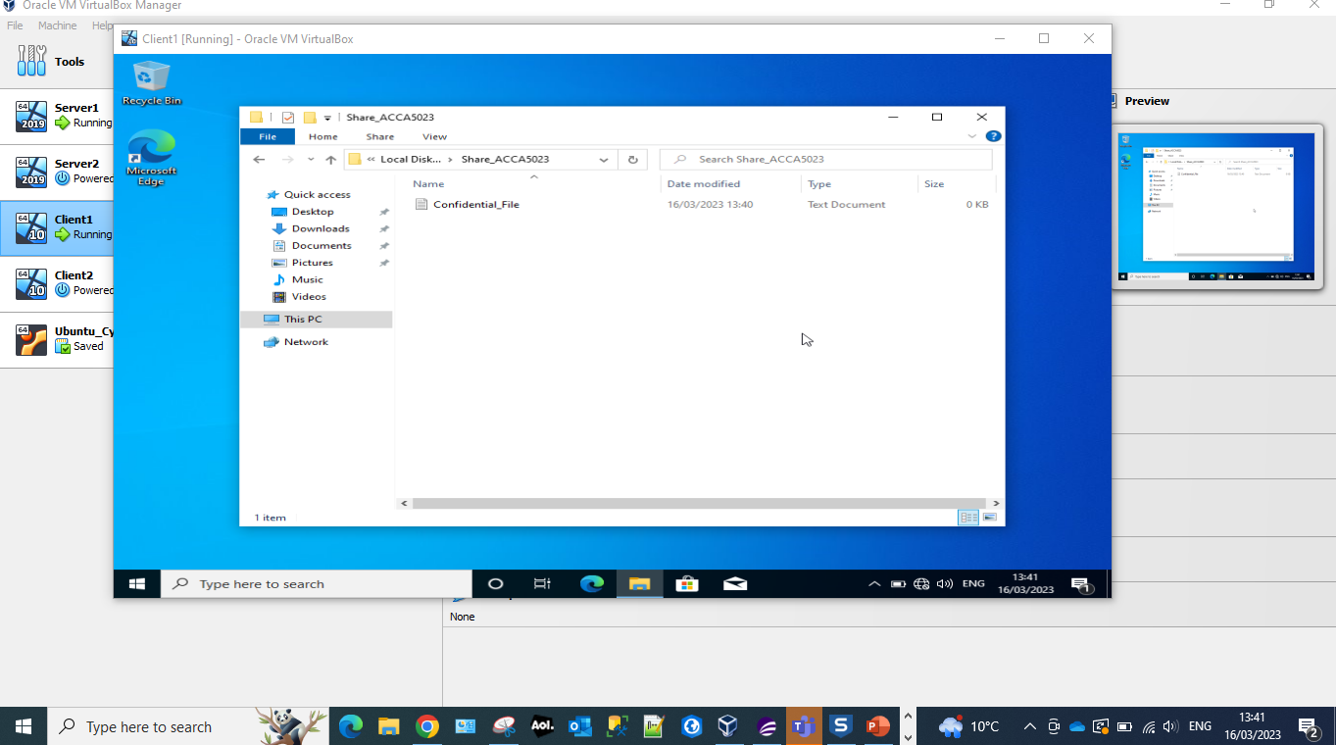
Creating a new folder called confidential_file within the folder Share_ACCA5023 of the administrator group on Client1.
Screenshot 2 Inherited permissions.
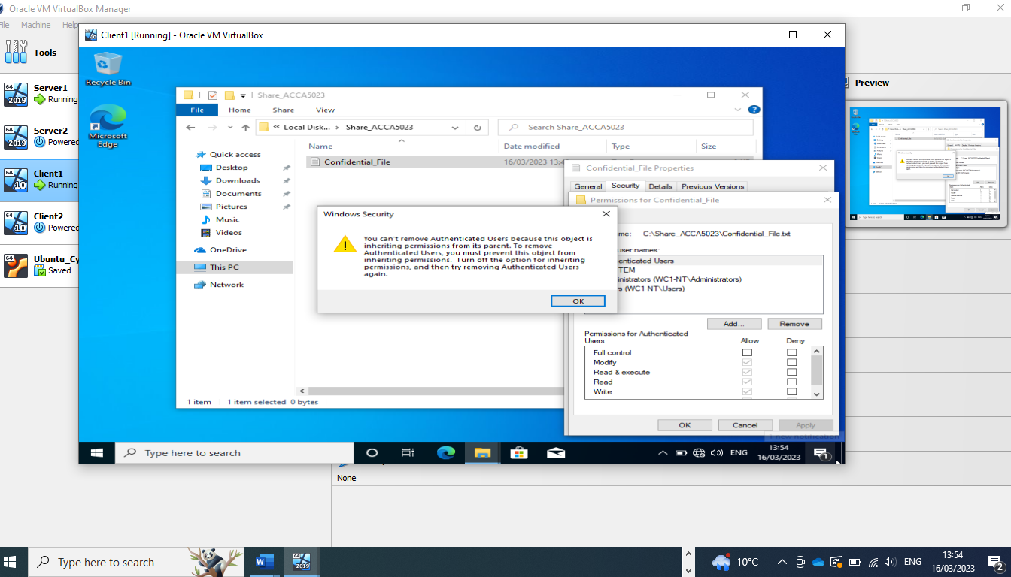
Unable to alter permissions for the user as they have inherited permissions. Inherited permissions are permissions that are given to an because it is a child of a parent object. Turning off inherited permissions is chosen as it is an easier way to restrict access to a specific sub-folder inside of a parent folder, while still allowing it to access the rest of the sub-folders within the parent folder.
Screenshot 3 Enable inheritance.
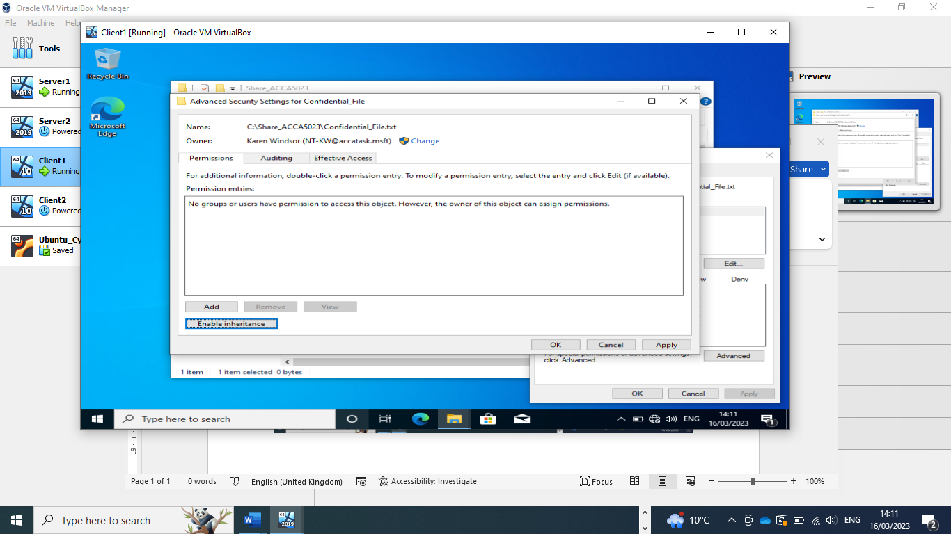
Disabling inheritance in order to set New Technology File System (NTFS) permissions.
The NTFS is a process that Windows operating systems uses for storing, organising and locating files quickly and efficiently.
Screenshot 4 Disabling Inheritance.
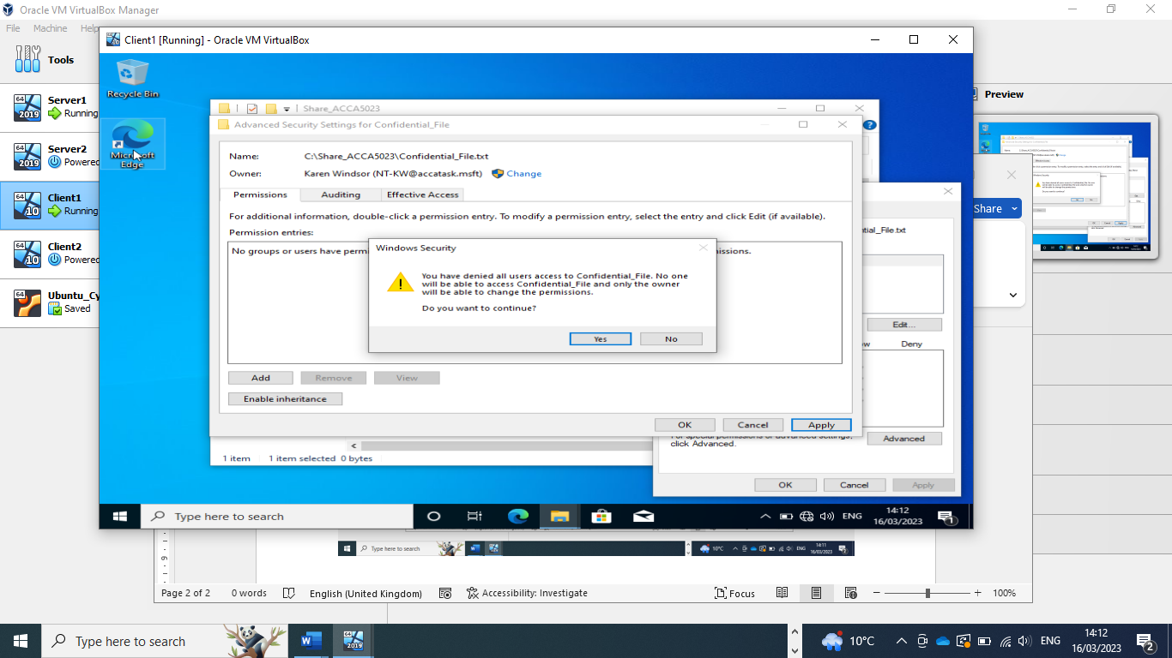
Confirmation that only the ‘owner’ has access to the Confidential_file.
When setting the ‘disable inheritance’ protocol it is important to remember that when you see a button ‘Disable inheritance’, inheritance from above is currently enabled for this folder and when button ‘Enable inheritance’ shows it means that inheritance from above is currently disabled for this folder.
Screenshot 5 Adding permissions.
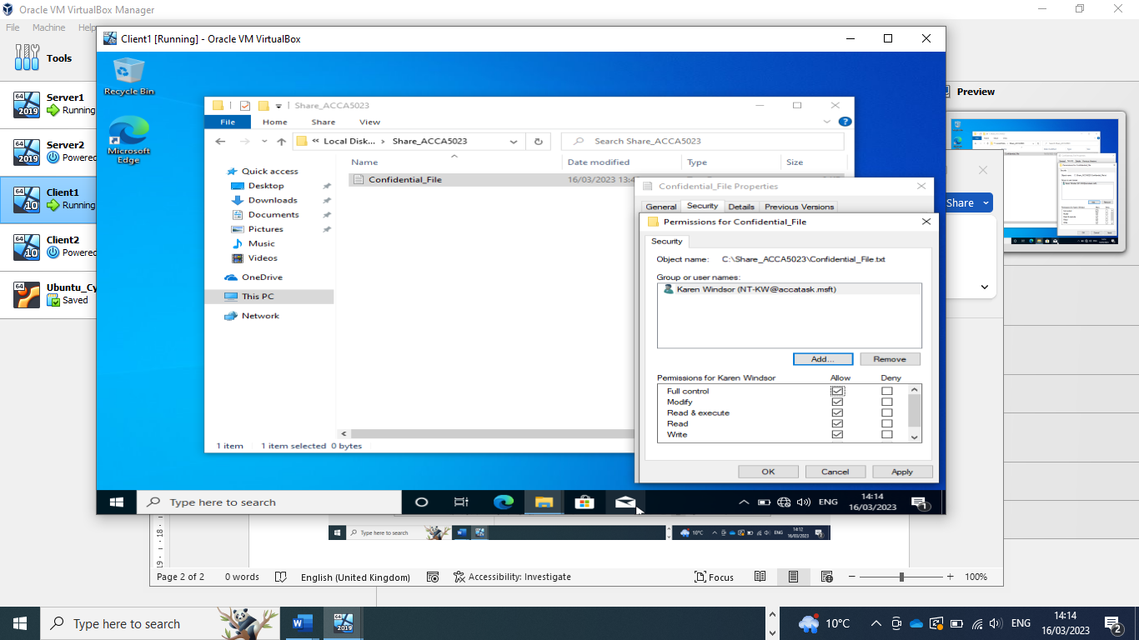
Adding full permissions to administrator user so that they have full permissions for the Confidential_file:
- Modify – Users can view and modify the Confidential_file and its permissions, including deleting and adding files to a directory or file properties to a file.
- Read & Execute – Users can run executable files, including scripts.
- Read – Users can view the Confidential_file and its properties.
- Write – Users can write to the Confidential_file.

Screenshot 6 Confirmation of permissions
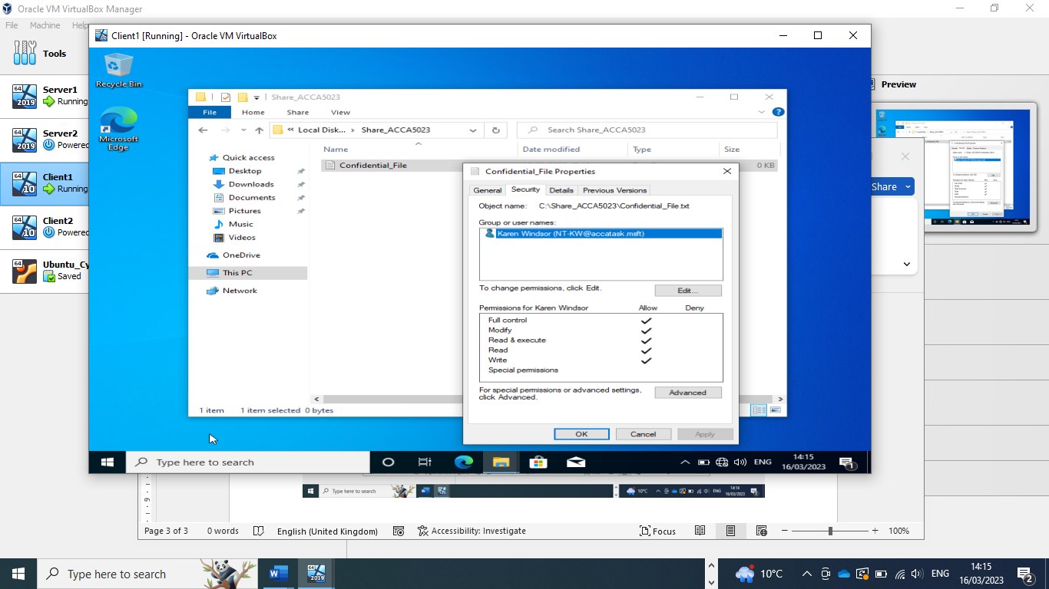
Confirmation that the administrator has full permission for the Confidential_file.
Screenshot 7 Adding permissions for another user.
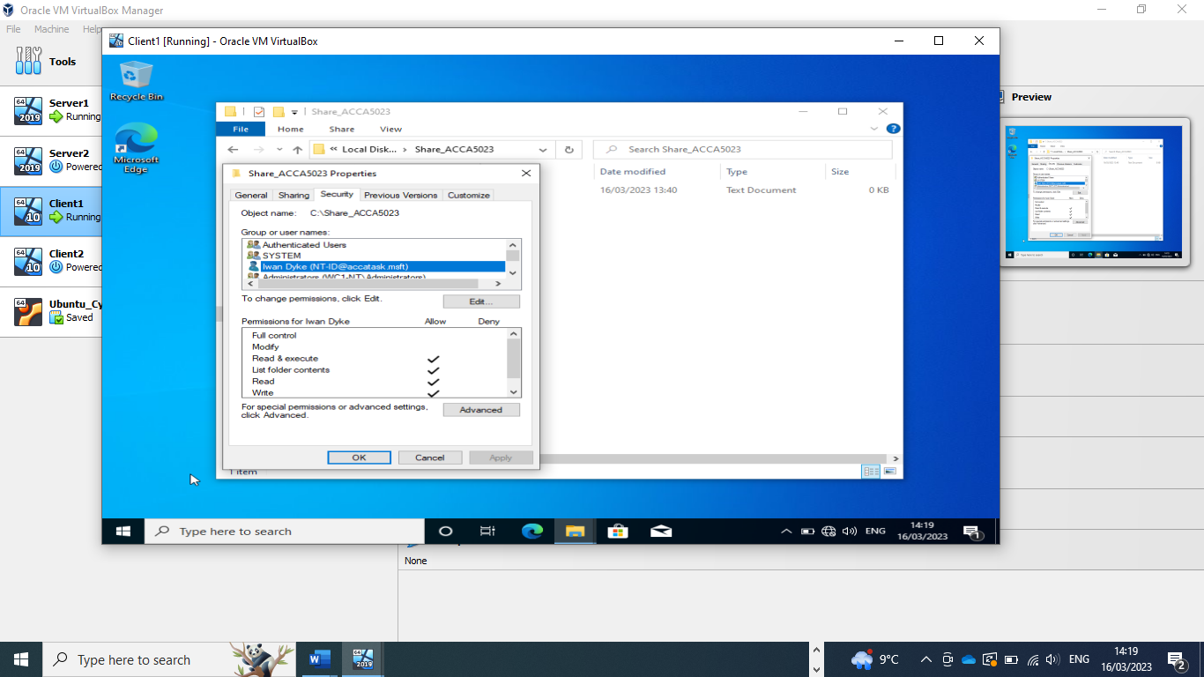
Allowing permissions to Confidential_file to secondary user but with more restrictive permissions. This user can only Read & Execute, List folder contents, Read and Write.

Screenshot 8 Adding text to file.
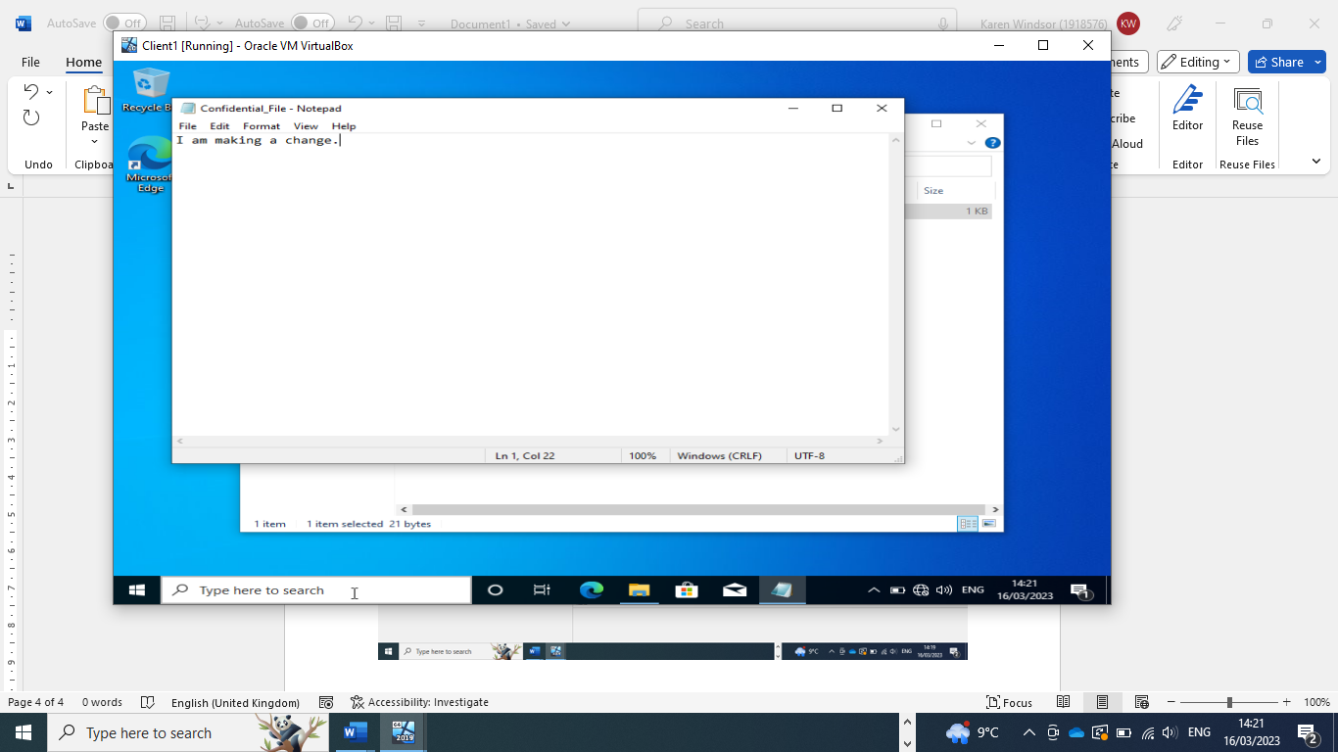
(Made a change as there is no star on the name this indicates the change has been successful)
Screenshot 9 Time Restriction
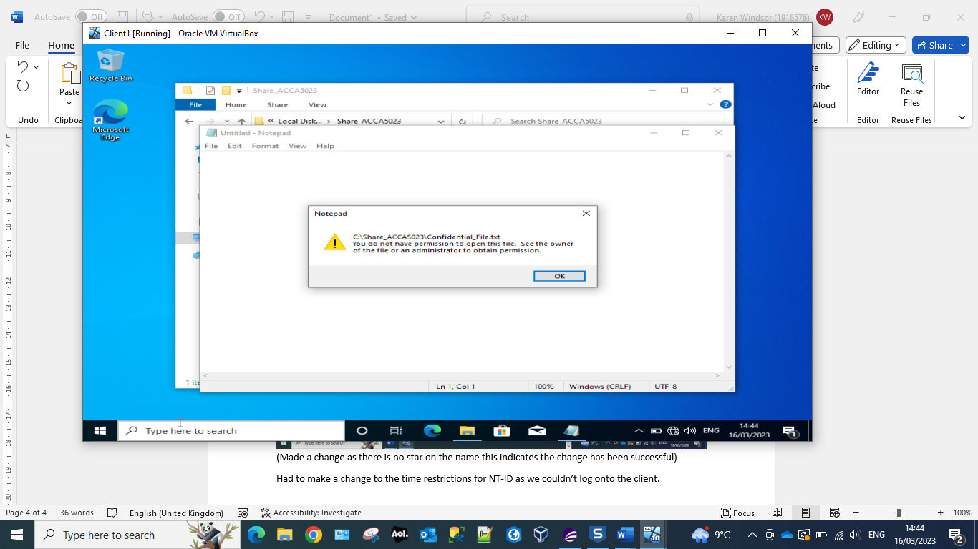
Had to make a change to the time restrictions for NT-ID as we couldn’t log onto the client as we had previously set a time restriction for logins for this user.

Share Permissions
Screenshot 10 Share Location
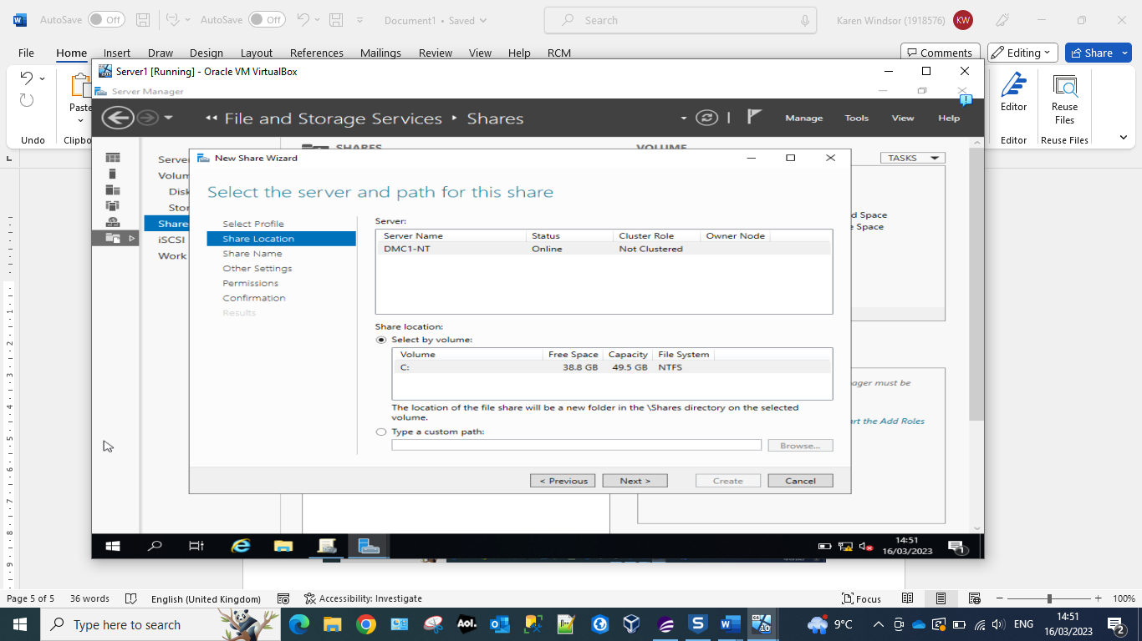
Server Message Block (SMB) protocol is a client-server communication protocol. It provides an authenticated inter-process (IPC) mechanism, and it is used to facilitate shared access to :
- Files
- Directories
- Printers
- Serial ports
- Other end device resources available on the network.

Screenshot 11 Share Name
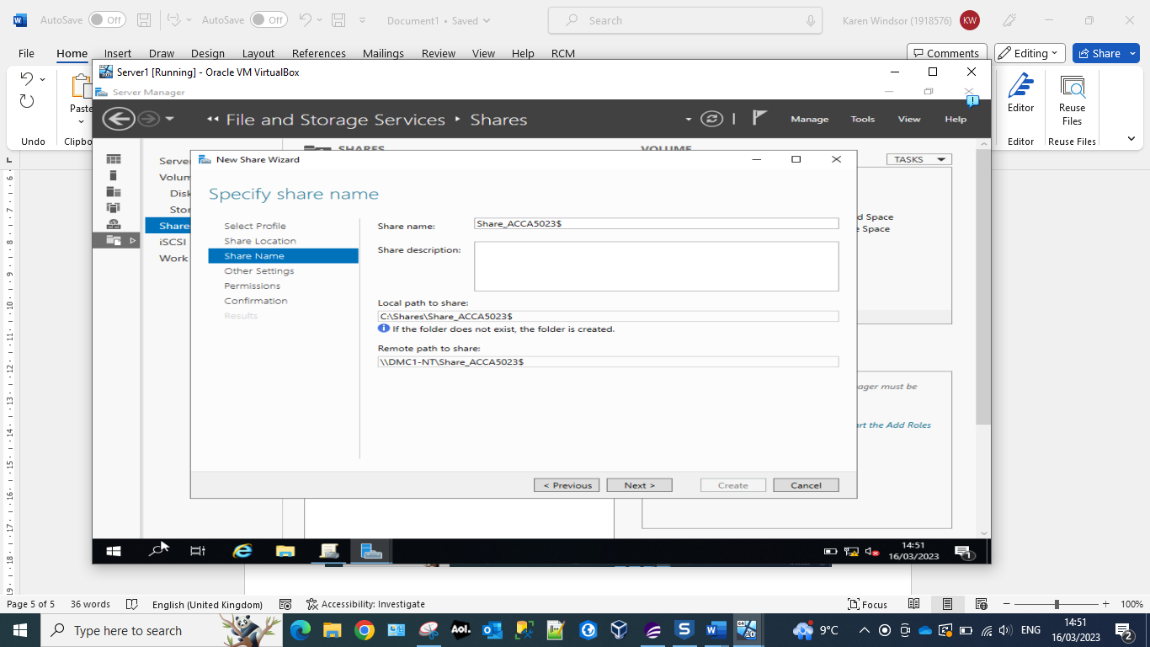
Local path for Share_ACCA5023$, which should be recorded in order to access the files over the network from a different machine or if we need to Map a network drive to the file server. Mapping a network drive means that you are planning to make a specific drive available to other users connect to a common network.

Screenshot 12 Configure Share Settings
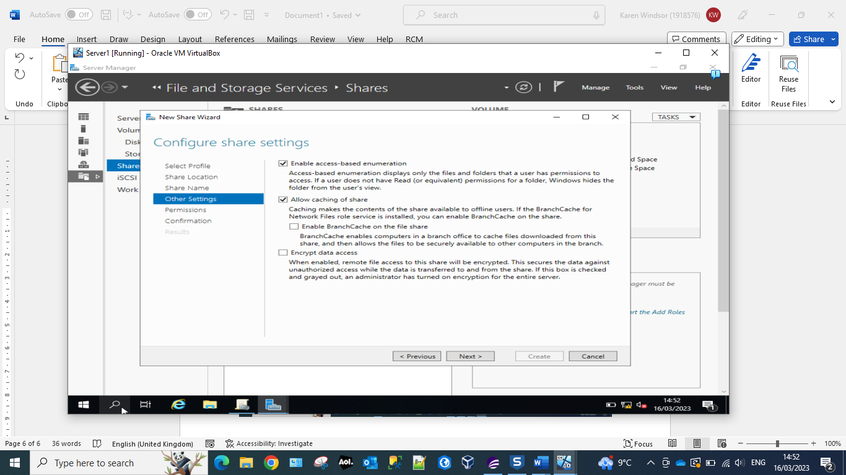
By enabling Access-Based Enumeration (ABE) it enables the user to see only a subset of files or directories to which they have access permissions when they are browsing content, versus seeing the complete of file and folders. ABE enables the comingling of files/folders utilising file access-permissions to restrict users’ visibility and access.
Allow caching of sharing permits the user to set shared files as available offline, this works by caching the files on the user’s local machine. Caching is the process of storing copies of the in a cache or temporary storage location, so that they can be accessed quickly.

Screenshot 13 New permissions
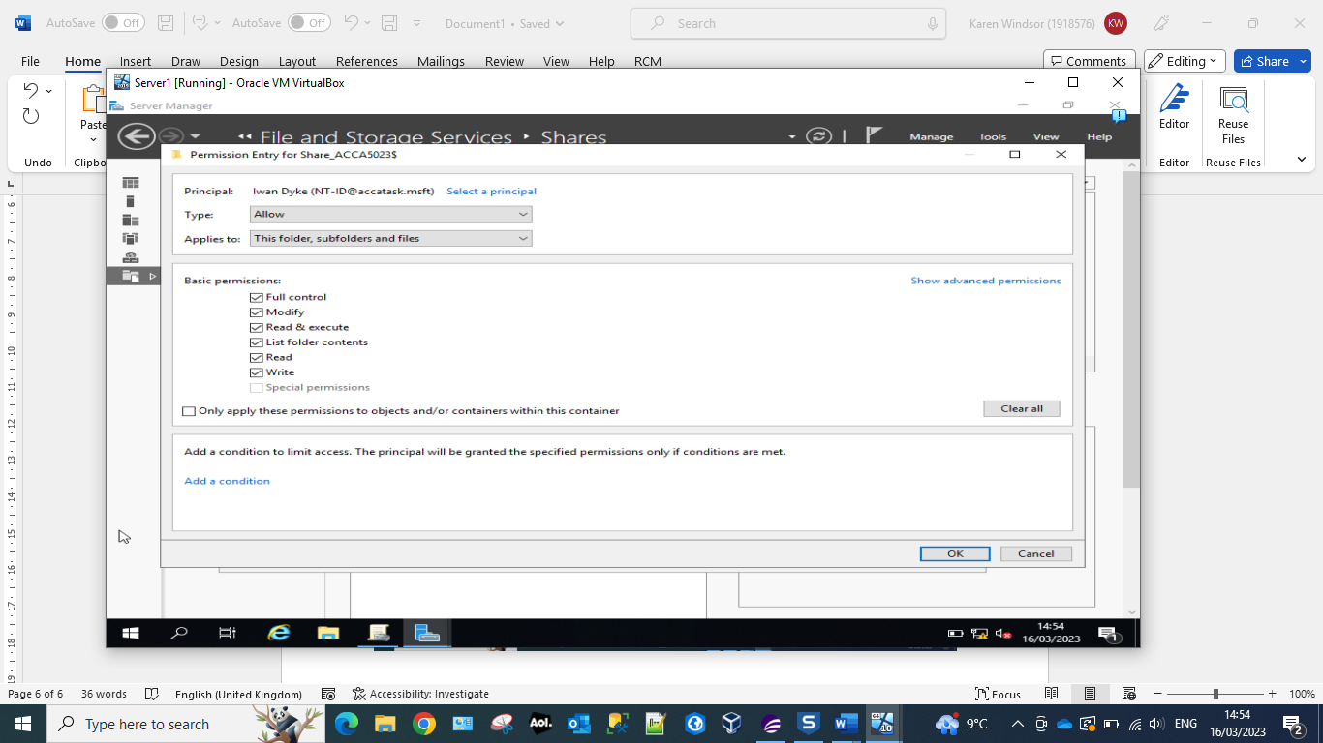
Giving full permissions to user Iwan Dyke

Screenshot 14 Specify permissions to control access.
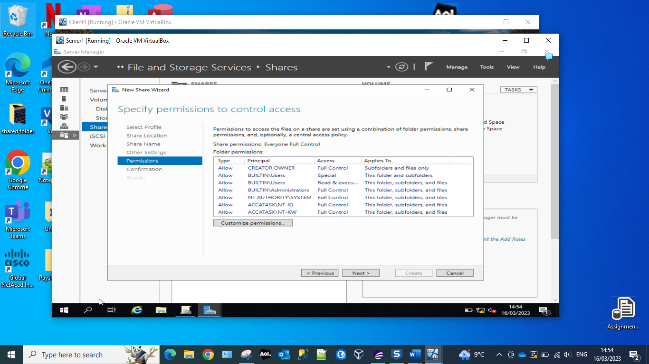
Confirmation that users NT-ID and NT-KW have ‘Full Control’ access.

Screenshot 15 Creating network file share.
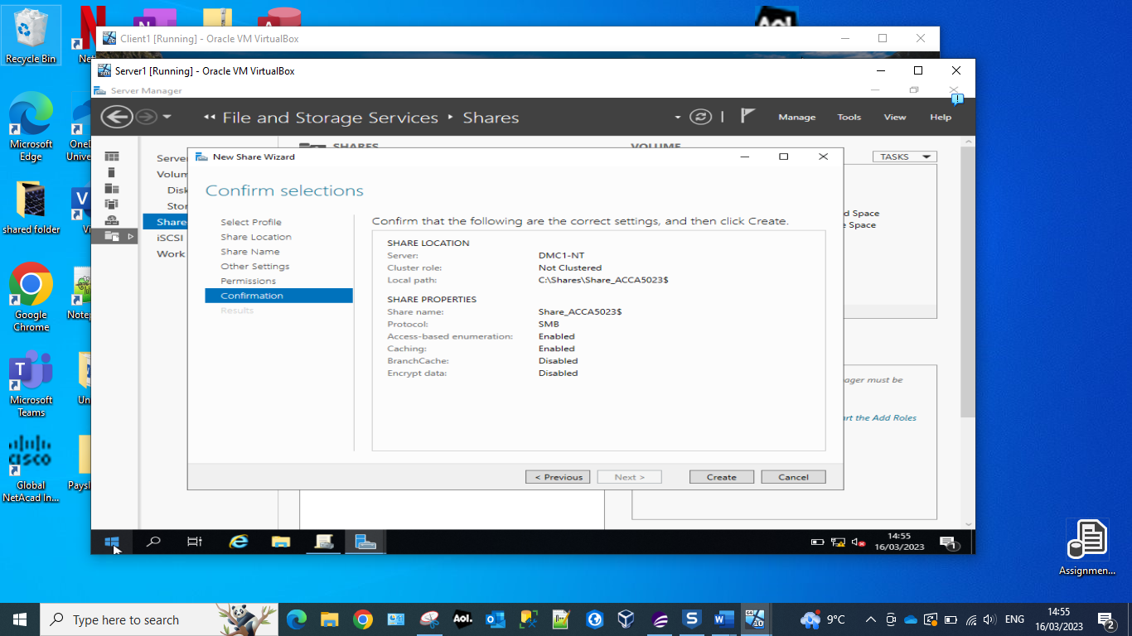
Final step of creating a network file share on the server1.
Which includes:
- Protocol SMB
- Access Based Enumeration (ABE) which allows the administrator the ability to hide files and folders from users who do not have the right permissions to access them.
- Caching is enabled per file object, and it occurs under the Cache manager. File data in the system file cache is then written to the disk at time periods that are set by the operating system.
- Branchcache has been disabled as this a intended for use by remote offices that intend to cache to a centralised location.
- Encrypt data has been disabled – this can be enabled by the administrator at a later date if they feel that this is necessary for network security.

Accessing the file share/server over the network.
Screenshot 16 Map Network Drive
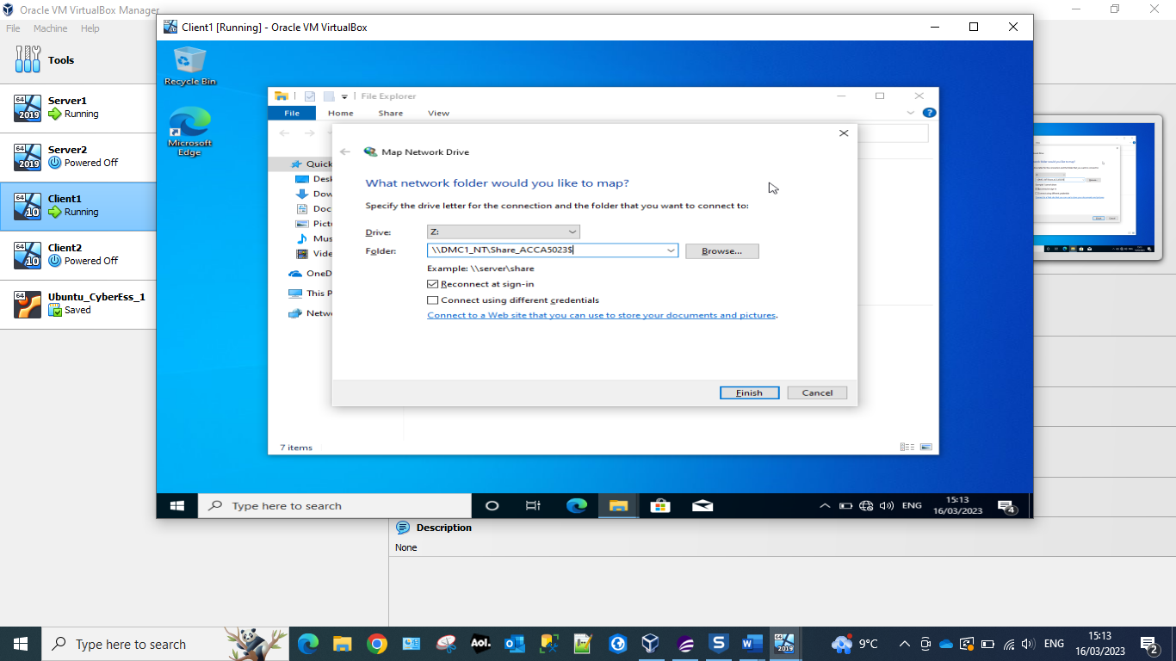
The ‘Drive letter Z’ – Drive Z is a temporary folder (Virtual Drive) from which updates are applied and where temporary file movement is organised. This allows the network share to be permanently stored on Client1, until the user disconnects from it.
The folder is the server’s name plus the full share name.

Screenshot 17 Verification of share
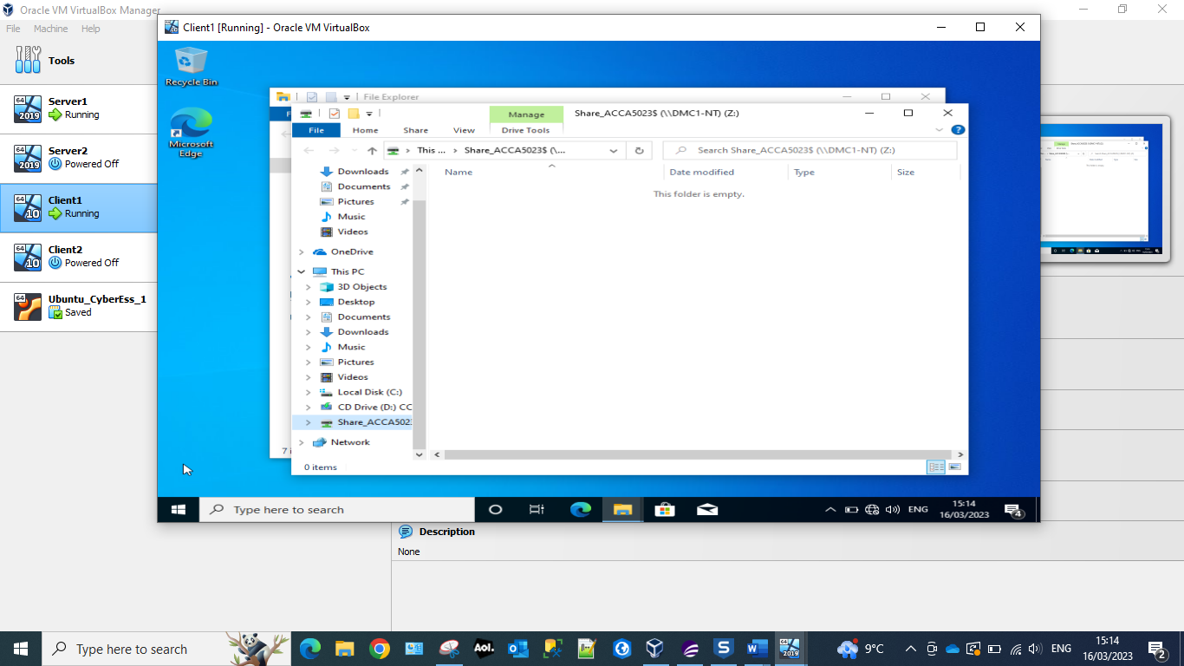
Confirmation that the drive has been mapped and that the ‘share’ can be viewed by entering the server’s name and Share_ACCA5023$

Utilising Group Policy Management Console to better facilitate network object management.

Configuring User Environment and Computer Environment
Screenshot 18 Organizational Unit
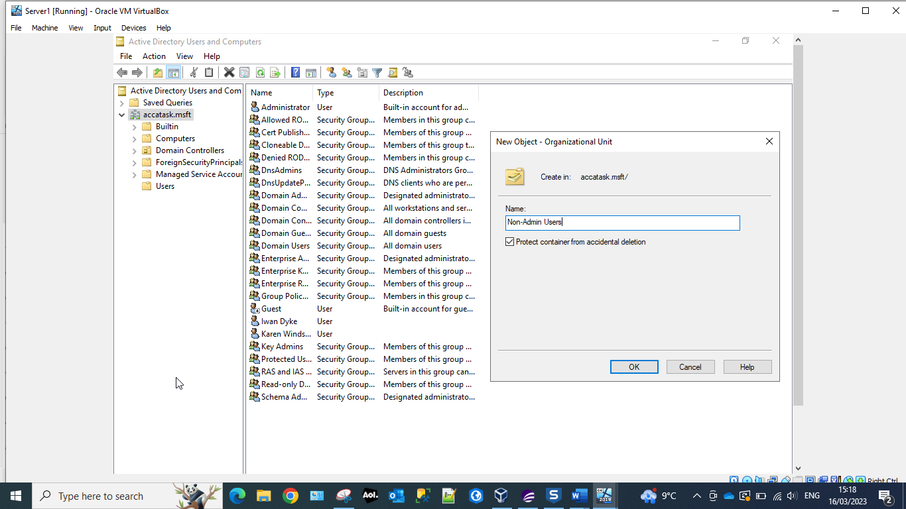
Creating Organizational Unit (OU) Non-Admin Users. An OU is a container within a Microsoft Active Directory domain which can be used to hold user, groups and computers. The above screenshot displays how the administrator would create a new OU ‘Non-Admin Users’.

Screenshot 19 No Control Panel Access
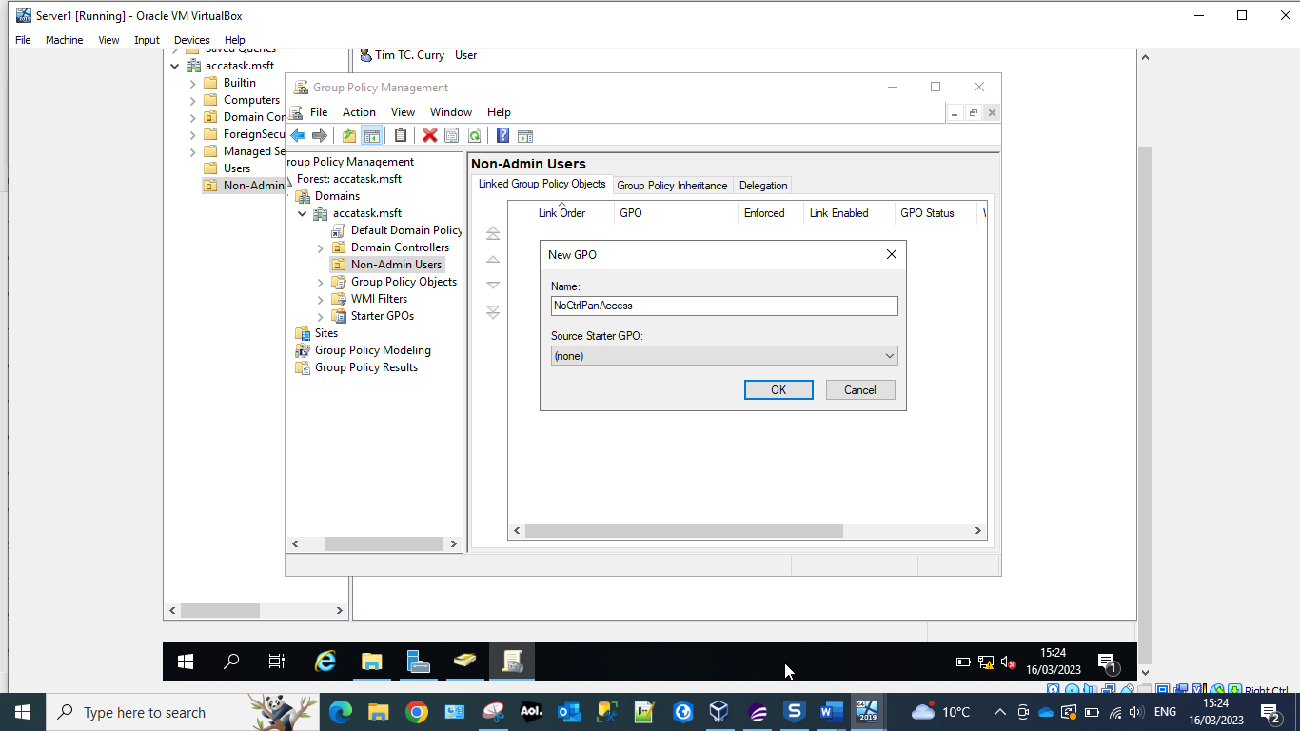
New user Tim Curry created and new Group Policy Object(GPO) within the Group Policy Management Console(GPMC). A GPO is a collection of Group Policy setting that defines what a system will look like and how it will behave for the user Tim Curry. It is created in the GPMC, which is a Microsoft Management Console that provides a graphical user-interface that enables the Active Directory administrators to manage the GPOs.

Screenshot 20 Prohibit access to Control Panel and PC settings.
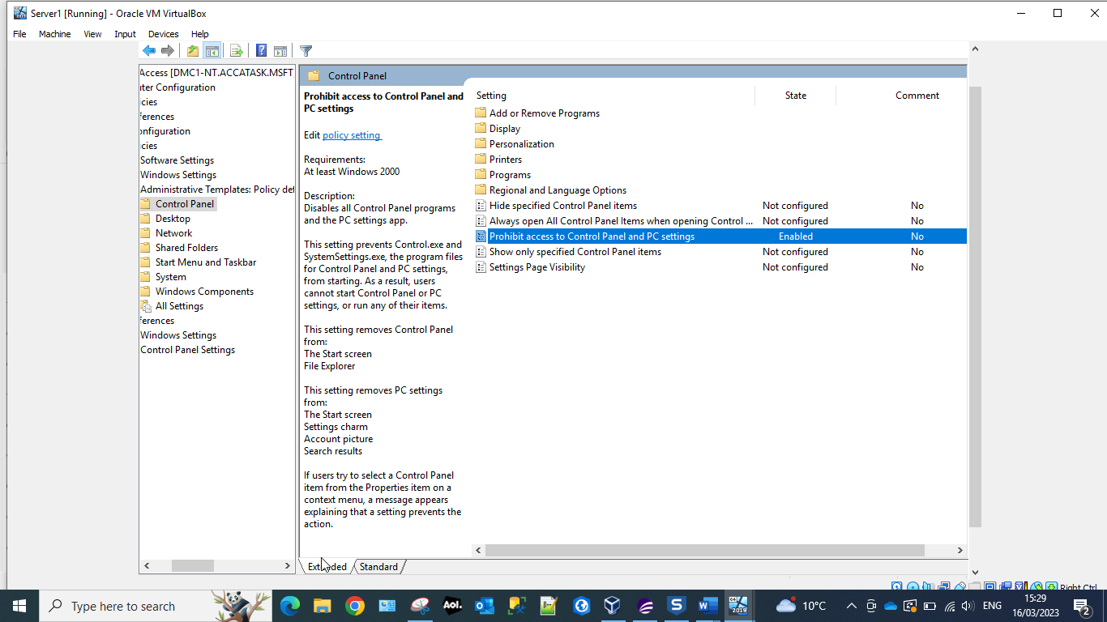
Restricting the user Tim Curry’s access to the Control Panel and PC settings. This will prevent the user from altering how the Window’s operating system looks and works. For example:
- Network and Internet functions, deleting browsing history and cookies.
- Hardware and access sound and video options.
- The ability to install/uninstall programs and well activate/deactivate Windows features.
- Modify user accounts access and change passwords.
- Modify fonts and contrasts.
Screenshot 21 Command prompt ‘Run as Administrator’.
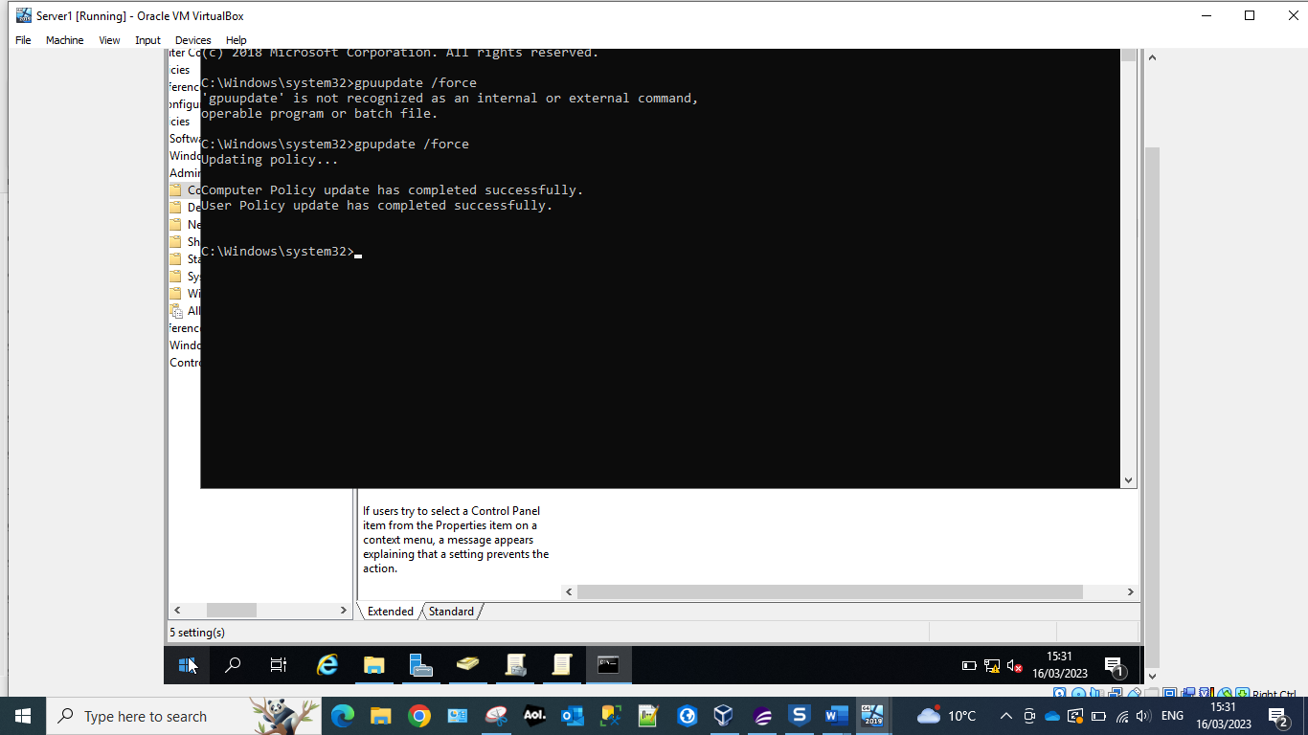
Running the command ‘gpupdate /force’ – applies all policy settings that have been changed by the administrator.
Group Policy Update – gpupdate.
By default changes in the Group Policy are not instantly applied and there is a 90 minute default wait applied. But by using the ‘force’ command we can force the update through immediately.

Screenshot 22 Confirmation of restrictions
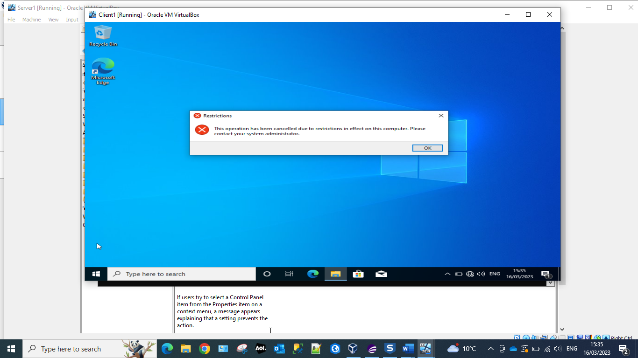
Confirmation that the user is no longer able to access the Control Panel.
Screenshot 23 Prevent access to command prompt.
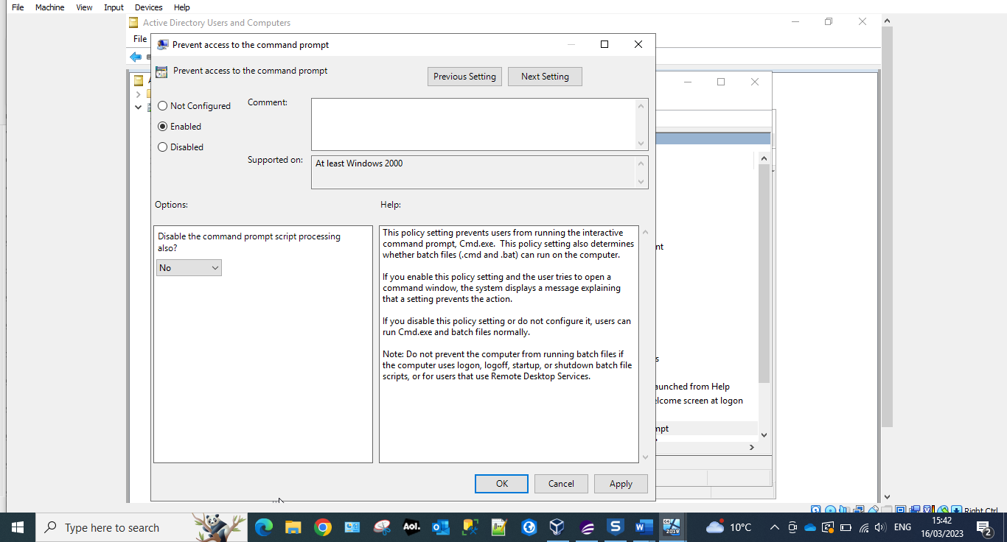
Enable the restriction to prevent the user Tim Curry access to Command Prompt. Access to the command prompt is used to prevent users who are not admins from accessing more resources than they are permitted. Such as:
- Network configurations
- Storage configurations
- Advanced file manipulation
Screenshot 24 Confirmation of no command prompt access
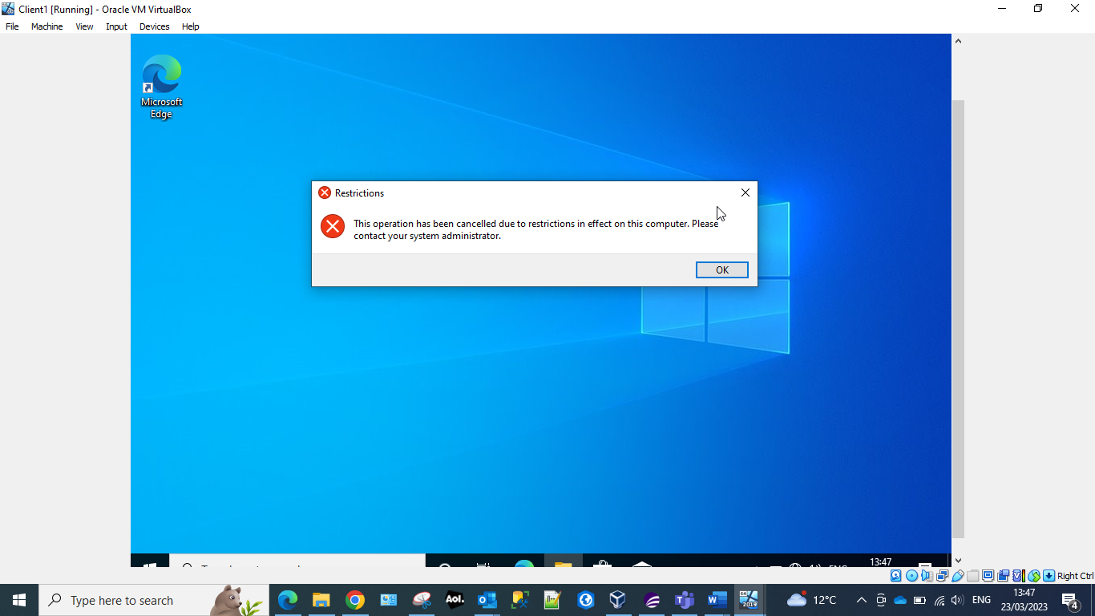
When the user attempts to access the command prompt they generate the restrictions message. That informs them that they do not have access to this function, and that if they need it they should contact their systems administrator. The systems administrator can restore this function to the user if they deem that it is necessary for the user to have this functionality in order for them to carry out specific tasks.

Screenshot 25 Removable storage access
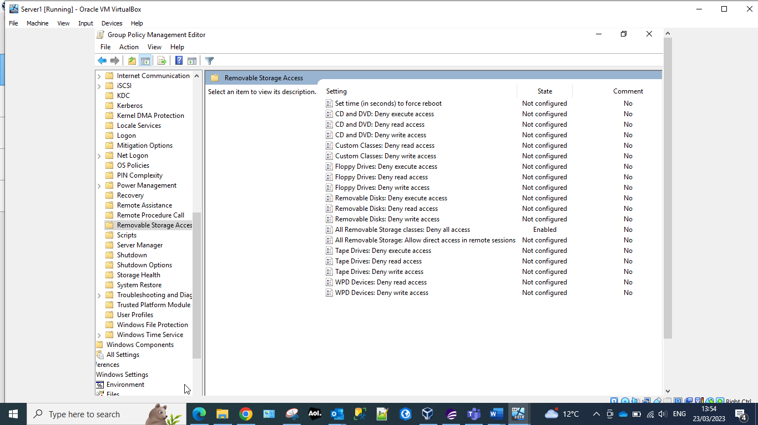
Removable storage is a risk to organisations as it is a common method of uploading viruses onto the system. To prevent this, the system administration has removed the users access to Removable Storage. As seen above this functionality has been disabled.
Screenshot 26 accatask.msft
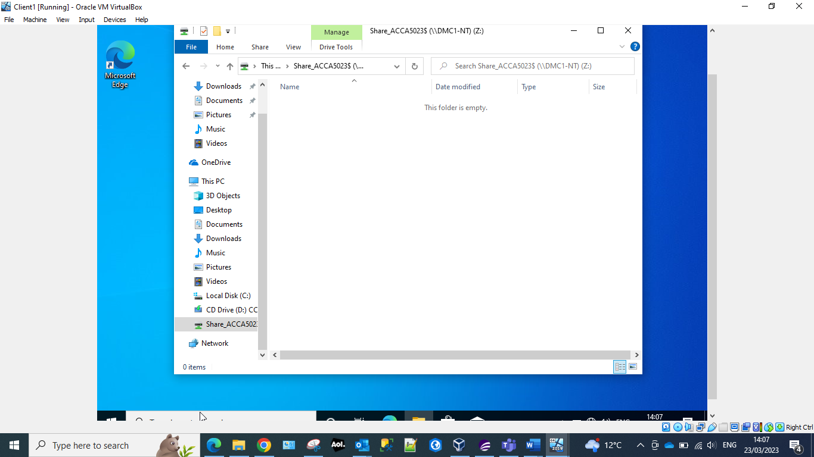
Within Active Directory the system administrator has started the process of removing the functionality from the user to install new software. This is to prevent the user for unknowingly/knowingly uploading malicious software that could attack the organisations systems.

Screenshot 27 New Organisational Unit NWClientComputers
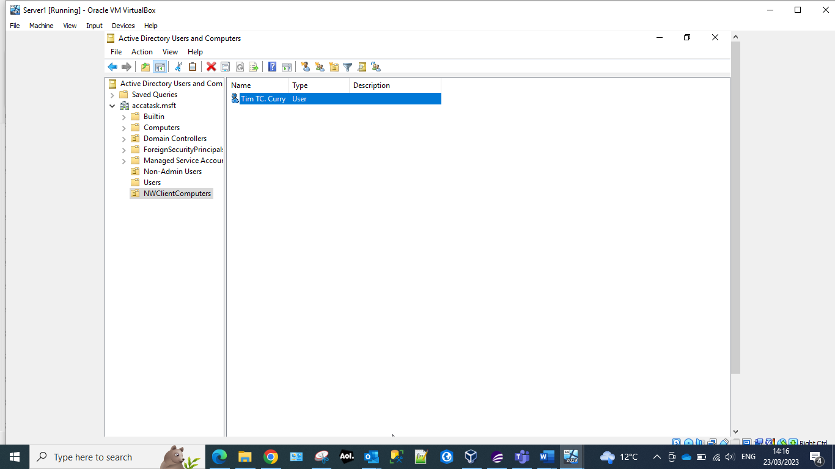
The administrator has created a new Organisational Unit within the Active Directory and has moved the Computer Object, which in this case is our user so that the administrator can configure the software installation restriction.
Screenshot 28 Prohibit User Installs
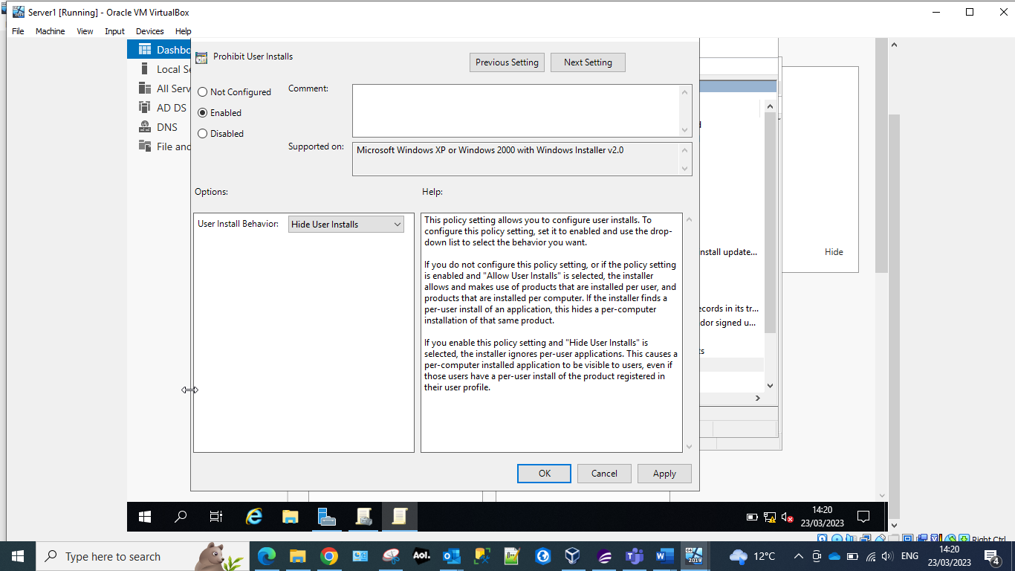
The above screen shows that the administrator has started to restrict the users access to the functionality of Software installations. To complete the configuration, they need to apply and ok the configuration.
Screenshot 29 User restriction for installation of programs
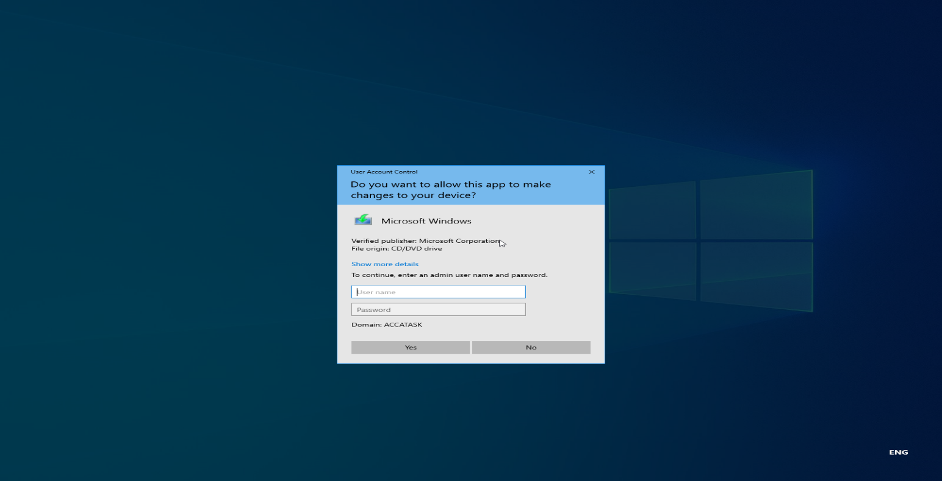
Restricting the user from being able to install programs/software prevents them from downloading malicious programs that could harm the organisations data or critical systems. System administrators are still able to install and update programs and systems, they will need to enter their own admin credentials so allow this.
Screenshot 30 Password settings
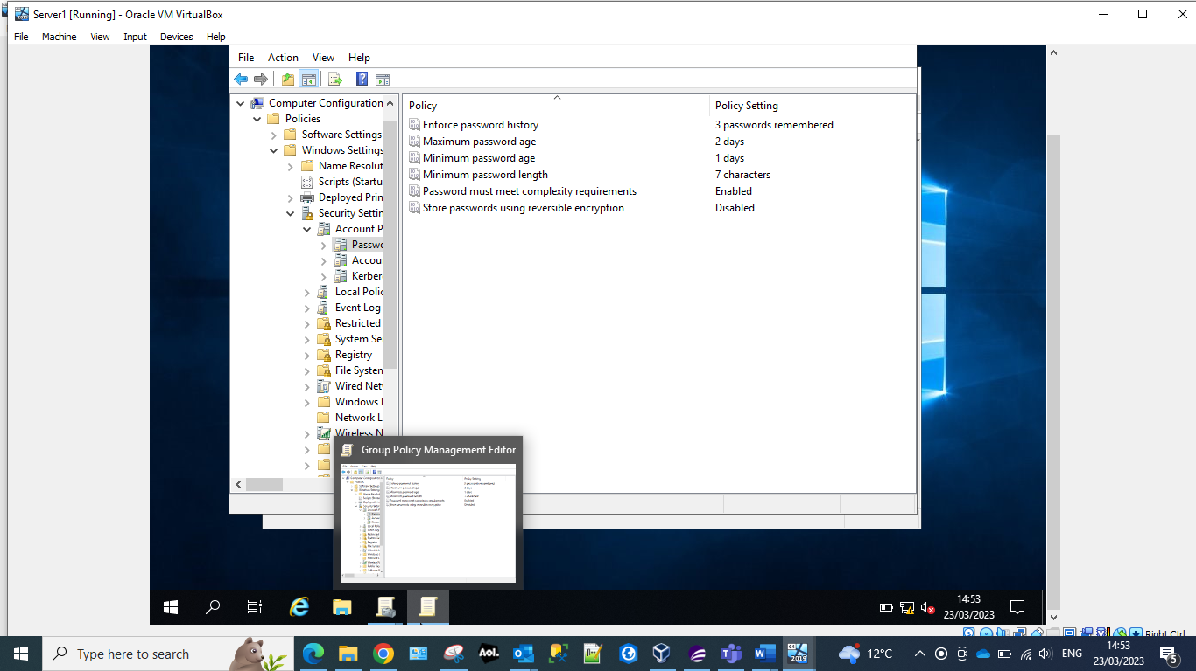
The administrator has pre-defined the setting to the password allocation for the user. Which are:
- The current password cannot be one that has been used in the last 3 previous passwords.
- The user must change the password every 2 days.
- The password must be at least one day old.
- The password must have a minimum character length of 7 characters.
- The password must meet the complexity requirements. That is containing upper case characters, lower case characters, digits 0-9 and a special character.
Screenshot 31 Password restrictions set.
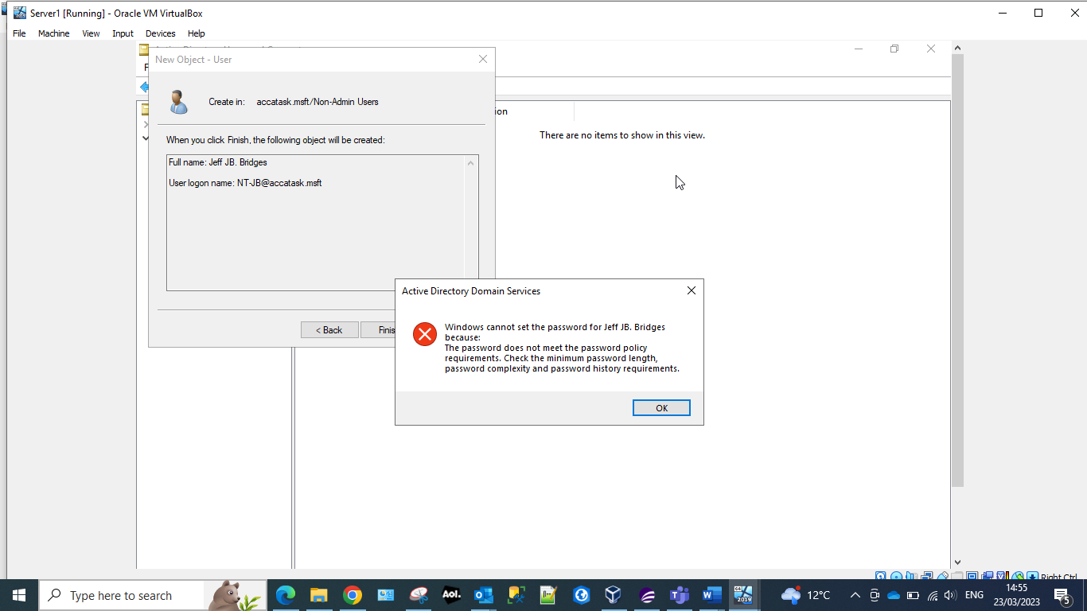
The system now forces the user to enter a password that includes all of the setting that the administrator has configured.

Routing and Packet Filtering within Core TCP/IP services and critical Failover/Redundancy Practices

Utilising ARP and Routing Tables
Screenshot 32 ARP -A command
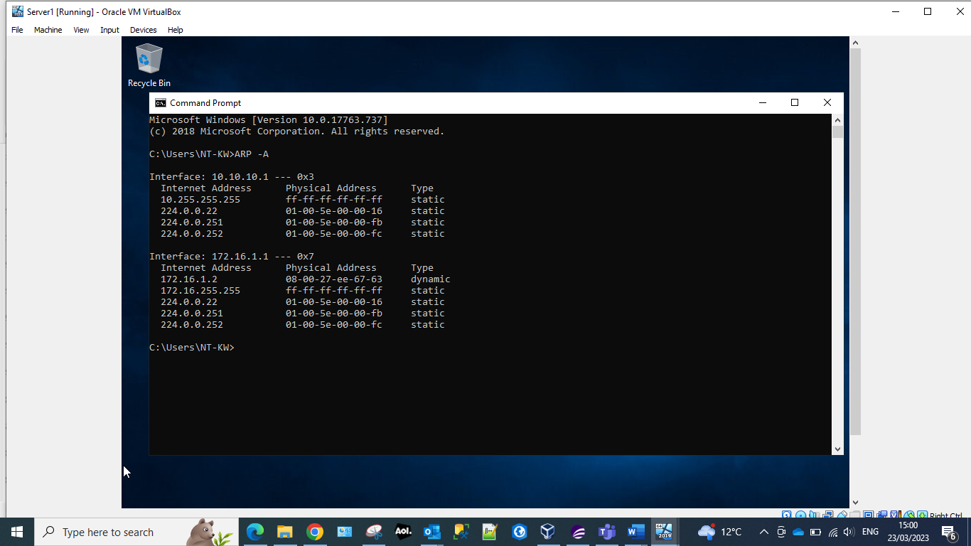
The ARP – A displays ARP (Address Resolution Protocol) data to view mappings. By entering this the administrator is able to see if the current state matches the mappings. The administrator could also use this command to troubleshoot any network connectivity issues.
Screenshot 33 route PRINT
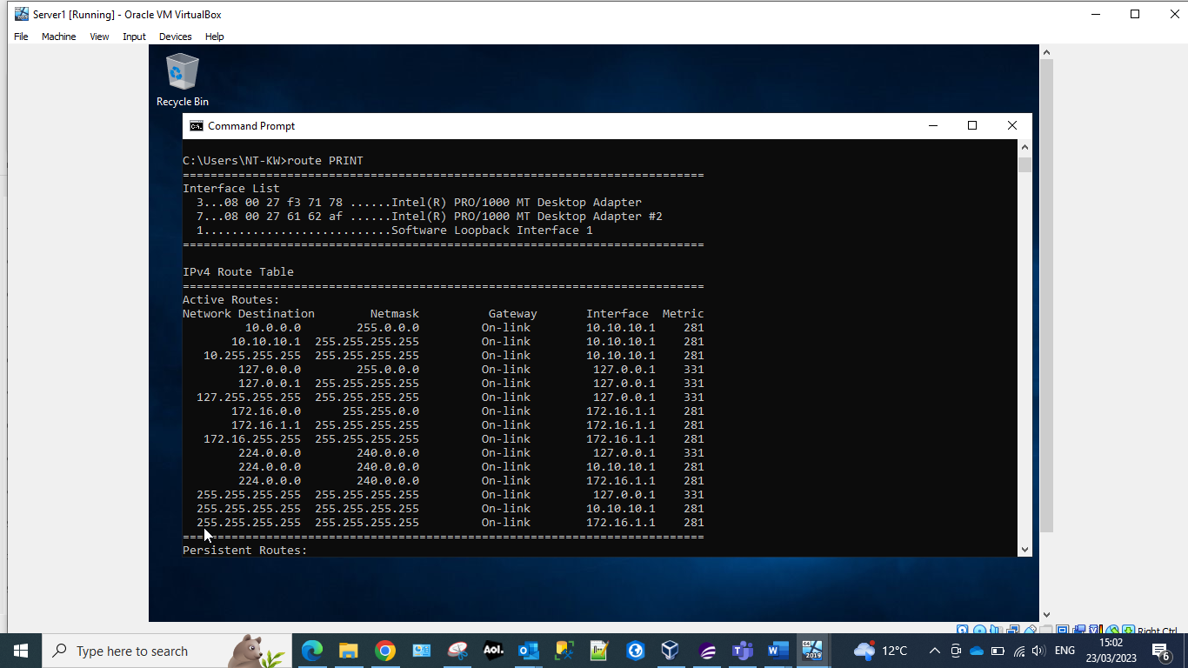
The command route PRINT allows the administrator to view the routing table.

Screenshot 34 Server Manger
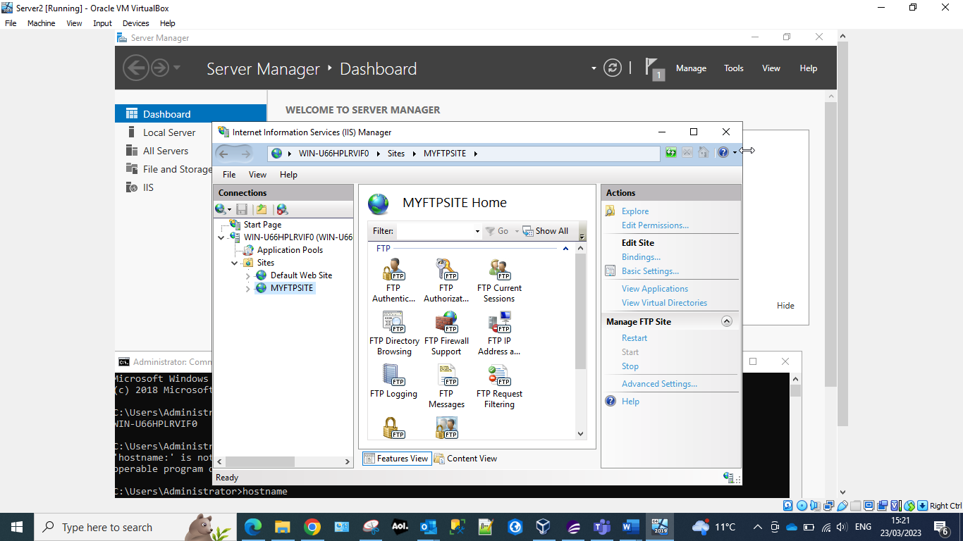
The server manager allows the administrator to monitor, start, stop or restart and configure database connections, login authentications.
Screenshot 35 MYFTPSITE
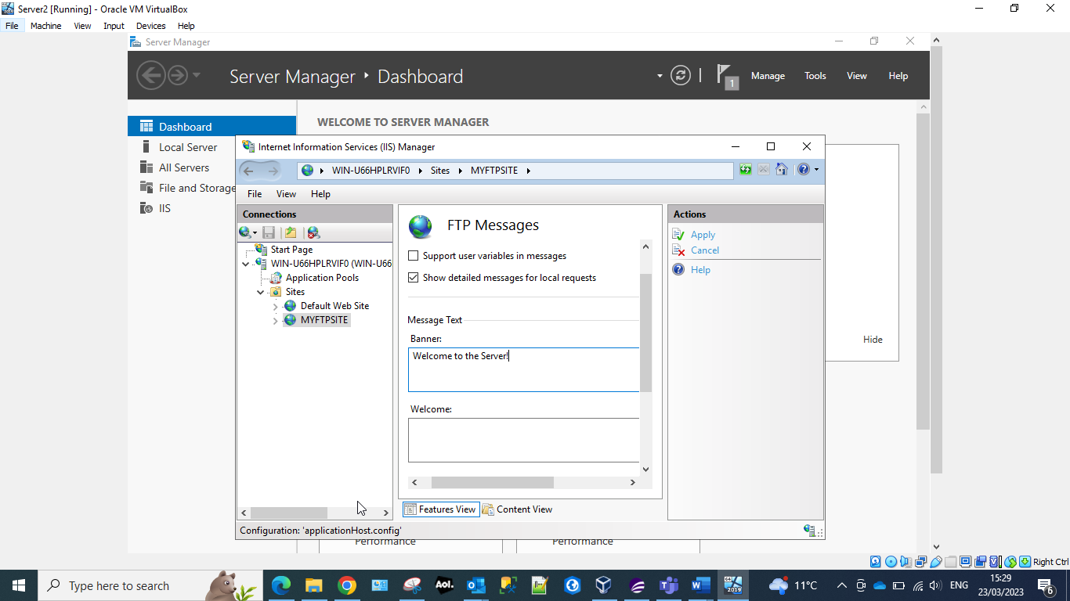
FTP (File Transfer Protocol) Server is used for transferring files across the internet. They have two functions PUT (uploading of files to the server from the client) and GET ( getting files from the server from the client). The administrator has entered a welcome message to the server banner.
Screenshot 36 MyFtupuploads folder
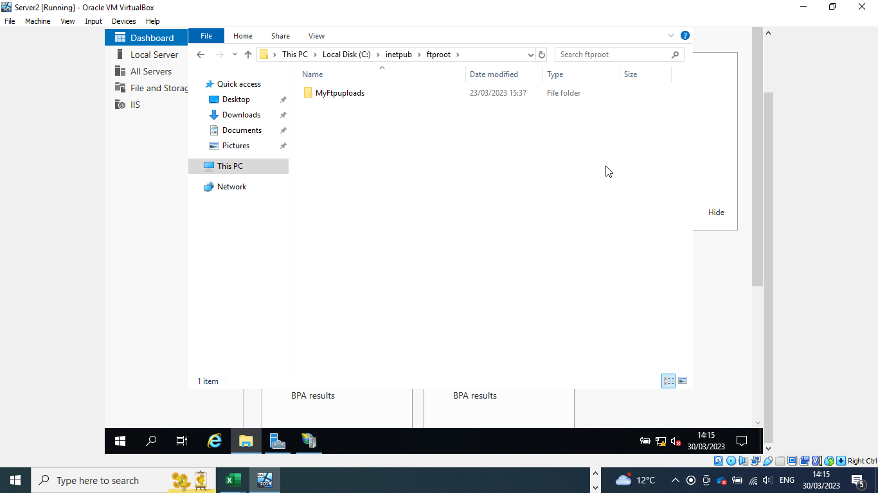
Creation of a folder to hold the ftp documents.
Screenshot 37 ftpuser23
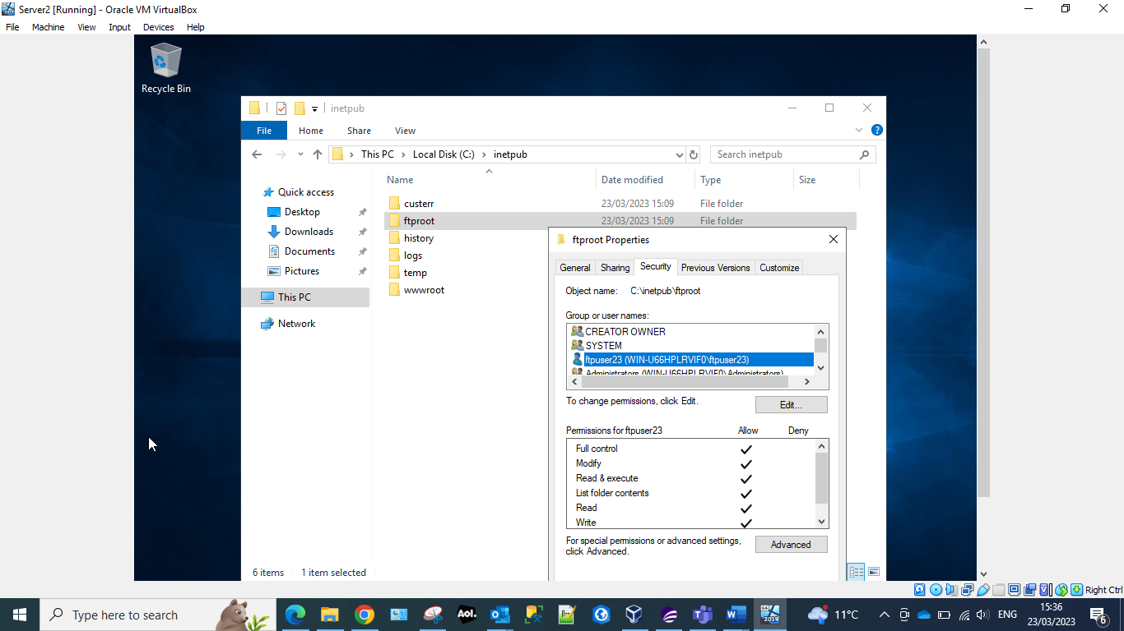
Allowing user to the FTP – domain user accounts allow for easier access and auditing for domain resources. Local user accounts are better than domain user accounts when you are trying to limit access to your domain.

Screenshot 38 Firewalls Server2
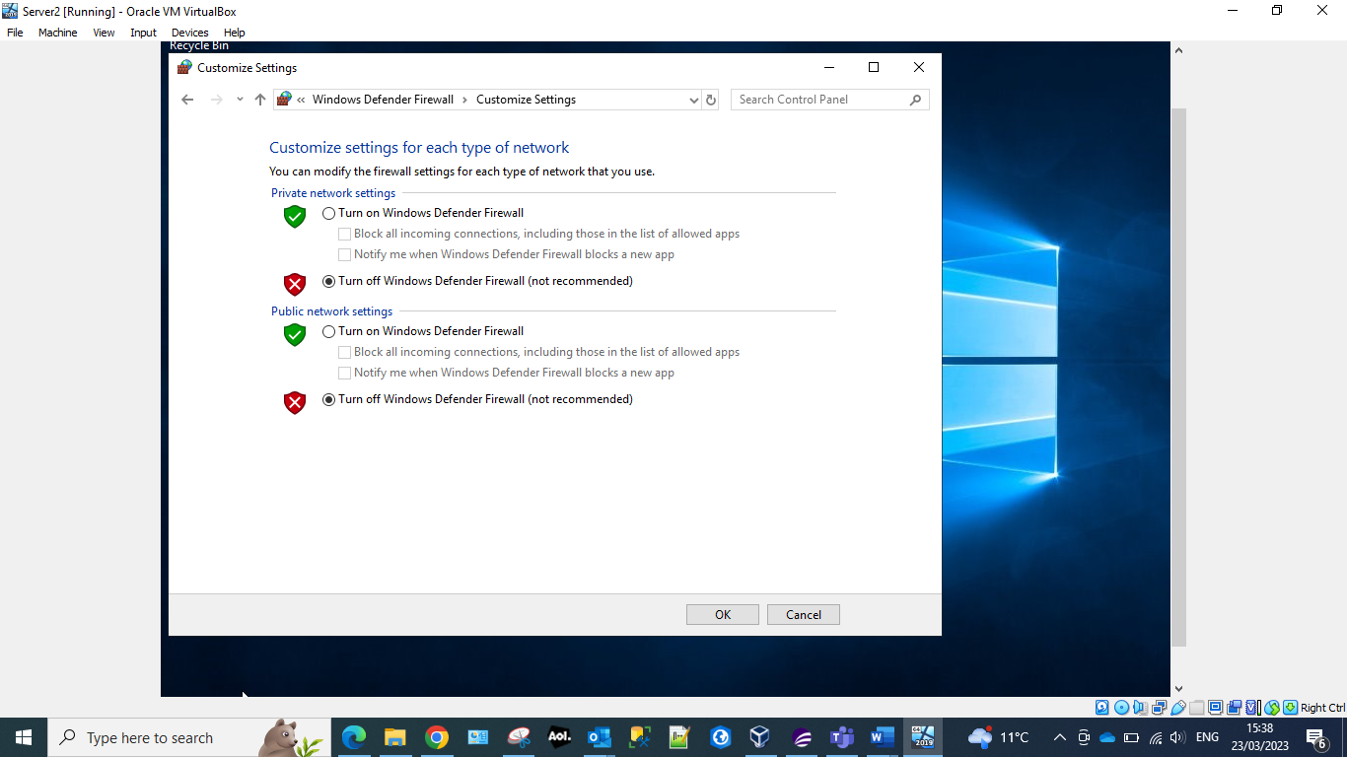
Confirming that the firewalls for Server2 have been turned off.
Screenshot 39 FTP Server
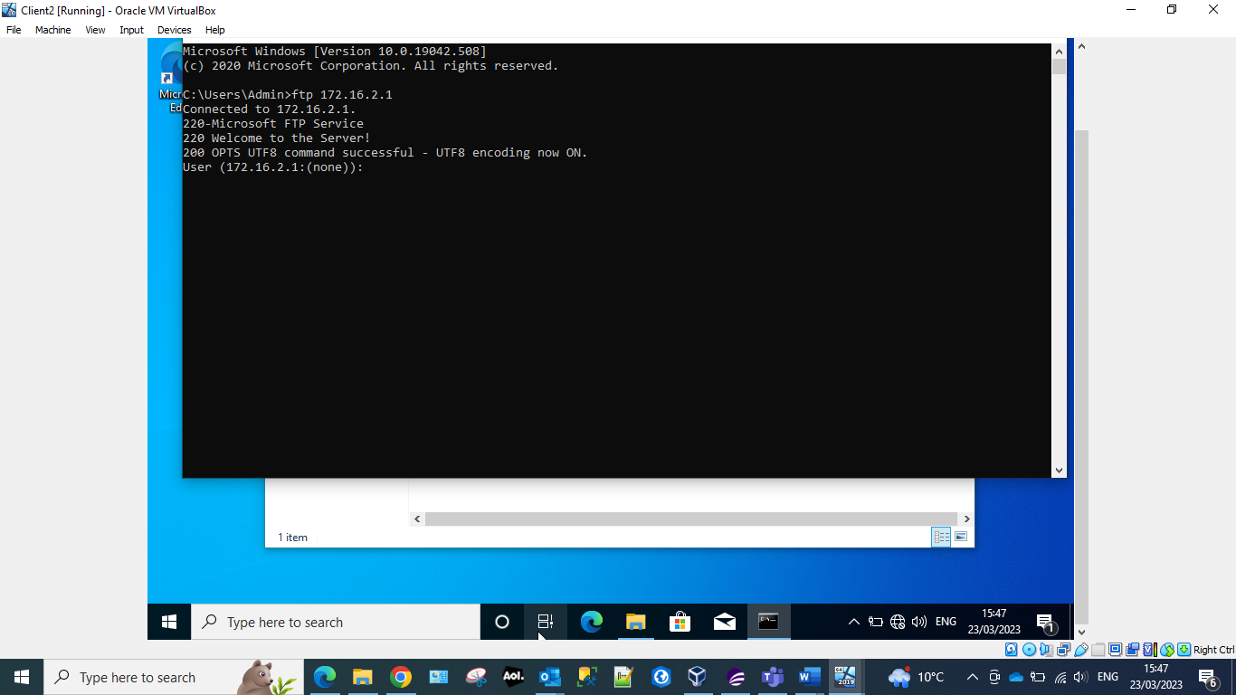
The ftp command followed by the server address – connects to ftp service.
Screenshot 40 Connecting to Server2 with ftpuser23.
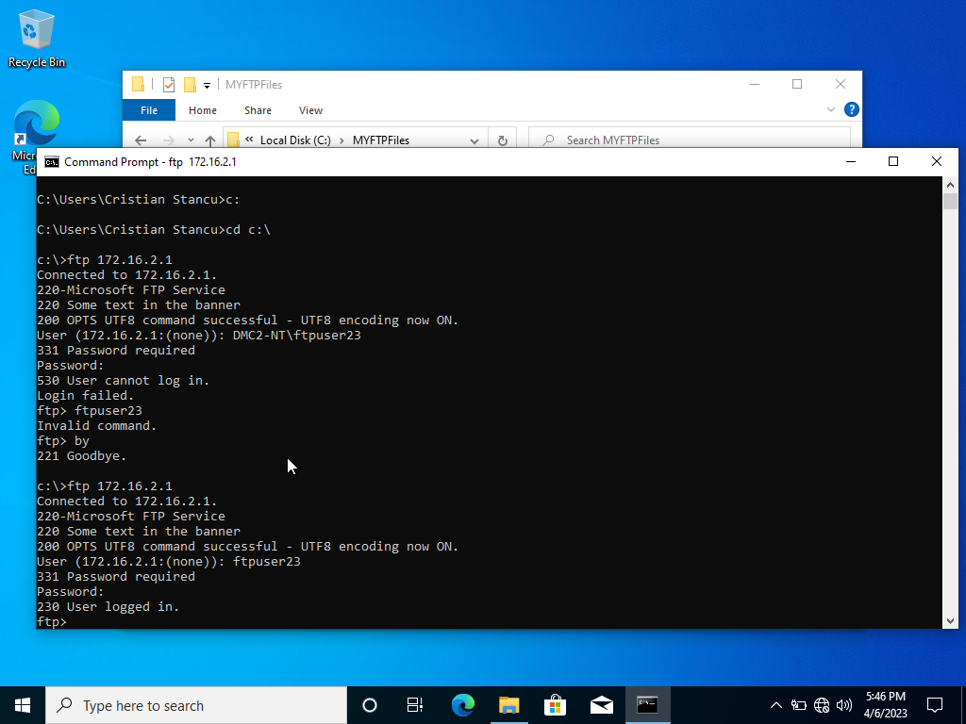
Whilst completing this task it was noted by the group that the worksheet contained several errors for this task. The FTP username doesn’t have to include the windows domain, so when we connect through FTP to Server1 (which has the computer name DMC2-NT) using the user ftpuser23, the windows domain doesn’t have to be used like DMC2-NT\ftpuser23 or accatask.msft\ftpuser23. The connection can be made using the username only: ftpuser23.

Screenshot 41 Server1 Server Manager
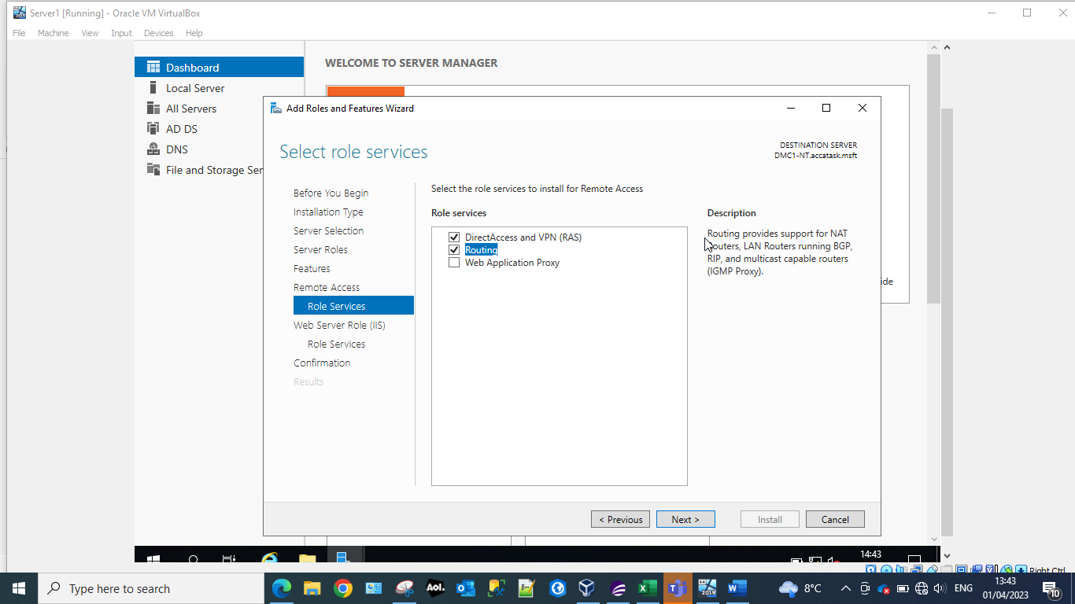
Server manager provides the administrator with an interface to Windows servers. From here the administrator can monitor and manage various aspects of the server which includes Role services. Role services allows the administrator to manager server features.
Screenshot 42 Deploy VPN and LAN routing.
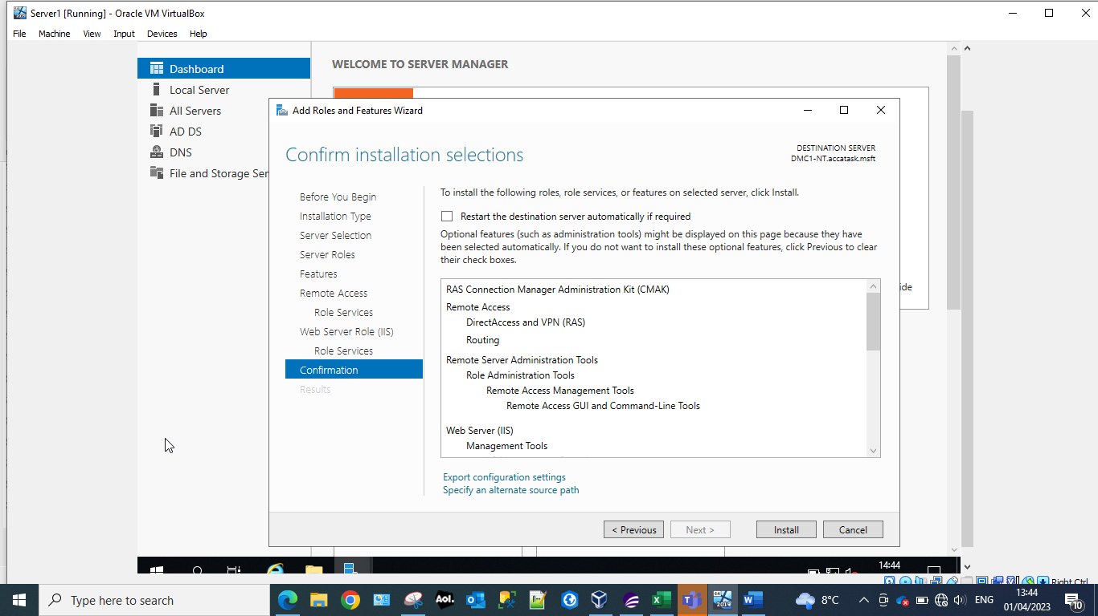
VPN deploy in role services configures the VPN role on a Windows server. It allows the provision of secure remote access to the organisations internal network. By using this the administrator can ensure that they are protecting the organisations network from malicious/unauthorised access and potential theft of data.

Screenshot 43 Routing and remote access
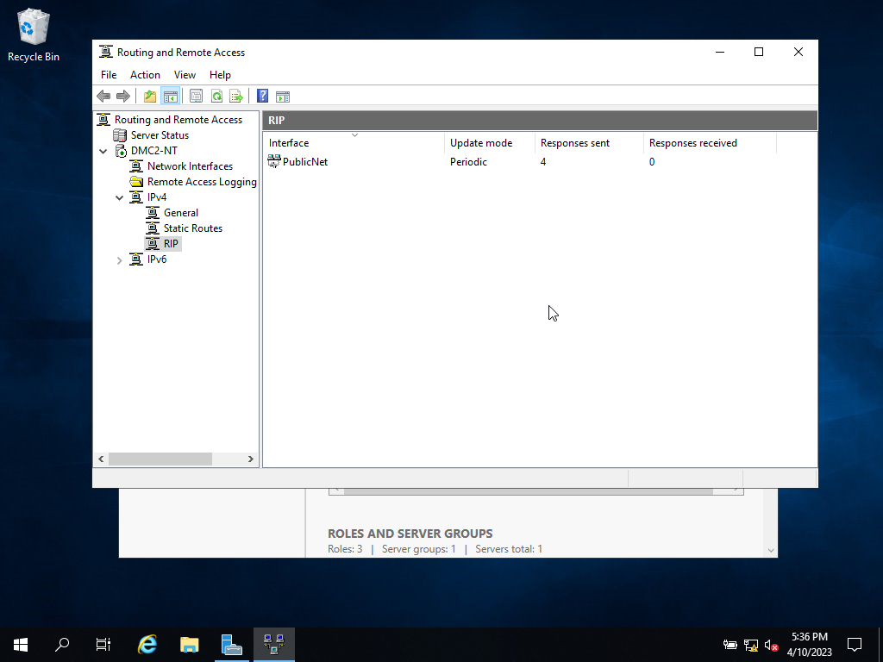
Routing and remote access completed on both Server1 and Server2 – ensuring that the PublicNet is added to the IPv4RIP.
RIP is the Routing Information Protocol and is what is known as a distance vector protocol that uses hop count as its primary metric. The RIP defines how routers should share information when moving traffic among an interconnected group of local area networks. However, according to Brush [1] that this has been replaced by Open Shortest Path First (OSPF) as the Interior Gateway Protocol in enterprise and larger, more complex networks.
Only the PublicNet interface should be present as it is the one that is announcing the routes for the server.

Screenshot 44 Ping from Server1
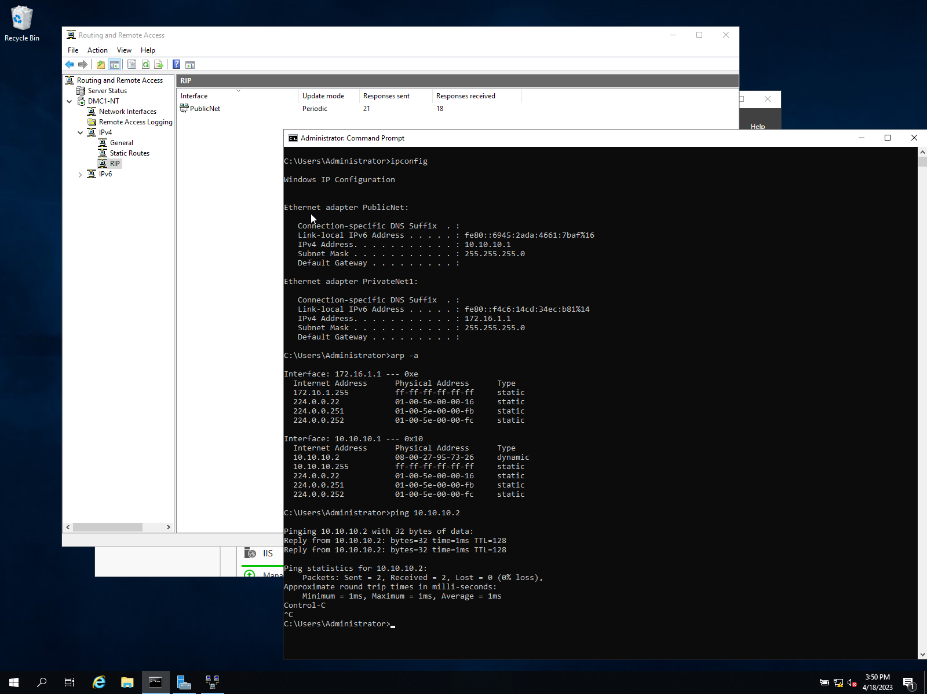
The above screenshot shows the configuration of the RIP and ping test.
The configuration for this model is similar to the figure shown below.
Figure 1 Routing model [2]
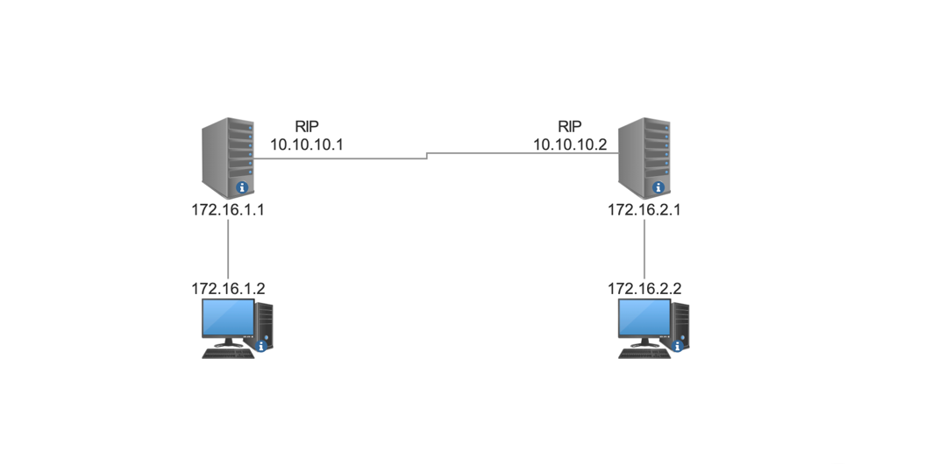
Screenshot 45 Ping Server2 from Server1
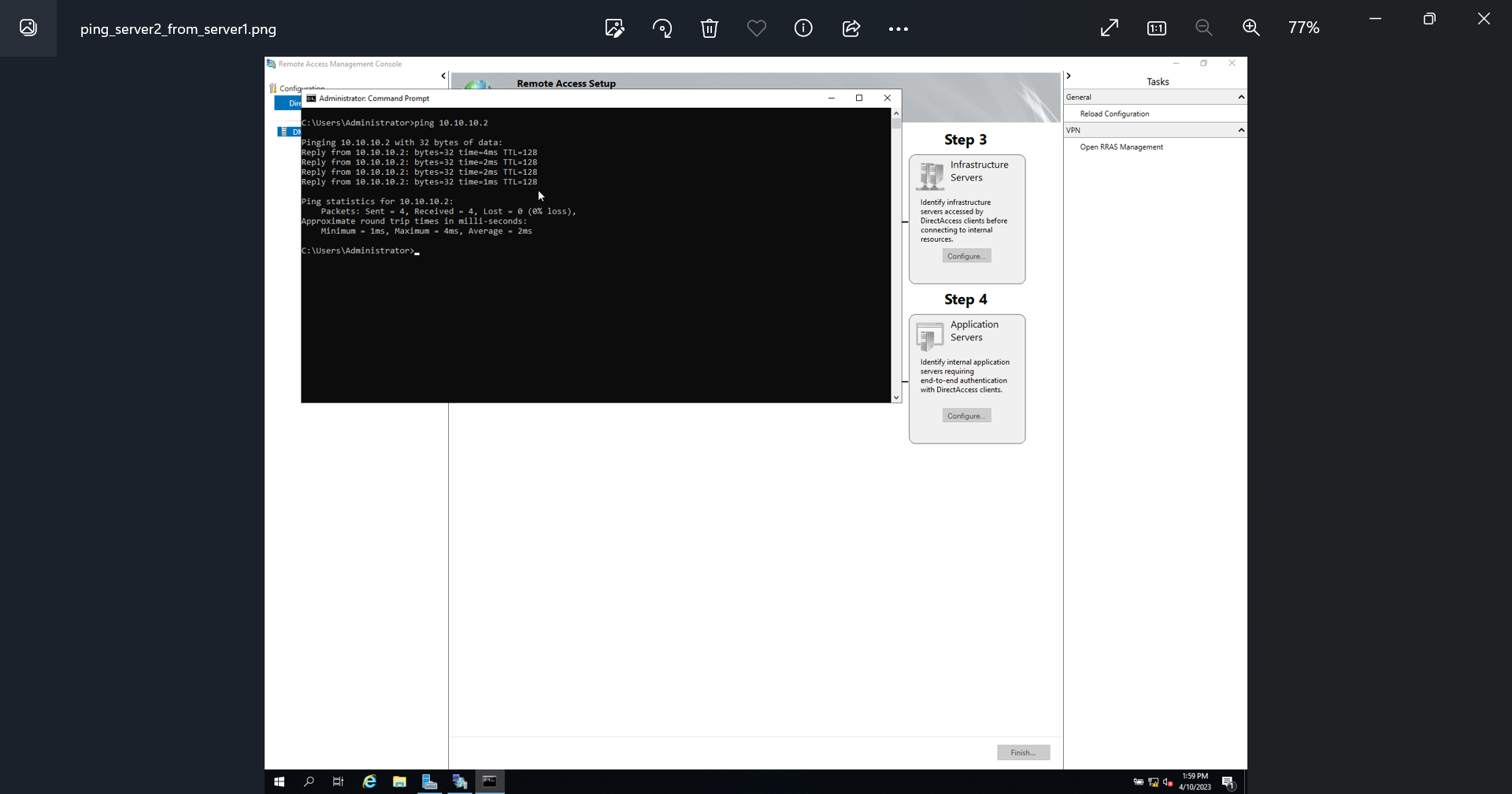

IP Filtering

Filter 1 Stopping ‘anyone’ in PrivateNet1 from Pinging the Router Firewall Service
Screenshot 46 Inbound Filters
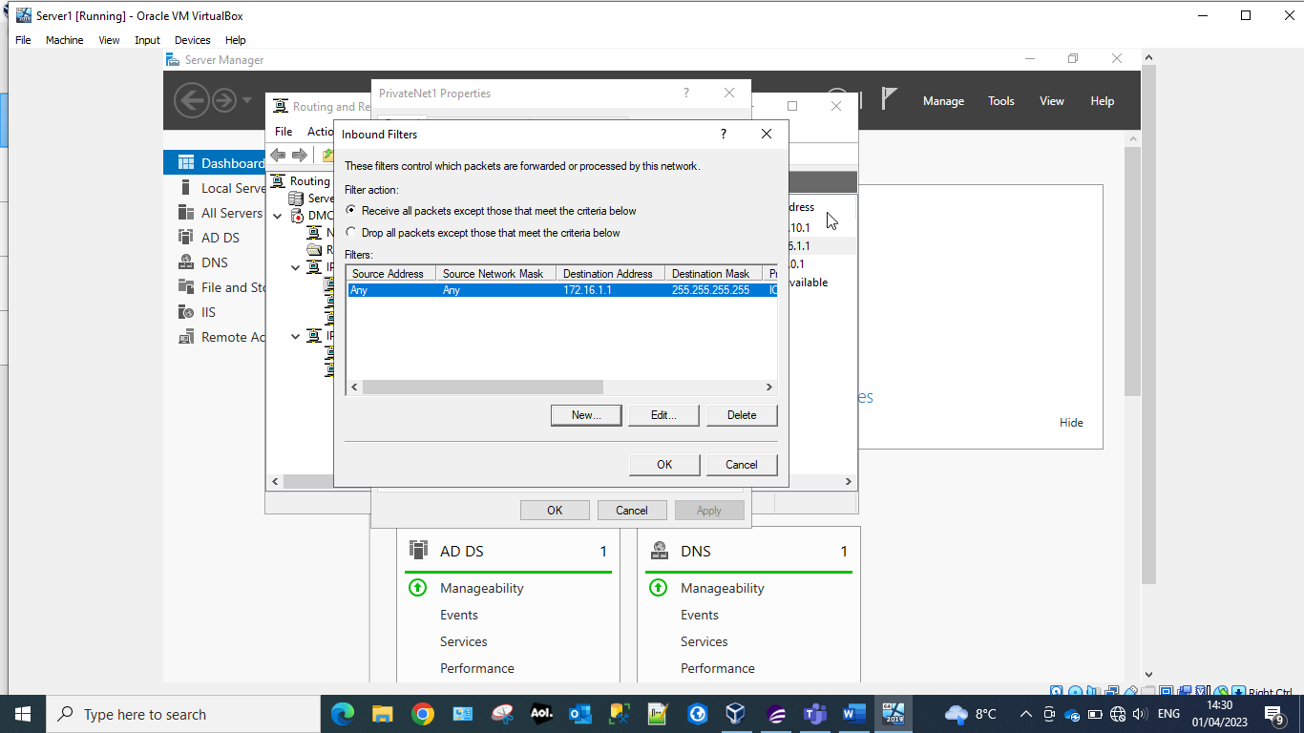
Inbound filters are a set of rules that control the incoming network traffic to the server. They form part of the Windows Firewall, which is a built-in security feature in Windows server that helps to protect the server from unauthorised access and malicious attacks.

Filter 2: Restrict Access to FTP Service on Server2 to only hosts in PrivateNet2.
Screenshot 47 Client1 can connect to ftp server.
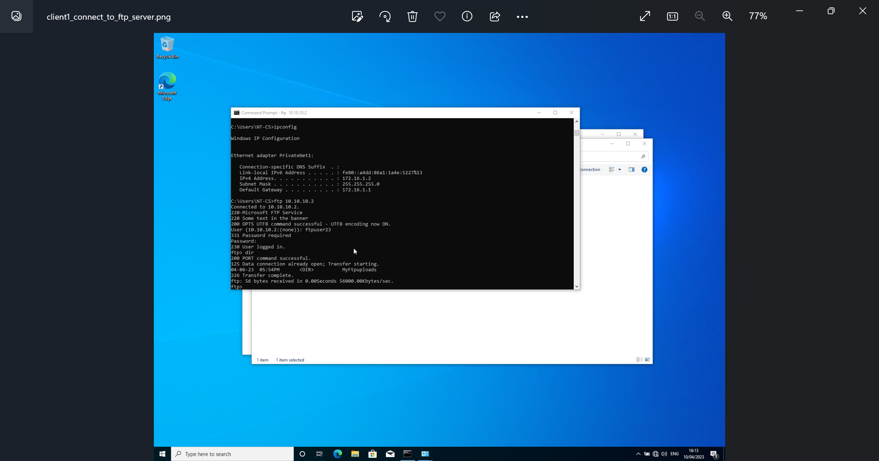
Confirmation of connection prior to the outbound filters being set.
Screenshot 48 Setting outbound filters.
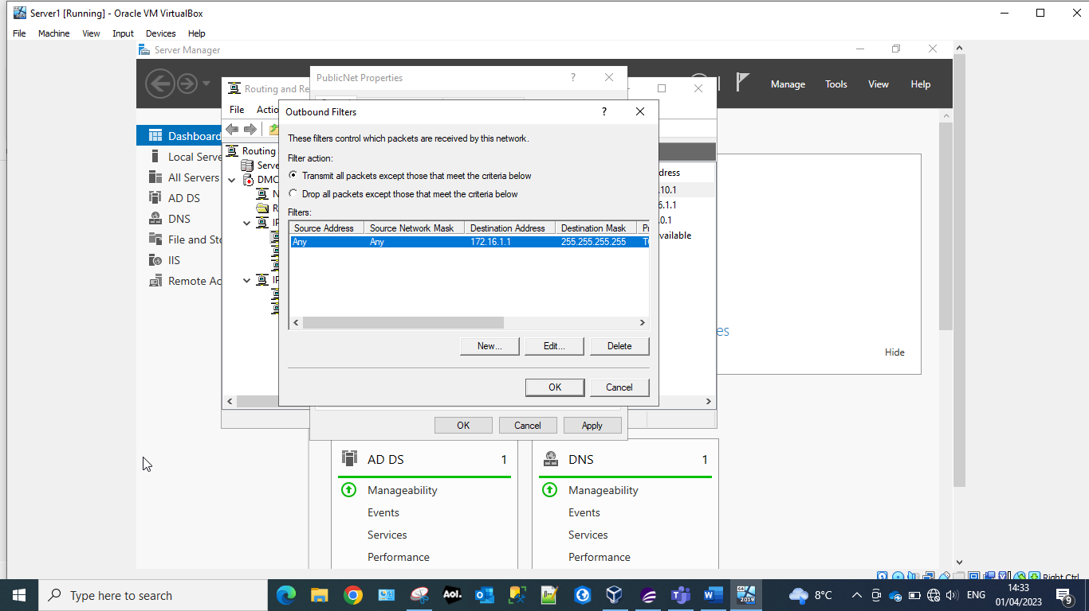
Outbound filters control the outgoing network traffic from the server. When an application or service on the server requests a network connection to a remote destination, it evaluates the connection against the outbound filters to determine if this connection is permitted or blocked. Outbound filters can be set to restrict specific types of traffic, or traffic to specific ports or to specific IP addresses. In the above screen the administrator has set an outbound filter to restrict Client1 from connect to ftp server1.
Screenshot 49 Client 1 not able to connect to ftp server1.
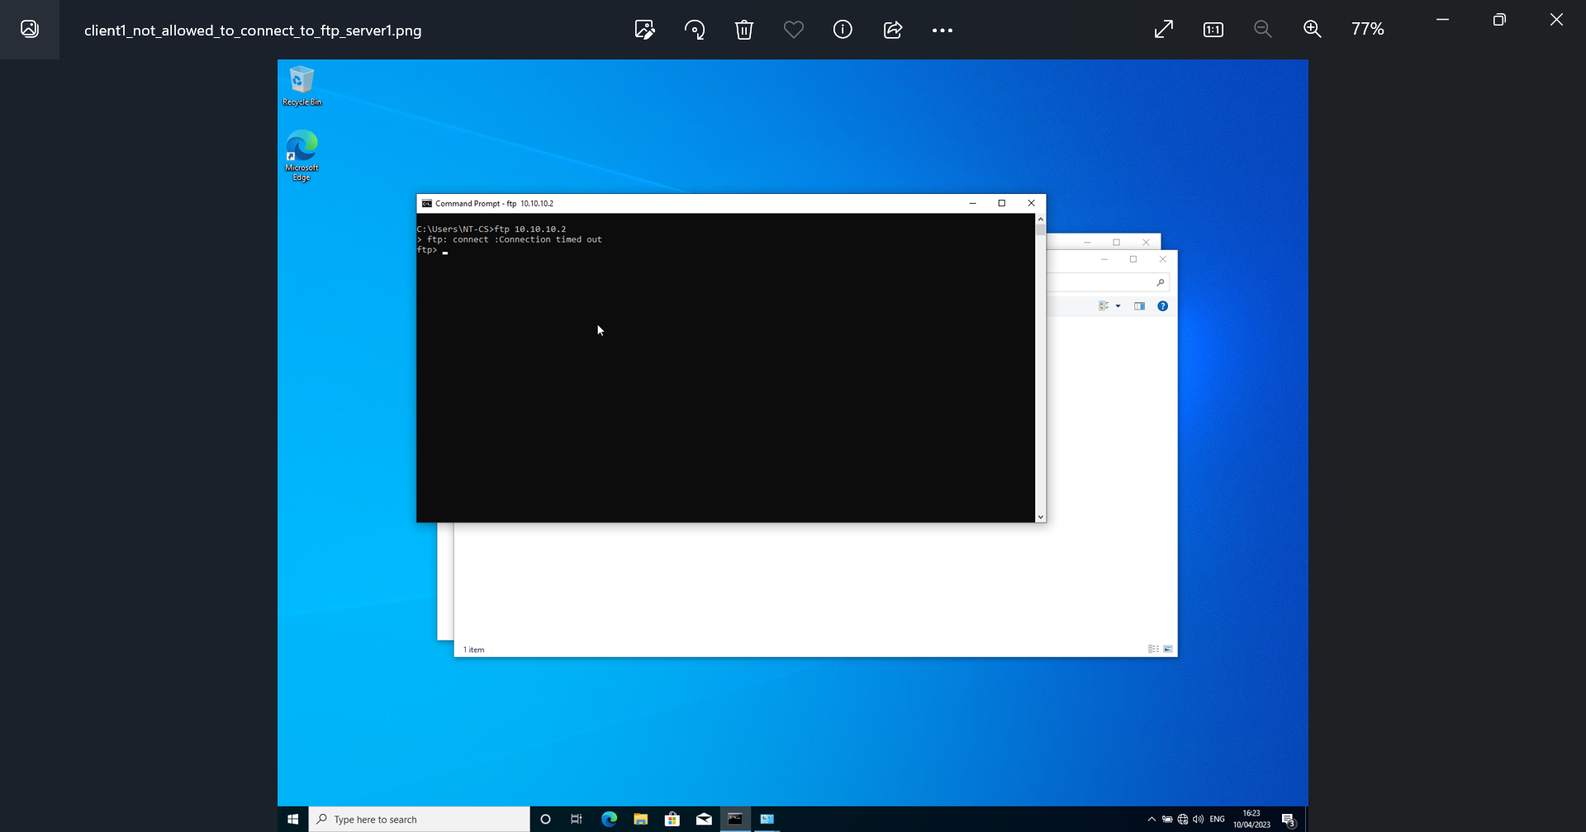
Confirmation after the outbound filter set that Client 1 can no longer connect to ftp Server1.

Filter 3: Only allow specific hosts in PrivateNet1 to access the FTP server Server2
Screenshot 50 Client 1 can connect to ftp server.
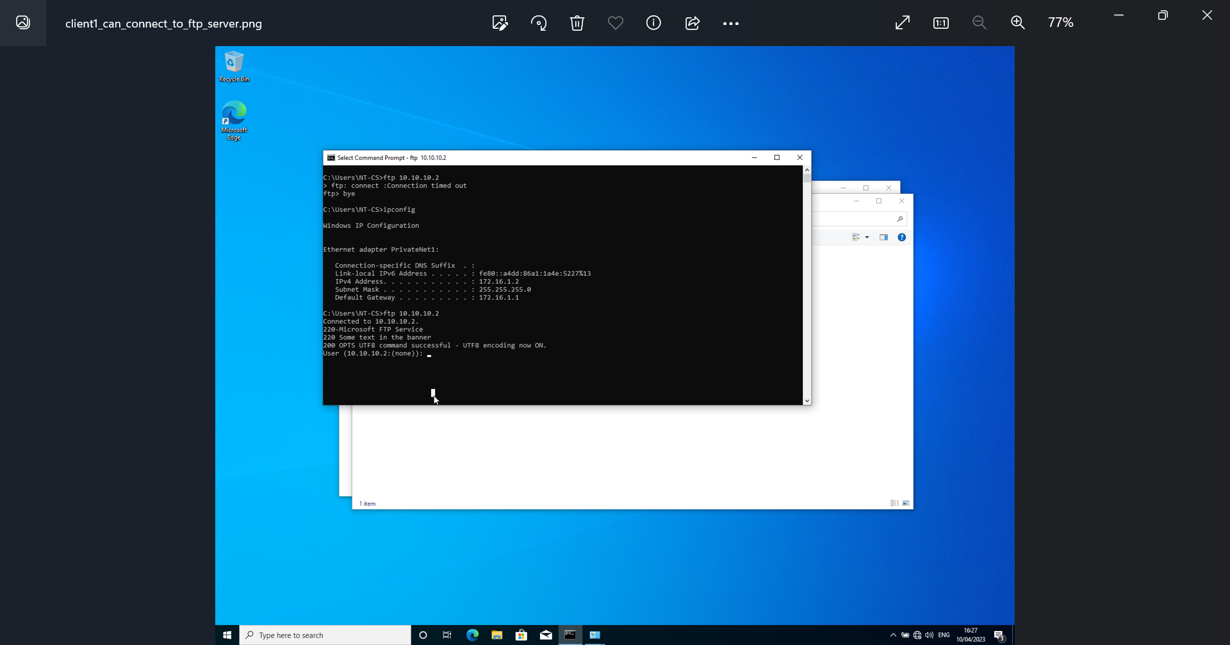
Confirmation that prior to the administrator setting the inbound filters Client1 can connect to ftp server.
Screenshot 51 inbound filter
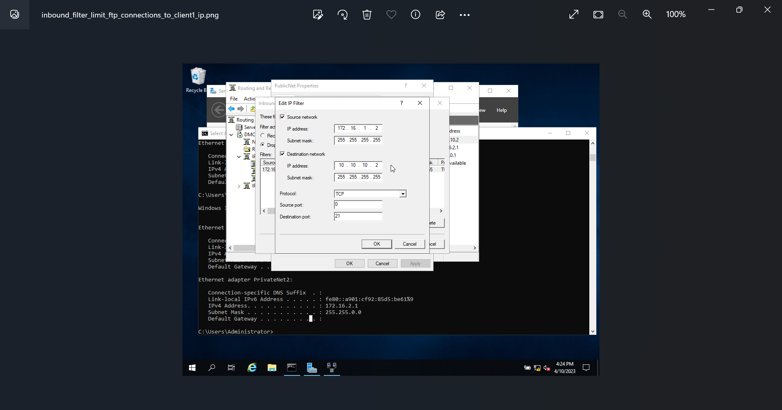
The administrator has set an inbound filter to limiting the access to the FTP server.
Screenshot 52 Server1 cannot connect to ftp server.
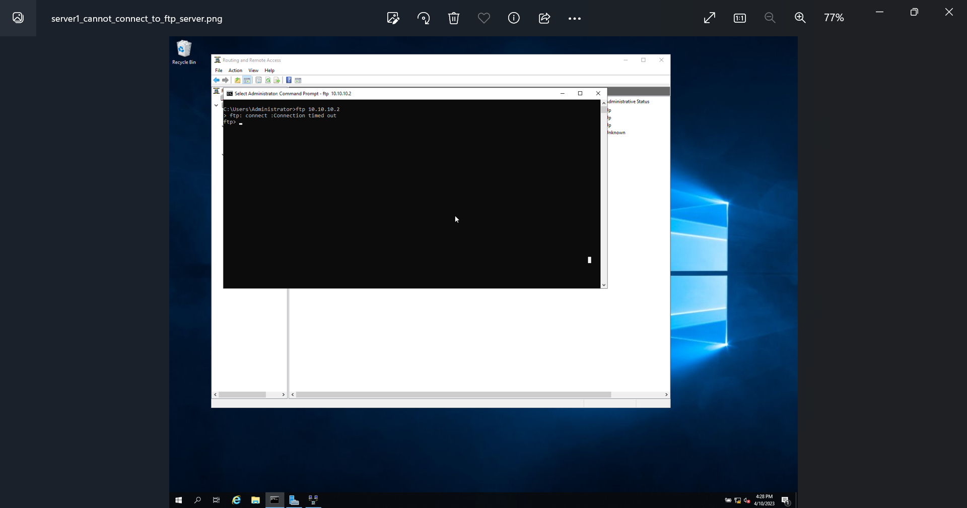
Confirmation that the inbound filters that the administrator has set now work – Server1 now cannot connect to the FTP server.

Part 2 – Observational Tasks

Enhancing security on a SOHO (Small Office/ Home Office) Network
There are several actions you can take to enhance the security of a Small Office / Home Office network, with the majority needing no additional equipment or fees.
- Change the default login credentials for all devices, systems, and servers on the SOHO network to prevent unauthorized access, and ensure that strong passwords are used these systems to prevent unauthorized access by both internal and external actors/users. A lot of times, systems are set up with either the default credentials from the factory, or network administrators will reuse the same default admin password, which opens up the systems to vulnerabilities.
- Disable remote management of any systems, servers, and devices on the SOHO network that do not require remote external access to prevent external actors gaining access.
- Keep all devices and systems up to date with the latest firmware and software updates to address security vulnerabilities.
- Install and run antivirus and anti-malware software on all devices on the SOHO network to protect against malware and other threats constantly.
- Use a firewall to block unauthorized access to your network and only keep the specific required ports open to the external internet to prevent unauthorised access from outside the network.
- Regularly backup your data to protect against data loss due to malware or hardware failure.
- Ensure that all users have the correct permission level set on their access accounts, for example using AD Groups and Organisational Units to regulate the access from a specific user to a set list of functions (e.g. blocking all software installs, disabling the command prompt, etc).
- Ensure that all file servers are protected correctly using group permissions, to allow only specific users / groups access to certain files and folders, and ensure that the various different levels of access is utilised, for example read only on certain folders, and hiding files that the user’s group membership does not permit them to view.
- Utilise MAC address filtering, to ensure that only a controlled set list of devices can communicate on the SOHO network, while blocking unrecognised devices and systems.
- Ensure that access to the physical devices, systems, and servers is strictly controlled with the use of physical access control, for example having door mag locks on certain areas, with only the required personnel having access to open these door locks via photo ID cards [3].

Failover Clustering for high availability systems/services
High Availability, or Continuous Availability, in a server environment is where failover clustering is used to remove the single point of failure in a data centre environment to ensure that the critical workloads are always available in the event of a hardware or software failure. This is accomplished by having multiple hosts grouped into a single cluster using shared storage to provide a single point of access for all the servers in the cluster. If one of the servers fails, the workload is automatically moved to another server in the cluster, ensuring that the application or service remains available to users. For example, in a Windows Server environment, this is achieved by using the Failover Clustering functionality built into Hyper-V, to allow multiple nodes to be configured so that there is continuous availability within the datacentre [4].
Before installing a Hyper-V failover cluster, there are several key considerations that should be taken into account to ensure a successful deployment, for example, but not limited to, the following:
- Hardware compatibility - Ensure that all hardware components, including servers, storage devices, network adapters, and switches, are compatible with the version of Windows Server you plan to use. This can be done by checking the hardware compatibility list (HCL) provided by Microsoft to ensure that all components are sure to work with Windows Server.
- Network configuration - Plan the network configuration to ensure that the cluster will have sufficient bandwidth and redundancy, and use dedicated network adapters for cluster elements.
- Storage configuration - Choose a shared storage solution that is compatible with Windows Server failover clustering, for example iSCSI.
- Backup and recovery - Plan the backup and recovery strategy carefully to ensure that the system can recover from data loss or corruption [5].

To set up Hyper-V failover clustering, at least two physical servers running Windows Server 2016 or later are required, and a shared storage device such as a SAN [4].
- Install the Failover Clustering feature on each server.
- Connect the servers to the shared storage device. 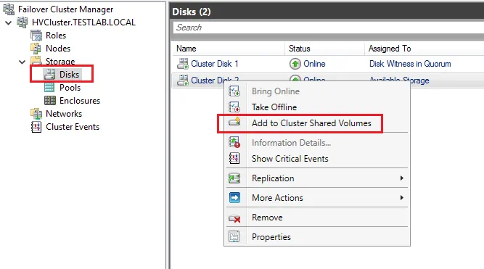
- Create a failover cluster using the Failover Cluster Manager tool. 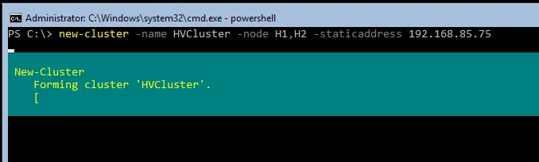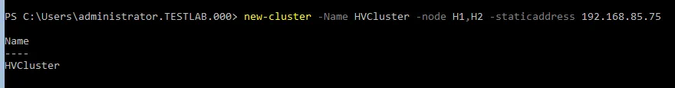
- Add the Hyper-V role to each server in the cluster.
- Create a virtual machine on one of the servers, and configure it as desired.
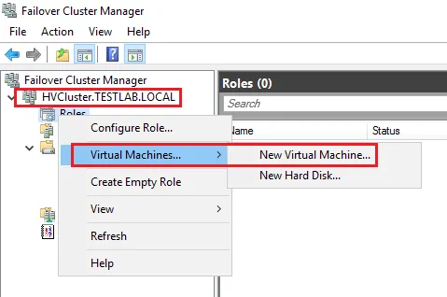
- Enable the virtual machine for replication.
- Configure the replication settings, specifying the other server in the cluster as the replica server.
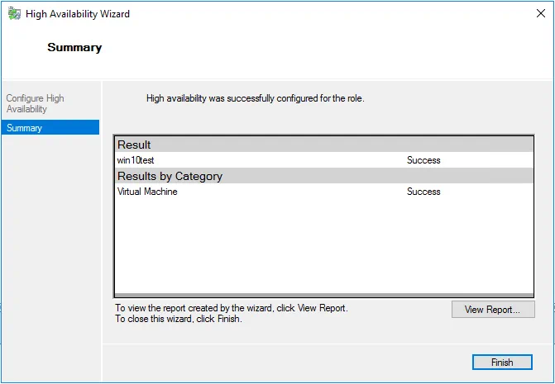
- Start the replication process.
- Test the failover by manually moving the virtual machine to the other server in the cluster.
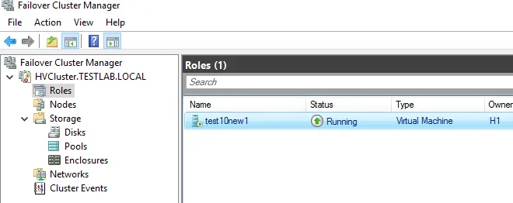

Draft Enterprise Network Policy
- Network Design: The Enterprise Network will be designed using a hierarchical topology with core, distribution, and access layers. The core layer will provide high-speed connectivity between all locations, while the distribution layer will provide routing, filtering, and load balancing. The access layer will provide access to end-user devices and will be segmented into VLANs to ensure security and manageability [6].
- High Availability: Critical business applications will be deployed in a highly available configuration using clustering, load balancing, or other appropriate technologies. Redundant network devices and links will be used to provide fault tolerance and minimize downtime. Regular testing and maintenance will be performed to ensure that the high availability configuration is functioning correctly.
- Security: The Enterprise Network will be secured using a industry led approach that includes multiple layers of security controls. These controls will include firewalls, antivirus and antimalware software, and access controls. Network traffic will be monitored for suspicious activity, and security incidents will be promptly investigated and remediated.
- Remote Access: Remote access to the Enterprise Network will be provided using secure VPN technologies that use strong authentication and encryption. Remote access will be granted on a need-to-know basis, and access will be monitored and audited to ensure compliance with security policies.
- Physical Access: Critical or sensitive equipment will be housed in secure areas, protected by a secure perimeter, with appropriate security barriers and entry controls. Critical or sensitive equipment will be protected from power supply failures. Critical or sensitive equipment will be protected by intruder alarms and fire suppression systems. Smoking, eating and drinking is forbidden in areas housing critical or sensitive equipment. All visitors to secure areas must be logged in and out. The log will contain name, organisation, purpose of visit, date, and time in and out.
Entry to secure areas housing critical or sensitive equipment will be restricted to those whose job requires it [7].
- Wireless Access: Wireless access to the Enterprise Network will be provided using secure Wi-Fi technologies that use strong authentication and encryption. Wireless access will be monitored and audited to ensure compliance with security policies.
- Third Party Access: Third party access to the network will be based on a formal written contract, with access monitored and audited to ensure compliance.
- Network Monitoring: The Enterprise Network will be monitored using appropriate tools and technologies to ensure that it is functioning correctly and that security policies are being enforced. Network traffic will be analysed for performance and security issues, and appropriate action will be taken to address any problems that are identified.
- Disaster Recovery: The Enterprise Network will have a disaster recovery plan that includes regular backups, offsite storage of backup data, and procedures for restoring critical systems in the event of a disaster. The disaster recovery plan will be tested regularly to ensure that it is effective and up-to-date [8].

Reflection
In conclusion, completion of this task has been thoroughly enjoyable and I have learnt massive amounts during the physical section in Part One and the research that enabled me to complete Part Two. The knowledge that I will finish this part of the module with will equip me going forward in my day to day work life. This task has been the second of my University life where collaborative work has been required. While it’s been a nice change in the University lifecycle, I personally believe that to truly get the most out of this module, independent learning is required – for the majority of task one and the previous worksheet, I found myself being massively ahead of the rest of the team, and even experimenting with more advanced tasks.

References

[1] | K. Brush, “Routing Information Protocol,” TechTarget, Dec 2022. [Online]. Available: https://www.techtarget.com/searchnetworking/definition/Routing-Information-Protocol. [Accessed 19th April 2023].
[2] | Lionel, “Dynamic routing,” InformatiWeb Pro, 23rd Nov 2017. [Online]. Available: https://us.informatiweb-pro.net/system-admin/win-server/ws-2012-2012-r2-dynamic-routing-ripv2.html. [Accessed 19th April 2023].
[3] | Professor Messer, “Securing a SOHO Network – CompTIA A+ 220-902 – 3.7,” 2023. [Online]. Available: https://www.professormesser.com/free-a-plus-training/220-902/securing-a-soho-network/. [Accessed 03 05 2023].
[4] | NAVIKO, “Hyper-V Cluster Setup on Windows Server Machines: A Step-by-Step Guide,” 20 06 2022. [Online]. Available: https://www.nakivo.com/blog/hyper-v-cluster-setup/. [Accessed 03 05 2023].
[5] | Microsoft, “Failover clustering hardware requirements and storage options,” Microsoft, 29 03 2022. [Online]. Available: https://learn.microsoft.com/en-us/windows-server/failover-clustering/clustering-requirements. [Accessed 03 05 2023].
[6] | Cisco, “Campus Network for High Availability Design Guide,” 21 05 2008. [Online]. Available: https://www.cisco.com/c/en/us/td/docs/solutions/Enterprise/Campus/HA_campus_DG/hacampusdg.html. [Accessed 03 05 2023].
[7] | Digital Social Care, “Network Security Policy – Template,” 2023. [Online]. Available: https://www.digitalsocialcare.co.uk/resource/network-security-policy-template/. [Accessed 03 05 2023].
[8] | C. Moozakis and S. Gittlen, “Ultimate guide to network management in the enterprise,” TechTarget, 02 03 2022. [Online]. Available: https://www.techtarget.com/searchnetworking/Ultimate-guide-to-network-management-in-the-enterprise. [Accessed 03 05 2023].

