

COURSE’S NAME: Indipendent Project (LCLM 6006)
STUDENT’S NAME: Alba Bartolini
STUDENT’S ID: 2230835
LECTURE’S NAME: Olusoyi Richard Ashaye

ASSIGNMENT TITLE:

Exploring Employee Turnover and Its Impact on Employee Morale: A Case
Study at The North Face in London

Acknowledgements

I would like to express my sincere gratitude to my dissertation supervisor for their invaluable guidance, constructive feedback, and continuous support throughout the development of this research. Their insights and encouragement have been instrumental in shaping the direction and quality of this study.
I am also deeply grateful to all the participants who generously gave their time to take part in the interviews. Their openness and willingness to share their experiences provided the foundation for this research and made it possible to gain meaningful insights into employee turnover and morale within the organisation.
My appreciation extends to the academic staff at the University of Wales Trinity Saint David for their support and for providing a stimulating learning environment throughout my studies. The knowledge and skills I have developed during my degree have played a crucial role in the completion of this dissertation.
Finally, I would like to thank my family and Erika Vegh for their constant encouragement, patience, and understanding. Their support has been invaluable throughout this journey and has motivated me to persevere and complete this research.

Abstract

Employee turnover remains a significant challenge within the retail sector, with important implications for organisational performance and employee well-being. This study investigates the relationship between employee turnover and employee morale within The North Face retail stores in London, with a particular focus on the role of leadership and organisational culture.
Adopting an interpretivist research philosophy and an inductive approach, the study employs a qualitative case study design. Primary data were collected through semi-structured interviews with employees working within the organisation. The data were analysed using thematic analysis to identify key patterns and insights related to turnover and morale.
The findings reveal that employee turnover is influenced by a combination of organisational and psychological factors, including workload, limited career development opportunities, and perceived lack of recognition. High levels of turnover were found to negatively impact employee morale by increasing work pressure, disrupting team cohesion, and reducing overall job satisfaction. The study also highlights the critical role of leadership and organisational culture, demonstrating that supportive leadership and a positive work environment can mitigate some of the negative effects of turnover.
The research contributes to existing literature by providing an in-depth, qualitative understanding of the relationship between turnover and morale within a retail context. It offers practical implications for organisations seeking to improve employee retention and enhance workplace well-being. However, the findings are limited by the small sample size and the focus on a single organisational setting.

Table of Contents
Chapter 1: Introduction 6
1.1 Introduction 6
1.2 Background of the Study 6
1.3 Problem Statement 6
1.4 Research Rationale 7
1.5 Significance of the Study 7
1.6 Need for the Study 8
1.7 Scope of the Study 8
1.8 Research Aim and Objectives 8
1.9 Research Questions 9
1.10 Overview 9
Chapter 2: Literature Review 9
2.1 Introduction 9
2.2 Employee Turnover 10
2.3 Employee Morale 10
2.4 Relationship Between Employee Turnover and Morale 11
2.5 Leadership 12
2.6 Organisational Culture 12
2.7 Theoretical Framework 13
2.7.1 Maslow’s Hierarchy of Needs 13
2.7.2 Herzberg’s Two-Factor Theory 14
2.7.3 Job Demands–Resources (JD-R) Model 14
2.8 Consequences of the Cycle: Survivor Syndrome and Workload Spike 16
2.9 Research Gap 16
2.10 Conceptual framework 17
2.11 Summary 17
Chapter 3: Research Methodology 18
3.1 Introduction to Research Methodology 18
3.2 Research Philosophy 18
3.3 Research Approach 18
3.4 Research Design 19
3.5 Data Collection Method- Primary Data Collection 19
3.6 Sampling Strategy 19
3.6.1 Sampling Method 19
3.6.2 Sample Size 19
3.7 Data Analysis Methods 20
3.8 Ethical Considerations 20
3.9 Summary 20
Chapter 4: Data Analysis, Findings and Discussion 21
4.1 Introduction 21
4.2 Participant Profile 22
4.3 Thematic analysis 23
4.3.1 Thematic Analysis of Interview Data 23
4.3.2 Causes of Employee Turnover (RO1) 23
4.3.3 Impact of Turnover on Employee Morale (RO2) 23
4.3.4 Leadership and Organisational Culture (RO3) 24
4.3.5 Improvements and Retention Strategies (RO4) 24
4.3.6 Analytical Summary 24
4.4 Coding and Categorisation Analysis 25
Identification and Relationship of Variables 25
4.5 Alignment with Research Question 30
4.6 Discussion 30
4.9 Summary 32
Chapter 5: Conclusion, Limitations, and Recommendations of Research 33
5.1 Introduction 33
5.2 Summary of Key Findings in Relation to Research Objectives (RO1–RO4) 33
5.3 Limitations of the Study 34
5.4 Future Study 34
5.5 Implications of the Study 35
5.6 Recommendations 35
5.7 Conclusion 36
References 38
Appendices 40
Appendix A 40
Appendix B 43
Personal Reflection Gibbs Reflective Cycle 54
POSTER 57

Chapter 1: Introduction

1.1 Introduction
Employee turnover and employee morale are key determinants of organisational performance, particularly in the retail sector. High turnover increases costs, disrupts team cohesion, and reduces service quality, while morale influences motivation, engagement, and job satisfaction in customer-facing environments (Jung and Yoon, 2021).
Although some workforce mobility may support flexibility, this is less relevant in retail, where consistency is essential. High turnover is therefore more likely to affect performance and employee engagement negatively.
The North Face emphasises innovation, sustainability, and performance, yet maintaining a stable and motivated workforce remains a challenge. This study explores the relationship between turnover and morale from employees’ perspectives.

1.2 Background of the Study
The retail industry is characterised by high employee turnover, often driven by demanding working conditions, limited career progression, and inconsistent management practices. While these structural factors are well established, they may overlook how employees’ perceptions and daily experiences shape turnover behaviour. Employees’ subjective interpretations play a key role in influencing their decision to remain or leave (Al Mamun and Hasan, 2023).
Retail employees are central to both sales’ performance and customer experience. However, the emotional demands of retail work can place additional pressure on employees, which is not always fully captured in traditional turnover models.
Employee morale is closely linked to turnover. Dissatisfaction may lead employees to seek alternative employment, while turnover can negatively affect remaining staff by increasing workload and disrupting team relationships. This reflects a dynamic and reciprocal relationship between turnover and morale (Wang et al., 2022).

1.3 Problem Statement
Employee turnover remains a significant challenge in the retail sector, often driven by dissatisfaction, limited development opportunities, and work-related stress. These factors can negatively affect engagement, service quality, and organisational performance (Saeed et al., 2021).

Within The North Face, turnover may disrupt team cohesion, increase workload, and reduce motivation. A perceived lack of leadership support may further intensify dissatisfaction and turnover intentions, highlighting the critical role of leadership in employee retention (Karatepe et al., 2020).
Despite extensive research, much of the literature remains generalised and predominantly quantitative, limiting understanding of employees’ lived experiences. There is limited qualitative research exploring how frontline retail employees interpret turnover, morale, leadership, and organisational culture. Addressing this gap is essential for developing more context-specific and effective retention strategies.

1.4 Research Rationale
This study adopts an employee-centred perspective to examine turnover and morale. Existing research has largely relied on quantitative methods, which may not fully capture the complexity of employees’ lived experiences. Qualitative approaches are therefore important for understanding subjective meanings and interpretations (Busetto et al., 2020).
The retail context, characterised by high interaction and emotional labour, provides a suitable setting for examining this relationship. This study contributes by exploring how employees interpret and experience workplace conditions, offering both academic and practical insights.

1.5 Significance of the Study
This study is significant from both academic and practical perspectives. Academically, it contributes by providing qualitative insights into employee turnover and morale, addressing a gap in research that has traditionally prioritised quantitative analysis. While existing studies are effective in identifying patterns, they often fail to capture the complexity of employees’ lived experiences. As argued by Tracy (2020), qualitative research is essential for understanding subjective meanings and workplace experiences in greater depth.
From a practical perspective, the findings can assist organisations in identifying key factors influencing employee retention and morale. By focusing on employee experiences, organisations can develop more targeted strategies to improve leadership, workplace culture, and engagement.
Furthermore, the study is relevant to the wider retail sector, where managing turnover remains a persistent challenge requiring deeper contextual understanding. By offering insights grounded in employee perspectives, this research supports more informed and effective organisational practices.

1.6 Need for the Study
The need for this study arises from ongoing challenges related to employee turnover in the retail industry. Despite extensive research, there remains a limited focus on employees’ subjective experiences, particularly within specific organisational contexts. Shin and Hur (2021) highlight that understanding employee perceptions is essential for improving retention strategies.
This study addresses this gap through a qualitative approach that enables in-depth exploration of employee experiences. In addition, evolving workplace expectations further emphasise the need to reassess traditional approaches to employee management (ILO, 2022).

1.7 Scope of the Study
This study focuses on employees working at The North Face, including individuals in roles such as sales assistants, supervisors, and managers. The research adopts a qualitative approach, using semi-structured interviews to collect primary data.
The scope is limited to examining the relationship between employee turnover and employee morale, with particular emphasis on leadership support and organisational culture. While the qualitative approach provides detailed insights, the findings may not be generalisable to all retail organisations (Bell et al., 2022).
The study prioritises employee perceptions rather than quantitative performance data.

1.8 Research Aim and Objectives
Aim
This study aims to explore the relationship between employee turnover and employee morale at The North Face.
Objectives
1. To critically examine the factors contributing to employee turnover.
2. To examine how employee turnover influences employee morale.
3. To understand employees’ perceptions of leadership support and organisational culture.
4. To explore employee perspectives on potential improvements to enhance retention and morale.

1.9 Research Questions
1. What are the main causes of staff turnover at The North Face?
2. How does staff turnover impact employee morale and motivation?
3. How do employees perceive leadership support and workplace culture in relation to turnover?

1.10 Overview
This dissertation is structured into five chapters, each addressing a specific aspect of the research.
Chapter One introduces the study by outlining the research background, problem statement, research aim, objectives, and research questions.
Chapter Two presents a critical review of the literature on employee turnover, morale, leadership, and organisational culture, alongside relevant theoretical frameworks.
Chapter Three outlines the research methodology, including the qualitative approach, data collection methods, and data analysis techniques.
Chapter Four presents and critically analyses the findings derived from the primary data, linking them to existing literature and theoretical perspectives.
Chapter Five concludes the study by summarising key findings, offering practical recommendations, and identifying limitations and areas for future research.
Overall, this dissertation aims to provide a comprehensive and context-specific understanding of the relationship between staff turnover and employee morale.

Chapter 2: Literature Review

2.1 Introduction
This chapter critically reviews existing literature on employee turnover, employee morale, leadership, and organisational culture within the retail sector. These factors are central to understanding employee experiences and organisational performance in customer-facing environments. While previous research provides valuable insights, it is largely dominated by quantitative approaches, often overlooking employees’ lived experiences.
Accordingly, this chapter synthesises and critically evaluates key theoretical frameworks, including motivation theories and the Job Demands–Resources (JD-R) model, to explain how workplace conditions shape employee outcomes. It also identifies key gaps in the literature, particularly the limited qualitative exploration of employee perceptions within specific organisational contexts, thereby justifying the present study.

2.2 Employee Turnover
Employee turnover refers to the rate at which employees leave an organisation and are replaced. Within the retail sector, turnover remains consistently high and is often linked to structural factors such as job insecurity, irregular working hours, and limited career progression.
Recent research conceptualises turnover as a psychological process shaped by employee dissatisfaction and perceived alternative opportunities, where individuals actively interpret their work experiences rather than simply reacting to external conditions (Hom et al., 2020). However, this perspective often relies on quantitative data and may overlook the depth of employees’ subjective experiences.
Turnover is increasingly viewed as a strategic organisational issue rather than purely operational. High turnover can disrupt service quality and reduce organisational knowledge, particularly in customer-facing environments. While some scholars suggest that turnover may be functional, this view may underestimate broader consequences, such as reduced morale and team instability.
Overall, existing literature provides valuable insights but remains limited by its reliance on quantitative indicators. This highlights the need for qualitative research to better understand employees’ reasons for leaving within specific organisational contexts.

2.3 Employee Morale
Employee morale refers to employees’ overall emotional well-being, job satisfaction, and motivation within the workplace. It is closely linked to engagement and organisational commitment, influencing both individual performance and organisational outcomes. Low morale is associated with increased absenteeism, reduced productivity, and higher turnover intentions (Saks, 2022).
Within the retail sector, morale is particularly important due to its direct impact on customer experience. Employees with positive attitudes are more likely to deliver high-quality service and contribute to a supportive work environment, whereas low morale may result in disengagement and reduced performance. These outcomes are shaped by organisational factors such as workload, staffing levels, and managerial practices.
Despite its importance, a key limitation of existing research lies in the subjective nature of morale. Quantitative measures often fail to capture the complexity of employees’ emotional experiences, reducing morale to simplified indicators. This highlights the need for qualitative approaches to better understand how morale is experienced within specific organisational contexts.
Morale is therefore influenced by interconnected factors, including leadership, organisational culture, and job demands, reinforcing the need for an integrated perspective when examining employee experiences.

2.4 Relationship Between Employee Turnover and Morale
The relationship between employee turnover and employee morale is complex and mutually reinforcing. Rather than operating as independent variables, these factors interact continuously, shaping both employee experiences and organisational outcomes. Low levels of morale, often associated with dissatisfaction and limited organisational support, can significantly increase employees’ intentions to leave (Kim and Beehr, 2020).
Conversely, high turnover can negatively affect the morale of remaining employees. The departure of colleagues may increase workload, disrupt team dynamics, and reduce organisational knowledge, contributing to stress, lower motivation, and a weakened sense of belonging. These effects are particularly significant in retail environments, where teamwork and communication are essential for performance.
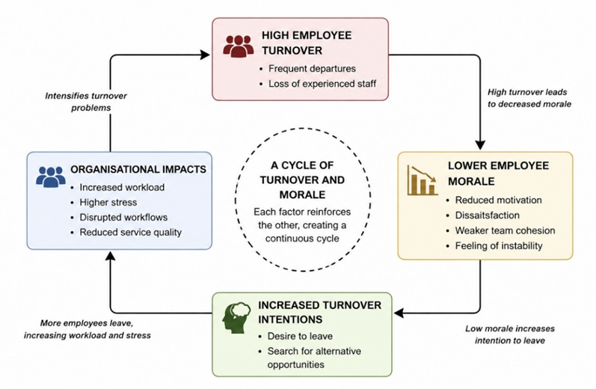
Figure 2.1: Conceptual relationship between employee turnover and employee morale (Source: Developed by the researcher based on Kim and Beehr, 2020)
This interaction can be understood as a cyclical process, as illustrated in Figure 2.1, in which turnover and morale influence each other over time. High turnover may reduce morale through instability and increased pressure, while low morale can further intensify turnover intentions. Over time, this cycle may become embedded, making it difficult to maintain a stable workforce.
This dynamic is especially relevant in retail contexts such as The North Face, where even minor disruptions in morale or staffing can affect both employee performance and customer experience. Understanding this relationship is therefore essential for improving retention and organisational effectiveness.

2.5 Leadership
Leadership is a key factor influencing employee morale and turnover within organisations. Effective leadership fosters a supportive work environment, enhances communication, and promotes engagement, whereas ineffective leadership can lead to dissatisfaction and increased turnover intentions (Inceoglu et al., 2021). This highlights leadership as a central driver of employee experience.
Transformational leadership, characterised by inspiration and support, has been associated with higher levels of morale and organisational commitment. Leaders who recognise contributions and support development are more likely to create positive work environments. However, leadership effectiveness is context dependent. In fast-paced retail settings such as The North Face, managers must balance operational demands with employee support, which may limit the consistent application of such behaviours.
Leadership also shapes employees’ perceptions of fairness and organisational support. When managers are approachable and consistent, employees are more likely to remain engaged. Conversely, poor communication and inconsistency may increase dissatisfaction and turnover intentions.
Overall, leadership plays a central role in influencing morale and turnover, highlighting the importance of effective and adaptive management practices.

2.6 Organisational Culture
Organisational culture plays a fundamental role in shaping employee experiences, behaviours, and attitudes within the workplace. It reflects the shared values, beliefs, and norms that guide how individuals interact and perform within an organisation. According to Schein’s model, culture consists of three interconnected levels: artefacts, espoused values, and underlying assumptions, which together provide a framework for understanding organisational dynamics (Schein and Schein, 2021).
A positive organisational culture, characterised by trust, collaboration, and recognition, can enhance employee morale and contribute to higher levels of engagement and retention. In retail environments, where teamwork and customer interaction are essential, a supportive culture fosters a sense of belonging and encourages effective performance. Employees who feel valued are more likely to develop stronger organisational commitment, reducing their likelihood of leaving (Taris and Schaufeli, 2021).
However, organisational culture may also have negative effects when there is misalignment between espoused values and actual practices. Organisations may promote values such as teamwork and respect, yet employees may experience inconsistent behaviours or limited support. These discrepancies can lead to dissatisfaction, reduced trust, and increased turnover intentions, highlighting that culture is defined not only by stated values but by their consistent implementation.
In retail organisations such as The North Face, cultural factors including communication, fairness, and managerial support are particularly significant. Therefore, a well-aligned organisational culture is essential for maintaining morale and reducing turnover.

2.7 Theoretical Framework
This study adopts an integrated theoretical approach to examine employee turnover and morale within a retail context, recognising that a single framework would provide only a partial explanation. Therefore, multiple theories are combined to capture both individual and organisational influences (Cooke et al., 2021).
Maslow’s Hierarchy of Needs and Herzberg’s Two-Factor Theory explain motivation and job satisfaction at an individual level, highlighting how unmet needs and lack of recognition can reduce morale and increase turnover intentions. However, their focus is limited in addressing wider organisational factors (Nguyen et al., 2022).
To overcome this, the Job Demands–Resources (JD-R) model is incorporated, showing how job demands and resources interact to influence employee well-being. Together, these frameworks provide a more comprehensive understanding of employee morale and turnover within The North Face London.

2.7.1 Maslow’s Hierarchy of Needs
Maslow’s Hierarchy of Needs proposes that individuals are motivated by the fulfilment of a sequence of needs, ranging from basic physiological requirements to higher-level needs such as esteem and self-actualisation (Maslow, 1943). According to this model, lower-level needs must be satisfied before individuals can be motivated by higher-level aspirations. In organisational contexts, this suggests that employees require adequate working conditions, job security, and financial stability before they can fully engage with opportunities for recognition and personal development.
However, the model has been criticised for its rigid hierarchical structure and limited consideration of contextual factors influencing motivation (Taormina and Gao, 2021). Employees may prioritise needs differently depending on individual circumstances, organisational culture, and external pressures.
In the context of The North Face London, unmet higher-level needs such as recognition, career progression, and personal development may contribute to reduced morale. When employees perceive limited growth opportunities, their motivation may decline, increasing the likelihood of turnover intentions. Therefore, Maslow’s model provides a useful framework for understanding how unmet needs can influence both morale and employee retention.

2.7.2 Herzberg’s Two-Factor Theory
Herzberg’s Two-Factor Theory distinguishes between hygiene factors and motivators as key determinants of employee satisfaction (Herzberg, 1959). Hygiene factors, such as salary, working conditions, and company policies, do not necessarily increase satisfaction but can lead to dissatisfaction if absent. In contrast, motivators, including recognition, achievement, and growth opportunities, are essential for enhancing job satisfaction and motivation.
Despite its influence, the theory has been criticised for oversimplifying the relationship between satisfaction and dissatisfaction, as some factors may operate differently depending on context (Alfayad and Arif, 2021). Additionally, the distinction between hygiene factors and motivators is not always clear in practice.
Within The North Face London, dissatisfaction related to pay, workload, and working conditions may contribute to higher turnover, while the absence of motivators such as recognition and career development opportunities may reduce employee morale. This highlights the importance of addressing both hygiene factors and motivators to create a more balanced and supportive work environment.

2.7.3 Job Demands–Resources (JD-R) Model
The Job Demands–Resources (JD-R) model provides a broader organisational perspective by examining how job demands and resources interact to shape employee well-being and behaviour. Job demands, such as workload, time pressure, and staffing shortages, require sustained effort and can lead to stress and burnout when excessive. In contrast, job resources, including managerial support, recognition, and autonomy, help employees cope with demands and maintain motivation.
Within a retail context such as The North Face London, the balance between demands and resources is particularly significant. High workloads and limited staffing may increase pressure on employees, while insufficient support can intensify strain and reduce morale. Conversely, when adequate resources are available, employees are better able to manage demands, sustain performance, and remain engaged.
The JD-R model, therefore, complements motivation-based theories by incorporating organisational conditions, offering a more comprehensive explanation of how workplace factors contribute to employee morale and turnover intentions (Demerouti and Bakker, 2022).
Table 2.1 Overview of Theories
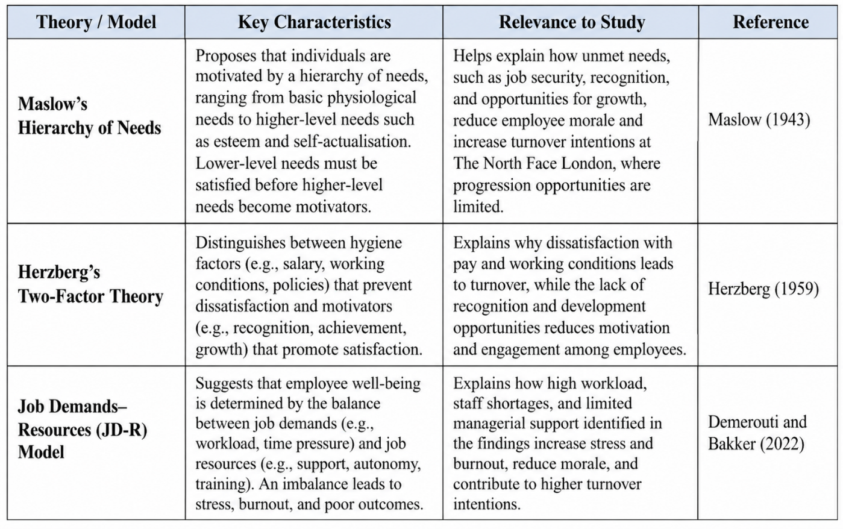
The table outlines the key theoretical frameworks underpinning this study and demonstrates how each contributes to understanding the relationship between employee turnover and morale. Maslow’s Hierarchy of Needs explains how unmet basic and psychological needs such as job security, recognition, and opportunities for growth can reduce motivation and increase the likelihood of employees leaving. Herzberg’s Two-Factor Theory builds on this by distinguishing between hygiene factors (e.g., salary and working conditions), which prevent dissatisfaction, and motivators (e.g., achievement and development), which actively enhance satisfaction and engagement.
The Job Demands–Resources (JD-R) model provides a more comprehensive perspective by linking individual motivation to organisational conditions. It shows how high job demands, such as workload and time pressure, combined with insufficient resources, such as managerial support or training, can lead to stress, burnout, and ultimately higher turnover intentions. By integrating these frameworks, the table highlights that employee experiences are shaped by the interaction between personal needs, job design, and organisational support, offering a multi-dimensional explanation of turnover and morale within The North Face London.

2.8 Consequences of the Cycle: Survivor Syndrome and Workload Spike
When turnover occurs at The North Face, the immediate consequence is a significant spike in workload for the remaining staff. Fathi et al. (2023) define this as "Survivor Syndrome," where employees feel a mix of guilt, anxiety, and exhaustion. These survivors must cover more floor space and handle more technical queries with fewer resources, which often leads to the prioritization of sales targets over technical storytelling. This increased demand leads to rapid burnout, which Ahmad et al. (2023) link to a total collapse in team cohesion. For a flagship store, this means that even if sales targets are temporarily met, the underlying human infrastructure is being eroded by the pressure of covering gaps, making the remaining staff more susceptible to external recruitment offers.

2.9 Research Gap
Despite extensive research on employee turnover and morale, existing literature presents several limitations. Much of the research in the retail sector adopts a quantitative approach, focusing on measurable factors such as turnover rates and job satisfaction, while overlooking employees’ subjective experiences and perceptions. This creates a gap in understanding how individuals interpret and respond to workplace conditions.
Furthermore, many studies examine turnover or morale in isolation rather than exploring their dynamic and reciprocal relationship. As a result, limited attention has been given to how declining morale can both result from and contribute to turnover. Additionally, the use of single theoretical frameworks often restricts the ability to capture the complexity of employee experiences shaped by both individual motivation and organisational conditions (Holtom et al., 2022).
This study addresses these gaps by adopting a qualitative approach within a specific retail context, The North Face London, and by integrating multiple theoretical frameworks to provide a more comprehensive understanding of how employee morale and turnover interact.

2.10 Conceptual framework
This study develops a conceptual framework to examine the relationship between employee turnover and employee morale at The North Face London, directly aligned with the research questions (RQ1–RQ3). The framework adopts an integrated approach, combining the Job Demands–Resources (JD-R) model with Maslow’s Hierarchy of Needs and Herzberg’s Two-Factor Theory to capture both individual and organisational influences on employee outcomes (Demerouti and Bakker, 2022).
In relation to RQ1 (causes of turnover), the framework identifies key drivers such as high job demands (e.g., workload and time pressure) and insufficient job resources (e.g., managerial support, recognition, and development opportunities). These factors, alongside unmet employee needs and dissatisfaction, contribute to increased turnover intentions.
Regarding RQ2 (impact of turnover on morale), the framework conceptualises turnover as a cyclical process. High turnover increases pressure on remaining employees, leading to stress, reduced motivation, and declining morale, which in turn reinforces further turnover.
In relation to RQ3 (perceptions of leadership and organisational culture), job resources such as leadership support, fairness, and communication are central. Positive leadership enhances motivation and satisfaction, while inconsistent management reduces trust and negatively shapes employee experiences.
Overall, the framework proposes that employee turnover and morale are interdependent outcomes shaped by the interaction between job demands, job resources, and individual motivational factors, reflecting the complexity of employee behaviour in organisational settings (Van den Broeck et al., 2021).

2.11 Summary
This chapter has critically examined the literature on employee turnover, employee morale, leadership, and organisational culture, highlighting their interdependent nature within retail environments. The review demonstrates that turnover and morale are not isolated constructs, but are shaped by the interaction between individual motivation, organisational conditions, and workplace relationships.
While existing research provides valuable theoretical insights, it is often constrained by an overreliance on quantitative approaches, which reduce complex employee experiences to measurable variables and overlook their subjective and context-dependent nature. In addition, turnover is frequently conceptualised as a static outcome rather than a dynamic and evolving process, limiting understanding of how employees interpret their work experiences over time.
Classical motivation theories, such as Maslow’s Hierarchy of Needs and Herzberg’s Two-Factor Theory, offer important insights into individual behaviour but are limited in capturing broader organisational complexity. In contrast, the Job Demands–Resources (JD-R) model provides a more integrative perspective by examining the interaction between job demands and organisational support.
These limitations highlight a key gap in the literature, particularly the lack of qualitative, context-specific research. This study addresses this gap by adopting a qualitative approach, enabling a deeper understanding of employee experiences within The North Face London.
The following chapter builds on these insights by outlining the methodological approach used to investigate these issues.

Chapter 3: Research Methodology

3.1 Introduction to Research Methodology
This chapter outlines the methodological approach adopted to explore the relationship between employee turnover and employee morale within The North Face, London. It presents the research philosophy, approach, design, data collection methods, sampling strategy, and data analysis techniques. The chapter also addresses ethical considerations and research quality issues to ensure the credibility and trustworthiness of the findings.

3.2 Research Philosophy
This study adopts an interpretivist research philosophy, focusing on understanding subjective meanings and employee experiences. Interpretivism is appropriate as it enables exploration of how individuals perceive turnover, morale, leadership, and organisational culture within their work environment. Its strength lies in producing rich and meaningful insights, which align with the exploratory nature of this research (Denzin and Lincoln, 2023).

3.3 Research Approach
This study adopts an inductive research approach, which is particularly suitable for qualitative research, as it allows for flexibility and the development of new theoretical insights grounded in participants’ experiences (Timmermans and Tavory, 2022).
Although existing theories, such as the JD-R model and motivation theories, inform the study, they are not directly tested. Instead, the research seeks to explore how these theoretical concepts are reflected in employees’ lived experiences.
A limitation of the inductive approach is the potential for researcher bias in interpreting the data. To address this, a systematic and transparent process is followed throughout data analysis to enhance consistency and reliability.

3.4 Research Design
Qualitative research is particularly effective for exploring complex social phenomena, as it captures detailed and context-rich data that cannot easily be quantified. According to Flick (2022), qualitative approaches enable researchers to explore participants’ subjective meanings and experiences within real-life contexts.
This study employs a case study design, focusing on The North Face. The case study approach allows for a detailed investigation of a specific organisational setting, enabling a deeper understanding of employee turnover and morale within a real-life context.
While this design may limit the generalisability of the findings, it enhances the depth and contextual relevance of the analysis, aligning with the interpretivist research philosophy.

3.5 Data Collection Method- Primary Data Collection
The semi-structured interview guide used to collect data is presented in Appendix A, providing a balance between structure and flexibility. Semi-structured interviews are particularly suitable for this study as they facilitate the exploration of complex issues such as employee morale, leadership, and organisational culture. Open-ended questions enable participants to provide rich and detailed responses. Interviews were conducted face-to-face within three days, and participants’ consent was obtained to ensure accuracy and depth of data collection by the manager.

3.6 Sampling Strategy

3.6.1 Sampling Method
A purposive sampling strategy was used to select participants based on their relevance to the research aim. This approach enables the collection of meaningful insights from individuals with direct experience of the research context (Saunders et al., 2023).

3.6.2 Sample Size
Based on a sample size of 18 employees, the study included ten participants across different organisational levels, comprising one store manager, one assistant manager, two supervisors, and six sales assistants. This structure reflects the organisation and allows comparison between managerial and frontline perspectives.
The sample size is appropriate for qualitative research, where the focus is on depth rather than generalisation (Hennink et al., 2020).

3.7 Data Analysis Methods
Data were analysed using thematic analysis to identify and interpret patterns within the data (Braun and Clarke, 2021). This approach aligns with interpretivist research by allowing for the exploration of participants’ subjective experiences.
The analysis followed a structured process involving coding, theme development, and refinement. Themes were defined and presented through an analytical narrative integrating participant evidence with relevant theory.
A detailed interview coding table was developed to organise themes and participant responses, ensuring transparency and analytical consistency, providing a clear foundation for the findings in Chapter 4.

3.8 Ethical Considerations
Participation in this study was entirely voluntary. Although access to participants was facilitated through permission granted by the store manager, all employees were approached independently and were under no obligation to participate.
Participants were fully informed about the purpose of the research and provided informed consent before participation. They were also made aware of their right to withdraw at any time without consequences.
Given the sensitivity of some workplace discussions, confidentiality and anonymity were strictly maintained throughout the research process (British Psychological Society, 2021).
Ethical approval for this empirical study was formally granted by the University of Wales Trinity Saint David, ensuring that the research complied with institutional ethical requirements and protected participants throughout the research process.
For Ethical form please see Appendix B.

3.9 Summary
This chapter has outlined the methodological framework used to explore the relationship between employee turnover and employee morale within The North Face. An interpretivist philosophy and inductive approach were adopted to gain in-depth insights into employees’ subjective experiences. A qualitative case study design was employed, with data collected through semi-structured interviews using a purposive sample of participants across different organisational levels.
The data were analysed using thematic analysis, ensuring a systematic and transparent process for identifying key patterns and themes. Ethical considerations were carefully addressed, with voluntary participation, informed consent, confidentiality, and institutional ethical approval ensuring the protection of participants. Overall, the chosen methodology provides a robust and appropriate foundation for analysing the research questions in Chapter 4.

Chapter 4: Data Analysis, Findings and Discussion

4.1 Introduction
This chapter presents a critically interpretative analysis of qualitative data collected through semi-structured interviews with employees at The North Face. It examines the relationship between employee turnover and employee morale in line with the research aim and objectives. A thematic analysis approach is used to identify key patterns and relationships within participants’ experiences.
Rather than describing responses, the chapter explains how and why specific factors influence employee attitudes and behaviours, providing insight into organisational dynamics within a retail context. The analysis is structured around four interconnected themes: causes of turnover, its impact on morale, the role of leadership and organisational culture, and strategies to improve retention.
The chapter begins with a brief demographic overview, followed by the analytical framework, before presenting findings that are critically interpreted in relation to relevant theoretical perspectives.

4.2 Participant Profile
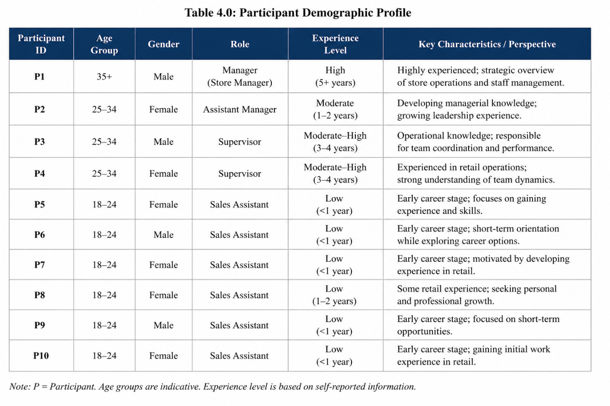
The sample included employees across different organisational levels, consisting of one store manager, one assistant manager, two supervisors, and six sales assistants. This distribution reflects the typical structure of a retail organisation, where most employees operate in frontline roles.
A key distinction within the data is the difference between more experienced managerial staff and younger frontline employees. The manager and supervisors demonstrated a broader organisational perspective, often referring to operational challenges, staffing pressures, and retention issues. In contrast, sales assistants, who were generally younger and less experienced, focused more on immediate working conditions, such as workload, pay, and interpersonal relationships.
These variations are significant, as they indicate that perceptions of employee turnover and morale are shaped by role, experience, and career stage. Consequently, the findings should be interpreted with consideration of these differences, as they influence how workplace conditions are experienced and evaluated.

4.3 Thematic analysis

4.3.1 Thematic Analysis of Interview Data
The qualitative data were analysed using thematic analysis following Braun and Clarke (2021), enabling the identification of recurring patterns across participants’ experiences. Four key themes were developed in line with the research objectives: causes of employee turnover, impact on employee morale, leadership and organisational culture, and improvements for retention.

4.3.2 Causes of Employee Turnover (RO1)
The findings indicate that employee turnover is driven by a combination of financial, structural, and organisational factors. Financial dissatisfaction emerged as a key issue, with participants highlighting that “pay doesn’t reflect the workload” (P2), suggesting that compensation is closely linked to perceptions of fairness.
Limited career progression was another significant factor. Participants expressed frustration with restricted growth opportunities, reinforcing the idea that employees seek long-term development rather than short-term employment. In addition, external opportunities, such as better-paying jobs or roles aligned with personal goals, further contribute to turnover decisions.
Work-related conditions also play a role. Unstable schedules and high workload pressure, particularly during peak periods, increase stress and reduce job satisfaction. These findings suggest that turnover is not caused by a single issue but by the interaction of multiple organisational and external pressures.

4.3.3 Impact of Turnover on Employee Morale (RO2)
Turnover has a direct and negative impact on employee morale. One of the most prominent effects is increased workload, where remaining employees experience “heavy workload and stress” (P2), leading to burnout.
Emotionally, frequent staff changes create instability and frustration, making employees feel less secure in their roles. Socially, turnover influences behaviour through what can be described as turnover contagion, where employees begin to consider leaving after observing others do so, as reflected in the statement “makes me feel like I should leave too” (P5).
Turnover also disrupts team dynamics. Constant changes in staff make it difficult to build strong working relationships, weakening team cohesion. These findings demonstrate that turnover not only affects organisational performance but also reshapes employees’ emotional and social experiences at work.

4.3.4 Leadership and Organisational Culture (RO3)
Leadership and organisational culture play a crucial role in shaping employee experiences. Positive leadership was associated with higher levels of morale and retention, with participants noting that “good leadership makes people want to stay” (P3). This suggests that supportive management can act as a protective factor against turnover.
However, inconsistencies in management support reduce trust and weaken employees’ sense of security. Some participants highlighted issues of favouritism and unfair treatment, which negatively impact engagement and morale.
Workplace culture also influences employee experience. A team-oriented and collaborative environment can enhance satisfaction and mitigate some of the negative effects of turnover. In contrast, negative cultural elements can amplify dissatisfaction. These findings indicate that leadership and culture are central to both employee retention and morale.

4.3.5 Improvements and Retention Strategies (RO4)
Participants identified several strategies to improve morale and reduce turnover. Financial improvements, particularly better pay, were consistently highlighted as a key factor. Employees also emphasised the importance of clear career progression pathways, which enhance motivation and long-term commitment.
Work conditions, including the need for a better work-life balance and more stable schedules, were also identified as critical. A fixed schedule was seen as reducing stress and improving overall satisfaction.
Additionally, organisational support, particularly adequate staffing and resources, was viewed as essential for reducing workload pressure. These findings suggest that improving retention requires a comprehensive approach that addresses financial, developmental, and organisational factors simultaneously.

4.3.6 Analytical Summary
The thematic analysis demonstrates that employee turnover and morale are closely interconnected and influenced by multiple factors. High job demands, limited resources, and weak organisational support contribute to dissatisfaction and turnover, while positive leadership and supportive environments can enhance retention. The findings highlight the complexity of employee experiences and reinforce the need for an integrated approach to managing turnover within retail settings.

4.4 Coding and Categorisation Analysis

Identification and Relationship of Variables
To structure the data analysis, this study categorises workplace factors using a variable framework. Independent variables represent organisational drivers such as pay, managerial support, career progression, and workload. These influence dependent variables, including employee morale, team cohesion, and turnover intentions. The relationship is further shaped by moderating factors, such as personal career goals and the predominantly young (18–24) workforce. This framework highlights how weaknesses in organisational drivers lead to negative employee outcomes, while moderators explain variations in responses.
Table 4.4.1 Conceptual Variable Framework of Organisational Drivers, Employee Outcomes, and Moderating Factors
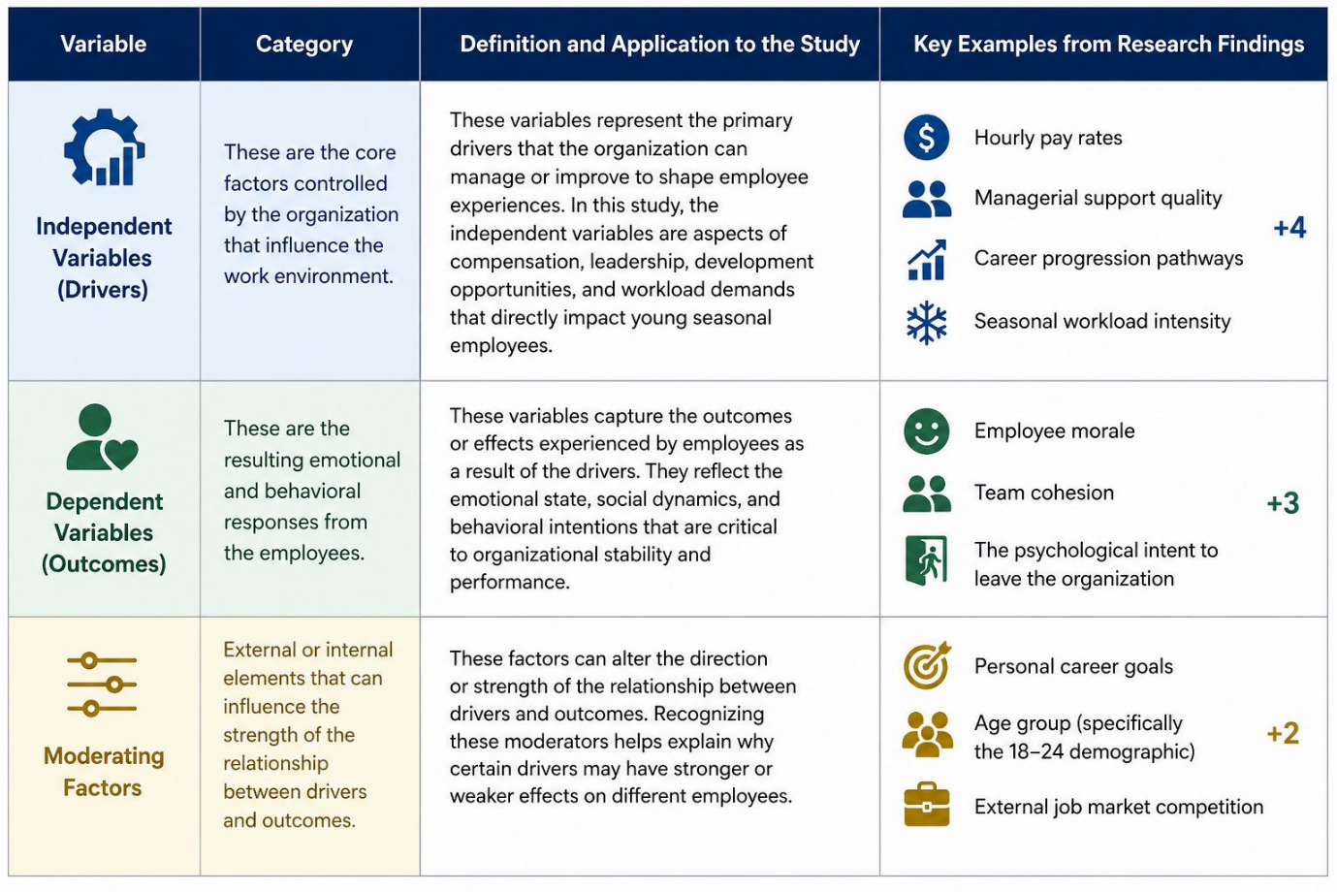

Table 4.4.2 Factors Influencing Employee Turnover (RO1)
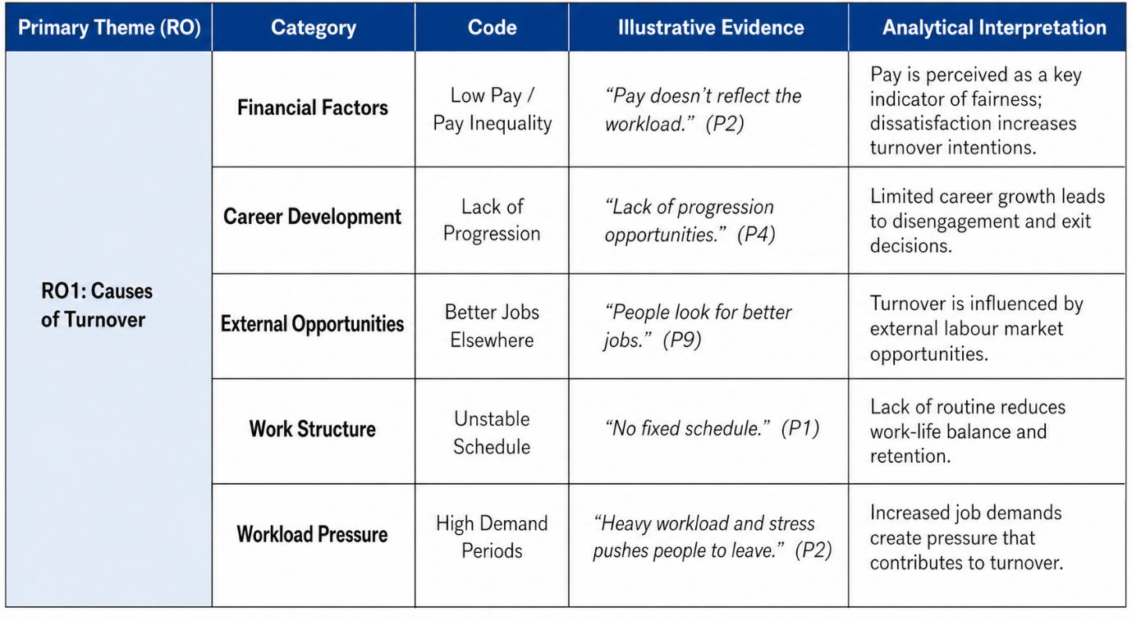
The table you provided explains the main causes of employee turnover (RO1) by organising participants’ responses into categories, codes, and interpretations. It shows how raw interview data is transformed into meaningful themes.
Each row represents a specific factor contributing to turnover. For example, the category Financial Factors is supported by the code Low Pay / Pay Inequality, illustrated by the quote “Pay doesn’t reflect the workload” (P2). This is then interpreted to show that employees see pay as a reflection of fairness, meaning dissatisfaction increases their intention to leave.
Similarly, Career Development highlights that a lack of progression leads to disengagement, while External Opportunities shows that employees may leave simply because better jobs are available elsewhere. The table also captures organisational issues such as unstable schedules, which reduce work-life balance, and high workload pressure, which creates stress and pushes employees to leave.
Overall, the table demonstrates that turnover is influenced by multiple interconnected factors, rather than a single cause. By linking participant quotes to analytical interpretations, it provides clear evidence that employee decisions to leave are shaped by financial, structural, and organisational conditions within the workplace.

Table 4.4.3 Impact of Employee Turnover on Employee Morale (RO2)
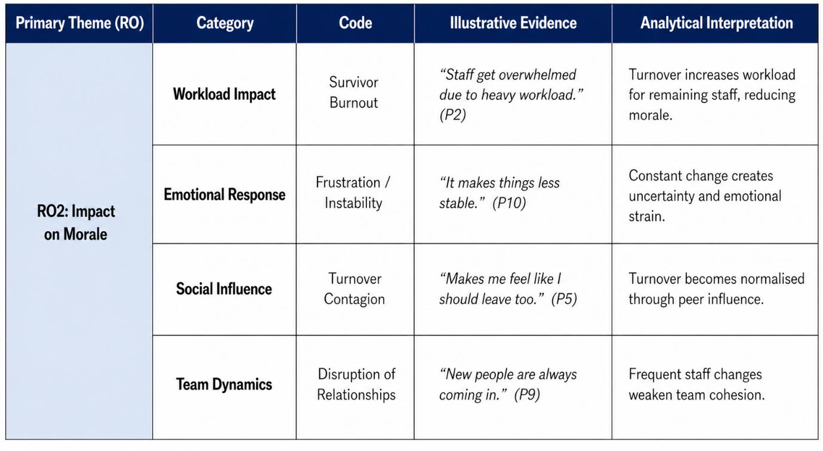
This table presents the impact of employee turnover on employee morale (RO2) by organising participants’ responses into categories, codes, and interpretations. It demonstrates how turnover affects employees not only operationally but also emotionally and socially within the workplace.
The first category, Workload Impact, highlights survivor burnout, where remaining employees experience increased pressure due to staff shortages. This shows that turnover directly increases job demands, leading to reduced morale.
The Emotional Response category captures feelings of frustration and instability. Frequent staff changes create uncertainty, making employees feel less secure and more emotionally strained.
The Social Influence category introduces turnover contagion, where employees are influenced by others leaving. Observing colleagues exit normalises the idea of leaving, which can spread dissatisfaction across the team.
Finally, Team Dynamics demonstrates how turnover disrupts relationships. Constant staff changes weaken team cohesion and make it more difficult to maintain stable working relationships.
The table highlights that turnover has a multi-dimensional impact on morale, affecting workload, emotions, social behaviour, and team structure, and contributing to a cycle where reduced morale can further increase turnover intentions.
Table 4.4.4 Leadership and Organisational Culture Influencing Employee Morale (RO3)
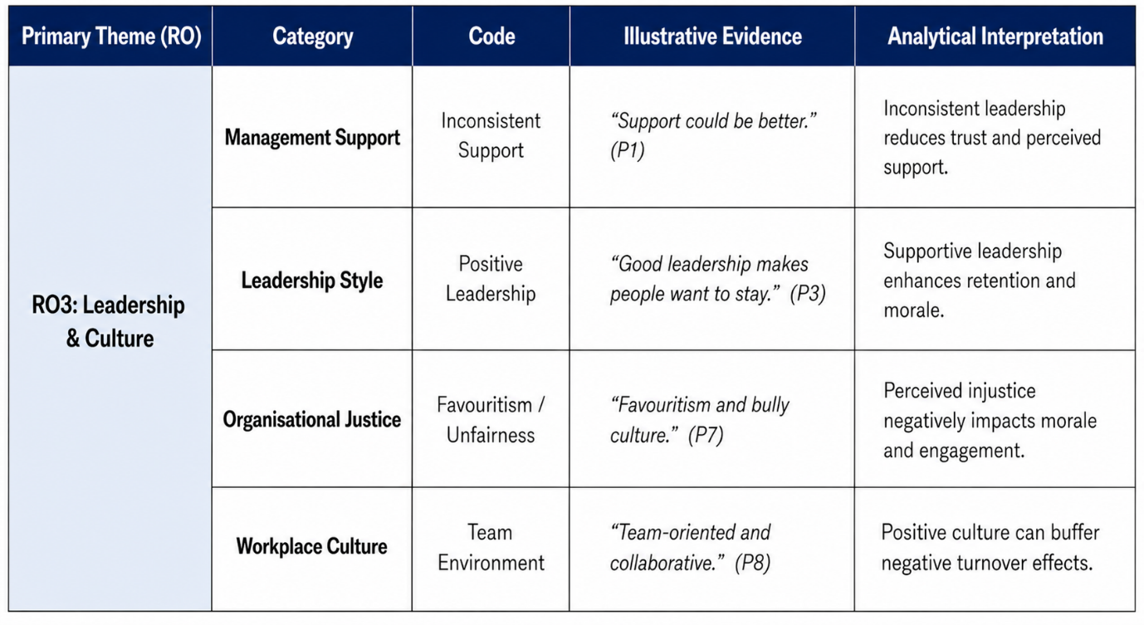
This table presents the findings related to leadership and organisational culture (RO3) by structuring participants’ responses into categories, codes, and analytical interpretations. It shows how different aspects of leadership and workplace culture influence employee morale and retention.
The Management Support category highlights issues of inconsistent support, where participants feel that leadership is not always reliable. This reduces trust and weakens employees’ perception of organisational support.
The Leadership Style category reflects the positive side, showing that supportive and effective leadership encourages employees to stay. This suggests that leadership quality plays a direct role in enhancing both morale and retention.
The Organisational Justice category introduces concerns around favouritism and unfair treatment. These perceptions negatively impact employee morale, as employees feel undervalued and disengaged when fairness is lacking.
Finally, Workplace Culture emphasises the importance of a team-oriented environment. Positive and collaborative cultures help employees feel supported and can reduce the negative effects of turnover.
The table demonstrates that leadership and culture act as key influencing factors, where positive practices can strengthen morale and retention, while inconsistency and perceived unfairness can significantly undermine employee experience.
Table 4.4.5 Improvements and Retention Strategies (RO4)
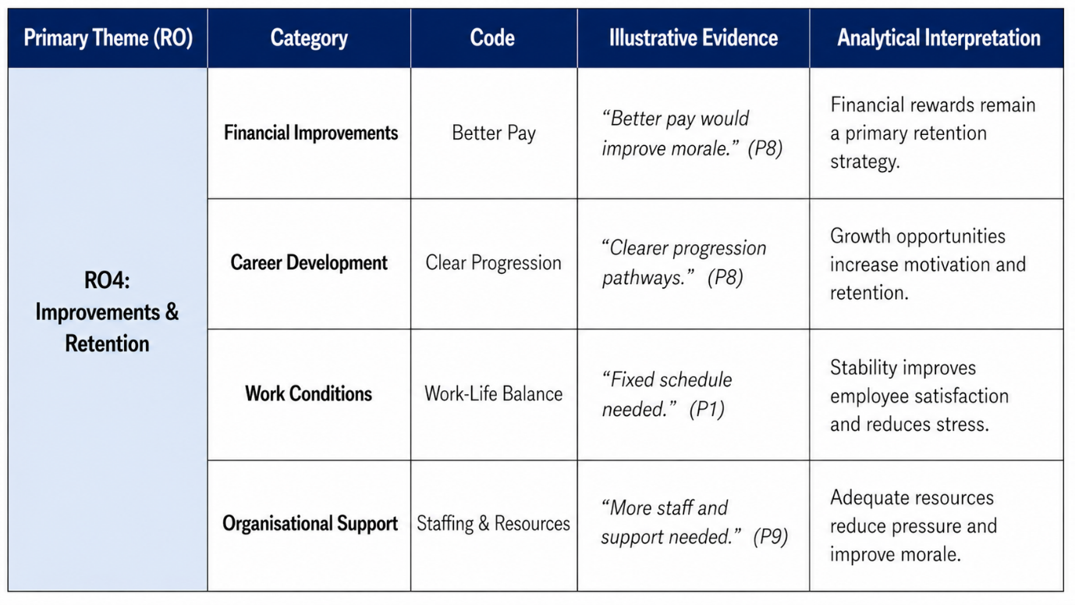
This table presents the findings related to improvements and retention (RO4) by organising participant responses into key categories, codes, and interpretations. It identifies the main areas employees believe should be addressed to improve morale and reduce turnover.
The Financial Improvements category highlights better pay as a central factor. Participants link financial rewards directly to motivation, suggesting that fair compensation is essential for retaining employees.
The Career Development category focuses on clear progression pathways. Employees are more likely to remain in the organisation when they can see opportunities for growth and advancement, which increases engagement and long-term commitment.
The Work Conditions category emphasises work-life balance, particularly the need for stable and predictable schedules. A fixed schedule is seen as improving satisfaction and reducing stress, making roles more sustainable.
The Organisational Support category identifies the importance of adequate staffing and resources. When teams are properly supported, workload pressure decreases, which positively impacts morale.
The table shows that improving retention requires a combination of financial, developmental, and organisational changes, reflecting the need for a holistic approach to enhancing employee experience.

4.5 Alignment with Research Question
The figure presents a conceptual variable framework that structures the analysis in line with the research questions (RQ1–RQ3). It distinguishes between independent variables (organisational drivers), dependent variables (employee outcomes), and moderating factors that influence the strength of these relationships. This framework provides a systematic lens for understanding how workplace conditions shape employee experiences within The North Face London.
In relation to RQ1, the independent variables such as pay, managerial support, career progression opportunities, and workload intensity, which represent the key drivers of employee turnover. These factors reflect aspects of the organisational environment that directly influence employees’ decisions to remain in or leave the organisation.
Regarding RQ2, the dependent variables capture the outcomes of these drivers, including employee morale, team cohesion, and the psychological intention to leave. The framework illustrates how negative organisational conditions, such as high workload or limited support, translate into reduced morale and increased turnover intentions.
In relation to RQ3, moderating factors such as personal career goals, age demographic, and external labour market conditions, which shape how employees perceive leadership and organisational culture. These factors help explain why similar organisational conditions may produce different responses among employees.
This framework establishes a clear analytical structure by demonstrating that employee turnover and morale are not isolated outcomes but are shaped by the interaction between organisational drivers and individual characteristics. It supports a comprehensive interpretation of the findings by linking empirical data to the research questions and underlying theoretical perspectives.

4.6 Discussion
The findings indicate that employee turnover and employee morale at The North Face are not separate issues, but interconnected processes shaped by structural conditions, individual perceptions, and social dynamics. Rather than operating independently, the causes of turnover (RO1), its impact on morale (RO2), and the role of leadership and culture (RO3) interact in a cyclical system.
Financial dissatisfaction and limited progression reduce morale, particularly when employees feel undervalued. This effect is intensified by inconsistent leadership and poor communication. In turn, low morale increases turnover intentions, which further disrupts team stability and increases workload, reinforcing dissatisfaction. This demonstrates that turnover is not a linear outcome but part of a dynamic organisational process.
The findings extend the Job Demands–Resources (JD-R) model by showing that the impact of job demands depends on how employees perceive support, fairness, and recognition. Employee motivation is also influenced by intrinsic and extrinsic factors, as explained by self-determination theory (Ryan and Deci, 2020). In this context, employees not only respond to external conditions such as pay and workload, but also to internal factors such as recognition, sense of value, and personal development. Similarly, motivation is not experienced in fixed stages, as suggested by Maslow, but reflects multiple needs pursued simultaneously. Herzberg’s distinction between hygiene factors and motivators is also blurred, as pay is associated with recognition and fairness, not only dissatisfaction.
Turnover is also socially influenced, as employees are affected by colleagues’ decisions to leave, reinforcing perceptions of alternative opportunities. This contributes to a self-reinforcing cycle where turnover reduces morale, and declining morale increases further turnover.
The findings highlight the importance of consistent leadership and organisational culture. Employees value fairness, stability, and respect, and inconsistency weakens trust and engagement.
This analysis suggests that turnover should be viewed as an indicator of deeper organisational issues rather than a standalone problem. Addressing it requires a holistic approach that considers organisational structures, leadership practices, and employee perceptions simultaneously. See summary of validation below:
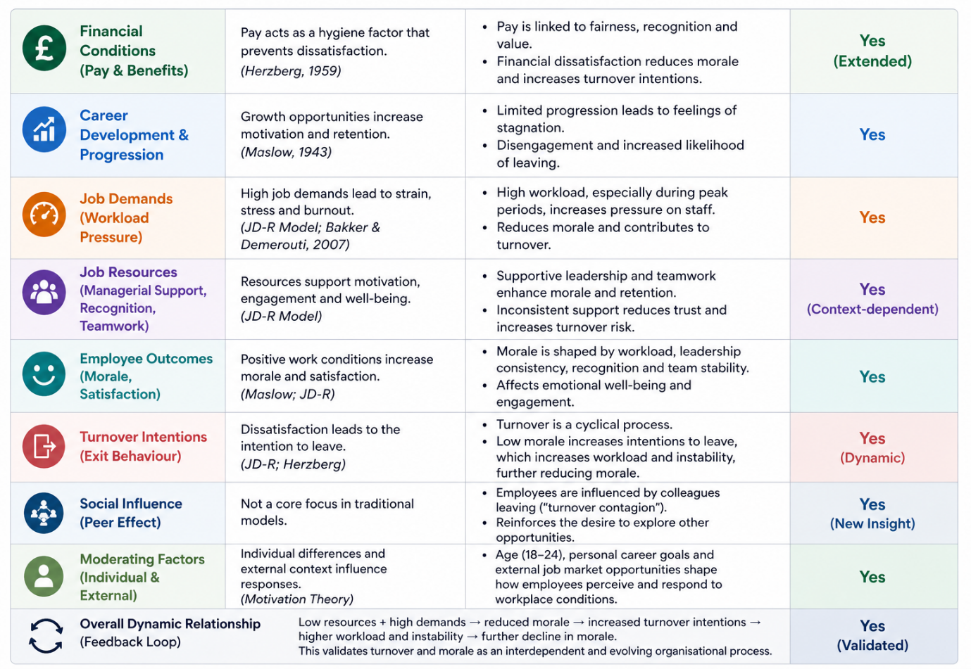

4.9 Summary
This chapter has presented a critically interpretative analysis of qualitative data examining the relationship between employee turnover and employee morale at The North Face London. Through thematic analysis, the findings identified four interconnected dimensions: the causes of turnover, its impact on morale, the role of leadership and organisational culture, and potential strategies to improve retention.
The results demonstrate that employee turnover is shaped by a combination of financial dissatisfaction, limited career progression, workload pressures, and organisational conditions. These factors do not operate in isolation but interact to influence employee perceptions and behaviours. Turnover was shown to have significant consequences for morale, increasing workload, creating instability, and weakening team cohesion. In turn, declining morale contributes to higher turnover intentions, reinforcing a cyclical and self-sustaining process.
Leadership and organisational culture emerged as critical mediating factors. Supportive and consistent leadership can enhance morale and retention, whereas perceived unfairness and inconsistency reduce trust and engagement. The findings also highlight the importance of broader organisational practices, including fair compensation, clear development pathways, and adequate staffing, in shaping employee experience.
The integration of thematic findings with the conceptual framework further strengthens the analysis by demonstrating how organisational drivers, employee outcomes, and moderating factors interact. This validates the complexity of employee behaviour and supports the view that turnover should be understood as an indicator of underlying organisational dynamics rather than a standalone issue.
Overall, this chapter provides a comprehensive and evidence-based understanding of employee turnover and morale within a retail context. The insights generated form a strong foundation for the recommendations presented in the following chapter, which aim to address the identified challenges and improve organisational outcomes.

Chapter 5: Conclusion, Limitations, and Recommendations of Research

5.1 Introduction
This chapter provides a critical synthesis of the research findings in relation to the research objectives (RO1–RO4), drawing together the key insights developed throughout the study. It moves beyond description to evaluate the broader meaning of the findings within the organisational context of The North Face London.
The chapter translates these insights into practical, evidence-based recommendations aimed at improving employee retention and morale. In doing so, it reflects the applied nature of the research and its relevance to real-world organisational challenges within the retail sector.
Furthermore, the chapter outlines the theoretical and practical implications of the study, critically reflects on its methodological limitations, and proposes directions for future research. This ensures that the study not only contributes to organisational practice but also adds value to wider academic discussions on employee turnover and morale.

5.2 Summary of Key Findings in Relation to Research Objectives (RO1–RO4)
This study explored the relationship between employee turnover and morale at The North Face London, revealing turnover as a gradual, cumulative process shaped by multiple interrelated organisational factors.
In relation to RO1, financial dissatisfaction, limited career progression, and workload pressures were the main drivers. Pay was viewed not just economically but as a symbol of fairness, recognition, and organisational value.
Regarding RO2, turnover negatively impacted morale directly and indirectly. Staff shortages, reduced team cohesion, and organisational instability increased stress and disengagement. Declining morale further reinforced turnover intentions, creating a self-perpetuating cycle.
For RO3, leadership and culture were central. Inconsistent management, especially in communication, fairness, and support, reduced trust, showing that effective leadership depends on consistency and relational fairness.
In relation to RO4, improving retention requires a holistic approach. Employees highlighted fair treatment, development opportunities, recognition, and manageable workloads, which interact dynamically, meaning isolated interventions are insufficient.
Overall, turnover is an ongoing evaluative process; when negative factors accumulate without response, turnover becomes a rational and inevitable outcome.

5.3 Limitations of the Study
Despite providing valuable insights, this study has several limitations.
Firstly, it was conducted within a single organisation, The North Face London, limiting generalisability. However, this focus allowed deeper exploration of employee experiences.
Secondly, the relatively small sample size, while appropriate for qualitative research, may not capture the full diversity of perspectives. Findings should be interpreted as context-specific rather than universally applicable.
Thirdly, reliance on self-reported data introduces potential bias, as responses may reflect personal perceptions or reluctance to share negative views, despite confidentiality measures.
Additionally, exclusive use of primary data, while enhancing authenticity, created challenges in time management and data collection; incorporating secondary data could have strengthened contextual support.
Nevertheless, these limitations are offset by the depth, richness, and relevance of the data, providing meaningful insights into turnover and morale.

5.4 Future Study
Future studies could expand this research by including a larger and more diverse sample across multiple retail locations to improve generalisability. A comparative approach between different organisations or regions would also provide deeper insight into how contextual factors influence employee turnover and morale.
In addition, adopting a mixed-methods approach could strengthen the findings by combining qualitative insights with quantitative data, such as turnover rates or employee satisfaction scores. Longitudinal research would also be valuable to examine how employee perceptions and organisational conditions evolve over time.
Finally, further research could explore specific variables in greater depth, such as leadership consistency or generational differences, to better understand how these factors influence employee experiences and retention in contemporary retail environments.

5.5 Implications of the Study
The findings of this study have several important implications for organisational practice, especially in retail.
Firstly, turnover is multidimensional and cannot be addressed through single interventions. Organisations must consider the interaction of financial, organisational, and psychological factors when developing retention strategies.
Secondly, leadership plays a critical role in shaping employee experience. Inconsistent management can undermine morale and contribute to turnover, making leadership development a strategic priority.
Morale is both an outcome and a driver of turnover, reinforcing the need to actively manage employee experience rather than treating morale as passive.
From an HR perspective, an integrated, employee-centred approach is essential. Organisations must proactively address the root causes of dissatisfaction.
Overall, improving performance in retail depends on creating a consistent, supportive, and engaging work environment aligned with employee expectations.

5.6 Recommendations
The findings of this study indicate the need for a strategic and integrated approach to improving employee retention and morale at The North Face London. Management should prioritise the development of transparent and consistent organisational practices, particularly in relation to workload allocation, communication, and decision-making. Clear criteria for task distribution and managerial decisions should be established and communicated openly to employees. This approach reduces perceptions of favouritism and enhances organisational justice, which is critical for building trust and long-term commitment. Consistency should be embedded across all managerial levels to ensure a unified employee experience.
The organisation should introduce structured career development pathways, including training programmes, mentorship opportunities, and clearly defined progression routes. Employees need to perceive a future within the organisation to remain engaged and committed. This is particularly important in retail environments, where roles are often perceived as temporary, and visible growth opportunities can encourage longer-term retention.
Recognition should move beyond occasional rewards and become an integrated element of everyday management practices. This includes regular feedback, acknowledgement of performance, and informal appreciation. Such practices enhance employee motivation by reinforcing a sense of value and belonging, and should be applied consistently and inclusively to avoid perceptions of inequality.
Management should also conduct regular reviews of staffing levels and workload distribution, particularly during peak operational periods. Ensuring adequate staffing reduces pressure on employees and helps maintain service quality. More equitable workload distribution can prevent burnout, improve morale, and reduce turnover intentions, requiring proactive rather than reactive planning.
Leadership development initiatives should focus on promoting consistent, supportive, and fair management behaviours. Training should emphasise communication skills, emotional intelligence, and conflict management, ensuring that employees experience reliable and supportive leadership across different teams.
Finally, the organisation should implement structured feedback mechanisms, such as regular check-ins, surveys, or informal discussions, to encourage employee voice. Providing employees with opportunities to express concerns and contribute ideas enhances engagement and enables early identification of issues, while ensuring that feedback leads to visible action is essential for maintaining trust and credibility.

5.7 Conclusion
This chapter has critically synthesised the key findings in relation to the research objectives and translated them into practical and theoretically informed recommendations.
The study demonstrates that employee turnover is a multi-dimensional, dynamic, and evolving process, shaped by the interaction of organisational factors including fairness, leadership, workload, and development opportunities.
Addressing these factors in an integrated and consistent manner is essential for improving employee morale and reducing turnover. Ultimately, the findings highlight the importance of creating a supportive, fair, and engaging work environment, which not only enhances employee well-being but also contributes to long-term organisational sustainability and performance.

References
Al Mamun, C.A. and Hasan, M.N. (2023) ‘Factors affecting employee turnover in the retail sector’, Journal of Retailing and Consumer Services, 70, 103132. Available at: https://doi.org/10.1016/j.jretconser.2022.103132 (Accessed: 12 April 2026).
Alfayad, Z. and Arif, L.S.M. (2021) ‘Employee voice and job satisfaction: The role of employee engagement’, International Journal of Productivity and Performance Management, 70(6), pp. 1273–1290. Available at: https://doi.org/10.1108/IJPPM-01-2020-0013 (Accessed: 20 April 2026).
Bakker, A.B. and Demerouti, E. (2017) ‘Job demands–resources theory: Taking stock and looking forward’, Journal of Occupational Health Psychology, 22(3), pp. 273–285. Available at: https://doi.org/10.1037/ocp0000056 (Accessed: 20 April 2026).
Bell, E., Bryman, A. and Harley, B. (2022) Business Research Methods. 6th edn. Oxford: Oxford University Press. Available at: https://global.oup.com/academic/product/business-research-methods-9780198869443 (Accessed: 12 April 2026).
Braun, V. and Clarke, V. (2021) Thematic Analysis: A Practical Guide. London: SAGE Publications. Available at: https://uk.sagepub.com/en-gb/eur/thematic-analysis/book248481 (Accessed: 20 April 2026).
British Psychological Society (2021) Code of Human Research Ethics. Leicester: BPS. Available at: https://www.bps.org.uk/guideline/code-human-research-ethics (Accessed: 20 April 2026).
Busetto, L., Wick, W. and Gumbinger, C. (2020) ‘How to use and assess qualitative research methods’, Neurological Research and Practice, 2(14), pp. 1–10. Available at: https://doi.org/10.1186/s42466-020-00059-z (Accessed: 12 April 2026).
Cooke, F.L., Xiao, Q. and Chen, Y. (2021) ‘Still in search of strategic human resource management?’, Human Resource Management Journal, 31(1), pp. 1–17. Available at: https://doi.org/10.1111/1748-8583.12337 (Accessed: 20 April 2026).
Demerouti, E. and Bakker, A.B. (2022) ‘The Job Demands–Resources model: Challenges and prospects’, Journal of Occupational Health Psychology, 27(1), pp. 1–14. Available at: https://doi.org/10.1037/ocp0000286 (Accessed: 20 April 2026).
Denzin, N.K. and Lincoln, Y.S. (2023) The Sage Handbook of Qualitative Research. 6th edn. London: SAGE Publications. Available at: https://uk.sagepub.com/en-gb/eur/the-sage-handbook-of-qualitative-research/book284740 (Accessed: 20 April 2026).
Flick, U. (2022) An Introduction to Qualitative Research. 7th edn. London: SAGE Publications. Available at: https://uk.sagepub.com/en-gb/eur/an-introduction-to-qualitative-research/book273994 (Accessed: 26 April 2026).
Hennink, M., Hutter, I. and Bailey, A. (2020) Qualitative Research Methods. 2nd edn. London: SAGE Publications.
Herzberg, F. (1959) The Motivation to Work. New York: Wiley.
Hom, P.W., Lee, T.W., Shaw, J.D. and Hausknecht, J.P. (2020) ‘One hundred years of employee turnover theory and research’, Annual Review of Organizational Psychology and Organizational Behavior, 7, pp. 1–28. Available at: https://doi.org/10.1146/annurev-orgpsych-012119-044651 (Accessed: 20 April 2026).
Holtom, B.C., Mitchell, T.R., Lee, T.W. and Inderrieden, E.J. (2005) ‘Shocks as causes of turnover: What they are and how organizations can manage them’, Human Resource Management, 44(3), pp. 337–352. Available at: https://doi.org/10.1002/hrm.20074 (Accessed: 20 April 2026).
ILO (2022) World Employment and Social Outlook: Trends 2022. Geneva: International Labour Organization. Available at: https://www.ilo.org/global/research/global-reports (Accessed: 12 April 2026).
Inceoglu, I. et al. (2021) ‘Leadership behavior and employee well-being: An integrated review’, Human Resource Management Journal, 31(2), pp. 1–17. Available at: https://doi.org/10.1111/1748-8583.12313 (Accessed: 20 April 2026).
Jung, H.S. and Yoon, H.H. (2021) ‘The effects of emotional labour on employee outcomes’, International Journal of Hospitality Management, 94, 102878. Available at: https://doi.org/10.1016/j.ijhm.2020.102878 (Accessed: 12 April 2026).
Karatepe, O.M., Rezapouraghdam, H. and Hassannia, R. (2020) ‘Job stress and turnover intentions’, International Journal of Contemporary Hospitality Management, 32(6), pp. 1–20. Available at: https://doi.org/10.1108/IJCHM-05-2019-0468 (Accessed: 12 April 2026).
Kim, M. and Beehr, T.A. (2020) ‘Empowering leadership: Leading people to be present through affective organizational commitment’, Journal of Vocational Behavior, 121, 103470. Available at: https://doi.org/10.1016/j.jvb.2020.103470 (Accessed: 20 April 2026).
Maslow, A.H. (1943) ‘A theory of human motivation’, Psychological Review, 50(4), pp. 370–396. Available at: https://doi.org/10.1037/h0054346 (Accessed: 19 April 2026).
Nguyen, H.M., Nguyen, C. and Nguyen, T. (2022) ‘Employee engagement and organisational commitment’, Sustainability, 14(2), 679. Available at: https://doi.org/10.3390/su14020679 (Accessed: 20 April 2026).
Noer, D.M. (1993) Healing the Wounds: Overcoming the Trauma of Layoffs and Revitalizing Downsized Organizations. San Francisco: Jossey-Bass.
Saeed, B.B., Afsar, B. and Cheema, S. (2021) ‘Transformational leadership and employee outcomes’, Leadership & Organization Development Journal, 42(1), pp. 1–15. Available at: https://doi.org/10.1108/LODJ-01-2020-0033 (Accessed: 20 April 2026).
Saks, A.M. (2022) ‘Caring human resources management and employee engagement’, Human Resource Development Review, 21(2), pp. 1–20. Available at: https://doi.org/10.1177/15344843221083845 (Accessed: 20 April 2026).
Saunders, M., Lewis, P. and Thornhill, A. (2023) Research Methods for Business Students. 9th edn. Harlow: Pearson. Available at: https://www.pearson.com/en-gb/subject-catalog/p/research-methods-for-business-students/P200000003322 (Accessed: 20 April 2026).
Schein, E.H. and Schein, P.A. (2021) Organizational Culture and Leadership. 5th edn. Hoboken, NJ: Wiley. Available at: https://www.wiley.com/en-gb/Organizational+Culture+and+Leadership%2C+5th+Edition-p-9781119212041 (Accessed: 20 April 2026).
Shin, Y. and Hur, W.M. (2021) ‘When do service employees suffer more?’, Service Industries Journal, 41(7–8), pp. 1–20. Available at: https://doi.org/10.1080/02642069.2020.1737454 (Accessed: 12 April 2026).
Taormina, R.J. and Gao, J.H. (2021) ‘Maslow and the motivation hierarchy’, Journal of Management Psychology, 36(2), pp. 1–12. Available at: https://doi.org/10.1108/JMP-11-2019-0624 (Accessed: 20 April 2026).
Taris, T.W. and Schaufeli, W.B. (2021) ‘Measuring employee morale and engagement’, Work & Stress, 35(2), pp. 1–15. Available at: https://doi.org/10.1080/02678373.2020.1774931 (Accessed: 20 April 2026).
Timmermans, S. and Tavory, I. (2022) ‘Theory construction in qualitative research: From grounded theory to abductive analysis’, Sociological Theory, 40(2), pp. 1–21. Available at: https://doi.org/10.1177/07352751221082616 (Accessed: 20 April 2026).
Tracy, S.J. (2020) Qualitative Research Methods: Collecting Evidence, Crafting Analysis, Communicating Impact. 2nd edn. Hoboken, NJ: Wiley.
Van den Broeck, A. et al. (2021) ‘A review of self-determination theory’s basic psychological needs at work’, Journal of Management, 47(5), pp. 1217–1244. Available at: https://doi.org/10.1177/0149206320919672 (Accessed: 20 April 2026).
Wang, Z., Chen, S. and Zhu, Y. (2022) ‘Employee turnover and organisational outcomes’, Frontiers in Psychology, 13, 858433. Available at: https://doi.org/10.3389/fpsyg.2022.858433 (Accessed: 12 April 2026).

Appendices

Appendix A
Semi-Structured Interview Guide
Title
Exploring Employee Turnover and Its Impact on Employee Morale: A Case
Study at The North Face in London
Research Aim
This study aims to explore the relationship between employee turnover and employee
morale at The North Face London.
Research Objectives (RO)
RO1: To explore the key factors contributing to employee turnover.
RO2: To examine how employee turnover influences employee morale.
RO3: To understand employees’ perceptions of leadership support and organisational
culture.
RO4: To explore employee perspectives on potential improvements to enhance retention
and morale.
Research Questions (RQ)
RQ1: What are the main causes of staff turnover at The North Face?
RQ2: How does staff turnover impact employee morale and motivation?
RQ3: How do employees perceive leadership support and workplace culture in relation to
turnover?
Participant Information and Consent
Participants are invited to take part in this research study, which explores employee
experiences related to staff turnover and employee morale at The North Face.
Participation is entirely voluntary. Although access to participants was facilitated through
permission granted by the Store Manager.
All responses will remain anonymous and confidential, and the data collected will be used
solely for academic purposes. The interview is expected to last approximately 15–20
minutes. Participants may withdraw from the study at any time without consequence. There
are no right or wrong answers; the purpose is to understand individual experiences and
perspectives.
Interview Questions
General Experience
Q1. Can you describe your overall experience working at The North Face?
Causes of Employee Turnover (RO1)
Q2. What factors do you think contribute most to employees leaving the organisation?
Q3. How do workload and working conditions influence employees’ decisions to stay or
leave?
Q4. To what extent do opportunities for career development affect employee retention, and
why?
Impact on Employee Morale (RO2)
Q5. How does staff turnover affect your own motivation and morale at work?
Q6. In what ways does turnover influence team dynamics and relationships among staff?
Leadership and Organisational Culture (RO3)
Q7. How would you describe the level of support you receive from management?
Q8. In what ways does leadership influence your decision to stay or leave the organisation?
Q9. How would you describe the workplace culture within your store?
Improvements and Retention (RO4)
Q10. What changes do you think could improve employee morale and reduce turnover?
Closing Question
Q11. Is there anything else you would like to add about your experience working at The
North Face?
Closing Statement
Thank you for your participation. Your responses are valuable and will contribute to a deeper
understanding of employee experiences related to turnover and morale. All information
provided will remain confidential and will be used solely for academic purposes.

Appendix B
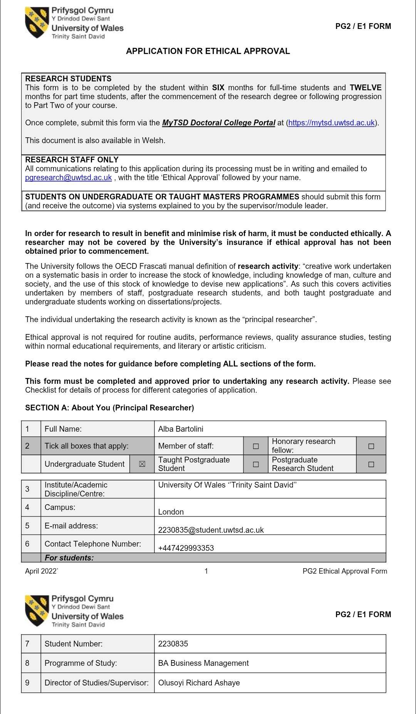
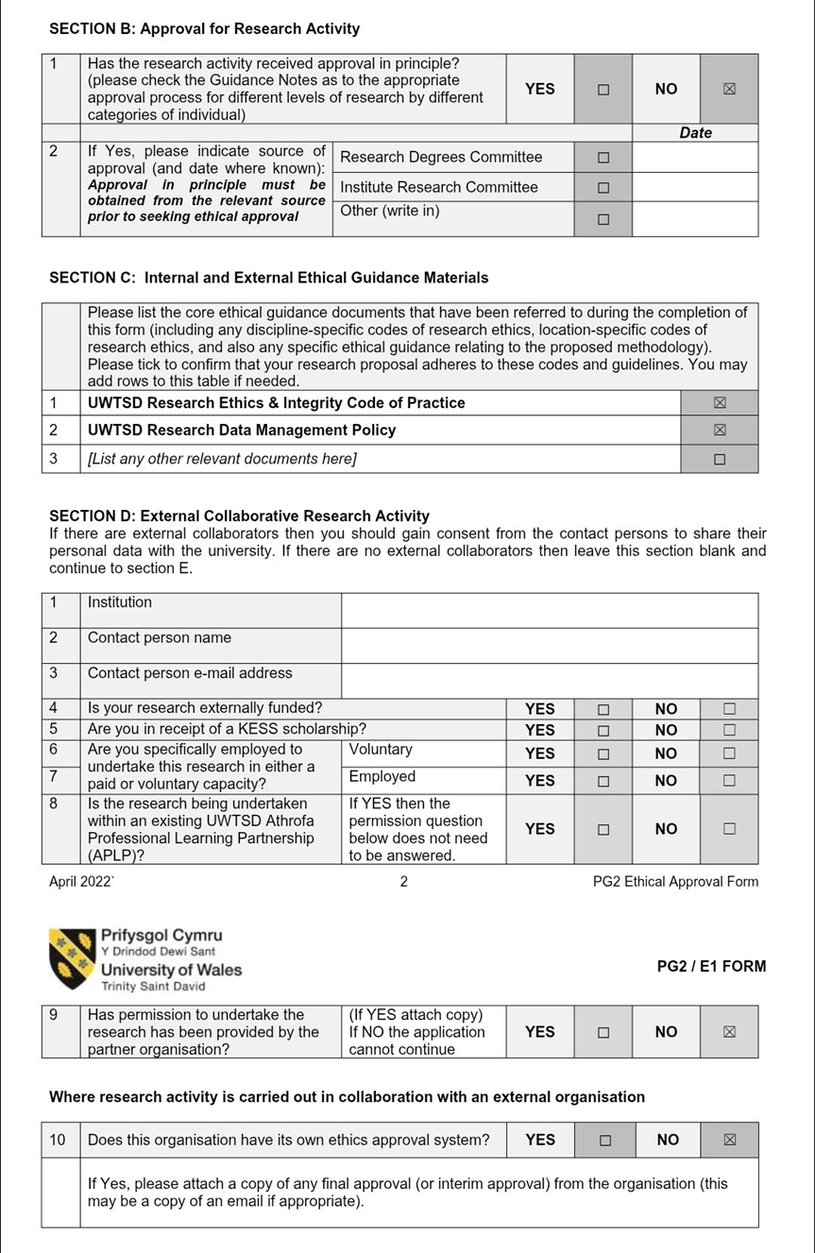
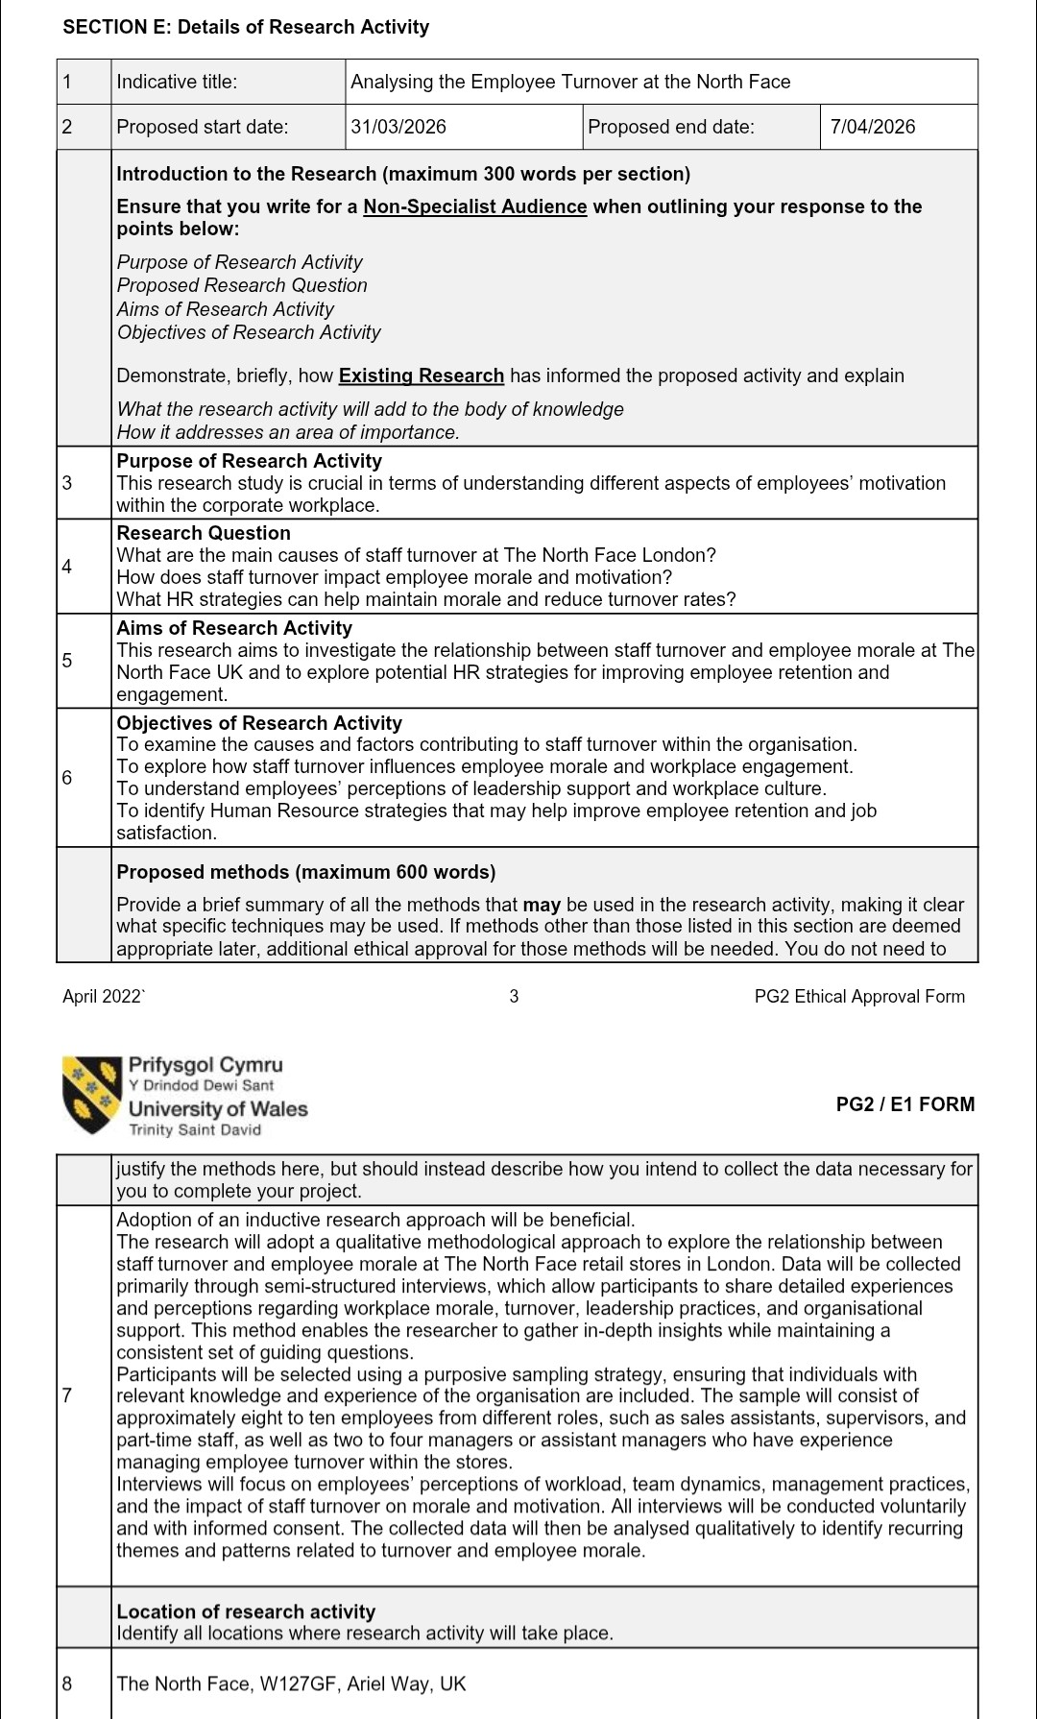
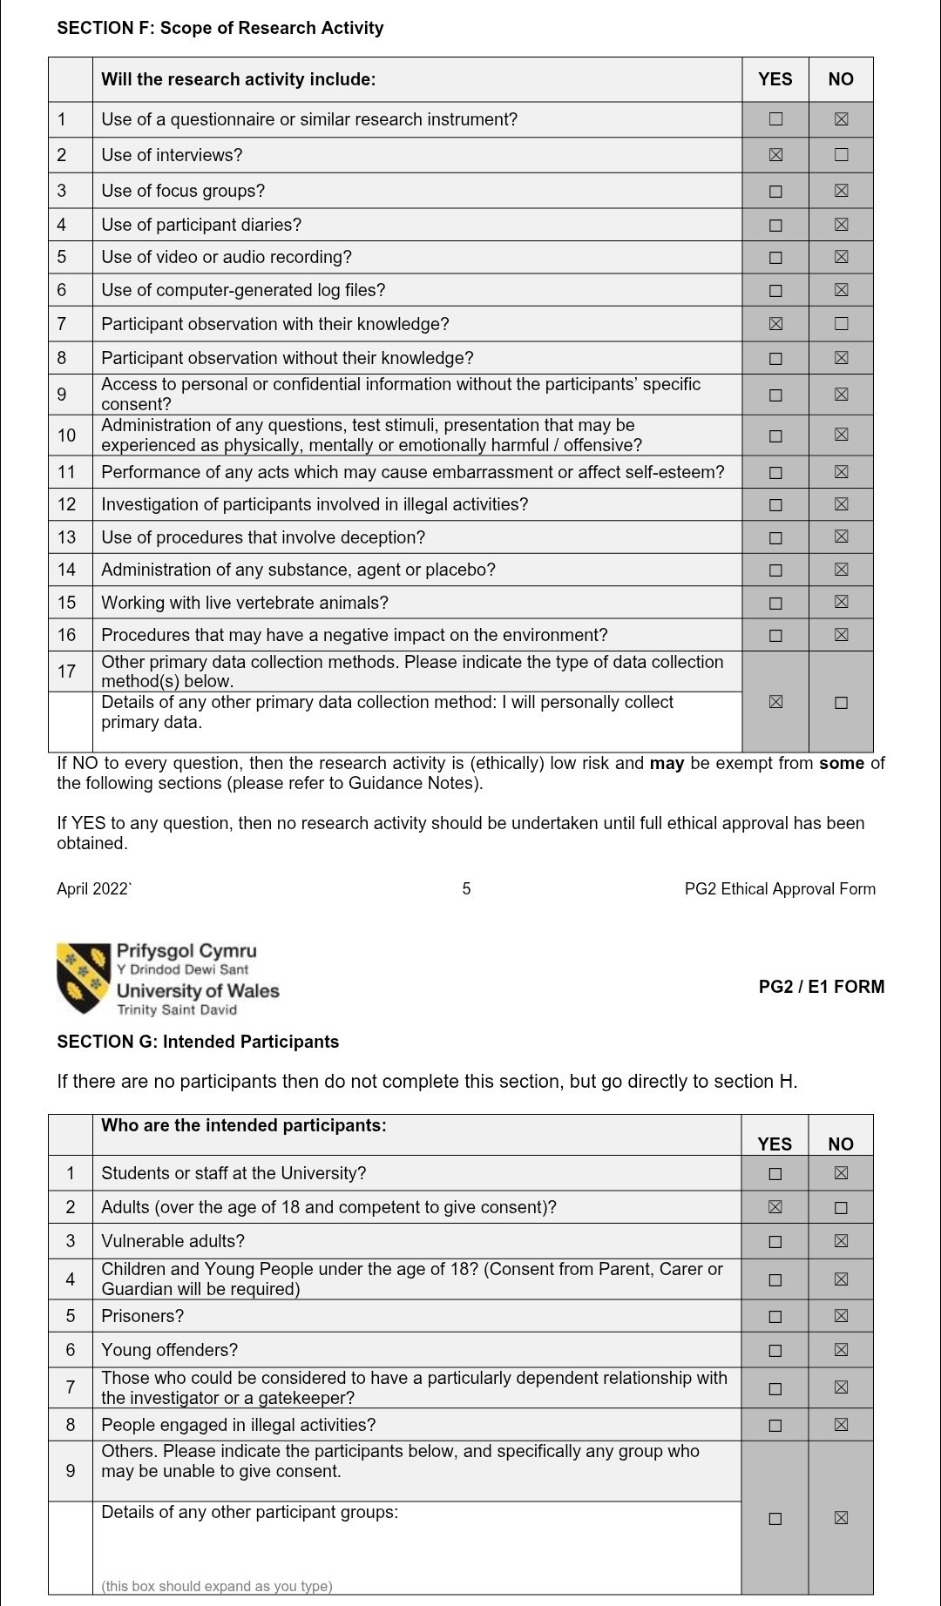
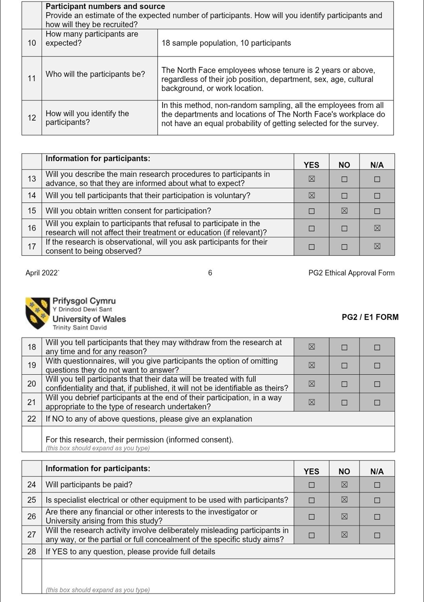
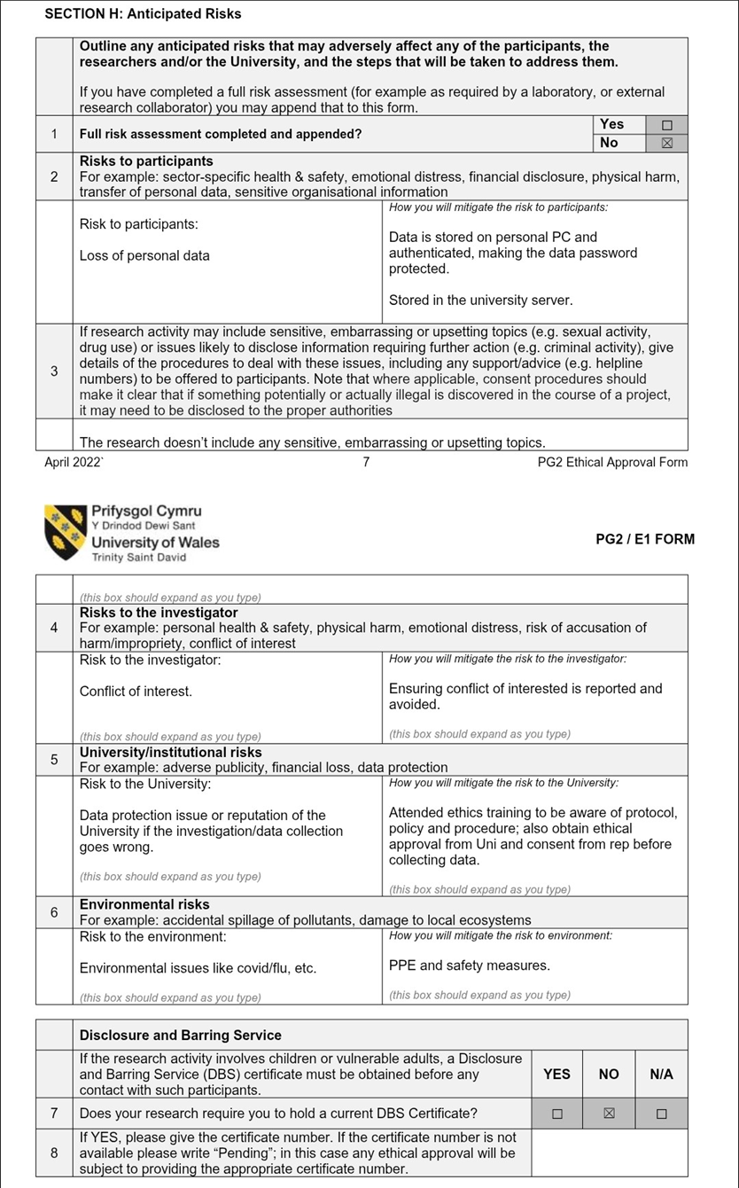
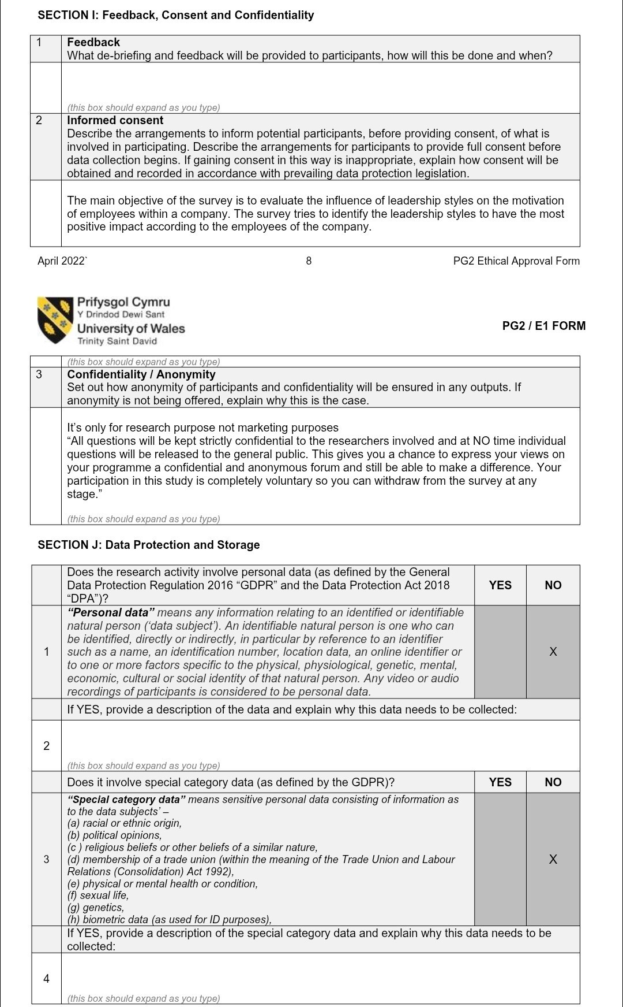
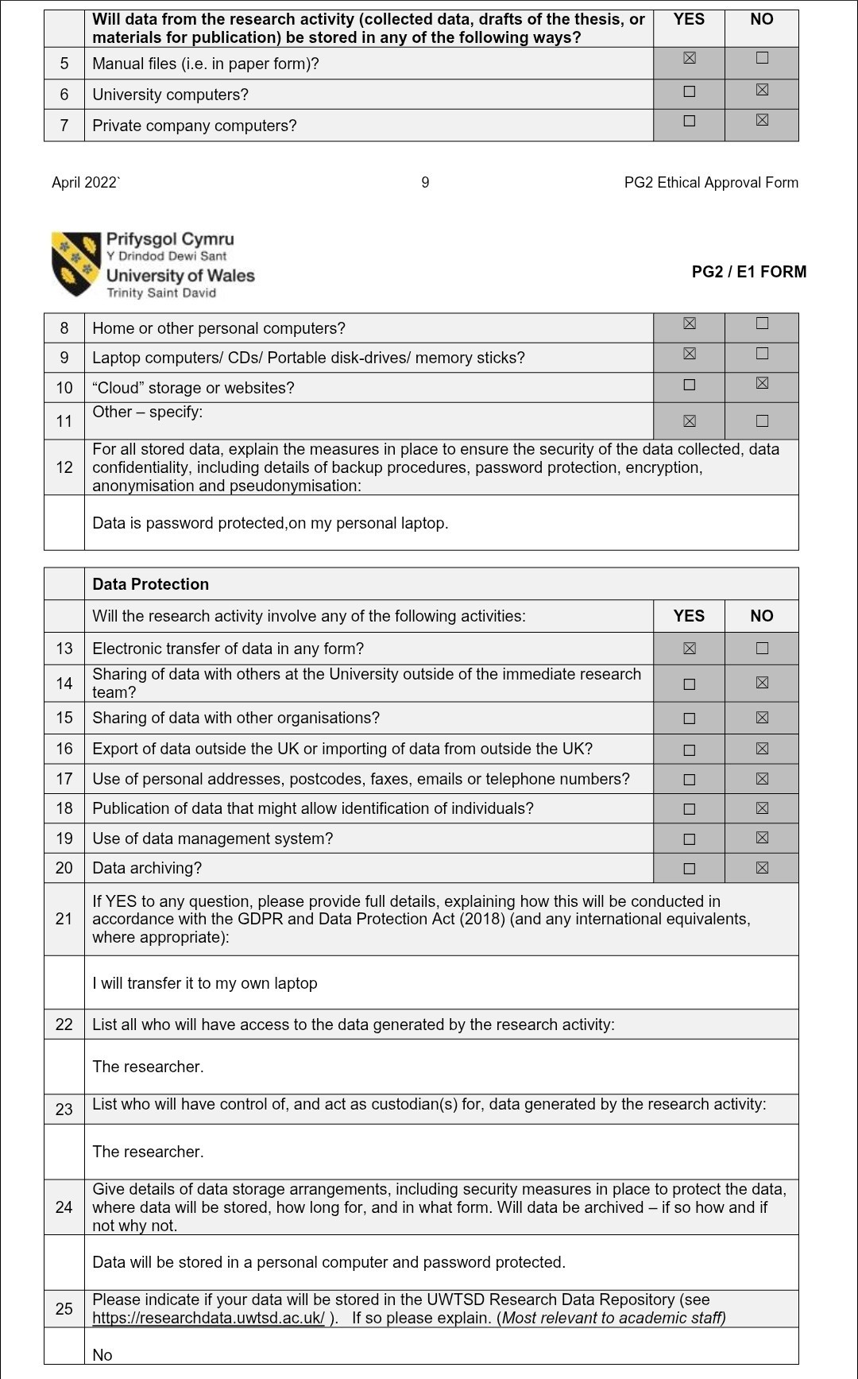
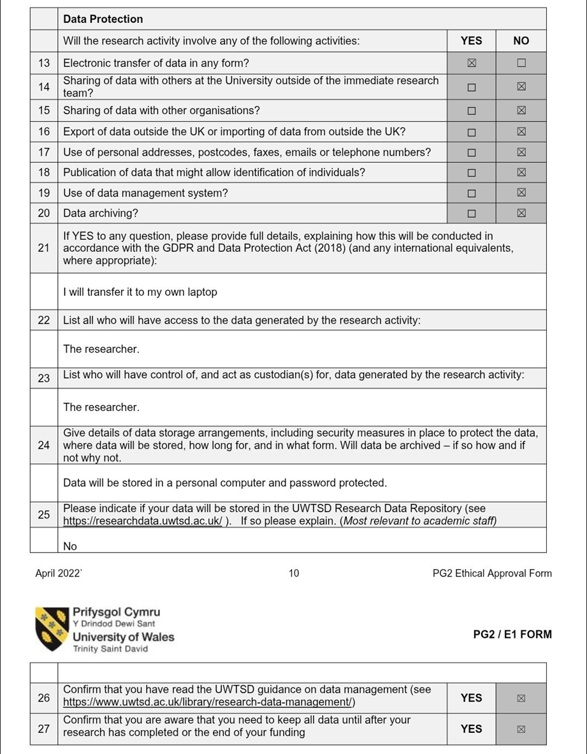

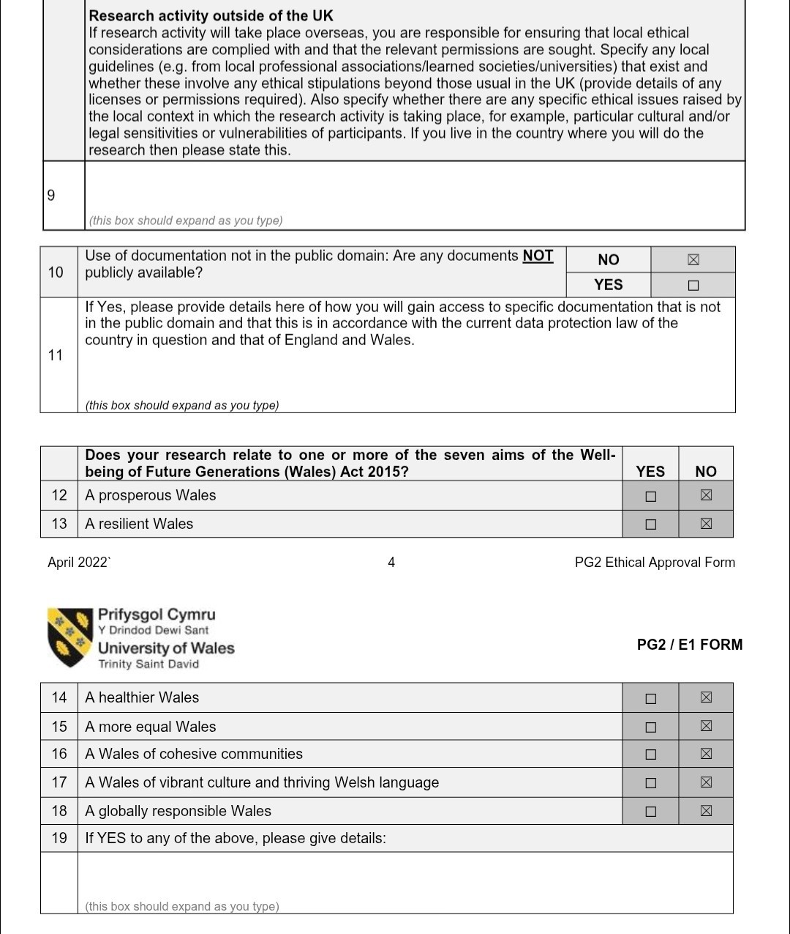

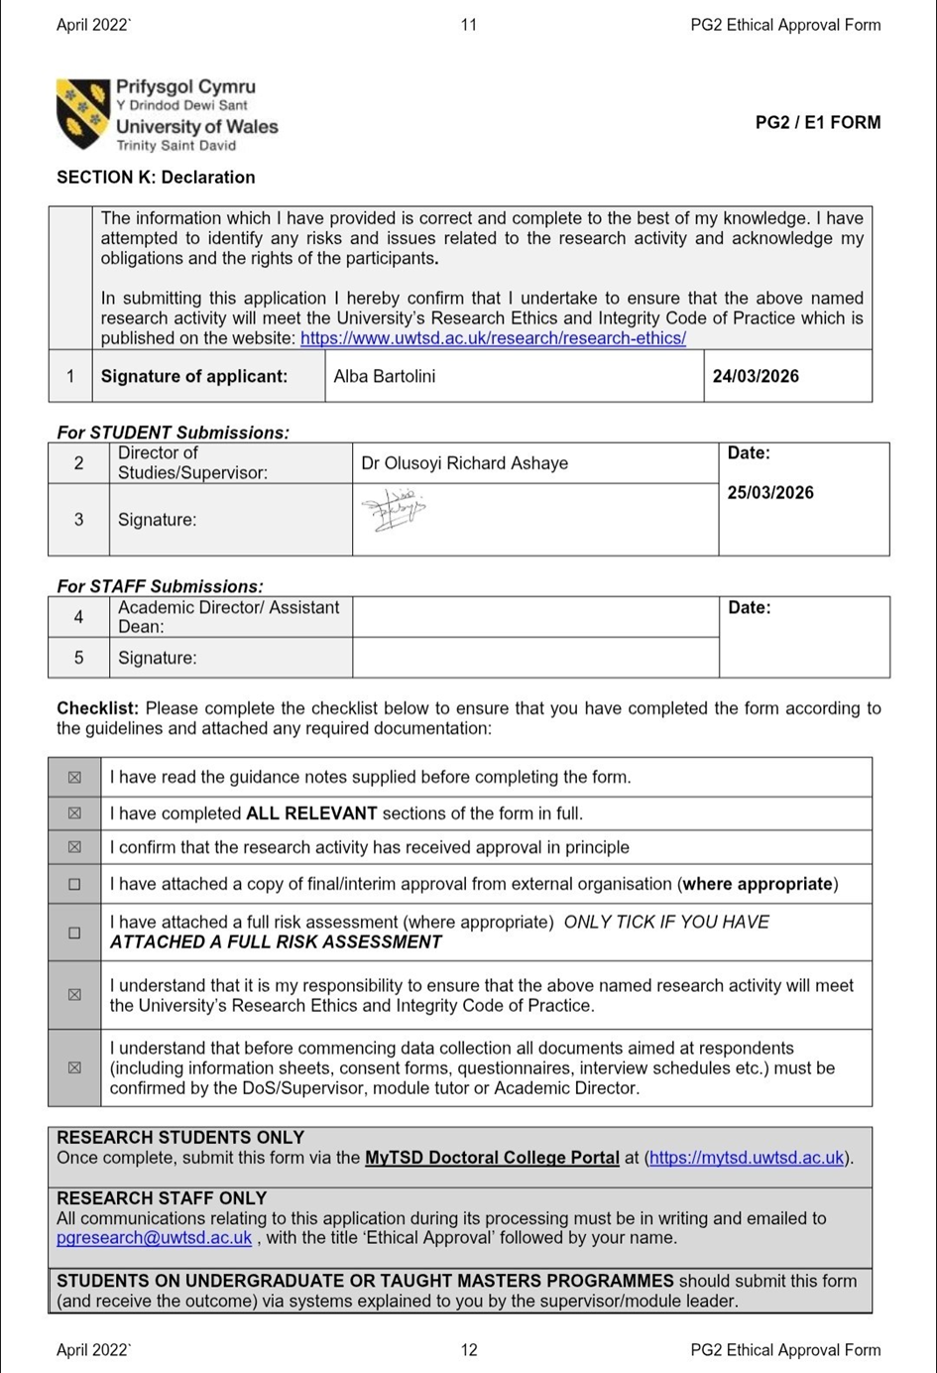

ELEMENT 2
Research Process Reflection

Personal Reflection Gibbs Reflective Cycle
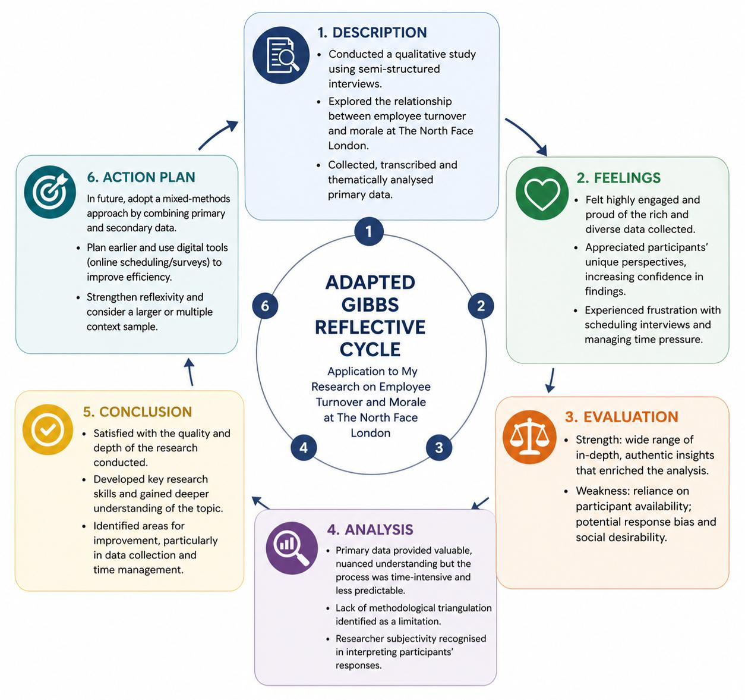
Adapted Gibbs Reflective Cycle for This Study (Source: Adapted from Graham Gibbs, 1988)
Description
This research project explored the relationship between employee turnover and employee morale within The North Face using a qualitative approach. Primary data was collected through semi-structured interviews, allowing participants to share their personal experiences, perspectives, and insights. The process involved engaging with different individuals, analysing their responses, and linking findings to relevant theoretical frameworks.
Feelings
Throughout the research process, I felt highly engaged and personally invested in my work. I was particularly pleased and proud of the data I collected, as I was able to obtain a wide range of responses from different participants. Individuals provided unique experiences and perspectives, which made the research more meaningful and enriched the overall analysis. This diversity of viewpoints increased my confidence in the depth and authenticity of my findings.
At the same time, I experienced some frustration during the data collection phase. Organising interviews and relying on participants’ availability was sometimes challenging and time-consuming, which created pressure in managing deadlines.
Evaluation
One of the strongest aspects of this research was the variety and quality of the responses collected. Engaging directly with participants allowed me to gain deeper insights into real employee experiences, which strengthened the validity of my findings. The diversity of perspectives contributed significantly to the richness of the analysis.
However, the main limitation of the process was the difficulty in coordinating with participants. The reliance on primary data meant that progress depended heavily on others’ availability and willingness to participate. This sometimes slowed down the research process and made it less predictable.
Analysis
This experience highlights both the strengths and challenges of using primary qualitative data. While it provides valuable, in-depth insights, it also requires strong organisational and time management skills. The difficulty in scheduling interviews demonstrates that primary data collection can be resource-intensive and less efficient compared to other methods.
From a critical perspective, this suggests that incorporating secondary data could have improved the research process. Secondary data is more accessible and does not depend on participant availability, which could reduce time pressure. However, relying solely on secondary data might have limited the depth and specificity of the findings. Therefore, a balanced approach may be more effective.
Conclusion
Overall, I am satisfied with how I conducted this research, particularly in relation to the quality and diversity of the data collected. The experience allowed me to develop important research skills and gain a deeper understanding of the topic. However, it also highlighted areas for improvement, particularly in relation to data collection and time management.
Action Plan
If I were to conduct this research again, I would improve the data collection process by planning earlier and considering alternative methods. I would combine primary and secondary data to reduce reliance on participant availability while maintaining depth. Additionally, I would use more efficient tools, such as online surveys or scheduling systems, to make the process smoother.
Overall, this reflection has provided valuable insights into my research approach and will guide my future academic work.
References
Bassot, B. (2023) The Reflective Practice Guide: An Interdisciplinary Approach to Critical Reflection, 3rd edn. London: Routledge. Available at: https://www.routledge.com/The-Reflective-Practice-Guide-An-Interdisciplinary-Approach-to-Critical-Reflection/Bassot/p/book/9781032234540 (Accessed: 24 April 2026).
Gibbs, G. (1988) Learning by Doing: A Guide to Teaching and Learning Methods. Oxford: Oxford Polytechnic. Available at: https://radar.brookes.ac.uk/radar/file/a7e1f738-c0a2-47b5-8ab7-95b8973cdbf9/1/Learning%20by%20doing%20-%20Graham%20Gibbs.pdf?temp.hb=true&temp.hn=true (Accessed: 24 April 2026).

Element 3

POSTER



