

NAME: POOJITH VEMULA
STUDENT NUMBER: 2212578

MODULE: LCBM7001

TITLE: MARKETING MANAGEMENT ASSESSMENT 1

LECTURER: TUSHARA BALENDRAN

WORD COUNT: 3500 WORDS OR EQUIVALENT

SUBMISSION DATE: 09/01/2023

Table of Contents
Introduction 3
Company Background Information - Starbucks 3
Communication - Definition 4
Communication Model - Explanation with Diagram 4
Integrated Marketing Communication (IMC) - Definition 5
Promotional Strategies used in Starbucks in raising Brand Awareness 6
Branding and Brand Equity - Definitions 7
Explaining and Relating Keller’s Brand Equity Model in Starbucks 8
Customer Journey and Touch-points in Starbucks 9
Customer Journey Map - Explanation with Diagram 11
Applying Total Engagement Model in Starbucks 12
Conclusion 13
Reference List 15

Introduction
In consideration of marketing, it can be suggested that it plays one of the most essential roles in the development of a company as it helps a customer in gaining awareness about the products and services of a company (Morgan et al. 2019). Along with that, it is also one of the most effective ways to engage with the customer base which plays a crucial role in ensuring greater buying decisions for the customers. Furthermore, with an effective marketing plan, an organization can create as well as maintain demand, reputation, competitive positioning, and relevance in the market. Regarding this here, in this study innovative marketing strategies development process for Starbucks UK is assured. For that here, company background information, implication of different communication models, importance of integrated marketing communication, promotional strategies of the company, brand equity, customer journey across different communication channels, and application of total engagement model along with other things are discussed in this study.

Company Background Information - Starbucks
Starbucks was established in 1971 by Jerry Baldwin. It has also been seen that apart from coffee and tea beverage drinks items, this company has also been selling food products, snack items, and official merchandise products like mugs, tumblers, and others. Starbucks Corporation has been considered an American multinational chain of cafes and roisterers, which have also been headquartered in Seattle, Washington, US. This organization has also become the globe's largest coffeehouse chain. Since 2011, Starbucks has been using its current logo along with key business operations thereafter. Starbucks has been satisfying its customers millions of times a week, and the company has also committed to serving the highest quality standard of coffee products (Starbucks.com, 2022). In this way, the company has become able to engage its valued customers and community embodied with responsible business operations. In recent times, Starbucks has acquired more than 32,000 stores across around 80 nations, whereas also the company has been striving to bring its heritage and values with exceptional experience to life at the same time.
The mission statement of Starbucks Corporation is “to inspire and nourish the actual human souls - one individual, one cup of coffee, and one neighborhood at a time” and should always be served with quality standard coffee and tea beverage items. The core values and aspects of Starbucks Corporation have played major roles to work with key business partners, their coffee products, and customers at their core business segment values. In detail, rich warm business culture and belongings, courageous acting with status quo, transparency; dignity; respect, accountability, performance-driven humanity business practices, and others have been embedded as core business values thereafter. In FY2021, Starbucks induced its operating profit worth £16.5 million, whereas the profit before tax was £13.3 million, which has also been improved from £41 million tax loss as of FY2020 thereafter (Starbucks.com, 2022).

Communication - Definition
In consideration of communication, it can be suggested that it is a process by which information is exchanged between sender and receiver, in this aspect information is exchanged through common systems such as signs, symbols, and behaviors (Morgan et al. 2019). Regarding this, in the aspect of business communication, it can be suggested it is exchanging information among different stakeholders. Without effective communication and interaction between management and employees, an organization can never effectively obtain its organizational goals. Company needs to share information inside and outside of the organization to stay relevant and engaged with the stakeholder base which is essential for organizational success.

Communication Model - Explanation with Diagram
Various types of communication models can be found, among them here, Laswell's communication model is selected here, as this model is one of the most effective business models that is used by companies to effectively engage and understand the needs and demands of the customers (Saliu, 2020). Along with that this communication model also helps an organization in understanding the market trends as well which can ensure the needed changes within a company.
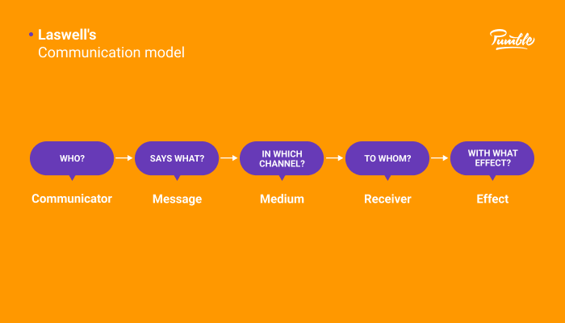
Figure 1: Laswell’s Communication model
(Source: Babaei et al. 2021)
Laswell’s communication model is a linear mass communication model, as per the model communication is transmission of a massage with the effect as the results. In this aspect, it also can be suggested that the effects are the obvious and measurable change in the behavior of the receiver of the message, and these changes are caused by the elements of the communication (Saliu, 2020). According to the model if any element of the communication changes the effects that can be seen on the receiver also will be changed. Laswell's communication model aims for answering 5 essential questions regarding the elements of communication, those questions are provided below:
i. By whom the message is created?
ii. What is said by the creator of the message?
iii. What types of communication channels are used by the creators of the message?
iv. For whom the message is created (Babaei et al. 2021)?
v. What effect does the message have on the receiver?
As per the model the answers to these questions offer the main components of the communication process, regarding that there are also 5 main components for each question can be found those are provided below:
i. Communicator
ii. Message
iii. Medium
iv. Audience/Receiver
v. Effect

Integrated Marketing Communication (IMC) - Definition
Integrated marketing communication can be referred to as the process which is used for unifying the marketing communication elements such as social media, analytics of audiences, public relations, advertising, principles of market development, and others into an identity of a brand that remains consistent across distinct channels of communication. Moreover, as stated by Baines, Fill and Rosengren (2017), integrated marketing communication also can be suggested as a planning process that is designed to assuring that all brand contracts received by a prospect or customer for a service, product, as well as organization, are relevant to that person or entity and consistent over time. It also can be ensured as a strategy for a company that acts as connective tissue for ensuring brand consistency across all channels and aligns communication with the objectives of the business. It considers who the target audiences are and the effective way to communicate with us are them as well as an effective place and channel to communicate with them for better engagement to move the business forward.

Promotional Strategies used by Starbucks in raising Brand Awareness
In consideration of promotional strategies of Starbucks, it can be found that the organization assures all types of marketing processes for raising the brand awareness of the company. In that regard with trends and changes in the marketing process this company also follows the changes, that as this is the era of digitalization social media marketing is one of the most crucial and effective ways for this company to reach its customer base in today's market (Ungerman et al. 2018). For that, different online platforms are used by the organization such as Twitter, Instagram, YouTube, and others. In the aspect of social media platforms, the company creates a lot of content for the customer to keep them engaged with the organization, then based on the user base and based on the social media platform different types of content are shared by this company. For example, in its Tweets, the company shares everything from insider stories to new products of the company along with exciting things that are going on in the company (Twitter.com, 2022).
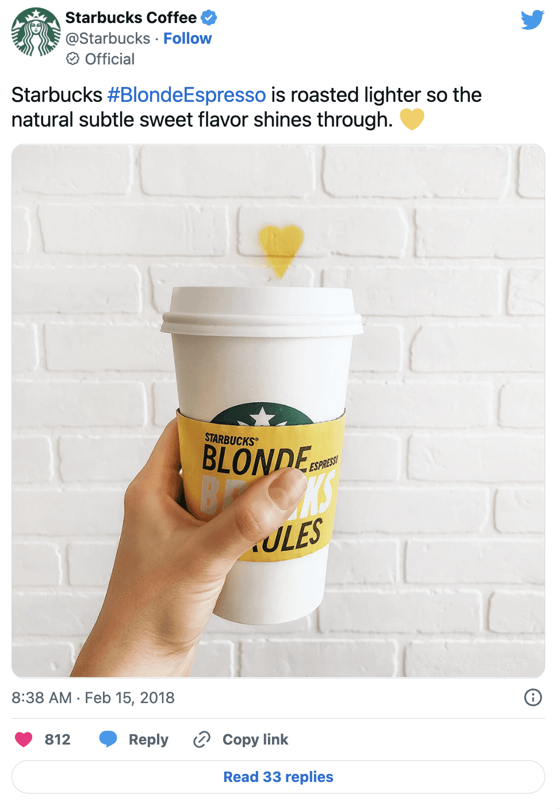
Figure 2: Starbucks Twitter post
(Source: Twitter.com, 2022)
In inconsideration to promotion the organization also uses loyalty programs, where the regular customers or special customer, provides 'stars' and with those stars, customer can get free coffee and other products from the company. Moreover, for promotion organizations also used collaborative approaches, where they collaborate with organizations like Barners & Noble, Nestle, and PepsiCo which helps them in gaining new customers from the customer base of the venturing organization (Coschedule.com, 2022). Moreover, the in-store marketing process also can be seen in this company as well as Starbucks stores are carefully designed for making people stay longer, and purchase more visits again, and from lighting to the counters of ordering everything has a purpose in this company which is related to promotion (Starbucks.com, 2022). Moreover, traditional market processes are also used by the organization to ensure brand awareness among the customers, for that TV and Radio advertising; newspaper advertising, usage of banners, and hoarding in popular places can be seen. These considerations help the organization increase a great portfolio image in the market as well as it also helps they in gaining better competitive advantages as well.

Branding and Brand Equity - Definitions
In consideration of branding, it can be suggested that it is the process for a company to create a distinct identification or identity among the mind of their target market (Ungerman et al. 2018). In this consideration, it also can be suggested that branding is the process of communicating a unique selling proposition to the target customer base, as well as differential sets of services and products to the customers for gaining a differentiable portfolio image which will make them apart from other competitors in the market. At the most basic level, branding of a company is mainly made up of the company's logo, visual design, voice tone, or mission.
Brand equity simply is a marketing term that is used for describing the value of a brand. Regarding that, it can be suggested that according to brand equity the value of an organization is determined by the perception of the customers and the experiences the customers had with the brand (Hall, 2022). In that aspect, if customers think highly of a brand, it means that the brand has positive brand equity. That by measuring the consumer perception of the brand, brand equity can be determined.

Explaining and Relating Keller's Brand Equity Model to Starbucks
Keller’s Brand Equity model has also been known as Customer-Based Brand Equity (CBBE) framework, which has helped organizations in exploring unique ways of establishing a strong brand by shaping how the company's key consumers have thought and felt about them all (Steinhoff and Zondag, 2021). Moreover, this framework has also supported determining the stage, where the brand should be belonged and moved further up in business thereafter.
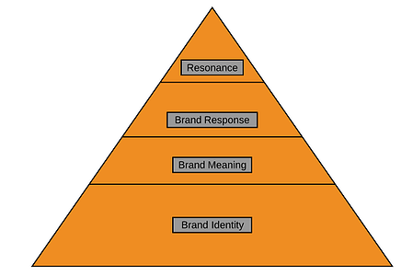
Figure 3: Keller’s Brand Equity (CBBE) Model
(Source: Self-developed)
Now, here has been discussed this model-based application in the key business context of Starbucks Corporation with its key stages and developments further as follows:
- Brand Identity: In brand development, Starbucks has needed to establish a unique identity to create top-on-mind awareness, recognition, and brand recall among consumers. Hence, the company has created a unique brand identity and value or mantra, which has delivered rewarding and standard coffee beverage products to its valued consumers (Steinhoff and Zondag, 2021). Moreover, Starbucks’ company logo has also helped to acquire a large market share through its loyal customer base across unique social media channels and platforms. Hence, such core business aspects have played major roles to develop brand salience, which also helps the company to combat negative reviews across social media with benefits.
- Brand Meaning: In this stage, of establishing a brand, Starbucks has included key tasks of developing building blocks further. To embrace imagery and performance, such building blocks have played major roles to improve the company’s coffee products across price ranges, effectiveness and efficiency, design, and whole product market performance. Imagery and performance of the organization have also helped to develop a pleasant business environment in the global business environment. However, when Starbucks was involved in a racial business controversy, its brand image staggered the most (Volle, 2021). At the same time, such building blocks have helped to develop a friendly business environment with higher means of customer engagement and values.
- Brand Response: In this stage of brand establishment, two (2) essential building blocks such as feelings and judgment have been highly justified. In the case of judgment, Starbucks has mainly been selling its coffee products to be made with quality standard ingredients or raw coffee beans. In addition to this, such high-quality standards of products have enabled the company to gain higher brand values and recognition in the whole coffee industry and market (Bisello, 2021). However, despite many business challenges faced, its valued consumers have always made positive feelings about the brand, whereas right business actions and solutions have been highly justified in the aspect of brand profiling after all.
- Brand Resonance: In this last stage of brand development, the building block named resonance has been justified to make good and fruitful relationships. In Starbucks, it has been observed that its pleasant business environment and unique taste of coffee have played major roles to gain enhanced levels of customer loyalty in business (Volle, 2021). Besides, it has also been embraced that though different kinds of controversies might stagger Starbucks’ brand reputation, its higher means of brand response and resonance have handled the whole unusual business circumstances with higher rates of employee and customer engagement and values at the same business point after all.

Customer Journey and Touch-points in Starbucks
Customer Journey or Customer Experience (CX) has played major role in a business entity. It has been referred to as a whole experience that a consumer has acquired at the time of communication with the same brand of the same business organization after. It is important for business, as it has ensured that the entity has not been missing out on any chance of interacting with customers at any business stage. In this way, the core business leaders have also become able to gain valuable insights into general consumer pain points (Nam and Kannan, 2020). With the help of such business insights, it has also become able to serve more customized and optimized customer experiences in business.
Now, in the context of Starbucks Corporation, it has been seen that over 30,000 cafes in the world have played major roles in accounting, sales, and marketing at 57% of the whole coffeehouse market segment. More than 14,000 store locations in the US alone along with its differentiated product range have helped a lot to nurture its future business operations seamlessly. Moreover, for nurturing the CX of the same organization, Starbucks has mainly invented some key business innovations to improve its overall customer journey scenario in the workplace (Gupta et. al. 2018). Amongst them, as the Espresso culture can be easily transferred from Italy to the UK and US also, the company has satisfied its customers with quality standard espresso coffee beverages. Then, it has also been seen that by reinventing a strong commodity like espresso, Starbucks has become able to induce a unique culture with the delicious taste of coffee to its customers. Apart from that; as Starbucks has offered its customers to take away their cups of coffee outside, its loyal customer base rate has been increasing with a whole new shopping experience for its valued customer base after all.
On the other hand, Customer Touchpoints have been considered a company's key brand points, through which its customers can contact from top to bottom. For instance, it has also been seen that when consumers might find a company's ad online, their ratings and reviews have also been checked via its website or social media pages (Nam and Kannan, 2020). It must deliver a snapshot of its ley customer service operations from a realistic business eye. It has also been identified that for major business organizations, such customer touch-points have mainly influenced how its target market has felt about the same brand whether it is positive or negative after.
Now, in the context of Starbucks Corporation, it has been observed that in the sense of product branding and its core developmental aspects, its Logo has been considered a highly recognized element with its elegance and green color shades connected to its coffee. In its logo, as per Greek mythology, the mermaid luring sailors to the coast called Starbucks must grab the attention of every coffee lover in the whole market segment. Then, Starbucks’ Bring Your Tumbler idea has emphasized the highest and enhanced meaning of business sustainability. Moreover, it has also been explored that by promoting this same approach in business, Starbucks has become able to reduce waste in business after coffee consumption, which has also been turned into a positive CSR initiative in the whole market segments and communities after. It has also been found that across major Starbucks coffee houses, eco-friendly management techniques and operations have appeared, whereas the core business aspect related to renewable energy usage, good water management practices, and other sustainable business approaches have been highly prioritized (Gupta et. al. 2018). The Starbucks coffee cup has also delivered its customers a personal touch by writing their names with gentle and mild feelings of business growth and development.

Customer Journey Map - Explanation with Diagram
It has been defined as a proper visualization of the core customer or user journey in a specific business entity. It has played major role to deliver CXs of brands across different mass mediums like social media, email, and other networks thereafter (Rudkowski et. al. 2020). Here has been demonstrated and explained Starbucks’ customer journey map with key findings and insights of business as follows:
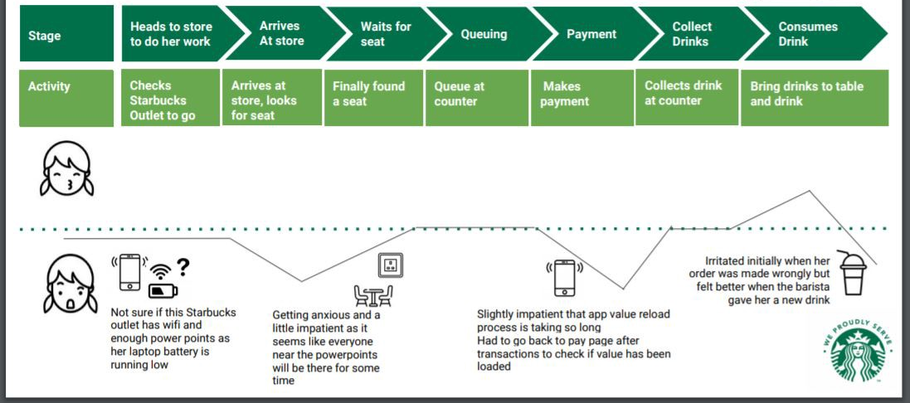
Figure 4: Customer Journey Map of Starbucks
(Source: Self-created)
As observed from the above graphical representation, the customer journey map of Starbucks has been understood. Based on this visualization, it has been seen that by correlating stages and key business activities, when customers are heading towards the store for their work, they must check which outlet to go to (Medium.com, 2018). Then, when the customers have arrived at stores, they are mainly looking for a seat. Then, if they have to wait for a seat and finally find it, the same customers are getting ready to stand in the queue to go to the counter. After that, in the stage of payment, after completing payments, customers mainly collected their ordered drinks and finally consumed their drinks while sitting on the chair at the same time.
On the other hand, it has also been identified that apart from facilities and advantages to be availed in Starbucks, there are also some pain points for customers. Additionally, these have also caused hesitation or confusion among themselves. For example, if a customer is not sure about whether in the nearest store, public Wi-Fi is either available or not, which is also safely applicable for power sources or charge points (Santana et. al. 2020). However, in some cases, customers might feel anxious or a little impatient, if their needs have not been fulfilled properly. Apart from that; it has also been understood that if a patient will face some kind of technical glitch or slowdown in their app while payment, or found a new substitute product like Barista in cheaper as well as and affordable price range, they might become getting bored and go to Starbucks in some cases of purchasing and business after all.

Applying Total Engagement Model in Starbucks
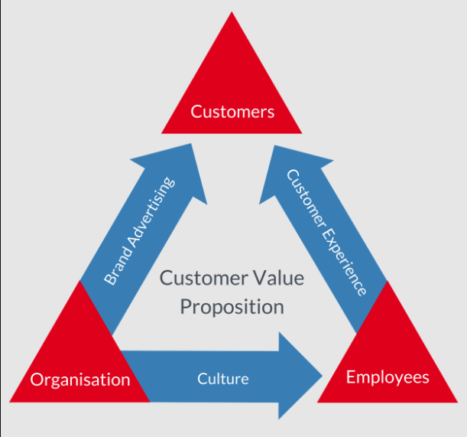
Figure 5: Total Engagement Model
(Source: Dutton et al. 2020)
In consideration of the total engagement model, it can be found that the model suggests organizations focus on four key elements those are brand advertising, culture, customer value proposition, and experience of the customers for gaining greater engagement with their customer base (Klenk and Meehan, 2017). Along with that there are various steps also ensured as per the model to create engaged customers for the company those steps are provided below:
1. Developing a unique value proposition based on strong customer insights.
2. Then the company needs to constantly communicate its value proposition in its brand advertising process.
3. Then the promise made by the company needs to be delivered by reliable and skilled employees who understand and support the strategy, along with that it also needs to be ensured that the employees have a great understanding of their roles in making the promise a success (Dutton et. al. 2020).
4. This foundation of culture helps organizations in gaining a result of planned customer experience that helps the company in making the promises ensured in their advertisements.
Regarding this model for ensuring greater customer engagement in Starbucks the model needs to be effectively followed. In summary from the model, it can be suggested that the company Starbucks needs to make unique and relevant promises to the customer base, and then they need the work of their strength to engage the staff to deliver those expectations as well as may exceed expectations against these promises. With these fundamental approaches of this model, the organization can build trust and gain customer engagement more effectively.
In this aspect, it needs to be understood by Starbucks that they should promise things that they can provide, otherwise, trust issues can be seen among the brand and the customer which can affect their organization's portfolio image as well as competitive positioning at the same time. Moreover, as opined by Klenk and Meehan (2017), having reliable employee and staff base is also essential in the company alongside, for that organizations can create engagement programs with their staff to effectively assure their roles and responsibilities for achieving the promises made by the company. For that, the employees and staff of ten company need to have a better understanding of their roles themselves and they also need to be professional about it, regarding that ensuring effective training and development programs for the employees is a crucial consideration as that not only help the employees in understanding their roles and responsibilities it also will help them in increasing their effectiveness in the workplace as well.

Conclusion
From the above discussion, it can be suggested that an effective marketing process helps organizations like Starbucks in gaining better success in the aspect of brand image development, better customer engagement as well as ensuring a better competitive advantage at the same time. Regarding the strategies ensured by Starbucks, it can be suggested that until now in ensuring innovative marketing processes the organization has been quite successful. However, as suggested in the study there is still room for better future development which can be ensured by the company through their present practice of maintaining continuous relationships with their customers as it will help them in understanding their needs and demands as per the changes in the market trends.

Reference List
Babaei, P., Ghavidel, S. and RiahiNia, N., 2021. Content Analysis of Infographics with the Theme of Reading Based on the Lasswell's Communication Model. Research on Information Science and Public Libraries, 26(4), pp.629-664.
Baines, P., Fill, C. and Rosengren, S., 2017. Marketing. Oxford University Press.
Bisello, G., (2021). Starbucks and Illycaffé: different strategies to successfully enter the Chinese coffee market.
Coschedule.com (2022), Starbucks Marketing Strategy: Create A Remarkable Brand, Available at: https://coschedule.com/marketing-strategy/marketing-strategy-examples/starbucks-marketing-strategy [Last Accessed on 14th December 2022]
Dutton, T., Marjoram, J., Burgess, S., Montgomery, L., Vail, A., Callan, N., Jacob, S., Hawkes, D., Saville, M. and Bailey, J., (2020). Uptake and acceptability of human papillomavirus self-sampling in rural and remote aboriginal communities: Evaluation of a nurse-led community engagement model. BMC Health Services Research, 20(1), pp.1-9.
Gupta, P., Nagpal, A. and Malik, D., (2018). Starbucks: global brand in emerging markets. Emerald Emerging Markets Case Studies.
Hall, S., 2022. Innovative B2B marketing: new models, processes and theory. Kogan Page Publishers.
Klenk, N.L. and Meehan, K., (2017). Transdisciplinary sustainability research beyond engagement models: Toward adventures in relevance. Environmental Science & Policy, 78, pp.27-35.
Medium.com, (2018), Are you getting the RIGHT Starbucks Experience? — Redesigning the Starbucks Singapore App, Available at: https://medium.com/nyc-design/are-you-getting-the-right-starbucks-experience-redesigning-the-starbucks-singapore-app-2cd07e1ff53d [Last Accessed on 14th December 2022]
Morgan, N.A., Whitler, K.A., Feng, H. and Chari, S., 2019. Research in marketing strategy. Journal of the Academy of Marketing Science, 47(1), pp.4-29.
Nam, H. and Kannan, P.K., (2020). Digital environment in global markets: Cross-cultural implications for evolving customer journeys. Journal of International Marketing, 28(1), pp.28-47.
Rudkowski, J., Heney, C., Yu, H., Sedlezky, S. and Gunn, F., (2020). Here Today, Gone Tomorrow? Mapping and modeling the pop-up retail customer journey. Journal of Retailing and Consumer Services, 54, p.101698.
Saliu, H., 2020. Public Diplomacy and Related Concepts from the Perspective of Lasswell’s Communication Model. Jahr–European Journal of Bioethics, 11(2), pp.357-376.
Santana, S., Thomas, M. and Morwitz, V.G., (2020). The role of numbers in the customer journey. Journal of Retailing, 96(1), pp.138-154.
Starbucks.com, (2022), About Us, Available at: https://www.starbucks.com/about-us/ [Last Accessed on 14th December 2022]
Steinhoff, L. and Zondag, M.M., (2021). Loyalty programs as travel companions: Complementary service features across customer journey stages. Journal of Business Research, 129, pp.70-82.
Twitter.com (2022), Starbucks Coffee, Available at: https://twitter.com/starbucks?lang=bn [Last Accessed on 14th December 2022]
Ungerman, O., Dedkova, J. and Gurinova, K., 2018. The impact of marketing innovation on the competitiveness of enterprises in the context of industry 4.0. Journal of competitiveness, 10(2), p.132.
Volle, P., (2021). Rhetorical history and strategic marketing: the example of Starbucks. Journal of Historical Research in Marketing.

