Module Code: LCHS7003
Module Title: Community Care and Management of Longer-term Conditions
Lecturer’s Name: Dr Aishat Bakre
Assignment Title: Component 1: Information Booklet of Long- term Condition Management

Student Name
Student Number

Table of Contents
1. Introduction 2
2. Understanding Type 2 Diabetes 2
3. Epidemiology and Evaluation of Health Data 4
4. Risk Factor and Aetiology 5
5. Critical Impact of Type 2 Diabetes 7
6. Evidence-Based NHS Management and Treatment 10
7. Theoretical Perspectives and Models of Care 11
8. Political, Health and Social Care Agendas 11
9. Recommendations for Improving Person-Centred Care 13
10. Conclusion 15
11. Reference List 16

List of Figures
Figure 1: Estimated Prevalence of Diagnosed and Undiagnosed Type 2 Diabetes 4
Figure 2: Link between Ethnicity and Type 2 Diabetes Risks 8
Figure 3: Rising Costs of Type 2 Diabetes 10
Figure 4: Key Recommendations for Improving Person-centred Care 15

1. Introduction
Type 2 Diabetes Mellitus is considered as one of the most impactful long-term health conditions across the world, which causes substantial challenges for the individuals, society, and healthcare system (Goyal et al., 2023). This long-term health condition is mainly characterised by insulin resistance, and impaired glucose metabolism, which are associated with some serious concerns including cardiovascular disease, kidney failure, visual impairment, and neuropathy. In addition, effective management of T2D has become a major priority for public health along with the enhancing emphasis on prevention, reducing healthcare inequalities, and early intervention (Lu et al., 2024). This information booklet is typically designed for supporting the healthcare professionals through providing an evidence-based overview of the current conditions, and approaches to its management.
Contemporary healthcare has moved beyond the traditional disease-centered medical model, which mostly focuses on treatment and diagnosis while considering social, biological, and psychological dimensions of health. Aligning with principles of long-term condition management, this booklet addresses the significance of health promotion, integrated care, and self-management, while reflecting the public health agenda to improve patient outcomes.

2. Understanding Type 2 Diabetes
Type 2 Diabetes Mellitus or T2DM is a chronic metabolic condition that raises blood glucose level due to insulin resistance and gradual decrease in the function of the pancreatic β-cells (Galicia-Garcia et al., 2020). Type 1 Diabetes is an autoimmune disease which results in absolute insulin deficiency, which is often diagnosed in childhood or adolescence, whereas T2DM tends to develop over time, while highly influenced by lifestyle choices and genetics.
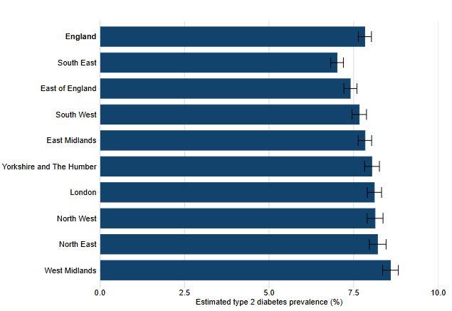

Figure 1: Estimated Prevalence of Diagnosed and Undiagnosed Type 2 Diabetes
(Source: GOV.UK, 2025)
The above figures shows that the estimated prevalence of diagnosed and undiagnosed Type 2 diabetes in England was around 7.8% (GOV.UK, 2025). On the other hand, pathophysiology is decreased insulin responsiveness by cells, followed by insufficient insulin production to regulate glucose, and microvascular and macrovascular complications. Application of Biopsychosocial or BPS Model developed by George Engel represents a comprehensive framework which includes biological, psychological, and social factors, which describes how these factors interact to give rise to health outcomes (Bolton, 2023). In terms of biology, insulin resistance and genetic predisposition are risk factors for disease, while self-management behaviours and glycaemic control are affected psychologically by health beliefs, stress, motivation and adherence to treatment.
Disease development and outcomes are further influenced by social determinants such as poverty, cultural practices, unhealthy lifestyles and unequal access to health care services. One of the key benefits of applying the BPS model is its ability for providing the foundation for person-centred care, while recognising that T2DM can be a complex and multifaceted condition, mainly when relating to the management of LTCs (Gregg et al., 2024). However, there are some major challenges in terms of operationalisation of the model as the biological, psychological and social interactions, which vary from person to person, and multidisciplinary interventions, resources and coordinated healthcare systems.

3. Epidemiology and Evaluation of Health Data
The International Diabetes Federation or IDF and Diabetes Atlas are reported that there were an estimated 589 million adults between the ages of 20-79 years, living with diabetes globally, which is expected to reach 852.5 million by 2050, due to the ageing of the global population, obesity and lifestyle changes (Diabetes Atlas, 2026). Diabetes is also a huge burden on the UK's NHS, with approximately 90% of all diabetes cases in the UK being Type 2 Diabetes, while NHS England reported that there were 3.6 million people identified with non-diabetic hyperglycaemia (pre-diabetes) in 2023 (Au-Yeung et al., 2024; NHS UK, 2024). The total cost of diabetes care is estimated to be £10.7 billion per year for the NHS, which is a significant economic burden. Epidemiological measures are essential to the assessment of disease patterns and interventions. Also, in cohort studies, Relative Risk (RR) is commonly used to illustrate the higher risk of developing T2DM in people with obesity, although it is more difficult to follow-up and with substantial resources (Pandey et al., 2020). In addition, Odds Ratio (OR) is a frequently used measure in case-control studies, where incidence data is not available, and may result in an overestimation of risk in common conditions.
However, a combination of Absolute Risk Reduction or ARR, Relative Risk Reduction or RRR, Control Event Rate or CER, and Experimental Event Rate or EER, are useful for evaluating the effectiveness of lifestyle interventions, pharmacological treatments, and prevention programmes (D’Arrigo et al., 2023). Additionally, using epidemiological evidence accounts for data quality, confounding factors, selection bias, and social determinants of health. From the perspective of social epidemiology, the determinants of diabetes risk and its outcomes indicate the factors such as deprivation, lack of education, and inequalities in access to healthcare, where the statistical evidence needs to be understood within a broader social and environmental context.

4. Risk Factor and Aetiology
Category | Risk Factor | Contribution to Type 2 Diabetes
Biological | Age | Insulin sensitivity declines with ageing, increasing disease risk.
Biological | Family history | Genetic predisposition increases susceptibility.
Biological | Ethnicity | South Asian, Black African and African-Caribbean populations are at higher risk.
Biological | Obesity | Excess adipose tissue promotes insulin resistance and metabolic dysfunction.
Psychological | Stress | Chronic stress elevates cortisol levels, impairing glucose metabolism.
Psychological | Depression | Associated with poor glycaemic control and reduced self-management.
Psychological | Behavioural choices | Physical inactivity, unhealthy diet and smoking increase risk.
Social | Income | Low income restricts access to healthy lifestyles and healthcare.
Social | Education | Lower health literacy may reduce disease prevention and management.
Social | Employment | Occupational stress and unemployment can negatively affect health behaviours.
Social | Food environment | Availability of unhealthy, energy-dense foods promotes obesity.
Social | Deprivation | Social disadvantage contributes to health inequalities and increased diabetes prevalence.
Table 1: Categorised Risk Factors
(Source: Self-developed)
T2DM development has been developed through the interaction of psychological, social and biological determinants rather than from the single causes. Biological factors are elevated age, genetic predisposition, ethnic background and obesity. However, people over 40 years old have an increased risk of developing T2DM, while South Asian, Black African and African-Caribbean people have an increased risk of developing the condition after 25 years (Diabetes UK, 2026). People with a first degree relative with diabetes have an increased risk from T2DM, which ranges from two to six times. In addition, the issues regarding obesity are also recognised by the UK Government as the key modifiable risk factor. On the other hand, psychological factors like chronic stress, depression and poor lifestyle behaviors can have a negative impact on lifestyle choices, treatment adherence, and metabolic control, which causes higher risk of progression of the disease.
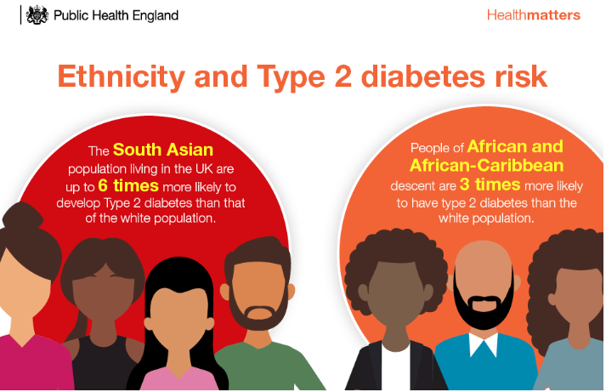

Figure 2: Link between Ethnicity and Type 2 Diabetes Risks
(Source: GOV.UK, 2018)
Further, social factors such as poverty, poor education, poor food environment and poor access to health care influence the prevalence of T2DM. For example, the UK Government estimates that this rate of T2D patients among residents of the most deprived areas is approximately 60% higher than among those living in the least deprived areas (GOV.UK, 2018). These findings are well aligned with the Social Determinants of Health approach and the Marmot Review, which both highlight the importance of socioeconomic inequalities throughout the life course affecting health outcomes. However, this provides an integrated perspective on T2DM and that refers to it as a multifactorial disease, which requires comprehensive public health and person-centred interventions.

5. Critical Impact of Type 2 Diabetes
The impacts of Type 2 Diabetes is possible to address by focusing on three major phases such as Physical Impact, Psychological Impact, and Social Impact, which are explained below:
Physical Impact
The T2DM or Type 2 Diabetes Mellitus has been associated with major long-term physical complications that are mostly efficient to enhance mortality and morbidity. Around 35.4% people with diabetes are at a substantially greater threat of cardiovascular disease, while 40.7% of patients with disease regarding diabetic kidney remains one of the leading causes for chronic kidney failure (Lautsch et al., 2019; Martínez-Montoro et al., 2025). Diabetes can also cause peripheral nerve damage such as diabetic neuropathy and damage to the blood vessels in the retina, which is known as diabetic retinopathy that causes vision loss. Diabetes UK states that lower-limb amputations are a significant problem in England, which are caused by preventable complications of the foot (Diabetes UK, 2026). The outcomes highlight the need to initiate early diagnosis, frequent monitoring and evidence-based management for preventing further disease progression, while achieving better patient outcomes.
Psychological Impact
The psychological effects of T2DM can be significant, which have some major impacts on disease management and wellbeing (Aklé, 2023). Diabetes UK recognises depression, anxiety and diabetes-related distress as frequent comorbidities which can impact on motivation and adherence to a diabetes management plan. The constant need for glucose testing, dietary limitations and the fear of complications can cause emotional burnout and decrease in quality of life. The National Institute for Health and Care Excellence claimed that the need for psychological assessments as a routine part of diabetes care as mental health issues are linked to poorer glycemic control and higher health service usage (Latoo et al., 2026). Thus, holistic interventions and effective management are required to manage both physical symptoms and psychological wellbeing.
Social Impact
The issues regarding Type 2 Diabetes can significantly affect different aspects of social life, which involves employment, financial stability, and family relationship (Hendryx et al., 2020). The chronic nature of the disease might lead to frequent health visits, medication and dietary changes, which may affect the productivity of work and contribute to indirect economic costs. Public Health England identifies that diabetes disproportionately affects deprived communities and availability of opportunities for having healthy eating, doing physical activity and accessing quality healthcare services (Xie et al., 2026).
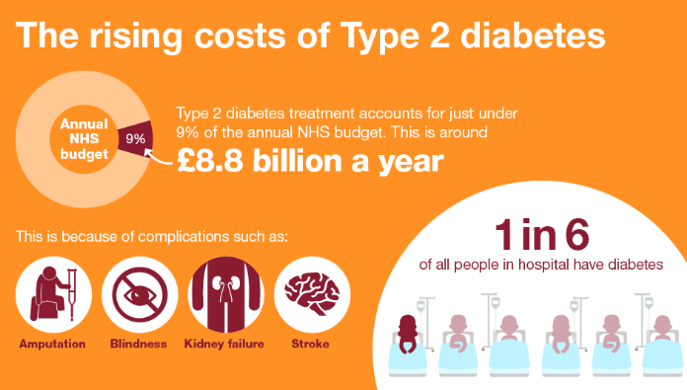

Figure 3: Rising Costs of Type 2 Diabetes
(Source: GOV.UK, 2018)
For example, 80% of the direct costs are associated with the complications of Type 2 diabetes, while its treatment accounts for under 9% of the annual NHS budget (GOV.UK, 2018). Additionally, diabetes treatment spending has doubled to £1.92 billion, which makes it difficult for the lower-income people to afford (NHS, 2025). Further, continuous disease management can lead to social isolation and decrease in community involvement. These social impacts highlight the need for consideration of broader social drivers of health in addition to clinical care.
Theoretical Integration using Dynamic Biopsychosocial Perspective
The Dynamic Biopsychosocial Model claims that Type 2 Diabetes evolves through the perpetual interplay of biological, psychological and social factors (Khalil et al., 2025). Biological changes such as insulin resistance and disease complications, can increase psychological stress, which can lead to poorer treatment adherence and impact physical health. In addition, Bronfenbrenner's Ecological Theory demonstrates that a variety of environmental systems have an impact on outcome such as family support, community resources, healthcare services, and national health policies (Amali et al., 2023). In a similar way, Sameroff's Transactional Model highlights that there is a bidirectional interaction between patients and the environment over time, where stresses can increase the chances of diabetes. However, these frameworks indicate that effective long-term diabetes management demands integrated, multidisciplinary and person-centred approaches rather than pure biomedical interventions.

6. Evidence-Based NHS Management and Treatment
The NHS has adopted an evidence-based and person-centred approach to reduce the issues of Type 2 Diabetes Mellitus, which are focused on the early detection, prevention of complications and long-term management of the condition. Treatment pathway consists of screening of high-risk populations, early diagnosis by HbA1c, lifestyle modification, patient education, pharmacologic therapy, frequent monitoring and prevention of complications (Serbis et al., 2021). As per the guideline of NICE, adults with T2DM are required to be provided with structured education at diagnosis and repeat education, while reinforcement every year for improved self-management of T2DM and treatment adherence (NICE, 2026). The NHS and NICE also recommend 9 annual care processes such as HbA1c, blood pressure, cholesterol, kidney function, foot screening, smoking review and retinal screening to minimise the risk of complications (NICE, 2026). Evidence-based interventions consist of weight management, physical activity, dietary modification, smoking cessation programmes, appropriate medicines, and multidisciplinary care.
On the other hand, the NHS Type 2 Diabetes Path to Remission Programme focuses on losing weight of around 10 kg, which resulted in better glycaemic control (NHS, 2026). The principle of empowerment is mainly aligned with Self-Management Theory, which posits that empowering patients to be actively involved in their medications, lifestyles and symptoms, which will lead to better long-term outcomes through health literacy, motivation, and social support. The Person-Centred Care model also supports dignity and respect, co-ordinated care, personalised treatment and patient empowerment (Švab and Cerovečki, 2024). However, there are still workforce shortages, resource constraints, health inequalities and differences in service availability that pose challenges to the consistent implementation of the system in the UK health system.

7. Theoretical Perspectives and Models of Care
The proper management of T2DM or Type 2 Diabetes Mellitus enhancingly relies on the integrated theoretical models that effectively supports prevention, long-term self-management, and person-centred care. In the context of the UK, the NHS Long Term Plan effectively promotes personalized care, digital healthcare, disease prevention as well as community-based management approaches using ICS or Integrated Care System framework (Gould et al., 2025). NHS England estimates that around 2.5 million people will benefit from personalised care approaches, such as shared decision-making and supported self-management (NHS England, 2025). The technological developments underway with digital services such as remote glucose monitoring and the NHS App, which are designed to make these services more accessible, more continuous. Moreover, ICSs are a forum for multidisciplinary collaboration between NHS organisations, local authorities and community partners, which helps to reduce the fragmentation and waste of services (Lalani et al., 2025). Although, the implementation process has suffered due to some barriers involving lack of workforce, funding constraints, regional disparities and poor digital literacy.
Further, the organisations like World Health Organization or WHO, apply Health Promotion Framework focusing on prevention, community involvement, empowerment, and healthy public policy from an international perspective to reduce the burden of chronic diseases (WHO, 2026). However, this model can be used to look at the behavioural and social determinants of health, rather than clinical treatment. Diabetes long-term management is also enhanced by the use of supporting frameworks such as the Chronic Care Model and the House of Care Model, which foster collaborative care planning, integrated care, and self-management support (Puzhakkal et al., 2025). However, these models are complex, which demands efficient inter-system coordination and ongoing investment and organisation to justify quality outcomes for patients.

8. Political, Health and Social Care Agendas
Policies and Framework | Key Priorities | Relevance to Type 2 Diabetes Management
NHS Five Year Forward View (2014) | Prevention, sustainability, early intervention | Promotes reducing obesity, preventing diabetes, and strengthening community-based healthcare.
NHS Long Term Plan (2019) | Integrated care, personalised care, digital transformation | Supports self-management, NHS Digital services, and coordinated long-term condition management.
Marmot Review (2010) | Reducing health inequalities and addressing social determinants | Highlights the influence of deprivation, education, employment, and environment on diabetes risk.
Public Health England (PHE): From Evidence into Action | Prevention, reducing premature mortality, improving wellbeing | Encourages evidence-based interventions and population-level strategies to prevent Type 2 Diabetes.
Local Service Development | Community diabetes services, primary care, social prescribing, Integrated Care Systems (ICSs) | Improves multidisciplinary collaboration and provides holistic support closer to patients' homes.
Table 2: Key Agendas that Support Type 2 Diabetes Management
(Source: Self-developed)
Prevention and early intervention have become the major priorities in the NHS Five Year Forward View, which improves the health of the population while providing a sustained NHS services into the future (NHS England, 2017). The strategy acknowledged that the increasing prevalence of obesity and Type 2 Diabetes represented an increasingly onerous burden on health systems unless there was sufficient focus on prevention. On the other hand, the NHS Long-term Plan has paved the way for the creation of Integrated Care Systems or ICSs, personalised care and digital transformation to increase the lives of those with long term conditions (Tracy et al., 2025). NHS England estimates that approximately 2.5 million people will benefit from personalised care initiatives and digital technologies will aid remote monitoring and self-management (NHS England, 2025).
Further, the Marmot Review also highlights the importance of socioeconomic factors in driving health inequalities such as deprivation, poor education and a lack of employment opportunities, which increases the prevalence of diabetes (Kilvert and Fox, 2023). In a similar manner, the "From Evidence into Action" or FIA campaign of Public Health England calls for prevention and reduction of premature death through evidence-based public health interventions (FIA Foundation, 2025). Local community diabetes services, primary care networks, social prescribing and ICSs seek to deliver co-ordinated multidisciplinary services at the local level. However, implementation of these frameworks represents some major challenges due to the barriers such as lack of funding, shortage of NHS staff, differences in health literacy, cultural diversity and digital exclusion, which minimise the equitable access to healthcare services.

9. Recommendations for Improving Person-Centred Care
Based on all the above it has been possible to provide some key recommendations, which can be effective to improve person-centred care. There are some recommendations mentioned below:
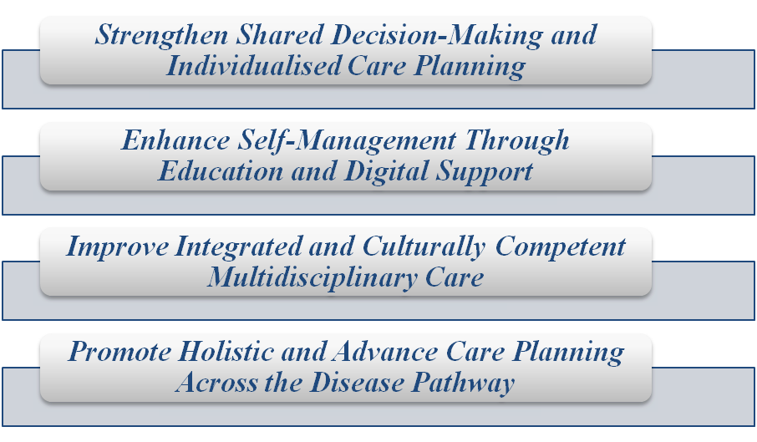

Figure 4: Key Recommendations for Improving Person-centred Care
(Source: Self-developed)
- Strengthen Shared Decision-Making and Individualised Care Planning
Healthcare professionals recommended engaging with patients actively in terms of their treatment decisions, customized care plans, and treatment choices, while considering patients' preference, cultural beliefs and clinical needs (Krist et al., 2017). Care objectives also need to be specific and measurable, using frameworks like SMART objectives.
- Enhance Self-Management Through Education and Digital Support
The inclusion of structured education initiatives, digital monitoring of glucose, and behavior change interventions required to be expanded for improving capabilities of self-management (Ranjbar et al., 2024). Further, the recommendations also empower patients with knowledge and confidence to self-manage their medication, lifestyle and symptoms.
- Improve Integrated and Culturally Competent Multidisciplinary Care
The person-centred diabetes management is recommended to promote multidisciplinary collaboration, while recognising culture diversity as well as health literacy differences (Shapiro and Grajower, 2024). Fragmented healthcare delivery can be minimised by co-ordinated care with specialist nurses, dietitians, pharmacists and community services.
- Promote Holistic and Advance Care Planning Across the Disease Pathway
Long-term diabetes care recommended to include advance care planning, family engagement, whole-person care, and collaborative care (Chamoun et al., 2024). Further, aligned with Person-Centred Care that has focused on four major principles such as Dignity, Respect, Co-ordinated Care and Empowerment.

10. Conclusion
Thus from the above information, it can be concluded that managing Type 2 Diabetes Mellitus requires a multifaceted, long-term strategy that needs to be designed with both biomedical and non-biomedical factors. However, integrating epidemiological evidence, theory, evidence-based interventions and national health policies are essential for effective care to ensure better patient outcomes. The Biopsychosocial Model, person-centred care and integrated healthcare systems offer a complete approach to the support of holistic and coordinated management.

11. Reference List
Aklé, M., 2023. 3 Emotional and psychological needs of people with diabetes (interactive session). https://bmjpaedsopen.bmj.com/content/7/Suppl_1/A1.3
Amali, N.A.K., Ridzuan, M.U.M., Rahmat, N.H., Seng, H.Z. and Mustafa, N.C., 2023. Exploring learning environment through Bronfenbrenner’s ecological systems theory. Journal of Academic Research in Progressive Education and Development, 12(2), pp.144-162. https://www.researchgate.net/profile/Hui-Seng/publication/370144077_Exploring_Learning_Environment_Through_Bronfenbrenner's_Ecological_Systems_Theory/links/645c3e154353ba3b3b5828f0/Exploring-Learning-Environment-Through-Bronfenbrenners-Ecological-Systems-Theory.pdf
Au-Yeung, C.H., Ellis, D., Dallaway, A., Riley, J., Varney, J. and Howell-Jones, R., 2024. Socioeconomic and ethnic inequalities increase the risk of type 2 diabetes: an analysis of NHS health check attendees in Birmingham. Frontiers in Public Health, 12, p.1477418. https://www.frontiersin.org/journals/public-health/articles/10.3389/fpubh.2024.1477418/full
Bolton, D., 2023. A revitalized biopsychosocial model: core theory, research paradigms, and clinical implications. Psychological medicine, 53(16), pp.7504-7511. https://www.cambridge.org/core/journals/psychological-medicine/article/revitalized-biopsychosocial-model-core-theory-research-paradigms-and-clinical-implications/8FC915C01228857ED6B5E123536E8994
Chamoun, D., Ramasamy, M., Ziegler, C., Yu, C.H., Wijeyesekera, P., Advani, A. and Pritlove, C., 2024. Patient, family and caregiver engagement in diabetes care: a scoping review protocol. BMJ open, 14(8), p.e086772. https://bmjopen.bmj.com/content/14/8/e086772.abstract
D’Arrigo, G., Gori, M., Pitino, A., Tsalikakis, D.G., Liakopoulos, V., Roumeliotis, S. and Tripepi, G., 2023. Measures of frequency and effect in clinical research. International urology and nephrology, 55(12), pp.3147-3152. https://link.springer.com/article/10.1007/s11255-023-03626-w
Diabetes Atlas, (2026). 589 million adults (20-79 years) are living with diabetes worldwide. Available at: https://diabetesatlas.org/?gad_source=1&gad_campaignid=8198961119&gbraid=0AAAAAC2rxokcyW-Y7w9iNHLUvW8FfWsPA&gclid=Cj0KCQjw_7PRBhDcARIsAMjV7jmWgkvLE7Xcq1aC1Eq2g1zwYkzG3VnwDnDLUNJiP8WA62LcB011WCQaAkvvEALw_wcB [Accessed on 13th June, 2026]
Diabetes UK, (2026). Ethnicity and type 2 diabetes. Available at: https://www.diabetes.org.uk/about-diabetes/type-2-diabetes/diabetes-ethnicity [Accessed on 13th June, 2026]
Diabetes UK. (2026). Research on preventing amputations. Available at: https://www.diabetes.org.uk/our-research/about-our-research/our-impact/preventing-amputations [Accessed on 13th June, 2026]
FIA Foundation, (2025). 1.9 million premature deaths preventable with better traffic emission policies by 2040, says new FIA Foundation supported study. Available at: https://www.fiafoundation.org/news/19-million-premature-deaths-preventable-with-better-traffic-emission-policies-by-2040-says-new-fia-foundation-supported-study [Accessed on 13th June, 2026]
Galicia-Garcia, U., Benito-Vicente, A., Jebari, S., Larrea-Sebal, A., Siddiqi, H., Uribe, K.B., Ostolaza, H. and Martín, C., 2020. Pathophysiology of type 2 diabetes mellitus. International journal of molecular sciences, 21(17), p.6275. https://www.mdpi.com/1422-0067/21/17/6275
Gould, B., Tucker, D., Majdzadeh, R. and Di Cesare, M., 2025. Integrated care services: Developing strategies for integrated care-A relational content analysis. Public Health, 249, p.106043. https://www.sciencedirect.com/science/article/pii/S0033350625004895
GOV.UK, (2018). Health matters: preventing Type 2 Diabetes. Available at: https://www.gov.uk/government/publications/health-matters-preventing-type-2-diabetes/health-matters-preventing-type-2-diabetes [Accessed on 13th June, 2026]
GOV.UK, (2025). Diabetes profile: statistical commentary, March 2025. Available at: https://www.gov.uk/government/statistics/diabetes-profile-update-march-2025/diabetes-profile-statistical-commentary-march-2025 [Accessed on 13th June, 2026]
Goyal, R., Singhal, M. and Jialal, I., 2023. Type 2 diabetes. StatPearls [Internet]. https://www.ncbi.nlm.nih.gov/books/NBK513253/
Gregg, E.W., Pratt, A., Owens, A., Barron, E., Dunbar-Rees, R., Slade, E.T., Hafezparast, N., Bakhai, C., Chappell, P., Cornelius, V. and Johnston, D.G., 2024. The burden of diabetes-associated multiple long-term conditions on years of life spent and lost. Nature Medicine, 30(10), pp.2830-2837. https://www.nature.com/articles/s41591-024-03123-2
Hendryx, M., Nicholson, W., Manson, J.E., Kroenke, C.H., Lee, J., Weitlauf, J.C., Garcia, L., Jonasson, J.M., Wactawski-Wende, J. and Luo, J., 2020. Social relationships and risk of type 2 diabetes among postmenopausal women. The Journals of Gerontology: Series B, 75(7), pp.1597-1608. https://academic.oup.com/psychsocgerontology/article-abstract/75/7/1597/5480178
Khalil, Y., Abu-Khalaf, L., Abu-Khalaf, R., Abu-Khalaf, S. and Al-Balootti, K., 2025. The Biopsychosocial Model in Type 2 Diabetes Mellitus: A Narrative Review. Cureus, 17(11). https://www.cureus.com/articles/426519-the-biopsychosocial-model-in-type-2-diabetes-mellitus-a-narrative-review.pdf
Kilvert, A. and Fox, C., 2023. Health inequalities and diabetes. Practical Diabetes, 40(1), pp.19-24a. https://wchh.onlinelibrary.wiley.com/doi/abs/10.1002/pdi.2435
Krist, A.H., Tong, S.T., Aycock, R.A. and Longo, D.R., 2017. Engaging patients in decision-making and behavior change to promote prevention. Information Services and Use, 37(2), pp.105-122. https://journals.sagepub.com/doi/abs/10.3233/ISU-170826
Lalani, M., Peters, M., Sugavanam, T., Crocker, H., Caiels, J., Hay, H., Gunn, S., Hogan, H., Page, B. and Fitzpatrick, R., 2025. New ways of working to manage and improve quality in integrated care systems in England. International journal of health policy and management, 14, p.8424. https://pmc.ncbi.nlm.nih.gov/articles/PMC11845859/
Latoo, J., Khan, Y.S., Latoo, A., Alabdulla, M., Jan, F., Masoodi, N., Sura, D., Islam, S. and Wadoo, O., 2026. The psychological burden of diabetes: common mental health disorders, their impact on disease outcomes and strategies for intervention. Journal of Diabetes & Metabolic Disorders, 25(1), p.105. https://link.springer.com/article/10.1007/s40200-026-01915-6
Lautsch, D., Wang, T., Yang, L. and Rajpathak, S.N., 2019. Prevalence of established cardiovascular disease in patients with type 2 diabetes mellitus in the UK. Diabetes Therapy, 10(6), pp.2131-2137. https://link.springer.com/article/10.1007/s13300-019-00698-9
Lu, X., Xie, Q., Pan, X., Zhang, R., Zhang, X., Peng, G., Zhang, Y., Shen, S. and Tong, N., 2024. Type 2 diabetes mellitus in adults: pathogenesis, prevention and therapy. Signal transduction and targeted therapy, 9(1), p.262. https://www.nature.com/articles/s41392-024-01951-9
Martínez-Montoro, J.I., Aparicio-Sánchez, J.J., Pimentel, B., Juárez-Campo, M., Alamillo, M.L. and Fernández-García, J.C., 2025. Screening, prevalence, and burden of chronic kidney disease in people with type 2 diabetes managed by endocrinologists: A nationwide cross-sectional study. Diabetes research and clinical practice, 226, p.112326. https://www.sciencedirect.com/science/article/pii/S0168822725003407
NHS England, (2017). NEXT STEPS ON THE NHS FIVE YEAR FORWARD VIEW. Available at: https://www.england.nhs.uk/wp-content/uploads/2017/03/NEXT-STEPS-ON-THE-NHS-FIVE-YEAR-FORWARD-VIEW.pdf [Accessed on 13th June, 2026]
NHS England, (2025). Personalised Care. Available at: https://www.england.nhs.uk/personalisedcare/ [Accessed on 13th June, 2026]
NHS UK, (2024). NHS identifies over half a million more people at risk of type 2 diabetes in a Year. Available at: https://www.england.nhs.uk/2024/06/nhs-identifies-over-half-a-million-more-people-at-risk-of-type-2-diabetes-in-a-year/ [Accessed on 13th June, 2026]
NHS, (2025). NHS diabetes treatment spending reaches £1.92 billion as new medications become available. Available at: https://media.nhsbsa.nhs.uk/press-releases/e29454d6-7346-4183-b9fe-57a31a04ce1e/nhs-diabetes-treatment-spending-reaches-1-92-billion-as-new-medications-become-available [Accessed on 13th June, 2026]
NHS, (2026). NHS Type 2 Diabetes Path to Remission Programme. Available at: https://www.england.nhs.uk/diabetes/treatment-care/diabetes-remission/ [Accessed on 13th June, 2026]
NICE, (2026). Type 2 diabetes in adults. Available at: https://www.nice.org.uk/guidance/qs209/chapter/Quality-statement-2-Structured-education-programme [Accessed on 13th June, 2026]
Pandey, A., Patel, K.V., Bahnson, J.L., Gaussoin, S.A., Martin, C.K., Balasubramanyam, A., Johnson, K.C., McGuire, D.K., Bertoni, A.G., Kitzman, D. and Berry, J.D., 2020. Association of intensive lifestyle intervention, fitness, and body mass index with risk of heart failure in overweight or obese adults with type 2 diabetes mellitus: an analysis from the Look AHEAD trial. Circulation, 141(16), pp.1295-1306. https://www.ahajournals.org/doi/abs/10.1161/CIRCULATIONAHA.119.044865
Puzhakkal, S., Kavanagh, S., Conway, B., Kow, C.S. and Hasan, S.S., 2025. Self-care and self-management in diabetes: concepts, theories and practices. International Journal of Clinical Pharmacy, pp.1-7. https://link.springer.com/article/10.1007/s11096-025-01941-z
Ranjbar, F., Karimi, M., Zare, E. and Ghahremani, L., 2024. The effect of educational intervention based on the behavioral reasoning theory on self-management behaviors in type 2 diabetes patients: a randomized controlled trial. BMC Public Health, 24(1), p.1761. https://link.springer.com/article/10.1186/s12889-024-19207-0
Serbis, A., Giapros, V., Kotanidou, E.P., Galli-Tsinopoulou, A. and Siomou, E., 2021. Diagnosis, treatment and prevention of type 2 diabetes mellitus in children and adolescents. World journal of diabetes, 12(4), p.344. https://pmc.ncbi.nlm.nih.gov/articles/PMC8040084/
Shapiro, J. and Grajower, M.M., 2024. The influence of diverse cultures on nutrition, diabetes management and patient education. Nutrients, 16(21), p.3771. https://www.mdpi.com/2072-6643/16/21/3771
Švab, I. and Cerovečki, V., 2024. Person-centred care, a core concept of family medicine. European Journal of General Practice, 30(1), p.2393860. https://www.tandfonline.com/doi/full/10.1080/13814788.2024.2393860
Tracy, D.K., Lloyd, L.C., Shergill, S.S. and Hanson, K., 2025. Integrated care in practice: lessons from three tiers of healthcare provider and commissioner staff in two London Integrated Care Systems. BJPsych Open, 11(5), p.e214. https://www.cambridge.org/core/journals/bjpsych-open/article/integrated-care-in-practice-lessons-from-three-tiers-of-healthcare-provider-and-commissioner-staff-in-two-london-integrated-care-systems/8D9330403EF79BDD9D30012EAF3C83A0
WHO, (2026). Health promotion and disease prevention through population-based interventions, including action to address social determinants and health inequity. Available at: https://www.emro.who.int/about-who/public-health-functions/health-promotion-disease-prevention.html [Accessed on 13th June, 2026]
Xie, Y., Anjum, N., Pierscionek, B., Kiran, M., Partac, M. and Wang, Y., 2026. An analysis and projection of diabetes prevalence in East England region. BMC Public Health. https://link.springer.com/article/10.1186/s12889-026-26433-1

