 | University of Wales  Trinity Saint David
Programme | BA Business management
Module code | LCBB4005
Unit tittle | The global Business Envoirnment
Lecturer | Nadeem Mirza
Student ID | 1916917

ROLLS-ROYCE MOTOR CARS LIMITED
Global Business Environment

Student: Silviya Lazarova

Contents
Introduction: 2
a) Explaining the major forces that are shaping the business environment of the car manufacturing industry: 2
PESTEL analysis: 2
Porter 5 forces analysis: 4
b) Critical assessment of the opportunities and challenges that these forces present and how Rolls Royce can best position themselves for effective competitive advantage: 6
SWOT analysis: 6
Product Life Cycle: 7
Porter’s Value Chain: 8
Conclusion 9
References: 10

Introduction:
The car manufacturing industry is very knowledge intensive as well as capital intensive industry which has an extremely essential role in the country’s and world’s economy. The car manufacturing industry has been a very rapid growing and evolving industry too. It has been seen that with the technology upgrade this industry has also transformed and has improved with time. Through the help f this report, the British luxury car manufacturing organization Rolls Royce motor car company has been considered for understanding. The report has shown that how the existing forces in the market has shaped the business environment for the company. In addition, the report has also focused on providing a proper understanding regarding the opportunities and challenges which are present for the organization and how the organization can gain effective competitive advantage in the business. In order to support the overall understanding, suitable framework and models has been applied.
Company overview: Rolls Royce motor is wholly owned by German group BMW. The company was established in 1998. The headquarters of the organization is in Goodwood, West Sussex., England, UK. Currently the business serves worldwide. The different car models offered by the organization include- Wraith, Phantom, Ghost, Dawn etc. The number of employees in the business is approximately 1300.

a) Explaining the major forces that are shaping the business environment of the car manufacturing industry:

PESTEL analysis:
The PESTEL analysis is a framework which helps in evaluating and understanding the external forces and impacts upon the organization. This is very helpful for understanding market dynamics and to have proper idea for improving business continuously.
Political:
It has been observed that Rolls Royce operates globally for this reason; different prevailing political conditions of these countries influenced the business of the organization. In the context of UK, the organization has faced many issues since the news of post-Brexit. It has resulted in lowering sells and increasing costs also the ease of operation has been affected (Mattioli, 2020). However, as the organization supplies advance vehicle engines to the armies it has a good hold in the market and it has the power to influence various political situations for their favour.
Economical: Year 2020 has been tough for each and every business. It has been observed that one of the strongest economies of the world, UK has also faced negative impact on their GDP rate due to the continuous lockdowns for pandemic situation. The country has also experiencing change in the exchange rates. The organization has the potential of getting affected by recession and this will lower the sales (Clements, 2017).
Social: The standard of living in the country is comparatively higher than other countries. The employment rate is 75.6 percent which indicates that the country has comparatively higher income earners. This is very effective for continuing the sales effectively for their luxury cars.

Technological: UK is very rich in technology and research-development. This positively influences the organization to obtain innovation and creativity in their upcoming models with their touch of heritage. The technological support from the country has been extremely helpful for the organization to maintain their growth and development (Bottani, 2018).
Environmental:
In order to sustain the business effectively, the organization needs to focus on reducing carbon foot print with their car technology and design. In addition, following all the environmental guidelines and regulations are also extremely important.
Legal: Following the employment act is equality act of UK is extremely essential for maintaining the rights of the labours and employees in the country and executing business efficiently.
Through this discussion, it can be understood that the external forces has highly influenced the business and its operations in the last few years.

Porter Five Forces analysis:
With the help of this framework the intensity of the external forces in the market can be understood for the selected industry.
Bargaining power of suppliers:
The car manufacturing industry generally obtains their raw material from numerous suppliers across the world. This is very effective in terms of avoiding the monopoly of the suppliers. This power of this particular force is comparatively low. For this reason, this is beneficial for the organization for increasing their margin (Mateut, 2018).
Bargaining power of buyers: The changing demands of buyers have a huge influence over the revenue of the organization. In case of car manufacturing industry, the bargaining power of buyers is very high. The tendency of switching of buyers is very common due to wide availability of the similar products. Customers select their best option based on the available information and diverse car options.
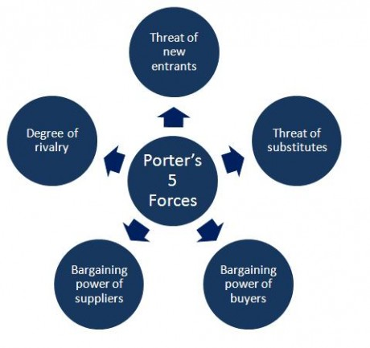
Threat of new entrants:
For the car manufacturing industry the threat of new entrants is very low. This particular industry is highly competitive and in order to establish business in such industry it is important to have proper logistics, resources and capital which are highly difficult. Hence, this force is weak in case of Rolls Royce organization (Bruijl, 2018).
Threat of substitute:
In case of Rolls Royce, this threat is comparatively low to moderate. it has been observed that the cars and engines by the organization is highly advance and different compared to other car manufacturing companies in the industry. This helps the organization to develop high competitive advantage against this particular force.
Competitive rivalry:
Through the understanding of the dynamics in the car manufacturing industry, it can be seen that the competition in this market is very high. Hence, this force can be considered as a string force for the organizations in this industry. In the market, there are numerous companies that offer luxury cars across the world. Hence, in order to achieve competitive advantage, it is important for the organization to generate suitable strategies and approaches (Tzarevski, 2020).
Through the critical evaluation of this mode, it can be understood that the car manufacturing industry faces many external forces while executing their business. In the case of Rolls Royce, the organization needs to understand the intensity of these forces to improve their potential in the market with effective diversity and innovation.

b) Critical assessment of the opportunities and challenges that these forces present and how Rolls Royce can best position themselves for effective competitive advantage:

SWOT analysis:
Strengths – Rolls-Royce Motor Cars Limited has various factors of strength: first of them is its brand image. The British automobile manufacturer is known for its world-class structure, hi-tech performances and luxurious presentation. This brand image has helped the organisation to be among the premium listed automobile makers in the UK and all over the world. Along with that, Rolls-Royce offers cars of different variance including Phantom, Ghost etc. Another strength factor is its global presence; it has large customer base across nearly 180 countries around the globe (Do Quang, 2017).
Weaknesses – One of the significant weakness factors of Rolls-Royce Motor Cars Limited is it generally serves the richest in the society and not affordable for the economically middle or low classes of people. And it has more or less same clientele, which makes it largely thrive on the narrow and same clientele. As the organisation chooses to serve particular group of people, they are completely depend on the repetitive purchase of the same people. In this way, it makes its operation to be limited.
Opportunities – The technical fineness and advanced design along with supreme features of the cars have high capability of appealing to the elites, thus increasing its business greatly. It has been observed that they have introduced different latest technology in their cars such as machine learning, data connectivity, Internet of Things etc. Moreover, Rolls-Royce Motor has planned to manufacture wholly electric cars by the year 2040. The increasing focus of the automobile manufacturer towards automation will bring great opportunities for them (Armitage, 2019).
Threats – Rolls-Royce Motor has a number of major competitors such as Audi, Lamborghini, Mercedes etc., which gives it tough competition as well. While operating in different countries, the company often faces threats of currency fluctuation that affects its business significantly. In addition to that, the growing operational and fuel costs act as serious threats for the organisation.

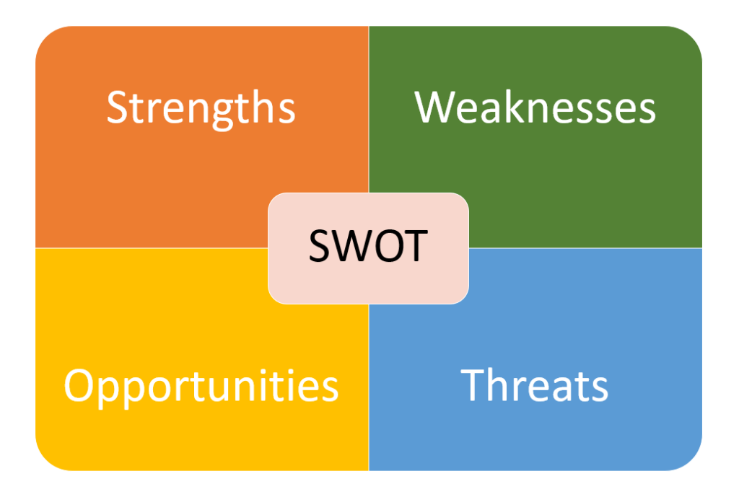

Product Life Cycle:
On the basis of technological prowess, Rolls-Royce Motors Car Limited has introduced fine luxurious cars over the years. Its product life cycle is consisted of four stages: introduction, growth, maturity and decline.
It has been found that a Rolls-Royce car has its life cycle of 9 years. The manufacturer demands this based on the excellent engineering standards, drive for excellence as well as conscientious care provided by them to maintain this product life cycle. It keeps introducing new features to its every range making it strongly demanding every year. For example, Phantom being on the top spot followed by Dawn and Wraith respectively. It has also been observed that its new SUV, Cullinan plays huge role in increasing sale for the organisation.
Rolls-Royce Motor Cars Limited manufactures its cars keeping mind the changing needs and demands or present trends of customers’ behaviours. For over the years, it has pushed the boundaries of greatness and luxury and grew significantly with new realities in its automotive design. In the life cycle of 9 years, the manufacturer has infused new ideas and significant changes into these models to improve and upgrade the quality, performance and feature (Cars, 2019).
There five Rolls Royce models are available: Cullinan, Phantom, Wraith, Ghost and Dawn. For major automobile manufacturer like BMW, Rolls-Royce also has no such maturity and decline stages. As generally it has been noted in the product life cycle model, in case, the value of the products is gradually falling and its sale is also going down, then it is considered to be reached maturity stage. After maturity, the products are withdrawn from the market. But Rolls-Royce has not experience of decreasing sales rate, instead with the inclusion of all-new features, the manufacturer advances the quality management and product development (Kopp, 2020).
Rolls-Royce Motor Cars are famous for its high-status branding image. The high-class engineering and sophistication make the brand applicable to the high-profile customers in the society. Hence, with the application of new technology, up-gradation, customisation and unlimited operational costs, the automobile maker stands itself different from the others. The cars have two prime stage of introduction and growth in its life cycle of 9 years, where the maker gets numerous opportunities to invent and apply fineness to its products, thus ensuring strong and glorious market position in automobile industry.
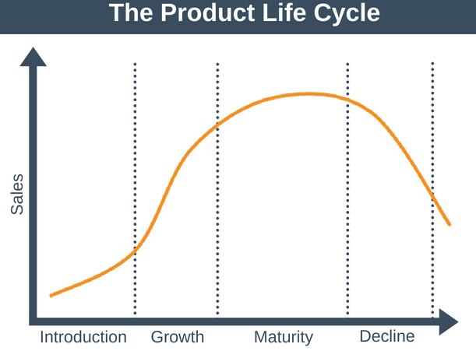

Porter’s Value Chain:
Primary Activities – Rolls-Royce has large base of suppliers from around the globe by identifying them in fair as well as transparent way. They ensure their global suppliers to maintain resilient and robust. The organisation maintains Global Supplier Code of Conduct as the foundation of approach to manage global suppliers. Rolls-Royce handles both service and manufacturing operations in order to improve productivity, ensure competitive success as well as the efficiency of the products. It operates worldwide with exclusive features. Rolls-Royce has its own wide network of dealers as well as retailers to maintain the outward flow of products to the customers. It is important to mention that Rolls-Royce cars are sold based on their brand image. The organisation has adopted digital marketing strategy to sale their products and along with that, it has enhanced its digital presence as well. It caters to ultra-rich segment of the society (Marketingdive.com. 2019).
Secondary Activities – Rolls Royce performs service of automobile customisation. Torsten Muller-Otvos is its CEO. Technology is being the field of a good amount of investment by the organisation. It is even investing on manufacturing electric cars. Rolls-Royce Motor has highly skilled and talented employees. It maintains the work force very well. With the contribution from employees from different backgrounds, it holds diverse knowledge and skills. It has set efficient purchasing and supply network to manage the quality control and procurement.
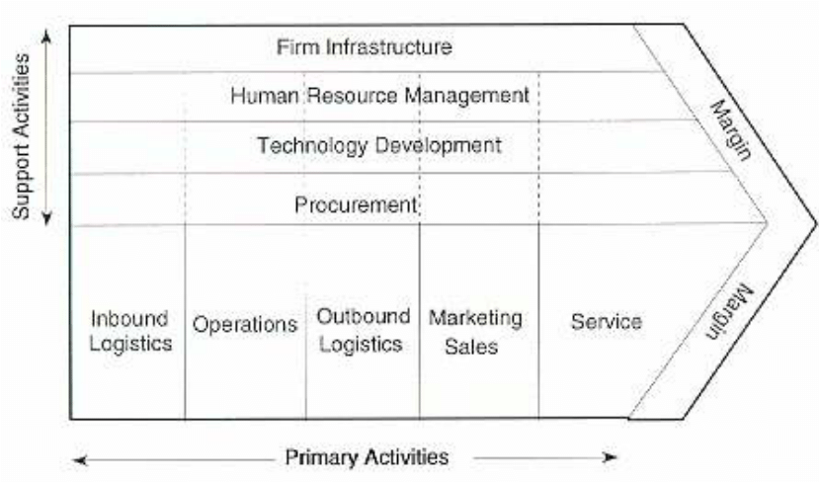

Conclusion
It has been understood from the above discussion that the major and significant forces such as political, economic, social, technology and environmental factors over the years have strong impact on the global business environment. The automotive industry of the UK being highly capital intensive and of high economic status of the country make Rolls-Royce highly competitive for the other players in the industry. So these analyses have given clear information of the changes occurred in the industry with the time and position of the organization at present. Following that, through the analysis of SWOT, factors of strength, weakness, opportunity and threat of Rolls-Royce have been presented well. Then frameworks such as Product Life Cycle and Porter’s Value Chain analysis have been explained to show that Rolls-Royce Motor Cars Limited is able to put them in the best position in order to ensure effective competitive advantages with its strength factors by creating opportunities for future growth.

References:
Bottani, E. and Vignali, G., 2019. Augmented reality technology in the manufacturing industry: A review of the last decade. IISE Transactions, 51(3), pp.284-310.
Bruijl, G.H.T., 2018. The relevance of Porter's five forces in today's innovative and changing business environment. Available at SSRN 3192207.
Clements, L.M. and Kockelman, K.M., 2017. Economic effects of automated vehicles. Transportation Research Record, 2606(1), pp.106-114.
Mateut, S. and Chevapatrakul, T., 2018. Customer financing, bargaining power and trade credit uptake. International Review of Financial Analysis, 59, pp.147-162.
Mattioli, G., Roberts, C., Steinberger, J.K. and Brown, A., 2020. The political economy of car dependence: A systems of provision approach. Energy Research & Social Science, 66, p.101486.
Tzarevski, A. and Thabethe, T., 2020. Competition Commission publishes Draft Guidelines for the Automotive Aftermarket Industry. Without Prejudice, 20(3), pp.15-16.
Do Quang, H., 2017. Marketing SWOT Analysis of Rolls-Royce Motor Cars (Doctoral dissertation, Empire State College).
Kopp, C., 2020. Understanding Product Life Cycles. [online] Investopedia. Available at: <https://www.investopedia.com/terms/p/product-life-cycle.asp#:~:text=The%20term%20product%20life%20cycle,growth%2C%20maturity%2C%20and%20decline.> [Accessed 30 January 2021].
Cars, R., 2019. ROLLS-ROYCE MOTOR CARS DELIVERS HISTORIC RECORD RESULT IN 2019. [online] GlobeNewswire News Room. Available at: <https://www.globenewswire.com/news-release/2020/01/07/1966954/0/en/ROLLS-ROYCE-MOTOR-CARS-DELIVERS-HISTORIC-RECORD-RESULT-IN-2019.html> [Accessed 30 January 2021].
Marketingdive.com. 2019. Rolls-Royce gets responsive to reach consumers more efficiently | Marketing Dive. [online] Available at: <https://www.marketingdive.com/ex/mobilemarketer/cms/news/content/21658.html> [Accessed 30 January 2021].
Armitage, J., 2019. Being Luxurious: On the Rolls-Royce Ghost Black Badge and beyond. The Third Realm of Luxury: Connecting Real Places and Imaginary Spaces, p.25.

