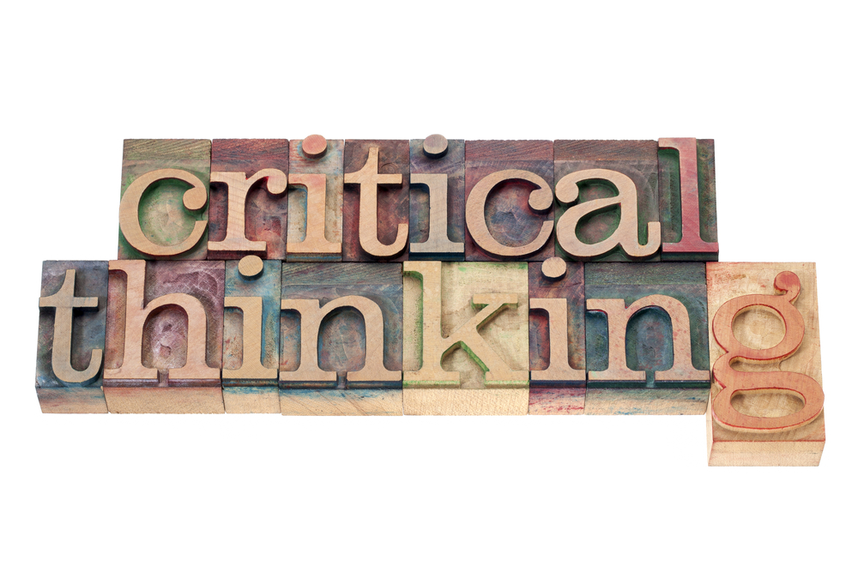

Developing Workplace Critical Thinking
  - Critical Analisys of management theories relevant to work place
Marinela Berendei | 1706156 | 11 January 2019
  - Acknowledgement
Although the students and employees understand the need for the development of new abilities, they could not consistently deliver reliable results because of the level and complexity of information that radiated all around. Unprepared for workplace market new changes along framing in the workforce and whit the speed that everything moves these days Critical Thinking is the skill that could change everything. Don't take anything for granted, always put a question. Thinking is not a criticism of personality characteristic or a born skill but is an art that can be learned. Critical thinking has the support of convincing the subject in the right to doubt everything and all, is the thinking that decommissioned information in their details, it goes in profundity, inside things — the resolution obtained by analysing the situation”. "To fool you," to commit an error is not only frequently, but it is also – as paradoxical as it may seem – necessary. That is how knowledge begins. Nobody can start by knowing: Only realising nonscience can force to investigate. If the answer I find in a question is wrong, where it is the correct answer? That actual knowledge begins the moment realise the error. Critical thinking is not negative thinking as opposed to positive or creative thinking, the one who thinks critically, asks. However, asking the questions is to decide what is reasonable to believe, which makes the man who thinks critically to distinguish between the testimony of trust and questionable and to weigh the evidence, to decide what is reasonable.

  - Table of content

Content……………………………………………………………. Page number

Acknowledgement………………………………………………………………………………………...1

Table of Content………………………………………………………………..………………………….2

Executive Summary……………………………………………………………………………………….3

Procedure and Method………………………………………………………………………….………4

Introduction…………………………………………………………………………………………..……..5

Main Body……………………………………………………………………………………………………..6-18

Conclusion…………………………………………………………………………………………………….19

Reference………………………………………………………………………………………………………20-21

Recommendation………………………………………………………………………………………….22

Appendix……………………………………………………………………………………………………….23-27

  - Executive sumary
This report aims to reveal the connection of critical analysis, the impact of beliefs, attitudes and values on workplace behaviour that candidate already has, and one needs to develop. It is essential for the workplace to be critical. It is also essential to be part of, a group that fit with the candidate’s beliefs, attitude, values and commitments. This type of environment, like many others, involves working and managing people, which is very complicated to do if the candidate does not have critical skills.

  - Procedure and Method
There are representative books, journals, videos, magazines, journals, acquired from the internet, shops, library, also hunted on the internet and were interviews with people who already participated in critical thinking training skills. There is a new approach, not just students, more and more companies are investing in upgrading employees whit new skills. Lack of cognitive abilities development leads to a drop in the quality of employee, jobs, leaders and eventually the entire community. Various backing examples, best ways, fastest way of coaching critical thinking has been used to improve attitudes and values in the workplace. All of them are examined to develop an idea, to lead the discussion as critical thinking is related to objectivism, leadership, education and accomplishment and for that reason, critical thinking can overcome the challenges faced by employees, both those who come from schools as well as those already in work.

  - Introduction
Many businesses search for employees with the best attitude to acquire new skills. Usually, they learn better in the workplace, and they can learn quicker, solving problems, being creative, gather and analyse information, draw appropriate conclusions from the data and communicate their ideas clearly and efficiently. These are precisely the kinds of skills aimed at improving critical thinking in order to reduce the hole between finishing school and obtaining a proper job. In this environment, Ashkanasy and colleagues (2002) conclude that “emotional intelligence and diversity management skills are required to be efficient.”
Thinking critically and bring evidence in favour of opinion or a belief the result is reasoning (an argument), that opinion or belief is the conclusion of reasoning, the activity of analysing whether evidence or motives support the conviction is called argument analysis. Critical thinking deals with reasoning and arguments. Critical thinking means trying to understand what the other guy wants to say. “Criticism is not for the sake of destroying the other's arguments but for the sake of clarifying them.” It raised by Shaw, R. D. (1986) that critical thinking is a concept that has taken on multiple meanings and uses.
When formulating an argument, or when read one, the most important is to ask: what is the bottom line? What and why he wants to show through this argument? The critical thinking aims are testing the validity of assumptions and beliefs by applying a set of skills such as interpretation, inference, explanation, analysis, evaluation and self-evaluation. A critical thinker is the critic on the sources, recognises judgments, motivations, and assumptions, appreciate well the nature of an argument, including the reasons, assumptions, and evidence. In a way appropriate for the situation, draws conclusions and integrates all items in this list when deciding what it is trustful and what is not as was observed by McVittie et al., (2008) “such groups are believed to make better and more innovative decisions because they are less susceptible to ‘group think’.

  - Main Body
Critical thinking is a natural element of an organisational mission statement and outcome assessment. I-Care centre mission is to provide the best possible care for the service users by developing in the organisation individually and collective attention that will contribute to service users well-being, security and comfort because they are enabled to enjoy life to their fullest potential. To effectively provide the best quality with that to the customer, the skills and strategies of the manager are essential to achieving the goal. Critical thinking is committed to ensuring the health and safety of all the staff, clients, family and visitors in the organisation.
Critical thinking is essential in healthcare settings like for instance, in a day-to-day duty of a manager have to take a lot of data or information to adapt knowledge for issue clarification and solution which involves making decisions. There is one case wherein the manager received a complaint from the family of a Service User about the negligence of the staff due to short staffing. They have to consider many things concerning her decision like the values and belief of the organisation. A meticulous investigation was done to solve the problem. The manager called a reunion and listened to both sides aspect and argumentation. In this situation, critical thinking is crucial to establish whether the information or assessment obtained from both sides has accurately accumulated. Health care team demands critical thinking skills to thoroughly investigate and reflect on all aspects of observation or issue in order to decide the necessary actions.
In the current climate of short staffing, cost-cutting and high expectations for quality, skills in which critical thinking is necessary to move upon organisational and systems problems, because failure to act on these problems may result in indigent clients satisfaction, complaints from clients and their families and company's bad reputation or credibility.
Managers in the organisation should have skills in a superior level of thinking and reasoning skills to face effectively higher demands and greater accountability. A manager who thinks critically can adapt quickly to continuously changing surroundings and understand values and logical processes that manage the tasks and choice that they make. They are more fitted to shape and accept change and innovation, which is more critical for today's organisation.
Criticism of beliefs, attitudes and values are an essential element in our lives every day. They tend to shape thoughts, perceptions and feelings about the environment around us. As human beings, we have our own beliefs, attitudes and values followed from the beginning that the picture who we are and how we see the world. The manager, working with staff and clients with different beliefs, attitudes and values must be aware and ready to take their professional values and not impose our own opinions or our client.
Our beliefs are the assumptions we make about ourselves, others and the world about how we expect things to be. People or clients have their own beliefs that influence all aspects of daily life such as how they dress, can be influenced by religious beliefs and cultural and social customs. Each does not always agree with each other about different values and faith. However, we should think critically that this is how they brought their ancestors, so we have to respect their beliefs.
Attitudes established ways to respond to people and situations that we have learned, are based on the beliefs, values and assumptions we hold. Our attitude becomes manifest through our behaviour. Where we have a right attitude about something, we have the usual good results as at work in dealing with customers we should treat them as if they are our family because we always bear in mind that, where the family is in place. On the other hand, if we have a negative attitude some people around us will complain that will cause us not to feel good about ourselves. “But to be critical in the tradition of critical theory/pedagogy, the line of inquiry would have to continue until students turned an eye on their circumstances. In a sense, this is a final step toward critical action.” (Shaw, 2014)
Values are about ho learned to think things should be, or people should behave, especially concerning qualities such as honesty, integrity and openness. For us to develop critical thinking, we must possess specific moral values, ethical behaviour and positive mental attitude towards our work or co-worker to help come up with a decision correct and logical reasoning.
As an aspiring manager, it is good practice to think about attitudes, beliefs and values and to take into consideration when making its decision. To assess various issues at work, should have a better understanding of basic logic and critical thinking process because these are essential to make good decisions and build relationships casually. For example, in dealing with the conflict between the staff, would have to weigh the question of evaluation and assessment of the pros and cons of the conflict and the decision ought to think critically and to come to a right decision that will not be biased for both sides. When staff are present between, should deal with it in a calm assertive and professional manner.
Our beliefs grow from what see, hear, experience, read and think. From these things, we will develop an opinion which we hold to be true. Our beliefs come from our values, which may be correct or incorrect concerning evidence, however, hold to us. Our beliefs and values can strengthen through experience or evidence. For example, a patient in need of blood, but his son, who is a Jehovah's witness refused to help, but his father is between life and death. He said the blood transfusion is against Jehova's witness beliefs; However, it wants to prolong his father. So he agreed with the doctor, and his father recovered. It is possible for the beliefs and values to differ by overtime when encountering such experiences that challenge our views previously held in his life. Some people think it is a miracle from above; Others might have their faith in the goodness of human beings, particularly if they have a terrible experience.
In the setting of care, the way provides service user care reflect attitude, beliefs and values. For example, based on experience, treat the user as if they are family because learned the values that education and think saying "treat others as you treat yourself". Positive attitude and behaviour which we showed to others will come back, although we cannot please everyone. Sometimes despite the positive attitude when working with colleague still there is a conflict due to differences in belief and values that we possess. With this experience taught that even if there are, differences try to solve it because dealing with this type of situation will immediately create a positive result. Teamwork and critical thinking are essential in determining health care quality provided by the I-Care company. I-Care company must understand the values of critical thinking to know the relevance of it and to know the benefits of improvements in working with new and existing clients. In order to remain professional is essential to leave personal values from the customer, means that it is essential to allow clients to make decisions based on their values and beliefs. The relevance of theories in the job role has helped people in time to be more productive and to increase our personal and professional quality. It must be hard to deal with problems and maintain a stable or improved level of productivity through critical thinking and communication, but words of encouragement or merit show real concern and respect for staff and clients.
This next section explained the theory of management that have identified as relevant to the role, the impact of beliefs, attitudes and values on this theory and how someone with different beliefs, attitudes and values can interpret this working differently.

RED Person Critical Thinking model

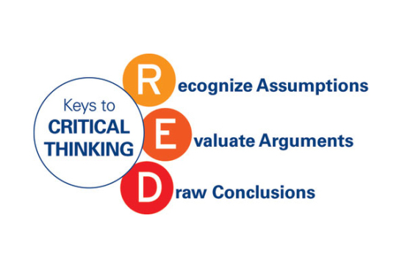

The RED model establishes a way to understand how critical thinking works and for developing each of the critical powers. Let's take a look at every critical skill of thought.

Recognises assumptions
I-Care center activity relations can be the right place for conflicts. Conflicts arise when there is not understanding and agreement on the facts and expectations. While many assumptions are needed to get every day, when we make assumptions about others ' words as well as actions and motivations, we run a high risk of being wrong. Making assumptions can lead to significant problems between people relations. Assumptions made when: peoples think they know reasons, skills, abilities, competencies (incompetence’s) based on gender, race, age, what information people have given, how information has understood. We are all susceptible to unconscious assumptions about the world around us. The ability to overcome is to remember to check every time.
That is the ability to separate reality from the dark side of assumptions. It is easy to listen to a comment or a presentation and assume the information presented, it is true, even if no evidence has been given to it back. Observing and questioning assumptions helps to reveal gaps in information or false logic. Making a step further, when they examine the assumptions through the eyes of different people (e.g. the view of the various stakeholders), the result is a richer perspective on a subject.
When we are collecting information, we must listen to what people are saying or evaluating a situation, we must think about what assumptions been going. Perhaps we assume that a reliable co-worker is providing reliable information – but is there evidence to uphold that up? We must learn to see gaps in logic, and opinion disguised as fact. For example, in a workplace, an employed can assume that it does not have a real opportunity to take a management role, based on a teammate that he said he knows that is now availabilities in the management roles. The thing to do is to put some questions about the availability of a position in the management board, will be more transparent and based on real facts.

Ask Questions
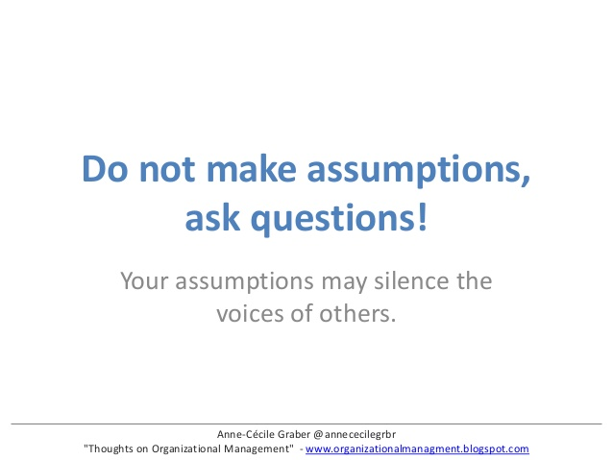
A set of questions that can pose:
Please explain how to understand what it said?
What are our goals? Expectations?
What did it want to accomplish when did that?
What information does have about, project responsibilities?
Understand how to work together?

Assessment of arguments
The art of assessing the cases involves analysing the information objectively and precisely, asking of evidence and understanding how emotion influences the situation. Common barriers allow emotions-yours or others-to get in real evaluation mode. People can quickly conclude, to avoid conflict. Being able to remain objective and sorting through the validity of the various positions helps draw more precise conclusions.
Often sort problems by contradictory information, because we let our emotions get in the way, or because – as just about everyone – we sometimes hear what we want to hear. Learn to push all that aside and analyse the information accurately and objectively. Managers and staff, in general, can make decisions too quickly as an uninspired response to the challenge came from a colleague. The case study below considers situations that are emotionally loaded, driven by a volatile personality; and how to deal with such incidents. Interpersonal conflicts of diffusing light work require an understanding of how to approach the problem and what questions to ask.

The case studies
Here's the background: no one does anything about Mia. They try to stay out of her way. However, the effects are terrific. Our team has broken, and everyone seems to have divided. People are ignoring and trying to undermine one another. Can't seem to look at each other, let alone to sit in meetings or dining together, like we used to. In this work environment, two people get together at a review report. Mia and Stan both should contribute to the report. Stan starts adding up saying its section has not completed. Mia loses. Stan is indignant that Mia cries out to him, he abuses in front of his colleagues. Stan thinks of all time Mia has upset him and others and how they put up with it and now, to abused for missing a time limit!
What is Stan to do here? Can stop from experiencing emotions during an argument at work but do have control over what is feeling and the intensity of feelings. Because each heartbeat occurs in perception, can change the way think about life to change what feel. The primary strategy here is to ask a few questions. Stan must ask himself: what are assumptions about this situation, am sure am right, what is the evidence that perceptions are right, what can do to help Mia and behaving more respectfully, will actions be perceived positively, how can ensure that the perception is positive?.
Conversation with Stan has and was at some point in time help Stan to work in its expectations and helps him figure out whether those expectations are realistic. Use questions to clarify the assumptions and expectations of and, in this case, Mia. Each office will experience arguments at work, the key to solving arguments at work is to understand the cause of the argument at work and then build a plan of action based on ten questions above. In some cases, the scope of argument extends from the workplace beyond just two people and includes departments or organisations. Proactive resolutions
specialise in solving arguments at work and restore respectful workplace so that future job arguments dealt with respectfully and productively.

Draw conclusions
People who have the ability for critical thinking can bring various information together to reach conclusions that logically follow from available evidence, and they do not generalise inappropriately beyond the evidence. Also, they will change their position when the evidence justifies it. They characterised as having “good judgement" because they usually arrive at a quality decision.
Use it: This is the reward. When thinking critically, the real picture becomes clear and can make the tough decision or solve a difficult problem. Find the main problem and ask what the position of the writer or speaker on this issue is. Look at the beginning or the end of sentences; The conclusion often found in one of these places. Ask what does the writer or speaker wants to prove?

TOULMIN MODEL OF ARGUMENT

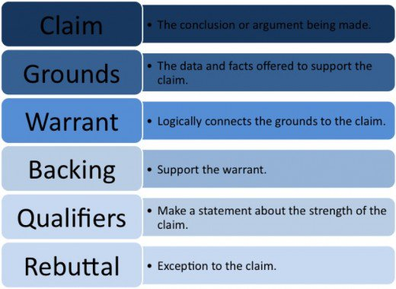
Named after the British philosopher Stephen TOULMIN is used for building critical arguments, for situations where there are no clear answers. This method involves six components that weigh and support pros and cons concerning an argument. (Peter and Wilson, 2019)
By applying the model, an argument is more reliable, credible, less susceptible, and generally more efficient and effective.

Claim
The Claim is an attempt to make an assertion or a desire to prove itself. In other words, the demand is the proposal of an argument that someone else will accept. Just use the question, "What is my main point? "
A claim is trying to make the assertion/wish to prove. In other words, the claim is the proposition an arguer wants someone else to accept. Ask, “What is my main point?”

There are three types of claims:
Fact-Based Claim: Claim that focuses on direct observation, experimentation, or other data-supported research.
Example: I-Care at the last interview did not find a qualified supervisor.
Judgment and Value Claim: Claim involving opinions, attitudes, and subjective evaluations.
Example: I-Care did not find a new supervisor because the salary offered it was too small.
Policy-Based Claim: Claim to advocate courses of action that should take.
Example: I-Care should pay a bigger salary to be able to fund a new supervisor.

The Evidence
The evidence provides support and reason for the assertion. Just ask, "What is my proof? " The samples may consist of: statistics, quotes, reports, findings, physical evidence, or other forms of data or reasoning following the Toulmin model. Evidence must always to be included and explicitly mentioned.
Reports and data from financial statements are primary evidence. Use information from several sources: reports of industry analysts, media reports, other company disclosures, among other sources.
Example: According to the 12 December I-Care report 50% of clients that represents 10% of the total customers who use the catering system daily, recommend the company to prepare a change of the catering company providing them food.

The Warrant
The warrant serves as an essential link between the claim and the evidence. A warrant is a reasoning chain linking evidential support and reason on demand. The warrant is usually widely accepted as truths that apply to a wide range of circumstances. That is a necessary component of a logical argument.
Example:
I-Care gives free t-shorts to each career at the end of the year.
New teammate received a mail that announces at the final meeting in December I-Care will give a new t-shirt to each employee.
This December I-Care will change the color of t-shirts as they do it each year and for that reason will give us all new t-shirts.

The Backing
The backing is evidence supporting a warrant. It is similar to evidence supporting a claim: It can include statistics, quotations, reports, findings, physical evidence, or other data or reasoning. There is a difference: evidence supporting a claim is a necessary component of a logical argument; but while backing can strengthen an argument, it is not a necessary component. When the backing included it must be explicit.
Example:
Training across I-Care Swansea concerning service users improves satisfaction along careers and service users. Decreasing times between training sessions shows that careers activities and service users satisfaction is reported improved.
Over eleven branches countrywide have adopted the same measures. Eight of these branches have reported an increased number of new service users due to the increasing quality of service. Three branches receive local awards.

Qualifier
Qualifier limits the power of an argument attributed to a statement. The qualifier associated with the strength of the evidence, the mandates or the existence of a valid counterargument, is transmitting how good the argument is. It is often correct to apply the rating.
Example: I-Care is going to pay more for the wages in the new year. If no one gets anything written, we can qualify false information. By receiving mail and being instantiated by the employer's intention, the rating can be of real information, and it can be more credible.

The Counterargument and Rebuttal
The counterargument brings objections to the claim and the rebuttal reduce objections by suggesting reasons the counterargument is decreasing significance, is this a part of the process of building arguments, refining them, interpreting and analysing them.

Theoreticians

Frank Bunker Gilbreth Sr.
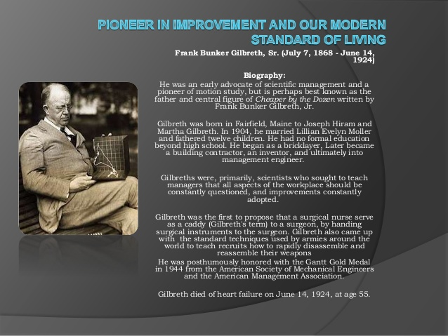
The Gilbreth time and motion studies, their consideration of the human factors in the workplace, develop many aspects of contemporary management theory. Gilbreth was an advocate of scientific management, an expert in industrial engineering in fields like motion study and human factors. His beliefs in the power of observation were huge.

Frederick Taylor
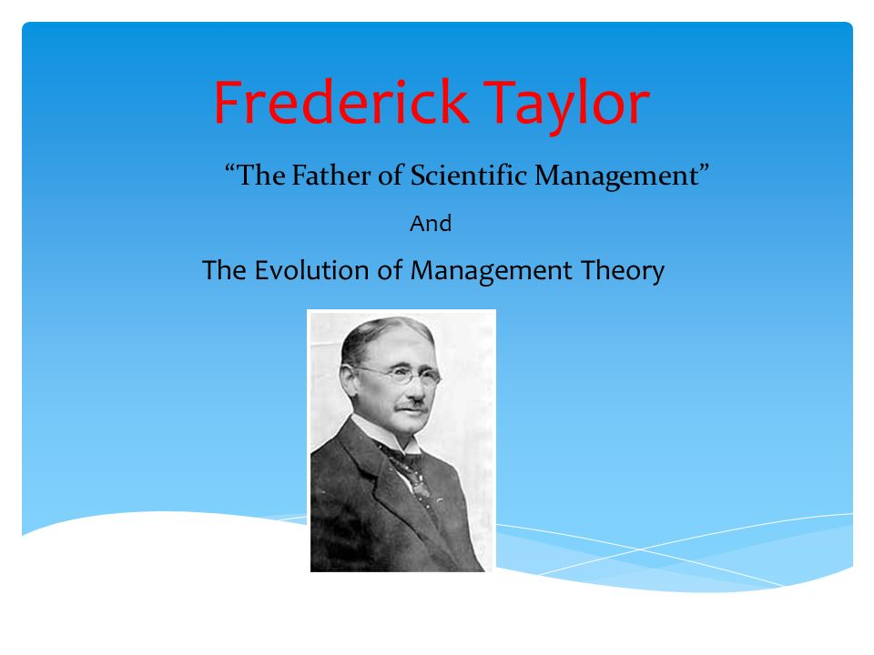“Passionate for order and efficiency, persistent, incredibly driven problem solver” (Rodgers, 2019) Taylorism known as scientific management which named after Frederick W. Taylor is a production efficiency methodology that splits work into simple segments and like that can be analysed and taught.

Elton Mayo
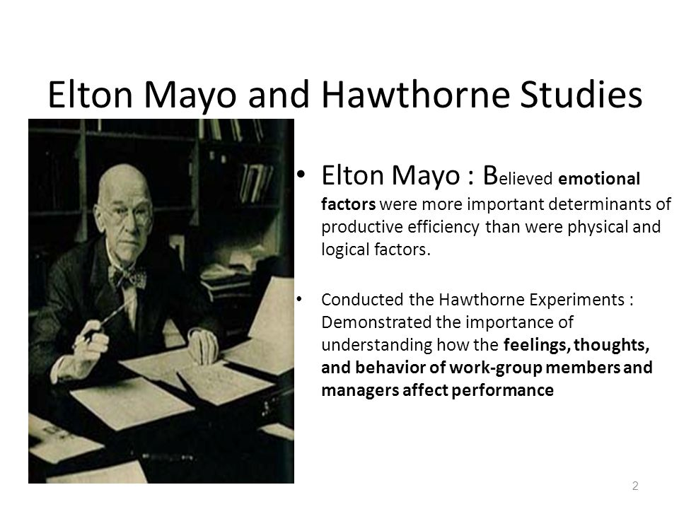
Elton Mayo (1880–1949) it was an Australian psychologist, an industrial researcher and an academic organisational management scientist. His studies, together with the Hawthorne studies, became the base for his lifelong breaking theories on Human Relations and scientific management.

  - Conclusion
If more people get united by good and legitim ideas, the result will be companies were everybody come with pleasure and hope. The conclusion is that we have a candidate who recognizes now all elements for the development of his critical skills that will help him to discover the right questions, answers and to deliver betters judgment. The candidate keeps improving all abilities, also fallows business management university in order to have a degree. The candidate is a plus for any eventual employer because it stays honest, works hard and it is critical even whit himself, regardless dilemma that will stand.

  - Reference
Alred. G. J. (1973) The Journal of Business Communication. 43(2), pp.79- 88.
Stieger. S., Kastner, C. K., Voracek, M. and Furnham, A. (2011) Psychological Reports. 108(2). pp.606-616.
Bowell, T. and Kemp, G. (2015) Critical Thinking: A Concise Guide (4th edition). London: Routledge.
Copi, I.M., Cohen, C. and McMahon, K. (2016) Introduction to Logic (14th edition). London: Routledge.
Cottrell, S. (2011) Critical Thinking Skills: Developing Effective Analysts and Argument (2nd edition). London: Palgrave Macmillan.
Dess, G.G., & Robinson, R.B.J. (1984). Measuring organizational performance in the absence of objective measures: The case of the privately-held firm and conglomerate business unit. Strategic Management Journal, 5(3), pp.265-273.
Dhanaraj, C., Lyles, M.A., Steensma, H.K., & Tihanyi, L. (2004). Managing tacit and explicit knowledge transfer In IJVs: The role of relational embeddedness and the impact on performance. Journal of International Business Studies, 35(5), pp.428-442.
Fisher, A. (2011) Critical Thinking: An Introduction (2nd edition). Cambridge: Cambridge University Press.
Graber, A. (2019). instead of assuming ask questions - Bing. [online] Bing.com. Available at: https://www.bing.com/images/search [Accessed 7 Jan. 2019].
Hodges, W. (2001) Logic (2nd edition). London: Penguin.
Kumar, R. (2014) Research Methodology: A Step-by-Step Guide for Beginners (4th edition). London: Sage.
Mathews, D. (2019). The Evolution of Management Theory. [online] Slideplayer.com. Available at: http://slideplayer.com/slide/6889575/23/images/1/The+Evolution+of+Management+Theory.jpg [Accessed 8 Dec. 2018].
McVittie, C., McKinkay, A. and Widdicombe, S (2008) Organizational knowledge and discourse of diversity in employment. Journal of Organizational Change Management, 21(3): pp.348-66.
Mencl. J. and Lester, S. W. [2014] Journal of Leadership and Organizational Studies. 21(3). pp.257-272.
Peter, G. and Wilson, C. (2019). THE TOULMIN MODEL OF ARGUMENTATION. [online] Navigatingaccounting.com. Available at: http://www.navigatingaccounting.com/sites/default/files/Posted/Common/Resources_web_book/Toulmin_Model_of_Argumentation.pdf [Accessed 1 Jan. 2019].
Rodgers, E. (2019). Frederick Winslow Taylor - ppt video online download. [online] Slideplayer.com. Available at: http://slideplayer.com/slide/7533739/ [Accessed 14 Dec. 2018].
Shaw, R. (2014). How Critical Is Critical Thinking? Music Educators Journal, 101(2), pp.65-70.
Shelton, C. (2019). critical thinking, scientology The Most Critical Thing That Scientologists Need. [online] Mncriticalthinking.com. Available at: http://mncriticalthinking.com/wp-content/uploads/2014/05/critical-thinking-wood-blocks.jpg. [Accessed 11 Jan. 2019].
Shsrecdn, S. (2019). slidesharecdncom. [online] Image.slidesharecdn.com. Available at: https://image.slidesharecdn.com/neoclassicalmanagementtheories-120924060105-phpapp02/95/neo-classical-management-theories-4-728.jpg?cb=1348466655 [Accessed 2 Jan. 2019].
Thomas, G. (2013) How to Do Your Research Project: A Guide for Students in Education and Applied Social Science. London: Sage.
van den Brink-Budgen, R. (2010) Critical Thinking for Students (4th edition). Oxford: How To Books.
van Vliet, V. (2017). Elton Mayo. Retrieved [1Jan 2019] from ToolsHero: https://www.toolshero.com/toolsheroes/elton-mayo/
Warburton, N. (2007) Thinking from A to Z (3rd edition). London: Routledge.
Wallace. M. and Wray, A. (2011) Critical Reading and Writing for Postgraduates (2nd edition). London: Sage.

  - Recommendation
The candidate has a vast experience in communication, teamwork, at the other main skills that are linked whit critical thinking, in this point, must be sensitive to acquire as much knowledge in the range as possible and evolve like on the personal plan and as well professional. It is not enough to have the wisdom to learn, and It is essential to reflect experience, draw on our knowledge and to identify new approaches and theories, which can then be applied to new situations. Without reflection, we would only proceed to replicate our errors.

  - Appendix



