Silvia Settle
Silvia Settle
Tim Bashford/mIKE dacey/nik white
Word count: /1500
accessibility rating web guide
search-based web application

Contents
1. Introduction 2
2. Background to the Proposed Research 2
3. Aims and Objectives 3
4. Methodology 3
4.1. Research Methodology 3
4.1.1. Philosophy 3
4.1.2. Approach 3
4.1.3. Strategies 4
4.1.4. Risks and Limitations 4
4.1.5. Ethical Issues 4
4.1.6. Validity, Reliability & Generalisability 4
4.2. Development Methodology 4
4.2.1. Software Development Methodology 4
5. Resources and Planning 5
5.1. Hardware Resources 5
5.2. Software Resources 5
5.3. Project Plan 5
6. Reference List 6

Introduction

One of the aims of the Equality Act from 2010 is to protect people from direct and indirect discrimination, including the duty to make reasonable adjustments for disabled people [1]. When visiting a venue or a place of interest, a person with specific needs would have to find out the accessibility levels for the place they intent to visit and this may involve extensive online research, often on more than one website. The proposed project aims to provide a one-stop-shop solution that will present the information for available places of interest grouped by categories and within a certain radius from a searched postcode or area name. Apart from being a time-consuming and cumbersome task, obtaining the desired information can prove challenging when different venues have different understanding of their accessibility level, and sometimes even mislead the user with their inaccurate interpretation.
There are not many solutions available currently that meet these kinds of requirements. The challenge some users face when using accessibility rating apps such as ‘AccessNow’ for example, is that they are linked to an ID and not everyone is willing to create an account in order to access the information on the app. There is a possibility that the user will have to pay to download the app, or alternatively, may have to endure targeted advertising and interruption. From development point of view a major consideration would be whether the app should be designed as a native to a specific mobile device operating system, or a hybrid one - with all the implications this may incur.
Another possibility is a web-based solution such as ‘Accessable’ (https://www.accessable.co.uk/), which despite being very informative and offering a lot of details, can also appear too busy and overwhelming.
The proposed local area accessibility web-application aims to alleviate the above-mentioned challenges by providing a fast and simple solution that combines accurate information with clean presentation and considerate user experience.

Background to the Proposed Research
The initial considerations for the project require the exploration of several areas of research. One significant point of exploration that will impact the direction the solution will take is the source of the data and what would be the best approach for obtaining it. Currently, a web-scraping approach is considered before the possibility of accessing readily available data through a readily-available third-party API. Even if the data obtained through an API is available for free, the request-and-response cycle adds another layer of complexity to the overall system [2], therefore a custom-built scraper is the current preferred solution. Most importantly, it is highly unlikely that the exact content of the data required for the project would be available through only one (or a few) APIs at the desired level of detail and format. Obtaining publicly available data directly from websites is therefore the chosen approach for the project due to the flexibility it offers and the ability to access a wider-range of data, including potential triangulation of sources of information [3].
Another point for consideration is the overall architecture of the application and the choice of programming language and framework [4], as well as the type of data-store the system will use and how this will be interrogated [5]. The solution is aiming to explore and implement the optimal combination of tools and technologies suited for meeting the requirements of the project. The expectation is for the processes of scraping the data and then responding to the user’s request to be completely independent of each other, a scenario where the user’s request is pre-empt and the required data has already been collected, stored and made readily available [6]. It is important therefore to have a data-store that is capable of being queried quickly and be able to return fast responses. This directly links to the considerations for the choice of data connectivity mechanism and communication framework used [7, 8, 9]. It also leads to questions such as what backend and middleware frameworks would be used, with implications such as ease of middle-ware support and integration, search-engine optimisation (SEO), need for microservices or containerisation.
Similarly, the format of the returned data will require further investigation as it is deemed important to be able to display the results in a clear, clean, concise, and visually attractive way. The aim is to build a dashboard that incorporates an interactive map. There are plenty of solutions available for presenting geo-spatial information such as Folium [10], Tile Mill [11], Open Layers [12], etc. Ultimately, the decision will be based on which solution is deemed best suited for the project [13], as well as is likely to be linked to the choice of programming language and the framework used for the project’s implementation of the project.
Finally, the security of the web application will be considered in general within the OWASP Top 10 framework [14], as well as on more granular level in terms of the security of data in transit (secure transmission and encryption) and at rest (data store) [15].

Aims and Objectives
The project aims to create a web-based application that, given an input of a place-name or a postcode, should return the accessibility categories for venues and places of interest within a certain radius. The application will have three main parts: a web-scraper that collates the accessibility data from the venues/places of interest web-sites and stores it in a data store; a front-end that facilitates the user’s request and displays the server’s response in the form of a data visualisation dashboard that incorporates an interactive map display; and finally a custom-built API as an engine that links the back-end data to the front-end. The project objectives overlap with finding the optimal solution(s) for building the three main parts of the web application. In addition, the solution will be tested to ensure that it meets the usability and performance requirements set out at the beginning of the project. It is also important to note that initially the boundaries of the solution will be limited to a small geographic area, most fitting within the proof-of-concept approach that aims to prove that this solution is feasible before expanding it to the rest of the UK and a wider geographic area.

Methodology

Research Methodology

Philosophy
The project research philosophy is positivism in terms of finding the optimal solution for the project – for example, what is the most appropriate web architecture and development framework. Existing solutions will be explored and used to inform the decision made during the implementation stages of the project.

Approach
The approach would be deductive, which would ultimately lead to a solution that meets the aims and objectives the project set out to achieve. The final product would be subject to developmental, integration and user-acceptance testing. There is a small element of inductive approach in terms of testing the user experience while using the web application.

Strategies
The chosen strategies for the project involve software development, document analysis/case study, focus groups (for the design and user testing). The software development strategy aims to produce a working product that meets the user requirement. The document analysis will be combined with a few case studies to explore similar existing solutions and draw on the best practices and approaches for the project. A focus group would be used both in the design and testing stages of the application development.

Risks and Limitations
A significant part of the risks associated with the project come from carefully considering the boundaries set out by GDPR and other data protection legislation when obtaining data through web-scraping. The project aims to only use data that is publicly available (factual and not personal or sensitive), data that does not violate the terms and conditions posed by the source of information (including the website’s robot.txt file) and that the data is not used for financial gain. This also aligns with the fact that the proposed solution is aimed at being a proof-of-concept only.
It is important to acknowledge that the solution will be limited in terms of the developer’s knowledge, skills and experience, as well as the time restrictions that the project must meet. The latter will be negated with the use of control measures such as detailed project planning and use of buffer time. To avoid any risk of losing any work produced, the student’s one-drive and a version control software application will be used (GitHub).

Ethical Issues
Some of the legal risks discussed above must also be considered from ethical point of view and more specifically ensuring that the data is obtained is strictly publicly available, does not violate any terms and conditions posed by the source, and is only used for the single purpose of displaying the accessibility categories of the place of interest. The data must also be stored and transmitted securely to avoid any malicious use, illegal implications or unethical practices.

Validity, Reliability & Generalisability
The credibility of the project can be measured through its levels of reliability, validity and generalisability.
Reliability of the solution is relatively low – it depends on the combination of choices for implementation of the different components of the application. If a different team was to develop the web app, their choice of approach, tools and technologies may vary.
Validity would be high in terms of clarity of outcome and if the aims and objectives set at the beginning of the project were achieved. The evidence to support this would be the test data to accompany the solution, as well as final product and its performance.
Generalisability of the solution is average, as initially the solution would be applicable to a contained geographic area, i.e. Wales. The application will have the potential to be expanded to the rest of the UK after the initial proof of concept is completed.

Development Methodology

Software Development Methodology
The software development methodology will follow the Agile principles: user-centred approach, iterative development, focus on producing a minimal viable product. Frequent communication and feedback from potential users will ensure that the product remains relevant and within the stakeholders’ specification.

Resources and Planning

Hardware Resources
A desktop or laptop with specification suitable for web development and testing, including tools and frameworks for programming back-end and APIs. (at least 16GB RAM, 2.6GHz processor, 1TB SSD drive)

Software Resources
Software development environment (IDE, SDK) suitable for the programming language and tools of choice (Visual Studio 2019, or Visual Studio Code, etc).

Project Plan

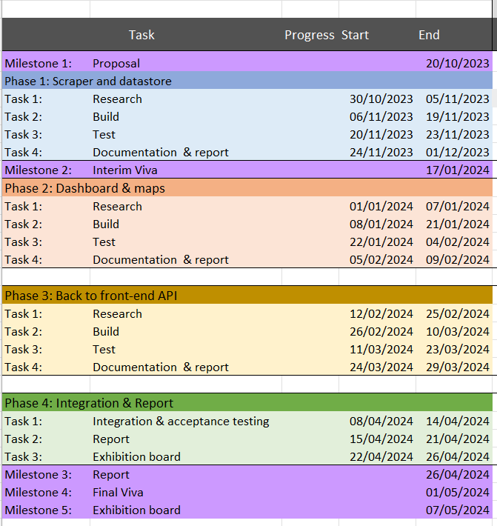

Reference List
[1] Equality Act 2010: guidance - GOV.UK (www.gov.uk)
[2] I. Dongo et al., “A qualitative and quantitative comparison between Web scraping and API methods for Twitter credibility analysis,” International journal of Web information systems, vol. 17, no. 6, pp. 580–606, 2021, doi: 10.1108/IJWIS-03-2021-0037.
[3] C. Slamet et al, "Web Scraping and Naïve Bayes Classification for Job Search Engine," IOP Conference Series. Materials Science and Engineering, vol. 288, (1), 2018. Available: https://www.proquest.com/scholarly-journals/web-scraping-naïve-bayes-classification-job/docview/2556525137/se-2. DOI: https://doi.org/10.1088/1757-899X/288/1/012038.
[4] D. V. Kornienko, S. V. Mishina, and M. O. Melnikov, “The Single Page Application architecture when developing secure Web services,” Journal of physics. Conference series, vol. 2091, no. 1, p. 12065–, 2021, doi: 10.1088/1742-6596/2091/1/012065.
[5] A. Lawi, B. L. E. Panggabean and T. Yoshida, "Evaluating GraphQL and REST API Services Performance in a Massive and Intensive Accessible Information System," Computers, vol. 10, (11), pp. 138, 2021. Available: https://www.proquest.com/scholarly-journals/evaluating-graphql-rest-api-services-performance/docview/2602022688/se-2. DOI: https://doi.org/10.3390/computers10110138.
[6] Ahmad, Farid. "Big Data Virtualization and Visualization on Cloud." Web Services: Concepts, Methodologies, Tools, and Applications, edited by Information Resources Management Association, IGI Global, 2019, pp. 922-932. https://doi-org.ezproxy.uwtsd.ac.uk/10.4018/978-1-5225-7501-6.ch.50
[7] J. Doolittle, “APIs With GraphQL,” IEEE software, vol. 40, no. 2, pp. 118–120, 2023, doi: 10.1109/MS.2022.3227254.
[8] Quiña-Mera, A. et al. (2023) ‘GraphQL: A Systematic Mapping Study’, ACM computing surveys, 55(10), pp. 1–35. Available at: https://doi.org/10.1145/3561818.
[9] Wittern, E., Cha, A. and Laredo, J.A. (2018) ‘Generating GraphQL-Wrappers for REST(-like) APIs’, in arXiv.org. Ithaca: Cornell University Library, arXiv.org. Available at: https://doi.org/10.1007/978-3-319-91662-0_5.
[10] Folium — Folium 0.1.dev1+g3715bad documentation (python-visualization.github.io)
[11] TileMill and GIS | TileMill (tilemill-project.github.io)
[12] OpenLayers - Welcome
[13] Management Association, Information Resources, ed. Information Retrieval and Management: Concepts, Methodologies, Tools, and Applications. Hershey, PA: IGI Global, 2018. https://doi-org.ezproxy.uwtsd.ac.uk/10.4018/978-1-5225-5191-1
[14] OWASP Foundation, the Open Source Foundation for Application Security | OWASP Foundation
[15] Vacca, J.R. (Ed.). (2020). Cloud Computing Security: Foundations and Challenges (2nd ed.). CRC Press. https://doi.org/10.1201/9780429055126

