Independent project

Research question:
How can Surface Pattern Designers use predictions of colour trends to influence consumer purchases?

Topics
Questions that I need to answer
Questions to ask
References
example
Explain Why/how?
To do
Info from mam

Section 1 – colour trends – forecasting – affect of pandemic?

Colour trends

Colour is vital to human experience making it a vital role within the design industry. Christine Olmstead says “colour communicates so much”, colour has a powerful tool in communicating moods and feelings

as individuals our mood, age, cultures, and beliefs allow us to interpret colours differently. An example of this is the colour red symbolises luck in China, whereas in South Africa red is considered a mourning colour. There are also some colours that are universal for their meaning and symbolism. (Bruna, 2020)

A trend is a general direction where something is developing or changing.

Most other trends are based on innovations (the creation of something new) whereas with colour already existing, colour trends are about understanding the psychology of people at a given time.

in most Colour trend presentations, they express mood, feelings, things that affect our behaviour that are relevant to the colour or trend.

Colour forecasting is understanding what is happening today and what surrounds us.

“To understand what is coming, we need to understand where we are”

Colour trend is a step-by-step movement direction

(NCS, 2021)
Colour for this year was made during the pandemic, has the colours been affected?

Commitment to stock buying throughout the pandemic has meant that there is a huge amount of products leftover to sell. As no one was able to go out and shop during the pandemic

Are businesses behind on trends from this effect of the pandemic?

Seeing a pattern that the pandemic is having an effect on colour forecasting, trends, and businesses.

The type of trends that exist within the design industry whether that is in fashion, interior, lifestyle etc, are Mega, macro, micro and fads. First level starts with the megatrends which has a longevity of up to 10 years. Often associated with big shifts in the world that could be affected by politics, social development, economics, and culture. Macro the following trend layer focuses more on current environment and society, a more particular change in consumer behaviour, this type of trend can last between five to ten years. Similar to this is micro trends often lasting a season, it refers to a smaller shift in consumer behaviour, possibly more influenced by seasons and the everlasting rise of social media. (Mühlstedt, 2021). The last layer of trends is fads a short-lived trend that can last less than a month, novelty driven choices that fade as quickly as they appear. Example?

Colour Forecasting

The practice of predicting colours is to influence direction, to change the way we think about colour.

The leading forecasting groups are Pantone Color Institute and the Akzo Nobel Global Aesthetics Centre (DULUX). Both companies have an impact on a range of industries such as fashion, graphics, interiors.

In order to select the most relevant colour of the year, Dulux undertake global research. Every year, they host a Trend Forecast where international designers share their thoughts of what is going on in the world present and future. By understanding they respond with a colour that matches the mood for these moments. 2021 Trend Forecast agenda focused solely on the natural world, and how nature supports and inspires us in 2023.Dulux colour of the year 2023: Wild Wonder captures a natural glowing tone that connects us with nature making us feel uplifted in our homes.

The trend forecasting process is launched usually 18 months to 2 years prior. Collecting global knowledge from areas such as colour, design, materials, fashion, architecture, and the economy (Shillingford, 2018).

Colour forecasters such as the Creative director of the Pantone Colour institute, Tod Schulman have a range of backgrounds in design and manufacturing. Tod Schulman has a background in product development whereas Leatrice Eiseman the Executive Director has a degree in psychology.

Colour forecasting can be influenced by social, cultural, and political actions.
Personal enquiries and research can also influence forecasting, information taken from museums, galleries, catwalks, nature etc

WGSN another trend forecasting company

Forecasting companies have their own methodology to predict and influence trends for the future. WGSN a world leading digital forecasting business uses a 5-stage approach that enables their teams to have precise forecasting skills. First step is to observe; covering a range of specialisms they build foundational research that focuses on creative culture, politics, technology, society, environment, and industry. They synthesise the changes within these observations adding industry context to identify future aesthetics to become the basis for their forecasts. To focus the abundance of research they add “diversity and inclusion, sustainability and global representation” (WGSN, n.d.) to categories and industries allowing predictions to be actionable across any product level. Although trends are made year on year, season by season, forecasting is a continuous process. Staying on top of developments through the constant flow of market communication and new research allows them to re-evaluate bringing rising trends to customers daily.

Social/enviroment affect

For example, the pandemic has affected how forecasters have decided on 2022 trends – across Colour forecasting companies you can see a running theme of colour palettes.


NCS colour trends – they “believe that 2022+ will be a post pandemic world” – time spent at home has given time to people to reflect personal and spiritual matters, embracing present moments. After isolation people are opening their doors to a world of new comforts and freedom again. People are re-evaluating what nature means to them, to be more conscious and positive towards the planet. Thinking more critically on how we live and how we treat the earth. The evaluations have affected how people feel and think about design and colour. NCS had predicted colour choices that are “carefully positive and more neutral”. (NCS Colour AB, n.d.)

Since the pandemic consumers developed a taste for earthier, grounded colour that was calm than ultra-bright and neon’s that can be over-stimulating. Although brands have started to bring colour back. Looking at rainbow palettes and childlike colour to portray hopefulness. Example – in 2021 Apple launched a variety of rainbow hued iMacs (Fussell, 2021).

Section 2 – why am I doing this? – why is it relevant to me?

- How do interview responses confirm or contradict your research

- Possible to speak to SPT graduate at DG – What has their colour journey been? Confidence? Growth?

In Surface Pattern design, choice of colour must be carefully selected, in order to achieve this, analysis and research is required. As designers we must establish the importance and suitability of the information found within the research. (Berry and Martin, 1991). Asking questions such as “who is it aimed at - gender, age, occasion?” for example red is often associated with Christmas, blue and pink for the birth of a child and so on.

Case study – how a business uses colour trends to drive design collections and ensure successful sales.

Having had work experience at Design group I thought that it would be a great place to see how they use colour trends and how they use them to ensure successful sales.

One of the largest manufacturing design businesses in the country, Design Group UK. They develop trend focused and market appropriate products such as every day and Christmas stationary, creative play products, crackers, greeting cards and gift wrap across retail sectors. The company’s creative design team feature a range of exceptionally experienced designers, utilising skills such as Illustration, Textiles, Graphic design and so on. In line with trend forecasting market research and industry shows, the trend team focus on thought provoking and unique capsule trends. Combining product alterations with an array of disciplines to cross boundaries and launch new commercial themes (igdesigngroup.uk, n.d.).

Compared to WGSN’s 5-stage approach to forecasting trends, Design Group uses a more simplistic approach. Their market research includes competitor shopping throughout various seasons, looking at products outside of their product categories such as lifestyle, homeware, and fashion. This research is to identify colour and pattern trends that could translate to paper products. Although competitor shopping is a big part of their research, they also use trend forecasting companies like WGSN, Trend Bible, Paper & Cloth to influence their own creation of trends.

Design groups customer base is Highstreet, grocers including international retailers as well as trades and wholesalers.

Information from research question to Design Group
- Design Groups forecasting partners include WGSN, Trend Bible and Paper & Cloth.
- Design Group are influenced by brands such as Liberty, Harrods, Fortnum & Mason, Anthropologie, Oliver Bonas, and Zara Home.
- Design Groups customer base is high street, grocers including international retailers as well as trades and wholesalers.
- Customers:
- Grocers: Tesco, Sainsburys, Morrisons, Waitrose, Aldi
- Discounters: B&M, Poundland
- Highstreet: John Lewis, Card Factory, TK Maxx, WHSmith, Wilko
- Trade/Wholesale: Booker, The Range, Garden centres
- Export accounts: Costco, Shoppers Drugmart, Canadian Tire Corp, Indigo

- Trend forecasting between pattern and colour come hand in hand within the industry, they are researched together.
- Design Groups market research includes competitor shopping throughout various seasons to get an overall vision of the market. They look at products outside of their product categories such as lifestyle, homeware, and fashion to identify colour and pattern trends that could translate to paper products.

- Design Group create macro trends which are a long-term strategy, suitable for all customers and micro trends which are more customer specific.
- Trends are created a year in advance and currently they are working on 2024 trends.
- They work with the majority of seasons such as spring/summer, Autumn/winter, Christmas, Valentine’s Day, Mother’s Day, Father’s Day, Easter and Teacher Appreciation.
- Design Group receive and review EPOS sales in order to review bestselling designs/trends etc, this plays a big part for their customers to build their ranges for the following year.
- Design Group doesn’t have a specific team designated to create the trends but are mainly developed by design managers or senior designers.
- Design Groups trends are started from gathering consumer trends as well as creative trends, this is done by looking through trend reports and identifying key themes and colour ways that are relevant to their product categories.
- For Christmas trends they set up each theme into sections within one of their board rooms, complete with mocked up samples and props to tell each story.
- Artworks are not always based on current trends, they have trends that are carried over year on year across their product categories, examples of these are icons such as rainbows, unicorns, dinosaurs, marble etc.
- There are certain colour combinations or variations of shade that are used repeatedly each year such as within Christmas there always tends to be a red theme, silver & blue theme, or a bright theme. However, across all themes they will propose refreshes each year.
- In order to present their trends to customers Design Group create both digital and physical boards. Since the pandemic digital trend boards have been more commonly used but in order to wow customers, they now are starting to create physical boards again.
- Design Group agree that colour is a key factor when designing. “You may have a beautiful commercial design, but in the wrong colourway it does not work”
- The meaning and symbolism to colour and icons are to be considered when designing for their customers. Robins don’t work so well in America and reindeers cannot have red noses in Canada. (why?)

Design Group have created a new sustainable brand designed and manufactured using kraft substrate, in the UK called Eco Nature. This range is inspired by nature and the design team are encouraged to visit nature reserves, botanical gardens and local parks and using sketchbooks, paints and pencils bring their creative ideas to life. Since the launch of the range the colours used are becoming more vibrant for it to be more appealing to all customers.
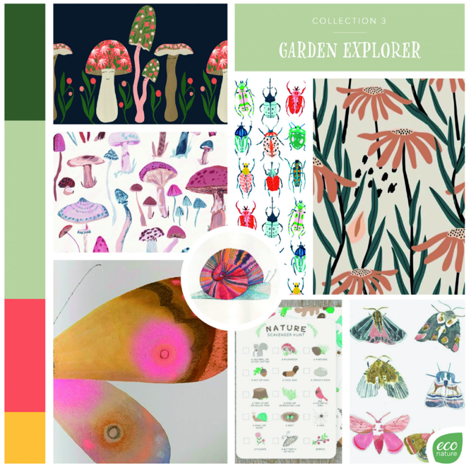
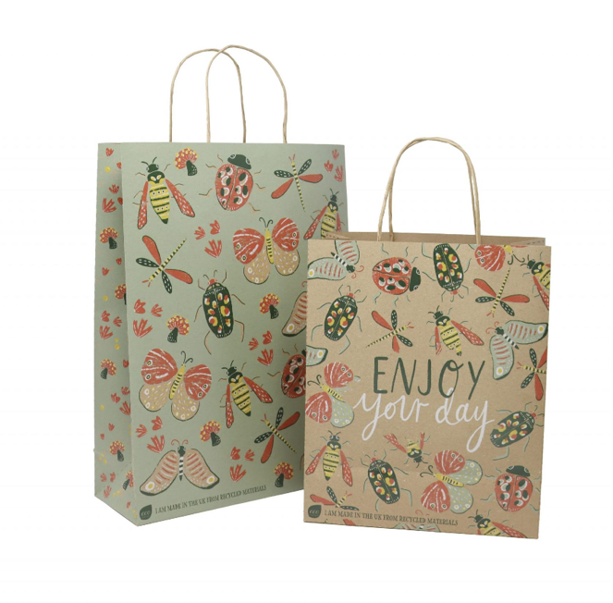

(Econature.co.uk, n.d.)

could talk about colour in sustainability

Section 3 – locating colour trends

Took a trip into Cardiff and my local area to visit a variety of grocers and high-street shops to locate colour trends focusing on stationery and greetings.
Visited – Wilko, Sainsburys, John Lewis, Paperchase, WHSmith’s.

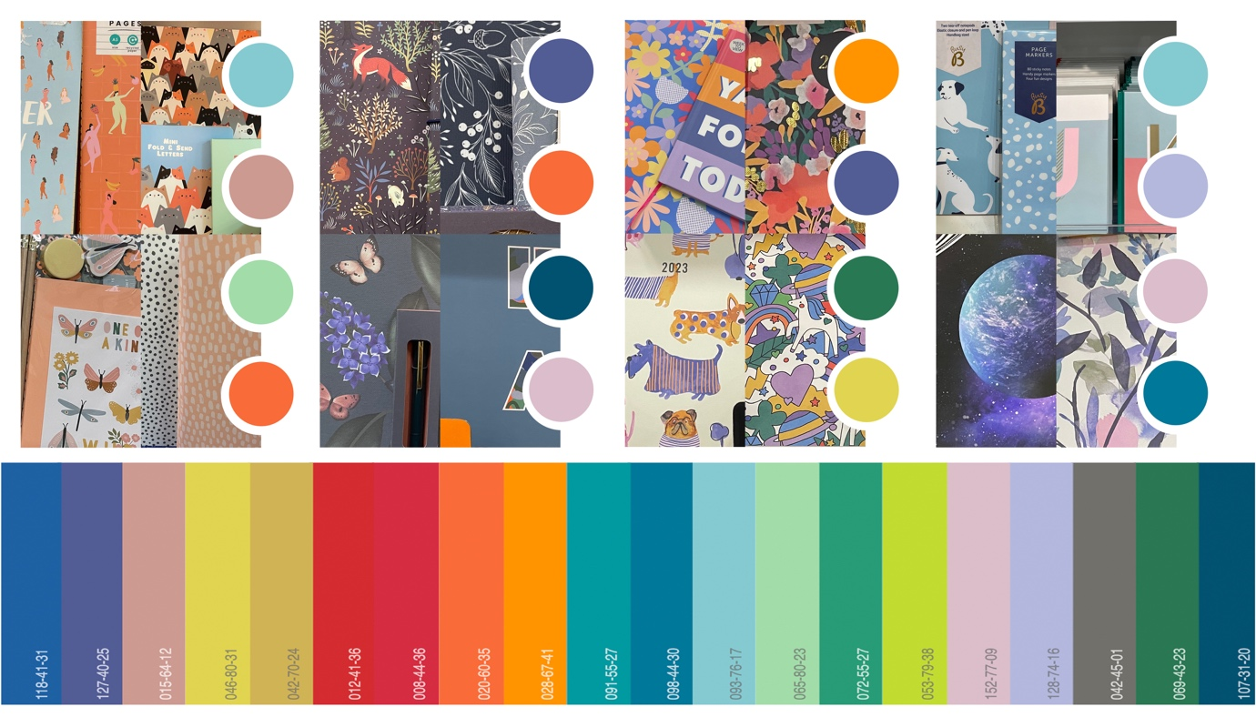

Above in figure _ is the digital Coloro global colour Palette of the year A/W 20/21. This palette of artificial hues embraces bright and mid-tones to invigorate autumn/winter collections. Although this colour palette was intended for a different year, I have found that these colours resonate with what is on the Highstreet and in grocers at this moment.

Action point for A/W 20/21 was to celebrate digital tones; spending more time observing screens will change the way we see colour, focus on sustainable colours; colours that live beyond autumn/winter and are less harmful towards the environment, this also relates to action point 5 that WGSN has made which is to make palettes trans seasonal; creating designs that less seasonal dependent and more flexible.

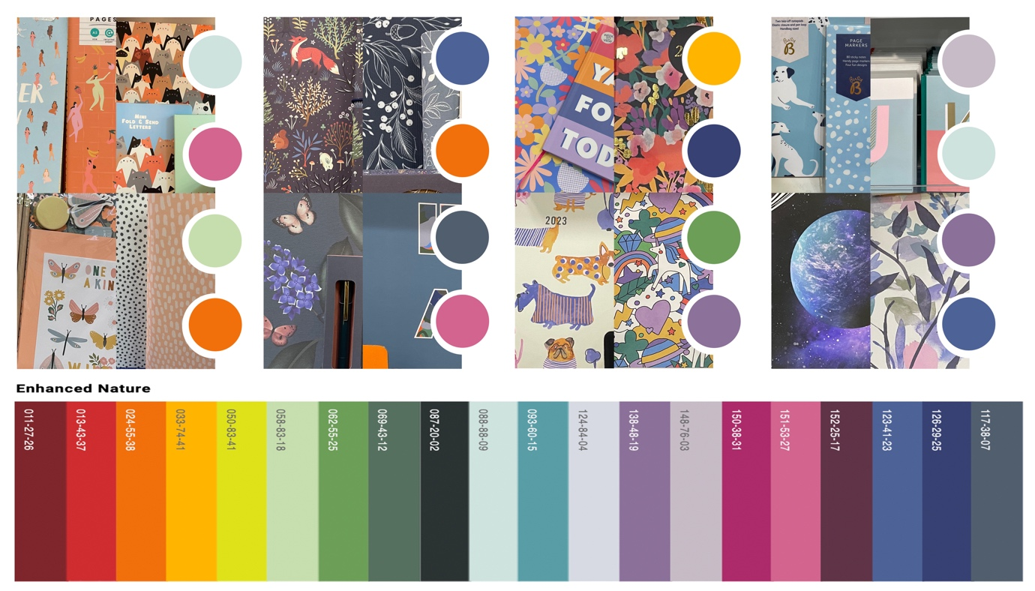

The Enhanced Nature palette is flexible for online and physical frameworks representing colours that are “rooted in nature, but also have an unnatural edge”. WGSN says that this colour palette will “activate senses, igniting feelings of joy, pleasure and tranquillity”.

As you can see above in figure _ this Coloro colour palette for S/S 22 is very similar to the A/W 22/23 palette. Comparing the colour palette to what I have gathered while researching the trends that are out in store. Slight difference in hue and tone but overall gives off the same affect. Looking at WGSN methodology report they have explained that because of sustainability becoming ever more imperative, consumers are now carefully considering their purchases. This discovery has driven forecasters at WGSN to continue with 30% of the colours from prior seasons, leading to a more focused and distinct approach to colour trend forecasting.

As you can see below in figure _ the global Coloro colour palette for A/W 22/23 does not resinate with what I have found while comp shopping
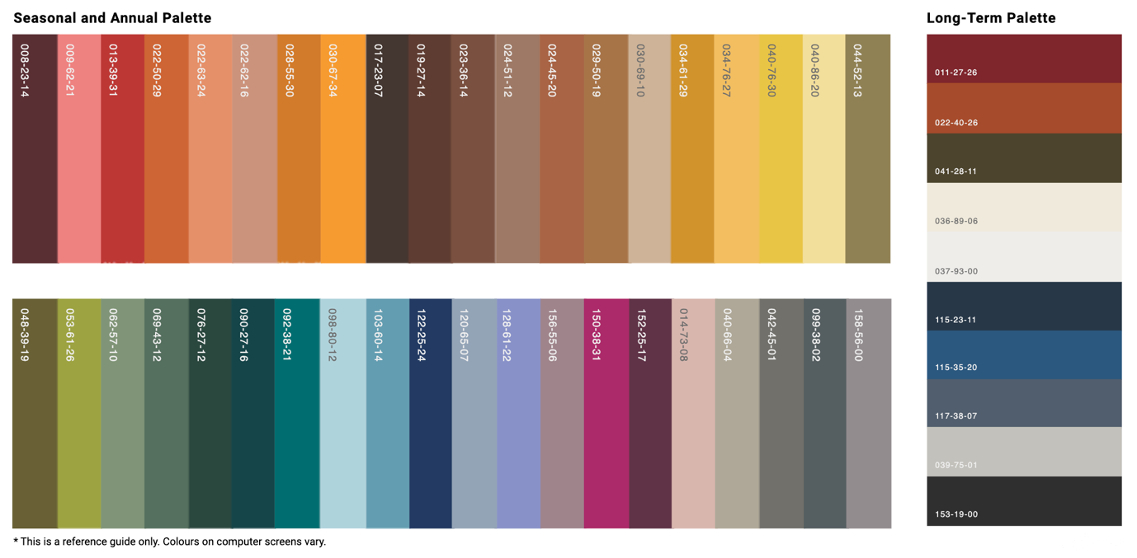
The colour palette above is Coloro digital global
Colour that has stayed throughout the seasons and year has been orange,

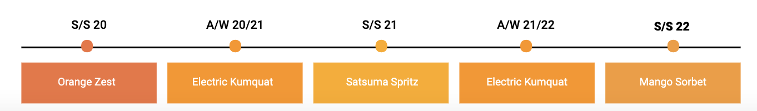

Throughout surface pattern design we are constantly reminded of the principals of colour the basics that can help us use colour more effectively. One of the most useful tools we can use in design is the colour wheel, it allows us to understand the relationship between each colour. The Wheel divides the colours showing which colours connect but also showing relation between primary, secondary, and tertiary colours. As you can see in the wheel below it shows how it the colours can be separated in to categories such as hue, tint, tone, chroma, and value.

Colour psychology works on the ideologies that the affect colour has on us goes beyond aesthetic (Perryman, 2021). Living through a time packed with information and distractions colour is increasingly important, playing a role in our day to day lives. Colour is a strong communication tool that can influence mood, phycological and physical responses, instructing many of our daily decisions. Usually, the impact of colour is the first element that catches your eye, followed by a picture, symbol, word, or phrase. Often colour represents an experience or an item such as a symbol or a sign (Elliot, Fairchild and Franklin, 2018).

Colour wheel terms
Hue – a colour family
Tint – a mixture of colour with white
Chroma – saturation of a colour (not mixed with any white grey or black)
Tone – a mixture of colour with grey or black (muted)
Value – lightness or darkness of a colour

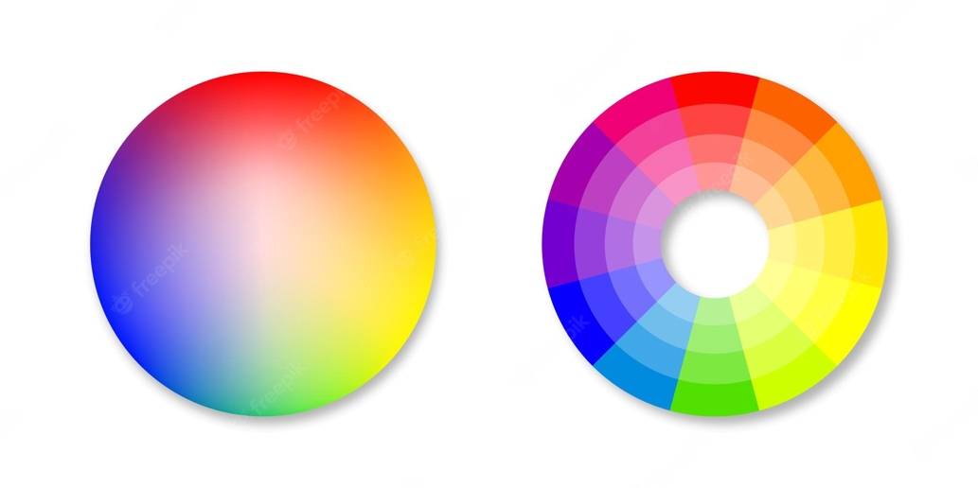

(Freepik, n.d.)

