

Student name: Binta Drammeh
Student ID:2317261

Module name: Empowering the Older Person.
Module code: BMHP6027
Lecturer’s name: Arif Ahmed

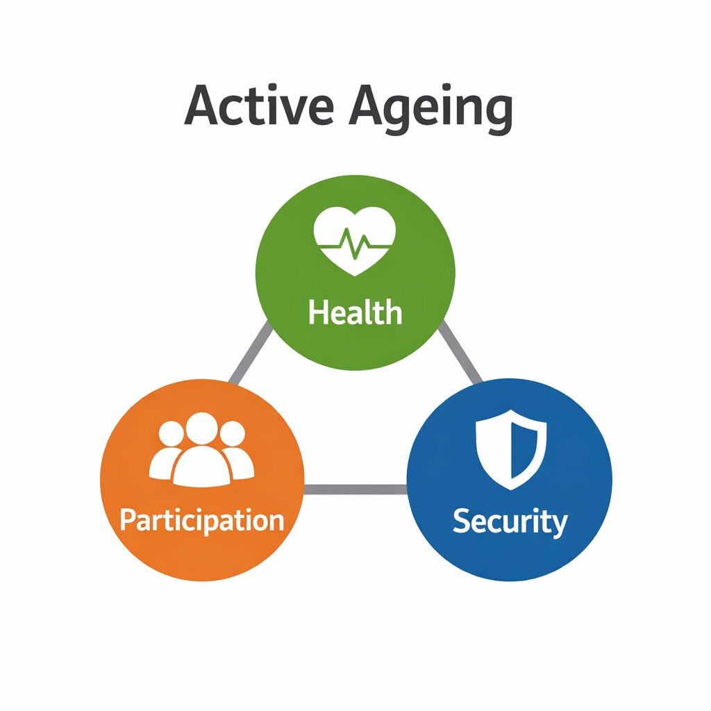  This model highlights that promoting health, participation and security is essential for supporting independence and empowerment in older people. However, inequalities in access to services may limit its effectiveness. |  | Care, Empowerment and Support Needs of Older Peopl  Older people have complex and interconnected needs that are essential for maintaining independence and quality of life.  Physical needs. Include managing chronic conditions, mobility, and frailty (Clegg et al., 2013). However, increasing demand means services are often overstretched, limiting effective support.  Psychological needs. Such as dementia, depression, and anxiety are common, yet mental health services for older adults remain underdeveloped (NICE, 2021).  Social needs. Including reducing loneliness and isolation, are critical for wellbeing (Gardiner et al., 2018). Despite this, access to community support is inconsistent.  Empowerment focuses on maintaining independence, choice, and dignity. However, structural issues such as funding constraints and workforce shortages reduce the ability of services to fully support these needs. |  | 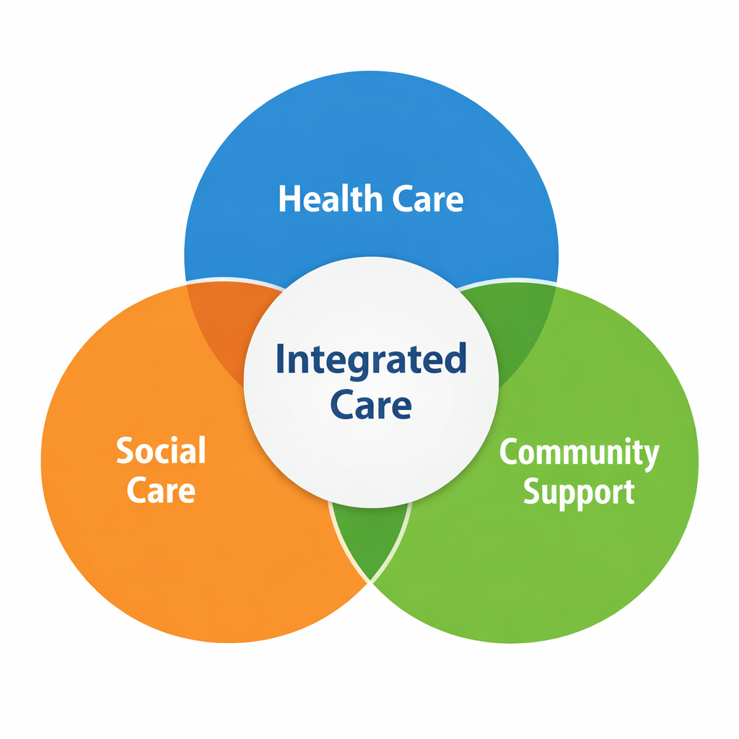  Integrated Care Approach (UK)  Combines health care, social care and community support to promote independence in older people.  However, funding pressures and inconsistent implementation limit its effectiveness.
Introduction to Ageing and Empowerment  Introduction  The ageing population in the UK is rapidly increasing, with over 11 million people aged 65 and over (19% of the population) (ONS, 2023). This places growing pressure on health and social care services.  Older people often experience complex physical, psychological and social needs, making effective care and support essential. Empowerment focuses on maintaining independence, autonomy and quality of life (WHO, 2015). |  |  |  | Challenges to Independence and  Functional Ability  Older people face several challenges that affect their ability to remain independent and maintain functional ability.  Physical challenges. Such as frailty, chronic illness and reduced mobility can limit daily activities (Clegg et al., 2013).  Psychological challenges. Including dementia, depression and anxiety, can reduce confidence and decision-making ability (NICE, 2021).  Social challenges. Such as loneliness and isolation are common and negatively impact wellbeing (Gardiner et al., 2018).  Digital exclusion. Also limits access to services, particularly with the increasing use of technology in healthcare.  Critical Insight  These challenges highlight that maintaining independence is not only an individual issue but is influenced by wider social and structural factors.  Recommendations  - Increase funding for social care to address workforce shortages  - Improve digital inclusion through training and access to technology  - Expand person-centred care to promote independence, choice and dignity  - Strengthen community-based services to reduce loneliness and isolation  These improvements would enhance independence and quality of life for older people  Conclusion  Older people require integrated and person-centred support to maintain independence and wellbeing. While UK services aim to promote empowerment, limitations in funding, access and implementation reduce effectiveness. Addressing these challenges is essential to ensure equitable and sustainable care.

Effectiveness of UK Policies, Interventions and Theoretical Approaches
UK policies and interventions aim to support older people’s independence and wellbeing.
The Care Act 2014 promotes person-centred care and independence. However, funding constraints and workforce shortages limit its effectiveness in practice. The NHS Long Term Plan (2019) focuses on integrated, community-based care, but implementation remains inconsistent across regions.
Activity Theory (Havighurst, 1961). suggests that remaining socially active improves wellbeing and supports successful ageing. This aligns with UK policies promoting independence, although not all older adults can remain active due to health limitations.
In contrast, Disengagement Theory (Cumming and Henry, 1961) argues that withdrawal from society is a natural part of ageing. However, this theory is widely criticised for reducing empowerment and promoting passivity.

References
Age UK (2023) Later Life in the United Kingdom. London: Age UK. Available at: https://www.ageuk.org.uk (Accessed: 20 March 2026).
Clegg, A., Young, J., Iliffe, S., Rikkert, M.O. and Rockwood, K. (2013) ‘Frailty in elderly people’, The Lancet, 381(9868), pp. 752–762.
Department of Health and Social Care (2014) Care Act 2014. London: HMSO. Available at: https://www.legislation.gov.uk (Accessed: 20 March 2026).
Department of Health and Social Care (2019) NHS Long Term Plan. London: HMSO. Available at: https://www.longtermplan.nhs.uk (Accessed: 20 March 2026).
Digital Health UK (2022) Technology and older adults report. Available at: https://www.digitalhealth.net (Accessed: 20 March 2026).
Gardiner, C, Geldenhuys, G. and Gott, M. (2018) ‘Interventions to reduce social isolation and loneliness’, Health & Social Care in the Community, 26(2), pp. 147–157.
Greenhalgh, T, Wherton, J, Papoutsi, C., Lynch, J, Hughes, G, A’Court, C, Hinder, Fahy, N, Procter, R. and Shaw, S. (2017) ‘Beyond adoption of digital health and care technologies’, BMJ, 358, j3453.
NHS England (2022) Ageing Well Programme. Available at: https://www.england.nhs.uk (Accessed: 20 March 2026).
NICE (2021) Older people: independence and mental wellbeing. Available at: https://www.nice.org.uk (Accessed: 20 March 2026).
Office for National Statistics (2023) Overview of the UK population. Available at: https://www.ons.gov.uk (Accessed: 20 March 2026).
Powell, J. (2020) ‘Social care and older people’, Journal of Social Policy, 49(2), pp. 345–362.
Public Health England (2019) Health Profile for England. Available at: https://www.gov.uk (Accessed: 20 March 2026).
Sixsmith, A. (2013) Technologies for Active Aging. New York: Springer.
Victor, C. (2018) Ageing, Health and Care. Bristol: Policy Press.
World Health Organization (2015) World Report on Ageing and Health. Geneva: WHO. Available at: https://www.who.int (Accessed: 20 March 2026).

