

Assessment 1 – Reading Task Template
PART 1: Upload your photo of your A3 in-class notes here:
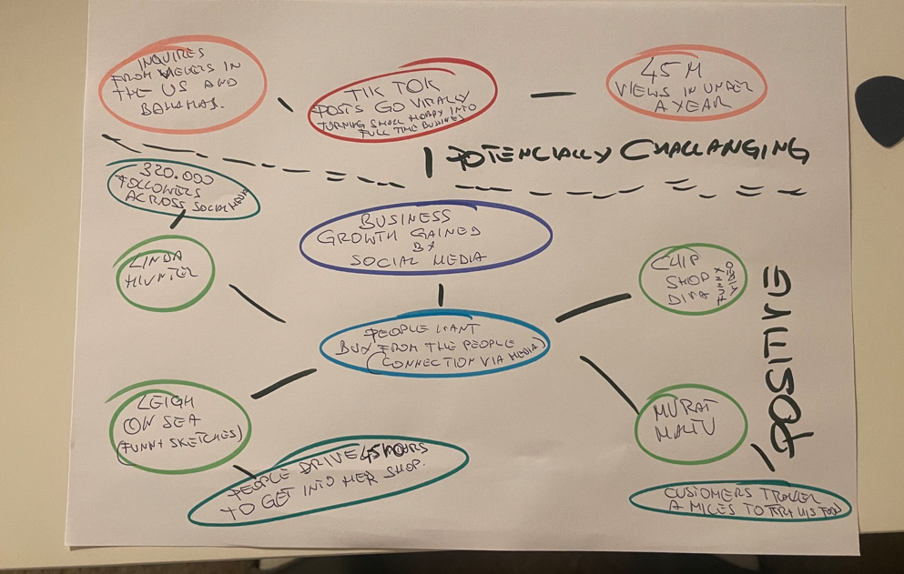

PART 2:
- Answer every question below in 1-3 full sentences.
- Use your own words. Do not use generative AI to answer these questions.
- Include a specific detail from the text when asked.
REMINDER
- The main idea is the overall message of the whole text.
- A key point helps to explain the main idea.
- A specific detail or example from the text shows that the key point is true.

- What is the main idea of the whole text?

The main idea is that the social media has a huge impact on business.

- What is one key point that supports the main idea, and which specific example from the text shows this ?

The key point is that the social media makes a kind of a bound in between the customer and the business. The customer not only focuses on a product anymore, but wants to be a part of the identity behind the brand. Its like the customer not only buying things, he also steps into community.

- What is a different key point that supports the main idea, and which specific example from the text shows this?

Another point is that, thanks to the social media, the information about the specific business goes virally over the internet. That turns the small activity into a real deal big operation. That may cause unexpected organizational and logistical difficulties.
Example:
Little love’s Pamper Bus changed the small weekend business activity into a fully operational business.
I’m not saying that stands in a text, as they (Chloe and Ross) seem to be happy with the overall outcome. Just wanted to mention the fact that the business explodes rapidly in a year may potentially bring some difficulties.

- Which part of the text do you think is most important, and why?

The most important part is in the conclusion. The final section titled ‘’ People buy from people’’
I think it’s a key message of the whole text cause it says that building a social community around the business does more than a million pound spent on a billboards. Its like, people like to buy from those they know and trust.
Reflection:
- What did you find difficult in this task (including in-class components), and why was it difficult?

To me the BBC text was a bit to long. Because of that it was difficult to find all the key info. I mean, I like to read nice stories about successful people , but there was too much of stories and the key info were kind of hidden. I think that’s why I kept my mind map very basic as I only wanted to focus on the important parts.

BYD text on the other hand was pretty much straight forward.

- What helped you with this difficulty, and how did it help you?

Notes I’ve made during the in-class lesson. I could have come back to what I’ve learned. That’s what kept me on the track.
Also 2 mugs of coffee and half a pack of Camel’s

