

Master of Business Administration

International Marketing: Principles and Practices (LCMB7026)

International Marketing: Principles and Practices

Company – Coca-Cola (Germany & India)

Student Name- Pathan Nurshamabanu Sarfaraj khan

Student ID- 2412330

Lecturer Name- Taonga Kaonga Sobere-Snithers

Word Count - 4781

Submission Date- 14 November 2025

Table of Contents
1. Introduction 4
2. Brand Overview 5
2.1 Coca-Cola: Global Background 5
2.2 Coca-Cola’s Presence in Germany 5
2.3 Coca-Cola’s Presence in India 5
3. Macro-environment (PESTLE) comparison 6
3.1 PESTLE analysis of Germany 6
3.2 PESTLE analysis of India 7
3.3 Key Comparisons and Contrasts between Germany and India 9
4. STP strategies 10
4.1 Coca-Cola’s STP Strategies in Germany 10
4.2 Coca-Cola’s STP Strategies in India 11
4.3 STP Comparison: Germany vs India 11
5. Marketing Mix (7Ps) comparison 12
5.1 Product Strategy 13
5.1.1 Product portfolio & variants - Germany 13
5.1.2 Product portfolio & localised flavours - India 14
5.2 Price Strategy 14
5.2.1 Pricing Strategy - Germany 14
5.2.2 Pricing Strategy - India 14
5.3 Place (Distribution) 15
5.3.1 Distribution and retail channels - Germany 15
5.3.2 Distributions and rural-urban channel strategy - India 15
5.4 Promotion 16
5.4.1 Promotional campaigns and messaging - Germany 16
5.4.2 Promotional campaigns and cultural localisation - India 16
5.5 People 16
5.5.1 Human resource or customer interaction - Germany 16
5.5.2 People and local workforce practices - India 17
5.6 Process 17
5.6.1 Supply chain and production - Germany 17
5.6.2 Bottling operations and vendor ecosystem - India 17
5.7 Physical evidence 18
5.7.1 Retail presence and packaging in Germany 18
5.7.2 Brand touchpoints and packaging in India 18
6. Performance evaluation 18
6.1 Performance in Germany 18
6.2 Performance in India 19
6.3 Comparative Evaluation 20
7. Marketing Ethics 20
8. Recommendations & Conclusion 21
8.1 Recommendations 21
8.1.1 Recommendations for Germany 21
8.1.2 Recommendations for India 21
8.1.3 Global and Future-Focused Marketing Strategy Suggestions 22
8.2 Conclusion 22

1. Introduction
Coca-Cola is a company in the beverage industry that has a prominent representation in the developed and emerging markets in the world, and it is therefore a good example in the study of international marketing. The Coca-Cola system has been able to localize its brand, products and promotions based on values of the local economy, cultures including diverse consumer tastes (CocaCola, 2025). The main objective will be to analyse and contrast Marketing Mix (7Ps), Segmentation, Targeting, Positioning (STP) strategies and macro-environment for the two countries and assess their effectiveness using performance measures of market share, sales while also considering brand involvement.
The paper also seeks to unravel ethical challenges related to the Coca-Cola marketing strategies in the two countries and make recommendations on how it can improve its international marketing strategy. Germany and India have been selected based on the fact that they have considerable differences in terms of socio-economic development, consumer culture, regulatory climate and consumption habits of beverages. Germany is a highly controlled and developed Western European market with good environmental regulations and an increasing trend towards healthier beverage products, whereas India is a fast-growing economy whose marketing approach is dictated by affordability, rural growth, and cultural appropriateness. The comparison of these two markets gives one an idea of how Coca-Cola strikes the right balance between global uniformity and local sensitivity, especially between markets that have dissimilar economic growth and cultural inclinations.
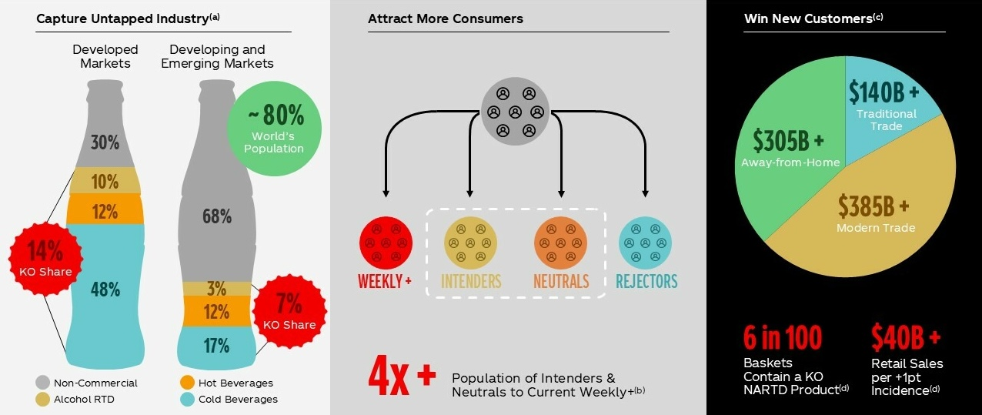
Figure 1: The growth strategy of Coca-Cola
(Source: Coca-Cola company, 2025)
The reason why Coca-Cola has been selected is due to its global leadership, high brand equity and the variety of approaches it has taken in different countries, such that this company is a perfect fit to be studied in the context of international marketing. The report is organised in the following way. A short background about the global existence of Coca-Cola, its activities in Germany and India is given (Coca-Cola company, 2025). Then the PESTLE analysis is used to compare the macro-environmental conditions of both countries. This is then accompanied by a close examination of STP strategies and the 7Ps of the Marketing Mix in the two regions. The report further analyses the performance results of marketing activities of Coca-Cola and explains ethical issues concerning its marketing activities. Lastly, the paper concludes by giving recommendations based on strategic solutions to improve the international marketing of Coca-Cola.

2. Brand Overview

2.1 Coca-Cola: Global Background
The Coca-Cola Company was established in 1892 in Atlanta, Georgia, as a producer of the well-known soft drink Coca-Cola. The company today is known to operate in more than 200 countries and territories, and it is estimated that more than 2.2 billion servings of its beverages are consumed daily across the world (Arthur, 2025). Its global portfolio covers hundreds of brands in the soft drinks, juices, waters and other non-alcoholic drinks. Coca-Cola controls approximately 46.5% of the carbonated soft drink segment in the global market of carbonated soft drinks in 2020.
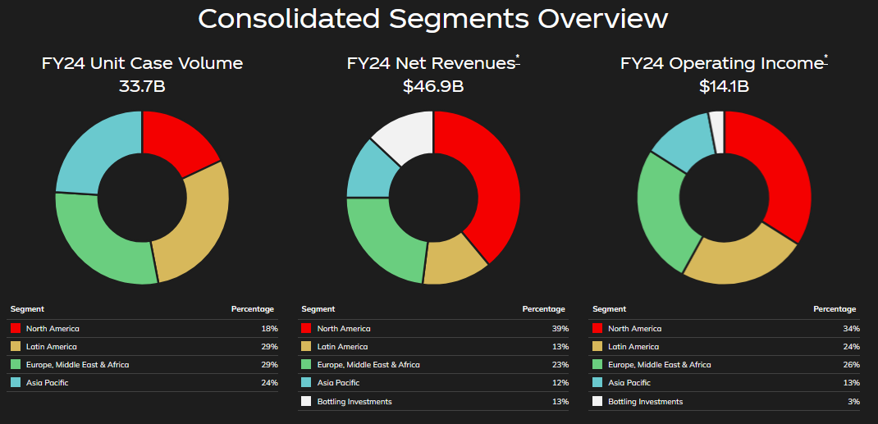
Figure 2: Consolidated segments
(Source: The Coca-Cola Company, 2019)

2.2 Coca-Cola’s Presence in Germany
In Germany, the history of local production, distribution, and investment of Coca-Cola is long. One of the company's priorities is local production and sustainability. As an example, the company has pledged to use 100% plastic bottles in its major brands in Germany. At the start of 2025, the local bottler Coca-Cola Europa Pacific Partners Germany declared a new investment of about 150 million euros in the German operations (Vishnu, 2025). In FY 24, Germany represented approximately 7% of the total unit case mix of Coca-Cola (The Coca-Cola Company, 2019).

2.3 Coca-Cola’s Presence in India
Coca-Cola returned to India in 1993 and has since been a force to reckon with in the Indian bottled-beverage market. The Indian bottling company of the company is Hindustan Coca-Cola Beverages Pvt Ltd, which provides a diverse range of brands and serves a vast number of farmers, suppliers and retailers (In-beverage, 2023). Germany was also surpassed by India as the sixth-largest market in volume for Coca-Cola in 2014.

3. Macro-environment (PESTLE) comparison

3.1 PESTLE analysis of Germany
Political | Germany is a parliamentary democracy and a founding member of the EU, which provides firms doing business in Germany with certainty in their trade rules, well-established institutions of the state and proximity to the regulation of the EU single market. Political stability is useful for long-term investment. However, the changes in governance (coalition politics) may influence the industrial and energy policy (IMF, 2024).
Economical | Germany is the largest European economy, yet its development has not been strong lately. IMF and domestic statistics reveal the relatively low growth in GDP (around 0.2% estimated in 2025) and slow recovery following the decline in 2023-24. The inflation has slowed down to an average of mid-2% (CPI =2.3-2.4% in late 2025). The labour market metrics suggest that the unemployment rate will be higher than pre-pandemic (unemployment rate of about the low-to-mid single digits, but 3 million unemployed in 2025) (IMF, 2024).
Social | German consumers are becoming more health-conscious, quality-conscious and sustainability-conscious. The ageing population and the environmentally conscious population influence the demand towards less-sugar beverages, recyclable packaging and provenance (Consultancy, 2025). The urban consumer is digitally sensitive and appreciates convenience and high quality.
Technological | Germany is highly digitalised and has good logistics/automation. In the EU context, household access to the internet is more than 90% and e-commerce penetration is high, which makes it possible to conduct omnichannel retail, digital promotion and data-driven marketing. Companies can use the availed superior tech in the supply chain, as well as highly mechanised bottling/packaging (Tradingeconomics, 2025).
Legal | Germany has strict EU and national laws on data protection (GDPR), advertising laws, food labelling and demanding Packaging Act (VerpackG) and extended producer responsibility and increased deposit programmes (Pfand). Compliance increases expenses and opens possibilities of having environmentally friendly brands.
Environmental | The existence of ambitious climate goals (net-zero by 2045, big 2030 intermediate reductions) and EU packaging/waste reforms compel companies to cut emissions, use more recycled material and utilise circular packaging (Clean Energy Wire, 2014). Sustainability is the focus of the policy of products and packaging due to environmental control and high green preference of consumers.
Table 1: PESTLE analysis of Germany
(Source: Self-developed)

3.2 PESTLE analysis of India
Political | India is a stable and federally governed parliamentary democracy, whereby the ruling coalition upholds business-friendly reforms such as the Make in India initiative. Yet, political risk is still in the regional state relations, the uncertainty of policies and the relations between the centre-state and the states.
Economical | India is still among the rapidly developing large economies. The GDP increased 7.8% year-on-year in April-June 2025. Projections indicate 6.3-6.8% growth in FY2025/26 (KPMG, 2024). As fast growth offers demand prospects, inflation, infrastructure limitations and disproportionate rural urbanisation are critical issues. The moderation of interest rates and tax cuts is increasing private consumption.
Social | India is also young (median age of approximately 28 years), and its urban middle class is rapidly expanding. The consumer behaviour is now shifting towards value, convenience, health and accessing the digital world. India Consumers are prepared to pay more for sustainable food production, as 73% of Indian consumers are prepared to pay more for sustainable food production, as compared to the global average (A value recipe for the food industry, 2025). The beverage sector is changing because consumers are shifting towards low-sugar products or no added sugar.
Technological | The adoption of digitalisation is in a good way. Besides the mobile internet, e-commerce and digital payments are increasing at a high rate. India intends to scale up third-party data-centre capacity by 1,250 MW in March 2025 to 2,500 MW in March 2028, which is an indicator of infrastructure construction and digital services (Economictimes, 2025). Technology can facilitate the new avenues of marketing (apps, social media) and supply-chain integration in FMCG/beverages.
Legal | Regulatory reforms are being undertaken. In 2025, the Food Safety and Standards Authority of India (FSSAI) required newly manufactured PET bottles of beverages to be made of at least 30% recycled PET (r-PET) (raceecochain, 2025). The packaging and labelling laws are getting increasingly tougher, with some suggesting outlawing food-contact materials.
Environmental | The environmental laws regulate this strictly, particularly packaging and plastic waste. As an illustration, new EPR (extended producer responsibility) regulations impose the responsibility on the brands to dispose of packaging waste and trace the origin of the materials.
Table 2: PESTLE analysis of India
(Source: Self-developed)

3.3 Key Comparisons and Contrasts between Germany and India
Germany and India exhibit high macro-environmental contrasts. Germany provides high political stability, rigid EU regulations, mature technology infrastructure and strict environmental laws, while India has a growing economy in place with developing regulations and digital adoption, but more regional policy differences. In Germany, consumers care as much about sustainability and health, while in India, the young, expanding middle class is more concerned with affordability and convenience, along with slow-growing health consciousness. Germany’s established market and slower GDP growth are contrasted with India’s high growth and expanding consumption. Both countries value sustainability and tougher packaging standards as well as digital-driven marketing. Therefore, environmental compliance and digital engagement matter in both markets for Coca-Cola.

4. STP strategies

4.1 Coca-Cola’s STP Strategies in Germany
Segmentation | Coca-Cola divides the German market into segments, which depend on demographics, lifestyle, and health awareness. The youthful adults, families, urban professionals, and more often health-conscious consumers are the key consumer segments interested in low-sugar and sustainable drinks. The ageing population and high wellness rates of Germany lead to the segmentation of sugar-reduced, zero-sugar, organic, and functional beverages.
Targeting | The brand aims at consumers with middle and upper income, environmentally aware people, as well as urban millennials who value convenience and ethical shopping. Coca-Cola also focuses on families by offering multi-serve bottles as well as low-cost packs.
Positioning | The Coca-Cola brand in Germany is a positioned brand of a premium, refreshing, socially interesting and sustainable brand. It focuses on heritage, quality, social moments, and high sustainability promises to its key brands, including 100% recycled PET bottles and ecological supply chain programs (Kaufmann, 2025). Coca-Cola Zero Sugar is also marketed by the company as a mainstream healthy product, which is consistent with the trends in wellness (Bantilan, 2019).
Table 3: Coca-Cola’s STP Strategies in Germany
(Source: Self-developed)

4.2 Coca-Cola’s STP Strategies in India
Segmentation | Coca-Cola divides the Indian market according to income, geography (urban and rural), age, lifestyle and price sensitivity. The youth, working-class consumers, middle-income families, and rural populations are the key segments.
Targeting | The company has positioned itself as a mass-market drink, and it appeals to the lower- and middle-income segments of the population by providing low prices like 10 and 20 packs of the drink, refundable glass bottles, and small PET bottles (Bhushan, 2023).
Positioning | In India, Coca-Cola is trying to position itself as a low-cost, cooling, and culturally pertinent drink, which can be included in the social celebrations, festivals and in day-to-day consumption experiences.
Table 4: Coca-Cola’s STP Strategies in India
(Source: Self-developed)

4.3 STP Comparison: Germany vs India
Coca-Cola’s segmenting, targeting and positioning across Germany focuses on high-end market offering, sustainability and health-conscious consumer segment by providing sugar-free and eco-friendly varieties to a mature, wealthy target audience. India’s STP, on the other hand, bases itself on mass affordability, cultural relevance and regionalised flavours to meet up with a price-sensitive and fast-increasing market. German positioning is framed around wellness and environmental leadership, while India’s is about celebration, youth engagement, and value. While both markets are favouring the no-sugar story, the one in Germany leans towards the premium aspect of sustainability messaging, and its main part in India follows accessibility and emotional connection, which aids the penetration into the market as well as builds brand loyalty.

5. Marketing Mix (7Ps) comparison
The international success of Coca-Cola is based on its ability to strike the right balance between standardised branding and localised strategies. This section makes a comparison between the marketing mix (7Ps) strategies used by Coca-Cola in Germany and India (two different markets, which differ in terms of consumer behaviour, economic structure and culture) on ways in which the company focuses its approach to remain competitive.
7Ps | Germany | India
Product | Focus on low-sugar and sustainable packaging. | Emphasis on affordability, local flavours such as Maaza.
Price | Premium pricing due to strong brand loyalty. | Penetration pricing to attract mass consumers.
Place | Widespread in supermarkets and vending machines. | Strong rural distribution network.
Promotion | Eco-friendly and health-oriented campaigns. | Youth-focused and celebrity endorsements.
People | Customer service efficiency and automation. | Personal engagement and local workforce.
Process | Advanced digital and automated bottling. | Cost-effective and localised production.
Physical Evidence | Sustainable packaging and clean outlets. | Bright, culturally resonant branding.
Table 5.1: Marketing mix table
(Source: Self-developed)

5.1 Product Strategy

5.1.1 Product portfolio & variants - Germany
Coca-Cola competes in Germany in a market that is mature and health-conscious while providing a wide variety of drinks. This includes Coca-Cola Classic, Zero Sugar, Fanta, Sprite, Mezzo Mix and even the ViO brand of mineral waters (Coca-Colaep, 2021).
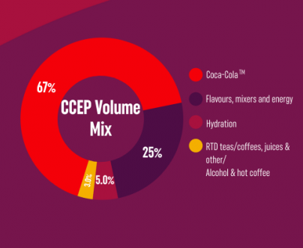
Figure 3: Brand portfolio of Coca-Cola in Germany
(Source: Coca-Colaep, 2021)
The German product strategy focuses on the low-sugar and no-sugar versions to fit the consumer needs based on the desire to lead healthier lifestyles. The new rebranding campaigns under the label Made in Germany are supposed to strengthen the sense of national pride and local production quality (Kaufmann, 2025).
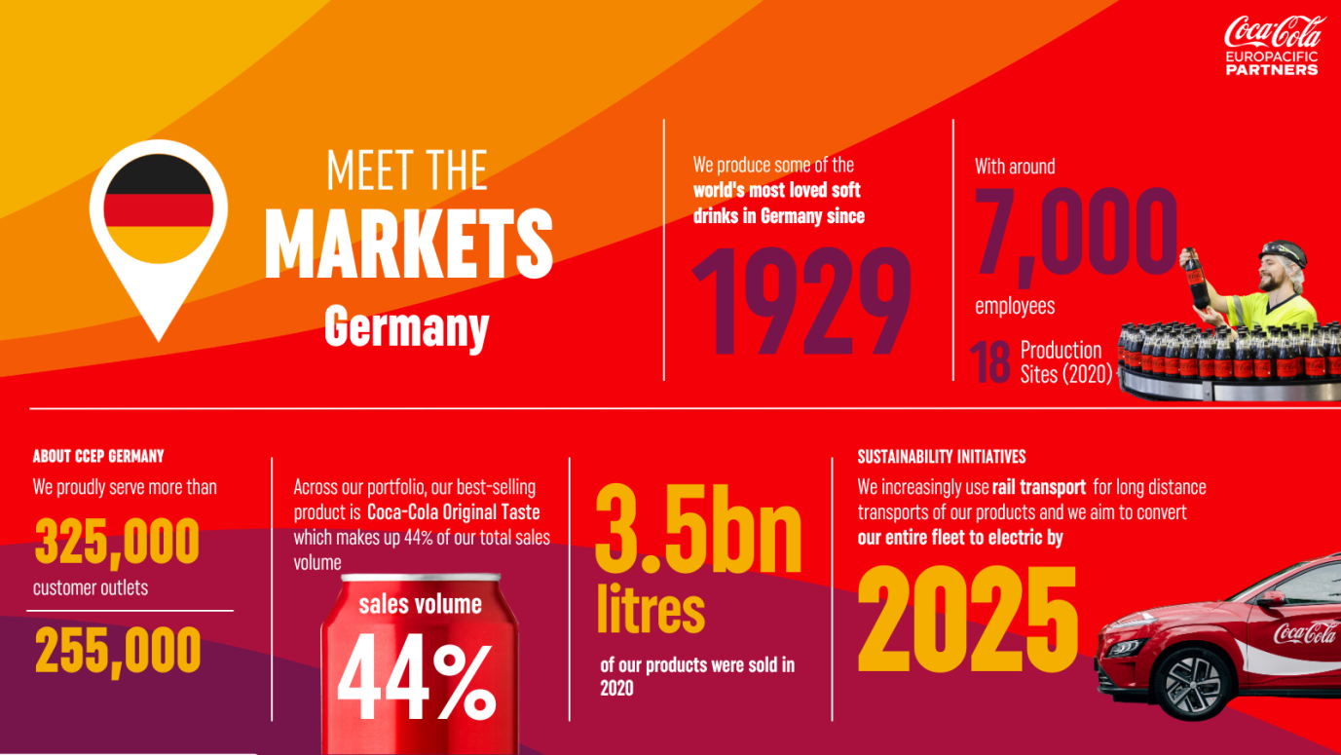
Figure 4: Market analysis of Germany
(Source: Coca-Colaep, 2021)
The investments of Coca-Cola in new production lines of returnable glass bottles and sustainable packaging of its plants in Mannheim and Luneburg demonstrate that the company is concerned with environmental sustainability and local sourcing (Krones, 2025). This localisation increases the brand's authenticity and meets the rising demands of sustainability.

5.1.2 Product portfolio & localised flavours - India
The product strategy of Coca-Cola India can be defined as regional tastes and affordability. It has global brands such as Coca-Cola, Fanta and Sprite as well as homegrown brands such as Thums Up, Limca, Maaza and Minute Maid (India Times, 2025). The local strategy of the company comes with the flavours of fruits and spices in the Indian region with innovations such as Maaza Gold and Fanta Apple Delite (Sea and Job, 2025). Another approach used by Coca-Cola in India is affordability in the form of smaller pack sizes and refillable glass bottles to the rural population and consumers with a lower income range. This localisation creates inclusivity in the context of various demographics while enhancing the cultural asset of a brand in the heterogeneous market.

5.2 Price Strategy

5.2.1 Pricing Strategy - Germany
The value-based pricing strategy that is used by Coca-Cola Germany is based on the brand equity, high production standards and sustainability of the operations (Lau, 2025). Prices are normally set at a high rate when compared to the local private brands, as the brand has a high heritage and a perceived quality. The prices of Coca-Cola are consistent with the deposit system of the E,U which affects the prices of retailers in the form of a bonus for bottle returns. Transfer pricing operations avoid any violation of global taxation laws and profitability (Gutsche, 2022). Coca-Cola is preserving its market presence by positioning itself with the help of differentiation and loyalty schemes that lay stress on sustainability and local production despite the growing rivalry of the brand by cheaper alternatives.

5.2.2 Pricing Strategy - India
Coca-Cola in India has used a segmented pricing approach that caters to different income groups and geographical markets. The rural region is characterised by lower prices of products, including 200 ml bottles, whereas the urban regions offer a higher margin on bigger packs and luxury drinks (Prasad and Patil, 2021). The company adjusts pricing dynamically depending on seasonal demand fluctuations and local purchasing power (Lau, 2025). This kind of pricing through affordability enhances market penetration and maintains profitability in competitive markets that have national players. This strategy takes into account a balance between volume development, accessibility and brand equity.

5.3 Place (Distribution)

5.3.1 Distribution and retail channels - Germany
The distribution of Coca-Cola in Germany can be described as efficient, technology-based and well-formed retail associations. The logistics network of the company is based on the use of automation, predictive analytics and sustainability tools to decrease the carbon emissions (Cocacolaep, 2023). The retailing outlets used by Coca-Cola are categorised as supermarkets, vending machines and food service establishments. The latest integration of production and logistics units indicates how the company is trying to adjust to the changing consumption trends and minimise the cost of operation (Lahiri, 2024). Traditional retail continues to dominate while digital retailing is expanding based on strategic collaborations with national retailers and restaurants.

5.3.2 Distributions and rural-urban channel strategy - India
The Indian distribution model that Coca-Cola uses is a multi-level model that incorporates urban, semi-urban and rural markets. The company adopts a hub-and-spoke model that involves the city bottling facilities providing regional distributors, which also serve the rural retail outlets (Singh, 2024). Outsourcing of bottling to the local partners has enhanced efficiency and market responsiveness at Coca-Cola (India Times, 2024). Its bottling associates have increased electric vehicle fleets and improved the last-mile connectivity, which represents sustainability and inclusion objectives (Coca-Cola India, 2025). Coca-Cola has more than 2 million retail stores, which means that its products are available even in the most distant villages, and this strengthens its strong market penetration.

5.4 Promotion

5.4.1 Promotional campaigns and messaging - Germany
The advertising campaigns of Coca-Cola Germany are based on authenticity, sustainability and national pride. The Made in Germany campaign presents the domestic production and the brand contribution to German society (Inside Beer, 2025). Advertising is a blend of conventional media and digital storytelling with the emphasis on the messages of togetherness and moments. The rebranding efforts to cope with the reputational challenges on a global level have strengthened the local identity and transparency of the brand (Kaufmann, 2025). These campaigns attract the feeling of trust and heritage to the consumers as well, and the attachment of Coca-Cola to German consumers on emotional grounds is enhanced.

5.4.2 Promotional campaigns and cultural localisation - India
Coca-Cola in India makes its promotions specific to local festivals, emotions and traditions. The advertising campaigns, such as ‘Sharing a Coke’, incorporate the cultural importance of togetherness and celebration (WARC, 2024). The brand engages underprivileged celebrities and sports stars to make it relatable. The Diwali and Holi festive campaigns by Coca-Cola can be considered in line with global brand messages, which are integrated with the Indian culture and emotional appeal, as well as seasonal promotions. The emphasis on storytelling and community-based interaction boosts brand resonance on linguistic and cultural levels.

5.5 People

5.5.1 Human resource or customer interaction - Germany
Coca-Cola Germany focuses on the well-being of its employees, their skills development and sustainability awareness among its employees. The people strategy of the company encompasses the training of technology and constant learning to increase customer service and operational excellence (Coca-Colaep, 2021). The employees are perceived as brand ambassadors which indicates professionalism and brand consistency at the retail as well as customer touchpoints.

5.5.2 People and local workforce practices - India
Coca-Cola's people strategy in India is centred around the inclusion principle, the balance between the genders and the community. The employees of this firm are a combination of local employees and bottling partners that promote local employment with empowerment (Coca-Cola India, 2025). The training programs focus on rural entrepreneurship and vendor relationships, which increase the socio-economic effect without affecting service quality. These actions create loyalty and enhance the image of a socially responsible employer for Coca-Cola.

5.6 Process

5.6.1 Supply chain and production - Germany
The supply chain of Coca-Cola Germany is one of the most developed in the world, and it includes digital technologies to predict maintenance, optimise the logistics and track the sustainability (Coca-Cola Hellenic, 2025) (White, 2020). Investment in returnable packaging and modernisation of the plant are also an indication of the company being committed to the principles of the circular economy (Krones, 2025). Coca-Cola is still streamlining its operations to meet environment and efficiency-related objectives, though numerous of its sites have been closed recently to cut costs (Lahiri, 2024).

5.6.2 Bottling operations and vendor ecosystem - India
The supply chain of Coca-Cola India is managed by a network of independent bottlers who are responsible for local production and distribution (India Times, 2024). The system has vendors who are experts in logistics, packaging and raw materials to make the ecosystem cost-effective and locally adaptable. Bottling partners have also invested in electric fleets and green logistics, and this is in line with the sustainability vision of Coca-Cola (Coca-Cola India, 2025). This decentralised structure boosts the sensitivity to various regional market requirements.

5.7 Physical evidence

5.7.1 Retail presence and packaging in Germany
The physical presence of Coca-Cola in Germany focuses on high-end retail display, sustainable packaging and explicit recycling information. The environmental responsibility of the brand and the quality assurance are strengthened by the usage of glass as well as reusable bottles (Coca-Colaep, 2021). Retail presence in vending machines and supermarkets presents a consistent brand identity associated with German reliability (Pekic, 2025).

5.7.2 Brand touchpoints and packaging in India
Physical evidence at Coca-Cola India is based on accessibility and cultural appeals. The brand has employed colourful small-sized packaging to appeal to rural shoppers, with bottles and cans of PET being used in urban areas, which are convenient to use. Festive branding, localised signage and point-of-sale materials make the brand image lively and relatable (Sea and Job, 2025). These points of contact guarantee uniformity in the presence of contemporary commercial as well as local retail stores. The marketing mix applied by Coca-Cola in Germany is focused on sustainability, efficiency and national identity, whereas the marketing mix is based on affordability, cultural adjustment and inclusivity in India. The strategies of Germany are in line with a health and environmental-conscious market. The localisation, affordability and emotional involvement are the main pillars of the strategy in India. Although these markets have the Coca-Cola global brand ethos, the implementation of the 7Ps reflects strategic flexibility with the global homogeneity in these countries, combined with local responsiveness.

6. Performance evaluation

6.1 Performance in Germany
Coca-Cola's German bottling partner, Coca-Cola Europacific Partners Deutschland GmbH (CCEP DE), showed a 2023 beverage volume of approximately 4.1 billion litres with turnover increasing at an average rate of approximately 12.5% per year (Yumda, 2025). Research by the industry helps to confirm that Coca-Cola still leads in the German market of carbonated soft drinks (CSD) and is known as the dominant player in the CSD sales in Germany (Mintel Store, 2025). Based on the FY24 statistics of the Company, Germany represented approximately 7% of the unit case volume mix in the Europe segment.
In Germany, Coca-Cola focuses more on heritage, quality and sustainability (such as a large number of PET bottles being produced from 100% recycled PET in Germany). The brand positioning would help to secure brand loyalty among German consumers who are gradually focusing on environmental attributes and healthy lifestyle decisions. However, the highly mature market and competition (including own label) limit growth: the industry of the whole German soft drinks has grown at a CAGR of 0.2 only between 2019-24 (IBISWorld, 2025).
Coca-Cola Germany has made actual sustainability actions. Some examples are converting the entire non-refillable PET bottles of brands such as ViO, Fuze Tea and Powerade to 100% PET recycling (Coca-Cola Europacific Partners, 2021). The close connection to the German consumer and regulatory demands contributes to the brand image of Coca-Cola in Germany, which makes it responsible as an international brand.

6.2 Performance in India
Coca-Cola occupies a dominant role in the carbonated drinks category in India: according to some reports, the company enjoys an approximate share of 60% in the segment of cola segment. The company (Coca-Cola India) has one brand, Fanta, which controls more than 50% of the share of the orange-flavoured CSD category (Coca-Cola India, 2025). The market penetration is enabled by the deep network distribution of the company, which has more than 50 manufacturing plants and is well distributed in rural areas.
India is reported to be the fifth-largest market in volume by Coca-Cola all over the world. During January-March 2025 (Q1 of FY 2025), the company has grown volume in India by a double digit, but the value share has been decreasing slightly because of price pressure (Financialexpress.com, 2025). The Indian beverage sector in general will perform very well (CAGR about 6.5% to 7) in the coming 10 years. India has a high brand recall due to cultural relevance, festival and pack size, and low pricing campaigns (Custom Market Insights, 2025).
Coca-Cola India is using digital campaigns centred on the youth and local festivals. The youth marketing is evident as 50% or above of youth make up the share of orange-flavoured Fanta. The wide popularity of localised marketing, influencer relationships and small-pack affordability reinforces the presence of the brand amongst the younger generation.

6.3 Comparative Evaluation
Comparing the strategy of the Indian market with the German market, the strategy in the Indian market seems to be growing more, gaining better market share and having a good prospect. India’s fast growth, its large youth population, increasing rural penetration and brand leadership make it a high-potential market for Coca-Cola to grow. Germany, although in a solid position in terms of brand image and sustainability leadership, had the lowest growth prospects as it was assessed to be a more mature market with stricter competition. The Indian strategy is more growth-oriented, being based on affordability, lower costs, localisation and upscaling in size. The German strategy is a more preserving business model and obstacles to entry, yet it is still the one to beat when it comes to margin, brand credibility and sustainability leadership.

7. Marketing Ethics
Coca-Cola shows ethical shortcomings and examples of highly favourable, ethical marketing practices in Germany and India. In Germany, Coca-Cola has a strong ethical record according to its marketing philosophy of sustainable packaging, carbon reduction goals and transparent labelling of sugar content (Coca-colacompany, 2024). A marketing focus on a healthier, lower-sugar alternative to Coke Zero reflects a positive responsiveness to changing consumer health attitudes and expectations. At least some critics also argue against Coca-Cola marketing (and selling) sugary drinks when childhood metabolic disorder rates are at historically high levels for a first-world country (Valinsky, 2019). Coca-Cola faces significant challenges to its ethical responsibility in India (Oikos, 2025). Ethical extremes include groundwater depletion, pesticide residues and targeting the youth population aggressively. Coca-Cola has improved public relations and companies by developing investable community water (either delivery or reclamation) and improving rural economic conditions; this extends beyond problems of soil or groundwater depletion to broader economic issues. There appears to be inherent tension between the financial return goals of Coca-Cola and community-based ethical responsibility in its marketing practice. Coca-Cola has made progress in being assigned sustainable and accountable ethical practices over the last two decades, though some marketing practices (environmental, social sensitivity) are not apparent.

8. Recommendations & Conclusion

8.1 Recommendations

8.1.1 Recommendations for Germany
Coca-Cola ought to enhance its act of being sustainable by developing its refillable bottle system and using a plant-based pack to address the eco-friendly requirements of Germany. Better consumer confidence can be achieved through increased openness of sugar minimisation and nutritional information (Sajdakowska et al. 2022). Collaboration with local environmental NGOs will enhance the ethical brand image of the Coca-Cola company and affirm its strategies to lead the European beverage sector through sustainability.

8.1.2 Recommendations for India
Coca-Cola should also maintain its focus on ethical issues in India by enhancing water stewardship and sustainable farming of the beverage ingredients. Brand loyalty will be achieved by reinforcing its rural supply chain by means of solar-powered bottling and environmentally friendly logistics (Shee Weng, 2025). Marketing should move away the celebrity campaigns to community-based campaign that entails marketing health awareness and education that generate harmony between social responsibility and business development.

8.1.3 Global and Future-Focused Marketing Strategy Suggestions
Coca-Cola ought to strive to have an integrated global sustainability vision based on environmental ethics and cultural sensitivity. The initiatives to invest in renewable energy to achieve the goal of zero-waste packaging and apply AI-based analytics to monitor the supply chain transparently will increase accountability (Arif et al. 2023). Marketing of the future must focus on emotional marketing of health, inclusiveness and environmentalism, which will be aligned with branding ethically.

8.2 Conclusion
The German market values environmentally sustainable practices and health-oriented consumption, while India values affordability and engaging with local communities. Coca-Cola's strategic elasticity has established a unique global brand while preserving its relevance in the two very different markets. Greater ethical challenges in the areas of health claim messaging and resource use, which means that there is an obligation to be continuously better. In the future, Coca-Cola will need to establish a greater level of association between its global sustainability initiatives while recognising local cultural and sustainability priorities. Coca-Cola can purposefully build its global presence and achieve sustainable growth by embedding ethical responsibility with innovative, data-driven strategies.

References
A value recipe for the food industry., (2025). Available at: https://www.pwc.in/assets/pdfs/pwcs-voice-consumer-2025-india-perspective.pdf?utm [Accessed 4 Nov. 2025].
Arif, J., Samadhiya, A. and Kumar, A., (2023). Net zero supply chain performance and industry 4.0 technologies: Past review and present introspective analysis for future research directions. Heliyon, 9(11). https://doi.org/10.1016/j.heliyon.2023.e21525
Arthur, R., (2025). How Coca-Cola creates billion dollar brands. [online] BeverageDaily.com. Available at: https://www.beveragedaily.com/Article/2025/03/11/coca-colas-billion-dollar-brands-sprite-fanta-maaza-more/.
Bantilan, C., (2019). Is Coke Zero Bad for You? [online] Healthline. Available at: https://www.healthline.com/nutrition/is-coke-zero-bad-for-you.
Bhushan, R., (2023). Small packs fit inflation-hit urban baskets. [online] The Economic Times. Available at: https://m.economictimes.com/industry/cons-products/fmcg/small-packs-fit-inflation-hit-urban-baskets/articleshow/98107246.cms [Accessed 4 Nov. 2025].
Clean Energy Wire., (2014). Germany’s greenhouse gas emissions and energy transition targets. [online] Available at: https://www.cleanenergywire.org/factsheets/germanys-greenhouse-gas-emissions-and-climate-targets?utm [Accessed 4 Nov. 2025].
Coca-Cola company, (2025). Driving Balanced Growth Across our Total Beverage Portfolio. Available from: https://investors.coca-colacompany.com/about/growth-strategy Accessed on: 13.11.2025
Coca-Cola Europacific Partners., (2021). Coca-Cola Europacific Partners. [online] Available at: https://www.cocacolaep.com/news-and-stories/meet-the-markets-introducing-germany/?utm [Accessed 4 Nov. 2025].
Coca-Cola Hellenic., (2025). Supply chain overview. Available from: https://www.coca-colahellenic.com/en/about-us/what-we-do/supply-chain [Accessed on: 04.11.2025]
Coca-Cola India., (2025). Coca-Cola’s Fanta Surges Ahead with 50% Market Share in Orange-Flavoured CSD Category. [online] Prnewswire.com. Available at: https://www.prnewswire.com/in/news-releases/coca-colas-fanta-surges-ahead-with-50-market-share-in-orange-flavoured-csd-category-302457700.html?utm [Accessed 4 Nov. 2025].
Coca-Cola India., (2025). Coca-Cola's Bottling Partners Bolster India's Logistics Network with Fleet, EV Expansion, and Welfare Push. Available from: https://www.prnewswire.com/in/news-releases/coca-colas-bottling-partners-bolster-indias-logistics-network-with-fleet-ev-expansion-and-welfare-push-302536664.html [Accessed on: 04.11.2025]
Coca-Cola., (2025). Our Company. [online] The Coca-Cola Company. Available at: https://www.coca-colacompany.com/about-us.
Coca-colacompany., (2024). The Coca‑Cola Company Evolves Voluntary Environmental Goals. Available from: https://www.coca-colacompany.com/media-center/the-coca-cola-company-evolves-voluntary-environmental-goals [Accessed on: 04.11.2025]
Coca-Colaep., (2021). Meet The Markets: Introducing Germany. Available from: https://www.cocacolaep.com/news-and-stories/meet-the-markets-introducing-germany/ [Accessed on: 04.11.2025]
Cocacolaep., (2023). Embracing technology within supply chain to better serve our customers. Available from: https://www.cocacolaep.com/news-and-stories/embracing-technology-within-supply-chain-to-better-serve-our-customers/ [Accessed on: 04.11.2025]
Consultancy., (2025). German sustainability-minded consumers look to second-hand and organic products. [online] Consultancy.eu. Available at: https://www.consultancy.eu/news/11737/german-sustainability-minded-consumers-look-to-second-hand-and-organic-products.
Custom Market Insights., (2025). India Carbonated Beverages Market 2024–2033. [online] Available at: https://www.custommarketinsights.com/report/india-carbonated-beverages-market/?utm [Accessed 4 Nov. 2025].
Economictimes., (2025). India to double third-party data centre capacity by March 2028: Icra. [online] The Economic Times. Available at: https://m.economictimes.com/tech/technology/india-to-double-third-party-data-centre-capacity-by-march-2028-icra/articleshow/124115199.cms?utm [Accessed 4 Nov. 2025].
Financialexpress., (2025). The Financial Express. [online] Available at: https://www.financialexpress.com/business/industry/coca-colas-value-share-in-india-dips-despite-robust-volume-growth/3826900/?utm [Accessed 4 Nov. 2025].
Gutsche, J., (2022). The effect of the Coca-Cola transfer pricing cases and selected shifts in the international tax regime on the determination of an arm's length price. https://open.uct.ac.za/handle/11427/37260
IBISWorld., (2025). Soft Drink & Bottled Water Production in Germany - Market Research Report (2015-2030). [online] Ibisworld.com. Available at: https://www.ibisworld.com/germany/industry/soft-drink-bottled-water-production/730/?utm [Accessed 4 Nov. 2025].
IMF., (2024). Germany and the IMF. [online] Available at: https://www.imf.org/en/Countries/DEU?utm [Accessed 4 Nov. 2025].
In-beverage., (2023). Coca Cola India – IBA. [online] Available at: https://www.in-beverage.org/member/coca-cola-india/?utm [Accessed 4 Nov. 2025].
India Times., (2024). Coca-Cola transfers bottling operations to streamline supply chain. Available from: https://timesofindia.indiatimes.com/business/india-business/coca-cola-transfers-bottling-operations-to-streamline-supply-chain/articleshow/106769966.cms [Accessed on: 04.11.2025]
India Times., (2025). Coca-Cola's product portfolio in India. Available from: https://timesofindia.indiatimes.com/india/local-brands-add-fizz-to-coke-portfolio/articleshow/117712273.cms [Accessed on: 04.11.2025]
Inside Beer., (2025). Germany: Coca-Cola launches “Made in Germany” campaign. Available from: https://www.inside.beer/news/detail/germany-coca-cola-launches-made-in-germany-campaign [Accessed on: 04.11.2025]
Kaufmann, D., (2025). Coca-Cola rebrands products in Germany amid US image crisis. [online] dw.com. Available at: https://www.dw.com/en/coca-cola-rebranding-made-in-germany-image-crisis/a-73896635 [Accessed 4 Nov. 2025].
Kaufmann. D., (2025). Coca-Cola rebrands products in Germany amid US image crisis. Available from: https://www.dw.com/en/coca-cola-rebranding-made-in-germany-image-crisis/a-73896635 [Accessed on: 04.11.2025]
KPMG., (2024). Decoding Indian economy. [online] Available at: https://kpmg.com/in/en/insights/2025/05/decoding-indian-economy.html?utm [Accessed 4 Nov. 2025].
Krones., (2025). Coca-Cola makes three investments in Germany. Available from: https://www.krones.com/en/company/press/magazine/reference/coca-cola-makes-three-investments-in-germany.php [Accessed on: 04.11.2025]
Lahiri. I., (2024). Coca-Cola is to shut down five production and logistics sites in Germany, in an attempt to cut costs and adapt to changing logistics trends. Available from: https://www.euronews.com/business/2024/10/02/coca-cola-loses-its-fizz-with-plan-to-axe-hundreds-of-jobs-in-germany [Accessed on: 04.11.2025]
Lau. S., (2025). Coca-Cola Pricing Strategy: Leveraging Brand Value for Competitive Advantage. Available from: https://newswirejet.com/coca-cola-pricing-strategy/ [Accessed on: 04.11.2025]
Mintel Store.. (2025). Germany Soft Drinks Market Analysis | Mintel. [online] Available at: https://store.mintel.com/report/germany-carbonated-soft-drinks-market-report?utm [Accessed 4 Nov. 2025].
Oikos.., (2025). Coca-Cola India’s Corporate Social Responsibility Strategy. Available from: https://oikos-international.org/coca-cola-india/ [Accessed on: 04.11.2025]
Pekic. B., (2025). Coca-Cola Unveils ‘Made in Germany’ Marketing Campaign. Available from: https://www.esmmagazine.com/drinks/coca-cola-unveils-made-in-germany-marketing-campaign-296088 [Accessed on: 04.11.2025]
Prasad, M.R. and Patil, L., (2021). A Study on Analysis of Coca Cola Company. Post Covid 19-Economic Opportunities & Challenges in India, p.93. https://vivaimr.org/pdf/NAAC/dvv_clarification/3.3.2/2.pdf#page=126
raceecochain.com., (2025). New 2025 Recycled FSSAI r-PET Mandate: [online] RACE. Available at: https://raceecochain.com/new-2025-recycled-fssai-r-pet-mandate/?utm [Accessed 4 Nov. 2025].
Sajdakowska, M., Gębski, J., Wardaszka, A. and Wieczorek, A., (2022). Evaluation of food labelling the products with information regarding the level of sugar: A preliminary study. Nutrients, 14(13), p.2697. https://doi.org/10.3390/nu14132697
Sea and job., (2025). Local Brands Strengthen Coca-Cola’s India Portfolio. Available from: https://www.seaandjob.com/local-brands-strengthen-coca-colas-india-portfolio/ [Accessed on: 04.11.2025]
Shee Weng, L., (2025). Green Logistics Innovations: Sustainable Supply Chain Strategies in Emerging Markets. Available at SSRN 5166641. https://papers.ssrn.com/sol3/papers.cfm?abstract_id=5166641
Singh. M., (2024). Coca-Cola distribution strategy for Indian D2C Startups. Available from: https://www.tice.news/brandtale/coca-colas-distribution-lessons-for-d2c-startups-8569968 [Accessed on: 04.11.2025]
The Coca-Cola Company.. (2019). The Coca-Cola Company. [online] Available at: https://investors.coca-colacompany.com/about/segments?utm [Accessed 4 Nov. 2025].
Tradingeconomics., (2025). Germany - Level of internet access - 2025 Data 2026 Forecast 2010-2024 Historical. [online] Available at: https://tradingeconomics.com/germany/level-of-internet-access-eurostat-data.html?utm [Accessed 4 Nov. 2025].
Valinsky. J., (2019). Coke targeted teens by saying sugary drinks are healthy. Available from: https://edition.cnn.com/2019/12/19/business/coca-cola-teens-advertisement-trnd [Accessed on: 04.11.2025]
Vishnu, P. N., (2025). Coca-Cola Europacific Partners invests in German operations. [online] Just Drinks. Available at: https://www.just-drinks.com/news/coca-cola-german-operations/?utm [Accessed 4 Nov. 2025].
WARC., (2024). Brand in action: How Coca-Cola India aligns global brand values with local festive culture. Available from: https://www.warc.com/newsandopinion/opinion/brand-in-action-how-coca-cola-india-aligns-global-brand-values-with-local-festive-culture/en-gb/6684 [Accessed on: 04.11.2025]
White. G., (2020). From factory to fridge: Inside Coca-Cola's supply chain. Available from: https://manufacturingdigital.com/lean-manufacturing/factory-fridge-inside-coca-colas-supply-chain [Accessed on: 04.11.2025].
Yumda., (2025). Coca-Cola bottling company achieves record sales. [online] Available at: https://www.yumda.com/en/news/1182814/coca-cola-bottling-company-achieves-record-sales.html?utm [Accessed 4 Nov. 2025].

