Network and Cybersecurity Essentials
fyysh

Student Name Magdy Bkheet
Student ID 2007446
Module Code ACCA4024
Lecturer Name Munyaradzi N Murira
Assignment Title Analyse the networks and
discuss its security postures.

Assignment

Introduction:

The NIST Cybersecurity Framework is one of the most important global standards for enhancing cybersecurity and infrastructure protection. It was developed by the National Institute of Standards and Technology (NIST) of the U.S. Department of Commerce.
The framework provides valuable guidance for organizations to effectively understand and manage cybersecurity risks by:

Identifying critical infrastructures and assessing their risks.
Developing appropriate protection, detection, and response strategies.
Developing comprehensive cybersecurity risk management programs.
Maintaining business continuity and disaster recovery plans.
Measuring security maturity levels and prioritizing improvement.
The framework focuses on 6 key functions: Identify, Protect, Detect, Respond, Restore and Govern.

TASK 1

a)
Identify: Identify critical assets and infrastructures and assess potential threats and vulnerabilities that may negatively impact them. [1]
Protect: Establish appropriate security controls to protect assets and ensure the confidentiality, integrity, and availability of critical information and systems.

Detect: Focuses on developing capabilities to detect cybersecurity activities, events, and threats in a timely manner.
Respond: Focuses on developing effective plans and procedures for responding to security incidents, containing damage and restoring systems.
Recover: Focuses on developing capabilities to restore critical systems and services and resume operations after incidents.
Governance: Focuses on ensuring that the cybersecurity strategy is aligned with the enterprise risk strategy.
The NIST Framework provides significant value to organizations seeking to improve their cybersecurity capabilities. Some of the benefits of the NIST
- Helps to identify and minimize cybersecurity risks and increase adaptability to changes in the threat, technology, and business environment
- Helps identify and achieve cybersecurity goals and objectives that are aligned with the organization's vision, mission, and strategy.
- Helps increase alignment with other cybersecurity requirements, recommendations, guidelines, standards, or frameworks.
- Helps increase communication and collaboration on cybersecurity issues within the organization and between organizations.
- Helps increase the public's confidence in the organization's ability to protect the privacy and security of their data and services.

b)

NMAP: Attackers use Nmap to scan large networks quickly by using raw IP packets to identify available hosts and services on the network and determine their vulnerabilities. Hackers and pen testers typically add specific options to cover their tracks.
Nmap, which stands for (Network Mapper) is a powerful and well-known tool for scanning and analysing networks. Nmap is used to discover which devices are connected to the network and which services are open.
on those devices. Nmap is open source and runs on various operating systems such as Linux, Windows, macOS, etc.
Nmap has a wide range of features and capabilities that make it a powerful tool for security scanning and network assessment. Here is a detailed explanation of some of the key features of Nmap:
1. Network Scanning: This is the core feature of Nmap. It can be used to scan networks and see what devices are connected to them. Nmap sends data packets to different devices and uses the responses to identify active hosts and examine open ports on those devices.
2. Service Identification: After scanning the devices, Nmap identifies the services available on those devices. It analyses responses from open ports and identifies running services such as servers, software, and other services.
3. Port Scanning: This feature helps identify open ports on target devices. Attackers can exploit open ports to carry out attacks, so analysing ports helps detect potential vulnerabilities.
4. Operating System Detection: Nmap can attempt to determine what operating system each device in the target network is running on. Nmap uses packet analysis and port responses to determine the unique attributes of each operating system.
5. Response to large and complex networks: Nmap is capable of handling large and complex networks. Nmap can be configured to handle huge networks with thousands of devices and ports.

Wireshark

Wireshark used as a tool for hackers. This usually involves reading and writing data transmitted over an unsecure or compromised network. Nefarious actors may seek out confidential data such as credit-card information, passwords, search queries, private messages, emails, financial transactions, and more.
Wireshark is a powerful tool used for network analysis and packet sniffing. Ethical hackers and cybersecurity professionals employ Wireshark to examine network traffic, capture packets, and analyse data flowing through a network. Here’s how attackers might use Wireshark:
Packet Capture: Wireshark listens to a network connection in real time and captures entire streams of traffic. It can handle tens of thousands of packets at once1.
Filtering: Wireshark allows users to slice and dice this live data using filters. By applying filters, they can focus on specific information they need to see1.
Visualization: Wireshark lets users dive into the heart of network packets. It provides a detailed view of conversations and network streams1.
Common Use of Wireshark:
Troubleshooting Networks: Wireshark helps identify performance issues in networks. It’s a major part of any IT professional’s toolkit, assisting with real-time or offline analysis1.
Detecting Traffic Bursts During Attacks: Ethical hackers often use Wireshark to quickly identify traffic bursts during attacks. By analysing captured packets, they can spot unusual patterns and investigate further2.
Analysing Encrypted TLS Traffic: Wireshark can intercept and analyse encrypted TLS traffic. With the appropriate settings and user permission, administrators can examine unencrypted web traffic by loading.

C) Cyber – Attacks and Mitigations strategies:

WannaCry:

- WannaCry is a type of crypto ransomware that had a global impact in May 2017. This attack targeted Microsoft Windows computers by encrypting data and demanding a ransom using the cryptocurrency Bitcoin1. WannaCry spread using an exploit known as Eternal Blue, an exploit developed by the US National Security Agency (NSA) for Windows systems. Eternal Blue was stolen and leaked by a group called The Shadow Brokers a month before the attack. Although Microsoft had previously released patches to close the vulnerability, WannaCry's spread was from organizations that had not applied these patches or were using older Windows systems that were past the end of their lifecycle. These patches were necessary for cybersecurity, but many organizations did not apply them, citing the need to run around the clock, the risk of previously running applications crashing due to the changes, lack of staff or time to install them, or other reasons1.

prevented already infected computers from encrypting or spreading WannaCry further1. The attack is estimated to have affected more than 300,000 computers in 150 countries, with total damage ranging from hundreds of millions to billions of dollars. At the time, security experts believed from the initial assessment of the worms that the attack originated from North Korea or agencies working for the country. In December 2017, the United States and the United Kingdom officially confirmed that North Korea was behind the attack, although North Korea denied any involvement in the attack.

The term “whaling” was coined because these individuals are often referred to as the “big fish” within their respective companies12.
How Whaling Attacks Work:
Disguised Permitted Emails: Whaling attacks involve fraudulent emails that appear legitimate. Attackers craft messages that mimic authorized communication.
Building Trust: The attacker’s goal is to establish genuine trust with the target. This process may take weeks or months.
Infiltration: The attack may begin with communication methods commonly used by both the impersonated associate and the target (such as email or office messaging).
Gaining Trust: The attacker may infiltrate the email account of the impersonated person and initiate emails that build trust. They use details about the target’s life (easily gleaned from social media) to create seemingly innocent messages.
Information Extraction: Once trust is established, the attacker seeks sensitive information. For example, they might request login credentials or proprietary data.

TeleRAT:
Message Bots are exceptional records that don't need an extra telephone number to arrangement and are for the most part used to advance Wire talks with content from outside administrations or to get tweaked warnings and news. And keeping in mind that Android malware manhandling Wire's Bot Programming interface to target Iranian clients isn't new information (the development of a Trojan utilizing this technique called IRRAT was examined in June and July 2017), we set off on a mission to research how these Message Bots were being mishandled to order and-control vindictive Android applications.
TeleRAT: Another Android Trojan Leveraging Telegram’s Bot API to Target Iranian Users (paloaltonetworks.com)
mitigation strategies:

Whaling:

Phishing for a more profitable target is called whaling. Attackers use spear phishing tactics to trick high-profile workers, such C-level executives, into transferring expensive wire transfers to them to engage in whaling.

Whaling attempts can be carried out by attackers alone, or they can use Business Email Compromise (BEC) to target their "whales." BEC, or "man-in-the-email," assaults entail a malevolent party getting access to a company email account by either social engineering the account owner's credentials or use brute force to crack their password. Once inside that account, the attacker assumes the identity of the legitimate account holder and coerces other stakeholders and members of the business into providing money or private information to them. BEC attacks require more time to execute.

Pharming:

Not to be overlooked is pharming, which is essentially "phishing without a lure" in which the email serves as the lure. A sophisticated kind of social engineering known as pharming involves the creation of a fictitious website, such as a login gateway for "Microsoft," by the attacker, who then manipulates the DNS server to lead their targets to this website. The target is directed to enter their credentials or financial information upon reaching the page, which is then transmitted straight to the attacker.

Pharming merely reroutes traffic from a legitimate website to a seemingly identical, fake page to capture users' information. It doesn't explicitly target any one person.

The significant data breach experienced by British Airways in 2018 serves as an illustration of this in action.

Secure Network (Topology)

A)
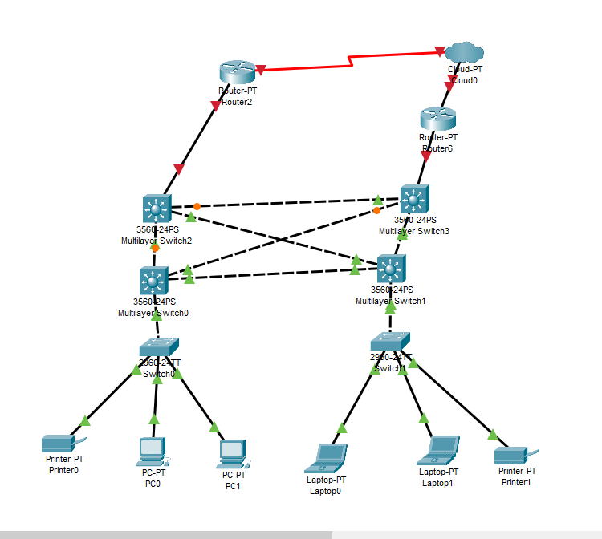

- By using redundant systems or components, you may make sure that in the event of a single point of failure, connection will take over without any problems. Power supply, network hardware, and redundant servers are a few examples of this.

- crossover cable is used to connect the same type of network equipment, such as the Ethernet cards of two different computers. It swaps the transmit and receive pins between its connectors, allowing direct connections between host devices...

B) Firewall:
Like gates, firewalls are used to protect the boundaries between your network and the internet. Network traffic is managed by firewalls, which permit authorized traffic while preventing access to unauthorized traffic.

Network segmentation:
Network traffic comes in a variety of forms, each with unique security threats. With network segmentation, you can limit traffic coming from dubious sources while allowing the appropriate traffic to pass through.

Application security:
Applications are viewed by many attackers as an exploitable defensive vulnerability. Any application that might be relevant to your network security can have its security parameters established with the aid of application security.

Web security:
Web security is a general term used to describe network security measures businesses take to ensure safe web use when connected to an internal network. It includes security tools, hardware, policies, and more. This lessens the likelihood that web-based threats will use browsers as entry points into the network.

References

Bibliography

[1] | N. Nachin, 1 March 2019. [Online]. Available: https://www.isaca.org/resources/isaca-journal/issues/2019/volume-2/how-to-increase-cybersecurity-awareness.
[2] | M. Akhter, 11 MAY 2023. [Online]. Available: https://envoy.com/blog/workplace-security-awareness.
[3] | OrnRin, 07 Augus 2019. [Online]. Available: https://www.gettyimages.co.uk/detail/illustration/hacker-with-laptop-computer-stealing-royalty-free-illustrat. [Accessed 1 MAY 2024].
[4] | [Online].
[5] | D. ELLIS, SECURITY METRICS, [Online]. Available: https://www.securitymetrics.com/blog/7-ways-recognize-phishing-email. [Accessed 1 MAY 2024].

