MANAGING ENTERPRISE IN THE 21ST CENTURY

BMSW4006_LON
LECTURER: AFZAL MUNNA
STUDENTS: SALEHA SHIRIN 2029506_Team Leader
LUCIAN-IOAN CICU 2109653
STEFAN IONUT DOTA 2028268
DUMITRU IULIAN FILOTE 1920814

Table of Contents
Business overview 3
Executive summary 3
Introduction 4
Mission statement 4
Vision statement 4
Aims and objectives 4
Business description and history 5
Business structure 7
Product or service description 8
Marketing 9
Operation management 17
Supply chain management 17
Other operational considerations 20
The number of staff the cafe has currently employed 20
From which the business will get operated? 20
Considerations of the laws and regulations for the cafe business 21
Insurance that recently has been in place or is intended to be put in place for the cafe business 21
Corporate Social Responsibility 22
Information Technology 23
Technology Plan 24
An important type of restaurant technology and the hardware 24
Using technology to help the cafe run more efficiently 25
Management and Organization 25
Organizational structure 26
Conclusion 28
Reference list 29

Business overview

Executive summary
As the chosen start-up business is a cafe whose name is given as 'cafe moonlight', hence, the products or services that are being provided by it thoroughly are lattes, iced coffee, croissant, breakfast sandwich, breakfast pizza, bagels and doughnuts. The services that are offered by this particular cafe are the coffee and the speciality espresso drinks, bottled drinks, and food items. Non-coffee drinks, and other beverage-based items. The objectives that tend to get covered by this cafe are maintaining a high standard of quality-based food and service, providing first-rate live entertainment without making a cover charge, and ensuring a friendly comfortable atmosphere respectively. Additionally, placing monthly ads in the neighbourhood publications and distributing the monthly flowers to the neighbourhood businesses and offering also discounted coupons. The entire description is needed for this cafe, that is making the baked goods, preparing the hot breakfast items such as oatmeal, grits and egg sandwiches. Hence, delivering fresh food or the yoghurt for the grab-n-go customers and making soups and salads for the lunch crowd respectively. The direct competitors may be from the other coffee shops and the indirect competitors may be the other options who are the customers who are also interested in purchasing the products from the direct competitors including restaurants, supermarkets and many more. The thorough competitive advantage that is grabbed by the coffee shop itself is to make a strategic view where the valuable characteristic that can be shared ubiquitously and where a source of the competitive advantage may be addressed in comparison with the franchise alternatives by choosing higher-quality based products and making a greater commitment to the entire social responsibility. As the cafe shop tends to offer a diverse menu that includes bagels, such as desserts and sandwiches, thus, the growth potential of the cafe shop tends to be associated with the coffee-shop industry where the expected growth estimation is near about £47 billion by 2021. The home delivery facilities are given by this cafe through the received offers on its own website with the help of QR codes from the customers within 405 kilometres of distance in total. This newly set-up cafe itself is a spelt cafe that arranges the establishment of small eating and drinking with featuring a limited menu for establishing the served online coffee.

Introduction
The UK-based companies relating to receiving and delivering the orders and products of coffee tend to sell approx. 34,947 tons of roasted coffee in 2020, where the sales value of this roasted coffee tends to be manufactured in the UK, addressing the roughly amount of £215 million (Poortinga & Whitaker, 2018). Henceforth, as the coffee imports in the UK were valued at £780 million in the other non-EU countries too, thus, the coffee is prone to contribute a total of £17.7 billion to the entire economy making a thorough impact on the overall UK-based coffee market that needs to be grown steadily (Jang & Lee, 2019). The ongoing caffeine addiction in the UK tends to relate to the coffee shop market being over £15 billion by 2020, hence, it grew by 10% approx. with the establishment of 20,700 coffee shops in the last year, which amounted to about £7.9 billion. The following business plan will provide detailed ideas and knowledge regarding the new business. An effective business plan involves different important aspects, like marketing, operations, management, CSR policies, technology plan, and others. The following business plan will involve each of the essential aspects of Cafe Moonlight. Proper aim and objectives for the new business will be set which will help the business owner and employees to perform effectively to achieve those objectives. The potential customers and main competitors of the business will be identified. To assess the external and internal environment of the business a SWOT and PESTLE analysis will be conducted.

Mission statement
The mission statement of this cafe is to identify the purpose of the restaurant that beads to be served while addressing the reason for the existence of the coffee shop that tends to make [airs of the values of the chosen cafe, namely, ‘cafe moonlight’.

Vision statement
The vision statement of that cafe is to help customers with articulating the things that are required for the business to move on. Hence, the business needs to be achieved in the long run by describing its thorough success of it by looking for a business and clarifying the overall purpose of the business relating to the coffee shop (Lee, Moon & Song, 2018).

Aims and objectives
The aim of this coffee shop is to provide a proper place for delivering, working and drinking coffee by using the appropriate atmosphere or helping more customers create a space where they can savour the coffee along with the experience at the time of the establishment of this shop (van Keulen & Kirchherr, 2021).
The objectives of this newly established coffee shop are as below:
To deliver a comfortable and a friendly atmosphere for providing the quality-based food to the customers
To serve and deliver the entertainment and required services to the customers at reasonable prices.

Business description and history
The business description of the coffee shop is to establish a cafe that tends to serve the coffee primarily of several types including latte, cappuccino, and espresso. Thus, it also keeps the beverages of soft drinks with the assimilation of the alcoholic drinks in continental Europe. Hence, the overall business description also includes a thorough comedy description that summarises the activities of the cafe, its goals and purposes that helps it to be unique by adding various commercial components of the business plan in terms of following the set objectives (Li, Liu & Huan, 2019). Since the cafe was first opened two years back, thus, during the 21st century, it flourished and enhanced its entire business in the entire UK, and as this is a start-up business, it has also planned to be expanded more later.
short -term objective
To relate the coffee shop to the actual frame where the raised turnover and the profit must be demonstrated and estimated by the following financial year.
Medium-term objective
To increase the market share and develop a new service or product
To reduce the cost and implement the new employee programme
To enhance the value of the shareholders and to advertise the budget of the cafe
Long-term objective
To make the specific improvements relating to that newly established cafe
To make the overall competitive position of this cafe by improving the domain of leadership and technology (Suhud et al., 2020)
To make and increase the rate of probability by making the return on investment and making also the employee relationships, brand recognition and the productivity
Skill and experience
Earlier experience
The previous experience of the recruited staff in this new cafe is to prepare and sell the food and the beverages at canteens and other outlets where the cafeteria must be clean and tidy for ensuring the customers deliver the ordered products. As the author has already worked in a coffee shop, thus it must be helpful for carrying out the experience in this new business.
Employment
The author was employed there as a manager, thus, he has enough capability and experience of serving the goods by maintaining the proper quality and quantity for bringing customer satisfaction (Viartasiwi & Trihartono, 2020).
Training and education relating to this business
As the author has received the training MBA in business and management, thus, he has enough skills for continuing this business entirely.
Transferable skills
The transferable skills that are actually possessed by the author are leadership, teamwork, written and verbal communication and personal motivation respectively (Kim, Kim & Holland, 2018).
The skill gaps
The skill gap that is present in the author is to utilise the current workforce that needs to be aligned perfectly with the skills that they actually require for completing the jobs. Hence, the primary skill gap regarding the improved technical skills must be added as the soft skills for doing and accomplishing the jobs well.
Qualification and experience
The qualification that must be possessed by the cafe manager is to carry out exceptional knowledge about the operations of the businesses where he must be responsible for managing and taking the required adequate responsibility for the cafe (Ashbeck, 2020).
Talents
The talents of a manager of the cafe are the appropriate working experience, especially the practical and the professional experience for making the availability of the works within the opening hours of the shops. Hence, as the excellent communication skills Must have the ability to manage and motivate the entire team, thus, the attitudes relating to the customer services just be added for bringing flexibility and increasing the commercial awareness.

Traits
The traits of the manager of the cafe are communication and motivational skills, organisational and planning skills respectively. Besides, making and developing the strategic thinking, accounting skills, business planning and choosing the ability to delegate the business plan for serving good interpersonal skills and the customer service skills (Filimonau, Krivcova & Pettit, 2019).

Business structure
A chain of command will be developed to create a suitable business structure for Cafe Moonlight. Selecting a proper business structure is a very significant aspect and one of the major decisions taken by an organisation as it develops and maintains the proper chain of command within the organisation. Moreover, it is important to provide the organisation with a proper framework that helps the business to grow over time (Jenkins and Williamson, 2015). The proper business structure will provide the employees of Cafe Moonlight with more clarity about the roles, responsibilities, and positions, assist manage expectations, provide consistency, and allow better decision-making. Cafe Moonlight will apply the following structure for their business.

Source: (Created by Author)
According to the above-presented structure, Cafe Moonlight will have a business owner who will supervise and control all the business activities. Managers and executive-level managers will work under the supervision of the owner. They will be accountable for a daily report to the owner. Accountant managers will be responsible for all the financial activities and budget making. Under the Executive Chief, head cooks will work and they will look after the activities and daily performance of assistant cooks and other staff within the kitchen department. Head waiters will work under the supervision of Assistant Cafe managers. Moreover, head waiters will supervise and manage the tasks of waiters. This organisational structure will be developed by following the hierarchy structure which will help the new business to progress the efficiency the business.

Product or service description
The products of Cafe Moonlight will involve a range of coffee and food items. The coffee items of the cafe will include cappuccino, cold brew coffee, cafe mocha, chocolate coffee, hazelnut coffee, Irish coffee, caramel coffee, black coffee, latte, maple syrup coffee, homemade Frappuccino, and others. They will moreover offer hot and ice tea along with different fruit juices, cold drinks, energy drinks, mocktails, and other beverages. The cafe will offer breakfast and different snacks, along with desserts, cakes, cookies, and ice creams. A range of plat-based and dairy fee food items and beverages will be offered for vegans. Cafe Moonlight will create a cosy and comfortable environment for customers along with outside and rooftop sitting arrangements.
The services of Cafe Moonlight will include online booking options for customers, dining, and takeaway. Customers will moreover order online through their website. Apart from that, the cafe will offer online payment and transaction options to their customers.

Marketing
Competitor analysis
A large number of cafes are operating the business in London. They offer almost similar food and beverage items at affordable prices. Moreover, most cafe owners develop the business with the aim of serving quality items within a vibrant and relaxing atmosphere. Therefore, it will be quite challenging for Cafe Moonlight to gain competitive advantages in the highly competitive market. To capture a strong position in the competitive market, Cafe Moonlight needs to understand the strengths and weaknesses of their competitors and in this case, conducting a SWOT analysis of the competitors will be effective.
Competitor 1: Regency Cafe
Strengths  - The major strength of the cafe is their market experience. Regency Cafe is operating the business since 1946 (regencycafe, 2022).  - The interior design and atmosphere of the cafe are other strengths that attract customers. Regency Cafe is designed in the art deco style.  - The cafe offers authentic English breakfast which is very famous to their customers. | Weaknesses  - Regency Cafe does not provide a delivery option to their customers.  - The sitting arrangement of the cafe is not comfortable for customers with heavyweights.  - The customer service of the cafe is not that updated.
Opportunities  - Regency Cafe can gain the opportunity to improve their customer service by adopting advanced technologies, such as Artificial Intelligence, Chatbots, and others.  - The cafe can increase their customer base by maintaining their food quality and starting online delivery options for customers. | Threats  - The current pandemic situation has adversely affected the business of cafes and restaurants which may reduce the sales of Regency Cafe.  - Many cafes in London are emerging with quality food and modern infrastructure that can provide a threat of competition to Regency Cafe.

Competitor 2: Terry’s Cafe
Strengths  - One of the biggest strengths of Terry’s Cafe is their pricing strategy. They offer food, coffee, and beverage at affordable prices (terryscafe, 2022).  - The cafe offers quality English breakfasts and flavorful coffee.  - The cafe provides effective customer service. | Weaknesses  - The interior design of Terry's Cafe is not that attractive and it is packed and placed in a small area.  - During peak times, the cafe faces difficulties to manage customer service and orders.  - Terry’s Cafe is not a good option for vegans.
Opportunities  - The pricing strategy and food quality can bring the opportunity to Terry’s Café for increasing their customer base.  - The cafe can focus on their online presence and marketing to attract more customers. | Threats  - The threats of immense marketing competition.  - The sales reduction is due to several rules regarding social distancing.

Competitor 3: Kaffeine
Strengths  - The interior design and ambience are attractive to customers.  - Kaffeine offers quality foods and a range of options for coffee.  - The cafe maintains proper hygiene and safety (kaffeine, 20222). | Weaknesses  - The prices of food items are quite high at Kaffeine.  - The cafe does have many spaces to manage a large number of customers at a time.
Opportunities  - Kaffeine has the opportunity to increase their sales and opportunities as they moreover offer catering services and courses. | Threats  - The immense market competition has been providing a huge threat to Kaffeine for increasing their customer base.

SWOT analysis of Cafe Moonlight
Strengths | Weaknesses
i) Cafe Moonlight will offer fresh and high-quality coffee, food, and beverage to their customers at affordable prices.  ii) Along with a range of artesian coffee, the cafe will provide a verity range of options for breakfast and snacks.  iii) Cafe Moonlight will offer a separate menu for vegetarians and vegans.  iv) Cafe Moonlight will create an eye-soothing and lenient atmosphere with soft music and decent lights. Moreover, it will design outside and rooftop sitting arrangements.  v) Safety and hygiene will be properly maintained.  vi) The cafe will provide excellent customer service by adopting advanced technology. | i) In the initial period of the business, Cafe Moonlight may face a lack of sufficient human resources.  ii) Cafe Moonlight will not provide a lunch and dinner menu to their customers.  iii) Another weakness that can be considered for the new business is insufficient financial resources.
Opportunities | Threats
i) Cafe Moonlight can develop effective marketing and promotional plan with the help of advanced technology.  ii) The new business can increase their sales by developing different online food delivery partners, like Deliveroo.  iii) In future, the cafe can include lunch and dinner items in their menu to increase their customer base and sales. | i) The effects of the pandemic may restrict Cafe Moonlight to increase their sales and profitability.  ii) It will be quite challenging for the new business to gain competitive advantages in the current market competition.  iii) The increasing price of raw materials, oils, and equipment can provide a huge threat to the new business to manage sufficient financial resources.

PESTLE analysis
Political | The political stability of the United Kingdom will help the new cafe business to effectively operate the business without any political hassle. However, the government policies can change anytime which may create difficulties for Cafe Moonlight in terms of budget planning, strategy implementation, taxations, and others. Moreover, the health and safety policies mostly affect the cafe and restaurant industry. Therefore, Cafe Moonlight needs to take care of maintain hygiene and cleanliness while conducting packing, cooking, and operations to abide by the government guidelines.
Economical | If the inflation rate rises in the UK economy, it will impact the prices of raw materials and ingredients. Disposable income of the consumer is another economic factor that has a strong impact on the business of cafes. Due to the pandemic and economic downturn, the disposable income of consumers has been reduced which may affect the sales margin of Cafe Moonlight. Apart from that, fluctuating taxes on ingredients and raw materials may lead to high prices of products.
Social | The increasing trend of people having coffee and breakfast in coffee shops with a relaxed atmosphere will ensure better revenue for Cafe Moonlight. On the other hand, the growing awareness of UK people regarding organic food may affect the business (Nguyen et al., 2018). However, Cafe Moonlight will offer plant-based products to attract more customers. Moreover, the changing taste and preferences of customers and their food habits may create challenges for the new business to retain and attract new customers.
Technological | Rapid technological growth and advancement have a strong impact on the business of cafes. The modern technological infrastructure will be beneficial for Cafe Moonlight in terms of ordering food online, improved customer service through Chatbots and AI, operating CCTV cameras, and others. The increasing popularity of social media will help the new business to effectively promote their business.
Legal | To operate the business successfully, Cafe Moonlight needs to maintain all the legal factors. They should strictly maintain health and safety-related rules and regulations to ensure that they are effectively maintaining hygiene to protect the customer's health. Moreover, the cafe should abide by the employment law to protect their workers' rights.
Environmental | The UK government has developed several rules and policies regarding environmental sustainability that should be followed by Cafe Moonlight. The cafe will develop different strategies to reduce their carbon footprint and manage waste. They will moreover utilise renewable energy to reduce their impact on the environment (Filimonau et al., 2020).

Market research
1. Market segmentation
There are four key market segmentations that will be followed by Cafe Moonlight where they will operate the business and target potential customers.
i) Demographic segmentation: Cafe Moonlight will target customers from the age group of 16-55. Moreover, the cafe will create a suitable atmosphere for customers below the age group of 15 and above the age group of 60. The main target customers of the cafe are people with stable income levels and education. The cafe will mainly attract college students and working people who go to the office without having breakfast from their homes (Venter et al., 2015).
ii) Psychographic segmentation: Cafe Moonlight will attract people who have the tendency to eat outside and spend their quality time in cafes. Moreover, people who prefer to visit coffee shops to have quality coffee and snacks during their break time will be targeted.
iii) Geographic segmentation: Cafe Moonlight will operate the business in the UK. It will be located in London and target the local customers.
iv) Behavioral segmentation: Cafe Moonlight will mainly attract customers who have spending habits on artesian and quality coffee and restaurant foods. Moreover, customers with online purchasing habits will be targeted (yieldify, 2020).
2. Data collection
The data regarding customer trends, purchase habits, current market demands, and others will be collected by conducting social media research. Nowadays, people share content and images about their favourite dishes, current visiting to coffee shops, and reviews which will help Cafe Moonlight to decide on their food menu and other strategies based on the current market trends.
Market analysis and needs
Coffee shops and cafes in the UK are part of the quick-service restaurant market which has potential growth. Over 10.5 million people in the UK visited local coffee shops in 2019 which has effectively contributed to local economic growth. However, in 2020-2021, due to the outbreak of Covid-19, the industry has adversely affected. In 2020, the value of the British coffee shop market dropped around by £7 billion (Lock, 2021). Currently, the industry is recovering the business as people again are coming outside. Moreover, due to the online food delivery, the sales margin of coffee shops and cafes is gradually increasing.
Partnership
Cafe Moonlight will develop partnerships with local coffee roasters and small local bakeries. Moreover, gradually after a few months of operating the business, they will develop partnerships with local non-profitable organisations for social care and catering services to provide quality snacks and coffees for different events and occasions.
Marketing Mix
Products/Services | Cafe Moonlight will offer quality products to ensure that customers are having healthy items which are good for their health. The menu of the cafe will involve artesian coffee, beverages, snacks, desserts, cookies, cakes, ice-creams, vegan foods, and others. They will offer both sitting arrangements and online food delivery options.
Price | Cafe Moonlight will offer quality food and coffee at affordable prices. Moreover, they will follow the one pricing strategy to attract their customers. For instance, normally the cafe will offer a large cappuccino at £3 and a vegetable cheese sandwich at £5. In this pricing strategy, they will offer the coffee and sandwich together at £7. In this case, customers will see this offer as a bargain and this will moreover help the cafe to increase their sales (Magloff, nd).
Place/Distribution | Cafe Moonlight will be located in the heart of London. This place is full of daily crowd and proper transportation system which will help to obtain more customers. Moreover, through the online delivery, the cafe will easily make available their products to local customers.
Promotion | Cafe Moonlight will promote their business through both the traditional and online approaches for promotion. They will publish advertisements in local newspapers, radio, television commercials, banners, hoardings, and will distribute leaflets. Along with that, different popular social media platforms, like Facebook and Instagram to promote their business (Thabit and Raewf, 2018).
People | Both internal and external people will be equally valuable for Cafe Moonlight. They will offer quality and fresh products to customers to protect their health. Moreover, they will create a suitable working environment and provide several opportunities to their employees.
Process | Cafe Moonlight will develop a systematic and effective process for the business. They will mainly focus on the food preparation process. Along with that, the new business will have a strong focus on marketing and customer service processes.
Physical evidence | Cafe Moonlight will design their interior with modern equipment and sustainable materials. The cafe will use disposable materials during the pandemic to maintain safety and hygiene and will pack their products with recyclable materials.

Key promotional activities
1. Cafe Moonlight will develop a social media strategy for promotion. They will publish unique content on different social sites to grab the attention of their customers.
2. The cafe will focus on mail-order marketing to offer a free item to customers in exchange for information and their valuable feedback.
3. The cafe will apply the customer referral incentive program where customers will get attractive offers and discounts in exchange for referring a new customer (Hose, 2019).

Operation management
Business operation is the term of using and defining a broad range of activities where the company needs to be associated with the regular based activities for continuing the business operations and making the ways easier comparatively for making money. Additionally, as stated by Tarafdar, Beath & Ross (2019), as the operation of the business tends to be associated with acquiring the values that are actually owned by a business, thus, the assets relating to it must be derived from the base of the physical asset where the ultimate values must be achieved on the basis of the royalty. Hence, the business operations of the cafe must be related to the key operational revenues that are also being considered the most important business activities that tend to generate revenue by including the production and selling of the overall products and services. Henceforth, the expenses relating to the key operational areas must be demonstrated from the perspective of incurring the costs that are also being generated from the progression and the improvement of the products. On the other hand, as reflected by Hacioglu & Sevgilioglu (2019), as the marketing and advertising carry out the extra cost, thus, the operating expenses of the personnel and the technology must be associated with the domain of the improvement of the sales and production of the coffee and the beverage-based products and services.

Supply chain management
The supply chain management itself is the law of management that associates the flow of goods along with the services where the business and locations include the management and the storage of the raw materials that need to be added for making work in progress. In addition, as the inventory including the finished goods must be added with the fulfilment of the orders, thus, the consumption of the goods and services must be associated with the handling of the entire flow of production relating to the products and services. As illustrated by Korauš et al. (2019), as the raw components state the ways of delivering the final products or services to the customers, henceforth, it tends to combine analytical thinking with addressing several practical steps of management. Henceforth, the goals or the objectives need to be demonstrated for managing the flow of the goods and services from the perspectives of the suppliers, where the raw materials must be highlighted as the final products, used by the customers. Thus, this management also depends on the integrated process where the planning and controlling of the flow of goods, money and information need to be associated across the entire values and the supply chain management. On the contrary, as interpreted by Ahmed et al. (2022), the customers must be related to the suppliers of the raw materials for the successful delivery process and the complex production of the goods while making too many challenges.
Roles or responsibilities
CEO: ABC
Roles: The CEO of the chosen cafe, Cafe Moonlight is responsible for managing the overall operations of the organisation or this cafe itself. Thus, directing and delegating the agendas, driving profitability and managing the organisational structure and strategy tend to communicate with the board.
Responsibility: The CEO of this newly established cafe tends to the community on the behalf of the organisation where the government entities, the public and the shareholders must be associated. Hence, as the company must be led and directed towards achieving the short-term and the long-term strategy, thus, creation and implementation of the vision and mission of the cafe must be added in this regard (Ahmed et al., 2021).
Marketing director: XYZ
Roles: The marketing director is totally responsible for the marketing and communication strategy for the cafe where the overall branding and its image of it need to be prepared for making the annual marketing plans by creating a total calendar of the overall events and the campaigns for setting the budget of marketing and also analysing the competitors and the market.
Responsibility: The responsibility of the marketing director states the duty of being a marketing expert for overseeing and storing the strategies of marketing and efforts for strengthening the market position of the cafe for achieving the targeted business goals. Additionally, as the director tends to lead and guide the efforts of the entire department of marketing, thus, it also tends to get associated with the monitoring and the evaluation of the projects for addressing several activities, analysing the outcomes and directing the research efforts at all (Tarkhanova, Chizhevskaya & Baburina, 2018).
Finance director: LMN
Roles: The finance director tends to make the overall planning of finance where the task is to make the budget by overseeing several financial activities making the timely reporting on revenue. Based on that, arranging training for the accounting data and disbursing funds to the departments, is needed to make the actual risk by completing several policies of improving the entire financial process.
Responsibility: The responsibility of the director of finance is to take active charge of leading and managing all kinds of financial functions and activities for supporting the senior shareholders for making several types of reviews of the business by managing the overall budgets. Henceforth, as it is needed to forecast the future needs of the business by making a long-term planning procedure, thus, the entire planning also needs to be added or merged for making the thoroughly informed decisions by improving the performance of the cafe (Mor et al., 2018).
Recruitment
The employees of the cafe can be recruited on the basis of the creation of the opening of the jobs where the promotion regarding job opening must be associated with the multiple job boards for making social media platforms effectively by placing the promotion on the website of the cafe, Moonlight.
Corporate policies
The corporate policies of the cafe are related to the addressing of proper dress code, ethics, safety, usage of the internet and so on that must also be included with the acceptable and the unacceptable behaviours for not stating any kind of ambiguity for the business that need not be tolerated.
HR development
The payroll and the updated records must be associated with the payments for monitoring the attendance of the employees and the working schedules that need to be included in planning and scheduling the onboarding sessions for relating the job-based training with making association of all the workers. Thus, the activities relating to the HR must be associated with the diverse functions for arranging proper training and development of the education for making the particular focus on the position of overarching goals for increasing the capacity of the people in terms of achieving the outcomes of life as per the desires (Tarafdar, Beath & Ross, 2019). As the key business operations tend to include the manufacturing, sales, marketing and the advertisement-based activities, thus, the operating income of the business must be associated with the demonstration of the through financial statements by generating the operational profits after reducing the overall operational expenses that can be derived from the operational revenues.

Other operational considerations
As this is completely a start-up business, hence, the selected cafe has currently considered the necessity of the staff recruitment that must be involved recruiting the manager, host, server, and cashier. This type of business may also carry out the benefits of improving the entire agility of the business where it also needs to state the ability to react to the change for increasing the efficiency and also accomplish the visibility (Hacioglu & Sevgilioglu, 2019). Henceforth, it needs to be ensured that the compliance and the security must be associated with the easy transfer of acquiring the business knowledge relating to the cafe business, thus, it also must be helpful for enhancing the opportunities for the continuous improvement of the entire business operations.

The number of staff the cafe has currently employed
As this is a small start-up business, thus, initially a total of 20 staff is being recruited for taking the overall operational and managing responsibility of the cafe business. Additionally, as the cafe workers tend to sell and serve the food and beverages by making the total consumption of the cafes by making the similar establishments, thus, the cafe assistant and the canteen attendant must be associated as the cafe worker without making the formal qualification for making the cafe useful (Korauš et al., 2019). The effective business practices must allow the whole business to maximise the effectiveness of the coffee business of this start-up company by using the inputs in terms of developing the products at a faster pace for reducing several defects of the competitors.

From which the business will get operated?
Manufacturing unit
The manufacturing unit of the Cafe Moonlight is to make the active involvement o the conversion of the raw materials that tend to usually be supplied in a simple form by relating the finishing products to the specific structure, shape and the properties of the products that need to be fulfilled entirely with the provided requirements.
Work-hub
The work-hub itself is a digital space that needs to be organised collaborative and communicative where the consolidation needs to be added with the existing organisational tools, goals and the processes for making the team aligned without creating any extra meetings in order to allow the organisation for moving towards the eco-friendly environment of business.

Considerations of the laws and regulations for the cafe business
As the chosen or selected cafe comes under the food and beverage industry, thus, the laws must be addressed in this regard with which the cafe and its business are actually associated respectively (Ahmed et al., 2022).
As per the prevention of the food adulteration act in 1954, it can be stated that the food needs to entirely be protected from the contamination of food that may carry out the health risk of consuming such products. Henceforth, as the action tends to deal with the fraudulent acts, thus, it can also completely be perpetrated by the dealers with the help of supplying the adulterated food items.
As per the law of the vegetable oil products order in 1947, it can be demonstrated that the availability of the vegetable oil must be associated with some of the relevant factors for prescribing the maximum or the minimum limits of the usage of the vegetable oil whale manufacturing the products relating to the vegetable oil so far. Thus, as it is required to make the active association of the beverage-oriented goods essential, the manufacturing and delivering of the coffee needs to be conducted in a safe way (Mor et al., 2018).

Insurance that recently has been in place or is intended to be put in place for the cafe business
As there are three types of businesses relating to insurance that are general liability insurance, commercial property insurance and also business income insurance. Henceforth, as the business insurance tends to protect the overall business from any kind of financial losses or damages, thus, the financial loss can also occur at the time of operating the business on an everyday basis (Pawar et al., 2021). Henceforth, as the policyholder of the government has tried enough for getting the coverage for reducing the risks associated with the employees, thus, the damages of the property along with the liabilities must be demonstrated from the perspectives of the ensuing the risks made by the insurer by including all the necessary activities relating to the reduction of the conducted risks respectively.
As the insurance needs to be added to the business of the cafe where the other foods and the beverages are also reactively included, hence, the complete protection must be provided against the overall financial loss that may arise because of the filing of the lawsuits relating to the property owned by the organisation itself. Thus, the owner of the cafe must be opted for business insurance properly for carrying out thorough business operations after such a huge loss of the business (Tarkhanova, Chizhevskaya & Baburina, 2018).

Corporate Social Responsibility
In terms of social responsibility and long-term viability, it can be argued that "Café Moonlight" will provide a fair wage to its employees. The coffee shop will also engage in activities such as charity campaigns to assist those in need. The business will still be on a moral high ground, fostering a community culture of decency and respect. The business model including the degrees of responsibility of the coffee shop is defined by the company's Corporate Social Responsibility, which can be argued (Chin et al., 2019). The following actions will have a good impact on the globe.
As per the Corporate social responsibility model, a corporation is held accountable to itself, its employees, as well as the general public as well as the local environment. By using the CSR model, the coffee shop will be able to take more care of social and environmental aspects. The following are CSR actions that the corporation can implement in the UK to become more environmentally friendly:
- Since it is one of the most essential and discussed topics in the industry, the coffee shop must always take the required efforts to reduce its carbon footprint.
- Veganism is on the rise in the United Kingdom, with the majority of individuals preferring plant-based cuisine. “Café Moonlight” must likewise cater to these types of cuisine and coffee, and their menu must have a section dedicated to Vegans.
- Instead of relying on most technological instruments, the cafe must always consider different ways to use resources effectively (Fernando, 2022).
- The coffee shop “Café Moonlight” should get involved in charitable organisations like Save the Trees, British Red Cross, and Save the Children among others.
- The coffee shop can also consider buying fair-trade products and investing in environmentally friendly businesses.
- The coffee shop will help members of the local community by giving them employment in the cafe.
- The coffee shop moreover has to become more involved in volunteer activities and strengthen its labour policies (Murillo & King, 2019).
- “Café Moonlight” must ensure that its cafe produces only what is needed and wastes as little as possible.
- Every day, the cafe will donate all of the leftover food to those in need in the United Kingdom. The coffee shop will moreover collaborate with a UK-based NGO to carry out the following activities, ensuring that the excess food is not wasted.
- In order to reduce food waste, the coffee shop will hold several training sessions for employees on how to reduce waste. The next session is open to the general public.
- The cuisine served at the “Café Moonlight” will be gluten-free, and the restaurant will cook using GMO-free ingredients to ensure the health of its patrons.

Information Technology
The coffee shop “Café Moonlight” will operate in its physical café in London. However, catering to the current needs of the customers and due to the outbreak of the global pandemic of Covid-19, the café will keep an option open for home delivery and online orders. Here, right after its launch, the customers can start to book their tables online, through the websites, or via phone call (He & Harris, 2020). The website will be active and quick to respond. For online booking and payment for home delivery, the customers can directly order on the website or can order via phone call. As of now, the cafe will be providing home delivery for up to 4-5 km.
Networking
Network marketing has taken a pace now and for a new cafe, there will be ample opportunities to build connections via networking. Apart from that, in terms of information technology networking, the cafe will be using high bandwidth internet access for the computers on fee payment. Besides, Cafe Moonlight will be using the latest technology including mobile printers that can integrate with that of POS. This will allow Cafe Moonlight to apply all the order data directly to recipe labels from transactions.
Support
Computers will be used in tracking the order shipments and inventory which can in turn simplify managing the order for coffee and other beverages and snacks. Besides, three will be usage of mindful design and modern coffee making machines as well as cappuccino machines (Jakšič & Marinč, 2018). Technology is a part of establishing any coffee shop and Cafe Moonlight needs to focus on it.
E-commerce
Cafe Moonlight will be focusing on its e-commerce operation and besides a cafe, it will also open the options for online orders and home deliveries which can be availed by reaching the cafe's website and ordering the food. It will maintain both brick-and-mortar and online deliveries. In the upcoming 6 months, the cafe will be collaborating with delivery apps to increase the radius or area of delivery.
Online advertising
Cafe Moonlight will have a social media presence. On Facebook and Instagram, it will keep on posting the special food items and coffee of the cafe along with the facilities (Jose, 2021). Online advertisement can be beneficial for Cafe Moonlight.

Technology Plan
In today's world, technology is believed to be among the most significant parts of running a business. Restaurants must modernise and recognise that the younger generation is tech-savvy as well as likes the web and communications to be integrated into it in order to do business. Technology appears to be making an impact in the restaurant industry. In today's environment, a restaurant must be able to quickly react to changes in standards and requirements in order to remain successful and nimble (Sehnem et al., 2021). The usage of technologies in the restaurant industry aids in optimising the operation of the establishment.
Additionally, because of the pandemic, technology utilisation is expected to be considerably more adaptive in 2020. The cafe was obliged to implement technological upgrades as a result of the pandemic, which helped them do more business.

An important type of restaurant technology and the hardware
To keep up with the times, the coffee shop “Café moonlight” will need to adapt to technology, which will aid in the café’s growth. The following are some of the technologies which can be implemented in a cafe to boost productivity:
1. Self-service kiosks
“Café Moonlight” will install self-order kiosks at their restaurants to provide speedy service and payment options. Due to their novelty, self-order kiosks appear to be building a reputation for themselves. It will assist the organisation in lowering the number of employees and increasing production as a result. Customers would not have to stand in the queue to make the orders thanks to the following technology (Ogunmokun et al., 2020). It will enhance the passenger experience while also assisting the business in minimizing productivity and manpower shortages.
2. Order & pay at the table
Following the Covid-19 outbreak, it is believed that efficiency, quickness, and safety are the most crucial aspects of the restaurant or café experience. To make the most of it, the “Café Moonlight” must operate with at least 50% of the seats occupied in order to maintain physical distance. With the provision of contactless and digital payments, customers will be able to select as well as pay for food directly from the devices. It will thus provide appropriate comfort to the guests and increase table turn times. It will also aid in the reduction of labour expenditures.
3. Display Cabinet for the Kitchen
“Café Moonlight” will be using this technology, as it is one of the most popular restaurants and cafes. Since it is digital, the accompanying technology is believed to be environmentally friendly. The device, which is mounted on the wall, allows the kitchen staff to review the orders which are placed on a single screen (Sharma, 2019). As a result, it aids the café’s personnel in organising and thereby completing the order. As a result, the following will assist the coffee shop in improving order speed and accuracy, hence improving the client experience.

Using technology to help the cafe run more efficiently
It is a technology that aids in optimising the café’s end-to-end processes and ensuring consistent customer service. It is a technology that can assist the cafe in gaining technological knowledge:
1. “Café Moonlight” must employ cutting-edge technology to track orders seamlessly. The café will be providing facilities for home delivery and online booking and order within an area of 4-5km as of now. However, in the future, the coffee shop “Café Moonlight” will be collaborating with food apps for faster delivery and thereby will be covering more areas increasing the customer base (Zaman et al., 2020).
2. The café’s front-end operations will improve as a result of the use of technologies in the coffee shop’s operations.
3. “Café Moonlight” will improve its marketing and consumer engagement by implementing technology.
4. With the usage of the Kitchen Display System, “Café Moonlight’s” personnel will be able to work more efficiently in the kitchen.

Management and Organization
In most businesses, including cafés or coffee shops, the management structure is divided into three levels: lower-level management, middle-level management, and upper-level management. Restaurant management positions can be said to differ from the other. As a result, it is considered to be determined by the scale of the café’s operation as well as the number of employees working there. As a result, for the coffee shop “Café Moonlight”, it can be said that in order to execute efficient cafe management, the following must be done:
1. The restaurant's management must ensure that all of the restaurant's employees are valued. Employee turnover is regarded to be the most serious issue in the restaurant industry (Jose, 2021). As a result, it is critical to provide sufficient value to employees in order to keep them motivated.
2. To improve foot traffic in the restaurant, the cafe owner should change the menus that are presented in the cafes on a rotational basis. “Café Moonlight” must offer certain signature dishes that will encourage guests to return to the restaurant.
3. The cafe should be thoughtful in its marketing because it is among the most essential factors in attracting customers to the establishment. To do business in London, Turkish Twist will need to create a robust restaurant marketing strategy. To promote the cafe, the coffee shop should use social media (Fernando, 2022). The coffee shop moreover can provide a cheaper option than usual marketing sources for its promotion. The company's social profile should be maintained.
4. “Café Moonlight” should also educate its employees to meet all of the customer's needs. When a consumer asks about changes to their dietary requirements, the entire company's employees must be prepared to respond.
5. On the other hand, the coffee shop must make sales monitoring and inventory management easier, as well as pay close attention to internet reviews.

Organizational structure
In terms of the coffee shop’s organisational structure, it can be argued that the café’s organisational structure aids in identifying the roles and responsibilities of its personnel. Every café or restaurant, it can be argued, is distinct from the others, and hence each has a unique organisational structure. However, the basic form of “Café Moonlight” will be built on along with personnel such as:
1. CEO
The CEO of Cafe Moonlight will be responsible for monitoring and managing the cafe's overall performance and operations. The role will include directing agendas, delegating, driving the cafe's profitability, managing the organisational structure of the company, and communicating with the board to name a few.
2. Marketing Director
On the other hand, the marketing director will guide and lead the marketing team of Cafe Moonlight. His duty will include keeping track of all the assigned accounts, evaluating and monitoring projects, and taking charge of the research efforts.
3. Finance Director
Whereas, the finance director will look into the long-term financial gains as well as the growth of Cafe Moonlight. The finance director of this cafe will moreover be responsible for establishing strategies that can help in gaining more profits, producing all accurate reports, and thereby overseeing the accounting operations of the coffee shop (Jakšič & Marinč, 2018).
3.1 Financial Plan
- Source of Capital £100000
- 4 Member x £12500 = £50000
- Bank Loan £50000
- Cash flow statement
- Profit and loss account

- Sales Forecast

3.2 Profit and Loss
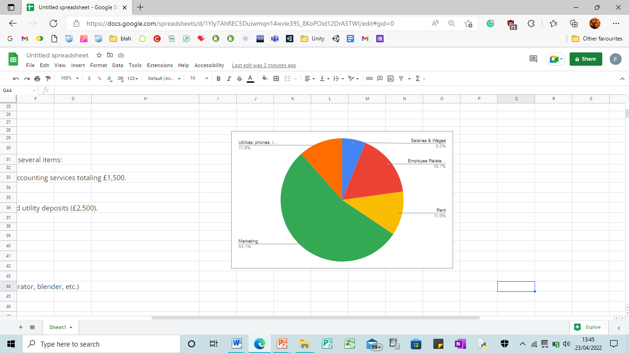
3.3 Cash Flow Statement
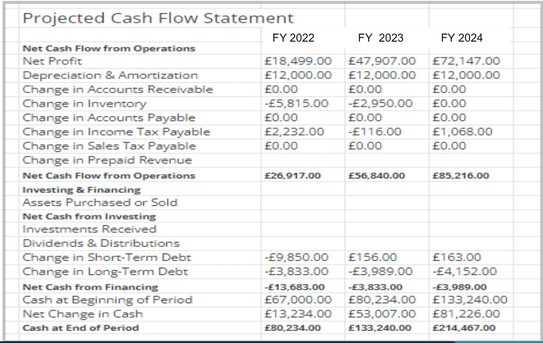
3.4 Expenses
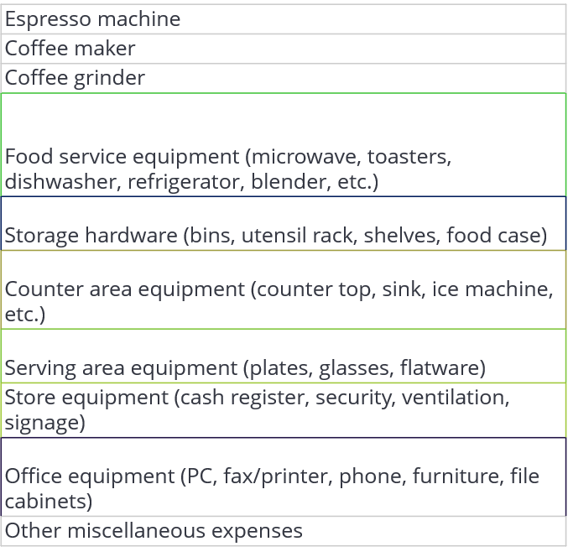
4. General Manager
With that, the coffee shop will also have a general manager and he will be responsible for looking into the overall operations of the cafe which includes all aspects of profitability or loss, training, hiring, regular execution, food quality, food preparation, and how the guests or customers are being served.
5. Assistant Manager
The assistant manager of the cafe will be guiding the line managers and other team members including the chef or staff at the counter. He will look after the recipes and menu that are set by the head chef and his team.

Conclusion
It can be concluded that the goals and purpose of this start-up cafe are actually primarily centred around the customers where it has set the proper aim of establishing a balance between meeting the universal desires of patrons like privacy and comfort. Thus, accounting for the individual differences in several user needs must be illustrated from the perspectives of the independent workspaces accordingly. The coffee that can actually be achieved at this coffee shop may boost physical performance and burn the fat of human beings. Additionally, coffee helps people in focussing on staying alert by lowering the risks of death, thus, it also reduces the possibility and chances of occurring cancer and also has reduced enough the possibility and rate of strokes by diminishing the risk of Parkinson's disease.
Appendix
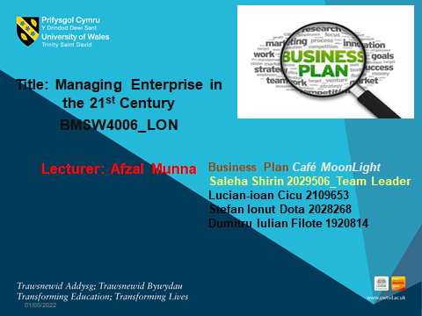
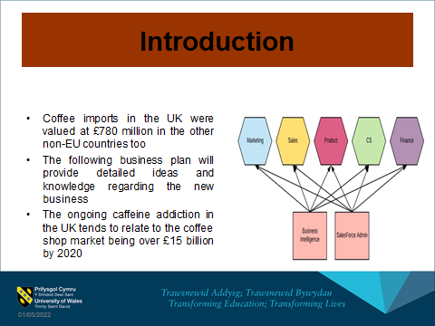
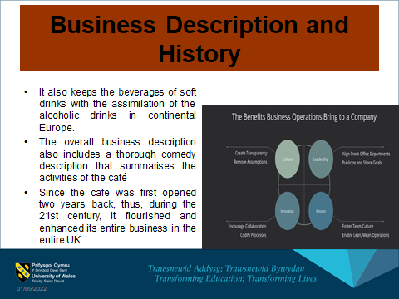
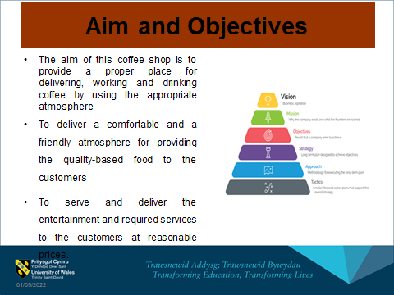
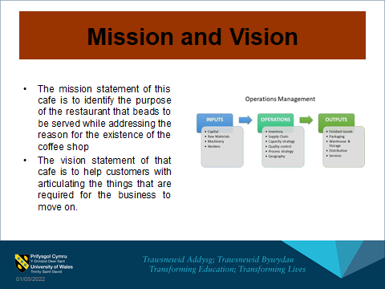
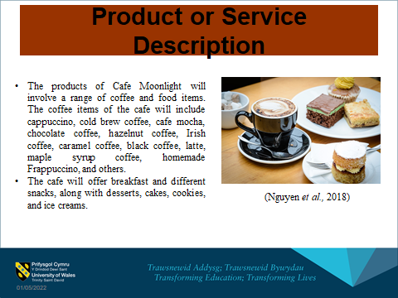
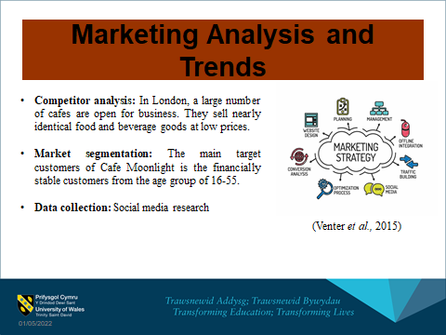
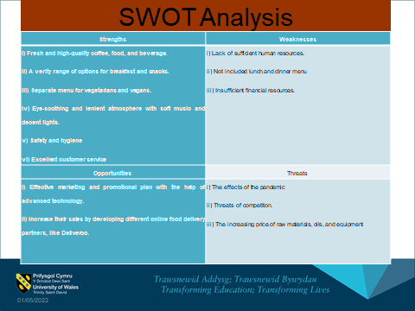
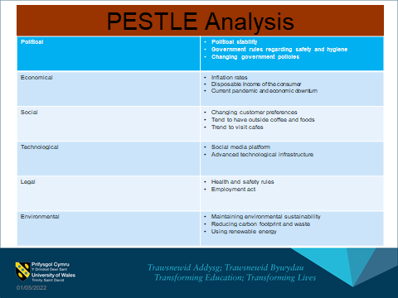
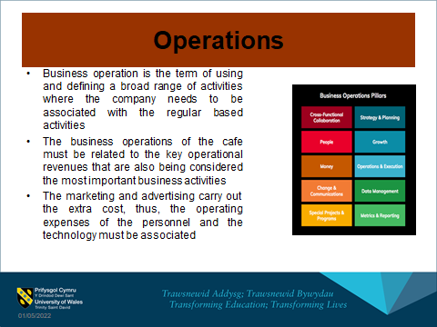
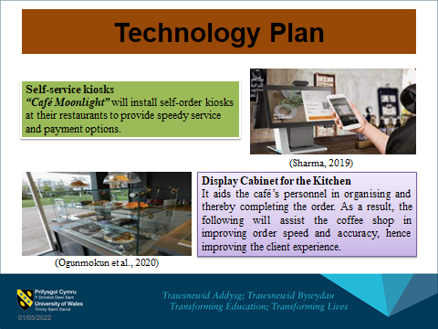
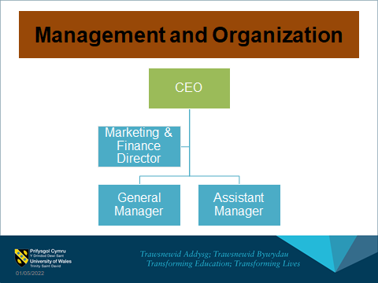
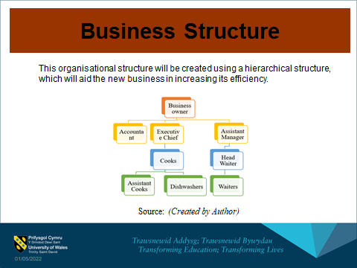
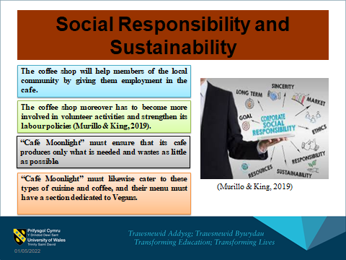
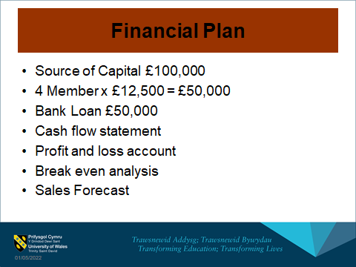
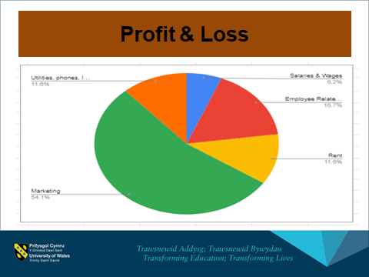
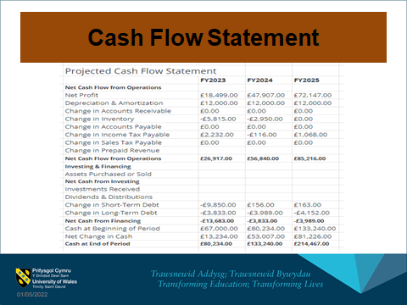
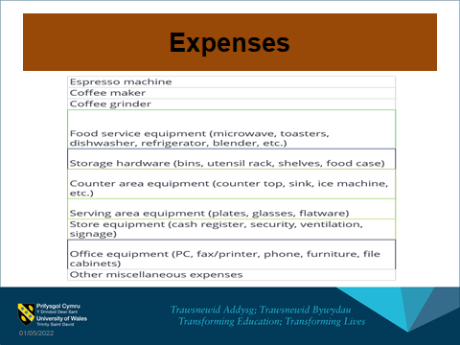
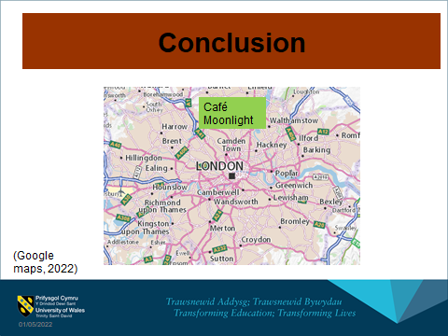
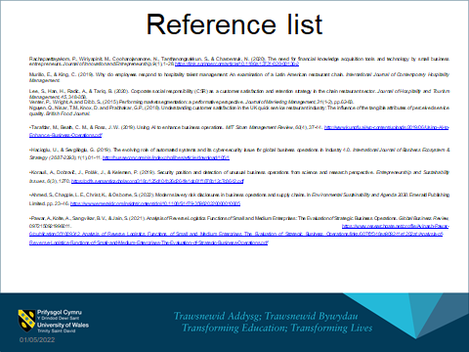
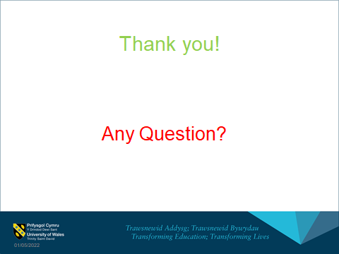

Reference list
Ahmed, S., Chapple, L. E., Christ, K., & Osborne, S. (2022). Modern slavery risk disclosures in business operations and supply chains. In Environmental Sustainability and Agenda 2030. Emerald Publishing Limited. pp. 23-46. https://www.emerald.com/insight/content/doi/10.1108/S1479-359820220000010005
Ashbeck, H. (2020). Coffee Shop Communication: social media & Engagement. pp. 1-12. https://minds.wisconsin.edu/bitstream/handle/1793/80304/Ashbeck%20Coffee%20Shop%20Communication%20Final%20Copy.pdf?sequence=1
Chin, W. J., Lim, M., Yong, J. C. E., Al-Talib, A. A. M., & Chaw, K. H. (2019, November). Service time performance analysis of improved automated restaurant by layout reconfiguration and conveyor system. In IOP Conference Series: Materials Science and Engineering (Vol. 692, No. 1, p. 012003). IOP Publishing. https://iopscience.iop.org/article/10.1088/1757-899X/692/1/012003/pdf
Fernando, J. (2022). Corporate Social Responsibility (CSR). [online] Investopedia. Available at: https://www.investopedia.com/terms/c/corp-social-responsibility.asp [Accessed 18 Apr. 2022].
Filimonau, V., Krivcova, M., & Pettit, F. (2019). An exploratory study of managerial approaches to food waste mitigation in coffee shops. International Journal of Hospitality Management, 76, 48-57. http://eprints.bournemouth.ac.uk/30675/3/R3.pdf
Filimonau, V., Todorova, E., Mzembe, A., Sauer, L. and Yankholmes, A., (2020). A comparative study of food waste management in full service restaurants of the United Kingdom and the Netherlands. Journal of Cleaner Production, 258, p.120775.
Hacioglu, U., & Sevgilioglu, G. (2019). The evolving role of automated systems and its cyber-security issue for global business operations in Industry 4.0. International Journal of Business Ecosystem & Strategy (2687-2293), 1(1), 01-11. http://bussecon.com/ojs/index.php/ijbes/article/download/105/1
Google maps 2022
He, H. and Harris, L. (2020). The Impact of Covid-19 Pandemic on Corporate Social Responsibility and Marketing Philosophy. Journal of Business Research, [online] 116(1), pp.176–182. Available at: https://www.ncbi.nlm.nih.gov/pmc/articles/PMC7241379/ [Accessed 18 Apr. 2022].
Hose, C., (2019). Top Ten Promotional Strategies. [Online]
Available at: https://smallbusiness.chron.com/top-ten-promotional-strategies-10193.html
[Accessed 2022].
Jakšič, M. and Marinč, M. (2018). Relationship banking and information technology: the role of artificial intelligence and FinTech. Risk Management, 21(1), pp.1–18.
Jang, H. W., & Lee, S. B. (2019). Applying effective sensory marketing to sustainable coffee shop business management. Sustainability, 11(22), 6430. https://www.mdpi.com/2071-1050/11/22/6430/pdf
Jenkins, W. and Williamson, D., (2015). Strategic management and business analysis. Routledge.
Jose (2021). Critical success factors throughout the life cycle of information technology start-ups - ProQuest. [online] www.proquest.com. Available at: https://www.proquest.com/openview/2ceed171b59a9259e0fd354631be8ecf/1?pq-origsite=gscholar&cbl=4916366[Accessed 18 Apr. 2022].
kaffeine, (2022). Reviews. [Online]
Available at: https://kaffeine.co.uk/
[Accessed 2022].
Kim, S. H., Kim, M., & Holland, S. (2018). How customer personality traits influence brand loyalty in the coffee shop industry: The moderating role of business types. International journal of hospitality & tourism administration, 19(3), 311-335. https://www.tandfonline.com/doi/abs/10.1080/15256480.2017.1324340
Korauš, A., Dobrovič, J., Polák, J., & Kelemen, P. (2019). Security position and detection of unusual business operations from a science and research perspective. Entrepreneurship and Sustainability Issues, 6(3), 1270. https://pdfs.semanticscholar.org/318c/125d404b26d264fe1dc61f1878b12c7c8642.pdf
Lee, W. S., Moon, J., & Song, M. (2018). Attributes of the coffee shop business related to customer satisfaction. Journal of Foodservice Business Research, 21(6), 628-641. https://www.researchgate.net/profile/Joonho-Moon/publication/328082694_Attributes_of_the_coffee_shop_business_related_to_customer_satisfaction/links/5bc6e7c1458515f7d9bfd7c2/Attributes-of-the-coffee-shop-business-related-to-customer-satisfaction.pdf
Li, Y., Liu, B., & Huan, T. C. T. (2019). Renewal or not? Consumer response to a renewed corporate social responsibility strategy: Evidence from the coffee shop industry. Tourism Management, 72, 170-179. https://www.sciencedirect.com/science/article/pii/S0261517718302668
Lock, S., (2021). Cafes and coffee shops in the United Kingdom (UK) - statistics & facts. [Online]
Available at: https://www.statista.com/topics/3650/cafes-and-coffee-shops-in-the-united-kingdom-uk/#dossierKeyfigures
[Accessed 2022].
Magloff, L., (nd). Cafe Pricing Strategy. [Online]
Available at: https://smallbusiness.chron.com/turbotax-taxes-13771756.html
[Accessed 2022].
Mor, R. S., Jaiswal, S. K., Singh, S., & Bhardwaj, A. (2018). Minimizing the uncertainty in business operations through demand forecasting: A structural-literature-review. Advances in Industrial Engineering and Management, 7(2), 46-54. https://aiem.com.my/wp-content/uploads/2019/06/Vol.-7-No.-2-2018-46-54.pdf
Murillo, E., & King, C. (2019). Why do employees respond to hospitality talent management: An examination of a Latin American restaurant chain. International Journal of Contemporary Hospitality Management.
Nguyen, Q., Nisar, T.M., Knox, D. and Prabhakar, G.P., (2018). Understanding customer satisfaction in the UK quick service restaurant industry: The influence of the tangible attributes of perceived service quality. British Food Journal.
Ogunmokun, O. A., Eluwole, K. K., Avci, T., Lasisi, T. T., & Ikhide, J. E. (2020). Propensity to trust and knowledge sharing behavior: An evaluation of importance-performance analysis among Nigerian restaurant employees. Tourism Management Perspectives, 33, 100590.
Pawar, A., Kolte, A., Sangvikar, B. V., & Jain, S. (2021). Analysis of Reverse Logistics Functions of Small and Medium Enterprises: The Evaluation of Strategic Business Operations. Global Business Review, 0972150921996011. https://www.researchgate.net/profile/Avinash-Pawar-6/publication/351009342_Analysis_of_Reverse_Logistics_Functions_of_Small_and_Medium_Enterprises_The_Evaluation_of_Strategic_Business_Operations/links/607f0f348ea909241e1202a1/Analysis-of-Reverse-Logistics-Functions-of-Small-and-Medium-Enterprises-The-Evaluation-of-Strategic-Business-Operations.pdf
Poortinga, W., & Whitaker, L. (2018). Promoting the use of reusable coffee cups through environmental messaging, the provision of alternatives and financial incentives. Sustainability, 10(3), 873. https://www.mdpi.com/2071-1050/10/3/873/pdf
regencycafe, (2022). Home. [Online]
Available at: https://regencycafe.has.restaurant/
[Accessed 2022].
Sehnem, S., Provensi, T., Silva, T.H.H. and Pereira, S.C.F. (2021). Disruptive innovation and circularity in start‐ups: A path to sustainable development. Business Strategy and the Environment.
Sharma, E. (2019). A review of corporate social responsibility in developed and developing nations. Corporate Social Responsibility and Environmental Management.
Suhud, U., Allan, M., Wibowo, S. F., Sabrina, E., & Willson, G. (2020). Measuring customer satisfaction of a café and coffee shop colony at a traditional market. Journal of Foodservice Business Research, 23(1), 78-94. http://eacademic.ju.edu.jo/m.allan/Lists/Published%20Research/Attachments/20/Measuring%20customer%20satisfaction%20of%20a%20caf%20and%20coffee%20shop%20colony%20at%20a%20traditional%20market.pdf
Tarafdar, M., Beath, C. M., & Ross, J. W. (2019). Using AI to enhance business operations. MIT Sloan Management Review, 60(4), 37-44. http://www.kungfu.ai/wp-content/uploads/2019/06/Using-AI-to-Enhance-Business-Operations.pdf
Tarkhanova, E., Chizhevskaya, E., & Baburina, N. (2018). Institutional changes and digitalization of business operations in financial institutions. Journal of institutional studies, 4, 145-155. https://hjournal.ru/en/journals/journal-of-institutional-studies/2018/206-no-4/1764-institutional-changes-and-ditigalization-of-business-operations-in-financial-institutions.html
terryscafe, (2022). Our story. [Online]
Available at: https://terryscafe.co.uk/
[Accessed 2022].
Thabit, T. and Raewf, M., (2018). The evaluation of marketing mix elements: A case study. International Journal of Social Sciences & Educational Studies, 4(4).
van Keulen, M., & Kirchherr, J. (2021). The implementation of the Circular Economy: Barriers and enablers in the coffee value chain. Journal of cleaner production, 281, 125033. https://www.sciencedirect.com/science/article/pii/S0959652620350770
Venter, P., Wright, A. and Dibb, S., (2015). Performing market segmentation: a performative perspective. Journal of Marketing Management, 31(1-2), pp.62-83.
Viartasiwi, N., & Trihartono, A. (2020). Café in small towns: A picture of the weakening social engagement. pp. 23-46. http://sbicafe.ufv.br/bitstream/handle/123456789/12762/Coffee%20Science_v.%2015_1687_2020.pdf?sequence=1&isAllowed=y
yieldify, (2020). 4 Types of Market Segmentation With Real-World Examples. [Online]
Available at: https://www.yieldify.com/blog/types-of-market-segmentation/
[Accessed 2022].
Zaman, R., Jain, T., Samara, G. and Jamali, D. (2020). Corporate Governance Meets Corporate Social Responsibility: Mapping the Interface. Business & Society, p.000765032097341.

