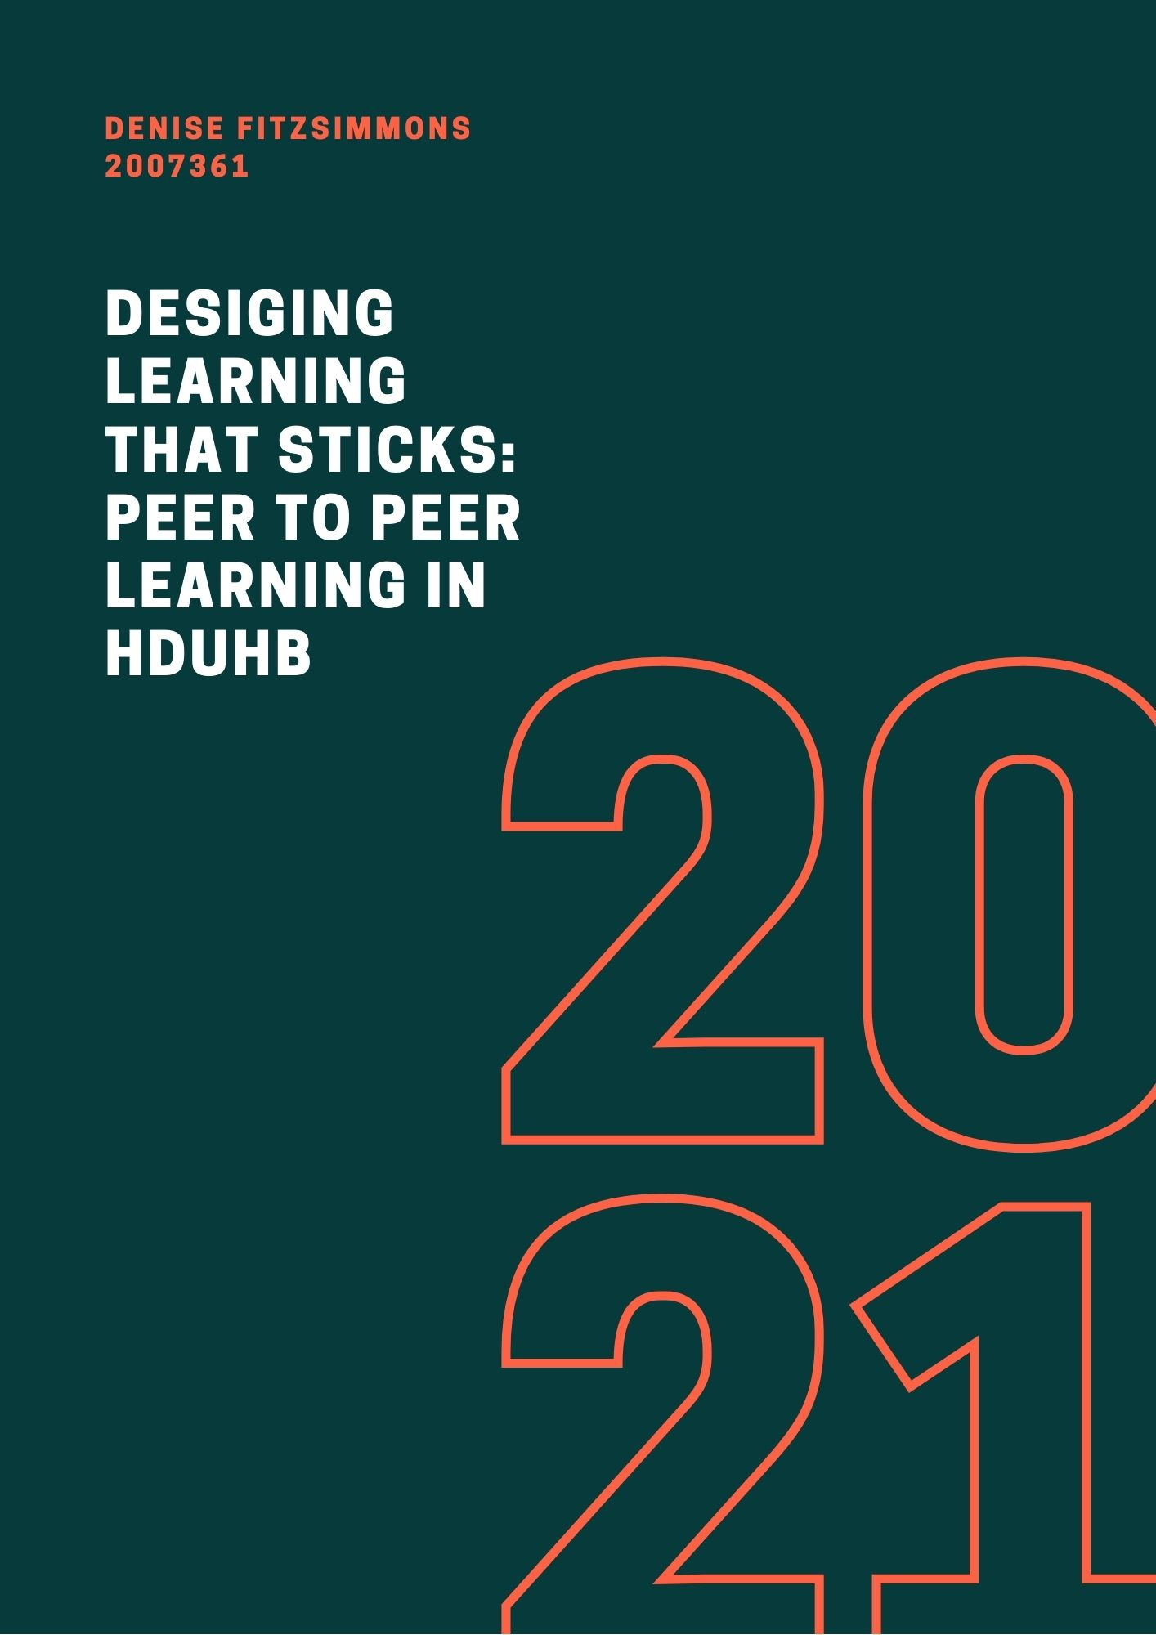


Executive Summary


The report below outlines the business case for introducing a learning interventio0n for leaders in HDUHB, in the form of peer-to-peer social learning via the online platform, Cognify.
The business case outlines the identification of the need to support leadership development to future-proof HDUHB. There are experienced senior leaders in the organisation who are moving towards retirement, who do not currently have an easily accessible way to succession plan and support newly recruited managers. The learning intervention will support succession planning help new leaders to reach full competency and deliver best practice in their roles more quickly.
The solution considers how the future workforce wants to learn, in terms of intuitive technology-friendly systems, which encompass the benefits of social learning. The proposal suggests pairing selected users or peers with those with similar or enhanced experience and allowing them to provide support and knowledge transfer for projects, roles, or service initiatives in the organisation.
The outline cost for this project is £31,200 per annum, based on all managers (2,600) having access to the platform. In terms of the roll-out, the scheme should be piloted, with an initial 100 managers, selected by the organisation. In terms of cost, this pilot would be in the region of £1,200, this could then be expanded to all managers in the service.
In terms of potential return on investment, it should support the retention of talent in the organisation as per the Healthier Wales Welsh Government Agenda and support managers to become better leaders and therefore have better healthcare performance outcomes. The project should attract savings in terms of retention and succession planning with a reduction in leavers and more employees able to reduce the harder-to-fill organisational roles.
The report also addresses some of the potential hurdles that may need to be overcome such as access to IT services, organisational buy-in to the project and ensuring the right skills and behaviours are being taught.
Overall, the learning intervention is designed to ensure that service needs are met alongside the need to ensure that learning is delivered in a modern, user-friendly method.

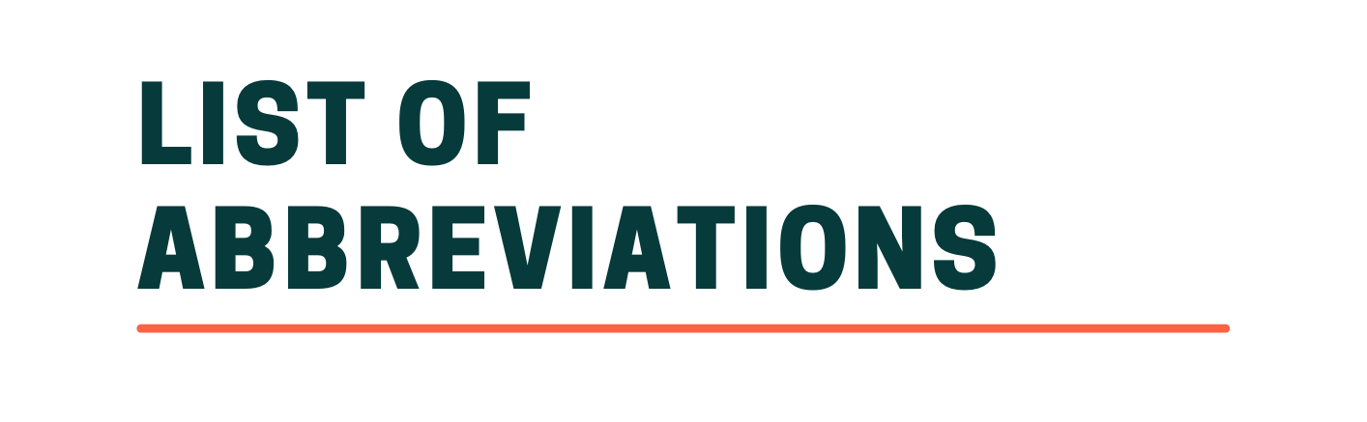

List of Abbreviations
HDUHB – Hywel Dda University Health board
LNA – Learning Needs Analysis
L&D – Learning and Development
VUCA – Volatile, uncertain, complex, ambiguous



Executive Summary 3
List of Abbreviations 5
Introduction 7
Literary Review 9
Macro Factors facing Organisational L&D 9
Figure 1. PESTLE Analysis HDUHB 9
Internal factors 10
Figure 2: SWOT Analysis 11
Learning Needs Analysis 12
Designing Learning Practices 13
Figure 3, AGES Model of Workplace Learning 15
Technology, AI and the Future of Learning 16
Evaluation and Ethics 17
Figure 4: Kirkpatrick’s Model of Evaluation 18
Conclusion 20
Recommendations 21
References 23
Bibliography 27
Appendix 31
Appendix 1 Cognify 31



Introduction
Hywel Dda University Health Board is a large public sector NHS healthcare provider. The organisation employs around 11,200 staff over 4 main acute sites, in three different counties in Wales. There are approximately 2,600 managers in the service. (Hywel Dda University Health Board, 2020)
L&D has changed substantially over the last 40 years and the main reason can be attributed to advances in IT and the introduction of the Internet (Cureton & Stewart, 2014). There have also been changes such as the globalisation of the economy which has caused focus to shift towards how talent is developed at a larger scale. As innovation in the digital world progresses, it moves away from traditional classroom learning methods (Llandis Barratt-Pugh, 2020).
According to Sambrook (2006), there are many different spaces for workplace learning to take place. The organisation already offers classroom-based and e-learning which provides an excellent grounding for training managers and leaders in the organisation and the proposal in this report seeks to enhance and diversify the current learning offering.
The CIPD defines leadership as the ability to influence others and achieve organisational goals. (CIPD, 2020). According to (Gooch, 2012) there are well-documented issues between poor nursing leadership and negative patient care and undesirable clinical outcomes and HR Review (2019), states that the OECD estimates ineffective management costs organisations in the region £84 million per annum, globally.
One of the key risks to the future of leadership in the orgnisation is the loss of knowledge in terms of staff retiring from the service. Without implementing peer-to-peer learning and effective knowledge transfer there is a chance that the skills experienced staff have will be lost through retirement. For example, Journal of Community Nursing (Ritchie, 2020) states that 25% of district nursing staff are planning early retirement in the next few years. One of the predominant reasons for this was the lack of learning opportunities. Of those surveyed, 76% stated that an absence of opportunities to further develop their expertise in their roles was part of the reason they wanted to leave.
To bridge this learning gap, the below report proposes the introduction of peer-to-peer learning for organisational leader, through a dedicated learning platform to support knowledge transfer and social learning in the organisation. The definition of peer learning is the transfer of learning through colleagues that have similar experiences or knowledge. The learning is usually self-directed and not taught through a lecturer or teacher (Toppin, 2005).

Literary Review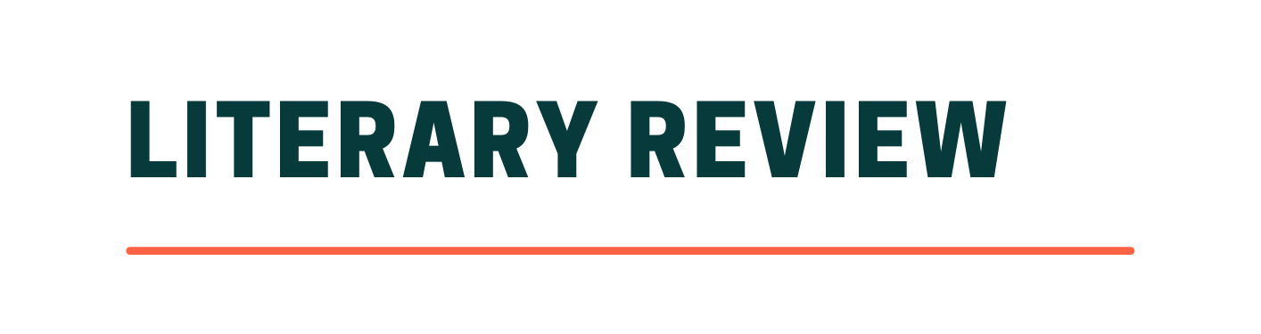

Macro Factors facing Organisational L&D
Over the last 12 months external factors have had a considerable impact on the L&D function. Below in Figure 1, these key factors are evaluated against HDUHB.

Figure 1. PESTLE Analysis HDUHB
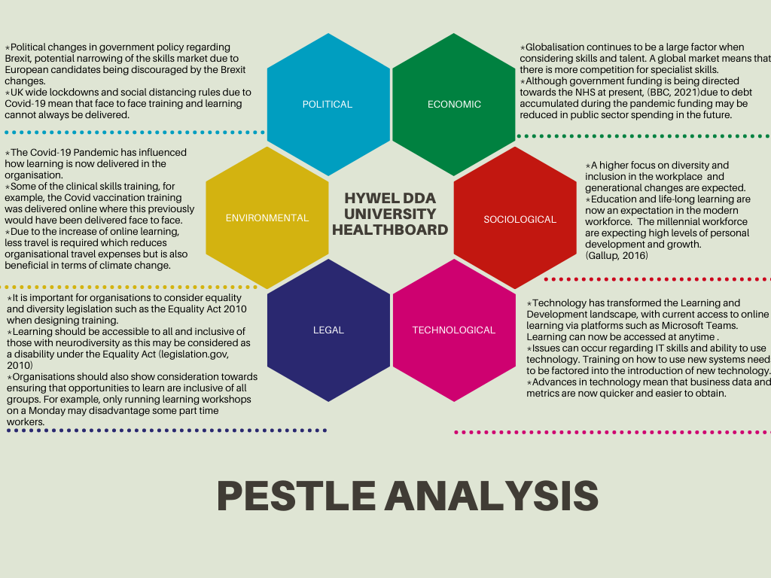
References: (Gallup , 2016), (BBC, 2021), (Equality Act , 2010)
Certain factors such as Brexit have had an impact on potential organisational skills shortages due to less economic migration from the EU into the UK. The CIPD (2020) found that 55% of organisations surveyed stated that they were not planning to change their investment in L&D after leaving the EU. If the findings are taken into account, this could be a potential future risk to employers in the future. In 2019, pre-Brexit, 43% of employers were reporting that it was difficult to fill vacant roles (CIPD, 2019). If this is set to increase post-Brexit, training skills within the organisation with a ‘grow your own’ approach would be a viable option to overcome this. According to the (CIPD , 2020) a reduction in skills due to Brexit and a narrowing talent pool, will impact how organisations plan for their future workforce and they must focus on what L&D is required to achieve future goals. According to 44% of HR and L&D professionals surveyed, having leadership skills to move business through change is going to be essential (Gaskell, 2016).
Other substantial factors that have influenced L&D include the coronavirus pandemic (World Health Organisation, 2021), which has caused major disruption to the way organisations deliver L&D. For example, HDUHB has moved a large majority of face to face learning online where it can be delivered remotely. Effective leadership is now more important than ever, due to the VUCA nature of the world we now live in (Benjamin E.Baran, Haley M.Woznyj, 2020).

Internal factors
The SWOT analysis below in Figure 2, shows some of the internal and external factors that can help illustrate how strengths and weaknesses can impact threats and progression in the organisation (HELMS and NIXON, 2010)

Figure 2: SWOT Analysis
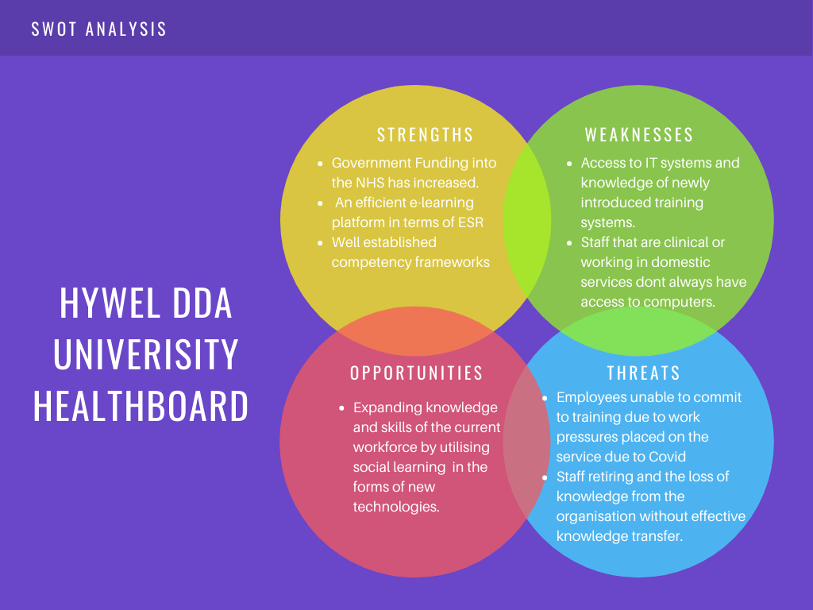

One of the internal factors that influence how learning is conducted in the organisation are mandatory training needs. These learning needs are decided at an All-Wales level by Welsh Government and Healthboards and are assigned predominantly through e-learning modules via an online training platform. These modules are driven by formal learning, which is structured around organisational needs rather than informally structured and learner controlled (Marsick & Watkins, 2001). These types of learning interventions are vital and important in meeting the requirements of legislation and best practice.
The competency frameworks used by HDUHB are matched against job descriptions and used in performance appraisals. Whilst this is beneficial in terms of establishing competency and standardised expectations of the roles in question, however, they can sometimes oversimplify the combination of skills and knowledge that are required to fulfil a role (Stewart, Cureton, 2014)
In David Clutterback's (2012) review of organisational Talent Planning, he suggests that competencies are classroom learned but the capability to do the role is picked up from experience in the job. The right combination of learned skills will only work if they are used in the right way. In these circumstances, learned classroom skills and competency frameworks provide a positive base for knowledge but can be elevated with on-the-job learning or social learning for leaders.

Learning Needs Analysis
In terms of establishing a learning need, Harrison’s (2009) four methods of LNA are Comprehensive analysis, key task analysis, problem-centred analysis and competency-based analysis. These methods include;
- The comprehensive analysis reviews the whole job role, for example, this is usually a job description or person specification. Job descriptions are highly regulated and fixed in HDUHB.
- Key task analysis would review the core outputs of the job role.
- Problem-centred would look at performance issues, such as sickness or complaints about service or care.
- Competency-based relies on competency frameworks, which relate to behaviours that are necessary to complete the role. These are favoured in HDUHB.
In terms of a learning need for peer-to-peer learning, the method would be bridging the gap between problem-centred issues, for example, decreasing the time taken for new managers to reach their full competencies in their role and ensuring they meet some of the behavioural requirements of the role. There is also the need to allow for effective knowledge transfer from experienced staff, who are close to retirement and new managers that are entering the service.
Part of the Healthier Wales (Welsh Government , 2021) initiative states that part of the healthcare workforce strategy is to deliver inclusivity and the ability to retain talent in our workforce. By establishing a robust social learning network that allows individuals to have autonomy over some of their learning and adapt quickly to changes and the reactive nature of learning in a pandemic.
From this perspective, the 70:30:10 (Samantha J. Johnson, 2018) approach would bolster the gap between formal learning and self-directed social learning. Although the formalised leadership training provides excellent foundational learning, there are limitations in the availability of some sessions, for example, class sizes need to remain small for the Manager’s Passport training due to the nature of the course and staff usually only take on the learning once they have started in the post. With peer-to-peer learning, newly recruited or promoted managers can use the platform to approach managers within the network to support learning and find coaching opportunities before starting in their roles.
In terms of promoting best practices, the CIPD (2021) advises that organisations should actively encourage a social learning culture, especially in online training. Ground rules need to be established for how groups will interact with each other but connectivity should be promoted.
In HR Disrupted Lucy Adams’ (2017) mentions that although many organisations favour competency frameworks and have a complex indicator of behavioural needs for leaders they don't take him to perspective what it feels like to be managed as it only focuses on the leader themselves. By gaining the insights of peers and others would potentially support with leadership perspective.

Designing Learning Practices
Nick Shakelton-Jones (2019) mentions that it's important to review ‘push and pull’ factors that can influence learning. Pull learning being related to learner-directed interest, for example looking for ‘how to videos’ on YouTube and Push learning relating to adhering meaning to a subject that a learner may not have an initial interest in.
If Adult Learning Theory, is considered, it focuses on the self-directed nature of learning. Knowles et al (2005) suggest that learners need to be aware of why they are learning and that the learning is focused on real-life problem-solving. In this theory learners should be self-motivated to learn, this theory is also known as Andragogy. From this perspective, utilising an online learning platform, which can be accessed by staff when needed would support the andragogy theory. This method of approach is self directed by the learner, so it will be important to promote the benefits of this learning method to ensure that the users access the platform.
The CIPD (2021) has mentioned that this form of learning could be viewed as ‘Netflix’ style learning where resources are recommended to the learner based on interests and needs. From this perspective, learning platforms such as Cognify (Appendix 1) would be beneficial. It allows users to upload their details and be effectively ‘matched’ with peers who are specialised in certain fields or share the same levels of expertise.
Social Learning Theory focuses on learning through communities and learning from others within the organisation (CIPD, 2020). For example, Google uses a ‘G2G’ (Googler to Googler) model of learning for 80% of its learning interventions (Re:Work, 2021) . This method uses a peer to peer network that allows others to learn from their colleagues (Jabian , 2014). In terms of creating a network of learners it is important to identify the right peers and ensuring that peers are adequately matched in the organisation.
With regards to experimental learning, People Management Magazine (2021) suggests that learning from failure is an important way for employees to learn and fosters creativity, this has been dubbed as ‘Intelligent Failure’. In terms of applying this to HDUHB, this may have its hurdles, there is the element of justifying the cost of projects that may fail, as the money lost in doing this would be taken from the public purse. To mitigate the potential risks learners must have the opportunity for regular reflection, review and discussion. In Samantha J. Johnson, Deborah A. Blackman and Fiona Buick’s (2018), appraisal of experimental learning, to work effectively it must have adequate support and regular reflection to work as a learning tool.
In terms of how Peer-to-peer learning can work, learners can share experienced learning, practice, and ask questions around a topic that they need support from experienced peers (O’Kelly, Mary, et al, 2015). An example of this could be a new manager asking an experienced member, how they would approach a difficult conversation with staff. According to Elisabeth Carlson and Marie Stenberg (2018), nursing students can increase learning by gaining a different perspective of their experience from their peers, this form of cognitive diversity is beneficial in broadening learned experience. The study also found that in peer learning environments learners felt more responsible in ensuring their knowledge was up to date (2015)
If the AGES model below is taken into account, it is important to recognise the importance of social activities in the make-up of learning and that whilst formal structured learning is vital, social and varied formats for learning make up part of this offering.

Figure 3, AGES Model of Workplace Learning
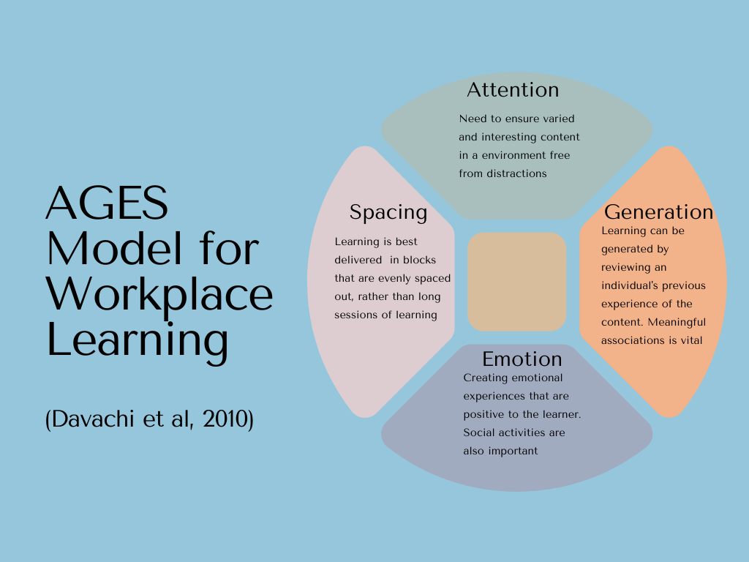
(CIPD, 2020)
One alternative approach that considers social learning is coaching and mentoring. Coaching is usually employee-directed and has a high emphasis on developing the individual. Goals can include those set by the employee but also those set via the organisation, however, coaches need to be trained to deliver this method of learning. Mentoring can also take place but this is usually a longer ongoing method of delivery. (CIPD, 2020). These methods are the commonly utilised ideas when social learning is addressed in organisations and although there is the availability of formalised coaching and mentoring learning within HDUHB, it can prove time-consuming in terms of training coaches.
Some of the potential downfalls of social learning theory would include negative behaviours or leadership styles that potentially would not be wanted (Peter Cureton, 2014). This is also reiterated in The British Journal of Educational Technology (Saeed Latifi, 2021), which states that biases can occur when learners share similar knowledge and experiences with peers. This lack of diversity can inhibit the learning ability of the group.
However, David Clutterback suggests that from his report, the greatest value leaders found form from learning and development opportunities, were the opportunities they had created themselves. Possible mitigation of this risk may be to ensure that the selection process for managers entering the peer learning programmes and that the process is reviewed regularly to ensure that any negative behaviours are acknowledged and addressed appropriately.

Technology, AI and the Future of Learning
The CIPD’s Learning and skills at work 2020 report found that digital learning delivery had increased in recent years, with 57% of organisations using methods like digital classrooms or online courses before the pandemic (CIPD, 2020). The CIPD also promotes the collaboration benefits of digital learning. They encourage organisations to review the benefits that digital learning provides to bring different working areas together. This can strengthen networks and collaboration especially in a remote working environment (CIPD, 2021)
In terms of peer learning platforms, Cognify uses the 70:20:10 learning approach (Cognify, 2021). The platform allows users to connect via a social network platform on an app. One of the benefits of the programme is that it is accessible from mobile technology at any time which allows for greater connectivity. The 70:20:10 theory derives from work done by McCall, Lombardo and & Morrison, A. M. (1998), where their findings showed that 70% of learning was on the job, 20% through relationships with others and 10% through formalised learning platforms such as classroom taught courses.
Benefits of using new technologies and online learning include the ability to tailor learning to individual needs and having the flexibility to access learning anywhere. Learning App platforms can be used to connect learners and offer global collaboration opportunities. The suggested platform Cognify, allows for staff to join and approach others for learning opportunities at a time that is convenient to them, to help them reach the needs of the competency frameworks of the organisation. The platform costs £12 per annum/ per user for level access.
Technology infrastructure is likely to be the biggest barrier at HDUHB, despite the introduction of Microsoft Teams and the support for home working, many clinical departments do not have enough access to computers which can inhibit interactive learning (CIPD, 2021). To counteract this training on using the platform and IT functions could become part of the learning implementation. Other forms of social learning apps could include Facebook, which is an already well-established free app that can be used to network. The main drawback of using this option would be the additional administration. Cognify uses an algorithm to match data users, whereas, on Facebook, users would have to seek out peers with matching skills or be manually matched with them via a coordinator in the service.

Evaluation and Ethics
The CIPD (CIPD, 2020) suggests that costing and benchmarking by reviewing the benefits to the business, return on investment, overall cost and how many employees engage in the learning. However, Nick Shackleton ( 2019), suggests that as the majority of employee learning doesn't take part in formal sessions and it can be difficult to evidence these activities.
Below is Kirkpatrick’s Model of Evaluation which can be used to evaluate learning interventions.

Figure 4: Kirkpatrick’s Model of Evaluation
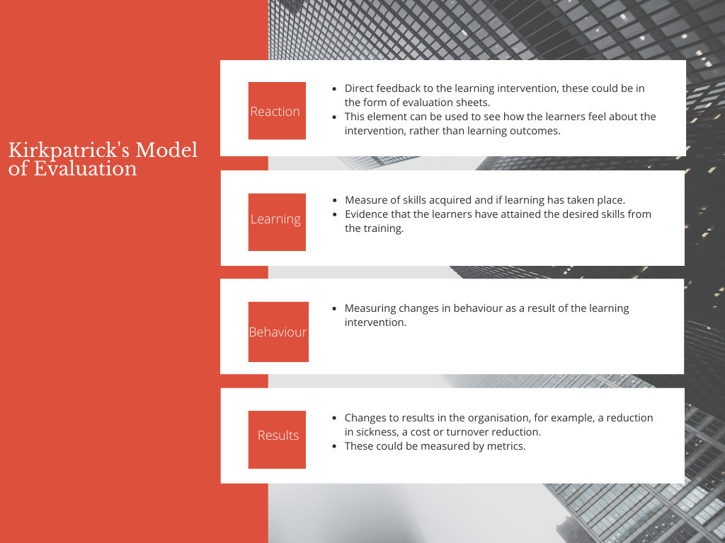
If the above model is taken into consideration, it will be important to ensure users of the Cognify platform are asked to provide evaluation feedback on the service. There will also need to be a review at annual appraisals with staff to ensure that firstly, they have obtained learning from the intervention and that there have been behaviour changes. For example, a new manager may use the peer-to-peer network to discuss support with managing performance in the team, with the improved performance management there may be better patient outcomes in the team and less staff sickness.
One of the many benefits of using Cognify to implement peer learning is that the app can track user usage and how many staff have accessed the platform, this would be beneficial to form part of the evaluation of the system.
It is also important to consider ethics in learning delivery. The Equality Act (2010) states there are nine protected characteristics. Employers must be mindful of these characteristics when approaching learning design. For example, the platform must be inclusive of those with sight impairments or neurodiverse conditions such as dyslexia.
With regards to ethical considerations, it is important to acknowledge that bias may occur when selecting individuals for training programmes. David Clutterback (2012) suggests there is a disparity between women and men in top leadership roles in organisations. He mentions that women who take time out to start a family can potentially be side-lined in favour of their male counterparts when recommending employees for talent pools and development. From this perspective, it will be important to review the selection process used to select candidates for the learning platform and ensure that it is free from potential bias.
Acknowledging diversity in learning is also important, according to Science for Work ( 2018) not all individuals will want to encompass informal learning and some leaders will prefer formalised learning in the workplace. In these cases, support from Senior Leadership will be an important factor in supporting social learning.

Conclusion


The information outlined in the document provides evidence for the importance of social learning in modern working environments. The analysis of theories relating to social, adult and experimental learning all indicate that there are substantial benefits of utilising peer-to-peer learning, especially in the field of healthcare. The inclusion of a learning platform such as Cognify, will add to the already excellent offering of formalised learning in HDUHB, in terms of support for peer-to-peer knowledge transfer.
By embracing new technologies and platforms to further the already competent formalised learning and development, savings in terms of time taken for managers to achieve full competencies in their role and the support for better leadership and positive health outcomes will undoubtedly improve HB performance outcome and help the service meet the needs of the Healthier Wales government targets.
Although there are limitations in terms of IT access and skills for staff, this is something that can be addressed by support, training and the increased access to IT equipment and systems.
As the CIPD mentions, the world of learning is moving towards a Netflix style reality where employees are expecting to access learning tailored to their interests rather than learning dictate in a fixed way as it was previously, to ensure that HDUHB moves with this modernisation, the organisation should consider implementing some of the recommended changes.

Recommendations

- Identify who the key users of the Peer-to-Peer Learning Network will be.
It is important to establish who the key users of the peer-to-peer learning network will need. There needs to be an adequate mix of leaders with skills and disciplines utilising the network to make it effective. The Cognify (2021) platform uses an algorithm to match users, but users will need to be encouraged to use the platform and therefore see the benefits of doing so. The costs outlined below state the total cost for all managers in the service to use, however, not all managers will use the system initially.
- Encourage engagement in social learning activities.
As previously mentioned in the report, the main factors of andragogy are self-directed learning that needs to be relevant to the learner. For this form of learning to be effective users will have to trust its benefits. There may be resistance in terms of user time restraints and therefore adequate promotion in terms of workshops and senior leadership buy-in will be vital.
- Implement a Peer-to-Peer Learning Platform
The recommended peer-to-peer learning platform is Cognify. In terms of cost, the basic platform cost of the programme would be £12 per user/ per annum. As referenced earlier in the assignment there are approximately 2,600 managers in the service. This would give a total cost of £31,200. It is advised to pilot the programme initially will 100 managers, which would cost £1,200 per annum. This will allow for promotion and feedback of the platform before full rollout. In terms of return on investment, the time taken to reach management competencies should decrease, it should lead to better leadership practice and improved patient care, better management networks and improved succession planning.
- Provide training for staff in terms of the benefits of peer-to-peer learning (promote the opportunities)
It would be recommended to achieve employee buy-in, an employee’s knowledge might be lost when leave. And how important peer-to-peer learning is and that it can create benefits for experienced staff as well as employees in their early career.
- Allow learners the opportunity for reflection on learning.
As discussed in the report, peer-to-peer learning networks are only effective when learners can reflect on their practice and what has been learned. From this perspective, it is advisable to schedule reflection sessions to allow users to evaluate the success of their learning.

References
- Adams, L., (2017). HR Disrupted. 1 ed. Milton Keynes: Practical Inspiration Publishing .
- BBC, (2021). Budget 2021: How much will it cost the UK and how will we pay?. [Online]
Available at: https://www.bbc.co.uk/news/business-52663523
[Accessed 14 March 2021].
- Benjamin E.B. , M.Woznyj H. , (2020). Managing VUCA: The human dynamics of agility. Organizational Dynamics, 49(3).
- CIPD , (2020a). Brexit impact on workforce trends. [Online]
Available at: https://www.cipd.co.uk/knowledge/brexit-hub/workforce-trends#52112
[Accessed 1 March 2021].
- CIPD, (2015). Learning and development survey. [Online]
Available at: https://www.cipd.co.uk/knowledge/strategy/development/surveys
[Accessed 11 April 2021].
- CIPD, (2019). Labour Market Outlook Autumn 2019. [Online]
Available at: https://www.cipd.co.uk/Images/labour-market-outlook-autumn-2019_tcm18-67336.pdf
[Accessed 17 March 2021].
- CIPD, (2020b). Coaching and mentoring. [Online]
Available at: https://www.cipd.co.uk/knowledge/fundamentals/people/development/coaching-mentoring-factsheet#:~:text=Coaching%20and%20mentoring%20are%20development%20approaches%20based%20on,practice%20the%20two%20terms%20are%20often%20used%20interchangeably.
[Accessed 1 April 2021].
- CIPD, (2020c). Costing and benchmarking learning and development. [Online]
Available at: https://www.cipd.co.uk/knowledge/strategy/development/benchmarking-factsheet
[Accessed 12 May 2021].
- CIPD, (2020d). Leadership in the workplace. [Online]
Available at: https://www.cipd.co.uk/knowledge/strategy/leadership/factsheet
[Accessed 2 March 2021].
- CIPD, (2020e). Learning Skills at Work 2020. [Online]
Available at: https://www.cipd.co.uk/Images/learning-skills-work-report-1_tcm18-79434.pdf
[Accessed 18 April 2021].
- CIPD, (2020f). Learning theories for the workplace. [Online]
Available at: https://www.cipd.co.uk/knowledge/strategy/development/learning-theories-factsheet
[Accessed 17 April 2021].
- CIPD, (2021a). Digital Learning Factsheet. [Online]
Available at: https://www.cipd.co.uk/knowledge/fundamentals/people/development/digital-learning-factsheet
[Accessed 12 May 2021].
- CIPD, (2021b). DIGITAL LEARNING IN A POST-COVID-19 ECONOMY. [Online]
Available at: https://www.cipd.co.uk/Images/digital-learning-literature-review-report-2_tcm18-89290.pdf
[Accessed 18 April 2021].
- CIPD, (2021c). Impact of Covid-19 on the Learning Profession. [Online]
Available at: https://www.cipd.co.uk/Images/impact-COVID-19-ld-profession_tcm18-92209.pdf
[Accessed 16 April 2021].
- Clutterbuck, D., (2012). The Talent Wave: Why Succession Planning Fails and What to Do about it. London: Kogan Page, pp. 75,76.
- Cognify, (2021). Social Learning that Works. [Online]
Available at: https://www.cognify.co.uk/peer-to-peer-learning-platform/
[Accessed 3 April 2021].
- Equality Act 2010, [Online]
Available at: https://www.legislation.gov.uk/ukpga/2010/15/contents
[Accessed 1 March 2021].
- Gallup , (2016). How Millennials Want to Work and Live. [Online]
Available at: file:///C:/Users/denis/Downloads/Gallup_Millennials_Full_Report.pdf
[Accessed 1 March 2021].
- Gaskell, C., (2016). CHANGE HERE FOR BREXIT. Training Journal, pp. 23-25.
- Gooch, S., (2012). A Strong Lead. Nursing Standard , 26(43).
- Gray, R., (2021). Learning from Failure. People Management Magazine, 1(April/May), pp. 42-46.
- Harrison, R., (2009). Learning and Development. 5th ed. London: McGraw-Hill Education.
- Helms, M.M. and Nixon, J., (2010). Exploring SWOT analysis - where are we now?: A review of academic research from the last decade. Journal of Strategy and Management, 3(3), pp. 215-251.
- Hywel Dda University Healthboard ,( 2019/2020). Hywel Dda University Health Board Annual Report and Accounts 2019/2020, Carmarthen: Hywel Dda University Health Board.
- Jabian , (2014). A Model for Mastery: Learning and Development in the Digital Age. [Online]
Available at: https://journal.jabian.com/wp-content/uploads/2018/10/Fall14_JJ_A_Model_for_Mastery-Learning_and_Development.pdf
[Accessed 17 April 2021].
- Llandis B.P., Hodge S. and Smith E.,( 2020). Learning and development practitioners: identity, profession and future trajectory. Asia Pacific Journal of Human Resources, Volume 50, p. 220–246.
- Knowles M.S , Holton III E.F, Swanson R.A., (2005). The Adult Learner: The Definitive Classic in Adult Education and Human Resource Development. 6th ed. s.l.:A Butterworth-Heinemann Title.
- Stenberg M and Carlson E, (2015). Swedish student nurses' perception of peer learning as an educational model during clinical practice in a hospital setting-an evaluation study. BMC Nursing, 14(1), p. 48.
- McCall, M. W., Jr., Lombardo, M. M., & Morrison, A. M. , (1998). The lessons of experience: How successful executives develop on the job. Lexington, MA: Lexington Books.
- O’Kelly M., et al, (2015). Building a Peer-Learning Service for Students in an Academic Library.. Johns Hopkins University Press, 15(1), pp. 163-182.
- World Health Organisation (2021). Timeline: WHO's COVID-19 response. [Online]
Available at: https://www.who.int/emergencies/diseases/novel-coronavirus-2019/interactive-timeline#!
[Accessed 14 March 2021].
- Papadatou, A., (2019). POOR MANAGEMENT COSTS UK BUSINESS £84 BILLION A YEAR. [Online]
Available at: https://www.hrreview.co.uk/hr-news/strategy-news/poor-management-costs-uk-business-84-billion-a-year/116817#:~:text=The%20UK%20currently%20has%20an,the%20next%20generation%20of%20leaders.
[Accessed 5 April 2021].
- Cureton P. , Stewart J., (2014). Designing, Delivering and Evaluating Learning and Development . In: Designing, Delivering and Evaluating L&D: Essentials for Practice. London: CIPD, pp. 1 -3 .
- Re:Work, (2021). Guide: Create an employee-to-employee learning program. [Online]
Available at: https://rework.withgoogle.com/guides/learning-development-employee-to-employee/steps/introduction/
[Accessed 12 May 2021].
- Ritchie, G.,( 2020). Why is there still a crisis in district nursing and what can we do about it?. Journal of Community Nursing, 4(1), pp. 8-13.
- Latifi S., Noroozi O., and Talae E., (2021) Peer feedback or peer feedforward? Enhancing students’ argumentative peer learning processes and outcomes. British Journal of Educational Technology, Vol 52(2), p. 768–784.
- Johnson S.J., Blackman D.A. , Buick F., (2018) The 70:20:10 framework and the transfer. Human Resource Development Quarterly, 29(4), p. 383–402.
- Sambrook, S., (2006). Developing a Model of Factors Influencing Work-Related Learning: Findings from two Research Projects, s.l.: s.n.
- Science for Work , (2018). Informal Learning: Your Essential Guide. [Online]
Available at: https://scienceforwork.com/blog/informal-learning/?utm_source=mc&utm_medium=email&utm_content=Issue+81.10/19/2018.634072.https%3A%2F%2Fscienceforwork.com%2Fblog%2Finformal-learning%2F&utm_campaign=&utm_term=2278033
[Accessed 13 May 2021].
- Shakleton-Jones, N., (2019). How People Learn. London: Kogan Page,
- Stenberg M., and Carlson. E, (2018). Peer learning-making use of sociocultural theory. Nurse Education in Practice, Volume 46.
- Toppin, K. J., (2005). Trends in Peer Learning. Educational Psychology, 25(6), p. 631–645.
- Marsick V. J, and Watkins K. E., (2001). Informal and Incedental Learning. New directions for Adult and Continuing Education, 2001(89), pp. 25-34.
- Welsh Government , (2021). A healthier Wales: long term plan for health and social care. [Online]
Available at: https://gov.wales/healthier-wales-long-term-plan-health-and-social-care
[Accessed 12 May 2021].

Bibliography
Adams, L., 2017. HR Disrupted. 1 ed. Milton Keynes: Practical Inspiration Publishing .
BBC, 2021. Budget 2021: How much will it cost the UK and how will we pay?. [Online]
Available at: https://www.bbc.co.uk/news/business-52663523
[Accessed 14 March 2021].
Benjamin E.Baran, Haley M.Woznyj, 2020. Managing VUCA: The human dynamics of agility. Organizational Dynamics, 49(3).
CIPD , 2020. Brexit impact on workforce trends. [Online]
Available at: https://www.cipd.co.uk/knowledge/brexit-hub/workforce-trends#52112
[Accessed 1 March 2021].
CIPD, 2015. Learning and development survey. [Online]
Available at: https://www.cipd.co.uk/knowledge/strategy/development/surveys
[Accessed 11 April 2021].
CIPD, 2019. Labour Market Outlook Autumn 2019. [Online]
Available at: https://www.cipd.co.uk/Images/labour-market-outlook-autumn-2019_tcm18-67336.pdf
[Accessed 17 March 2021].
CIPD, 2020. Brexit impact on workforce trends. [Online]
Available at: https://www.cipd.co.uk/knowledge/brexit-hub/workforce-trends#52112
[Accessed 17 March 2021].
CIPD, 2020. Coaching and mentoring. [Online]
Available at: https://www.cipd.co.uk/knowledge/fundamentals/people/development/coaching-mentoring-factsheet#:~:text=Coaching%20and%20mentoring%20are%20development%20approaches%20based%20on,practice%20the%20two%20terms%20are%20often%20used%20interchangeably.
[Accessed 1 April 2021].
CIPD, 2020. Costing and benchmarking learning and development. [Online]
Available at: https://www.cipd.co.uk/knowledge/strategy/development/benchmarking-factsheet
[Accessed 12 May 2021].
CIPD, 2020. Leadership in the workplace. [Online]
Available at: https://www.cipd.co.uk/knowledge/strategy/leadership/factsheet
[Accessed 2 March 2021].
CIPD, 2020. Learning Skills at Work 2020. [Online]
Available at: https://www.cipd.co.uk/Images/learning-skills-work-report-1_tcm18-79434.pdf
[Accessed 18 April 2021].
CIPD, 2020. Learning theories for the workplace. [Online]
Available at: https://www.cipd.co.uk/knowledge/strategy/development/learning-theories-factsheet
[Accessed 17 April 2021].
CIPD, 2020. Learning theories for the workplace. [Online]
Available at: https://www.cipd.co.uk/knowledge/strategy/development/learning-theories-factsheet
[Accessed 12 May 2021].
CIPD, 2021. Digital Learning Factsheet. [Online]
Available at: https://www.cipd.co.uk/knowledge/fundamentals/people/development/digital-learning-factsheet
[Accessed 12 May 2021].
CIPD, 2021. DIGITAL LEARNING IN A POST-COVID-19 ECONOMY. [Online]
Available at: https://www.cipd.co.uk/Images/digital-learning-literature-review-report-2_tcm18-89290.pdf
[Accessed 18 April 2021].
CIPD, 2021. IMPACT OF COVID-19 ON THE L&D PROFESSION. [Online]
Available at: https://www.cipd.co.uk/Images/impact-COVID-19-ld-profession_tcm18-92209.pdf
[Accessed 18 April 2021].
CIPD, 2021. Impact of Covid-19 on the Learning Profession. [Online]
Available at: https://www.cipd.co.uk/Images/impact-COVID-19-ld-profession_tcm18-92209.pdf
[Accessed 16 April 2021].
Clutterbuck, D., 2012. The Critical Challenges: What is Talent?. In: The Talent Wave: Why Succession Planning Fails and What to Do about it. London: Kogan Page, pp. 75,76.
Cognify, 2021. Social Learning that Works. [Online]
Available at: https://www.cognify.co.uk/peer-to-peer-learning-platform/
[Accessed 3 April 2021].
Equality Act 2010, 2010. [Online]
Available at: https://www.legislation.gov.uk/ukpga/2010/15/contents
[Accessed 1 March 2021].
Gallup , 2016. How Millennials Want to Work and Live. [Online]
Available at: file:///C:/Users/denis/Downloads/Gallup_Millennials_Full_Report.pdf
[Accessed 1 March 2021].
Gaskell, C., 2016. CHANGE HERE FOR BREXIT. Training Journal, pp. 23-25.
Gooch, S., 2012. A strong lead. Nursing Standard , 26(43).
Gray, R., 2021. Learning from Failure. People Management Magazine, 1(April/May), pp. 42-46.
Harrison, R., 2009. Learning and Development. 5th ed. London: McGraw-Hill Education.
HELMS, M.M. and NIXON, J., , 2010. Exploring SWOT analysis - where are we now?: A review of academic research from the last decade. Journal of Strategy and Management, 3(3), pp. 215-251.
Hywel Dda University Healthboard , 2019/2020. Hywel Dda University Health Board Annual Report and Accounts 2019/2020, Carmarthen: Hywel Dda University Health Board.
Jabian , 2014. A Model for Mastery: Learning and Development in the Digital Age. [Online]
Available at: https://journal.jabian.com/wp-content/uploads/2018/10/Fall14_JJ_A_Model_for_Mastery-Learning_and_Development.pdf
[Accessed 17 April 2021].
Llandis B.P., Hodge S. and Smith E.,, 2020. Learning and development practitioners: identity, profession and future trajectory. Asia Pacific Journal of Human Resources, Volume 50, p. 220–246.
Malcolm S. Knowles, E. F. H. I. R. A. S., 2005. The Adult Learner: The Definitive Classic in Adult Education and Human Resource Development. 6th ed. s.l.:A Butterworth-Heinemann Title.
Marie Stenberg & Elisabeth Carlson, 2015. Swedish student nurses' perception of peer learning as an educational model during clinical practice in a hospital setting-an evaluation study. BMC Nursing, 14(1), p. 48.
McCall, M. W., Jr., Lombardo, M. M., & Morrison, A. M. , 1998. The lessons of experience: How successful executives develop on the job. Lexington, MA: Lexington Books.
O’Kelly, Mary, et al, 2015. Building a Peer-Learning Service for Students in an Academic Library.. Johns Hopkins University Press, 15(1), pp. 163-182.
Organisation, W. H., 2021. Timeline: WHO's COVID-19 response. [Online]
Available at: https://www.who.int/emergencies/diseases/novel-coronavirus-2019/interactive-timeline#!
[Accessed 14 March 2021].
Papadatou, A., 2019. POOR MANAGEMENT COSTS UK BUSINESS £84 BILLION A YEAR. [Online]
Available at: https://www.hrreview.co.uk/hr-news/strategy-news/poor-management-costs-uk-business-84-billion-a-year/116817#:~:text=The%20UK%20currently%20has%20an,the%20next%20generation%20of%20leaders.
[Accessed 5 April 2021].
Peter Cureton, J. S., 2014. Designing, Delivering and Evaluating Learning and Development . In: Designing, Delivering and Evaluating L&D: Essentials for Practice. London: CIPD, pp. 1 -3 .
Re:Work, 2021. Guide: Create an employee-to-employee learning program. [Online]
Available at: https://rework.withgoogle.com/guides/learning-development-employee-to-employee/steps/introduction/
[Accessed 12 May 2021].
Ritchie, G., 2020. Why is there still a crisis in district nursing and what can we do about it?. Journal of Community Nursing, 4(1), pp. 8-13.
Saeed Latifi, O. N. a. E. T., 2021. Peer feedback or peer feedforward? Enhancing students’ argumentative peer learning processes and outcomes. British Journal of Educational Technology, Vol 52(2), p. 768–784.
Samantha J. Johnson, D. A. B. F. B., 2018. The 70:20:10 framework and the transfer. Human Resource Development Quarterly, 29(4), p. 383–402.
Samantha J. Johnson, D. B. a. F. B., 2018. The 70:20:10 framework and the transfer. Human resource development quarterly, p. 383–402.
Sambrook, S., 2006. Developing a Model of Factors Influencing Work-Related Learning: Findings from two Research Projects, s.l.: s.n.
Science for Work , 2018. Informal Learning: Your Essential Guide. [Online]
Available at: https://scienceforwork.com/blog/informal-learning/?utm_source=mc&utm_medium=email&utm_content=Issue+81.10/19/2018.634072.https%3A%2F%2Fscienceforwork.com%2Fblog%2Finformal-learning%2F&utm_campaign=&utm_term=2278033
[Accessed 13 May 2021].
Shakleton-Jones, N., 2019. Learning Design - Push or Pull . In: How People Learn. London: Kogan Page, pp. 70-108.
Stenberg, E. C. a. M., 2018. Peer learning-making use of sociocultural theory. Nurse Education in Practice, Volume 46.
Toppin, K. J., 2005. Trends in Peer Learning. Educational Psychology, 25(6), p. 631–645.
Victoria J. Marsick, K. E. W., 2001. Informal and Incedental Learning. New directions for Adult and Continuing Education, 2001(89), pp. 25-34.
Welsh Government , 2021. A healthier Wales: long term plan for health and social care. [Online]
Available at: https://gov.wales/healthier-wales-long-term-plan-health-and-social-care
[Accessed 12 May 2021].

Appendix

Appendix 1 Cognify




