Assignment Title: Component 2 - Individual written report

Student Name – Vasile Slevoaca
Student ID - 2332190

Table of Contents
Introduction 3
Task 1: Emotional Intelligence in the Workplace 4
Task 2: Managing a Multigenerational Workforce 10
Conclusion 13
Reference List 14

Introduction
Emotional Intelligence postulates the ability of an individual in controlling emotional aspects while making practical and situational decisions. Strong emotional intelligence (EI) among employees in a multigenerational workplace bridges the gap between different groups in fostering a cohesive operational unit to perform better in the industrial context (Igbokwe et al., 2023, p. 44). The following report will try to demonstrate different aspects associated with emotional intelligence in highlighting how it basically affects the overall decision making in a multigenerational workforce. However, a multigenerational workforce actually refers to the workplace where employees from different age groups and generations work together under a certain specific hierarchy. Moreover, the way emotional intelligence actually makes difference in between values, communication styles, motivation, and technological adaptability of different generational groups will also be focused over here in this report. Most importantly, a detailed theoretical underpinning section is going to be illustrated in the report to highlight how strong EI can influence organisational decisions in managing multigenerational workforce.

Task 1: Emotional Intelligence in the Workplace
The way employees can apply the core components of emotional intelligence in the
Workplace to improve performance, collaboration, and well-being
Strong emotional intelligence (EI) or emotional quotient (EQ) among employees is actually important in analysing how controlled emotions can lead to better decision making through the analytical approaches. Employees for an organisation primarily apply EQ by recognising how feelings impact behaviour and decision making to ensure exponential progress (Stein, 2023). The core components of emotional intelligence are self-awareness, self-regulation, empathy, motivation and social skills. The practice of developing active listening traits to analyse others' viewpoints, sharing clear feedback with others, focusing on the long term goals and taking a pause before reacting are some of the key strategies through which employees often use core components of emotional intelligence in the workplace in improving performance, collaboration and wellbeing. A brand starts performing well in the industry when better emotional aspects are there among employees to ensure better performance and collaboration for effective decision making (Chung et al., 2023, p. 4). The following section will try to demonstrate the way employees can focus on applying the core compliments of emotional intelligence.
Self-Awareness: Self-awareness is all about knowing own emotions, strengths and weaknesses before making long term decisions. Effective self-awareness basically enhances the decision making of employees in formulating strategic actions to ensure better communication and collaboration in a team based setup.
The way employees apply: Doing fact checking multiple times, pausing before making any decisions and stepping back before making poor choices are some of the ways through which employees apply self-awareness in the workplace to improve performance, collaboration and well-being.
Self-Regulation: Self-regulation is primarily the ability of a person in controlling emotions rather than letting emotions dictate the overall decision making for that individual (Chernis and Adler, 2023). Strong approaches related to self-regulation can have better decision making for an individual in working within a cohesive team based setup.
The way employees apply: Staying calm under pressure, solving problems without causing drama and analysing surrounding situations beforehand while making decisions are some of the ways through which employees often apply the core attributes of emotional intelligence in improving overall collaboration in getting better productivity.
Empathy: Empathy is nothing but the ability to analyse how others feel and see different things from various perspectives. Empathy builds employee trust in a workplace to solve any complex situation through long term decision making.
The way employees apply: Listening to the co-workers carefully, creating trust between each other and lowering down anxiety through stress management strategies, employees of a workplace actually apply empathy as a part of their emotional quotient.
Social Skills: Social skills are mainly the attributes that employees often use in the workplace to hold strong relationships with others (Chernis and Adler, 2023). Social skills actually solve conflicts between employees by fostering collaboration between each other to make faster decision making.
The way employees apply: Sharing clear feedback with others, working well in a group and celebrating wins together are some of the ways through which employees apply social skills to control emotions while making any kind of decisions.
Motivation: Motivation is the sense of drive and hunger that makes employees achieve their personal and professional goals. Effective motivational aspects eventually drive employees to achieve exponential heights in the professional context by focusing on long term growth.
The way employees apply: Focusing on the big goal, self-assessment and continuous learning are some of the ways through which employees for an organisation often apply motivational drive to make better decisions through controlling emotions.
The overall performance, collaboration, and well-being of employees within the workplace context gets better at times when strong emotional intelligence is there among employees to ensure long term strategic growth. As far as overall growth and professional development is concerned, a brand tries to build a cohesive unit in its workplace to manage complex situations in a careful manner. Thus, employees often focus on long term goals, empathetic approaches and listen to co-workers carefully to manage and control emotional intelligence in a better way altogether while making any decisions.
Performance development: Strong emotional intelligence assists a brand in streamlining its workforce operations in order to handle complex situations in a careful manner. The practice of handling conflicts through using controlled emotions and effective decisions eventually enhances the performance of workers within a team based setup (Chernis and Adler, 2023). EI allows better connection between employees which often creates a respectful and positive work environment. People with high emotional intelligence are better at managing stress and interpersonal communication. It eventually leads to better workplace performance and productive capacity to ensure efficiency along the way.
Effective collaboration: Prominent governance of EI application from the employees leads to better collaboration and communication between employees. Listening actively, ensuring trust and solving conflicts are some of the ways through which employees of an organisation often use core principles of EI to ensure better collaboration with others.

Employee wellbeing: The overall employee well-being is yet another massive element that eventually dictates how a brand is going to function in ensuring better retention rate and customer acquisition from the industry. Accurate governance of EI can enhance employee performance, foster an inclusive leadership across generations and support a psychologically safe work environment for everyone. All of these elements eventually lead to less stress management for employees within a workplace context to ensure effective employee-wellbeing at times.
Theoretical Underpinnings
Goleman’s Emotional Intelligence framework
Goleman’s Emotional Intelligence framework is a behavioural model that talks about the importance of emotional quotient (EQ) for a person in dictating personal competence. As per their framework, EQ matters just as much as IQ (intelligence quotient). This particular framework is mainly divided into two prior competencies such as personal competence and social competence (Surti, 2026, p. 135). Self-awareness and self-management are two of the major abilities through which a person can develop personal competencies at times. Similarly, effective social awareness, relationship management and organisational awareness are some of the core elements through which professional competencies can be developed for a person as well. Based on the application of this framework, emotional quotient can actually uplift the overall personal and professional competence associated with an individual. An individual can focus on developing different sets of competencies to ensure better results in the terms of managing both personal and professional life simultaneously. However, based on the principles of the concept, employees can rely on strong emotional intelligence through developing empathy, social skills and self-awareness.
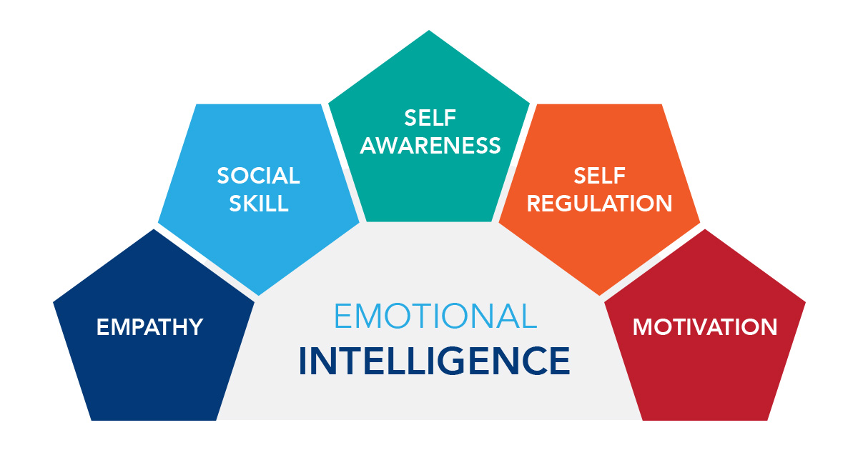
Figure 1: Fundamentals of Goleman’s Emotional Intelligence framework
(Source: Uluç, 2023)
Mayer and Salovey’s Ability Model
Mayer and Salovey’s Ability Model emphasises emotional intelligence (EI) as a standard and measurable intelligence rather than just a personal trait. This particular concept emphasises on cognitive processing of emotional information which majorly consists of four different branches such as perceiving emotions, using emotions to facilitate thought, understanding emotions and managing emotions (Supramanian et al., 2021, p. 154). As per the fundamentals of the model, the ability to harness emotions and comprehend complex emotional language can primarily dictate the ability of a person in controlling strong emotions accordingly. Thus, cognitive processing of emotional information can affect the overall decision-making and understanding associated with an individual. Based on the principles of this model, the ability to interpret emotion through active listening and practical thinking can majorly assist employees to perform better within a workplace context. Employees will be able to collaborate well with each other if strong emotional intelligence is there to deal with different situations and external scenarios.
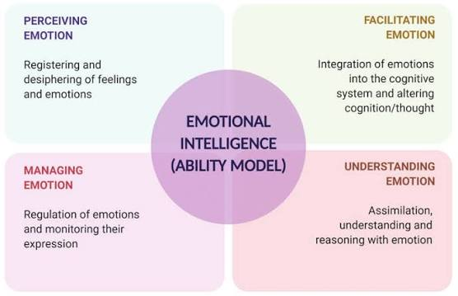
Figure 2: Core fundamentals associated with Mayer and Salovey’s Ability Model
(Source: Supramanian et al., 2021)

Bar-On’s Emotional-Social Intelligence Model
Bar-On’s Emotional-Social Intelligence Model is a strategic framework that views EI as the combination of different social and emotional skills which majorly assists an individual in analysing the perspective of others in dealing with daily stress. This particular model has categorised social and emotional skills into 5 core areas such as intrapersonal skills, interpersonal skills, adaptability, stress management and general mood. Winter and McCann (2022, p. 74) argues that the process of knowing and caring about others, handling hard situations, remaining flexible with different decision making along with staying positive despite any situations are some of the core elements through which strong social and emotional skills can be developed for an individual. Based on the principles of this model, knowing own limits, strengths, evaluating the situation of others, staying calm when situation gets worsen and keeping the feelings check can be some of the major ways through which employees for an organisation can apply the core components of emotional intelligence in the workplace to improve performance, collaboration, and well-being.
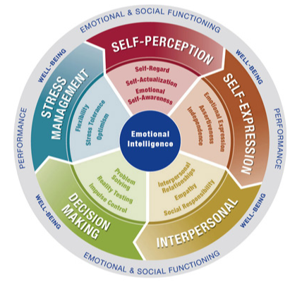
Figure 3: Key elements associated with Bar-On’s Emotional-Social Intelligence Model
(Source: Kruse, 2025)

The way emotional intelligence contributes to effective communication, conflict management, leadership, and decision-making within modern organisations
Strong EI or emotional intelligence can work massively for an individual in handling conflicting situations in the workplace context through fostering trust, cohesion and collaboration. Efficient emotional intelligence fosters clarity, collaboration, solves problems and ensures trust between the employees for an organisation to address different organisational concerns (Brou Fossier, 2022). Prominent EI from employees can result in effective communication, leadership traits, conflict management strategies and efficient decision making within modern organisations to handle complex situations in a careful manner altogether.
Effective communication: EI or emotional intelligence is responsible for building trust within a workforce where people share different ideas freely (Chin, 2021).
Conflict Management: Emotional intelligence basically assists an individual in solving problems peacefully by helping that individual control emotions (Vicci, 2024). Strong EI among individuals can result in better conflict resolution within a workplace context.
Leadership: Emotional intelligence also assists different managers and senior employees to inspire their teams effectively through effective collaboration all the time. Employees often feel safe and respected when strong emotional intelligence is there.
Decision Making: Prominent EI stops managers from reacting too fast regarding a situation. Managers and leaders often analyse any situation better and control their emotions while conveying any particular message. As a result, choices become calm and smart at times to solve any major dispute at times.

Task 2: Managing a Multigenerational Workforce
Distinct characteristics and expectations of different generational groups within the workplace
A multigenerational workforce is mainly a workplace where individuals from different generations work together to manage the organisational proceedings in meeting industry expectations. Effective management of a multigenerational workforce requires moving past stereotypes to ensure prominent communication, co-ordination and tailored mentoring approaches (Mulvie, 2021). The process of implementing accurate mentorship, varying communication, offering choice based benefits and prioritising meaningful feedback are some of the core elements through which a multigenerational workforce can be managed accordingly to ensure better results (Pıtout and Hoque, 2022, p. 204). Analysing generational differences and their priorities are important for managers to know as such differences may have both a positive and negative influence on people’s emotional intelligence practice. However, it is important to know distinct characteristics and expectations of different generational groups within a multigenerational setup to formulate adequate business strategies to manage them.
Generation X: Generation X are mainly those individuals who were actually born between 1965 and 1980. Individuals from this generally actually prioritise a healthy work-life balance and values autonomy while working within a workplace. However, such individuals are highly independent, pragmatic and adaptable, preferring direct and effective communication (Mitchum, 2025). Individuals from this generally hate micromanagement in handling workplace governance. Apart from that, this particular generation expects the freedom to work independently without having any kind of workplace bindings. As a result, this entire generation values diversity, autonomy, independence and work life balance while working.
Generation Y (Millennials): People born between 1981 and 1996 came under this generation. Individuals from this generation have witnessed digital revolutions, globalisation along with the rise of the internet. As far as key characteristics are concerned, the entire generation is digitally comfortable, socially conscious and collaborative in handling different workings. Individuals from this generation value teamwork and prioritise learning in achieving highly ambitious goals in life (Mitchum, 2025). Such individuals often expect clear communication in doing any meaningful work. Employees from this generation look for employers who support their personal growth by offering flexible arrangements at times.

Generation Z: Generation Z include individuals who were eventually born in between 1997 and 2012. This entire generation has grown up with smartphones and social media which have eventually made them digitally proactive. As far as characteristics are concerned, individuals from this generation are true digital natives who value transparency, clarity and diversity. Employees from this generation are quick to respond and spontaneous in decision making. However, in terms of expectations, employees from this generation expect employers to offer flexibility and mental health support all the time. Thus, employees from this generation seek work life balance as well. Individuals from Generation Z often tries to work with organisations that possess high value and transparency to handle different situations.
The way differences in values, communication styles, motivation, and technological adaptability can impact organisational effectiveness
Difference in interest, value, ethical beliefs, communication and skills can result in organisational bottleneck for a brand in managing daily business operations. Disparities in workforce values, communication, motivation and adaptability can influence effectiveness for a brand in handling different complex situations (Mufti et al., 2021). The combination of all these factors can result in confusion, enhanced operational constraints and delay in proceedings for an organisation which eventually leads to employee retention rate as well. A brand starts performing well in the industry when the values, communication approaches, motivation and adaptability from each and every individual are aligned with organisational goals.
Values: Misaligned values between different individuals can impact the overall organisational effectiveness for a brand in remaining competitive within an industrial context. Moreover, it can lead to conflict within a workplace which often leads to slow decision making approaches to implement any process. For example, many employees may value strict hierarchy and long hours at the desk whereas some individuals value flexible approaches in completing any work.
Communication Styles: Prominent communication is actually critical for employees to share information with each other in making relevant decisions on the industry. Misalignment with preferred communication styles can also result in misunderstanding which often hamper the quality of work within an organisation. For example, some people prefer sharing information by phone whereas some individuals prefer face to face communication.
Motivation: The factors that affect the overall motivation aspects for an individual are actually different for various individuals (Bartels, 2025). There are people who get driven by extrinsic rewards all the time whereas some people get driven by intrinsic rewards such as personal growth and creative liberty. Thus, conflict in terms of motivation can often lead to miscommunication and misalignments in achieving industry specific goals from an organisational perspective.
Technological Adaptability: The ability to handle different digital tools and software applications are different for various individuals as technical skills are somewhat different. As a result, some people adopt software and automation platforms faster where some of them often struggle to do so within a workplace context. It actually leads to workplace miscommunication and operational bottlenecks sometimes from an organisational perspective.
The way managers can use EI and mindfulness to create an inclusive and productive work environment when recruiting, managing, and retaining employees
Managers often use emotional intelligence to manage two way mentoring and mindful communication with the employees in order to ensure flexibility and proactive approach in handling workplace situations. Despite that, managers can focus on using EI and mindfulness to recruit and manage employees from various backgrounds in order to foster a strong collaboration between each other (Bartels, 2025). Prominent analysis of skills before judging any individuals from their backgrounds can assist managers in developing inclusivity while developing recruitment strategies in the industry.
Recruiting: The process of using technical screening and mindful job interviews can be some of the major EI uses that managers can focus on while recruiting individuals from diverse backgrounds. Apart from that, avoiding stereotypical questions and focusing on technical attributes can ensure diversity for an organisation as well.
Managing: Information sharing, two way mentoring, mindful communication and empathy are some of the core elements through which managers can also use EI and mindfulness to manage effective staff recruitment in order to foster diversity. Mindful communication, using formal email, open to all communication styles and analysing the needs of different age groups can be yet another approach through which managers can focus on maintaining diversification in recruiting candidates from a range of different backgrounds.
Retaining: The practice of active listening, not judging anyone based on their background, allowing flexibility, and self-regulation are some of the key approaches through which managers can also ensure better communication with employees (Bartels, 2025). Effective communication and flexibility often leads to better employee retention rate for a brand. Thus, adhering to such approaches of EI use and mindfulness, managers can often focus on maintaining inclusivity in recruiting employees from diverse backgrounds.

Conclusion
This entire report has been prepared to put an emphasis on the impact of emotional intelligence and mindfulness in managing employee communication and prominent cooperation within a workplace context. It has been inferred that prominent use of EI can result in better communication, enhanced collaboration and mindful approaches from an individual's perspective in dealing with different uncertainties while working for an organisation. Better alignment in values, motivation, communication styles and adaptive approaches among different individuals ensure streamlined business operations from an organisational perspective. Thus, businesses often try to better inclusivity and workplace collaboration to ensure prominent productivity in the industry. As a result, it becomes critically effective for a brand to focus on efficient recruitment and employee development to manage different sets of proceedings accordingly. However, the report has also emphasised on different sets of characteristics and expectations of different generational groups within a multigenerational workforce. Besides that, the report has also illustrated the way managers can use EI and mindfulness to create an inclusive and productive work environment when recruiting, managing, and retaining employees from various backgrounds.

Reference List
Bartels, M.E., (2025). Workforce Management Strategies for a Multigenerational Workforce: Challenges and Difficulties of an Aging Workforce (Doctoral dissertation, National University). https://search.proquest.com/openview/d5b87a3aa9d42b495bfad54aa8c09003/1?pq-origsite=gscholar&cbl=18750&diss=y
Brou Fossier, K., (2022). Emotional Intelligence. Radiation Therapist, 31(1). https://search.ebscohost.com/login.aspx?direct=true&profile=ehost&scope=site&authtype=crawler&jrnl=10841911&asa=N&AN=155735936&h=imX22xN1B7RPtrxy6Wk4PM7YO%2F5vytY0JiDWOdGVik4DO8T%2BwFcQpng7r2tApeER0HrIdVI2o%2BeREGkoewC%2FMA%3D%3D&crl=c
Chernis, C. and Adler, M., (2023). Promoting emotional intelligence in organizations. Association for Talent Development.
Chin, S.T.S., (2021). Influence of emotional intelligence on the workforce for industry 5.0. Journal of Human Resources Management Research, 2021(2021), p.882278. https://ibimapublishing.com/articles/JHRMR/2021/882278/882278.pdf
Chung, S.R., Cichocki, M.N. and Chung, K.C., (2023). Building emotional intelligence. Plastic and Reconstructive Surgery, 151(1), pp.1-5. https://journals.lww.com/plasreconsurg/fulltext/2023/01000/Building_Emotional_Intelligence.1.aspx
Igbokwe, I.C., Egboka, P.N., Thompson, C.C., Etele, A.V., Anyanwu, A.N., Okeke-James, N.J. and Uzoekwe, H.E., (2023). Emotional intelligence: practices to manage and develop it. European Journal of Theoretical and Applied Sciences, 1(4), pp.42-48. https://www.academia.edu/download/105262972/79.pdf
Kruse, K. (2025). The Reuven Bar-On Emotional Quotient Inventory (EQ-i): What It Is, Why It Matters, How To Use It. [online] LEADx. Available at: https://leadx.org/articles/bar-on-emotional-quotient-inventory-eq-i/ [Accessed 11 July 2026].
Mitchum, A., (2025). Strategies to Manage a Multigenerational Workforce to Increase Productivity (Doctoral dissertation, Walden University). https://search.proquest.com/openview/d40895c434787fff933d51877ef493f7/1?pq-origsite=gscholar&cbl=18750&diss=y
Mufti, S., Qazi, A.J., Qazi, F.A. and Hussain, Z., (2021). Managing Multi-Generational Workforce by Leaders. Annals of the Romanian Society for Cell Biology, 25(6), pp.1206-1216. https://search.proquest.com/openview/ef40e04c63e53545ab53d926b947c963/1?pq-origsite=gscholar&cbl=2031963
Mulvie, A., (2021). Learning and development for a multigenerational workforce: Growing talent amongst age diverse employees. Routledge.
Pıtout, S. and Hoque, M., (2022). Exploring challenges faced by managers dealing with multi-generational workforce. The Eurasia Proceedings of Educational and Social Sciences, 25, pp.202-212. https://dergipark.org.tr/en/pub/epess/article/1221498
Stein, S.J., (2023). Emotional intelligence for dummies. John Wiley & Sons.
Supramanian, K., Shahruddin, R. and Sekar, M., (2021). Emotional intelligence using ability model in context of nursing and its impact on end-stage renal disease patients: A narrative review. Int J Curr Res Rev, 13, pp.151-158. https://www.researchgate.net/profile/Mahendran-Sekar-2/publication/354203752_Emotional_Intelligence_Using_Ability_Model_in_Context_of_Nursing_and_its_Impact_on_End-Stage_Renal_Disease_Patients_A_Narrative_Review/links/612f8163c69a4e4879729883/Emotional-Intelligence-Using-Ability-Model-in-Context-of-Nursing-and-its-Impact-on-End-Stage-Renal-Disease-Patients-A-Narrative-Review.pdf
Supramanian, Kogila, Shahruddin, Rashidah, Sekar and Mahendran. (2021). Emotional Intelligence Using Ability Model in Context of Nursing and its Impact on End-Stage Renal Disease Patients: A Narrative Review. International Journal of Current Research and Review. 13. 151-158. 10.31782/IJCRR.2021.131609. ‌https://www.researchgate.net/publication/354203752_Emotional_Intelligence_Using_Ability_Model_in_Context_of_Nursing_and_its_Impact_on_End-Stage_Renal_Disease_Patients_A_Narrative_Review/citation/download
Surti, N., (2026). Gender Differences in Emotional Intelligence: A Comprehensive Study Using Goleman’s Model. Asia-Pacific Journal of Management Research and Innovation, 22(2), pp.132-136. https://journals.sagepub.com/doi/abs/10.1177/2319510X261431073
Uluç, Ö.S. (2023). A Milestone of Intelligent Development: Daniel Goleman’s Emotional Intelligence Theory - Experianta. [online] Experianta - Land of Experiential Learners! Available at: https://experianta.com/directory/concepts/a-milestone-of-intelligent-development-daniel-golemans-emotional-intelligence-theory/ [Accessed 10 July 2026].
Vicci, D.H., (2024). Emotional intelligence in artificial intelligence: A review and evaluation study. Available at SSRN 4818285. https://papers.ssrn.com/sol3/papers.cfm?abstract_id=4818285
Winter, R. and McCann, K., (2022). Implementing Emotional and Social Intelligence Competencies in an Educational Business Service. Journal of instructional Research, 11, pp.71-76. https://eric.ed.gov/?id=EJ1363115

