Leadership
An analysis of the leadership approach taken by Richard Branson

1601299- Jade Farley
SBUS6114 – Leadership and Management, Theory and Practice

Executive Summary
This report draws upon the transformational leadership approach adopted by Richard Branson. Highlighting the emphasis on employee engagement, by obtaining a ‘employee first’ attitude, this report analyses and evaluates transformational leadership that is underpinned by charisma, along with additional aspects of Richard Branson’s approach to leadership, such as; servant leadership, path-goal theory and leader-member exchange theory. Subsequently, the following recommendations have been made for Richard Branson moving forward;
- Ensure the needs of all followers are prioritised and not just select groups to certify that the needs of all are fairly and highly regarded and no one feels overlooked.
- Support the work-life balance of employees to avoid ‘burn-out’, as motivated employees often give vast amounts of their time and efforts in attending the needs of the business, which can subsequently lead to them burning out without an appropriate work life balance.
- Prioritise the maintenance of self-awareness to avoid falling into common pitfalls of new venture failure.

Table of Contents
Executive Summary 1
1.0 Introduction 3
1.1 Overview of Richard Branson 3
1.2 Leadership 3
2.0 Main Findings 4
2.1 History of Leadership 4
2.2 Current Themes in Leadership 5
2.3 Transformational Approach adopted by Richard Branson 6
2.3.1 Criticisms of this Approach 9
2.3.2 Other Elements of the Leadership Approach Adopted by Richard Branson 10
3.0 Conclusion 11
4.0 Recommendations 11
References 12

Introduction

1.1 Overview of Richard Branson
Richard Branson is the British entrepreneur who launched Virgin Records in the early 1970’s, which later became the multinational Virgin Group well known today. Employing an estimated 71,000 people in 35 countries, Virgin has become one of the world’s most irresistible brands which has expanded to develop more than 60 Virgin companies in diverse sectors, from travel to telecommunications, health to banking and music to leisure (Branson, 2019). Voted the world’s most social CEO, Branson has become renowned for being an outstanding leader and admired for his overwhelming success (Branson, 2019).

Leadership
(Stogdill, 1974) suggested that there are almost as many different definitions of leadership as there are persons who have tried to define the concept. Simply put, leadership is described as “A process whereby an individual influences a group of individuals to achieve a common goal” (Northouse, 2015). For the purpose of this report, it is felt that the most appropriate definition of a leader is as follows, “people who tap the motives of followers in order to better reach the goals of leaders and followers” (Burns, 1978). Richard Branson him-self has accurately distinguished between management and leadership, as demonstrated below;
“Management is much more about maintaining processes, disciplines and systems than about changing them. Strong leaders, on the other hand, while maintaining stability, must have vision, creativity and perhaps most importantly, the ability to influence others to follow and support them in the challenges of moving an organisation into unchartered and often highly risky territory” – Richard Branson

Main Findings

History of Leadership
While many feel they have an understanding of what leadership is, providing a definition for the term has challenged scholars and practitioners alike. This is because it has been more than a century since leadership became a topic of academic introspection, therefore definitions have evolved continuously throughout that period (Northouse, 2015).
Between 1900 and 1929, definitions of leadership emphasised control and centralization of power, with a common theme of domination. This can be demonstrated by leadership being defined in 1927, as, “the ability to impress the will of the leader on those led and induce obedience, respect, loyalty, and cooperation” (Moore, 1927).
In the 1930’s, traits came into the forefront of defining leadership, with influence becoming an emerging view, rather than domination. Leadership was then defined as, “the interaction of an individual’s specific personality traits with those of a group” (Northouse, 2015).
In the 1940’s, the group approach became the focus of defining leadership. At this time leadership was defined as, “the behaviour of an individual while involved in directing group activities” (Hemphill, 1949). During this period, leadership by persuasion was distinguished from drivership or leadership by coercion (Copeland, 1942).
During the 1950’s, three themes dominated leadership definitions. The first theme was the continuance of group theory. The second theme defined leadership as a relationship that develops shared goals, based on the behaviour of the leader. The final theme of defining leadership during this decade was effectiveness, where leadership was defined by one’s ability to influence a group’s overall effectiveness (Northouse, 2015).
The 1960’s saw harmony amongst leadership scholars, with leadership commonly defined based on behaviour that influences people toward achieving shared goals, as demonstrated by leadership being defined as, “acts by persons which influence other persons in a shared direction” (Seeman, 1960).
During the 1970’s, the group focus became replaced by the organisational behaviour approach, where leadership became defined as, “initiating and maintaining groups or organisations to accomplish group or organisational goals” (Rost, 1991). The most dominant concept of leadership to emerge at this time was the definition of leadership as, “the reciprocal process of mobilizing by persons with certain motives and values, various economic, political, and other resources, in a context of competition and conflict, in order to realise goals independently or mutually held by both leaders and followers” (Burns, 1978).
During the 1980’s, scholarly and popular works on leadership boomed, resulting in several dominant themes underpinning leadership definitions. The theme of, ‘Do as the leader wishes’ held a significance, whereby leadership definitions suggested that leadership is getting followers to do what the leader wants done (Northouse, 2015). Influence became the forefront of most leadership definitions, as it was used to differentiate between management and leadership. (Peters & Waterman, 1982), brought traits back to be a prevailing bases for defining leadership. It was during this period that defining leadership as a transformational process was initiated, as leadership was found to occur when, “one or more persons engage with others in such a way that leaders and followers raise one another to higher levels of motivation and morality” (Burns, 1978).

Current Themes in Leadership
Into the 21st century, the question as to whether leadership and management are separate processes remains a key debate. However, research emphasises the process of leadership to be an individual influencing a group of individuals to achieve a common goal, with emerging leadership approaches, rather than developing new ways of defining leadership (Northouse, 2015). Authentic leadership emphasis the authenticity of leaders and their leadership. Spiritual leadership emphasises the importance of values and a sense of calling to motivate followers. Servant leadership places the leader in the role of servant who acts on caring principles to focus on the needs of followers to help them become more autonomous and knowledgeable. Adaptive leadership is another leadership approach of this century, where leaders encourage followers to confront and solve problems and changes to adapt. In recent years, the Agile approach to leadership has been developed and increasingly adopted, where the focus on the needs of others is emphasised (Center for Agile Leadership, 2019).

Transformational Approach adopted by Richard Branson
The term ‘transformational leadership’ was introduced by (Downton, 1973). This approach suggests that leadership differs from power, as it is inseparable from followers’ needs (Burns, 1978). Transformational leadership is the process during which a person engages with others, creating a connection that elevates levels of morality and motivation in the leader along with that of their followers (Bass, 1998) (Northouse, 2015). Transformational leaders are found to be attentive to the needs and motives of followers, who try to assist followers in reaching their fullest potential (Bass, 1985) (Northouse, 2015).
Richard Branson’s attentiveness to his employees’ needs, acts as the greatest indicator that his leadership approach is transformational.
“If you take care of your employees, your employees will take care of your customers, and your customers will take care of your shareholders” – Richard Branson.
While a more common ‘customers come first’ attitude is adopted by most businesses today, Branson has thrown out this approach and replaced it with an ‘employees come first’ approach (Day, 1999). This is because Branson believes that in any business value chain, nothing happens without your employees’ participation (Branson, 2019).
“Businesses are nothing more than a group of people, and they are by far and away your biggest assets. In fact, in probably the majority of businesses your people are your product” – Richard Branson.
The Engagement Profit Chain, as demonstrated by Figure 1.0, was developed as a variation on the Service Profit Chain model and suggested that great leadership comes from adopting this approach (Kruse, 2012).
Figure 1.0
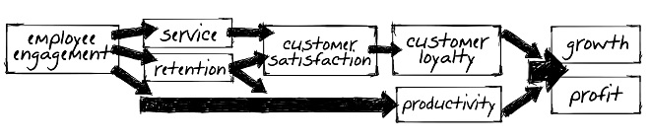
(Kruse, 2014)
Branson has clearly adopted this approach as he believes that if you engage your employees, they will provide a better service for your customers, which in turn increases customer satisfaction through more productivity, loyalty and passion and therefore drives higher sales, leading to greater profits and growth (Sasser, et al., 1997). Shareholder value subsequently increases as a result of this approach (Anderson, et al., 2004).
Branson utilizes mission as a tool for employee engagement, as demonstrated below, as research demonstrates that “73% of employees who report working for a purpose-driven company are engaged” (Denny, 2017).
“Once you know what your own motivations and aspirations are, talk to your employees and colleagues about theirs, if you haven’t already. Then structure their jobs in a way that allows them to tap into this energy, too. With you and your employees approaching your work with renewed energy and commitment, you’ll find that there’s little that you can’t accomplish together” – Richard Branson.
“Being a good listener is absolutely critical to being a good leader; you have to listen to the people on the front line.” – Richard Branson.
“Listening is one of the most important skills that anyone can have. That’s a very Virgin trait. Listening enables us to learn from each other, from the marketplace, and from the mistake that must be made in order to get anywhere that is original and disruptive.” – Richard Branson.
Branson has acknowledged here what many leaders lack. While most have recognised the importance of communication, it is two-way communication that is fundamental and not just sharing more with employees that is needed. This allows Branson to take action on the things that need to be improved (Northouse, 2015).
Theory suggests strong links between the transformational leadership approach and charisma (Northouse, 2015). Figure 2.0 below, demonstrates the personality characteristics of charismatic leaders, along with the effects of these characteristics on their followers.
Figure 2.0
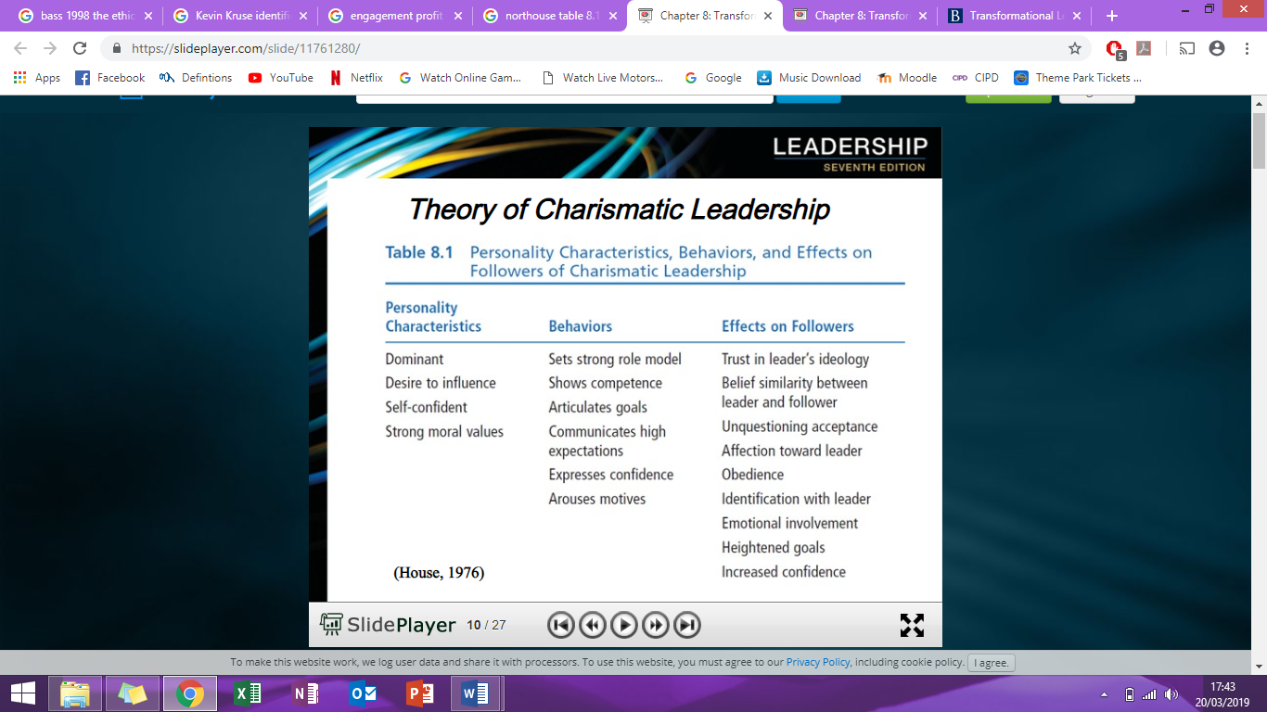
(House, 1976)
Branson demonstrates dominance, influential desire, self-confidence and strong moral values which are congruent with the personality characteristics of charismatic leaders, demonstrated previously in Figure 2.0. (House, 1976) suggests that these characteristics are what develops strong follower engagement, trust, obedience and emotional involvement, as seen throughout Richard Branson’s leadership approach. This would suggest that it is Richard Branson’s charisma that underpins his approach to leadership.

Criticisms of this Approach
This approach is seen to be modern and responsible for Branson’s unquestionable success, however it does have its drawbacks. While transformational leaders are commended for their ability to motivate and engage followers by prioritising their needs, a tendency to prioritise the needs of only select groups often occurs, meaning that some followers’ needs are not met. Followers of transformational leaders are often thought to ‘burn out’, so it is important to encourage work life balance to prevent this (Leonard, 2019). Followers of a charismatic transformational leader are often influenced to fulfil the vision of their leader, regardless of its merit. This can lead to failure without careful consideration from the leader and the Virgin brand has experienced a number of failures over the years as a result.
We’ve never been 100% sure that any of the businesses we’ve started at Virgin were going to be successful. But over 45 years, we’ve always stood by our motto: ‘Screw it, let’s do it’.” – Richard Branson.
Branson believes that failure is the foundation for growth and innovation which is critical to long-term success. Branson has adopted this approach as it is tolerant of risk and negative outcomes, allowing him to adapt and evolve to a rapidly changing environment and assisting him in overcoming this hurdle often experienced by transformational leaders.

Other Elements of the Leadership Approach Adopted by Richard Branson
Regarded a 21st century approach to leadership, servant leadership, “begins with the natural feeling that one wants to serve, to serve first… to make sure that other people’s highest priority needs are being served” (Greenleaf, 1970). Branson starts up new business ventures not to make money, but to better people’s lives. Combine this desire with his passion for employee engagement, listening and two-way communication and Branson clearly demonstrates elements of servant leadership throughout his leadership approach.
Within this transformational approach, Richard Branson demonstrates elements of Leader-member exchange (LMX) theory. LMX theory conceptualizes leadership as a process that is, “centred on the interactions between leaders and followers” (Northouse, 2015). Researchers suggest that high-quality LMX produces lower levels of employee turnover, increased positive performance evaluations, a greater frequency of promotions, increased employee commitment and passion and greater participation and support from the leader.
Path-goal theory defines how leaders motivate their followers to accomplish set goals (Northouse, 2015). Richard Branson displays elements of this theory throughout his participative leadership behaviour. According to path-goal theory, participative leaders involve their followers in decision making by consulting them to obtain their opinions and ideas. A participative leader will then integrate these suggestions into the decision-making process. Path-goal theory suggests that a follower of a participative leader, holds characteristics such as; is autonomous, has need for control and need for clarity (Northouse, 2015). According to path-goal theory, task characteristics of participative leaders are; ambiguous, unclear and unstructured. Path-goal theory is the only leadership approach to deal directly with motivation.
“I immerse myself in getting the businesses set up and am very involved the first three or four months, get good people to run them, give them a stake in the company and a lot of freedom, and then step back and move on to the next” – Richard Branson.
Branson believes that employees must experience autonomy, mastery and purpose in order to be fully motivated and to take ownership, achieve growth and act with pride throughout.
“We find brilliant people to run it, give them a lot of freedom to make mistakes, and don’t second guess them all the time” – Richard Branson.
This ability to delegate effectively is critical to successful leadership as it increases the engagement of employees and allows for increased productivity through the leveraging of the time and ability of others.

3.0 Conclusion
Often regarded as one of the world’s most successful leaders, Richard Branson has adopted a predominantly transformational leadership approach. While the view of ‘employees first’ is unconventional and disregards the more popular ‘customers first’ outlook, this approach has proven to be fundamental to the success of the Virgin brand, along with the highly regarded reputation as a leader experienced by Richard Branson. Theory suggests that the incorporation of elements of servant leadership, path-goal theory and leader-member exchange theory into this approach boasts additional benefits, however there is theory to support that it is more likely the underlying charisma of Branson that drives his success as a leader.

4.0 Recommendations
- Ensure the needs of all followers are prioritised and not just select groups to certify that the needs of all are fairly and highly regarded and no one feels overlooked.
- Support the work-life balance of employees to avoid ‘burn-out’, as motivated employees often give vast amounts of their time and efforts in attending the needs of the business, which can subsequently lead to them burning out without an appropriate work life balance.
- Prioritise the maintenance of self-awareness to avoid falling into common pitfalls of new venture failure.

References
Anderson, E. W., Fornell, C. & Mazvancheryl, S. K., 2004. Customer satisfaction and sharholder value. Journal of Marketing, 68(4), pp. 172-185.
Bass, B. M., 1985. Leadership and performance beyond expectations , New York : Free Press.
Bass, B. M., 1998. The ethics of transformational leadership. In: 1, ed. Ethics: The heart of leadership. 1 ed. Westport : Praeger, pp. 169-192.
Branson, R., 2019. Virgin. [Online]
Available at: https://www.virgin.com/richard-branson/how-to-be-a-leader
[Accessed 16 March 2019].
Branson, R., 2019. Virgin. [Online]
Available at: http://www.virgin.com/richard-branson/biography
[Accessed 8 March 2019].
Burns, J. M., 1978. Leadership, New York : Harper & Row .
Center for Agile Leadership, 2019. Center for Agile Leadership. [Online]
Available at: https://centerforagileleadership.com/what-is-agile-leadership/
[Accessed 20 March 2019].
Copeland, N., 1942. Psychology and the soldier , Harrisburg: Military Service Publications .
Day, G. S., 1999. Creating a market driven organisation. Sloan Management Review, 41(1), pp. 11-22.
Denny, J., 2017. Growth Engineer. [Online]
Available at: https://www.growthengineering.co.uk/benefits-communicating-business-mission/
[Accessed 18 March 2019].
Downton, J. A., 1973. Rebel Leadership: Commitment and charisma in a revolutionary process, New York : Free Press.
Greenleaf, R. K., 1970. The servant as leader, Westfield : Greenleaf Center for Servant Leadership.
Hemphill, J. K., 1949. Situational factors of leadership, Columbus : Bureau of Educational Research .
House, R. J., 1976. A 1976 theory of charasmatic leadership. In: J. G. Hunt & L. L. Larson, eds. Leadership: The cutting edge . Carbondale : University Press, pp. 189-207.
Kruse, K., 2012. What is Employee Engagement. Forbes, 22 June .
Kruse, K., 2014. Employee engagement: The wonder drug for customer satisfaction. Forbes, 7 Jan.
Leonard, K., 2019. Negatives of transformational leadership. Chron, 5 February.
Moore, B. V., 1927. The May conference on leadership. Personnel Journal , Volume 6, pp. 124-128.
Northouse, P. G., 2015. Leadership: Theory and practice. 7th ed. CA: SAGE Publications .
Peters, T. J. & Waterman, R. H., 1982. In search of excellence: Lessons from America's best-run companies, New York: Warner Books.
Rost, J. C., 1991. Leadership for the twenty-first century, New York: Praeger.
Sasser, W. E., A., S. L. & Heskett, J. L., 1997. Customer satisfaction and customer loyalty. s.l.:Free Press .
Seeman, M., 1960. Social status and leadership, Columbus: Bureau of Educational Research .
Stogdill, R. M., 1974. Handbook of leadership: A survey of theory and research. New York: The Free Press.

