Name: Petrica-Lucian Ionesi
Student ID: 1813705
Module code: BMSK4003_LON
Assignment Name: Digital Skills and Research Methods
Lecturer’s Name: Anupam Mazumdar

Table of Contents
Introduction 2
Effectiveness use of Modern Technology at the workplace 2
How Modern Technology can be used for various purpose: 2
Exploring Social Media as a Tool 4
Marketing 4
Communication 4
Information gathering 6
Proof of Online Presence 8
Conclusion 9
References 10

Introduction

- This assignment sample discusses the concept old Technology and Modern Technology how effective of use it is and how can be applied at the workplace.
- Technology is the application of tools, materials, and knowledge to solve problems and extend human capabilities. Example of technology:
  - Sheets, blankets, pillows.
  - Computers, cell phones, electronic devices.
- Modern technology is simply an advancement of old technology. The impact of technology in modern life is unmeasurable. Example of Modern Technology:
  - Cloud storage, Email, Dropbox, OneDrive, Internet.

Effectiveness use of Modern Technology at the workplace

How Modern Technology can be used for various purpose:

- Technology is such an important part of the 21st-century at the workplace, that any business without some level of technical practicality will likely fail. It is that critical if you’re intimidated by hardware, software and all the interconnectedness of the internet (Emma, 2019).

- At the basic level, technology permits you and your employees to be more creative and effective. Whether you’re using a word processing program that allows you to edit with ease or an electronic office system that pulls data at the touch of a keystroke. Technology makes life simpler. This can be effective for the workplace to help employers to have a better response to his work and make the company grow up faster (Emma, 2019).

- The society has been radically changed with the progress of technology. Before the initiation of modern-day technology, life was difficult and everyday tasks spent too much of our time. Technology provides big occasions, which plays an important role in human life, producing a lot of benefits:

- Access to education, medicine, industry, transportation (GoodWriter, 2017).

- Effectiveness and accessibility delivered by technology life have been changed radically. There was a time when been needed to perform an easy task, would take you most of the day. Due to modern technology, our barriers have been raised up and we have additional time and vitality to make what we wish (GoodWriter, 2017).

- Technology can be used for Business communication, Marketing sales, Social media, E-mail which allows companies to have better interaction platforms relative to traditional (Kokemuller, 2017).

- No matter what business or activity you are running, modern technology allows to expand your production beyond that you could do with old technology. Small businesses regularly compete with big companies functioning efficacy. Producers frequently looking to upgrade equipment and tools for a better and constantly production (Kokemuller, 2017).

- Technology is constantly advancing, with new software regularly developing to resolve issues and disorganisations that business may not even know that. Business leaders can occasionally feel overwhelmed in the face of so much.
- Here are five areas new technology brings advantages to the workplace:
  - Speed, Efficiency, and Agility: The goal for any new office technology is to speed up workflow processes, giving your employees the ultimate resource – extra time – to focus on the main job.
  - Storage and Sharing: Technology that streamlines information storage and sharing is vital not only for efficiency, but also for security.
  - Mobility and Remote Connectivity: Employees need to be able to access technology systems remotely. Applying the modern technology allows organizations to connect with the best ability, all over the world, instantly.

  - Automation: Another effective use of modern technology is that it allows companies to automate tasks that previously required employees. Functions like data entry and analytics, accounting, and interaction management can be incompletely or completely automated, which allows companies to work beyond professionally without the risk of human error (Anon., 2019).

Exploring Social Media as a Tool

- In order to answer this task, I am going to explain how social media can be used as a tool for Marketing, Communication and Information gathering bellow.

Marketing

- In the last year’s Businesses looking to use Social Media for marketing operations, for developing business, marketing platform strategy, promoting products, brands. To advertise newsletter’s, offers, prices, discounts. In the last years, the public has not only grown savvy to established marketing methods used by businesses but has also almost become immune to these techniques (Chatterjee, 2014).

- The best reason for your small company to be marketing across social media is that your customers are using time on these networks. Statistic related 70% of the U.S population has at least one social media account. And by 2018, the number of worldwide social media users extend all most to 2.5 billion people. With this quantity of people consuming social media every day, could be a great chance for small companies to reach their online audience (SMITH, 2018).

- Social media have an important position in the shopping journey for a long time and still keeping going forward day by day. In the last stages, social media focused on the individual, but it is progressively serving as a platform for marketing activity and to personalize a business's relationship with its clients, prospects, and partners (Blood-Rojar, 2017).

Communication

- Social Media become in the last period well documented and for many people become a lifestyle using Twitter, Instagram, and Facebook offering opportunity to start conversations, expand business partnerships and increase the online community to earn new followers and potential clients but also to communicate and interact with each other’s, with friends and family. Using Social Media have the opportunity to develop a strong media connection interacting with clients online faster (Chatterjee, 2014).

- Social media has radically changed how we interconnect. Not too long ago, we interconnected through the:
  - mail, land-line telephone, and in person.
- In these days, we send:
  - text messages
  - leave voice messages
  - use instant messenger
  - send emails
  - talk through headphones
  - cell phones
  - and online video phones
- Relate through the Internet where a plethora of social media tools has redefined communication. Such a redefinition has had a massive result. The entire pattern of social media has altered the basic rules of communication, principally between corporate and their audiences. The one-way communication methods of the recent past business-to-customer and business-to-business have been replaced by a more robust multidimensional interaction model. To communicate effectively in the social media world means understanding the new instructions of the road.

- People want:
  - To have a say, expressive dialogue, to be engaged and involved in the process, personal interactions with others, to be listened to and to help shape what they find useful (News, n.d.)

- Social media the most common ways of communication and pretty much of knowing anything and everything around the world these days, and it is growing very quickly. It changes and affects each person in a different way or ways. Some may say that social media has a bad impact on children and young adults, and that it negatively affects their brains, character, or personalities, while most people see that the social media has a more positive effect on them than a negative one. In addition, social media has helped many people around the world to connect, or re-connect, with each other, easily. Social media is basically the new way of keeping in touch with everything and everyone, and of even strengthening bonds between each other. This can be used for businesses to improve communication between employers and customers for fast response, problem-solving (Anon., n.d.).

Information gathering

- The importance of social media on information gathering can be extended and determined to utilize several factors for example:

- Conversation: The interaction one-way, transmission or somehow sent to a passive audience. Social media is at least a two-way conversation, and habitually a multidimensional conversation. Social media engages everyone involved. This is essential as news can be scrutinized anywhere, anytime before even reaching the press. A live example can be taken from last year’s false alarm on a BRT accident on the Third Mainland Bridge. Within minutes, different comments had been made online and soon everybody knew there was no such event.

- Contribution: Social media supports assistances and reactions from anyone who is interested. ‘Support’ is the key here. Social media solicits an interaction, positive and negative, by making it easy to contribute. In news gathering, this is essential, because people are allowed to contribute and have no fear of being found out.

- Collaboration: Everyday social media is doing promotes an exchange of information between you and your audience, and among audience members, by inviting participation. Making quick and simple platform for collaboration, demands that information be planned and easily allocated.

- Connection: In these days, in the 21st century for searching for information on the internet only takes a click. Social media succeeds on connections, within its own Web vehicles and through links to other sites, resources, people, and automatic feeds. People can even create their own personalized site of connections. This is quicker, securer and inexpensive than the old-style phone call.

- Community: In social media, the essential characteristic is the creation of community: a partnership and association with others who share the same behaviors, welfares, and targets. Communities form fast and correspond successfully. Communities create support from memberships to the hosting organization and among members. While these communities are only virtual, with members rarely they meet each other in person. They are no less robust than the physical communities in which we live and, in many ways, more robust from the simple fact that barriers are removed.

- With these factors, one has to accept that social media itself has developed a powerful tool in the mass communication scene. This is most certainly the next best thing after the advent of emails and the internet. As the world evolutions, new innovations develop and as such enable the spread of news. (News, n.d.)

Proof of Online Presence

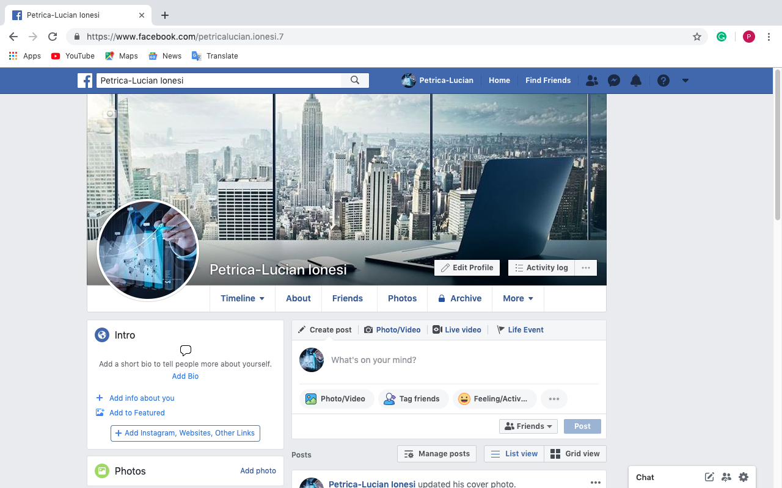

- Please click the link in order to access the page:

- https://www.facebook.com/petricalucian.ionesi.7

Conclusion

- The conclusion of modern technology touched a turning fact with the development of the Internet. Once a government mission, the Internet was created for military purposes. Through the course of its development, researchers began finding other uses for the network, and use of the technology spread worldwide. Access to the Internet today by individuals, businesses, and institutions, has generated a global market for Internet service and has spurned an increase in productivity in the technological communication field. Modern technology has created staying in touch easier than ever, but the traditional has gone by the wayside (Kathyw, 2011).

- Considering social media as a tool to find information’s and support, an immediate occasion that becomes noticeable is the aggregation and curation of content. Social media platforms have shortcomings that weaken their appeal for formal professional development and establish them only as platforms for resource finding and creating connections with others. Is the market for professional development using social media is reasonably saturated at the moment. Is been solidified over the last 5 years, and there has been a large amount of consolidation in the industry as new companies get obtained by existing businesses. There appears to be many established ways of using social media for professional development (jetz66, 2013).

References

Bibliography
Anon., 2019. Advantages of New Technology in the Workplace. [Online]
Available at: https://www.reflektive.com/blog/advantages-new-technology-workplace/
[Accessed 22 04 2019].
Anon., n.d. [Online].
Anon., n.d. [Online]
Available at: https://www.bartleby.com/essay/How-Social-Media-Improved-Communication-PKFLW6AVJ
[Accessed 18 04 2019].
Blood-Rojar, C., 2017. How to use social media as a marketing tool. [Online]
Available at: http://www.tradeready.ca/2017/topics/marketingsales/use-social-media-marketing-tool/
[Accessed 18 04 2019].
Chatterjee, K., 2014. How Can Social Media be used as a Marketing Tool?. [Online]
Available at: https://www.b2bmarketing.net/en-gb/resources/blog/how-can-social-media-be-used-marketing-tool
[Accessed 17 04 2019].
Chatterjee, K., 2014. How Can Social Media be used as a Marketing Tool?. [Online]
Available at: https://www.b2bmarketing.net/en-gb/resources/blog/how-can-social-media-be-used-marketing-tool
[Accessed 17 04 2019].
Emma, L., 2019. Importance of Technology in the Workplace. [Online]
Available at: https://smallbusiness.chron.com/importance-technology-workplace-10607.html
[Accessed 15 April 2019].
GoodWriter, 2017. postmodernclog.com. [Online]
Available at: http://postmodernclog.com/a-5-paragraph-essay-sample-on-modern-day-technology.php
[Accessed 17 April 2019].
jetz66, 2013. Conclusion of social media. [Online]
Available at: https://blogs.ubc.ca/etec540socialmedia2013/conclusion/
[Accessed 20 04 2019].
Kathyw, 2011. Conclusion The Impact of Modern Technology on Communication. [Online]
Available at: http://nodramamamaconclusion.blogspot.com/2011/03/impact-of-modern-technology-on_11.html
[Accessed 20 04 2019].
Kokemuller, N., 2017. Why Is Technology Important in Business?. [Online]
Available at: https://bizfluent.com/about-6320228-technology-important-business-.html
[Accessed 17 04 2019].
News, T. L., n.d. [Online]
Available at: http://thelightnews.com/importance-social-media-information-gathering/
[Accessed 18 04 2019].
SMITH, K., 2018. Why Marketing Through Social Media is a Must For Every Small Business. [Online]
Available at: https://www.lyfemarketing.com/blog/marketing-through-social-media/
[Accessed 17 04 2019].

