Assignment Title: | Hotel Standards, Reputation Management, Building and Retaining Customer Loyalty
Student Name: | Gabriela Zosllei
Student Number: | 2133167
Module Code: | BMIH4003
Module Title: | Hospitality and Guest Services
Lecturer Name: | Kathryn Flynn

Executive summary
This report has mentioned the purpose of brand consistency standards, how hotels regulate their reputations efficiently, and how they can make customers loyal. This report also states that it is required for identifying, maintaining trust levels, and interacting personalities, and with this, the hotel industry can improve customer diligence and loyalty, create brand authority, and differentiate themselves from other competitive companies. Numerous perspectives regarding any destination can be seen on online platforms like booking or review sites, to which the entire internet user from various areas can turn. A company can also lose its best employees due to resentment and anger, and hotels can lose clients due to poor hotel services. It can also hurt the business's revenues.The hotel also organized loyalty programs for the customers, as visitors earn rewards based on nights booked or money spent. Rewards are in the form of points that can be utilized for further stays, like dining discounts, room upgrades, etc. There can be a deficiency of resources or capital bandwidth for maintaining the hotel's standards and reputation. Marriott International suffers financial and economic losses, as well as guest compensation lawsuits, which harm the company's reputation.

Table of Contents
Executive summary 2
Introduction 4
Main Findings 4
Purpose of brand consistency standards 4
Reputation Management 5
Customer loyalty 6
Recommendations 7
Obstacles faced by some companies 7
Conclusion 8

Introduction
Guest service in the hospitality sector trains hospitality managers to fulfil the requirements of the guests and visitors via quality service that is apparent to the entire operation, its people, and its strategy. The hospitality industry contains restaurants, hotels, casinos, amusement parks, entertainment, etc., and offers services like catering, reception, hostesses, entertainment, etc. This report mainly focuses on hotel standards, reputation management, and customer loyalty. This report describes the purpose of brand consistency standards, how hotels regulate their reputations efficiently, and how they can make customers loyal. Examples are provided in this report. This report also recommends how hotels can develop themselves as per market dynamics and outlines the challenges they are facing in this industry.

Main Findings

Purpose of brand consistency standards
Hotel standards entail both the operational norms (such as facilities given to visitors, promotion, staffing, etc.) and the physical norms (such as the condition and utility of the fixtures and leased personal property, the quality, etc.). Hotels are characterized by their size, location, service levels, entrepreneurship, affiliation, number of rooms, etc. It is also categorized based on the star, diamond, or crown system, and it relies on geological location (Perez-Aranda et al., 2019). Brand consistency reflects the way the business represents itself in the market, and it remains similar across all of the marketing channels; uniting the image and message that clients and potential clients see. It is required for identifying, maintaining trust levels, and interacting personalities, and with this, the hotel industry can improve customer diligence and loyalty, create brand authority, and differentiate themselves from other competitive companies. If the hotel perceives brand recognition, it will aid in attracting a larger customer base and preserve the quality of its products and services to meet the customer’s expectations (Desai, 2019). For example, McDonald’s is a family-friendly restaurant because their lower-priced food can be identified easily due to their red and yellow colour scheme and popular golden arches. It also provides kid-friendly foods, and if they increase its prices, customers will not recommend them to anyone. Companies need customer-friendly schemes to maintain brand consistency (Budianto, 2019).
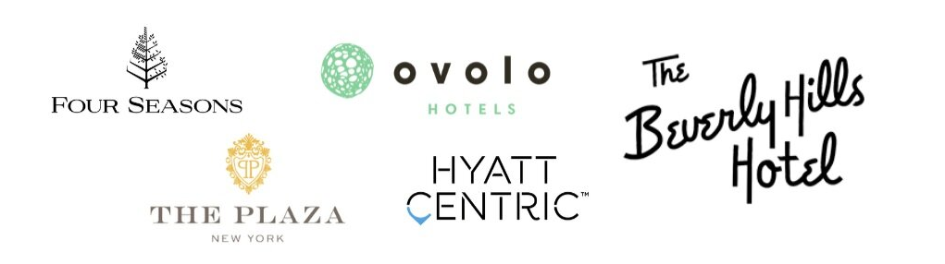
Figure 1: Hotel brands- (Dam and Dam, 2021)
In today’s world, numerous hotels are making an impressive and effective brand presence, and it can be achieved by many popular hotels with extended histories of movie-star guests as well as their unique identities, which provide them effective results in the global market (Jezierski, 2020). For instance, Four Seasons Hotels and Resorts is a global luxury hospitality business that provides amenities to customers globally. They foster their business on social media sites so that they can make their branding stronger as well as recruit great hospitality talent (Ouyang et al., 2019).

Reputation Management
Hotel reputation management entails the process of monitoring and influencing how the hotel performs digitally, which includes keeping track of review sites, optimizing the site for searches, posting and engaging on social media, and so on. Hotel reputation is important throughout the company and being the market leader; can distinguish the top hotel industry from competitors (Rodríguez‐Vidal et al., 2021). Numerous perspectives regarding any destination can be seen on online platforms like booking or review sites, to which the entire internet user from various areas can turn. The hotel industry can regulate it by seeing online reviews, which influence the booking decisions of the customers (Gössling et al., 2019).
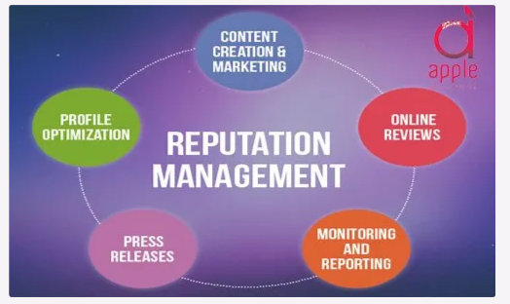
Figure 2: Reputation management- (Chan et al., 2021)
It can create a strong relationship with potential visitors and planners as well as assure visitors that their property is safe and they are protected under the principles of health and safety. Videos can also enhance the involvement of the customers, and clients are more attracted to those that are shown in an online video (Sánchez-Casado et al., 2019.). Authentic interaction and communication can aid in enhancing brand loyalty so that customers come back repeatedly and make continuous bookings. Hotels can choose an effective marketing strategy to promote themselves digitally. Marriott International, for example, relies on advertising and marketing experts to promote their hotels, which help them, gain a larger clientele (Yang et al., 2020).
Importance of effective guest reviews management and impact of negative review in hotel industry
It is important because it enhances customer loyalty by connecting and providing the visitors with a voice, as well as preserving the trust of the customers. Positive feedback can increase the company's brand recognition and make the business more trustworthy and risk-free for clients (Tian et al., 2019). It also helps in producing leads through online reviews, and it is connected to the online reputation of the company. Although poor customer service can harm a company's reputation, it can also harm sales and have an impact in a variety of other ways. It makes the customer angry, and many leads are not converted into loyal customers (Schuckert et al., 2019). A company can also lose its best employees due to resentment and anger, and hotels can lose clients due to poor hotel services. It can also hurt the business's revenues. For example, the Beverly Hills Hotel was famous for providing services to famous actors and musicians, but some allegations and bad reviews damaged the reputation of the company as it announced Shariah law in the nation. Customers are boycotting their services and properties, as well as terminating their events, etc (Ramos, 2022).

Customer loyalty
In the view of the hospitality industry, customer loyalty is the result of excellent services, as it encourages the customers to persistently obtain the best services and fulfil their demands. Any customer who returns to the business becomes acquainted with the specific hotel, and they then become loyal customers (Gao et al., 2020). Visitors’ feedback and reviews can help the hotel recognize its loyal customers, as loyal guests prefer to communicate about the brand as well as recommend it to their family and friends. Customer loyalty can be retained through word-of-mouth, referrals, or high-ranking online reviews. Loyal customers also share pictures and posts regarding the services of the hotel, as well as suggest them to people on digital platforms (Pollák and Markovič, 2022). The hotel also organized loyalty programs for the customers, as visitors earn rewards based on nights booked or money spent. Rewards are in the form of points that can be utilized for further stays, like dining discounts, room upgrades, etc. Few hotel rewards programs also provide the option of shopping with known brands or utilizing the credit cards they partner with.
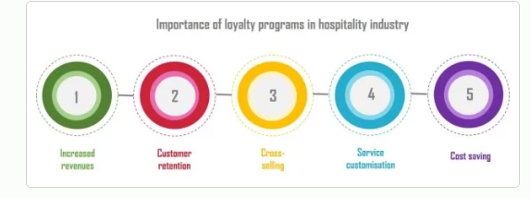
Figure 3: Importance of customer loyalty programme- (Mulyono and Pasaribu, 2021)
Enhancing customer retention as well as improving hotel services, guest perception, and guest experience can all help to build customer loyalty. It can be escalated in numerous ways, like by offering the best customer service, replying to their reviews and feedback, etc (Alrawadieh and Dincer, 2019). For example, The Savoy ensures customer loyalty by sending them personalized emails that are similar to their personal preferences, past bookings, or future trips. They mainly send customized recommendations to customers who want to visit London, as it shows they epitomize the choices of their customers.
The loyalty programs can provide economic benefits to the hotel as well as aid them in providing value-added services to clients and ensuring their convenience and preferences (Davahli et al., 2020). It also enhances cost-effectiveness, and customer retention can be done with the help of close association with the prevailing customer base.

Recommendations
Hoteliers can maintain brand consistency and standards by providing excellent care to their employees, who are the company's most valuable asset. They tailor their best services to ensure the highest number of repeat customers. For instance, housekeeping departments are responsible for maintaining hygiene within the hotel so guests can appreciate their efforts. The hotel must epitomize the latest technology to cater faster and excellent services to the visitors, as well as enhance the motivation level of the employees. The hotel industry should treat all guests equally and provide memorable experiences, as well as train their staff to guide visitors (Anagnostopoulou et al., 2019). The hotel can work on its improvement areas as per the customer feedback so that it can attain a better position in the market. It can also aid them in enhancing the reputation of the company as well as customer loyalty.

Obstacles faced by some companies
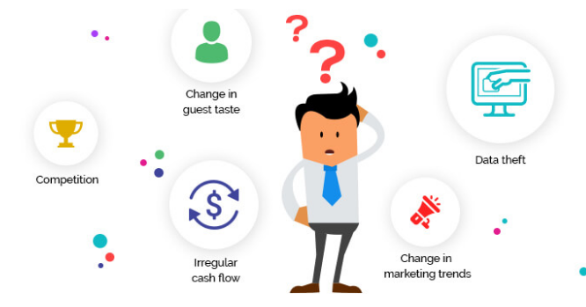
Figure 4: Challenges in Hotel industry- (Budur and Poturak, 2021)
Bad customer reviews and feedback regarding the food and beverage services harm the Hilton’s reputation as their staff cannot satisfy the demands of the customers. If there is a change in the marketing trends, then it causes issues for the hotel industry, and their conventional marketing methods could not be effective in retaining customers. The hotel industry also suffers from operational issues where they are not able to manage the entire task, which causes chaos and customer dissatisfaction (Khairawati, 2020). There can be a deficiency of resources or capital bandwidth for maintaining the hotel's standards and reputation. Marriott International suffers financial and economic losses, as well as guest compensation lawsuits, which harm the company's reputation.

Conclusion
This report mainly discusses hotel standards, reputation management, and customer loyalty, as well as how hotels can develop themselves according to market dynamics and the challenges they are facing in this industry. If the hotel perceives brand recognition, it will aid in attracting a larger customer base and preserve the quality of its products and services to meet the customer’s expectations. This report states that authentic interaction and communication can aid in enhancing brand loyalty so that customers come back repeatedly and make continuous bookings. The hotel also organized loyalty programs for the customers, as visitors earned rewards based on nights booked or money spent. The hotel industry should treat all guests equally and provide memorable experiences, as well as train their staff to guide visitors.

References
Alrawadieh, Z. and Dincer, M.Z., 2019. Reputation management in cyberspace: evidence from Jordan’s luxury hotel market. Journal of Hospitality and Tourism Technology.
Anagnostopoulou, S.C., Buhalis, D., Kountouri, I.L., Manousakis, E.G. and Tsekrekos, A.E., 2019. The impact of online reputation on hotel profitability. International Journal of Contemporary Hospitality Management.
Budianto, A., 2019. Customer loyalty: quality of service. Journal of management review, 3(1), pp.299-305.
Budur, T. and Poturak, M., 2021. Employee performance and customer loyalty: Mediation effect of customer satisfaction. Middle East Journal of Management, 8(5), pp.453-474.
Chan, J., Gao, Y.L. and McGinley, S., 2021. Updates in service standards in hotels: how COVID-19 changed operations. International Journal of Contemporary Hospitality Management, 33(5), pp.1668-1687.
Dam, S.M. and Dam, T.C., 2021. Relationships between service quality, brand image, customer satisfaction, and customer loyalty. The Journal of Asian Finance, Economics and Business, 8(3), pp.585-593.
Davahli, M.R., Karwowski, W., Sonmez, S. and Apostolopoulos, Y., 2020. The hospitality industry in the face of the COVID-19 pandemic: Current topics and research methods. International Journal of Environmental Research and Public Health, 17(20), p.7366.
Desai, V., 2019. Digital marketing: A review. International Journal of Trend in Scientific Research and Development, 5(5), pp.196-200.
Gao, B., Ding, X., Chen, W., Jiang, X. and Wu, J., 2020. When online reviews meet ACSI: how ACSI moderates the effects of online reviews on hotel revenue. Journal of Travel & Tourism Marketing, 37(3), pp.396-408.
Gössling, S., Araña, J.E. and Aguiar-Quintana, J.T., 2019. Towel reuse in hotels: Importance of normative appeal designs. Tourism Management, 70, pp.273-283.
Jezierski, A., 2020. Managing reputation on TripAdvisor–a case study of Cracow’s hotel market. Studia Periegetica, 29, pp.9-27.
Khairawati, S., 2020. Effect of customer loyalty program on customer satisfaction and its impact on customer loyalty. International Journal of Research in Business and Social Science (2147-4478), 9(1), pp.15-23.
Kwiatek, P., Morgan, Z. and Thanasi-Boçe, M., 2020. The role of relationship quality and loyalty programs in building customer loyalty. Journal of Business & Industrial Marketing.
Mulyono, R.A. and Pasaribu, L.H., 2021. The impact of mobile service quality and brand image on customer loyalty. Enrichment: Journal of Management, 12(1), pp.1-7.
Nastasoiu, A. and Vandenbosch, M., 2019. Competing with loyalty: How to design successful customer loyalty reward programs. Business Horizons, 62(2), pp.207-214.
Ntounis, N., Parker, C., Skinner, H., Steadman, C. and Warnaby, G., 2022. Tourism and Hospitality industry resilience during the Covid-19 pandemic: Evidence from England. Current Issues in Tourism, 25(1), pp.46-59.
Ouyang, Z., Wei, W. and Chi, C.G., 2019. Environment management in the hotel industry: does institutional environment matter?. International Journal of Hospitality Management, 77, pp.353-364.
Perez-Aranda, J., Vallespín, M. and Molinillo, S., 2019. Hotels’ online reputation management: benefits perceived by managers. International Journal of Contemporary Hospitality Management.
Pollák, F. and Markovič, P., 2022. Challenges for Corporate Reputation—Online Reputation Management in Times of Global Pandemic. Journal of Risk and Financial Management, 15(6), p.250.
Ramos, C.M., 2022. Reputation Intelligence. In Encyclopedia of Tourism Management and Marketing (pp. 679-681). Edward Elgar Publishing.
Rodríguez‐Vidal, J., Carrillo‐de‐Albornoz, J., Gonzalo, J. and Plaza, L., 2021. Authority and priority signals in automatic summary generation for online reputation management. Journal of the Association for Information Science and Technology, 72(5), pp.583-594.
Sánchez-Casado, N., Artal-Tur, A. and Tomaseti-Solano, E., 2019. Social Media, Customers' Experience, and Hotel Loyalty Programs. Tourism Analysis, 24(1), pp.27-41.
Schuckert, M., Liang, S., Law, R. and Sun, W., 2019. How do domestic and international high-end hotel brands receive and manage customer feedback?. International Journal of Hospitality Management, 77, pp.528-537.
Tian, Z., Gao, X., Su, S., Qiu, J., Du, X. and Guizani, M., 2019. Evaluating reputation management schemes of internet of vehicles based on evolutionary game theory. IEEE Transactions on Vehicular Technology, 68(6), pp.5971-5980.
Yang, H., Shao, C., Wang, H. and Ye, J., 2020. Integrated reward scheme and surge pricing in a ridesourcing market. Transportation Research Part B: Methodological, 134, pp.126-142.

