University of Wales Trinity Saint David
School of Engineering



Materials and Introduction to Processing
ACMA4000

Cori-James Davies
1303441
05/02/2024

Table of Contents
1 Introduction 1
2 Forming Operations - Rolling 1
3 Casting - Investment 4
4 Miscellaneous - Welding 7
5 References 11

Introduction

In this assignment, we will explore three different manufacturing processes of metals: rolling forming operations, investment casting, and a miscellaneous process called welding. Each of these processes has unique characteristics, benefits, and drawbacks that contribute to the overall field of material engineering. Through this exploration, we aim to understand these operations comprehensively, as well as the advantages and disadvantages of each process, including their technical aspects on a specific material, process defect issues, and measures to overcome them.

Forming Operations - Rolling
Rolling in forming operations refers to a manufacturing process where metal is passed through a set of rotating rolls to reduce thickness, alter cross-sectional shapes, or achieve a desired surface finish. It is commonly used to produce sheets, plates, and other metal components.

Various types of rolling mills are available for forming operations, each with unique characteristics and applications. Some commonly used types of rolling mills include:

- Two-High Rolling Mill: This is the simplest type of rolling mill, consisting of two rolls that rotate in opposite directions. It is used for basic shaping and forming operations—figure 1.
- Three-High Rolling Mill: This type of rolling mill has three rolls arranged vertically. It is used for heavier workloads and can apply more pressure to the rolled material—figure 2.
- Four-High Rolling Mill: This rolling mill has four rolls arranged in a vertical column. It is used for precision rolling and can achieve a higher degree of thickness reduction than other rolling mills—figure 3.
- Cluster Rolling Mill: This type of rolling mill has multiple rolls arranged in a cluster, which enables it to achieve a high degree of thickness reduction in a single pass—figure 4.
(Testbook, 2023)

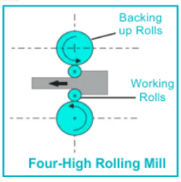
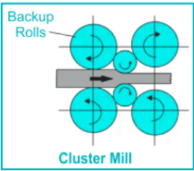
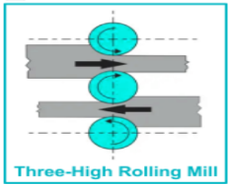
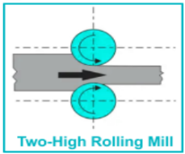

Figure 1: Two-High Mill Figure 2:Three-High Mill Figure 3:Foure-High Mill Figure 4: Cluster Mill
(Testbook, 2023)

Manufacturers choose the most suitable type of rolling mill based on the material being processed, required thickness reduction, and other specific needs.

Advantages of rolling in forming operations:
- Enables precise control over material thickness, which reduces waste and leads to material savings.
- It can enhance material strength and hardness through deformation, improving mechanical properties.
- It is a continuous process which allows for the efficient production of large quantities of the formed material.
- Often, it results in a smooth surface finish, which reduces the need for additional finishing processes.
- Can achieve precise workpiece tolerances for accuracy and consistency.
(Premier Products, 2022)
Disadvantages of rolling in forming operations:
- Initial equipment costs can be very high when setting up rolling mills.
- Alone, they may not be able to achieve some intricate shapes, requiring additional processes.
- It can consume significant amounts of energy, especially during hot rolling.
- It may not be suitable for certain materials, and some alloys or materials may need to be better suited for this process.
- Achieving tight tolerances can be difficult, particularly with thin materials.
(Testbook, 2023)

Understanding these factors helps manufacturers choose the most suitable forming method based on their needs and material characteristics.
Hot rolling is a cost-effective way to produce thin sheets of aluminium alloys with a thickness of 2mm for cold rolling. Near-net shape casting methods are energy-efficient but only suitable for a limited number of alloys. (Lenard, 2014)

Figure 5 shows the corresponding typical microstructure evolution of non-heat-treatable Al-Mg-Mn alloys. (A) grain structure, (B) constituent and dispersoid particles and (C) texture.

A
B
C
Figure 5: Microstructure Al-Mg-Alloys

Figure 6: Microstructure Al-Mg-Alloys

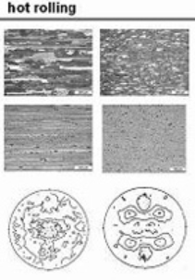

When the alloy is at a high temperature for a sufficient time, precipitates may coarsen. As the dispersoid size strongly affects final material properties, it needs to be controlled by optimum heat treatment conditions. (Hirsch, 2007)

The actual stress–strain curves of different orientations were plotted by analysing experimental data in Figure 6. It was found that the actual stress–strain curves had the same trend in three directions, and the difference was not particularly significant. So, the average stress value at a specific strain in each direction was the final measured stress-strain data. (Lirong Sun, 2019)
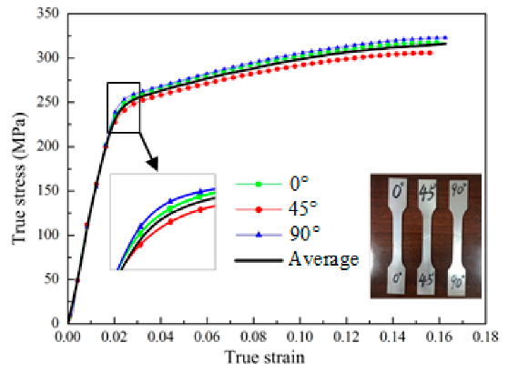

Figure 6 Results from Experiment
Rolling material defects include surface cracks, scale inclusions, and wavy edges.
- Surface cracks are caused by improper material composition, excessive roll pressure, inadequate lubrication, or high temperatures.
- Scale inclusions are formed due to incomplete scale removal, improper heating, or inadequate descaling methods.
- Wavy edges result from uneven roll pressure, misalignment of rolls, or improper material feeding.
(Blackstone - Advanced Technologies, 2020)
Proper material selection, control of process parameters, adequate lubrication, effective descaling methods, regular equipment maintenance, and uniform material feeding can help overcome defects.

Casting - Investment
Investment casting is a manufacturing process that uses a ceramic mould to produce complex metal parts with high dimensional accuracy and a smooth surface finish. It involves pouring molten metal into a ceramic mould made from a wax pattern of the desired part. After solidification, the ceramic mould is broken away to reveal the finished product. (Signicast, 2024)

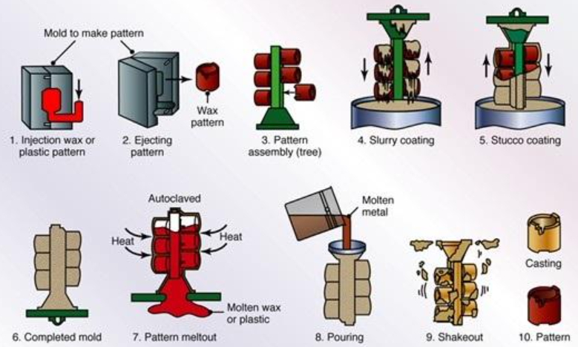
Figure 7:Investment Casting Steps
Figure 7 shows the steps involved in the process: First, the master pattern is made, and then the master die is manufactured. Next, pattern making and assembly are done, followed by refractory mould making, dewaxing, casting, and finally, the removal of the parts.
Investment casting is widely used in aerospace, medical and automotive industries to create accurate, complex parts with intricate shapes and geometries.
Advantages of Investment Casting:
- It allows complex geometries and intricate details impossible with other casting methods.
- The finishing process is optional as the parts have a high-quality surface finish.
- This process offers high dimensional accuracy and consistency, making it ideal for parts with strict tolerances.
- It can be used with various materials, including metals, alloys, and ceramics.
- This process produces less waste material, making it an eco-friendly option than other casting methods.

Disadvantages of Investment Casting:
- Creating a wax pattern and ceramic mould can be costly and time-consuming.
- The process may take weeks or months, which is not ideal for time-sensitive projects.
- Typically used for low to medium-volume production runs, it is less efficient than other casting methods for high-volume production.
- The part size is limited by mould size and furnace capacity.
- Quality end products require skilled operators.
(The Federal Group USA, 2020)

The stainless steel material (316L) shown in Figure 8 shows a microstructure composed of ferrite dendrites in an austenitic matrix. (Shimaa El-Hadad, 2015)

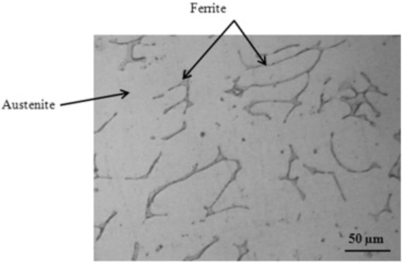

Figure 8: Microstructure of stainless steel (316L) (Shimaa El-Hadad, 2015)

Steel alloys, such as 316L, are commonly used as biomaterials in biomedical sciences. Recent advancements in investment casting processes have led to the development of artificial hip joint materials. A study evaluated the mechanical properties of 316L stainless steel after undergoing investment casting with duralumin moulding. The material's ultimate tensile strength (UTS) was found to be 579MPa, which is a critical parameter for evaluating its structural integrity and durability. (IAEME, 2020)

Investment casting defects are listed below, and also what measures are required to eliminate them:
- Shrinkage defects happen due to insufficient material in some casting areas during solidification. Proper gating and riser design, pouring parameters optimisation, and feeding systems help minimise these defects.
- Porosity appears as small voids or gas pockets within the casting, compromising its structural integrity. Effective venting systems, optimised mould permeability, and proper degassing techniques help reduce porosity.
- Surface irregularities include rough surfaces, pits, or uneven textures on the casting's exterior. Regular maintenance of moulds, high-quality wax patterns, and proper shell coating application contribute to smoother surface finishes.

Controlling parameters like mould design, material selection, pouring conditions, and post-casting treatments can address processing defects in investment casting. Continuous quality monitoring and process improvement help minimise these defects.

Miscellaneous - Welding
Welding joins metal pieces by heating or pressure and adding filler material. The process creates a strong joint. Types include arc, resistance, gas, and laser welding. The type of weld used depends on the metal and desired strength. Typical welds include butt, fillet, and lap. (TWI, 2024)

Arc welding is widely used in construction, manufacturing, and repair industries, particularly in fabricating steel structures like buildings, bridges, and pipelines.
Arc welding is a process that melts the base metal and filler material using an electric arc. The electrode melts and solidifies a pool of molten metal to form a strong bond between the two metals. (TWI, 2024)
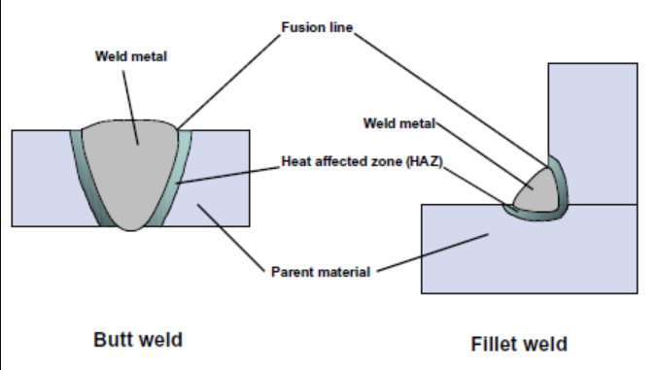

Figure 9: Arc Welding Butt & Fillet (Steel Construction, 2024)
Arc welding is a popular process that uses an electric arc to join two metal pieces.

Advantages of Arc Welding:
- Various metals can be used, including steel, aluminium, and titanium.
- It can be done in all positions, making it easier to weld in hard-to-reach areas.
- It is an affordable welding process that requires fewer resources than other welding processes.
- Equipment is relatively lightweight and portable, making transport to different job sites easy.
- Provides better control over the welding process, allowing welders to adjust as needed.
Disadvantages of Arc welding:
- Not suitable for all metals. Best for mild steel and low-alloy materials. It is not practical for highly reactive metals like aluminium and titanium.
- It is a slow process compared to other welding methods, which can limit productivity in some applications.
- Requires access to both sides of the joint, which can be challenging in some situations.
- Welding requires precise arc and filler metal control, which can be challenging to master.
- Welding produces heat, light, and harmful fumes. Safety equipment and procedures are necessary to protect everyone nearby.
(CHOONG NGAI ENGINEERING , 2022)
Arc welding has advantages and disadvantages that should be considered before using it for a particular application. Arc welding mild steel results in a weld with a microstructure that includes a fusion zone, a heat-affected zone, and base metal.
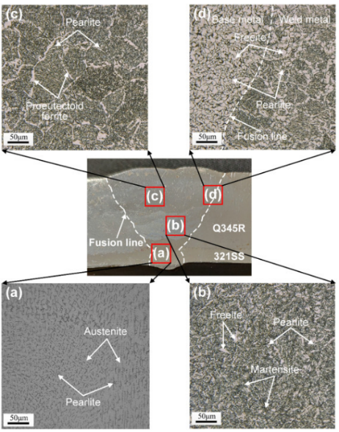
Figure 10(a) shows that Austenite grains form at the centre of the weld due to the stainless steel filler metal. The first two welds have finer austenite grains due to better cooling conditions during the initial stages of welding. In Figure 10(b), Vertical columnar austenite grains are formed near the fusion line due to easy heat release and lower nucleation energy. (ELSEVIER, 2020)

Figure 10: Microstructure of the weld filled with stainless steel (ELSEVIER, 2020)
Figure 11 below displays the typical tensile curves. All specimens were fractured at the base metal in the tensile tests. The samples had a tensile strength ranging from 462-472 MPa. Using carbon steel or stainless steel as filler metal can result in welded joints with higher tensile strengths than the base metal. (ELSEVIER, 2020)
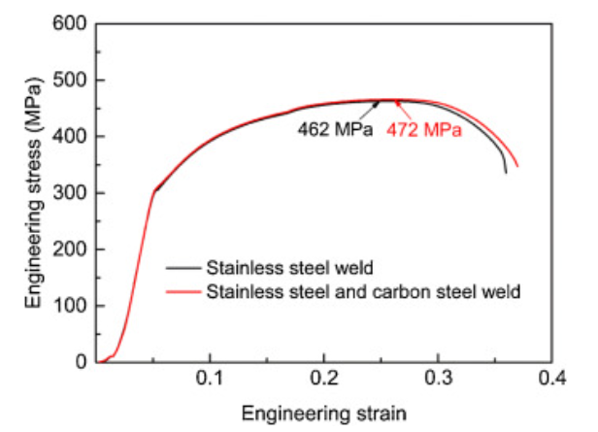
Figure 11: Tensile curves of different joints. (ELSEVIER, 2020)

In the arc welding process, several standard process defects can occur. Some of these defects include:
- Porosity: Defect caused by gas pockets forming small holes in the welded area.
- Cracks: Welding cracks may result from stress or incorrect techniques.
- Incomplete fusion: Weak joint due to incomplete melting or fusion of metal caused by incorrect welding techniques or insufficient heat.
(Technoweld, 2013)

To eliminate these defects, specific measures can be taken, including:
- Ensuring proper shielding gas flow and concentration to prevent porosity.
- Using proper welding techniques to prevent cracks and incomplete fusion.
- Before welding, prepare the metal surface by removing any dirt, rust, or oil.
- Performing post-welding inspections to ensure the absence of defects and the quality of the joint.
By taking these measures, manufacturers can ensure the production of high-quality welded products and minimise the occurrence of defects. (Technoweld, 2013)

References
Blackstone - Advanced Technologies, 2020. Common Rolling Defects. [Online]
Available at: https://blog.blackadvtech.com/common-rolling-defects-and-how-to-combat-them
[Accessed 11 January 2024].
CHOONG NGAI ENGINEERING , 2022. What Is Arc Welding: Advantages And Disadvantages. [Online]
Available at: https://www.choongngaiengineering.com/what-is-arc-welding-advantages-and-disadvantages
[Accessed 21 January 2024].
Cumic, 2024. Steel in Automotive. [Online]
Available at: https://www.cumic.com/automotive-industry-using-steel.html
[Accessed 10 January 2024].
ELSEVIER, 2020. Journal of Materials Research and Technology. Microstructures and mechanical properties of stainless steel clad plate joint with diverse filler metals, 9(2), pp. 2522-2534.
Hirsch, J., 2007. Total Materia. [Online]
Available at: https://www.totalmateria.com/page.aspx?ID=CheckArticle&site=ktn&LN=HU&NM=183
[Accessed 11 January 2024].
IAEME, 2020. MECHANICAL PROPERTIES OF AISI 316L FOR. International Journal of Advanced Research in Engineering and Technology (IJARET), 11(6), pp. 175-183.
Lenard, J. G., 2014. Primer on Flat Rolling. In: Primer on Flat Rolling. s.l.:Elsevier, pp. 279-289.
Lirong Sun, Z. C. D. H. &. L. L., 2019. Aluminum Alloy Sheet-Forming Limit Curve Prediction Based on Original Measured Stress–Strain Data and Its Application in Stretch-Forming Process, 1(1), pp. 3-4.
Premier Products, 2022. Premier Products of Racine. [Online]
Available at: https://www.customrollform.com/blog/five-key-benefits-of-metal-roll-forming/
[Accessed 8 January 2024].
Ray, S., 2016. Introduction to rolling process. Principles and Applications of Metal Rolling, pp. 1-29.
S.Yue, 2002. The Mathematical Modelling of Hot Rolling of Steel. [Online]
Available at: https://www.sciencedirect.com/topics/chemistry/hot-rolling
[Accessed 8 January 2024].
Shimaa El-Hadad, W. K. A. N., 2015. Surface modification of investment cast-316L implants: Microstructure effects. In: M. Today, ed. Materials Science & Engineering. s.l.:Elsevier, pp. 320-327.
Signicast, 2024. Investment Casting. [Online]
Available at: https://www.signicast.com/en/about-investment-casting/investment-casting
[Accessed 11 January 2024].
Steel Construction, 2024. Welding. [Online]
Available at: https://www.steelconstruction.info/File:Terminology.png
[Accessed 21 January 2024].
Technoweld, 2013. THE MOST COMMON WELDING DEFECTS: CAUSES AND REMEDIES. [Online]
Available at: https://technoweld.com.au/2019/11/13/the-most-common-welding-defects-causes-and-remedies/
[Accessed 14 January 2024].
Testbook, 2023. Rolling Process: Working Principle, Types, and Advantages and Disadvantages. [Online]
Available at: https://testbook.com/mechanical-engineering/rolling-process
[Accessed 8 January 2024].
The Federal Group USA, 2020. The Advantages & Disadvantages Of Using Investment Casting In Your Next Production Run. [Online]
Available at: https://www.tfgusa.com/the-advantages-disadvantages-of-using-investment-casting/
[Accessed 10 January 2024].
TWI, 2024. WHAT IS WELDING? - DEFINITION, PROCESSES AND TYPES OF WELDS. [Online]
Available at: https://www.twi-global.com/technical-knowledge/faqs/what-is-welding#:~:text=Welding%20processes%20are%20commonly%20used,a%20growing%20community%20of%20artists.
[Accessed 11 01 2024].

