Exploring representations of beauty in high medieval texts and iconography

Beauty is a concept that has been understood by every generation in both history and pre-history. The attraction we feel towards certain physical features could even be argued as evolutionary to an extent. However, concepts of beauty over history have not remained the same. The eye of the beholder is influenced by the world around them and by their previous generations. Medieval beauty is certainly highly recognisable to the modern gaze; however, it remains different none the less. These differences can be found in certain physical features but can also be found in the spiritual and moral lens from which the medieval gaze originated. This essay will endeavour to explore these differences and similarities with a direct focus on the source material of iconography and texts, and to understand further the medieval eye of the beholder.
First it is important to set the foundation of beauty and medieval beauty. There have been many attempts to define beauty throughout history and prehistory by means of perfect mathematical proportion to the body, however this is something that does not appear to have been important during the medieval period. This could be seen as the devaluation of the corporeal body in favour of spiritual beauty. The medieval attitude to beauty was intrinsically woven into the medieval attitude to morality and vice versa. To be beautiful was to be morally pure and to be immoral was also to be ugly. This is not to say that maths, or at least numbers, were not involved in medieval understandings of beauty. Medieval writers seem to have placed a great importance on the numbers four and five in their relation to balance, perfection and beauty. The Tractatus de musica plana, 12th century, explains the importance of the number four, ‘as in many cases nature is divided in to four parts…Four are the regions of the world, four the elements, four the primary qualities, four the principal winds, four the physical constitution, four the faculties of the soul.’ Five likewise was a number of special importance, symbolising mythic and aesthetic perfection. A circular number that when multiplied, continually comes round to itself. Hugh of Saint Victor stated that body and soul reflect the perfection of divine Beauty, the former basing itself on the even number, imperfect and unstable, and the latter on the odd number, determined and perfect. It is important to view medieval aesthetics through this lens of morality and not as a separate concept.

Evidence of this link with morality and aesthetics can be found in the poetry and prose of the middle-ages. The Roman de la Rose, written by Jean de Meung between 1268 and 1285, and based on the works of Guillaume de Lorris some 40 years earlier, between 1200 and 1240, follows Guillaume de Lorris on a journey through his dream. After he follows the river through the garden, he is met by ten figures on the wall, each representing a poor moral quality. First hatred is described by Guillaume:
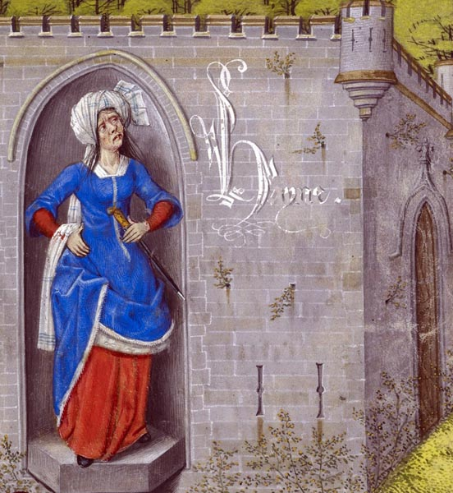
‘Full of malice towards each thing,
Was her portrait in its seeming.
Nor was she in a pleasing state,
But like one ever-enraged irate,
Frowning and sullen was her face,
The nose squat; all without grace,
Wrapped in a foul cloth was she,
That clung to her most hideously.’

Hatred is represented as disfigured by their malice. Their anger is seen as driving their appearance, and as a direct affecting factor. She wears poor clothes to match her ugly disposition. Following hatred, Guillaume notices the figures of Felony and Villainy described in the same ‘foul, repugnant nature.’
Figure 1. Hatred, in a 15th century copy of The Romance of the Rose,
Poetry in Translation, 2019.

Next comes covetousness whose hands are ‘curved and hooked like claws… [as] Covetousness has no desire but to take what others own,’ again a direct link is draw between the character trait she embodies and her ugly figure. Avarice comes next and her appearance is described extensively:

‘[She] Was ill-formed foul and ugly.
An image of leanness, yet still alive;
Though she was green as any chive,
For so unhealthy was her colour,
She appeared half dead in languor,
A thing reduced to skin and bone,
As if she’d lived on bread alone,
…
Old and tattered, shabby, poor;
Both behind her and before
For every patch, there was a hole;
Beside her hung, upon a pole,
Set nearby, all torn and thin,
A mantle made of gabardine [a practical wool]
Without trace of ermine there,
Lined with black; a poor affair
Of lamb’s wool, course and heavy;
Her dress was old, a good twenty, [years]
…
Avarice was holding in her hand
A purse, which you’ll understand,
Was half concealed, knotted tight,
So that twas long before she might
Draw aught at all from it, for she
Has naught to do with such you see:’

In this description, like with hatred, the author draws upon her poor clothing as a sign of her poor morality. It is different though with avarice, her greed is not displayed in the wealth she has accumulated upon her body, but rather in her tight purse and her poor attire. It is interesting that when it comes to describing real people, it is often the opposite description that occurs, the greedy cloak themselves in fine fabrics above their station, and the clothing on their backs becomes a symbol of their morale impropriety. There are many often ecclesiastical authors that cover new immodest fashion trends with horror and as a symbol of moral decadence.

Pride is a linked concept with avarice and envy (whos appearance in the garden is not made much of) but is omitted from the garden. It appears to be however in many other texts from the medieval period. Oderic Vitalis, an Anglo-Norman historian, wrote in the 1130s, how the Count Fulk, a man with ‘many reprehensible, even scandalous habits’ had created shoes to hide his deformed and ugly feet that were pointy and curled ‘like scorpions’ tails.’ And that now ‘laymen in their pride, seize upon a fashion typical of their corrupt morals.’ It should be noted that although Oderic Vitalis sees this fashion as sinful and a product of pride, it is clear from his writing that although brief, the fashion was popular with all classes of society. Later on this fashion would come back in a number of times, famously with the poulaines of the 15th century and appears to have divided opinions on each occasion. However, with this example it is clear that Vitalis believes the fashion was begun by Fulk to cover his deformed feet. Furthermore, it sounds asif Vitalis draws a link between Fulks immorality and the bunions on his feet. This on the one hand appears to show that the view of ugliness of body was linked with that of the character among real people not just in the personified concepts depicted in The Roman de la Rose, but it also implies how deformity could impact how people were seen by their peers. Disfigurement of the body could, for this reason be seen as deforming the character. In The Awnryrs off Arthure at the Terne Wathelyn, the decaying body’s physical corruption reflects punishment for both individual moral decay and societies spiritual decay. It has been argued that the later medieval and early modern period cadaver effigies, displayed the waiting of the soul in purgatory as the subject underwent their gruelling moral cleansing.

Sorrow is described after envy in the Roman de la Rose, and is described as pale and in poor attire, torn in grief. The description can be read in a more pathetic manner than the others, without much emphasis on words such as ‘ugly’ that are common in the other descriptions, it is difficult in fact, not to feel pity for her. Old age is described with much more graphic physical details but similarly the character judgement is more reserved:

‘Her beauty wasted and, in its fall,
A thing of ugliness she’d become,
Worn and lined, scarred and numb.
Her hair was now as white, I’d say,
As if it had been decked with may.
No great loss were it if she’d died,
Nor a great wrong, for age had dried
Her flesh, left her but skin and bone;
Now was her face that of the crone,’

This passage illustrates perfectly the view of the corporeal form as a vessel that will diminish. In the middle-ages. It appears from texts such as this that although medieval. It also however speaks to the idea that the corporeal form is inherently sinful, and its degradation is a natural feature of this truth. True beauty and the freedom from sin is to be found in Heaven, after your sinful form has perished.

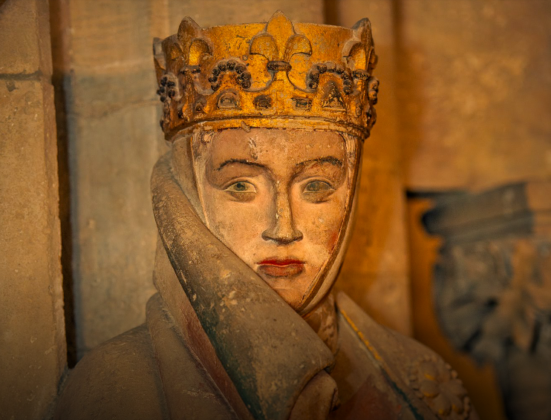
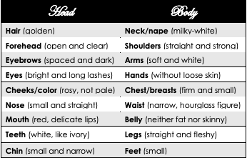
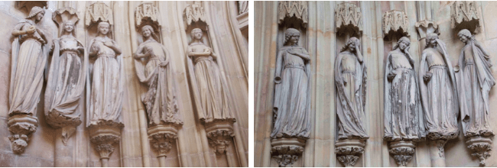
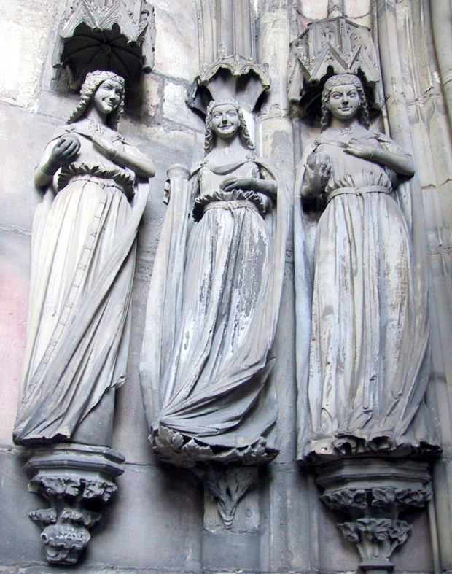
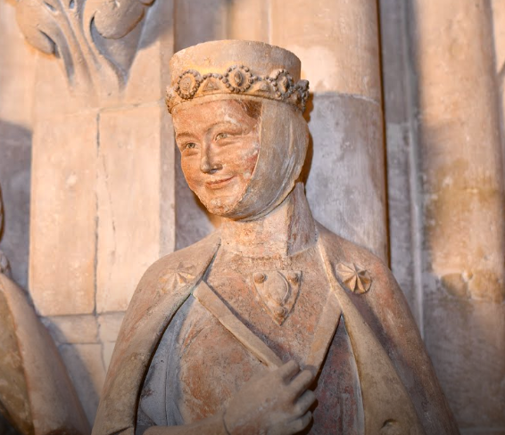
Living beauty in a physical sense, is a concept seen through other lenses than that of morality though. Evolutionary attractions as well as ideas of masculinity and femineity are key to unlocking the aesthetic eye of the middle ages. There is much evolutionary based research into the cultural overlap in features seen as beautiful, especially in women. Symmetrical features are generally seen as beautiful in both men and women throughout history, as asymmetry can indicate deformity, ill health or age. Research has also shown that men often look for features of the face body and skin that indicate youth, such as the distance between the lips and the bottom of the chin, a small chin, a small nose, a small mouth, full red lips, a high forehead, big eyes, and high curved eyebrows. Also important from the evolutionary lens are signals of fertility such as fat deposition in the breasts, thighs and buttocks. Medieval ideas of female beauty do not spread too far from this basis (figure 2.). Mathieu de Vendôme’s, 12th century Ars Versificatoria, gives a description of the infamous beauty of Helen of Troy. She has golden and free flowing hair, a ‘Milky-way white’ forehead; black and separated eyebrows, ‘like arches’; sparkling eyes, ‘like stars’; rosy cheeks; straight nose, neither too flat or too large; rosy and delicate lips; straight teeth, ‘whiter than ivory’; white neck, ‘whiter than snow’; and firm and small breasts. Another example includes other parts below the neck, dedicated to Venus: white teeth, “like ivory”; white and clear forehead; white neck, ‘like snow’; bright eyes, ‘like stars’; rosy lips; narrow waist; luscious and round belly; small feet; straight and fleshy legs; and hands without loose skin. Using this source and many others we can start to make out a cannon of beauty and ugliness among medieval literature. Da Sollers 2010 work on beauty in medieval literature with a focus on Iberia, arrived at such a canon (fig. 3.). As expected the body of the woman is idealised as fertile, young, and healthy. While the paradigm of ugliness is depicted as infertile, old, decrepit and unhealthy. These standards of beauty however are seen not just in literature but in the iconography also. Figure 2, depicts the famous Uta Von Naumburg statue in Naumburg Cathedral. Her body is covered in rich but modest clothing, however it is clear that she is of a healthy weight, with the fat deposits associated with fertility, her face has captured the imagination of many since her figure was erected in the mid 13th century. She has a clear forehead, clean and well-spaced dark eyebrows, a small and neat nose, full red lips, with a narrow chin. This is exactly in keeping with the aforementioned cannon of beauty. The 13th century sees as explosion of fine works of sculpture, remaining beautiful to this day. A famous group of figures called the Magdeburg virgins are depicted in the paradise portal of Magdeburg Cathedral. These 10 meticulously crafted figures are supposed to represent a group of virgins, some foolish and some wise. There are little differences between the wise virgins (left) and the foolish virgins (right) other than their rich clothing and adornment. The left virgins are depicted wearing considerably more expensive clothing as visible in the beautiful, elegant dresses, belts and mantles they are wearing. This further evidences the view that wealth and clothing was seen both as beautiful but also, contrasting to Le Roman de la Rose, virtuous within certain moderation. The virgins, wise and foolish, are generally depicted as falling within the cannon of beauty, they are slender but not overly skinny and have the correct proportions of the face. Despite being foolish, the right-side virgins are not immoral, virginity was itself seen as moral purity to an extent in the medieval world. The smiles however are very noticeable and what many might view as overly exaggerated, or even caricatured. It does not appear that it is being used to differentiate the fools from the wise in this depiction, and there are also many other similar depictions of both men and women where the smile is similar. Again depicted in the Naumburg Cathedral we see another example of this (figure 6.). As a depiction of the wife of one of the original donors to the cathedral, it is exceedingly unlikely to be depicting someone of poor morals or questionable beauty. While it is true that the donors are seemingly deliberately depicted with realistic features, there still remains a charming beauty to each figure including this one. It seems more likely that the beaming smile of the aristocratic lady was a virtuous, if not beautiful sign within itself, a smile that encourages, inspires and welcomes. there appears no other explanation for its prevelance as an artistic motif. The figure of the
Figure 2. Uta Von Naumburg, one of the 13th century figures in Naumberg Cathedral depicting its donors.
Google Arts &Culture, ‘Donor Figures of the Naumburg Cathedral’, https://artsandculture.google.com/story/the-donor-figures-of-the-naumburg-cathedral/BgKiRCfT_d6zIg [accessed 17th November 2024].
Figure 3. Caudio Da Sollers, canon of beauty, in:
MaryKate Powell, ‘Eternal Beauty, A Comparison of Secular and Sacred Self-Worth’, https://marykatepowellportfolio.wordpress.com/wp-content/uploads/2016/02/eternal-beauty.pdf [accessed 17th November 2024].
Figure 4. Oxford Bach Soloists, ‘Three of the Foolish Virgins in the Paradise Portal of Magdeburg CathedrAL C. 1245’ (2017) https://www.oxfordbachsoloists.com/2016/10/30/wachet-auf-the-meaning-behind-the-music/the-wise-and-foolish-virgins-in-the-paradise-portal-of-magdeburg-cathedral-c-1245-2/ [accessed 17th November 2024]
Figure 5. Magdeburg Virgins of the paradise portal of Magdeburg Cathedral. Three wise virgins.
Wikimedia Commons, File:ThreeWiseVirginsMagdeburg.jpg, https://commons.wikimedia.org/wiki/File:ThreeWiseVirginsMagdeburg.jpg [accessed 17th November 2024].
Figure 6. The wife of Margave Hermann, Naumburg Cathedral donor figures
Google Arts &Culture, ‘Donor Figures of the Naumburg Cathedral’, https://artsandculture.google.com/story/the-donor-figures-of-the-naumburg-cathedral/BgKiRCfT_d6zIg [accessed 17th November 2024].
.

Medieval beauty appears to be intrinsically linked with the soul. The morality and the sin or lack therof in a subject is all encompassed in the final beautiful form. It can also be concluded that there is standardisation within ideas of beauty, this is more present in the writing than in the iconography but remains present in both.

Bibliography
- Ed. Louise M. Sylvester, Mark C. Chambers, Gale R. Owen-Crocker, Medieval Dress And Textiles In Britain, A Multilingual Sourcebook (Woodbridge: Boydell Press, 2014)
- Umberto Eco, ‘On Beauty: A History of a Western Idea’, trans. Alistair McEwen (London: Secker & Warburg, 2004)
- Poetry in Translation, Guillaume de Lorris, The Romance of the Rose (Le Roman de la Rose, trans. A.S. Kline (2019) https://www.poetryintranslation.com/PITBR/French/LeRomanDeLaRosePartI.php#anchor_Toc891750 [accessed 12th November 2024].
- Barbara A. Goodman, ‘Physical Disfiguring and Body Forms in Middle English Metrical Romance’, Enarratio, 5 (1998), 15-33.
- Emile Heimerman, ‘A Portrait of Death: Analyzing the Transi Tomb of Guillaume de Harcigny (1300-1393 A.D.).’, The Coalition of Master’s Scholars on Material Culture (2021) <https://cmsmc.org/publications/a-portrait-of-death> [accessed 17th Novemeber 2024]
- Claudio Da Soller, ‘Beauty, Evolution, and Medieval Literature’, Philosophy and Literature, 34.1 (2010), 95–111 https://doi.org/10.1353/phl.0.0077
- C. Stephen Jaeger, ‘“She Is Beautiful and She Is Laughing?” Courtly Smiling in the Iconography of Virtue and Vice’, Feminintity, Querying smile, 5 (2014).

Umberto Eco, ‘On Beauty: A History of a Western Idea’, trans. Alistair McEwen (London: Secker & Warburg, 2004) p. 77.
Ibid.
Ibid. p. 80.
Ibid.
Poetry in Translation, Guillaume de Lorris, The Romance of the Rose (Le Roman de la Rose, trans. A.S. Kline (2019) https://www.poetryintranslation.com/PITBR/French/LeRomanDeLaRosePartI.php#anchor_Toc891750 [accessed 12th November 2024].
Ibid.
Ibid.
Ibid.
Ibid.
Ed. Louise M. Sylvester, Mark C. Chambers, Gale R. Owen-Crocker, Medieval Dress And Textiles In Britain, A Multilingual Sourcebook (Woodbridge: Boydell Press, 2014) p. 127.
Ibid. p. 131.
Barbara A. Goodman, ‘Physical Disfiguring and Body Forms in Middle English Metrical Romance’, Enarratio, 5 (1998), 15-33 (p. 22).
Emile Heimerman, ‘A Portrait of Death: Analyzing the Transi Tomb of Guillaume de Harcigny (1300-1393 A.D.).’, The Coalition of Master’s Scholars on Material Culture (2021) <https://cmsmc.org/publications/a-portrait-of-death> [accessed 17th Novemeber 2024]
Poetry in Translation (2019).
Claudio Da Soller, ‘Beauty, Evolution, and Medieval Literature’, Philosophy and Literature, 34.1 (2010), 95–111 https://doi.org/10.1353/phl.0.0077 p. 96.
Ibid. p. 98.
Ibid. p. 104-105.
C. Stephen Jaeger, ‘“She Is Beautiful and She Is Laughing?” Courtly Smiling in the Iconography of Virtue and Vice’, Feminintity, Querying smile, 5 (2014) p. 165.

