Component 2 : Written assessment : Problem and Solution Development

Module: Analysing and Solving Problems
Module Code: ACCA4019
Student Name : Esteri Paloka
Student ID: 2528244
Lecturer: Dr Abdullah Usman
Course: CertHE Computing Skills for the Workplace
Submission Date : 23 July 2026
Table of Contents
Introduction 4
1. Problem Deconstruction 5
1.1 Problem Analysis 5
1.2 Requirements and Constraints 6
Requirements: 6
Constraints: 6
1.3 Variables 7
1.4 MoSCoW Analysis 8
2. Proposed Solution 9
2.1 Overview of the Solution 9
2.2 Explanation of the Flowchart 10
2.3 Assumptions and Design Decisions 11
3. Reflection and Justification 12
References 13

Introduction
Organising group project meetings can be difficult when students have different timetables, part-time jobs and personal responsibilities. This can make it hard for all group members to attend meetings at the same time. As a result, some tasks may be delayed, workloads may become uneven, and project deadlines may be missed.[1]
This report analyses the problem of scheduling group meetings and proposes a structured solution. The problem will first be broken down into smaller parts by identifying the main requirements, constraints and variables. The MoSCoW technique will also be used to prioritise the features that are most important. A flowchart will then be created to show the logical process for finding suitable meeting times. Finally, the report will reflect on the problem-solving techniques used and discuss the strengths, assumptions and limitations of the proposed solution.[1]

1. Problem Deconstruction

1.1 Problem Analysis
The main problem in this scenario is that computing students find it difficult to organise group project meetings because every member has different responsibilities and schedules. Many students have part-time jobs, different class timetables and personal commitments, making it challenging to find a meeting time that is suitable for everyone. As a result, meetings are often postponed or cancelled, which can delay project progress and create an unfair distribution of work among team members.
This problem affects both communication and productivity. When group members cannot meet regularly, they may misunderstand their tasks, duplicate work or fail to complete their allocated responsibilities before the project deadline. Poor communication can also reduce collaboration and make it more difficult for the group to make important decisions. Therefore, an effective scheduling solution is required to improve teamwork and ensure that meetings take place before weekly deadlines.
To understand the problem more clearly, it can be broken down into smaller components using problem decomposition. Breaking the problem into manageable parts makes it easier to identify what information is required and what factors influence the final solution. This approach is an example of abstract thinking, where unnecessary details are removed and attention is focused on the most important aspects of the problem.[1]

1.2 Requirements and Constraints

To design an effective solution, it is important to identify the requirements and constraints of the scheduling problem. Requirements describe what the solution must achieve, while constraints are the limitations that the solution must work within.

Requirements:
The proposed solution should:
- Find a meeting time that all group members can attend.
- Reduce timetable conflicts between lectures, work and personal commitments.
- Ensure meetings are scheduled before weekly project deadlines.
- Allow every member to provide their availability.
- Help distribute work fairly by improving communication and attendance.

Constraints:
The solution must also consider several constraints, including:
- Students have different university timetables.
- Many students work part-time during weekdays or weekends.
- Personal commitments may change from week to week.
- Some students may not update their availability on time.
- Meeting rooms or online meeting platforms may not always be available.
- Weekly project deadlines reduce the amount of time available for scheduling meetings.
These requirements and constraints highlight why organising meetings is difficult. A successful scheduling process must balance the needs of every group member while ensuring that project work continues without unnecessary delays. Identifying these factors at an early stage helps create a more realistic and practical solution.[3]

1.3 Variables

Variables are the pieces of information that the scheduling solution needs to decide. They may change from one student to another or from one week to the next. By identifying these variables, the scheduling process becomes more organised and efficient.
The main variables include:
Variable | Description
Student availability | The days and times each student are free to attend a meeting.
University timetable | The lectures, seminars and workshops that students must attend.
Part-time work schedule | The days and hours when students are working.
Personal commitments | Family responsibilities, appointments or other activities that affect availability.
Project deadline | The date by which the group project must be completed.
Meeting duration | The amount of time needed for each meeting.
Number of group members | The total number of students who need to attend the meeting.

These variables allow the proposed solution to compare each student's availability and identify the most suitable meeting time. If any of these variables change, such as a student's work shift or timetable, the meeting schedule can be updated accordingly.[5]

1.4 MoSCoW Analysis

The MoSCoW prioritisation technique is used to identify and rank the most important requirements of the scheduling solution. It divides the requirements into four categories: Must Have, Should Have, Could Have, and Won't Have. This helps ensure that the essential features are implemented first while less critical features can be added later if time and resources allow.[2]
Priority | Requirement | Reason
Must Have | Find a meeting time that all group members can attend. | This is the main purpose of the scheduling system and is essential for successful collaboration.
Must Have | Ensure meetings are scheduled before project deadlines. | Meetings must take place early enough for students to complete their allocated tasks.
Must Have | Allow students to enter their availability. | The system cannot identify suitable meeting times without knowing when students are available.
Should Have | Reduce timetable conflicts with lectures and part time jobs. | This improves attendance and minimises scheduling issues, although some compromises may still be required.
Should Have | Send reminders before meetings. | Reminders help improve attendance and reduce the chance of members forgetting meetings.
Could Have | Suggest alternative meeting times if no common availability is found. | This provides greater flexibility but is not essential for the basic solution.
Could Have | Support both online and face-to-face meetings. | This gives groups more options depending on their circumstances.
Won't Have | Automatically change students' university timetables or work schedules. | These factors are outside the control of the proposed system and cannot be modified.

The MoSCoW technique helps ensure that the most important features are prioritised before additional improvements are considered. By focusing on the essential requirements first, the proposed solution is more likely to solve the scheduling problem effectively while remaining realistic and practical.[2]

2. Proposed Solution

2.1 Overview of the Solution
The proposed solution is a logical scheduling process that helps student groups identify the most suitable meeting time before each weekly project deadline. The solution works by collecting the availability of every group member, comparing their schedules and selecting the most appropriate meeting time that causes the fewest conflicts. If no suitable time is available, the process searches for alternative options until a meeting can be arranged.
This approach uses abstract thinking by focusing only on the information required to solve the problem, such as student availability, university timetables and project deadlines. It also applies problem decomposition, where the scheduling task is divided into smaller logical steps that are easier to analyse and implement.
The proposed solution has been designed to improve communication, reduce scheduling conflicts and ensure that meetings are organised consistently throughout the project. By following a structured process, student groups are more likely to meet regularly, complete tasks fairly and submit their work before the deadline.[4]

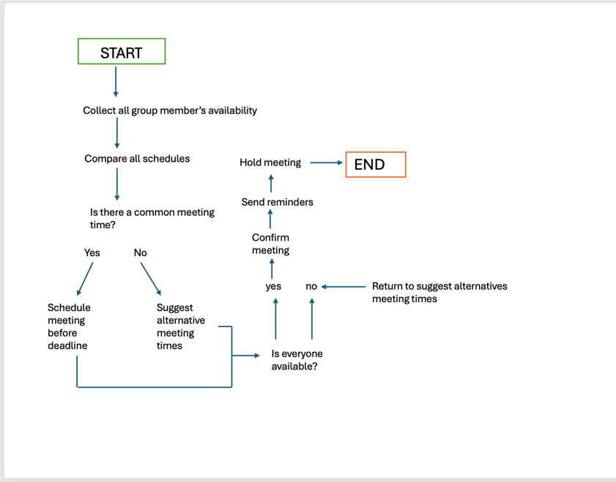

Picture 1. Flowchart illustrating the proposed group meeting scheduling process.

flowchart.pptx the link to the PowerPoint

2.2 Explanation of the Flowchart
The flowchart demonstrates the logical process used to organise group meetings while reducing scheduling conflicts. The process begins by collecting the availability of every group member. This step is important because each student may have different lecture timetables, part-time work commitments and personal responsibilities. By collecting everyone's availability first, the system works with accurate information before making any scheduling decisions.
The next step compares all group members' schedules to identify whether there is a common meeting time that everyone can attend. This comparison is one of the most important stages because it helps minimise timetable clashes and avoids arranging meetings when members are unavailable.
The first decision point asks whether there is a common meeting time. If the answer is Yes, the meeting is scheduled before the weekly project deadline. Scheduling meetings before the deadline ensures that group members have enough time to complete their allocated tasks, discuss progress and resolve any issues before submitting the project.
If the answer is No, the flowchart moves to suggesting alternative meeting times. Instead of stopping the process, the solution continues searching for another suitable time. This makes the process more flexible and increases the likelihood of finding a meeting time that works for the majority of the group.
After an alternative time has been suggested, the second decision checks whether everyone is available. If all members can attend, the meeting is confirmed. Reminder notifications are then sent to every group member to reduce the chance of someone forgetting the meeting. Finally, the meeting takes place and the process ends successfully.
If not, everyone is available, the process returns to suggesting alternative meeting times until a suitable meeting can be found. This loop makes the solution adaptable because student schedules may change from week to week. By repeating the process, when necessary, the proposed solution reduces scheduling conflicts, improves communication and supports successful teamwork throughout the project.[3]

2.3 Assumptions and Design Decisions
When designing the proposed solution, several assumptions were made to ensure that the scheduling process is realistic and practical. The first assumption is that every group member provides accurate and up-to-date information about their availability. If students do not update their schedules correctly, the system may suggest meeting times that are no longer suitable.
Another assumption is that all students are willing to cooperate and attend meetings once a suitable time has been agreed. The proposed solution can identify appropriate meeting times, but it cannot guarantee that every student will participate actively or complete their assigned tasks.
It is also assumed that students have access to a device, such as a laptop or smartphone, and an internet connection to receive meeting reminders and view the agreed meeting schedule. This ensures that all members can communicate effectively throughout the project.
Several design decisions were made to keep the solution simple and easy to follow. Firstly, the process uses only the information that is essential for scheduling meetings, including student availability, university timetables, work commitments and project deadlines. This demonstrates abstraction, as unnecessary information is ignored to focus on the factors that directly affect the problem.
Secondly, the solution includes decision points that allow alternative meeting times to be suggested whenever a common time cannot be found. This makes the process flexible and prevents it from ending without a solution. Finally, reminder notifications were included to reduce missed meetings and improve communication between group members.
Overall, these assumptions and design decisions make the proposed solution practical, logical and suitable for supporting student group projects.[5]

3. Reflection and Justification
The problem-solving techniques used in this report helped to develop a clear and structured solution to the scheduling problem. Breaking the problem into smaller sections through problem decomposition made it easier to identify the main challenges, including timetable clashes, part time work commitments and personal responsibilities. By analysing each part separately, it became easier to create a solution that addressed the needs of the group.
The use of abstraction was also important throughout the design process. Rather than considering every detail about each student, the solution focused only on the information that directly affected meeting scheduling, such as availability, deadlines and timetable commitments. This reduced unnecessary complexity and made the proposed solution easier to understand and implement.
The MoSCoW prioritisation technique helped identify which features were essential and which could be added in the future. Prioritising the most important requirements ensured that the solution focused on solving the main problem before considering additional improvements.
Although the proposed solution is practical, it also has some limitations. For example, it depends on students providing accurate availability and responding promptly to meeting requests. If this information is incorrect or not updated, the scheduling process may not produce the best results. In addition, unexpected events such as illness or last-minute work shifts could still require meetings to be rearranged.
Overall, I believe the proposed solution provides an organised and logical approach to scheduling group meetings. It demonstrates the use of computational thinking and problem solving techniques while supporting effective teamwork and helping students meet project deadlines more efficiently.[4]

References
[1] OpenStax, Introduction to Computer Science – 2.1 Computational Thinking. Available: https://openstax.org/books/introduction-computer-science/pages/2-1-computational-thinking. Accessed: Jul. 16, 2026.
[2] Atlassian, Six Product Prioritization Frameworks and How to Pick the Right One. Available: https://www.atlassian.com/agile/product-management/prioritization-framework. Accessed: Jul. 17, 2026.
[3] BBC Bitesize, Computational Thinking. Available: https://www.bbc.co.uk/bitesize/topics/z7tp34j. Accessed: Jul. 17, 2026.
[4] Project Management Institute, What Is Project Management? Available: https://www.pmi.org/about/learn-about-pmi/what-is-project-management. Accessed: Jul. 17, 2026.
[5] The Open University, Introduction to Computational Thinking. Available: https://www.open.edu/openlearn/science-maths-technology/introduction-computational-thinking/content-section-0. Accessed: Jul. 18, 2026.

