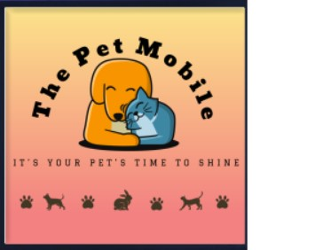  Managing Enterprise in the 21st Century  BMSW4006 | Business Plan for Mobile Pets Grooming in the UK (The Pet Mobile LTD.)  Lecturer: Md. Nazmul Hasan  Students:  Alexandra – Valentina Ghita -2127554  Beniamin Avram - 2131588  Elena Mihaela Radu - 2126383  Flavius – Daniel Pruna – 2129728

Table of content:

- Business overview
- Product and services
- Market audit
  - Competitors
  - SWOT analysis
  - Pestel analysis
- Target market
- Marketing plan
- Management team
- Financial plan
  - Cashflow forecast
  - Profit & loss
- References

- Business Overview:
The Pet Mobile Ltd. offers multipurpose pet grooming that is helpful, dependable, and productive to pet owners. In a calm environment close to home, The Pet Mobile Ltd. offers an entirely delicate, one-on-one preparation experience for all pets. For a pet to live a healthy and tidy life, it is imperative to educate the owners on the benefits of pet grooming (Ryan et al., 2019). A basic explanation of everyday prepping is that it includes cleaning the pet, minimizing the chances of medical conditions developing, and observing the pet's well-being by checking for cuts, irritations, or changes in disposition. This can happen because of disease or through a closer relationship between the pet and its proprietor.
The Pet Mobile company will start its journey in Erdington and the postcode will be B24, in hopping to make Erdington an improved, beautiful, and happier pet owners' neighbourhood which will create an unbreakable bond between pets and owners how you can see on the company’s logo. The company’s motto is “It’s your pet’s time to shine” and underlines our main priority, which is making your pet look amazing, shining, fashionable and, of course, most important, happy.

- Product and Services:
The Pet Mobile van will be equipped with a groom professional ultimate electric bath, a groom professional 110E electric grooming table, a clipper set with a trimming machine, a pet grooming tool set, a dryer, and a pet grooming and shedding de-shedding remove brushes vacuum kit. Other basic pet grooming tools which will be used are combs and brushes, bathing shampoos and conditioners, nail clipping and trimming clippers and scissors, massage oils, toothpaste for brushing the teeth, deodorants, pet sunscreen, and cosmetics.
Currently, pet owners have many options when it comes to preparing their pets. Our goal at The Pet Mobile Ltd. is to be the most suitable option for our clients. The trademark of our organization is to give fantastic prepping administrations at the client's doorstep in a pleasant and spotless environment with an added cost for esteem. When you book with The Pet Mobile Ltd., you will be able to use the net and convenient time for you, and we will do our best to accommodate your schedule. For the reason that pets are part of a family, an expert portable pet’s preparation service gives every client a sense of value and respect.
Our main responsibilities include washing, conditioning, and drying pets, detangling and removing hair as needed, styling and grooming pets according to directions from pet owners or standard grooming styles, clipping pets' nails, accommodating any special needs that pet owners may have, cleaning ears and brushing teeth, identifying health concerns in pets, such as ear infections, and communicating these findings to pet owners with an emphasis on ensuring that pets are healthy.

- Market audit
A marketing audit can be defined as an assessment that is carried out to analyse your current marketing strategy from top to bottom. The aim of a marketing audit is to spot the strengths and weaknesses of your marketing efforts and to help you conceive a plan to improve your effectiveness and performance.
3.1 Competitors
In the pet grooming business, the competition is medium at present, but compared to the past the competition is increasing. Because of the rising profits and lesser entry barriers in this business the number of pet stores is increasing massively.
 | C1 | C2 | C3 | The Pet Mobile
What are they offering? | 1- De-matting  2- De-shedding.  3- Discounts  4- Vouchers | 1-Discounts  2-Vouchers  3- Cosmetic services | 1- one free grooming for pets/ month  2- free treats after grooming  3- Discounts | 1- Discounts  2- Deep conditioning treatments  3- Vouchers  4- Bio products
Price/Unit | Between 30 to 100 pounds. | Between 20 to 90 pounds. | Between 18 to 88 pounds. | Between 20 to 55 pounds.
Exact location (post code) | B73 | B72 | B23 | B24
Delivery service? | Yes | No | No | Yes
Online service? | No | Yes | Yes | Yes

3.2 SWOT analysis
S  Strengths | - Convenience  - Flexibility  - Customized services
W  Weaknesses | - Limited space  - Weather-dependence  - Limited servicer offering
O  Opportunities | - Increasing pet ownership  - Expanding service offerings  - Demand for high-quality pet care is on the rise
T  Threats | - Competition  - Economic downturns  - Complying with regulations

Pet owners are given the convenience of having their pets groomed at their doorstep rather than having to transport them to a grooming facility thanks to mobile pet grooming. Mobile pet groomers can give each pet unique care and grooming in addition to personalised attention.
Compared to brick-and-mortar grooming salons, mobile pet grooming enterprises are constrained by space and resource availability but because pet owners are constantly searching for the highest pet care services, including grooming, and because our mobile pet grooming services offer health - care associated, this could represent a great opportunity.
Poor weather conditions may have an impact on mobile pet grooming enterprises and make it challenging to reach clients. Given the lack of available resources and space, mobile pet grooming businesses might not be able to provide the same variety of services as brick-and-mortar grooming salons.
Economic downturns may result in less money being spent on pet care services, which could be detrimental to the mobile pet grooming industry. But this threat can be passed by forming partnerships with other pet-related businesses like pet stores or veterinary offices, mobile pet grooming may increase the range of services it offers.

3.3 PESTEL ANALYSIS.
PESTEL ​ | ​
POLITICAL | - Regulations and licensing requirements  - Taxes and fees
ECONOMIC | - ​Customers' disposable income  - Economic downturns
SOCIAL | - Busy lifestyles  - Demand for pet ownership
TEHNOLOGICAL | - ​ Online presence – need a good online advertiser  - Equipment – need a high- quality equipment
ENVIROMENTAL | - Sustainability – need to offer an eco-friendly product  - Weather conditions  - Waste disposal
LEGAL | - ​ Employment laws

In order to see what and how the external factors will affect The Pet Mobile business we made a Pestle analysis to spot the problems that we will encounter in opening and run this business. The Pestle analysis studies the key external factors which are the political, economic, social, technological, legal and environmental ones that influence an organisation.
The Pet Mobile business will interfere with all of these external matters because it is a mobile business in which we will need to respect the regulations and laws in the area where the company will operate, the licensing that is required for the staff and for the van that will be used, the taxes and fees that the company will need to pay are: road taxes, insurance, MOT, fuel consumption and repairs if will be necessary. The company can be negatively impacted economically by customers disposable income and economic downturns.
Also, the social events can affect the company because people who have a busy lifestyle don’t have time to own a pet and this can affect the number of customers that the company has, and the demand of pet ownership is growing which will be an advantage for the business.

- MARKET SEGMENTATION/TARGET MARKET
The pet grooming industry's target market is vast, comprising a wide range of pet owners. Pet grooming services are in high demand for all types of pets, such as dogs, cats, birds, rabbits, and even exotic animals such as lizards and snakes.
It’s important to tailor your services to target different kinds of pets and as many of these groups as possible to have the broad customer base necessary to be successful in the dog grooming business.
The main target markets for The Pet Mobile are:
- Pet owners that prioritise their pets' health and well-being are the major target market for pet grooming services. These are ready to invest in their pets' care and grooming to ensure they look and feel their best (Chen, A., et al., 2012). These pet owners frequently have a lot of spare cash and are willing to pay a premium for high-quality grooming services.
- Busy pet owners who do not have the time or resources to groom their pets themselves are another target market for the pet grooming industry. Some people may have rigorous job schedules or other obligations that prevent them from providing enough care for their pets. People frequently rely on professional groomers to ensure that their pets receive appropriate grooming and care.
- Pet owners who prefer the convenience of having their pets groomed in the comfort of their residences are another target market for a mobile pet grooming business. This includes busy professionals who may not have the time to take their pets to a regular grooming shop, elderly people who may have difficulties transporting their pets, and pet owners with nervous or anxious pets who feel frightened when removed from their familiar environment.
- Pet owners who live in places where pet grooming services are limited may also be included in the target market.
Finally, pet owners who place a high value on customized and one-on-one attention for their pets may be interested in the mobile pet grooming service.

- MARKETING PLAN
Good marketing strategies are only the first step toward fruitful marketing. Having a great marketing strategy is useless if it is not effectively implemented. Implementing a marketing plan into a promoting activity leads to the achievement of key marketing objectives. (Kotler, Phil T., et al, 2019). To effectively advertise an item or administration, the four Ps need to be carefully examined and shrewdly executed. Product, price, place, and promotion make up this list. (W. & Van den Bulte, C. 1992).
For a good start, our mobile pet grooming company offers a distinctive value proposition. These grooming services will be practical and tailored, with affordable costs and eco-friendly supplies. We use our brand to represent our business and its unique value proposition. Our goal is to develop a logo and tagline that will resonate with pet owners. As part of our advertising campaign, we will use social media platforms, such as Instagram and Facebook, to display our services, and to build a strong online presence.
Our goal is to increase our business by partnering with local pet stores, veterinarians, and pet-related businesses. In addition, we offer them discounted services and ask them to promote our services to their clients. As a result, we may be able to reach a larger number of pet owners in your area.
To attract new customers, we will offer promotions and discounts. First-time customers can receive a discount or bundle packages can be purchased at a discount. This could stimulate repeat business and assist us in developing a loyal consumer base.
We will invite pleased consumers to submit reviews on our social media sites in order to grow our business. We believe that positive reviews can help us create confidence with future clients and boost our internet presence.

- MANAGEMENT TEAM

- FINANCIAL PLAN
7.1 Cashflow forecast
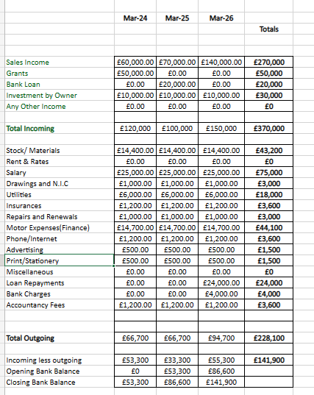

The table shows a cash flow projection for The Pet Mobile Ltd. over three years, with details of the incoming and outgoing cash flows. Sales income is the revenue generated from sales of products or services, which is expected to increase from £60,000 in year one to £140,000 in year three due to business growth. The business is expected to receive a grant of £50,000 in year one, which will provide additional funds for investment. To growth our business will take out a loan of £20,000 in year two to support further expansion.
The total incoming cash flow during the three years is £370,000, which comprises sales revenue, grants, bank loans, and the owner's investment. The entire incoming cash flow for the three years is £228,100, which comprises material costs, payroll, utilities, insurance, repairs and renewals, car costs, phone and internet, advertising, print and stationery, loan repayments, bank charges, and accountant fees. The net cash flow for the three years is £141,900, which is the difference between the incoming and outgoing cash flows. Year one's initial bank balance is £0, while year three's ending bank balance is £141,900.

7.2 Profit & loses
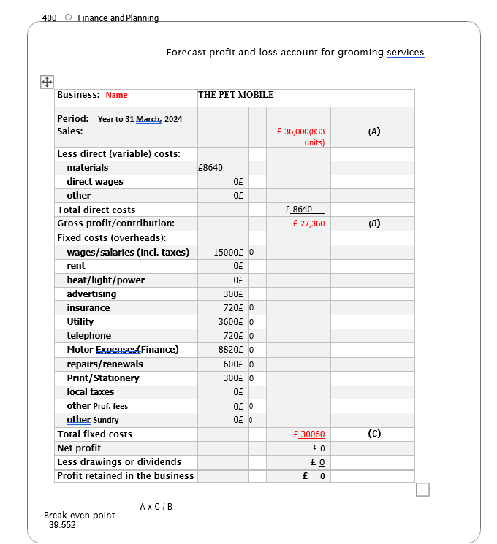

According to the prediction, the company would have a gross profit/contribution of £27,360 for the fiscal year ending March 31, 2024, based on sales of £36,000 (833 units) and direct costs of £8,640.
The fixed costs or overheads for the business are estimated to be £30,060, which includes wages/salaries, advertising, insurance, utilities, telephone, car expenditures (financing), repairs/renewals, print/stationery, and other professional fees.
The net profit is £0 after removing the fixed costs from the gross profit. This indicates that the company is not yet profitable throughout the anticipated term.

REFERENCES
Chen, A., et al., 2012, A cluster analysis examination of pet owners’ consumption values and behavior–segmenting owners strategically. Journal of Targeting, Measurement and Analysis for Marketing.
Kotler, Phil T., et al., 2019, Principles of Marketing, Pearson Education Limited, Harlow, United Kingdom. Available from: ProQuest Ebook Central. [11 March 2023].
Ryan, S., et al., 2019, WSAVA animal welfare guidelines. J. Small Anim.
W. & Van den Bulte, C. 1992, "The 4P Classification of the Marketing Mix Revisited", Journal of Marketing, Journal article-van Waterschoot, vol. 56, no. 4.

APENDIX 1 – PRICES LIST
SERVICES | PRICE
Extra small dogs (Pugs and Pomeranians) | £20 - £25
Small dogs (Shih Tzu, Miniature Schnauzer and West Highland White Terriers) | £25 - £35
Medium dogs (Cocker Spaniels, Cockerpoo’s and Schnauzer) | £30- £35
Large dogs (German Shepherd, Samoyed, and Standard Poodle) | £40
Extra large (Bernese mountain dogs, Newfoundland, Saint Bernard and Great Dane) | £55

APENDIX 2 – PRICE LIST FOR PRODUCTS

Equipment | Average cost (£)
Shampoo | £15/ bottle
Clippers | £170
Comb attachment | £35/set
Clipper blades | £25/blade
Clipper Oil | £5/500 ml
Ear Powder | £5 for 25 g
Nail Clippers | £10/ set
Blood stopper | £6
Slicker brushes | £15 for 3
Combs | £7
Scissors | £150
Steriliser | £60
De-shedding tools | £15

