
The top skills for a student to become a successful business owner

Module name: Academic Skills
Module code: LCBB4006
Student Name: Olga Andronic
Student Number: 2119164

Lecturer: Matthew Suff
Submitted date: 05th of January 2023

Table of Contents
Introduction 3
Importance of Teamwork 3
Importance of communication in teamwork 4
Success and benefit from the effective team working 6
Team Working in removing workplace issues 7
Team Working and motivation 9
Recommendations 9
Conclusion 10
Reference List 11

Introduction
Team Working is important because it helps the team members in sharing new ideas and responsibilities by which they can reduce their stress and also keep themselves contracted while completing any task. The study provides an analysis of the importance of teamwork and how team working provides comprehensive benefits to the individual in gaining success. The study also illustrates the importance of team working and how it is important for the business organisation. Team Working is also taken as a process of incorporating own ideas by which an individual can easily keep the team members free from conflict. For discussing the importance of team working, necessary examples are also provided.

Importance of Teamwork
Teamwork is necessary for every business organisation. In the current era of digitalisation, every individual must understand the importance of digitalisation and how an individual can easily develop their skills by working in a team. Every individual must understand the importance of team working skills which can be easily learnt from academic careers (Tai et al., 2022). In academic careers, it becomes important for every individual or student to understand the importance of a team and also complete any task in a team. Improving teamwork helps in understanding and increasing the productivity and performance of an organisation. Teamwork also helps in understanding the importance of healthy competition and also finding appropriate ways of gaining several benefits. Students need to understand the importance of team working and how an individual can easily gain several benefits. It is also necessary to understand the importance of team working and how it provides comprehensive benefits to the individual in building good relationships with their subordinates. Team Working is taken as a process by which an individual can easily identify their strengths and weaknesses and also focus on the weaknesses which can be overcome by working with other team members (Nguyen et al., 2022).
Collaborative working is one of the effective ways by which team members can easily identify their own strang and also natural delivery of a good outcome for a specific business organisation. It also becomes important for team members to understand the ways of accomplishing their goals and also foster their innovative ideas for gaining success. While working as a team the organisation is required to understand the ways of minimising their workload and also try to share new ideas and responsibilities. For example, in the classroom students are given PowerPoint presentations as a task and in this class, it becomes important for the team members to work all together and also incorporate new ideas for completing the task. Completing the task with the help of new ideas can be considered as the process of improving their skills and also find out the process of completing easily (Imam and Zaheer, 2021). Competition for a PowerPoint presentation in a creative way can provide comprehensive benefit to the individual in understanding the ways of gaining opportunities. The interaction in the learning opportunities in the workshop can be considered as a process by which an individual is gaining experience as an employee. Experience from the work can be considered as a positive way by which the individual can understand the requirements of the business organisation. After understanding the importance of teamwork, the individual can easily work with experienced team members in ways he or she can easily improve their ideas and also incorporate new ideas. The importance of teamwork also allows experienced employees to face challenges and also complete tasks in a given period. It can be also considered as a process by which individuals currently focus on their creative skills and those are incorporated into the development of their career.

Importance of communication in teamwork
Every individual needs experience from the workshop and it is one of the primary and most ways they can easily gain experience and also improve their low morale. Teamwork is one of the effective ways by which individuals can easily gain confidence and also maintain their experience for a longer duration of time (Raurell-Torreda et al., 2021). Team members are also responsible for gaining experience and also trying to understand the ways of working and also improving their accountability. If the individual is facing difficulties, it becomes the responsibility of the member to encourage other team members and also communicate with them regarding their challenges and issues. Encouraging the team members is one of the bright ideas and in this case communication will help in improving their confidence. If a union member is facing difficulties to communicate confidently then it becomes the responsibility of other team members to support them and also improve their communication on the standard. Communication is considered effective progress by which team members can easily lower their problems and also build trust in an automatic process. In simple words, it can also stay that communication is the process of gaining success and also completing the working activity effectively.
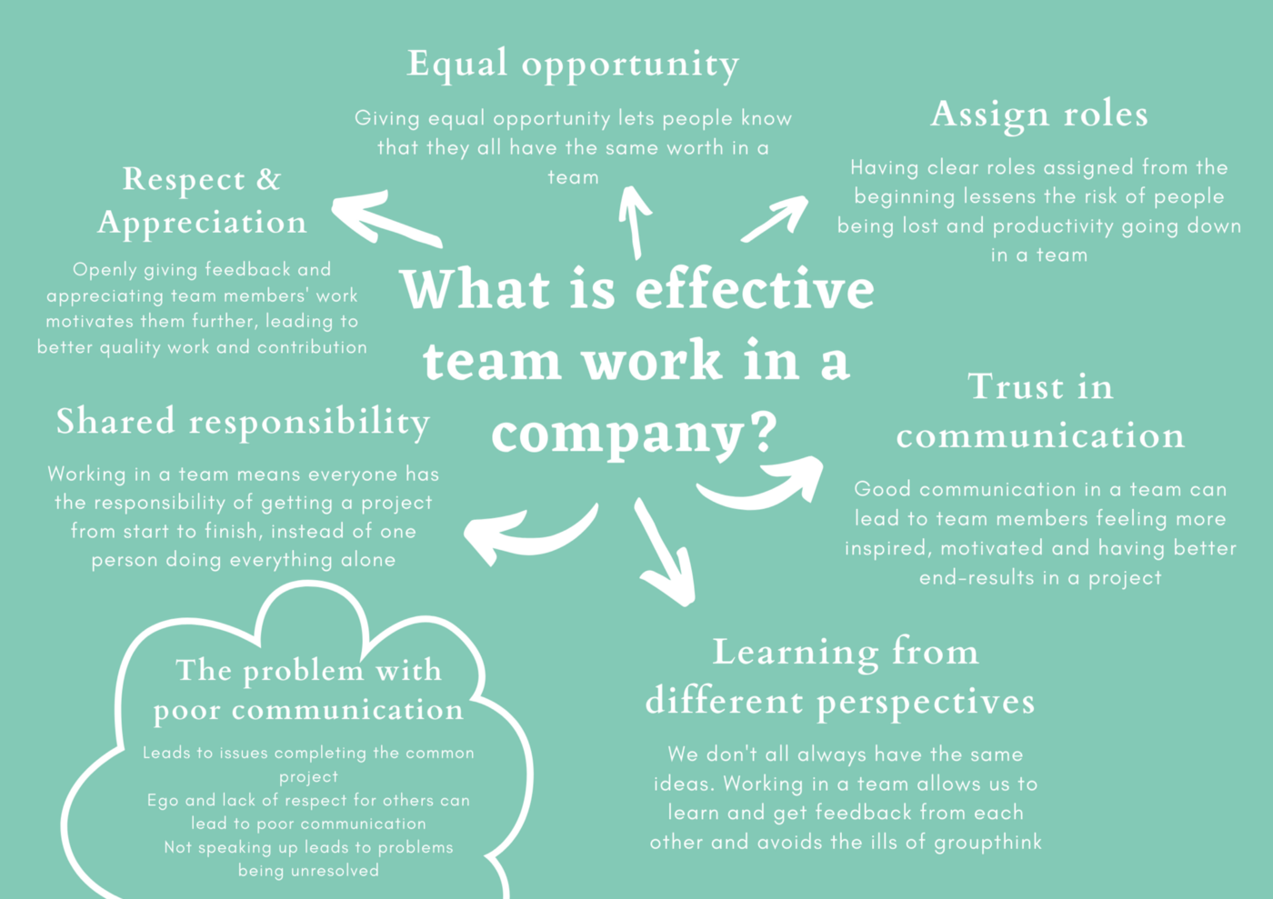
Figure: Effective Team Working
(Source: Raurell-Torreda et al., 2021)
Teamwork also emphasises the importance of communication and how it can help an individual in completing the task efficiently. Effective communication also helps remember in understanding the rules of avoiding duplication and also working appropriately (Chiu et al., 2021). It provided a major benefit to the team members in understanding the goal of the project and also realising the goals. Motivation is taken as an effective way by which team members can easily improve team working activity and also keep their working progress on track. It is also essential for the team members to understand the importance of effective communication and also give the authority to every member to deliver the speech. Effective communication will provide measurable benefit to the individuals in understanding the ways of completing the task and also lowering the issue of conflict. For example, if a teacher provided a presentation task force to students in the classroom, the primary responsibility of the student was to work altogether. The students are responsible for incorporating their ideas into the same work and also effectively delivering the presentation. If the student does not follow the same guidelines, then it can be considered of a challenging nature for the student to be incomplete in the presentation properly and result in a negative outcome (Folsom-Kovarick et al., 2021). In this case, the teacher is also for communicating with the average student and also trying to gather knowledge about the process of improving their morale and also making them capable of working in a team.

Success and benefit from the effective team working
Getting success by working in a team can be considered primary and progressive by which individuals can easily understand the necessary process and skills. It becomes important for every individual to understand the ways of solving several problems and also find appropriate ways for improving their performance.
- The primary and foremost way of gaining success is solving several problems by working in a team. An individual with problem-solving ability can easily direct the team for working and also accomplishing the task in a determined period. It can be also considered as a process of enduring success and correctly responding according to the requirement (Chiu et al., 2022).
- Increasing the potential innovation is necessary and, in this case, it becomes important for the team members to understand the ways of incorporating new ideas and also gaining success. According to the study of making a company, it is stated that team members can easily gain success and it becomes important for the team members to communicate effectively and also try to respect their diversified backgrounds. Providing respect to the diversified background can be taken as an effective way of improving their working activities and also gaining success.
- As a part of ongoing research on teamwork, it is identified that team members belong from different cultures, and it has become important for every team member to be in good relationships for the accomplishment of a task. The accomplishment of the task with creative ideas can benefit the individual in understanding the ways of using the ideas for future growth progress and also finding out the solution to several ongoing challenges.
- Personal growth is necessary, and, in this case, it becomes important for every individual to follow the Murphy theory. The theory is discovering new processes by which individuals can easily gain experience and also learn from their mistakes. It can be considered a vital way by which individuals can easily identify their weaknesses and also overcome the weaknesses with the help of their knowledge. Furthermore, the theory also provides a comprehensive benefit in understanding the weaknesses of team members which can be exposed with the help of feedback (Peng et al., 2021). Feedback usually provides measure benefit to the individual in understanding their weaknesses while working and also overcoming the weaknesses with the help of new strategies.
- Gaining opportunities is necessary and in this case, it becomes important for every individual to understand the ways of changing their working activities. Every individual in an Indian academic career needs to understand and get detailed knowledge about the use of new technology and also find out the necessary solutions for using technology. Technology and advancement can be considered as a process by which individuals can easily find out their creative activities and also meet their requirements.

Team Working in removing workplace issues
Workplace issues are becoming one of the major problems current days and it has become important for every individual to understand the ways of lowering work issues. The primary objective of every team member is to understand the ways of building good relationships and also foster their success with the help of innovative and creative ideas. Important for every team member to understand three different phases that can be incorporated for improving their working activities (Liu et al., 2022).
Actions Oriented roles:
At first, it is necessary to understand the importance of action-oriented rules that should be played by every member for gaining success. For understanding the Orient Road, the individual must find out the challenges and also try to overcome the challenges effectively. Overcoming challenges can be taken as a positive test by which individuals can easily understand the ways of completing their working activities and also gain new experiences. Finishing the project in a given period can be considered a process by which individuals can easily understand completing the task (Zawawi et al., 2022). It is also necessary for every individual to understand the ways of completing the task in a given period and it can be considered a process of maintaining their time management skills.
People Oriented Roles:
Every team and individual is responsible for acting as a chairperson who will be guiding other team members for completing the task with the help of new ideas. Completing the task with the help of new ideas can be considered a process by which teams identify the best possible ways of improving their working activities and explore new ideas for gaining necessary opportunities. It becomes important for every individual to find out the process of improving their working activities and also deliver the presentation effectively for gaining new opportunities. Presentation skill is considered a way by which individuals can easily understand the importance of working effectively (Kashive et al., 2022).
Thought Oriented Roles:
Presenting new ideas and opportunities can be taken as a process by which an individual can easily find out the best possible way for improving their working activities. It becomes important for the team members to find out the process of resolving the issues and also analyse the options by monitoring continuously. Every day remembers to be responsible for finding out the process of resolving the issues and also incorporating new strategies for overcoming the problem. It becomes important for the individual to understand the opportunities specialist.
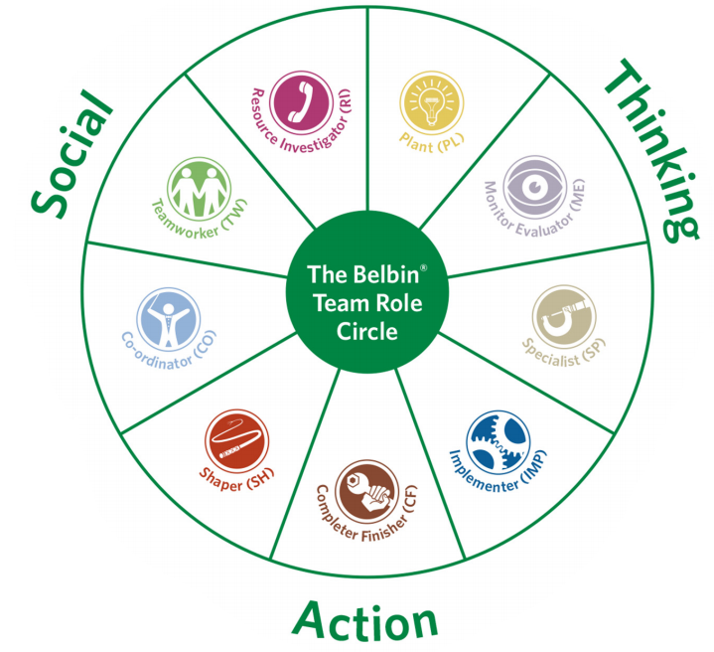
Figure: Belbin Team Role
(Source: Kashive et al., 2022)
Based on the above-mentioned activities that are incorporated as Belbin team roles, every organisation can easily understand the process of supporting the individual and also improving their working activities. The action-oriented goal is considered an effective way by which individuals can easily understand and incorporate new strategies for completing the task without creating challenges in the working environment (Ma et al., 2021). It is also taken as an effective strategy by which individuals can understand the best possible ways of shaping their working activities and also find out the process of maintaining excellence.

Team Working and motivation
Team Working is a process by which an individual or diversified group can easily gain several new ideas and incorporate them into the comparative working environment. Each individual to understand the ways of improving efficiency and also find out the solution to managing difficult tasks (Imam, 2021). Motivation is necessary and it is one of the effective processes by which individuals can easily find out the process of improving their working activities. It also becomes important for every individual to find out the solution to improving their business activities and also try to understand the importance of motivation. Motivation is also taken as a concert by which individuals can easily improve their working aspect and also try to maintain the high quality of learning activities. To improve the morale of team members it is necessary to understand the ways of highlighting the importance of teamwork in the office and also providing value to their subordinates. Subordinates are taken as the key driver of changes, and they are responsible for contributing to a positive outcome in the work environment.
Team Working also provides several learning opportunities for the individual. For example, an individual working in a team needs to understand the preference of the employer and also try to gather detailed knowledge from other employees (Gupta et al., 2022). After understanding the requirements of the organisation, it became my responsibility to focus on my working activities and also gather feedback based on my working activities. Gathering feedback can be taken as a primary aspect and on this basis, individuals can find out the best possible ways of improving their learning activities. Encouragement is taken as effective by which a business organisation can easily poster the innovation of employees and also make themselves capable of identifying possible ways of gaining success. Every team member needs to understand the importance of success and also find out the best possible ways of gaining success. Managerial interference is necessary for every business organisation and in this case, it becomes the requirement for the organisation to find out the best possible ways of improving the working activities (Bartlett et al., 2022).

Recommendations
First upon the importance of team working and how team working can provide measurable benefit to the individual in fostering success and also improving their working activities. Every individual must understand the importance of team working and how an individual can easily lower workplace conflict.
- The primary objective of every business organisation is to understand the importance of feedback and how feedback can help improve the weaknesses of the members (Kim et al., 2022).
- If the individual is still connected with the workshop, then it becomes the responsibility of the manager. Students can easily understand and identify the best possible ways of improving their working activities.
- Conflict is considered one of the major problems that can directly impact the working progress and also result in lowering the working activities and demoralising the team members.
- For improving the new working the organisation must understand the ways of guiding the team members and also motivating them.
- Leadership activities are also taken as an effective way by which organisations can easily improve their working activities and also maintain a better personality test (Nossek et al., 2021).

Conclusion
Working is taken as the ability of two or three individuals to work in a group and also complete the task in a determined period. In academic careers team working is considered as a process of completing a task and also improving their skills and knowledge which can be later used in their employment. The study provides an illustration of the importance of team working and how walking can provide measurable benefit to the individual in elements of toxic workplace culture. The elimination of toxic work culture can be considered beneficial for the individual in understanding the ways of completing the task and also maintaining good relationships for future productivity. The study also illustrates the importance of the Belbin team role and the process that can be incorporated for improving the knowledge of team members.

Reference List
Bartlett, D. L., Schnur, K. M., Wilson, A. K., and Moorman, S. S. (2022). Defining the micro and macro roles of a hemophilia treatment center social worker in the United States from an interdisciplinary team perspective. Haemophilia.
Chiu, C. Y., Balkundi, P., Owens, B. P., and Tesluk, P. E. (2022). Shaping positive and negative ties to improve team effectiveness: The roles of leader humility and team helping norms. Human relations, 75(3), 502-531.
Chiu, C. Y., Lin, H. C., and Ostroff, C. (2021). Fostering team learning orientation magnitude and strength: Roles of transformational leadership, team personality heterogeneity, and behavioural integration. Journal of Occupational and Organizational Psychology, 94(1), 187-216.
Folsom-Kovarik, J. T., Sieh, J., and Sinatra, A. M. (2021). Reasoning about Team Roles and Responsibilities for Team Assessment. In Proceedings of the Ninth Annual GIFT Users Symposium (GIFTsym9) (p. 201). US Army DEVCOM–Soldier Center.
Gupta, P., Mohapatra, M., and Srivastava, S. (2022). Towards Team Engagement Through Team Empowerment: Moderating Roles of Team Reflexivity and Team Orientation. Global Business Review, 09721509221075865.
Imam, H. (2021). Roles of shared leadership, autonomy, and knowledge sharing in construction project success. Journal of Construction Engineering and Management, 147(7), 04021067.
Imam, H., and Zaheer, M. K. (2021). Shared leadership and project success: The roles of knowledge sharing, cohesion and trust in the team. International journal of project management, 39(5), 463-473.
Kashive, N., Khanna, V. T., and Powale, L. (2022). Virtual team performance: E-leadership roles in the era of COVID-19. Journal of Management Development, (ahead-of-print).
Kim, H. H., Choi, J. N., and Sy, T. (2022). Translating proactive and responsive creativity to innovation implementation: The roles of internal and external team behaviours for implementation. Creativity and Innovation Management, 31(2), 162-178.
Kuehmichel, S. (2022). Examining small-group roles through team-building challenges. Communication Teacher, 1-6.
Liu, X., Zheng, X., Yu, Y., Owens, B. P., and Ni, D. (2022). How and when team average individual mindfulness facilitates team mindfulness: The roles of team relational stress and team individual mindfulness diversity. Journal of Organizational Behavior, 43(3), 430-447.
Ma, Z., Gong, Y., Long, L., and Zhang, Y. (2021). Team-level high-performance work systems, self-efficacy and creativity: differential moderating roles of person–job fit and goal difficulty. The International Journal of Human Resource Management, 32(2), 478-511.
Nguyen, P. T., Sanders, K., Schwarz, G. M., and Rafferty, A. E. (2022). The linkage between cognitive diversity and team innovation: Exploring the roles of team humor styles and team emotional intelligence via the conservation of resources theory. Organizational Psychology Review, 20413866221114847.
Nossek, A., Werning, A., Otte, I., Vollmann, J., Juckel, G., and Gather, J. (2021). Evolvement of peer support workers’ roles in psychiatric hospitals: A longitudinal qualitative observation study. Community Mental Health Journal, 57(3), 589-597.
Peng, J., Chen, X., Zou, Y., and Nie, Q. (2021). Environmentally specific transformational leadership and team pro-environmental behaviors: The roles of pro-environmental goal clarity, pro-environmental harmonious passion, and power distance. Human Relations, 74(11), 1864-1888.
Raurell-Torredà, M., Rascón-Hernán, C., Malagón-Aguilera, C., Bonmatí-Tomás, A., Bosch-Farré, C., Gelabert-Vilella, S., and Romero-Collado, A. (2021). Effectiveness of a training intervention to improve communication between/awareness of team roles: A randomized clinical trial. Journal of Professional Nursing, 37(2), 479-487.
Tai, K., Lee, K., Kim, E., Johnson, T. D., Wang, W., Duffy, M. K., and Kim, S. (2022). Gender, bottom-line mentality, and workplace mistreatment: The roles of gender norm violation and team gender composition. Journal of Applied Psychology, 107(5), 854.
Zawawi, A. A., Ab Halim, N., Kamarunzaman, N. Z., and Zawawi, A. A. (2022). The Roles of Technology Compatibility and Relational Boundary on the Performance of Rescue Frontliners. Global Business and Management Research, 14(1).

