L’Oréal
University Trinity Saint David London Campus
Marketing Management (LCMB7001)

Student: Ionela Madalina Saiz
Lecturer: Tushara Balendran

Table of Contents
Introduction 3
Organisation Background 3
L’Oréal – Marketing Approach 4
Challenges faced by L’Oréal 5
External Analysis using PESTEL 5
Porter’s 5 Forces model 9
Marketing mix strategies 11
Internal Analysis using SWOT 11
L’Oréal’s Competitor analysis 13
Recommendation for Future Improvement 14
Conclusion 14
References 15

Introduction
In marketing, enterprises develop plans and strategies that can help satisfy customer needs and increase their contentment about products or services. Thus, the present report aims to evaluate efficacy of marketing methods used by L’Oréal in UK. Efficacy will be measured in terms of changes it faced and techniques applied to company them. Along with the external and internal analysis will be performed to determine longevity of their marketing management.

Organisation Background
L’Oréal is leading beauty and cosmetic product retailer originating from France and has expanded to multiple countries due to increase in demand for their products. L’Oréal has expanded in 150 countries that included US, UK, South Africa, China, India and many others. Their extensive products improvement process that helped them to address varied customer requirements in different regions has supported expansion to other countries. In order to increase customer confidence regarding their product and do business in competitive edge, L’Oréal has obtained accreditation from ISO 9001 and ISO 22716 certified that specified about products quality and safety application. In terms of human resourcing, L’Oréal provides employment to 88,000 employees from different countries that he them addressed differences and diversity at workplace (loreal.com, 2020).
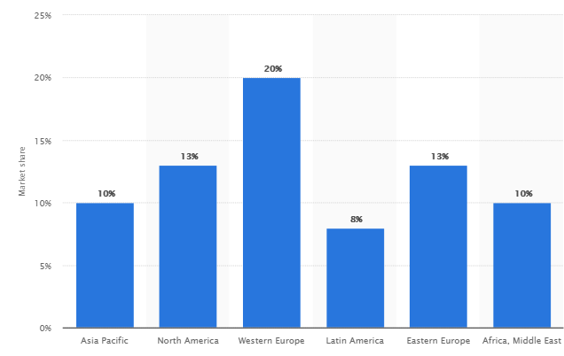
Figure 1: Market Share of L’Oréal
(Source: Shahbande, 2020)
It is found that demand for L’Oréal products is high in Western European countries and maximum in Europe. Market share of L’Oréal in UK is approximately 20% that makes it highly competitive for other cosmetic brands (Shahbandeh, 2020). In UK, L’Oréal received awards from The British Royal Society for the Prevention of Accidents for their excellent performance in driving product sales by addressing requirement of diversified workplace. Incorporation of modern technology in their services has been introduced in the UK for staying ahead of competition and increasing product sales.

L’Oréal – Marketing Approach
Marketing approaches that organization uses relies on their business objectives and goals that they desire to achieve. Through marketing, organizations tend to increase their customer awareness about their products and that pave path for introducing new products in existing markets. In case of L’Oréal, it is found that their marketing process concentrates to increase customer engagement by interacting with thorough social media, free product distribution and conducting customer surveys to address their requirements. Societal marketing and product concept in amalgamated by L’Oréal for their marketing management. Product concept focuses in diversifying their product range that suits preference of various customers in the UK. Societal marketing is oriented on addressing social issues that are occurring and incorporating them in their product manufacturing process (Fiore et al. 2016).
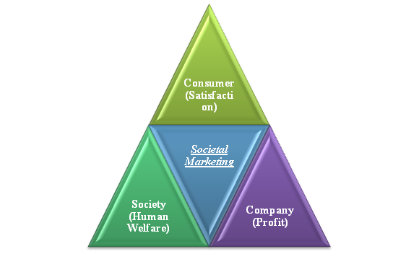
Figure 2: Societal Marketing Approach by L’Oréal
(Source: Fiore et al. 2016)
L’Oréal has used ‘Universalization’ strategy in their marketing whose agenda is to converged product preference of customers by respecting differences. With globalization, L’Oréal intends to make their product acceptable to different customers of various color, race and background. Based on this, they have formulated their marketing where they highlight empowerment of people and use social media platforms such as Twitter, Instagram and Facebook. This shows that emotional intelligence is embodied in their marketing process (loreal.com, 2020).

Challenges faced by L’Oréal
Beauty industry of UK is highly competent due to presence of large number of brands and this reinforces the requirement to alter business procedure to gain competitive advantages. In context of L’Oréal, the organization has increased their profit amount in 2019 by 2.0% as compared to value in 2018 that is 1.1%. It is predicted that their market value in UK would increase in future creating vast opportunities to improve their products and services. Meanwhile, the marketing head of L’Oréal inaugurated a 3.0 marketing approach in UK to transfer their business toward customer-centric (loreal.com, 2019). Marketing 3.0 is implemented using social media platforms to increase their market reach but their social media presence has increased arouses several issues. Circulation of fake news, personification of products and ad bombardment are some challenges that L’Oréal is facing due to marketing in social media. This indicates that technical capability is limited, which invited the scope to hackers to misuse their social marketing platform. Another challenge faced in UK by L’Oréal during 2020 is change in customer behavior where wearing mask and face covers has become a norm due to Covid 19. Intensity of customer purchase of their skin care and beauty products has declined creating a significant gap in their expected financial gains with actual (Gran, 2020).

External Analysis using PESTEL
External environmental analysis is used to determine factors that can have direct impact on business operation and productivity. In this context, PESTEL analysis is used to determine the impact of external environmental factors such as political, economic, legal, social, political, technological and environmental on marketing approaches of L’Oréal.
Elements | Description
Political | - Advertising Standard Agency (ASA) policy restrict stereotyping in commercial  - Cosmetic, Toiletry and Perfumery Association Ltd. (CTPA) mandates the formation of PIF (Product Information File)  - Marketing of products beyond 30 months of manufacturing is prohibited
Economic | - £9.8 billion is generated by cosmetic industry of UK during 2019  - Market value of cosmetic industry in 2019 reduced by 17%  - Online sales of beauty product increased by 38% in 2020
Social | - 84% of customers prefers purchasing beauty product from store  - Demand of organic beauty products have increased  - Less preference towards surfactants, emollients and fragrances in products
Technological | - Social media for product promoting and marketing increased  - Use of VR (virtual reality) and AR (augmented relating) for customer engagement  - Mobile application for delivering salon facilities
Environmental | - Climate Disclosure Leadership Index for sustainability  - Emphasizing on carbon footprints  - Increased use of palm oil for product development
Legal | - Unfair Trading Regulations 2008 for social media influencers  - Consumer Protection Act 1987  - Companies Act 2006
Table 1: Pestle Analysis of L’Oreal

Political
In UK, ASA regulated contents that can be displayed by organization in advertisements and commercials in print media and in digital platforms. ASA has mentioned that organizations using social media for their marketing approach have to follow CAP Code that provides details about context that are to be omitted. Strict policies are enforced regarding practicing stereotyping advertisements for attracting target audiences but creating mental segregation about product usage in society. In case of L’Oréal, political factors have moderate impact on their marketing approaches since they have focused on eliminating stereotyping. This is evident from the fact that they use the concept of universalization in product development and marketing without segregating society into different strata’s. CTPA has mentioned business transparency regarding chemicals used in product manufacturing, prices that are set and others. In addition to this, CTPA has specified that products retained through online mode need to have shelf life less than 30 months so that product quality can be retained (Dziobczenski and Person, 2017).
Economic
It is found that sales of cosmetics products in the UK have generated £9.8 billion during 2019 but market value of this industry has reduced by 17% indicating that its dominance in UK economy has reduced. Reduction in revenue generation is attributed to change in customer preferences in quality and price of beauty products. In context of L’Oréal, their sales in 2019 have increased by 2.0%, which indicates that economic factors have less impact on their product sales. In context of marketing, economic factors specify a boost in online product sales by 38% during first quarter of 2020 and this indicates that vast opportunities are available for L’Oréal to transfer their marketing process digitally (Pauley., A, 2020).
Social
It is found that customers before purchasing products conduits market research about different brands and compare products. Approximately 25% of customers prefer to purchase products from stores whose number of positive reviews in online platforms are high. This indicates that customers purchase behaviors have shifted toward digitalization and in order to increase products sales online presence is necessary (Wunsch, 2020). L’Oréal is found to have main accounts in different social networking sites where they market their products by implementing emotional intelligence such as focusing on gender equality, use of plant-based products and others (loreal.com, 2020). In this perspective, customers in the UK are shopping more interested in beats products that are less chemical ingredients and compounds that are more organic. Such customer preference and purchasing behavior has a significantly high impact on marketing approaches used by L’Oréal. The organization has fewer product ranges that are derived from plant products or manufactured organically and this creates challenges in retaining their customer base.
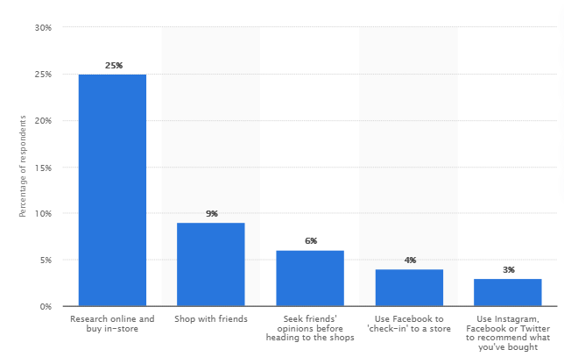
Figure 3: Customer preference of product purchase
(Source: Wunsch, 2020)
Below figure highlights products that are purchased online either through social marketing or directly from organization websites and mobile applications. L’Oréal has to increase their social media preference for grabbing opportunities that are available in UK market. L’Oréal has launched Style My Hair mobile application for providing salon services to customers in UK and increasing customer engagement (loreal.com, 2020).
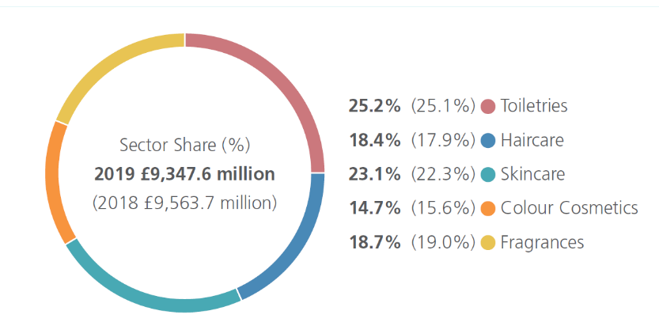
Figure 4: Beauty products purchased online in UK
(Source: ctpa.org.uk, 2020)
Technological
Technologies are used increasingly by cosmetic industry in UK for marketing where modern technical devices such as AR and VR are used. Technological factor has less impact on marketing process of L’Oréal since they have already undergone digital transformation.
Environmental
Environmental sustainability programs such as L’Oréal adopts Climate Disclosure for showing their concern towards chaining climatic patterns. Thus, environmental factors have negligible impact on their business process of L’Oreal.
Legal
Laws such as Companies Act 2006, Consumer Protection Act 1987 and Unfair Trading Regulations 2008 have to be followed by L’Oréal for avoiding chances of legal prosecution. The mentioned organization is found to have developed workplace policies and procedures that adjoined with UK legislation; thus, their change of legal obligation is narrow (Shibley, 2019).

Porter’s 5 Forces model
Conducting Porter’s five forces analysis in order to understand the dynamics of cosmetic marketing industry, so a strategic management plan can perform accordingly.
Bargain Power of Suppliers (low)
The abundance of raw materials used in the cosmetics industry results in reducing the bargain power of supplies, without letting to much space for negotiation.
The cosmetics companies are quickly increasing their revenue based on hight demand of their products, having massive sales and growth, and their suppliers main focus on delivering the highest value.
According with Pereira and Barbieri (2012), the cosmetic companies negotiate through a dominant approach with their suppliers to get the best value at the cheapest price possible, which results a low bargain power for suppliers, due to their dependence on the companies.
Bargain Power of Buyers (high)
The buyers are choosing from a broad range of global and local brands to buy from, having no significant cost to switch between brands.
L’Oréal use the loyalty factor to keep its customers, due to skin sensitivity, also when designing the products and setting the products prices, have to keep in mind the buyer’s power of bargain. The buyers bargain power has increased due to the accessibility of quality brands with the same or even more competitive pricing available (Darabos, 2013).
Competitive rivalry (high)
The cosmetic industry is facing the highest level of competitiveness due to the power of competitors strengthens. Only in 2017 with a 532 billion USD revenue, the global cosmetic industry is expected to increase by 7 percent till 2024. L’Oréal is the market leader with the highest market share with a vast range of products and brand reliability (Zion Market Research).
Threat of substitute (low)
People’s highly increased awareness related to skin care problems, beauty products and personal care resulted in a low substitutes threat. This reflects in a continuous change of cosmetic products, starting with the way that they are produced, processed till the latest innovation .
Threat of new entrants (low)
The threat of new entrants will always exist, even if they are negated due to the exceptional growth of the cosmetic industry. Banning the animal testing keeps them away somehow, because is requiring lot of capital for testing, producing and commercialising cosmetics. However, the impact on the market is unsignificant because of the fast market growth and the threat of new entrants being moderate (Ulubeyli, 2017).
Threats of new competitors
The basic threat of L’Oréal is the luxurious products which can downturn the economy of the company by overcoming the problems by lowering the price with distribution system.

Marketing mix strategies
Product
- L’Oréal spa shampoo, products of hair colour and makeup products like lipstick, mascara, etc.
- Result is comparable to the treatment of Hair Spa
- Chemical free shampoo
Place
- Retail stores- shopping malls, grocery stores and others
- Strategy of double layered channels which can be used by the retailers and distributors for the formation of chain
- Sales force can also be utilized for the developing a sales relationship
- Different issues of the channels like cannibalization, double marginalization, etc can be recognized.
Promotion
- Advertisements in radio, television as well as print media can be used as promotional campaign by L’Oréal
- Digital Marketing like promotion of the products in the social media using proper contents and blogging in YouTube, Facebook or Instagram can be beneficial for the brand awareness
- Couponing and sampling can also be used for the marketing purpose
Price
Customer division is considered as the largest and most essential way of the developing revenues for L’Oréal. The customers are always ready for the doling out the premium prices. The company maintains a policy of pricing which is considered as the group of high qualitative products.

Internal Analysis using SWOT
SWOT analysis is used for internal analysis of L’Oréal organizations and their marketing approaches that are used in the UK.
Strength | Weakness
- 36,000 stores globally (Medium)  - Use of digital tools such as VR (High)  - 3.0 marketing approaches (High)  - Salon E-motion as professional hairdressers platforms (Medium) | - Less monitoring in digital platforms that are used (High)  - Less personalized services offered to customers (Low)  - Marketing focuses more on print media (Medium)  - High price of products (High)
Opportunities | Threats
- Increase in market share in UK and gaining competitive advantages (Medium)  - Increase social media process for marketing (Medium)  - Increasing customer engagement through interactive session (High)  - Mobile application diversified their services ranges (High) | - Chance of hackers intrusion in digital platform is high (High)  - Decline in customer retention due high product price (High)  - Bobbi Brown and The Body Shop are the main competitors in UK (Medium)  - Less appropriateness in market research about customer preferences (High)
Table 2: SWOT Analysis
From SWOT analysis, it can be mentioned that use of 3.0 marketing is the strength of L’Oréal that allows them to interact with customers. This strategy of marketing management has been launched in 2019 in UK but its effectiveness is yet to be experienced (Rosati, 2017). Delay in technical innovation has introduced a weakness of L’Oréal that has both potential threats and opportunities. Opportunity is that they can focus on improving their marketing by use of modern digital tools for conveying their products details to customers vividly. Threats are that competitors of L’Oréal such as The Body Shop and Bobbi Brown have significant market share in UK and in this context, the chosen organization has to engage in continuous engagement for business sustainability (Withisuphakorn et al. 2019).

L’Oréal’s Competitor analysis
Avon Products, CHANEL, Estee Lauder, Coty and Revlon are found to be the top most competitors of L’Oréal in the UK (Rosen, 2016).
Objectives
The key objectives of the mentioned competitors of L’Oréal’s are as followers:
- To maximize their business network and customers base in domestic and international market
- To incorporate innovation and digitalization to provide and respond on every request of their customers
- To meet the demands and expectation of market and target audience and become leading brand in the market
Strategies
With the advent of technology, every business organization has been trying to transform and incorporate digitalization in their business operational activities. Considering this, it has been identified that the mentioned competitors have already transformed into digitalization and maximize its online presence to gain customer loyalty along with long-run business success (Gijsenberg and Nijs, 2019).
Strength and weakness
Strength
Competitors like Revlon, Avon, Estee Lauder, and others have already built a strong customer base in the UK as well as the global market. Having an effective brand reputation and strong business network can be considered as strength to the mentioned competitors.
Weakness
A version weakness has been identified among the competitors of L’Oréal. For example, lack of online presence negatively impacts the interacting process with customers for Avon as well as this also minimizes it customer loyalty. On the other hand, in case of Revlon, they target a mature and older population instead of the younger generation and this serves as a weakness for their maximization of their customer base over the world.
Threat for L’Oréal
Considering the analysis of competitors, it can be mentioned that having a strong business network, the existing customers are not willing to switch from their preferred brand to L’Oréal until they offer a unique range of products (loreal-paris.co.uk, 2020). Growing competition in the personal care industry can serve as a threat to the company.

Recommendation for Future Improvement
Recommendation that can be provided L’Oréal for improving their marketing process and ensuring business continuity are mentioned below:
- Server security devices should be synchronized with social and other digital platforms used by L’Oréal for reducing the chance of hacker’s interruption. Increasing functionality of social media increases customers' confidence in keeping their association with the organization.
- In marketing, L’Oréal should use VR for portraying details of their products and highlight details from different perspectives. This allows customers to collect required information about products and this governs their purchasing behavior.
- Customer surveys should be conducted in regular biases to gain insight about their requirements. This process when used in marketing has multi faceted benefits such as increasing customer engagement and collecting products modification ideas.

Conclusion
In relation to the above discussion, it can be mentioned that management concept in context of marketing emphasizes practical application of different marketing techniques that can create customers awareness and address challenges faced by organizations. In competitive environment, sustainability of organization depends on marketing methods used and improved to address change in internal environment. L’Oréal is facing challenges in UK market such as change in customer preferences and policies that are imposed by government. In addition to this, they have adopted marketing 3.0 methods for increasing their focus on needs of intended customers. This shows that their marketing approaches would be able to increase their business prosperity in the end.

References
ctpa.org.uk, 2020. Our Industry. Available at: https://www.ctpa.org.uk/market-statistics [Accessed on 8th November 2020]
Darabos, M. (2013). Strategic Analysis of Croatian Cosmetic Industry. Economic and Social Development: Book of Proceedings, 951.
Dziobczenski, P.R.N. and Person, O., 2017. Graphic designer wanted: A document analysis of the described skill set of graphic designers in job advertisements from the United Kingdom. International Journal of Design, 11(2). https://www.researchgate.net/profile/Paulo_Dziobczenski/publication/319417914_Graphic_Designer_Wanted_A_Document_Analysis_of_the_Described_Skill_Set_of_Graphic_Designers_in_Job_Advertisements_from_the_United_Kingdom/links/59a943dea6fdcc2398415054/Graphic-Designer-Wanted-A-Document-Analysis-of-the-Described-Skill-Set-of-Graphic-Designers-in-Job-Advertisements-from-the-United-Kingdom.pdf
Fiore, M., Vrontis, D., Silvestri, R. and Contò, F., 2016. Social media and societal marketing: a path for a better wine?. Journal of Promotion Management, 22(2), pp.268-279. https://d1wqtxts1xzle7.cloudfront.net/44065338/Social_Media_and_Societal_Marketing.pdf?1458824627=&response-content-disposition=inline%3B+filename%3DSocial_Media_and_Societal_Marketing_A_Pa.pdf&Expires=1605270759&Signature=b4Lf~L1QSAjCmHp7SFr7jsP2~l1UyVjR5Gs0a8vnfc8gojlKHOjd6q94n1nL2sYHtPJpXrXXLrhuu5qum~rFVVKxBAzOMYEjQFbCJ0Z1sGbvP1zKgeO1SqaBuR9cJZhkncL5ooVt8Js2iCvLAnP73qxZk92wgcFobBTua6QNozCXARq~nVbpW1MZlkjhhpSo-aC2In~d0gXX96f-RFxQyaTXAr225gNF7Wg~Retn8QxhuqfOtKaFDiTWdQkoXz6K-vJO~FYgBXjJNXPHxjCjapyWo0GEGfhFTNtVdCi79w~54rsXq1GfclvAgX0ZuJzWLUXi6irtbcUFYkIU9sRfIg__&Key-Pair-Id=APKAJLOHF5GGSLRBV4ZA
Gran., K, 2020. Make-up sales have fallen so sharply that consumer beauty tastes may have changed ‘permanently’, L’Oreal UK boss predicts. Available at:https://inews.co.uk/news/consumer/make-up-sales-lipstick-beauty-face-masks-loreal-maybelline-recycling-641516 [Accessed on 5th November 2020]
https://professionalbeauty.co.uk/site/newsdetails/uk-online-beauty-sales-soar-covid-19 [Accessed on 5th November 2020]
Gijsenberg, M.J. and Nijs, V.R., 2019. Advertising spending patterns and competitor impact. International Journal of Research in Marketing, 36(2), pp.232-250. Available at: https://www.researchgate.net/profile/Maarten_Gijsenberg/publication/329781178_Advertising_spending_patterns_and_competitor_impact/links/5c80e495458515831f8b4171/Advertising-spending-patterns-and-competitor-impact.pdf
loreal-paris.co.uk, 2020. About Us. Available at: https://www.loreal-paris.co.uk/about-us [Accessed on 2 November 2020]
https://www.loreal.com/-/media/project/loreal/brand-sites/corp/master/lcorp/7-local-country-folder/uk/documents/loreal-uk-financial-statements-2019.pdf [Accessed on 5th November 2020]
loreal.com, 2019. Financial Statement For the Year Ended 31 December 2019. Available at:
loreal.com, 2020. Strategy & Model. Available at:https://www.loreal.com/en/group/about-loreal/strategy-and-model/ [Accessed on 5th November 2020]
Martínez-López, F.J., Merigó, J.M., Gázquez-Abad, J.C. and Ruiz-Real, J.L., 2020. Industrial marketing management: Bibliometric overview since its foundation. Industrial Marketing Management, 84, pp.19-38. http://repositorio.uchile.cl/bitstream/handle/2250/174828/Industrial-marketing-management%20%281%29.pdf?sequence=1
Pauley, A., 2020. UK online beauty sales soar 53% during Covid-19 but future forecast much bleaker. Available at: https://professionalbeauty.co.uk/site/newsdetails/uk-online-beauty-sales-soar-covid-19 [Accessed on 10th November 2020]
Pauley., A, 2020. UK online beauty sales soar 53% during Covid-19 but future forecast much bleaker. Available at: https://professionalbeauty.co.uk/site/newsdetails/uk-online-beauty-sales-soar-covid-19 [Accessed on 10th November 2020]
Pereira de Carvalho, A., & Barbieri, J. C. (2012). Innovation and sustainability in the supply chain of a cosmetic company: a case study. Journal of technology management& innovation, 7(2), 144-156.
Rosati, E., 2017. Intermediary IP injunctions in the EU and UK experiences: when less (harmonization) is more?. Journal of Intellectual Property Law & Practice, 12(4), pp.338-350. https://academic.oup.com/jiplp/article-pdf/12/4/338/13166046/jpx041.pdf?casa_token=XHnTmd4h42YAAAAA:eXndfwBf_7pkXS7qFitSzHsGzpIGxLQLMy2NJ5SAV8yxyLCN21gJe4BdZ1-d7oCM067expDofgSl
Shahbandeh., M, 2020. L'Oreal's market share worldwide 2019, by region. Available at:https://www.statista.com/statistics/243955/market-share-of-loreal-by-region/ [Accessed on 15 November 2020]
Shibley, K.E., 2019. United Kingdom Regulation of Gender Stereotyping in Non-Broadcast Media. Geo. Wash. Int'l L. Rev., 51, p.345. https://www.gwilr.org/wordpress/wp-content/uploads/2019/09/51.2_United-Kingdom-Regulation-of-Gender-Stereotyping_Shibley.pdf
Ulubeyli, S. (2017). Industry-wide competitiveness assessment through fuzzy synthetic evaluation: the case of cement industry. Journal of Business Economics and Management, 18(1). 35-53.
Withisuphakorn, P., Batra, I., Parameswar, N. and Dhir, S., 2019. Sustainable development in practice: Case study of L’Oréal. Journal of Business and Retail Management Research, 13(Special). https://www.researchgate.net/profile/Sanjay_Dhir2/publication/333431989_Sustainable_Development_in_Practice_Case_Study_of_L'Oreal/links/5cf1fd86a6fdcc8475fb9414/Sustainable-Development-in-Practice-Case-Study-of-LOreal.pdf
Wunsch,.N. G, 2020. Cosmetics market in the United Kingdom (UK) - Statistics & Facts. Available at:https://www.statista.com/topics/5760/cosmetics-market-in-the-united-kingdom-uk/#:~:text=The%20cosmetics%20boom%20in%20the,to%20the%20previous%20two%20years. [Accessed on 25th November 2020]
Zion Market Research.(2019). Global Cosmetic Products Market Share Expected to Reach $863 Billion by 2024:ZMR. Available at: https://www.globenewswire.com/news-release/2019/01/31/1708263/0/en/Global-Cosmetic-Products-Market-Share-Expected-To-Reach-863-Billion-by-2024-ZMR.html [Accessed on 25th November 2020]

