Strategies for Resilience and Prosperity (BMSP6006)
Callum Cresser

Table of Contents
3. Executive Summary
4. Introduction
5. Business Strategy
6.Strategic Management
7. Competitive Strategy
8. Main Findings
10. Porters Five Forces
13. Bowman’s Strategic Clock
15. SWOT Analysis
16. Stakeholder Analysis
17. Conclusion
18. References

Executive Summary
This report will investigate Adidas and the company’s strategy and management in the modern day. It will investigate the history of Adidas and how they look to grow the company in the future. The report will analyse the strategic management utilised by Adidas and the company’s strengths and weaknesses. This will done by using the theories of Porters Five Forces and Bowman’s Strategic Clock. The report will also investigate the stakeholder of Adidas and conduct a stakeholder analysis.

Introduction
Adidas is a German footwear, apparel, and accessories manufacturer. Adidas is the largest sportswear firm in Europe and second largest sportswear company in the world, behind Nike. The corporation bears the distinctive logo of three stripes. Adidas specialises in the design and production of footwear, athletic apparel, and sporting goods. They have a global presence in numerous sports, such as basketball, football, running, golf, cricket, and tennis (Robinson, 2009).
Adi Dassler registered his business, Adolf Dassler Sportschuhfabrik, in 1949. To distinguish his products from the competition, he began sewing three stripes on the side of adidas trainers. The 'brand with the three stripes' was created. Adi began utilising the three stripes emblem as the company's trademark (Walters, 2021). This proved to be an extremely successful marketing strategy as the ‘Three Stripes’ are now globally recognised as a symbol for Adidas.

Business Strategy
A key aspect of every business is strategy. A company strategy offers the guiding principles for a variety of organisational actions, including the hiring of new staff and the creation of new goods. It assists in defining the strategies and actions a business must employ within their organisation. A business strategy is a blueprint for the corporation. This is the plan developed and implemented by a company's management in order to achieve its strategic objectives (IMD, 2022). Businesses without a clearly defined strategy will struggle to grow and will lack a clear direction.
Johnson and Scholes state that long-term strategy is the direction and scope of an organisation that creates competitive advantage by the configuration of its resources in a dynamic environment, to satisfy the needs of markets and fulfil stakeholder expectations (2011).
In 1987, Mintzberg initially wrote about the topic of business strategy. Mintzberg emphasised that devising and implementing strategy correctly can be challenging. To consider it in further detail, he devised the 5 Ps of Strategy. Each of the 5 Ps indicates a distinct strategic approach (MindTools Team, 2017). Mintzbergs 5 Ps of strategy are:
- Plan.
- Ploy.
- Pattern.
- Position.
- Perspective.
The 5 Ps hypothesis by Mintzberg provides a simple and clear framework for organisations to follow. The theory also assists businesses in developing their strategies by utilising their strengths and best practises.

Strategic Management
Strategic management is the utilisation of an organization's resources to achieve its objectives and goals. Strategic management involves creating objectives, analysing the competitive environment, assessing strategies, and assuring the implementation of these strategies. Peter Drucker set out his theories of strategic management. Drucker revolutionised business management by proposing that company bosses should prioritise people and ethics over money utilising fewer rigid rules, and work structures. By following Drucker's approach, managers may motivate their staff, improve the company's core values, foster creativity, boost productivity, and create a nurturing and ethical workplace.

Competitive Strategy
Competitive strategy can be an extremely useful tool for businesses to use in order to gain an advantage in the market. Businesses use competitive techniques to increase revenues and expand. It identifies and implements activities that boost a company's competitiveness. Businesses use a variety of competitive strategies to maximise the value of their products and services for consumers, investors, and employees. Competitive strategy affects corporate strategies broadly. Without a competitive strategy, a company may struggle to compete with its rivals. Finding and developing innovative ideas for the company's products and services requires a competitive strategy (Indeed Editorial Team, 2021).

Main Findings
Adidas began their current strategy in 2020 with the campaign running for 5 years. The company has set numerous objectives that they work towards in a number of ways. Adidas has outlined their strategy and aims through 2025. This initiative has been termed as "Own the Game." Own the Game places the customer at the centre of everything the company does, and it is brought to life by its employees. The strategy focus is on enhancing brand trust, enhancing the consumer experience, and pushing the limits of sustainability. The execution of the strategy is enabled by an innovative mentality across all business dimensions and their digital transformation (Adidas, 2018). Adidas's stated aims place a primary emphasis on the consumer while aiming to be sustainable. Adidas focusses on the growing expectation on large businesses to be more sustainable in the current climate.
Adidas have adopted Drucker’s views on strategic management by focussing more on the human aspect. They are attempting to provide an environment in which employees feel important and a sense of belonging. To achieve our five-year strategy, we will assist our employees in taking initiative. Our employees embody the slogan "Own the Game" by placing the customer first. Developing a culture and environment in which our employees can grow, be successful, feel like they belong, and enjoy coming to work (Adidas, 2018). By focussing on the human aspect of management, Adidas can provide a good platform for both the growth of the employees as well as the company. Adidas wishes to create a sense of community within their employees; in turn creating an environment which amplifies creativity and productivity.
Adidas applies the notion of competitive strategy to their business practises in order to promote expansion and increase profitability. As Adidas adopts a competitive approach, it is conceivable for the corporation to maintain or even grow its existing market position. Adidas invests extensively in marketing and advertising to increase company sales and income. In 2017, the company spent a total of 2,7 billion euros on marketing and advertising. In recent years, the company's marketing approach has also undergone significant adjustments. The corporation has changed its concentration to urban markets, where the majority of its target market is located. As part of its acceleration strategy, the firm is also emphasising the use of digital technologies to deepen its customer relationships and become closer to its consumers (Pratap, 2019). By diversifying their marketing strategies, Adidas is able to reach more people.
Adidas have identified three areas of strategic focus, they are credibility, experience, and sustainability. These focusses are not limited to the sporting world, Adidas wish to also have an impact on cultures and the environments and environments around the world. Focusing their strategy on these areas will allow Adidas to grow their brand commercially while maintaining their reputation as an environmentally responsible business.

Porters Five Forces Analysis
Porter's Five Forces is a model that identifies and analyses five competitive forces that define any industry and assists in determining the flaws and strengths of a business. Analysis of the Five Forces is widely used to assess the structure of a business in order to define company strategy (Investopedia Team, 2022). Porters Five Forces provide companies with a summary of the industry's competitive rivalry. Businesses that utilise Porters Five Forces can determine the danger posed by new businesses, the negotiating strength of suppliers, and the bargaining power of buyers. The five forces of Porter can give insight into the company's strengths and weaknesses, showing areas where the firm succeeds and those where it does not. This will assist the management to identify the company's strengths and weaknesses, allowing it to pre-emptively avoid threats and vulnerabilities. The five competitive forces that Porter identifies are:
- Competition in the industry
- Potential of new entrants into the industry
- Power of suppliers
- Power of customers
- Threat of substitute products
These five competing forces can be applied to an analysis of Adidas. This enables an awareness of the company's strengths and weaknesses, as well as Adidas' position and strength relative to other industry elements.
Competition in the industry
The number of competitors and their ability to undercut a company represents the first of the Five Forces. Adidas exists in the sportswear industry, specialising in footwear. The worldwide market for sportswear is anticipated to increase from $170.94 billion in 2021 to $267.61 billion in 2028 (Fortune Business Insights, 2020). There are numerous large competitors for Adidas in this area, with Nike, Puma, and Under Armour commanding a substantial market share. This indicates that Adidas has intense competition within their industry. This increases supply chain competition and requires Adidas to maintain a competitive pricing structure for its products. The amount of competition is a weakness for Adidas, since the firm must compete with numerous large brands for all of its merchandise.
Potential of new entrants into the industry
The second of Porters Five Forces covers the ability of new entrants to gain a significant portion of the industry. Despite the intense competition in the sportswear sector, Adidas benefits from this circumstance. It will be difficult for new industries to invest and expand to the level of Adidas and its competitors. Nike, one of the world's foremost sportswear manufacturers, is a major player in the U.S. sports clothing industry. Nike owned a larger part of the sports apparel market in the United States in 2018 than Adidas, which maintained a six percent market share (Tighe, 2022). This shows how the largest sportswear companies have a strong hold on their market. Any new company would require a large investment of capital and manpower in order to become a formidable competitor. This is a strength for Adidas as they are unlikely to lose a significant percentage of the market to a new competitor.
Power of Suppliers
The third of Porters 5 Forces addresses how suppliers can affect the costs of acquiring goods. The sportswear industry has a tremendously large number of suppliers. The majority of companies outsource their supply and production, and Adidas is no different. The company's worldwide supply chain includes main manufacturing partners, componentry and materials suppliers, and raw material sources, including cotton, leather, and natural rubber. Globally, the majority of our goods are manufactured in the facilities of 114 manufacturing partners, with whom they work closely. Adidas values long-term partnerships: 65% of their independent manufacturing partners have worked with them for at least ten years, and 35% have more than twenty years of service (Adidas, 2017). Utilizing a wide variety of different supplier, it diminishes the influence of any one particular supplier.
Power of Customers
The fourth of Porters 5 forces describes the power the customer has on driving the prices of goods. In 2021, Adidas worldwide' sales totalled $23.5 billion. While Nike's worldwide sales of sportswear reached $44.5 billion. Together, Puma and Under Armour generated combined sales of $10.7 billion (All Top Everything, 2022). This indicates that the sportswear industry has a substantial number of consumers; hence, customer power will be low. This is a strength possessed by Adidas as it is unlikely that they will have to alter their price structure due to customer complaints.
Threat of Substitute Products
The last of Porters Five Forces describe the threat a company’s goods being substituted for goods from another similar company. Regarding Adidas, the threat of replacement is significant. Due of the sheer number of competitors, it is conceivable for consumers to substitute Adidas products with those of other brands. This may be viewed as a weakness for Adidas; however, its competitors are also impacted.

Bowman’s Clock
Bowman's Strategic Clock examines strategic positioning choices. It demonstrates the variety of ways in which a corporation, firm, or brand can position a product based on price and perceived value. (Think Insights, 2021). A company’s position on the is determined by two measurements. Their perceived value to their customers and the price of the products.
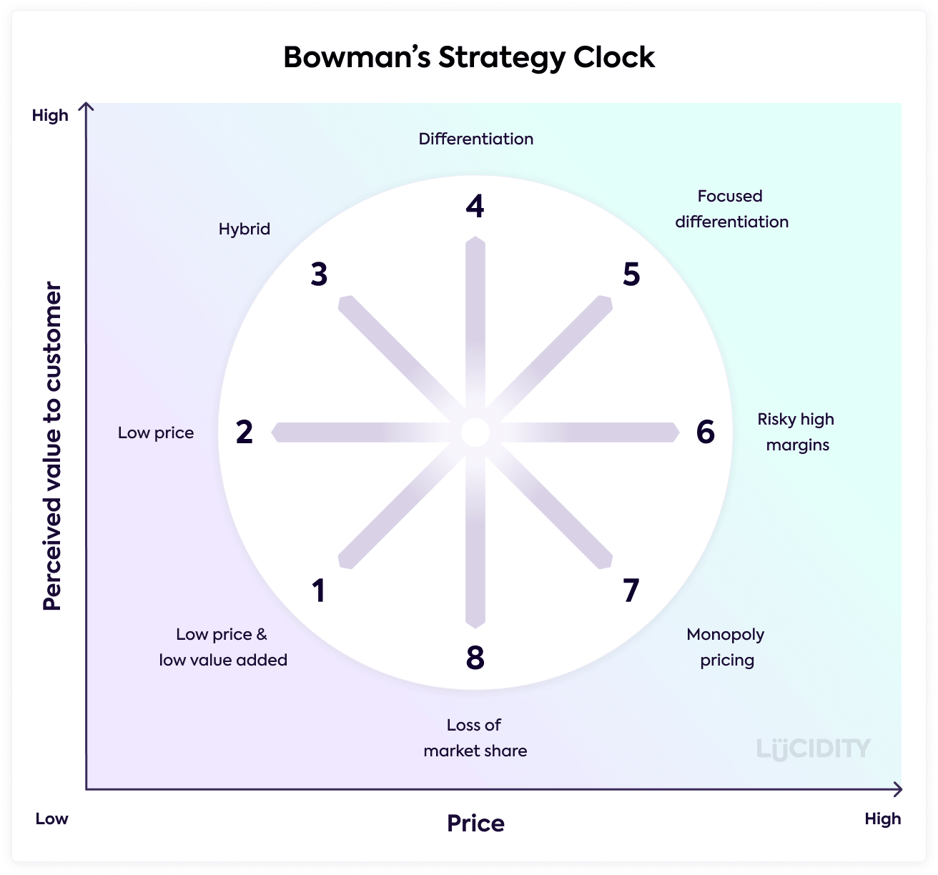

In order to utilise Bowman's Strategic Clock to analyse Adidas effectively, it is necessary to determine where Adidas falls on the clock. There are two possible sections that Adidas can fit within on Bowman’s Clock.
Firstly, Adidas can fit within the hybrid section. The hybrid section focuses on ensuring that the price is competitive, preferably with a low perceived price by consumers while also offering added value from the product. The success of a hybrid approach depends on achieving a balance between cost and distinctiveness while retaining healthy profits (Lucidity, 2022). Adidas provides a large array of products, allowing them to offer items at a wide range of prices. This allows them to ensure that they are competitive compared to their rivals. While certain products can be seen as expensive, others can be seen as low priced with good value.
Secondly, Adidas can fit into the differential section. In a differentiation strategy, a company focuses on distinguishing its products or services from those of its rivals by enhancing their perceived value. This strategy encompasses product diversity to distinctive characteristics within a main product. Within the range of products Adidas offers they attempt to create styles and products that are different. Adidas utilise partnership with high profile celebrities in order to create innovative lines of products. They do this via collaborations by capitalising on their strength, authenticity, and reach. We will extend their portfolio of partners, which now includes Beyoncé, Pharrell Williams, David Beckham, and Lionel Messi, among others (Adidas, 2018).
Due to both of these factors, Adidas can find itself in between both hybrid and differential sections of Bowman’s Strategic Clock. They aim to create products which can be seen as good value by the consumer, as well as creating lines of products that have distinctive characteristics.

SWOT analysis
Strengths  - Value of the brand  - Iconic ‘Three Stripes’  - Diverse product range | Weaknesses  - Supply chain outsourcing  - Product pricing
Opportunities  - Sportswear industry growth  - E-commerce growth | Threats  - Competition in the industry
Strengths
- Adidas’ is the second largest sportswear company in the world only being behind Nike. The company controls a large section of the market share.
- Adidas’ ‘Three Stripe’ logo is iconic across the world. Adidas sportswear is easily identifiable due to the stripes.
- The wide range of products that Adidas producing opens up a large number of potential consumers. The company produces equipment for multiple sports and athletes.
Weaknesses
- Despite the fact that Adidas’ main customers are based in the US and Europe, Adidas outsources their production and supply to countries in Asia.
- Although Adidas offers a wide variety of price points, certain products such as their premium footwear can be seen as overly expensive.
Opportunities
- The sportswear industry is growing in popularity at an increasing rate, with the industry expected to be valued at $267 billion by 2028.
- The growth of e-commerce provides Adidas with a platform to sell products around the world without the need for physical stores.
Threats
- The competition within the sportswear industry is extremely high. Brands such as Nike, Puma and Under Armour all compete for the same consumers.

Stakeholder Analysis
Keep Satisfied  - Employees – maintain a healthy and happy employee base  - Key Partners – maintain good relationships with sponsored figure  - Workers unions – avoid infringing on workers rights  - Shareholders – ensure investors in the business are satisfied with the direction | Manage Closely  - Supply chains – ensure the supply chains are working efficiently  - Distributers – make sure that the distribution network is operating correctly and at an efficient level  - Executives – must be managed so the company leadership is content with the company’s direction
Monitor  - Competitors – monitor other brands for new trends.  - Journalists – what is reported about the company in the media  - Workers in outsourced production factories – monitor the conditions and happiness of outsourced factory workers | Keep Informed  - Retailers – keep retailers informed of new products and campaigns

Conclusion
While Adidas’ roots are found in small town Bavaria, the company has now evolved into a giant of the sportswear industry. Its products are owned by billions of people worldwide and the company owns a large portion of the market. The company is immediately recognisable due to the effective Three Stripes advertising the original founder developed. The company uses the strategic management ideals developed by Peter Drucker and the company aim to develop the mental well being of their employees. The company also focus on creating a good customer experience while attempting to become more sustainable. Adidas has strong competition in their industry from multiple big-name brands however new entrants into the industry will struggle to gain a foothold compared to Adidas and its rivals. Adidas has the opportunity to expand their business in the coming years through online sales however the competition is becoming continuously stronger. Adidas has been able to solidify their place on the world stage and has created a loyal following by creating good products while not charging extortionate prices. Adidas will look to continue their growth in the coming years.

References

Bibliography
AboutAdidas. (2015). HISTORY. Retrieved from adidas.com: https://www.adidas-group.com/en/about/history/
AboutAdidas. (2018). OUR STRATEGIC FOCUS AREAS . Retrieved from Adidas.com: https://www.adidas-group.com/en/about/strategy-overview/#:~:text=Our%20strategic%20focus%20is%20on,pushing%20the%20boundaries%20in%20sustainability.
Adidas. (2017). SUPPLY CHAIN. Retrieved from adidas-group.com: https://www.adidas-group.com/en/sustainability/social-impacts/supply-chain/
Adidas. (2018). AboutStrategy. Retrieved from Adidas-group.com: https://www.adidas-group.com/en/about/strategy-overview/#:~:text=Our%20strategic%20focus%20is%20on,pushing%20the%20boundaries%20in%20sustainability.
Adidas. (2018). OUR PEOPLE. Retrieved from Adidas.com: https://www.adidas-group.com/en/about/strategy-overview/#:~:text=Our%20strategic%20focus%20is%20on,pushing%20the%20boundaries%20in%20sustainability.
Adidas. (2018). OUR STRATEGIC FOCUS AREAS . Retrieved from adidas-group.com: https://www.adidas-group.com/en/about/strategy-overview/
All Top Everything. (2022, October 6). Top 10 Biggest Sportswear Brands in the World. Retrieved from alltopeverything.com: https://www.alltopeverything.com/top-10-sportswear-brands/
all, J. e. (2011). Exploring Strategy Text and Cases. Pearson Education.
Connolly, K. (2009, October 19). Adidas v Puma: the bitter rivalry that runs and runs. Retrieved from theguardian.co.uk: https://www.theguardian.com/sport/2009/oct/19/rivalry-between-adidas-and-puma
Fortune Business Insights. (2020). Market Research Report.
IMD. (2022, August). What is a Business Strategy? And how to develop one! Retrieved from IMD.org: https://www.imd.org/reflections/business-strategy/#:~:text=In%20essence%2C%20a%20business%20strategy,strategic%20destination%20for%20a%20company.
Indeed Editorial Team. (2021, November 16). What Is Competitive Strategy? . Retrieved from indeed.com: https://www.indeed.com/career-advice/career-development/competitive-strategy
Investopedia Team. (2022, August 01). Porter's 5 Forces Explained and How to Use the Model. Retrieved from investopedia.com: https://www.investopedia.com/terms/p/porter.asp
Johnson, G. (2011). Exploring Strategy. Pearson Education.
Lucidity. (2022). Introduction to Bowman’s Strategy Clock. Retrieved from https://getlucidity.com/strategy-resources/introduction-to-bowmans-strategy-clock/
MindTools Team. (2017). Mintzberg's 5 Ps of Strategy. Retrieved from mindtools.com: https://www.mindtools.com/pages/article/mintzberg-5ps.htm
Pratap, A. (2019, March 15). Adidas Sources of Competitive advantage. Retrieved from https://www.notesmatic.com/adidas-sources-of-competitive-advantage/
Robinson, C. (2009, May 20). What Is Adidas? Retrieved from SportsRec.com: https://www.sportsrec.com/history-adidas-5398089.html
Think Insights. (2021). Bowman’s Strategic Clock – How to position your product? Retrieved from thinkinsights.com: https://thinkinsights.net/strategy/bowmans-strategic-clock/
Tighe, D. (2022, July 27). Market share of the U.S. sports apparel and footwear market as of 2018, by company. Retrieved from statista.com: https://www.statista.com/statistics/896595/sports-apparel-market-share-by-company-us/
Walters, M. (2021, August 3). THE HISTORY OF ADIDAS: A BACKGROUND OF COLLABORATION AND INNOVATION. Retrieved from gameplan-a.com: https://www.gameplan-a.com/2021/08/the-history-of-adidas-a-background-of-collaboration-and-innovation/

