

Course Title: MBA - International Business
Term 2

Student Name: Mansi Parmar
Student ID: 2507140

Module Name: International Marketing: Principles and Practices

Module Code: LCMB7026
Lecturer’s Name: Tushara Balendran

An International Marketing Report on Louis Vuitton in Brazil and Germany
Table of Contents
1. Introduction 3
1.1 Background 4
2. Comparative Macro-Environment Analysis 5
2.1 PESTEL Overview 5
2.2 Hofstede Model 9
3. Comparative STP and International Marketing Mix Analysis 11
3.1 Segmentation, Targeting, and Positioning 11
3.2 Product Strategy 12
3.3 Pricing Strategy 13
3.4 Place and Distribution Strategy 13
3.5 Promotion Strategy 14
3.6 People, Process, and Physical Evidence 14
4. Directional Development Strategy in Brazil 15
5. Ethical and Unethical Marketing Evaluation of Louis Vuitton in Brazil 16
5.1 Ethical Marketing Practices 16
5.2 Unethical Marketing Practices 17
6. Recommendations for Louis Vuitton 18
6.1 Recommendations for Brazil 18
6.2 Recommendations for Germany 19
7. Reflective Account Using Gibbs’ Reflective Cycle 19
8. Conclusion 22
References 24
Appendix 28

1. Introduction

Figure 1: Company Logo
Source: (Louis Vuitton, 2026)
The flag brand of LVMH corporation is Louis Vuitton, one of the most famous and appreciated luxury brands of the world, the value of the brand is estimated to be approximately $47.2 billion in 2023. The luxury market has an international portfolio of the brand that is among the most complex to manage; the brand operates in more than 50 countries (Hasan et al., 2024).
The report compares the macro-environment of both countries using the PESTEL model, Hofstede’s Cultural Dimensions framework is applied to evaluate cross-cultural differences influencing consumer behaviour and international marketing adaptation in Brazil and Germany. In addition, compares the STP and the 7Ps marketing mix in the two markets, analyses the directional development strategy of Louis Vuitton in Brazil through the Ansoff Matrix, critically examines ethical issues, and finally provides forward-looking strategic recommendations. Furthermore, Gibbs’ Reflective Cycle is used to support critical self-reflection on the learning process, enabling an evaluation of insights gained and future improvements in strategic marketing analysis.

1.1 Background
The brand, Louis Vuitton, was established in Paris in the year 1854 by Louis Vuitton, who initially started by specialising in trunk making and later became one of the most recognised luxury fashion houses of the world. It is the flagship brand of the LVMH Moet Hennessy Louis Vuitton the largest luxury conglomerate in the world today. Having presence in more than 50 countries and its stores spread all over the world, Louis Vuitton deals with leather products, ready-to wear, shoes, accessories, watches, jewellery, and perfumes (Bai, McColl and Moore, 2021).
Mission and Vision
Mission: To critically analyse and compare Louis Vuitton’s international marketing strategies in Brazil and Germany to evaluate their effectiveness, ethical implications, and strategic alignment.
Vision: To provide strategic insights that support the development of culturally adaptive, ethically responsible, and sustainable luxury marketing practices across diverse global markets.

2. Comparative Macro-Environment Analysis

2.1 PESTEL Overview

Figure 2: PESTEL Analysis
Source: (Bai, McColl and Moore, 2021)

Political Environment
Unfavourable for Brazil —
- Brazil is a federal presidential republic which is both typified by repeated political instability and one of the most protectionist trade policies globally. Finished leather goods and accessories are levied with import tariffs up to 60 percent and atop a multi-layered ICMS state sales tax of 13-19, retail costs are artificially increased and the possible consumer base of Louis Vuitton is dramatically reduced (Bai, McColl and Moore, 2021).
Favourable for Germany —
- The country is a part of the European Union; therefore, having a very stable parliamentary structure and functioning in a single European-union marketplace, which has removed all intraintra-EU tariffs (Malama, Chowdhury and Hyder, 2022).
Economic Environment
Unfavourable for Brazil —
- The GDP of Brazil is around $2.08 trillion, and its Gini coefficient is one of the highest in the world at 52.9. The severe income inequality significantly limits the luxury-ready consumers (Rashkova et al., 2023).
Favourable for Germany —
- Germany has a very stable economic condition that has a GDP of roughly $4.4 trillion, a Gini coefficient of only 31.7 coupled with an established luxury market with a value of around $8.9 billion of the Brazilian value of almost four times, 8.9 billion, in 2023 Vuitton (Rashkova et al., 2023).

Social and Cultural Environment
Social Environment
Favourable for Brazil —
- The level of aspirational middle- and upper-class consumer is developing in Brazil, which is highly conglomerated in urban centres like São Paulo and Rio de Janeiro, the locations where the process of luxury consumption is greatly evident (Hong et al., 2022).
Favourable for Germany —
- The German consumers are highly socially conscious towards sustainability, ethical consumption and responsible buying behaviour. An increasing number of buyers are looking to purchase luxury products that consider environmental and ethical values, which opens the prospect of brands that resonate with the socially conscious demands of customers (Tafani et al., 2024).
Cultural Environment
Favourable for Brazil —
- Cultural Dimensions According to Hofstede, Brazil has high scores in power distance and in collectivism, which promote conspicuous consumption in which owning luxuries is a symbol of prestige and social status (Hong et al., 2022).
Favourable for Germany —
- Germany is high on personalism and long-term orientation and the consumer attitudes are on crafts, genuineness, and tastes of low luxury than open display of status. It is a cultural inclination that leaves openings on how Louis Vuitton can position itself as a heritage, quality, and responsible luxury (Tafani et al., 2024).

Hofstede Model
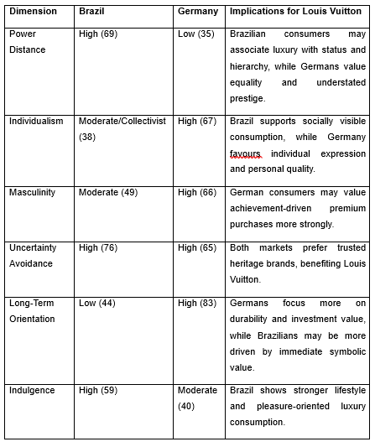
The model by Hofstede provides beneficial benefits to developing an organized frame of cross-nationally parallel comparison of cultural behaviour and empowers brands to systematically project consumer inspirations. The weaknesses of it are its extreme simplification of cultures into stagnant dimensions, inability to consider such changes in generations in consumer values, and the possibility of stereotyped culture that does not consider the substantial intra-country diversity (Tafani et al., 2024).
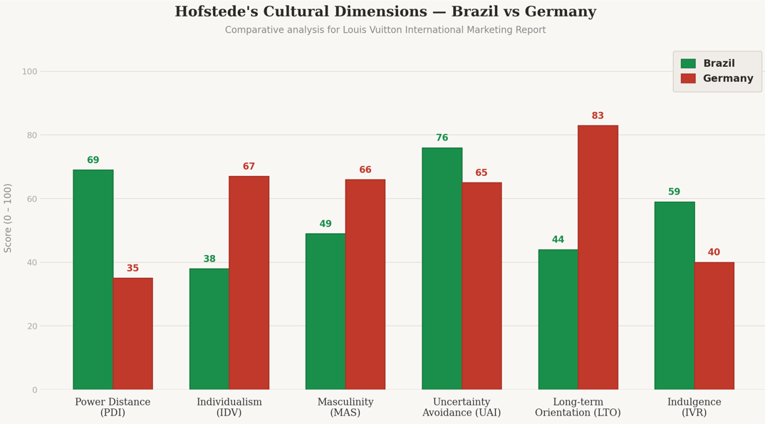
Figure 3: Hofstede’s Cultural Dimensions Graph
Source: (Tafani et al., 2024)
Advantages
- Provides a simple, structured framework for comparing cultures across countries
- Helps businesses predict consumer behaviour and tailor marketing strategies accordingly (Tafani et al., 2024).
- Widely validated across 70+ countries, making it globally applicable
Disadvantages
- Oversimplifies complex cultures into fixed numerical scores, ignoring internal diversity
- Data is outdated — original research conducted in the 1970s may not reflect modern consumer values (Malama, Chowdhury and Hyder, 2022).
- Risk of cultural stereotyping, treating entire nations as culturally uniform

Technological Environment
Partially Favourable for Brazil —
- Internet penetration in Brazil is estimated to be 84% with mobile commerce increasing by an estimated 27 a year. Nevertheless, the majority of logistics infrastructure is highly concentrated in the large city centres, which restrict efficient e-commerce outside of Brazil across other cities such as Rio and Sao (Kinawy, 2024).
Favourable for Germany —
- The internet penetration rate in Germany is about 88% and this is facilitated by high level of logistics infrastructure across the country, which facilitates easy omnichannel retailing (Kinawy, 2024).

Environmental Factor
Unfavourable for Brazil —
- Brazil undergoes the increasing international inspection of the Amazon deforestation and sustainability of the supply chains. It puts luxury brands such as Louis Vuitton under stress to show responsible sourcing behaviours, therefore, miss out on reputational harm in a more environmentally conscious global market (Kinawy, 2024).
Unfavourable for Germany —
- Consumers in Germany are very green and aligned with the European Green Deal. Consumers require self-proven sustainability emissions, i.e., Louis Vuitton needs to proactively communicate its efforts, including the LVMH LIFE 360 programme, which aims to become carbon-neutral by 2026, to ensure sustainability credibility in this market (Kinawy, 2024).

Legal Environment
Unfavourable for Brazil —
- A complex incentive taxes regime, huge rates of bureaucracy at the customs department and lax intellectual property laws characterize the Brazilian legal environment (Victoria-Sophie Osburg et al., 2024).
Partially Unfavourable for Germany —
- Germany has stringent GDPR laws that put considerable restrictions on online consumer profiling and retargeting. Although this ensures high-quality consumer protection, it also limits the capacity of Louis Vuitton to execute personalised digital marketing campaigns on a large scale, which can be a considerable limitation in an ever more information-based marketing context (Victoria-Sophie Osburg et al., 2024).
PESTEL Similarities and Differences
Similarities:
In terms of similarities, the two countries, Brazil and Germany, are governed by similar systems, democratic system, which has influence on trade and business regulation in both countries, and the two countries have shown increasing tendency towards luxury consumption implying that iloitzerland Vuitton has a consumer base in the two countries that is commercially viable (Kinawy, 2024).
Differences:
There are many more differences between the two markets than their similarities. In politics, Brazil is unreliable and protects its imports through tariffs of up to 60 percent, whereas Germany is a stable EU member with access to a single market, without tariffs (Bai, McColl and Moore, 2021). Germany has a luxury market that is almost four times bigger than Brazil and its considerably lower Gini coefficient showcases a much more diverse base of consumers that is more stable (Rashkova et al., 2023).

3. Comparative STP and International Marketing Mix Analysis

3.1 Segmentation, Targeting, and Positioning
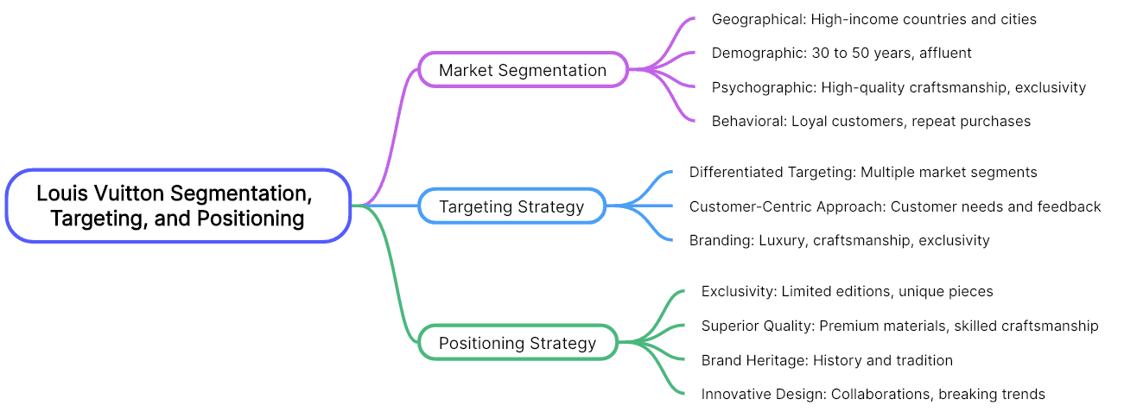
Figure 4: Segmentation, Targeting, and Positioning of Louis Vuitton
Source: (Victoria-Sophie Osburg et al., 2024)
Demographic Segmentation
The demographic segmentation points out the difference in the income levels, occupation and social classes in the two markets.
Age
- Brazil: Young affluent millennials and Gen Z luxury aspirers (25–40).
- Germany: Affluent professionals and mature luxury investors (30–55).
Gender
- Women’s handbags and accessories remain strong in both markets.
- Men’s luxury fashion and leather goods are growing in Germany.
Income
- Brazil focuses mainly on ultra-high-net-worth consumers.
- Germany targets broader high-income professionals.
Occupation
Executives, entrepreneurs, professionals and business elites form key segments.
Favourable
Germany: The availability of a large, solid, and wealthy population which comprises of professionals, executives and high income earners will guarantee a consistent demand of luxury products.
Brazil: With an increasing number of ultra-high-net-worth individuals and a growing aspirational upper- middle-income group, the luxury consumption has good growth prospects.
Unfavourable
Germany: The market is not new and this reduces the chances of a quick growth as it is rather mature just like the emerging economies.
Brazil: Income inequality is high and limits the number of the real luxurious consumers of the market making it more concentrated and less stable (Victoria-Sophie Osburg et al., 2024; Nguyen-Viet, 2022).
Geographic Segmentation
Geographic segmentation focuses on the distribution of target consumers across locations Geographic segmentation deals with the geographical distribution of the target consumers within the countries.
Favourable
Germany: Geographically locally spread out the wealthy population throughout cities like Berlin, Munich and Frankfurt is also good as the market accessibility is increased.
Brazil: Great concentration of wealth in such metropolises as Rio de Janeiro and Sao Paulo allows targeted marketing and cost-effective retailing activities.

Unfavourable
Germany: There is a broader geographic coverage and operational complexity with distribution costs to maintain brand presence.
Brazil: The presence of a small number of centres would reduce their possibilities of expansion outside of major cities (Victoria-Sophie Osburg et al., 2024; Nguyen-Viet, 2022).
Psychographic Segmentation
Psychographic segmentation analyzes the lifestyles, values and motives of consumers towards consuming luxury.
Favourable
Germany: Consumers are focused on quality, authenticity and sustainability which is compliant with the idea of conscious luxury and permits sustaining brand loyalty in the long term.
Brazil: Brazil has a high status, prestige, and social recognition and thus the consumption of symbolic luxury products is high.
Unfavourable
Germany: There are high expectations towards ethical sourcing and sustainability, which put pressure on brands to be transparent and responsible.
Brazil: The social-status-based luxury consumption can be affected by economic cycles and external social forces resulting in unstable demand (Victoria-Sophie Osburg et al., 2024; Nguyen-Viet, 2022).
VALS (Values, Attitudes, and Lifestyles) Segmentation
Beyond conventional psychographic segmentation, VALS allows to better understand the values and motivations behind consumer behaviour on luxury brands in both the Brazilian and German markets (Nguyen-Viet, 2022).
In the Brazilian market, Louis Vuitton's typical customers belong to the segments Achievers and Strivers. Achievers are status-seeking, achievement-oriented consumers who invest in luxury brands such as Louis Vuitton to signify their success and achievements. Strivers are humbler and less well-off, but also aspirational and highly likely to use luxury brands as a status symbol (Victoria-Sophie Osburg et al., 2024). In Germany, the most prominent VALS groups are Thinkers and Innovators. Thinkers are responsible and mature consumers focused on quality, authenticity and durability, and view luxury as a good investment. Innovators are the group with the most resources - successful, worldly, and open to high-quality newness (Tafani et al., 2024).
Targeting
In both markets, Louis Vuitton mainly focuses on high-net-worth people, but tailors it is depending on the size and attributes of the market. In Brazil, the emphasis is on a smaller but faster rising elite group, and aspirational customers of symbolic ownership of luxuries. In Germany, the brand aims at much more prosperous population covering professionals and ethically conscious customers, securing a more consistent and varied customer base (Victoria-Sophie Osburg et al., 2024; Nguyen-Viet, 2022).
Positioning
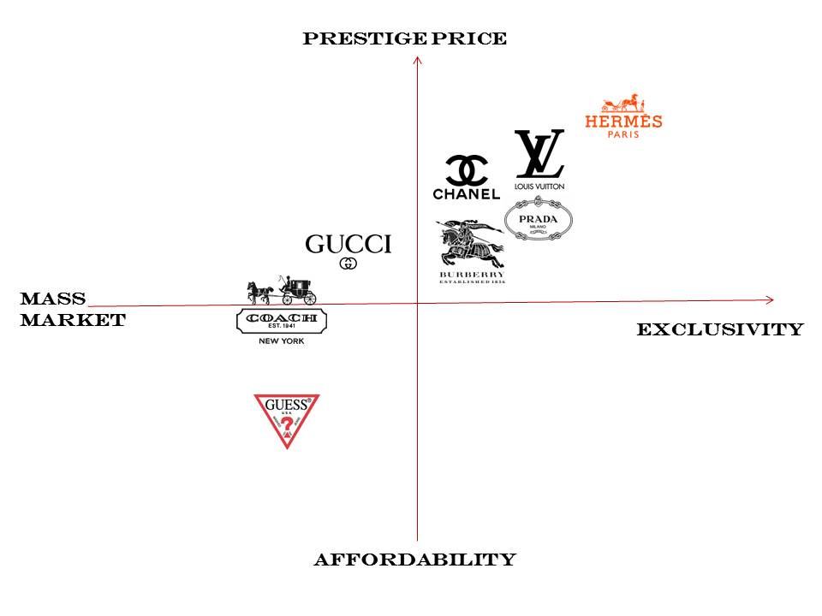
Figure 5: Positioning map of Louis Vuitton
Sources: (Victoria-Sophie Osburg et al., 2024)
There is a major difference in brand positioning in the two countries. Louis Vuitton in Brazil is positioned as the representation of exclusiveness, prestige, and social status, which is consistent with the need of buyers to have conspicuous consumption. In contrast, consumers in Germany seek authenticity and conscious luxury, focusing on quality and sustainability over status symbolism and competition, so the brand must focus on these attributes (Victoria-Sophie Osburg et al., 2024; Nguyen-Viet, 2022).
Undifferentiated Targeting involves promoting a single product to the whole market without any differentiation. This is not the case with Louis Vuitton in both markets, since the luxury market necessitates targeting (Victoria-Sophie Osburg et al., 2024). However, the brand's product line, standardised throughout the world - such as the Monogram canvas product line - can be considered as a semi- undifferentiated generic "footprint" maintained in Brazil and Germany to emphasise global brand equity.
Differentiated Targeting is a marketing strategy that entails targeting several segments with different offerings. In Germany, Louis Vuitton uses a differentiated targeting approach by targeting both older affluent consumers (aged 30-55) focused on luxury investing (heritage and investment value), and younger high-income professionals (28-40) who care more for environmental and ethical concerns (Tafani et al., 2024).
Concentrated (Niche) Targeting involves only targeting one segment. This is the most common approach in Brazil where Louis Vuitton targets exclusively the ultra-high net worth segment who mostly reside in São Paulo and Rio de Janeiro (Elo and Silva, 2022).
Similarities and Differences
Similarities
There are a number of key similarities between Brazil and Germany in terms of Louis Vuitton's STP. Both markets segment consumers primarily as high-income earners and affluent professionals, primarily based on demographic criteria such as income, profession and lifestyle (Victoria-Sophie Osburg et al., 2024). For example, Louis Vuitton targets corporate executives, entrepreneurs, and affluent individuals who view luxury brands as a symbol of success and social status in both markets (Nguyen-Viet, 2022).
Differences
However, although there are similarities in how LV uses the STP approach in Brazil and Germany, there are also key points of difference. In segmentation, Brazil has a smaller target market of very high-end consumers based on a high degree of income inequality (Gini 52.9), while Germany has a more diverse target market of high-end professionals based on a more stable and equal income distribution (Gini 31.7) (Dirk et al., 2016). Thus, in Brazil, a base of 1-2% wealthiest individuals is targeted in São Paulo and Rio de Janeiro; in Germany, targeting occurs across a number of cities including Berlin, Munich and Frankfurt (Nguyen-Viet, 2022).
International Marketing Mix Analysis 7Ps
The International Marketing Mix (7Ps) is a framework that helps organizations manage marketing across global markets by using seven elements-product, price, place, promotion, people, process, and physical evidence-adapted to different environments to meet customer needs and achieve goals.

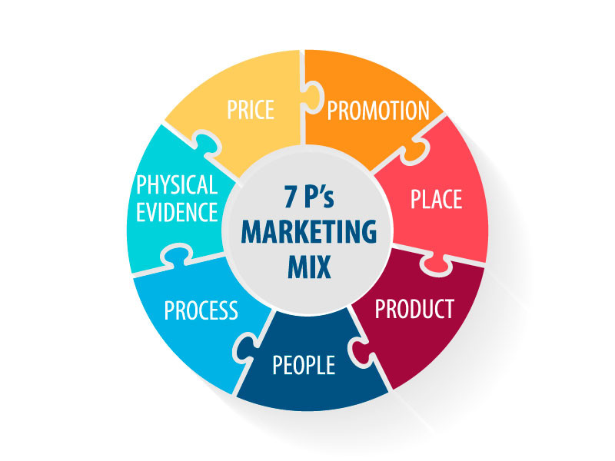

Figure: 7Ps of Marketing Mix
Source: (Bai, McColl and Moore, 2021)

3.2 Product Strategy
Louis Vuitton maintains a globally unified product line including leather goods, ready-to-wear, accessories, watches, jewellery, and fragrances (Nguyen-Viet, 2022).
Product Width —
The brand specialises in selective product lines in Brazil which are based on status-driven consumers, where leather products, accessories, and fragrances are the main product lines it deals with. In Germany, a wider range occurs, with ready-to-wear, jewellery, watches, shoes and tailored services being served, which is based on the purchasing behaviour of the German consumer being investment-oriented (Vuong, Lam and Bui, 2024).
Product Depth —
Personalisation services such as hot-stamping, and various Monogram canvas variations are used to create depth in Brazil. Depth in Germany goes even deeper with limited-edition projects, including the Yayoi Kusama line and Made-to-Order offerings, whereby consumers are willing to appreciate personalisation and workmanship over the traditional exclusivity with an item (Safeer et al., 2022).

3.3 Pricing Strategy
Pricing is the most radically differentiated element in the marketing mix of Louis Vuitton in the two markets. An archetypal Monogram Neverful MM handbag in Germany would traditionally retail at approximately 1,400 euro of the prices targeted less 19% VAT that is consistent with the overall European high-end brand of luxury pricing lifestyle. BRL 12, 500-14,000 price of the equivalent product in Brazil or a premium of about 64-85% of the European prices at Brazilian exchange rates in the year 2023 (Vuong, Lam and Bui, 2024).

3.4 Place and Distribution Strategy
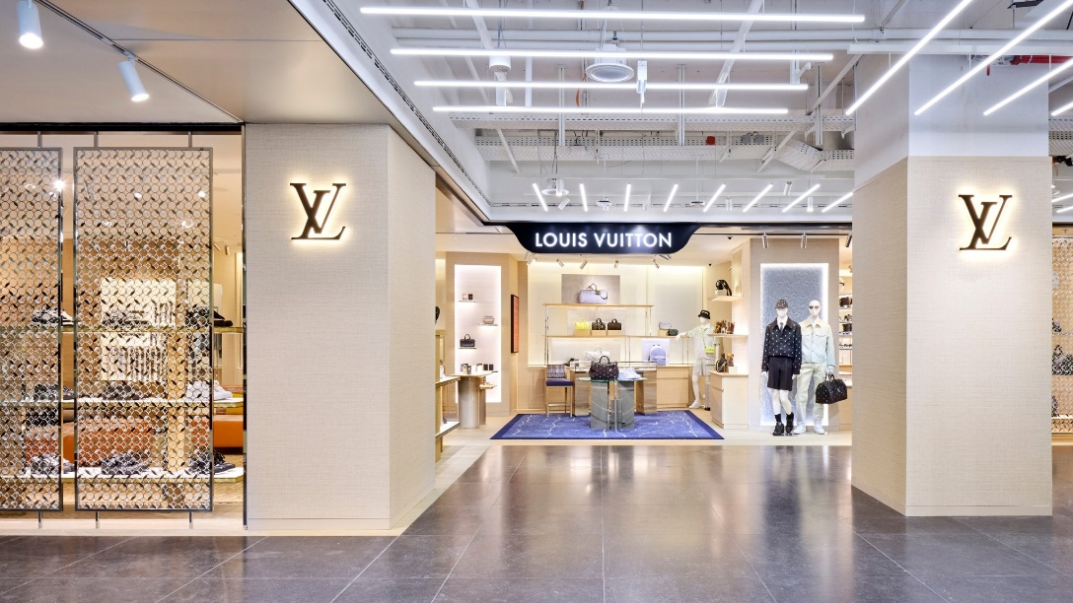
Figure 6: LV store in Germany
Source: (Louis Vuitton, 2026)
In Germany, Louis Vuitton has flagships in Berlin, Munich, Hamburg, Frankfurt and Dusseldorf as their whereabouts is in the most prime shopping areas within the cities. There is an already established e-commerce platform that provides efficient service within the country including the up-to-date delivery that will fit the sophisticated requirements of the omnichannel consumer in Germany (Lang et al., 2022).
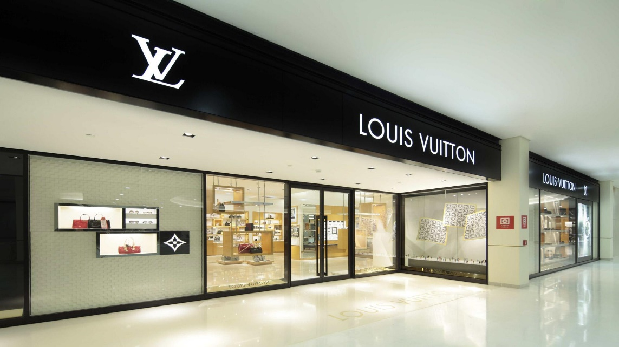
Figure 7: LV store in Brazil
Source: (Louis Vuitton, 2026)
The brand is specially few in number of retail stores in Brazil, and they include stores in Iguatemi and Cidade Jardim complex of luxuries of the city of Santiago of Bahia in the state of Sao Paulo, as well as in the district of Ipanema of Rio de Janeiro. One of the counted strategies is the retail touch point scarcity: it is a luxury to enter, and their entrance to the shop with Louis Vuitton is extremely prestigious as far as their social status is concerned (Özsomer, Batra and Steenkamp, 2024).

3.5 Promotion Strategy
The promotion techniques are externalized towards different cultural diversities between the markets. High-impact aspirational marketing products and services used by Louis Vuitton in Brazil include celebrity endorsements, social media and cultural sponsorships including alignment with the São Paulo Fashion Week. Brazil has the highest population of Instagram users of approximately 113 million, as of 2023, and it is one of the biggest social media markets, and the aspirational, celebratory, globally refined visual narrative is a story that accumulates quite well with the Brazilian customers (Özsomer, Batra and Steenkamp, 2024). In Germany advertising is extremely reserved and scholarly. This advertising, foreign use of high-end print media, sponsoring of cultural and art events, and working in association with the German cultural institutions represent a manifestation of the fact that the market is directed towards the substance, rather than the spectacle (Senanu, Anning-Dorson and Tackie, 2023).

3.6 People, Process, and Physical Evidence
People
Louis Vuitton has a globally integrated human resource policy backed by intensive training classes to provide a uniform luxury experience on a global basis. LVMH has a workforce of more than 200,000 employees spread across 28 countries in their retail advisor, brand experts and client relationship managers positions. However, the delivery of services is customized to the local cultural expectations. Brazil Client-advisor relationships in Brazil are interpersonal with traditions of warmness, emotional connection and relationship-building with staff basing their work on creating memorable, socially engaging experiences. Conversely, German workers are more focused on professionalism, efficiency and profound product knowledge and value customer autonomy and privacy (Senanu, Anning-Dorson and Tackie, 2023).
Process
To provide a smooth luxury experience, Louis Vuitton has a standardized but adaptable service process that guarantees seamless experience. The buying experience in Brazil is interactive and experience based, featured in person-to-person conversations and celebratory shopping atmosphere. Germany is a more organized and efficiency-based thinking process that revolves around clarity, precision and smooth transactions. Louis Vuitton adheres to a luxury service recovery procedure as far as customer complaints are concerned in both markets (Senanu, Anning-Dorson and Tackie, 2023).
Physical Evidence
The body of evidence is very important in supporting the luxury positioning of Louis Vuitton. The designs of the interior of the botique store in Brazil make it more goal-aspirational and exclusive, with its rich imagery and in-depth designs. In Germany, the design of stores displays the heritage and modernism minimalism in design, in accordance with the local aesthetics.
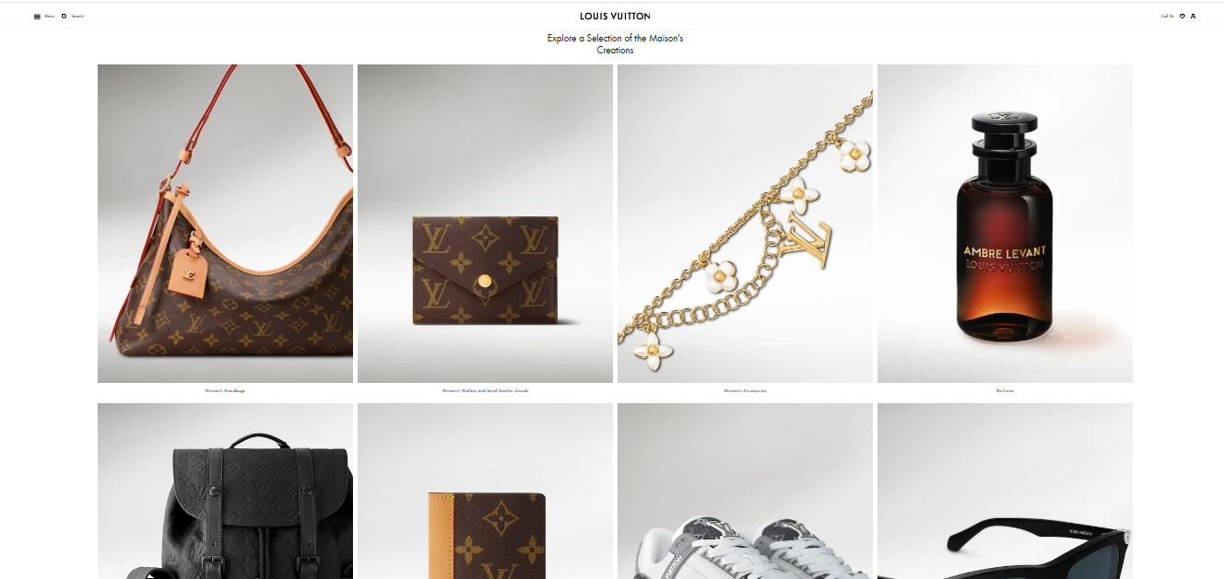

Figure 8: LV website
Source: (Louis Vuitton, 2026)
Moreover, the online presence of the brand, especially the official website of Louis Vuitton is a significant aspect of physical evidence. The site is luxurious due to the clean design, high-quality images, easy navigation, and customized online shopping experience. The luxury experience can be continued outside of the store by packaging as well as iconic monogram boxes and high-quality materials that can serve as a tangible emblem of exclusivity and brand tradition (Elo and Silva, 2022).
Similarities and Differences in 7Ps of Germany and Brazil
Similarities
In Brazil, as well as Germany, Louis Vuitton is a very strong global brand. The product mix is standardized, providing the same basic luxury items like leather products, accessories and ready to wear lines. Both markets adopt a premium pricing strategy that supports exclusivity and prestige by the brand. Distribution wise, Louis Vuitton employs selective distribution that consists of flagship stores in the high-end luxury areas. Promotion is internationally environmentally geared holding on to brand image, legacy, and exclusivity by use of integrated marketing communications (IMC) (Elo and Silva, 2022).
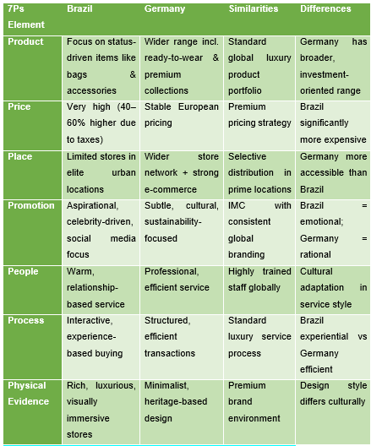
Table 2: Similarities and Differences in 7Ps of Germany and Brazil
Source: (Elo and Silva, 2022)
Differences
There are considerable adaptations despite global uniformity. Pricing is considerably high in Brazil because of import taxes whereas in Germany it is relatively stable and at European prices. Place is also a factor because Germany is more geographically covered and high in terms of e-commerce whilst Brazil is confined to just few elite urban stores. Brazil does promotions aspirational and celebrity-oriented whereas Germany has subtle, cultural and sustainability oriented promotion (Elo and Silva, 2022).

4. Directional Development Strategy in Brazil
To critically assess the growth direction of Louis Vuitton in Brazil Ansoff Matrix has been employed that characters four strategic vectors which include the following: market penetration, market development, product development and diversification.
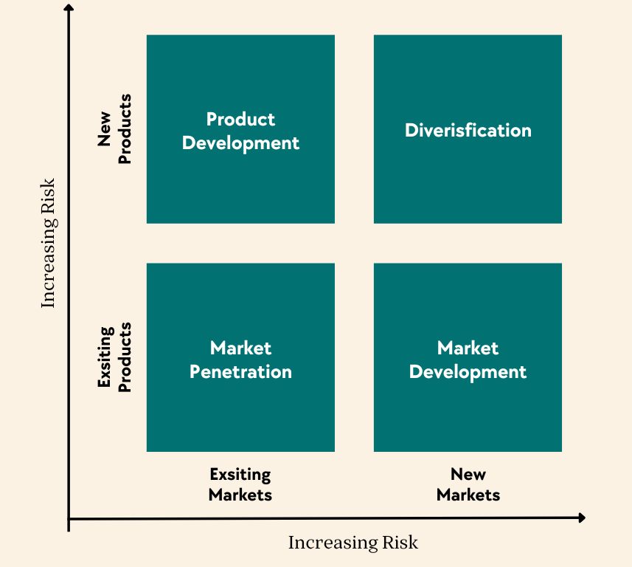
Figure 9: Ansoff Matrix
Source: (VanZandt, 2023)
In Brazil, market penetration strategy of the brand is the dominant one. Louis Vuitton is not aiming at expansion of its geographical coverage but increasing its concentration in its already existing ultra-premium consumer market. This has been tested by the fact that it has just two large retail stores which are strictly located in just two cities Sao Paulo as well as Rio de Janeiro (Elo and Silva, 2022). Strategic tool is the tactic of scarcity, and it applies to the maintenance of a privilege, which is associated with access to the brand, and its strengthening exclusivity positioning in the market that brand rarity can be ascribed with unmatched social ratings (Cai et al., 2025).

5. Ethical and Unethical Marketing Evaluation of Louis Vuitton in Brazil

5.1 Ethical Marketing Practices
Promotion: Culturally Inclusive Campaigns Featuring Brazilian Identity
Promotion is a term applied in brand communication that conveys messages to the people to inform, persuade, and influence them about the products and brand image. According to P Promotion, Louis Vuitton has demonstrated some ethics through some few campaigns that market Brazil culture and identity. Brazilian the Brazilian models, with the Afro-Brazilian talent used, were appearing in campaign content aired and distributed in Brazil, during which time luxury fashion was under massive backlash everywhere in the world because of its racial inclusivity (Santos, 2023).
Product: Commitment to Craftsmanship, Transparency and Anti-Counterfeiting
In the Product P, Louis Vuitton has been ethically justifiable in Brazil through fighting counterfeit products aggressively in form of legal suit and consumer education. One of the most behavioural markets in Latin America is the counterfeit market, and faked LV products can be found in the streets market in both Rio de Janeiro and Santiago (Sao Paulo). The continuous legal prosecution of counterfeiters being conducted by the Louis Vuitton, working jointly with the Brazilian customs and federal police and educating customers about the dangerousness of fake products, including their links with exploiting labour, is an ethical solution (Santos, 2023).

5.2 Unethical Marketing Practices
Price: Exploitative Pricing in a Context of Extreme Inequality
Louis Vuitton operates according to a global high-end pricing policy in Brazil and Germany, and their products are exclusive and high-status. Nevertheless, the influence on it is quite diverse. The price of a Louis Vuitton Neverfull bag in Europe and Germany is about €1,400-€1,800 and in Brazil a Neverfull bag is as expensive as €2,000-€2,700 because of high importing taxes (Williams et al., 2022). The brand does not internalize these costs but completely transfers them onto the consumers (Henriksson, 2025).
Place & Physical Evidence: Exclusionary Store Environments
In Brazil, physically and psychologically isolationistic with respect to high-end shopping, Louis Vuitton flagship stores will be flocked in Brazil into high-end shopping malls, such as Shopping Cidade Jardim, located in Brazil (Williams et al., 2022). Interestingly, some instances of racial profiling have occurred in Brazil through the store environments which have been enforcing high door policies, a security team that checks whoever enters the store as well as an in-store ambient that can either be understood by people who do not belong to the affluent population or outside the white race as an indication that one should not be there (Henriksson, 2025).

6. Recommendations for Louis Vuitton

6.1 Recommendations for Brazil
At the same time, Louis Vuitton should re-work its STP and correct unfair practices among Price and Physical Evidence elements of 7Ps in Brazil. Firstly, the brand does not have to be limited to ultra-high-net-worth individuals and should include the new Afro-Brazilian professional demographic and aspirational upper middle-income millennials; namely, female customers aged between 25-40 in Rio de Janeiro, Belo Horizonte, and Sao Paulo. This is a stable segment which is technologically connected and highly sensitive of brands which is a personalized and authentic expression of the self (Vieira, 2025).

6.2 Recommendations for Germany
Expanding business in Germany, Louis Vuitton must heed the sensitivity of the environmental considerations, stringency of legal measures and cultural undertones of the nation and utilize a business approach that would appeal to the local culture. The brand should re-Segmentation by not only focusing on the old wealth buyers, but also work with environmentally conscious earning high income professionals aged between 28 and 40 and in these cities such as Berlin, Munich, and Frankfurt (Vieira, 2025). This category is the same category having economic means to purchase luxuries but is highly concerned with brands whose appearance is that of superficiality, statusist, or lacking in transparency (Chakraborty et al., 2023).

7. Reflective Account Using Gibbs’ Reflective Cycle
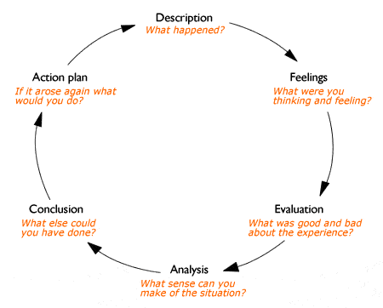
Figure 10: Gibbs’ Reflective Cycle
Source: (Hills, 2023)
Description
During this assessment, I was required to prepare a long term global market analysis report of the Louis Vuitton marketing campaigns in 2 target countries Brazil and Germany. This involved other analyses models including PESTEL, STP, 7p of marketing, ethical marketing and recommendations strategies. Firstly, I have selected Louis Vuitton as my desired counterpart due to its popularity beyond the national boundaries and variety of cross-cultural marketing practice (Rustaman and Widodo, 2023).
Feelings
It is understandable that I felt both thrilled and anxious when I started this assignment. It became obvious what the assignment was on since it included the study of a world-famous and luxurious brand in two countries with two polarities and cultures, which implied not only the presence of the knowledge of a marketing theory but also the understanding of socio-political contexts, cultural consumer behavior, and the ethics beyond marketing activities (Rustaman and Widodo, 2023). This was a topic that interested me personally, particularly considering the fact that Louis Vuitton is in a well-known place where aspirations, identity, and inequality converge that was frequently allowed to theorize and experiment on socially (Markkanen et al., 2023).
Evaluation
The aspect of the report that was most interesting to this process was the comparative aspect of the report. The comparison of two countries that are culturally and economically the reverse of Brazil and Germany forced me to reason point-blank how the same-brand may have the completely different meaning, be influenced by completely different ethical concerns and require absolutely different strategies depending on the circumstances in which it has to operate (Rustaman and Widodo, 2023). PESTEL framework was particularly helpful in establishing the macro-environmental analysis since I had a chance to comprehend which specific contextual factors, such as the Gini coefficient in Brazil and the laws regarding the racial equality, and the sustainability culture and consumer protection laws in Germany have impacted my subsequent analysis (Markkanen et al., 2023).
Analysis
Reflectively of this experience I can say that I learnt most during the most difficult moments. This is the kind of intellectual activity that Level 7 study is difficult to do when I was confronted with the challenge of coming up with the obvious evidence of what the specific pricing practices LV used in Brazil and this is what I should categorize as source triangulation and critical inference (making rational conclusions based on unfinished information).
Conclusion
In a reflective manner I may have been better off incorporating primary research lenses earlier on i.e. by attempting to establish a terrain on consumer sentiments study or brand perception survey with a bend on Brazil and Germany, rather than having to rely on secondary sources mostly. This would have given a better empirical contribution to my research on consumer behaviour of the two markets (Rustaman and Widodo, 2023). I also recognize that I would have gone deeper into the digital marketing procedure at Louis Vuitton particularly its application of social media in Brazil where digital usage is extremely high (Markkanen et al., 2023).
Action Plan
Just in case I do a similar job in future, I would start the research process way earlier, and I would have established a research plan of the various parts of the report to specific patterns and types of sources before I begin with the actual writing (Rustaman and Widodo, 2023).

8. Conclusion
This report has provided a comprehensive analysis regarding the international marketing of Louis Vuitton brand in Brazil and Germany. Through PESTEL, the macro-environmental variations would be identified as the two markets were rather different, with Brazil being characterized as uneconomically unequal and culturally varied, and Germany as eco-conscious and customer protection-oriented. It demonstrated that despite the reality that Louis Vuitton possesses the globally homogenous brand image, which is founded on the values that are considered traditional and exclusive, its marketing mix requires a significant alteration to be transformed not merely into the commercially viable, but also into the considerable social responsibility in all countries. The issues that were deemed ethical in both countries, which notably include the exploitative pricing and the store practice in which LV is discriminatory in Brazil and the risks encountered due to the greenwashing in Germany.

References
Bai, H., McColl, J. and Moore, C. (2021). Luxury fashion retailers’ localised marketing strategies in practice – evidence from China. International Marketing Review, 39(2), pp.352–370.
Cai, S., Liu, Y., Aduldecha, S. and Junaidi, J. (2025). Leveraging Customer Green Behavior Toward Green Marketing Mix and Electronic Word-of-Mouth. Sustainability, [online] 17(6), pp.2360–2360. doi: https://doi.org/10.3390/su17062360.
Chakraborty, S., Hoque, M.S., Biswas, M.C., Bardhan, D. and Lobaton, E. (2023). Fashion Recommendation Systems, Models and Methods: A Review. Informatics, [online] 8(3), p.49. doi: https://doi.org/10.3390/informatics8030049.
Elo, M. and Silva, S. (2022). Who creates international marketing agility? Diasporic agility guiding new market entry processes in emerging contexts. Thunderbird International Business Review, 64(5), pp.443–463. doi: https://doi.org/10.1002/tie.22284 .
Gupta, A.K., Garg, R.R., Khatter, H. and Sain, M. (2024). Counterfeiting Detection System: A Solution to Combat Product Counterfeiting. 2024 International Conference on Smart Technologies for Sustainable Development Goals (ICSTSDG), [online] pp.1–7. doi: https://doi.org/10.1109/icstsdg61998.2024.11026201.
Hasan, M.M., Rayhan, Z., Mukta, R.T. and Faruq, O. (2024). Research on Adapting Marketing Techniques to Different Culture Economics and Regulatory Environment to Entering New International Markets. Информатика. Экономика. Управление / Informatics. Economics. Management, [online] 3(4). doi: https://cyberleninka.ru/article/n/research-on-adapting-marketing-techniques-to-different-culture-economics-and-regulatory-environment-to-entering-new-international.
Henriksson, L. (2025). Excessive pricing and the elusive concept of exploitative abuse. [online] doi: https://doi.org/10.2139/ssrn.5180854.
Hills, R. (2023). Reflective Practice using Gibbs Reflective Cycle. [online] Rob Hills. doi: https://www.robhills.com.au/2018/07/31/reflective-practice/.
Hong, R., Zhang, Z., Zhang, C. and Hu, Z. (2022). Is brand globalness compatible with brand country-of-origin? An investigation of hybrid brand positioning strategies for emerging market brands. International Marketing Review, 40(1). doi: https://doi.org/10.1108/imr-08-2021-0260.
Kinawy, R.N. (2024). Unraveling consumer behavior: Exploring the influence of consumer ethnocentrism, domestic country bias, brand trust, and purchasing intentions. Strategic Change. doi: https://doi.org/10.1002/jsc.2607.
Lang, L.D., Behl, A., Guzmán, F., Pereira, V. and Del Giudice, M. (2022). The role of advertising, distribution intensity and store image in achieving global brand loyalty in an emerging market. International Marketing Review, 40(1). doi: https://doi.org/10.1108/imr-06-2021-0200.
Malama, M.F., Chowdhury, E.H. and Hyder, A.S. (2022). International marketing strategy of emerging market firms: the case of Bangladesh. Journal of Asia Business Studies, [online] 17(4). doi: https://doi.org/10.1108/jabs-12-2021-0504.
Markkanen, P., Välimäki, M., Anttila, M. and Kuuskorpi, M. (2023). A Reflective cycle: Understanding Challenging Situations in a School Setting. Educational Research, 62(1), pp.46–62. doi: https://www.tandfonline.com/doi/abs/10.1080/00131881.2020.1711790.
Nguyen-Viet, B. (2022). The impact of green marketing mix elements on green customer based brand equity in an emerging market. Asia-Pacific Journal of Business Administration, 15(1), pp.96–116. doi: https://doi.org/10.1108/apjba-08-2021-0398.
Özsomer, A., Batra, R. and Steenkamp, J.-B.E.M. (2024). Brands and Branding around the World. Journal of International Marketing, 32(3), pp.1–4. doi: https://doi.org/10.1177/1069031x241265816.
Rashkova, Y., Moi, L., Marku, E. and Cabiddu, F. (2023). Online integrated marketing communication strategies of international brands: standardization vs. adaptation approaches. Journal of Marketing Communications, 30(7), pp.1–24.
Rustaman, N.Y. and Widodo, A. (2023). Development of problem based learning for online tutorial program in plant development using Gibbs’ reflective cycle and e-portfolio to enhance reflective thinking skills. Journal of Physics: Conference Series, [online] 1157(2), p.022099. doi: https://doi.org/10.1088/1742-6596/1157/2/022099.
Safeer, A.A., Abrar, M., Liu, H. and Yuanqiong, H. (2022). Effects of perceived brand localness and perceived brand globalness on consumer behavioral intentions in emerging markets. Management Decision, 60(9). doi: https://doi.org/10.1108/md-10-2021-1296.
Santos, M. (2023). Dynamics of Cultural Diversity and Intercultural Communication in the Era of Multiculturalism and Cosmopolitanism in Brazil. International Journal of Sociology, [online] 8(1), pp.1–13. doi: https://pdfs.semanticscholar.org/c487/e985d653ddd3ad67e6b6c2723c8cba958ee7.pdf.
Senanu, B., Anning-Dorson, T. and Tackie, N.N. (2023). Social media insights for non-luxury fashion SMEs in emerging markets: evidence from young consumers. Journal of Fashion Marketing and Management: An International Journal, 27(6), pp.965–987. doi: https://doi.org/10.1108/jfmm-02-2022-0026.
Tafani, E., Vigneron, F., Azoulay, A., Crener, S. and Zahid, A. (2024). EXPRESS: The Influence of Culture and Gender in Luxury Brand Consumption: a Comparison across Western and Eastern Culture Consumers. Journal of International Marketing, 32(4). doi: https://doi.org/10.1177/1069031x241235629.
VanZandt, P. (2023). Analysis and Advantages of Ansoff Matrix. [online] IdeaScale. doi: https://ideascale.com/blog/analysis-and-advantages-of-ansoff-matrix/.
Victoria-Sophie Osburg, Vignesh Yoganathan, Bartsch, F., Mbaye Fall Diallo and Liu, H. (2024). How Sustainable Luxury Influences Product Value Perceptions and Behavioral Intentions: a Comparative Study of Emerging vs. Developed Markets. Journal of Business Ethics, 191(4). doi: https://doi.org/10.1007/s10551-024-05661-8.
Vieira, T. (2025). Analysing the effectiveness of chatbots as recommendation systems in fashion online retail: A Brazil and United Kingdom cross-cultural comparison. Journal of Global Fashion Marketing, pp.1–27. doi: https://doi.org/10.1080/20932685.2025.2491323.
Vuong, T.K., Lam, T.N. and Bui, H.M. (2024). Sustainable Consumer Behaviour in the Fast‐Moving Consumer Goods Sector: Moderating Role of Competitive Intensity in Green Marketing. Business Strategy & Development, 7(4). doi: https://doi.org/10.1002/bsd2.70047.
Williams, P., Hubbard, P., Clark, D. and Berkeley, N. (2022). Consumption, exclusion and emotion: The social geographies of shopping. Social & Cultural Geography, 2(2), pp.203–220. doi: https://doi.org/10.1080/14649360122365.

Appendix

