December 2022
Failure Analysis Report- EOD Pinzgauer Ramp
L6 – Materials Science (OME)
(ACDA6016)
Thomas A Harwood (1906968)
University of Wales Trinity Saint David

Abstract
This is a failure analysis report for a piece of equipment used by the UK EOD operators, the piece of equipment itself was a ramp which is attached internally to the Rear door of a 1973 Pinzgauer 6x6 tactical vehicle, the failures that were reported were in regard to the material used for the main frame of the ramp, the locking pin, and hinges. This report analyses and reviews the problems to give suitable recommendations to the user, a brief safety review of the ramp was also conducted to ensure the equipment was deemed as safe as possible, finally a new design was proposed for the ramp along with CAD captures and drawings showing the specific dimensions.
Contents
1
Abstract 1
Introduction 2
Failure Statement 2
Failure Statement Analysis 3
Background Research 3
Failure Point Review 5
Failure Point 1- Overall Weight of Ramp 5
Material Analysis 6
Future Proofing 6
Failure Point 2- Locking Mechanism of Ramp 6
Material Analysis 7
Future Proofing 7
Safety Review 7
ALARP 8
New Design Analysis 8
Conclusion 9
References 9
Annex A- EOD Ramp Drawing 10

Introduction
This report will evaluate the recent problem reported by the United Kingdom EOD regiments regarding the method of transporting the EOD remotely controlled vehicle (RCV), more specifically the issues regarding the ramp used to remove the RCV’s from their combat vehicle onto the ground. The combat vehicle in question which is used to transport there RCV’s during an abroad EOD operation is the 1973 Pinzgauer, this vehicle has been modified from its original specification to enable the EOD teams to use it as an operational transport vehicle.

Failure Statement
The problem reported by the EOD personnel is as follows. The current ramp used to remove the RCV’s and other large equipment out of the back of the combat vehicle is too heavy, also the current ramp is attached to the vehicle by two hinges which appear to be made out of a light metallic material which is prone to break when travelling over rough terrain. A third area of problem when looking at the ramp is the system to lock it in place when the vehicle is moving, the current locking system is using a spring-loaded pin which is made out of a similar material to the hinges which is prone to spanning when manoeuvring over rough terrain. Also the locking pin is prone to jamming in place which means the operators have to use their hand or other tools to unlock the pin. These problems were reported by multiple EOD squadrons over a short period of time, all of these problems seemed to occur when travelling through sandy or rocky terrain using the Pinzgauer with the Harris T7 in the back of the vehicle. The EOD squadrons also described the severity of these problems increasing during operations with adverse weather conditions such as sandstorms, high winds, or heavy rain downpours.

Failure Statement Analysis
From the statement discussed above, three key problems can be analysed in more detail. The first problem referenced in the statement is the overall weight of the ramp used to remove the RCV from the Pinzgauer, when analysing why the weight of the ramp is an issue a few reasons are brought into the light. The first being if in an operational situation only one person is available to drop the ramp downs, this violates the manual handling regulations as the overall weight of the ramp is deemed as a two person lift or causing injury to the operator if the weight of the ramp to too heavy for them. This relates to the other problem which is a potential crushing injury caused by the weight of the ramp. With these reasons in mind the weight problem is a high priority problem which needs to be rectified. The second and third key problem are both related to one another as they both reference a light metallic material which is prone to failure, in the statement two failure mechanisms are mentioned when discussing the material. The first being the shear cracking of the material when it is put under high load due to travelling across rough terrain, the second failure mechanism mentioned regarding the material was the jamming and sticky of the spring-loaded pin that holds the ramp in place. The shear cracking and jamming of keys components of the ramp could cause a variety of issues and injuries to the operators, thus making it a high priority problem. Although the issue regarding the material could be a direct result of the weight of the ramp and thus could be rectified if the weight of the ramp is reduced, thus focusing on the weight reduction of the ramp will be prioritised.

Background Research
To ensure a comprehensive analysis of the problem along with a suitable solution, the topics of background research where split into three main areas. The first area of research being EOD itself, in order to get a full scope of the problem and the personnel it affects. EOD stands for Explosive Ordnance Disposal and is the name of a branch within the UK army, that uses modern technology to detect, analyse and dispose of unexploded warheads and munitions within the homeland and foreign territories when required.
The second section of research selected was the vehicle, the Pinzgauer was designed by Steyr-Daimler-Puch in Austria. The Pinzgauer is a product line of all terrain military vehicles first designed in the 1960’s, this vehicle was designed in a 4 wheeled version along with a 6 wheeled version and was manufactured by BAE Systems in England [1]. This vehicle was suppled to 29 different countries across the world and is used in all types of terrain and environment. The vehicle type described in the problem above is a 1973 6-wheeled Pinzgauer which can be seen below. [2]

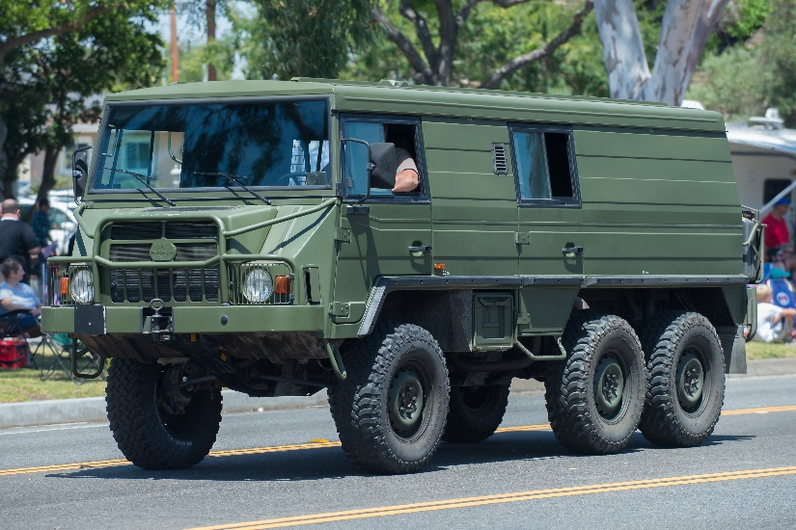
Figure 1- 1973 Pinzgauer [6]

Figure 1 is an image of a 1973 6-wheeled Pinzgauer, unfortunately the vehicle pictured in figure 1 is a converted version of the described vehicle so isn’t the exact colour or exterior design as the one used by the EOD teams, but it is a close enough representation for this purpose.
The third section of research was the RCV used with in the EOD regiment, this topic was selected as it would give a scope for what is required of the ramp and the reason for some of its design choices. Research in this section was conducted on the current in service RCV along with some of the previous models [3]. The current ins-service RCV is the Harris T7 this RCV was designed and manufactured by the United States company L3HARRIS, this RCV contracted to replace its predecessor the Wheelbarrow in 2017 and was initially delivered in 2019 according to the manufacturer’s website. This RCV has a totally weight of 322kg and total dimensions of 120.1 x 70.1 x 116.1 cm, this information will enable the materials selection later in the report [3].
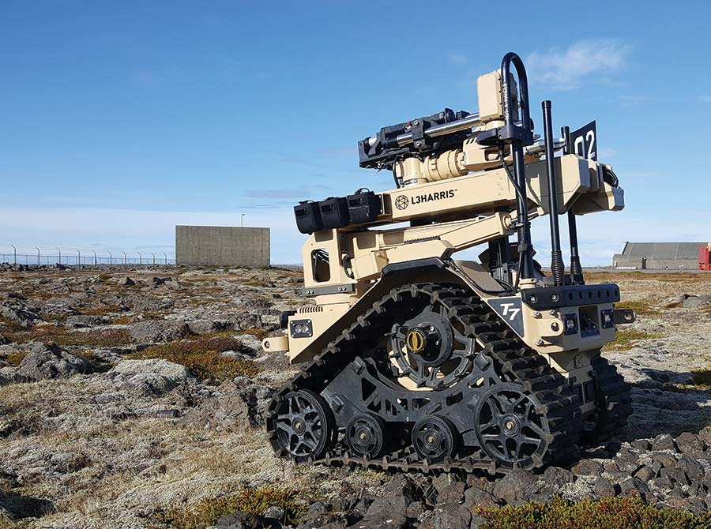
Figure 2- Harris T7 Remotely Controlled Vehicle [7]

Figure 2 is a photograph of the Harris T7 RCV, this image supports the deliberation of potential out recommendations of this report. This image also shows the type of attachments used on the RCV and therefore locations of where the weight and dimensions of RCV could increase or decrease.

Failure Point Review
In order to give an appropriate recommendation to improve the current situation, a more detailed analysis will be completed for each individual issue with this section.

Failure Point 1- Overall Weight of Ramp
Referring back to the original statement by the EOD operators, the first major failure point stated was the overall weight of the ramp. Through further discussion with the authors of this statement it was identified that the material currently used for the ramp is a mild steal which has an oil-based paint applied to the exterior. Upon further discussion with the EOD operators it was found that the weight of the current ramp was between 40-45kg, which within the current UK manual handling guidelines is deemed as a two-man lift. During the discussions with the EOD operators they expressed a desire to reduce the ramps overall weight to under the regulated one-man lifting limit, which at the time of writing is 25kg [5]. The EOD operators also stated the need for the replacement ramp to be corrosion resistant and the need for the ramp to have a max load of 400kg or above.

Material Analysis
With the EOD Teams’ requirements in mind, a review of materials was conducted to find a suitable material that would be able to replace the current mild steel ramp. This material review consistent of searching sources for composites and metals that would meet the corrosion resistance, weight, and load bearing requirements. When filtering through the variety of options one material was identified as potential choices for the ramp, the first of the materials is 6061-T6 Aluminium alloy. This material was selected as the first potential choice of material as it has a high yield strength, high corrosion resistance and it reacts well to heat treatment. The high yield strength of the material suggests a high load bearing capacity, when review the current commercially available ramp options this material is used by multiple different companies to produces product similar to the one described in this report. These companies suggest a load bearing capacity of the 6061-T6 Aluminium ramps of between 500-680 kg depending on the thinking of the aluminium used, the weight of the commercially available ramps were between 18-24kg [6]. The specifications of this material suggest that it would be an ideal replacement material, as it matches the current mild steel on load capacity and corrosion resistance while improving on the overall weight of the ramp by reducing it by 50%, stratifying the requirements set out by the EOD operators.

Future Proofing
To ensure that the new ramp would be protect from all the different elements and terrain it would encounter while being used by the EOD operators, Coatings or treatments can be added to the metal to protect and prolong the life of the material. In the case of the ramp analysis within this report, there are two coatings or treatments that could benefit the user if added to the ramp. The first coating that could be beneficial is a weather resistant oil-based paint, this coating could be done by the workshop in the military base so would require the ramp to be sent to a specialist company, it would give an extra layer of protection to the ramp against the heavy rain and sand/snow storms which could be encountered while being used in a combat situation. As added bonus it would also enable the military to colour the ramp to blend in with the rest of the vehicle. The second coating or treatment that would be beneficial for this ramp would be heat treatment more specifically for the suggested type of material liquid quenching the metal to improve its yield strength and durability, this would be beneficial as the constant heavy loading the ramp will undergo could potentially cause fracturing or other damage in the future [6].

Failure Point 2- Locking Mechanism of Ramp
In the statement from the EOD operators the second major failure point of the current system was the spring-loaded locking pins and the hinge mechanism used to keep the ramp in place while fully extended and in transit. During further discussion with the EOD operators a description of the spring-loaded bolt was given and a similar one was found online, this can be seen if Figure 4 below. [7]
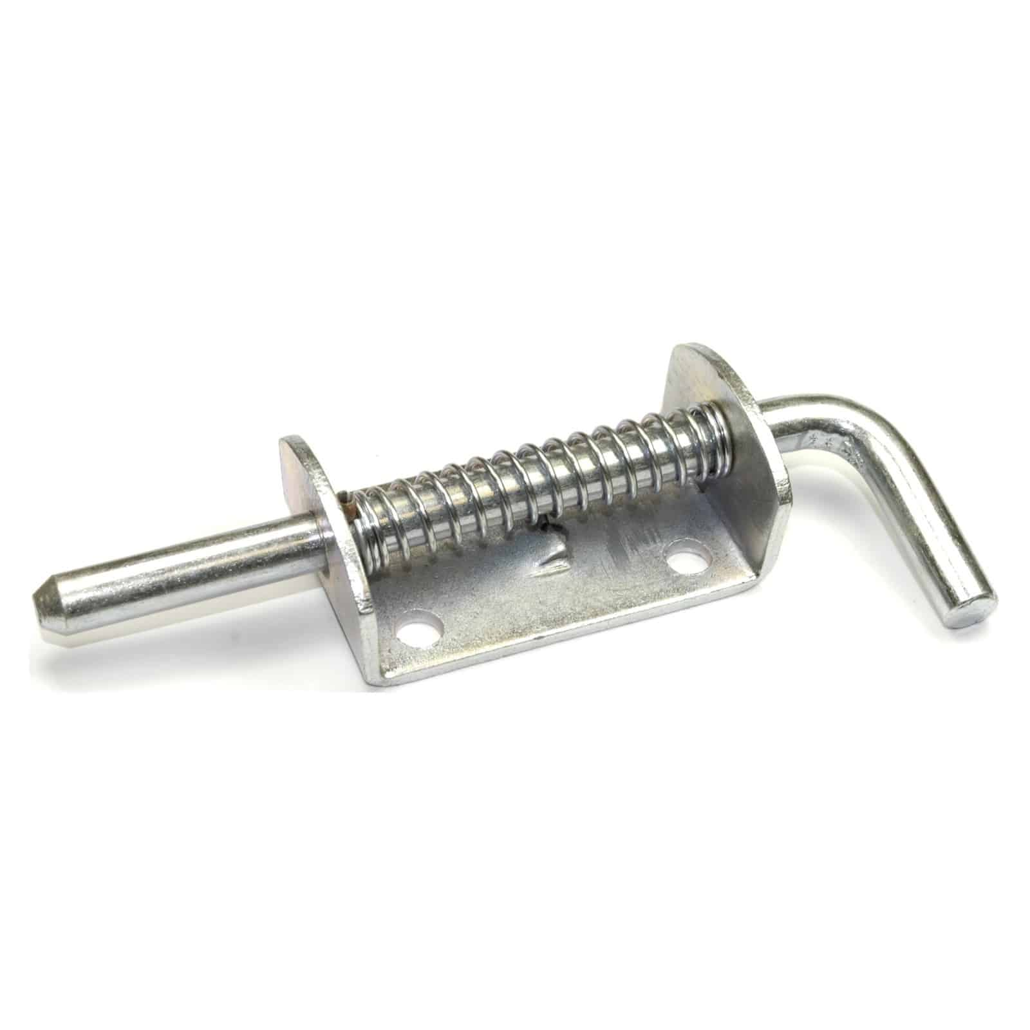
Figure 4- Spring-Loaded Bolt [11]

Within the further discussions with the operators it was determined that the material used for both the hinge mechanism and the spring-loaded bolt was the same aluminium-alloy which was prone to fracturing under the weight of the current steel ramp. The load produced by the steel ramp on these two components was amplified when travelling over rough terrain cause fracturing quicker than anticipated. Although this report has already recommended a solution to reduce the overall weight of the ramp, to ensure that longevity of this piece of equipment it would be best practice to analysis this second failure point for potential further improvements.

Material Analysis
When reviewing the potential material options for the hinge mechanism and spring-loaded a bolt, the material that was selected to improve on the current system was stainless steel, this material was chosen as the best option for these components as it has a high yield strength and has a resistance to oxidation. It is also a material that will remain in good condition even with consistent wear and tear, and its overall hardness will ensure that the high loads caused by vibrations from the vehicle and the weight of the ramp will not fracture the hinge or bolt mechanisms [8]. A considering was made for changing the whole locking pin system to reduce the chance of failure and injury but when evaluating other potential options it was deemed that the current locking system is best suited for this situation. [8]

Future Proofing
To ensure that these new components have a long service life, coatings and treatments could be added to the exterior to improve the chemical and physical properties of the base material. A zinc plating could be beneficial to the exterior of the material as it has a high level of protection against any corrosion and also increases the durability of the components, it is recommended to add this coating to these components due the amount of tension that each of these components have to withstand, these components require a high level protection due to their high amounts of usage and the constant load from the ramps main frame.

Safety Review
This report has recommended drastic changes to the current working system aiming to solve the issues analysed in the previous sections, to ensure the safety of all personnel involved within the new ramp working system, a review of the previous guidelines for using the ramp was undertaken to identify any guidance that could be improved to reduce any hazards or risks involved with working with the equipment. [5]

ALARP
The method used to analyse any Hazards or Risks within this working system was an ALARP review, ALARP stands for “As Low AS Reasonably Practicable” [9]. In order to achieve this status a working system must be deemed as having the lowest level of risk to its users and surrounding environment after any safety precautions have been implemented. In the previous sections of this report two main hazards were identified. The first hazard identified was the risk of crushing injuries caused by the ramp falling on the operator due to the equipment’s weight [10]. The likely of this hazard happening was severely reduced by changing the material ramp to a lighter and more manageable material for one operator to manoeuvre by themselves, along with a recommendation of only operating the ramp if the user feels comfortable with the weight and is also wearing the correct PPE for their environment I.e. the correct footwear when on rough and uneven terrain. The second hazard identified was hand and digit injuries caused by operating the spring load pin while on even terrain or from an unusual angle. To ensure this risk was a low as possible it was recommended that users only operate the ramp when on an even terrain with plenty of surrounding room to manoeuvre the ramp into place. If these recommendations are followed along with the current UK manual handling regulations, then the hazards and risk of using this working system will be deemed as ALARP. [5]

New Design Analysis
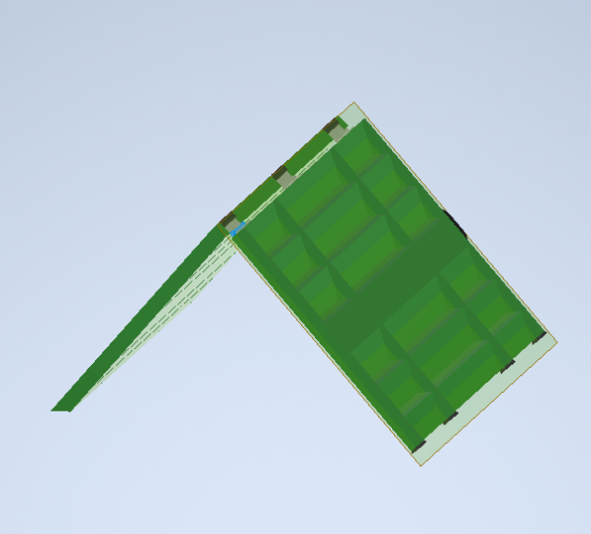
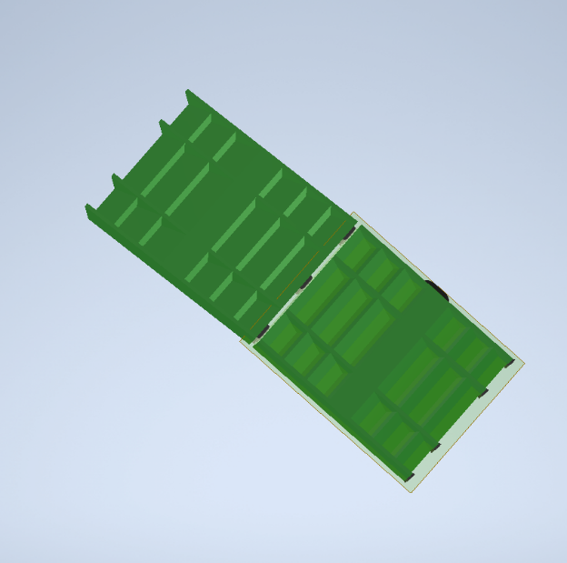
Figure 4- CAD Captures of Ramp

Figure 4 is captures of the CAD design of the Ramp; these two captures show the new ramp design in the fully open the half open position. These captures also show the Side handle used to extent the ramp out of the back of the tactical vehicle, also shown in the capture are the new set of hinges made out of a mild steel. Black rubber protective feet and buffers were added to the design to ass buffers reduce the wear and tear on the ramps main frame. The engineering drawing for the new ramp can be found in Annex A of this report, these drawings show the ramp design in more detail along with specific dimensions. The drawings in Annex A show the ramp with specifications for its length and width, it also shows the dimensions of the handle.

Conclusion
From the initial statement from the EOD operators that brought to light two problems which were affecting their ability to work affectively in certain scenarios. It safe to say that the original ramp was not fit for its intended purpose. After analysing the two major problems that were described in the original statement and researching for suitable solutions that would fulfil the EOD operators set of requirements. The new suggested design not only reduces the level of risk to the operator by changing the material to a better suited lighter Aluminium alloy but also includes a level of protection will extend the service life of the ramp as long as it is used within the recommended conditions.

References

[1] | S. BAE, “PInzgauer,” BAE Systems, 30 September 2009. [Online]. Available: http://www.baesystems.com/ProductsServices/l_and_a_ls_pinzgauer.html. [Accessed 05 December 2022].
[2] | A. T. Ltd, “PINZGAUER LIGHT OPERATIONAL VEHICLES,” New Zealand Defence Force, 15 December 2004. [Online]. Available: http://www.nzdf.mil.nz/news/articles/2004/10/1005-lov.html. [Accessed 4 December 2022].
[3] | de&s, “Starter Harris T7,” de&s, Not available Not available 2021. [Online]. Available: https://des.mod.uk/what-we-do/army-procurement-support/harris-t7-bomb-disposal-robot/. [Accessed 9 Dember 2022].
[4] | S. &. A. Systems, “L3HARRIS TECHNOLOGIES DELIVERS FINAL EXPLOSIVE ORDNANCE DISPOSAL ROBOT TO UK MINISTRY OF DEFENCE FOR PROJECT STARTER,” L3HARRIS, 28 June 2021. [Online]. Available: https://www.l3harris.com/newsroom/trade-release/2021/06/l3harris-technologies-delivers-final-explosive-ordnance-disposal. [Accessed 08 December 2022].
[5] | HSE, “Manual handling at work,” Not Available 01 2020. [Online]. Available: https://www.hse.gov.uk/pubns/indg143.PDF. [Accessed 10 December 2022].
[6] | a. M. LTD, “Aluminium Alloy - Commercial Alloy - 6061 - T6 Extrusions,” 13 November 2018. [Online]. Available: https://www.aalco.co.uk/datasheets/Aluminium-Alloy-6061-T6-Extrusions_145.ashx. [Accessed 10 December 2022].
[7] | RGS Technology, “1/2″ or 12mm Spring Bolt / Shoot Bolt,” RGS Technology, Not available Not available 2022. [Online]. Available: https://www.rgstech.co.uk/product/1-2-or-12mm-spring-bolt-shoot-bolt/. [Accessed 10 December 2022].
[8] | Metal4U, “What is Mild Steel? an in depth technical guide,” Metal4U, 26 February 2020. [Online]. Available: https://www.metals4u.co.uk/blog/mild-steel-in-depth-guide#corten. [Accessed 11 December 2022].
[9] | HSE, “Guidance on ALARP Decisions in COMAH,” Health and Safety Excutive, . . Unkown. [Online]. Available: https://www.hse.gov.uk/foi/internalops/hid_circs/permissioning/spc_perm_37/. [Accessed 2022 05 04].
[10] | HSE, “ALARP "at a glance",” Health and Safety Excutives, . . Unkown. [Online]. Available: https://www.hse.gov.uk/managing/theory/alarpglance.htm. [Accessed 2022 05 04].
[11] | ASEMS, “7. Risk and ALARP Evaluation,” 16 July 2021. [Online]. Available: https://www.asems.mod.uk/printpdf/guidance/posms/smp07. [Accessed 2022 05 04].
[12] | F. Bacardi, “Arnold Schwarzenegger runs errands in tank-like SUV,” Page Six, 12 November 2019. [Online]. Available: https://pagesix.com/2019/11/12/arnold-schwarzenegger-runs-errands-in-tank-like-suv/. [Accessed 05 December 2022].

Annex A- EOD Ramp Drawing


