My Dream Job:
Boss of Web Design Company

Student’s Name:
Anani Y. Mateev

Student’s Number:
1914594

Module Leader:
Tanja Nathan

Course Title:
Academic and Employability Skills

BCs Cloud Computing
University of Wales – Trinity Saint David

Contents
My Dream Job 1
1. Introduction 1
2. Personal Overview 1
2.1 Strengths 2
2.2 Weaknesses 3
3. Goals 3
4. Self-Evaluation 4
4.1 time management skills 4
4.2 Research skills. 4
4.3 Teamwork. 4
4.4 Database skills. 5
4.5 Programming skills. 5
4.6 Linux. 5
4.7 Quality assurance. 5
4.8 Information security. 5
4.8 Communication skills. 6
5. Personal development planning 6
5.1 Short-term goals 6
5.2 Mid-term goals 6
5.3 Long-term goals 6
5.4 Action plan 7
6. Data Backup strategies 10
7. Time management and organisation skills 11
8. Conclusion 12
References 13
Appendices 15

My Dream Job

Introduction
Every student dreams of landing a specific job after they are done with their degree. To achieve this, it is vital for learners to identify the ideal skills and knowledge they need for that specific job. This would help them in planning on how to develop each of the requirements. In this report, I am going to talk about my dream job as a Boss of Web Design Company. This will begin with my personal overview, which will be followed by an assessment of my goals. I will also make a self-evaluation and conduct a personal development planning. In addition, I will discuss about Data Backup strategies and Time management and organisation skills

Personal Overview
I am Anani Mateev, a student studying Cloud Computing with the aim of becoming a web designer.

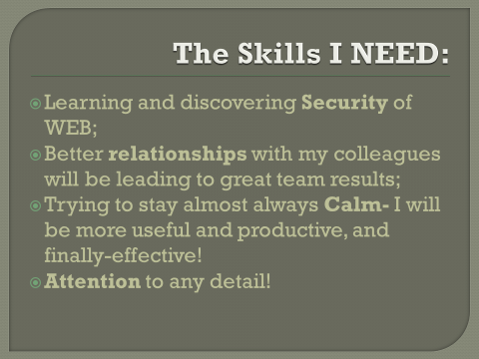

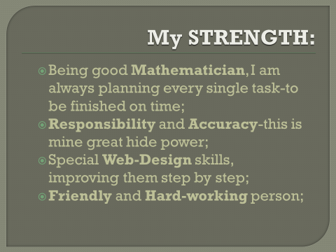
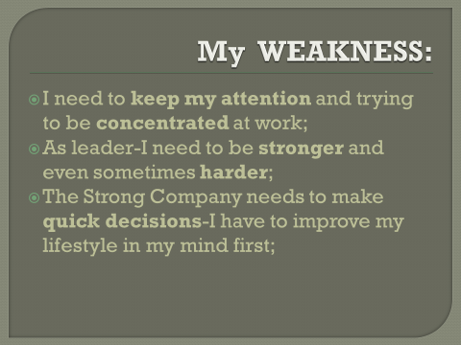

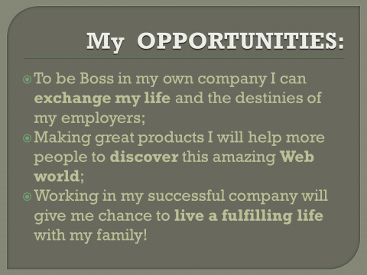

Key points that I learnt when trying to produce and deliver a successful PowerPoint presentation
I learned the aspect of using visual aids to make attractive presentation. This is after learning that presentations should be pleasing to my audience in addition to being sources of information.
As well, I also learned that a presentation requires few words. This is vital because using so many words could be a source of destruction to my listeners when presenting.

2.1 Strengths
Being good Mathematician, I always ensure to plan on every single task I intent to undertake to ensure that it is accomplished within the expected timescale.
Responsibility and Accuracy . This is one of my greatest strengths which I pride myself in. In this regard, I ensure to take full responsibility of all my undertakings and accurately deliver on them as required.
Special Web-Design skills . I have strong web-design skills which I am improving to obtain a better competency.
I am also a friendly and a hard working person. This specifically makes it easy for me to take part in teamwork and make resourceful contributions.

2.2 Weaknesses
Poor concentration and attention skills . I need to develop the ability to maintain my attention and concentration at work.
Poor leadership skills . I should develop leadership skills relevant for the job because it is a leadership role.
Slow decision making. The Strong Company needs an individual who can make quick and informed decisions.

Goals
3.1 Career goals
After completing my degree in Cloud Computing, it is my desire to climb my professional ladder and be a Boss of a Web Design Company. This will be a great opportunity for me to put into practise the skills, knowledge and competency which I will have acquired from my cloud computing degree. In addition, this will also be an opening for me to learn more about the field and improve on my personal and professional development.
3.2 Opportunities
Learning more on cloud computing from my degree programme . I will maximally utilise this opportunity to learn more the field in order to be able to deliver in my dream job.
Working in a successful company. Due to the competency which I will have developed, I will be able to secure a job in a successful company. This will be an opportunity for me to lead a fulfilling professional life.
3.3 Threats
Web Security. There has been a threat in the sector due to the increased web insecurity in aspects such as web applications, websites and web services which are prone to hacking and illegal access by unauthorised personnel (Hope, P. and Walther, 2008).
Technology as a threat to some human abilities . As are moving into mobile systems in World Web human abilities such as ability to read books and engaging in physical conversations are fading away.

Self-Evaluation
Being a student pursuing cloud computing, the following are some of the skills I require

4.1 Time management skills
This is a vital skill for me as a learner as I need to be able to effectively manage my time. The skill will help me remain organised, plan and prioritise my undertakings in order to ensure that I meet my goals effectively. The skill will also help me be able to balance between my academic and social life.

4.2 Research skills.
As a learner, I need the ability to identify how and where to find all the information which I will need when pursuing my degree. Through this skill, I will be able to undertake productive research on all the knowledge which I will need to gain as a cloud computing student. This will enhance my understanding of the field and help me learn how to apply what I learn.

4.3 Teamwork.
The ability to effectively function in a team and workout tasks is such a vital role to me as learner in a higher education level. According to Taylor (2011), this is necessary because I will be required to take part in different team assignments as a requirement for completion of my degree. In this regard, I need to have the ability to work with other students towards the achievement of different team objectives.

The following are the skills required for my employability as a web developer

4.4 Database skills.
As a web developer, I need the ability to manage , access and store data. This is vital in a company as most of the companies need a web developer who is seasoned in creating and being able to use cloud hosted databases in which the companies can have their large data stored without the threat of being manipulated or accessed by unauthorised personnel (Connell, 2008).

4.5 Programming skills.
I also need to have comprehensive programming skills to enable me to build, manage and deploy applications that scale to unlock cloud capabilities. According to Surakka (Surakka) I will need to be effective in using different programming languages such as Python, Perl, Jana, PHP and Ruby.

4.6 Linux.
Research shows that this is one of the most trending skill requirements for cloud professionals. Linux is an open-source operating system whose usage has increased in the recent years (Bang et al, 2013). The demand is attribute to the continued embrace of open-source market among some of the leading companies such as Microsoft. In this regard, companies need cloud professionals who are able to design, build and maintain Linux servers within a cloud environment (Bang et al, 2013).

4.7 Quality assurance.
Software quality assurance involves the process where developers ensure that the software which they develop meet all the expected requirements and are of acceptable quality (Miletsky, 2009). I will need this skill in order to be able to create quality software for the companies which I will work for.

4.8 Information security.
This is a skill which involves the ability to manage the processes, policies and tools which are necessary for preventing, detecting, documenting and countering threats to both digital and non-digital information (Malik et al, 2009). Hence, employers need an individual who is able to create business processes with the ability of protecting their information assets.

4.8 Communication skills.
As Robbins (2012) states, this is one of the most sought soft skills for web developers. This is because organisations need a web developer who has the ability to share information effectively using the right communication channels in order to keep operations in the company taking place smoothly. Due to this, a web developer needs to be effective in using both the written and unwritten forms of communication in a workplace context.

Personal development planning

5.1 Short-term goals
Learn more about cloud computing and identify the major skills and knowledge which I will need to develop through undertaking the course.
Identify the kind of employment opportunities available for a cloud computing student.

5.2 Mid-term goals
Identify opportunities to put in practise knowledge and skills which I will develop in undertaking my cloud computing degree such as internships and volunteering in organisations.
Achieve good results in my examinations

5.3 Long-term goals
Graduate with a bachelor’s degree in cloud computing.
Secure a job at a successful company where I can practise my knowledge and skills gained through my cloud computing degree.

5.4 Action plan
 | Goals | Actions to be taken | Time scale
Short-term | Learn more about cloud computing and identify the major skills and knowledge which I will need to develop through undertaking the course.  Identify the kind of employment opportunities available for a cloud computing student. | Research about cloud computing to identify the skills and knowledge which I need to gain as a cloud computing student.  Research on job opportunities for cloud computing graduates | April 2020 – august 2020
Mid-term | Identify opportunities to put in practise knowledge and skills which I will develop in undertaking my cloud computing degree such as internships and volunteering in organisations.  Achieve good results in my examinations | Apply for identified opportunities where I can practise my already acquired cloud computing skills such as internship and volunteer opportunities.  Ensure I attend all my classes, read and research widely and prepare adequately for my examinations. | September 2020 – January 2022
Long-term | Graduate with a bachelor’s degree in cloud computing.  Secure a job at a successful company where I can practise my knowledge and skills gained through my cloud computing degree. | Undertake all the requirements I need to be awarded my bachelor’s degree in cloud computing.  Research and apply for job opportunities in companies with openings for cloud computing students. | December 2022 onwards

Personal development plan
The following is a plan outlining how I will develop the skills and knowledge which I need to become a proficient web developer
Skills to be developed | Actions to be taken | Timescale
Database skills. | Undertake my database units to ensure that I develop the skills.  Use the internet to gain more knowledge on the database skills. | Throughout my degree program
Programming skills | Take on my programming skills in order to develop the programming skills.  Take part in programming group activities with my classmates to improve my programming proficiency. | Throughout my degree program
Linux | Study Linux as part of my degree programme in order to develop the skill.  Enhance the skills through developing and maintaining Linux servers in cloud environment. | Throughout my degree program
Information security | Effectively undertake my information security units and ensure that I grasp all the relevant knowledge and develop the required information security related skills. | Throughout my degree program
Communication skills | Research on the internet and learn about all the communication skills which I will need while working in an organisation.  Undertake an online course of workplace communication skills. | June 2020 – December 2020

Data Backup strategies
With the increasing use of data in different settings, data backup has become quite essential for both individuals and organisation. Due to this, it is vital to identify the most suitable data backup approaches which one would use to guarantee the safety of their data. The following is an assessment of some of the strategies I use for my data backup.
To begin with, I use passwords in all my electronic devices. I ensure to have passwords in all the devises which I use to store data such as my computer, mobile phone and tablet. This ensures that no authorised people have access to my data by accessing my devices and having access to the data. In addition to this, I also have passwords for folders in which I have stored important data. This protects my data even in instances I give out my devices to other people.
Regular backup of my computer. I ensure frequent full backup of my computer at any given time I use it using a hard drive backup. This ensures that I have my data updated and stored within the drive. With this, I am able to use the drive and easily access any data I generated even when it is lost in my computer. In addition to this, I would also be guaranteed with a backup of my data even in instances I lose my computer.
In addition to this, I also use cloud storage. I use some of the free cloud storage providers such as google drive and amazon drive to store my data (Kim, 2014). This has proved to be one of the most reliable strategy for storing my data. This is so because in instances of destruction or lose of my devices, I am able to assess all the data stored in the cloud using other devices. As well, the data stored in the cloud is more secure as it is less likely to be accesses illegally by unauthorised peoples such as through hacking.

Time management and organisation skills
Time management skills and Organisational skills are useful skills for me as a student. Through them, I am able to achieve both my short and long-term goals. The following is a discussion of some of the time management and organisation skills which I possess and how utilise them.
Prioritisation. In this, I ensure to assess all my responsibilities and ensure to prioritise them. I prioritise my responsibilities in the order of their importance and urgency to me. As Grissom and Loeb (2015) suggest,I give the first priority to the responsibilities which are more urgent and more important. Prioritising ensure that I create enough time for each of my responsibility to guarantee me with favourable results.
Organisation. I always make sure that I remain organised with all the tasks which I intent to undertake. In this, I ensure to keep up-to-date calendar in order to have a clear picture of what I need to attend to at a specific timescale. This makes it easy for me to have an organised approach on how and when to each task. Having my tasks written down makes it easy for me to identify what has been accomplished and what is yet to be attended to.
Goal setting is also a time management skill which I pride myself in. In this regard, I always set short, mid and long-term goals. This ensures that I understand what I want to achieve within a specific time scale. As a result of this, I always remain focused towards achieving the goals which I set. This has been helpful to me as it helps me avoid losing focus and being caught up by deadlines.
Planning also helps me in my time management. I always plan for my days and also my future. For instance, I ensure to plan my day every morning before taking up my tasks. In addition to this, I also plan for my future. My prioritising skills remain useful to me during my planning as I prioritise activities as I plan.
The ability to work effectively with other has also been a reliable approach to my time management. As a student, I am expected to take up some tasks as group work with some of my classmates. Due to this, I am able to effectively take part in my group work to achieve both personal and team objectives as claimed by Groot and Hollaar (2013). This has been useful to me as work done under teamwork tends to be accomplished within a shorter duration and also with better results.

Conclusion
Based on the report, it is evident that the journey of a learner transitioning from school to their dream job is such an involving aspect. It requires one to have a clear understanding of what they need to achieve both as students and after acquiring their dream job. With this understanding, a student is able to plan for their future. That is possible through the creation of action plans and personal and professional development plans with specified timelines of what they need to achieve. In the end, a learner is guaranteed of acquiring all the relevant skills, knowledge and competency which they need to acquire their dream jobs. Leaners who adhere to this would be assured of easily manoeuvring through their studies and later in job searching to land their dream goals.

References

Bang, S.K., Chung, S., Choh, Y. and Dupuis, M., 2013, October. A grounded theory analysis of modern web applications: knowledge, skills, and abilities for DevOps. In Proceedings of the 2nd annual conference on Research in information technology (pp. 61-62).
Connell, R.S., 2008. Survey of web developers in academic libraries. The Journal of Academic Librarianship, 34(2), pp.121-129.
Grissom, J.A., Loeb, S., 2015. Principal time management skills. Journal of Educational Administration.
Groot, J.M. and Hollaar, L.A., University of Utah Research Foundation (UURF), 2013. Method and system for supporting and enhancing time management skills. U.S. Patent 8,562,354.
Hope, P. and Walther, B., 2008. Web Security Testing Cookbook: Systematic Techniques to Find Problems Fast. " O'Reilly Media, Inc.".
Kim, E.B., 2014. Recommendations for information security awareness training for college students. Information Management & Computer Security.
Malik, M., Akunuri, N.V., Kern, C., Armandpour, T., Khavari, S. and Narasimhan, G., Yodlec com Inc, 2009. Method and apparatus for tracking functional states of a Web-site and reporting results to web developers. U.S. Patent 7,558,795.
Miletsky, J.I., 2009. Principles of internet marketing: New tools and methods for web developers. Cengage Learning.
Robbins, J.N., 2012. Learning web design: A beginner's guide to HTML, CSS, JavaScript, and web graphics. " O'Reilly Media, Inc.".
Surakka, S., 2007. What subjects and skills are important for software developers?. Communications of the ACM, 50(1), pp.73-78.
Taylor, C.W., 2011. Cloud Computing At The University Level: A Study Of Student Use Of Cloud Computing Applications. ZhurnalEksperimental’noi I TeoreticheskoiFiziki.

Appendices
Appendix 1: My threats


