Managing Enterprise in the 21st Century

Assignment Title: Business Plan
Module code: BMSW 4006
Module Lecturer: Dr Oluwaseun Adegbite
Students in group:
Adrian-Ioan Ulesan (2026789)
Gabriela Marin (2026922)
Danut Marin (2026923)
Alexandru Netoi (2026780)

Executive Summary
The food industry is a global industry where the customers based on their different preferences and choices tends to consume the products. Therefore, any business idea which comprises of the food products can be easily made to the level of success if one chooses the right approach. A business can launch new products after successfully creating a business plan that includes all the information relating to the business, its products, its market audit tools, target market, marketing plans, financial plans, etc. the business plan aids in knowing the various factors which stands necessary for the purpose of initiation of the new business. The Taste & Toast can address the changing opportunities of the market by serving the foods products which are organic in nature and because of this will create a huge demand among the customers in the market.

Table of Contents
Executive Summary 2
INTRODUCTION 3
TASK 4
Overview of Business - 4
Products and services - 4
Market Audit - 5
SWOT Analysis - 5
PESTLE analysis - 5
Target Market - 6
Management Team - 8
Financial Plan - 9
CONCLUSION 11
REFERENCES 13

INTRODUCTION
The business plan is fundamental document which lies in the written form. It specifies all the minor details that how a business need to be started while specifying its objectives and the ways in they are to be achieved. Simply it is a road map of the working of the different units of the business which are the financial, operation, marketing, etc. it is a document which stands very important for the new businesses which are about to start. Also for the purpose of attracting and fetching the investors the business plan is required to be formulated by the new owners. The following report will formulate a plan for the business named “Taste & Toast” which will be launched in the market as a cafe specifically for health conscious consumers. Further , a good and effective business plan must comprises of the executive summary, marketing analysis and strategies for the same, the details of the products and services, its financial plan and most importantly the estimated budget(Boustras and Waring, 2020).

TASK

Overview of Business -
Taste & Toast is a cafe which is related to the industry of food and beverages which mainly provides the services regarding the healthy and organic diets for the health conscious consumers. As in the present era with the raising concerns of the health there lies the high demand of healthy foods. This factor motivated the entrepreneurs to start the said business so that they can fetch the large area of the market while catering the needs of the customers. The said cafe is equipped with the organic as well as healthy diets which aims at providing the good taste as well as the satisfaction to the customers while keeping their health on priority. The organic and healthy foods also helps in boosting the immunity of the consumers which can ultimately helps in fighting the diseases and keeping the individual fit.
The cafe named Taste & Toast is planned to be based in London, United Kingdom. It will be established as a business outlet which will provide the services only of the organic foods, mainly targeting the health conscious consumers of age between 20 to 50 years comprises both the generation of youth as well as adult. It also targets the the group of people who are gym or health freaks(Chang and Andreoni, 2020)

Products and services -
The business desires to launch a cafe by the name of Taste and Toast which will have the menu comprising of the dishes having the combination of health and taste. Where the customers can ask to customize their diets as per their requirements and preferences. The raw food materials which will be required to prepare the foods items such as organic veggies as well as fruits and non-veg products will be directly brought by the farms and will be free of any added chemicals. The food items will be healthy and will comprise of the required nutrients such as vitamins, carbohydrates, etc. the business will also aid the interested customers in formulating their personal individual diet plans as per the requirements of their bodies(Gunasekaran, Subramanian and Ngai, 2019)

Market Audit -
Here the tools of market audit which will be used are of SWOT and PESTLE.

SWOT Analysis -
Strengths:  - The high demand of health products and normal cost of production are one of the major strengths for the outlet.  - Also the uniqueness of the diet plans and providing timely service as well as good distribution of the products with quality to the consumers. | Weaknesses:  - the concern of storage and transportation of the raw food materials , mainly of the perishable goods.  - Non availability of the products reason being their seasonality.
Opportunities:  - the loyalty of consumers as well as their changing needs and tastes.  - Also the growing natural and prosperity concern and quick lifting of the market are the underlined opportunities of the business. | Threats:  - the business can tends to face issues regarding its certification.  - The adverse weather conditions is one major threat of the business.

PESTLE analysis -
There lies the number of factors which makes impact on the working and performance of the business. The said external market factors has been elaborated as follows-
- Political factor – the food industry of the country is facing a lot a political pressure as the government tends to formulate the regulations in order to control the activities of the business. Similarly if the laws are made in such a way which promotes the concept of healthy life the it will help in encouraging the consumers to shift more towards the said business which will result in the growth of the Taste & Toast business.
- Economic factor – the sales of the business can be increased with the economic stability in the country. The organic food outlets are using the different channels with respect to the sale of their services and products such as the direct sales or the specialized shops. So the increase in the costs of labour can ultimately increase the selling prices of the products. Some of the factors which makes an impact are the inflation rate, unemployment rate, etc.
- Social factors – it comprises of the aspects such as the culture of people , lifestyle of the customers, social status and their way of living. All the said factors stands responsible for an individual to buy any services or products or the way in which they spend their money. The prevailing modern culture comprises of the people who are more conscious about their health and fitness and hence they are more attracted towards the organic means.
- Technological factors – technology can be used as an competitive advantage over the other prevailing businesses in the market. The outlet has to face various technical issues with start from the production of the foods to taking orders to their supplies. Here as the venture is taking the online order for the services of the doorstep delivery of foods so with the atomization of the technologies can aid with the increase of the sales.
- Legal factors – there lies the number of legislations and regulations which are formulate by the government in order to regulate the conduct of the food industry. The said rules must be adhered by the Taste and Toast in order to ensure effective and smooth running of the outlet. Also it must take care of all the safety and hygiene factors before producing and delivering the food products to the customers while detailing all its ingredients on the packaging.
- Environmental factor – in order to prepare the organic food it is required to be get purified by various means such as the use of chemical fertilizers, synthetic preservatives, etc. The Taste and Toast is facing the concern of disposing of the waste which results from the said process of cleaning or the residues while preparing the food products as this makes an impact on the sustainability of the business. Therefore, the cafe is using the recycling process as well as the paper bags for the purpose of packaging(Huang, Aimin and Smith, 2019) .

Target Market -
The said business in order to ascertain its exact target market is using STP.
- Segmentation – it is mainly the measure where the whole market is bifurcated into sub divisions based on the aspects of the analysis of the consumers characteristics and their preferences. The Taste & Toast will be using the psycho graphic and demographic segment for the purpose of classification of the target market. Where the former will help in placing the food products in accordance of the preferences of the customers whereas the later one will help in selling the products based on the factor of age, occupation or the group of health freaks(Vanclay, 2020). .
- Targeting – it is the process in which the said product is targeted to a particular segment. The Taste & Toast is mainly targeting the age group of 20 to 50 and the people who are health conscious or are being the part of any fitness group.
- Positioning – The Taste & Toast will be positioned as the only business which specifically provides the services of organic foods products and individual diets. The business also tends to sponsor the health related events in order to promote the and spread the awareness about health(O'Higgins and Zsolnai, 2018).

Marketing Plan:
The said business will use Marketing Mix which is also addressed by the name of 7P's of marketing in order to outline the suitable plan for marketing.
- Product – Taste & Toast comprises of the food products which are rich in health and are free from any added chemicals and preservatives. The menu of the outlet involves the products which are suitable for the health of an individual and are rich in vitamin, nutrients and carbohydrates.
- Price – it is addressed as the final value at which the said services or products are sold to the customers. The Taste & Toast sets the prices while analysing the pricing strategies of its competitors and seeing the demand in the market. The average prices of its products ranges in between £ 2 to £ 3 so that more consumers can afford it(Peschl, Deng and Larson, 2021) .
- Place – Taste and Toast primarily aims at opening the single outlet while having its services spread to the different regions by also offering the facilities of door step delivery to their customers.
- Promotion – the business promotes and provides its products and services to the group of people who are more into health concerns or are the fitness freaks. For which the cafe is taking the measure of media channels by the help of advertisements where they can fetch the large number of consumers.
- People – the cafe hires the chefs and supportive staff who are highly skilled and possess a good understanding of the health aspects so that the needs of the customers can be fulfilled in an more effective way.
- Process – it is the measure where the products are delivered to the customers. Here the Taste and Toast in order to deliver the ordered products has inculcated several equipments such as freezers, microwave, etc.
- Physical Evidence – Taste and Toast makes its products in such as way which stands physically evident by the outlining of the logo which bifurcates the products from that of the others in the market. Also because of their unique packaging style the products can be easily identified by the customers(Popkova and Gulzat, 2019).

Management Team -
It Is primarily the structure of the business which defines the responsibilities of each concerned department. The business comprises of the different units one each for the purpose of manufacturing, distribution, sale, marketing and finances.
There shall be the owner of the business who will also acts in the capacity of managing head and will be responsible for the supervision of the work. A head for the finance department that shall look after the balance sheets of income of the business so that estimates about the profit and loss of the business can be drawn. An operational manager that will look at all the operations of manufacturing and distribution of the product in the market. A marketing head who shall guide on the marketing and promotions of the product in the market among the consumers. These heads will have employees under them who can can carry out the tasks which can help to achieve the business goals. This will be the Management team of Taste and Toast (Saini and Jain, 2018)(Salamon, 2020)..

Financial Plan -
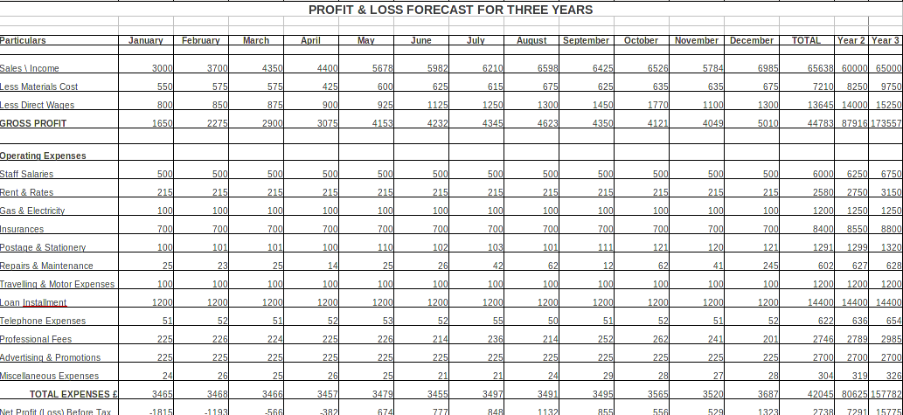

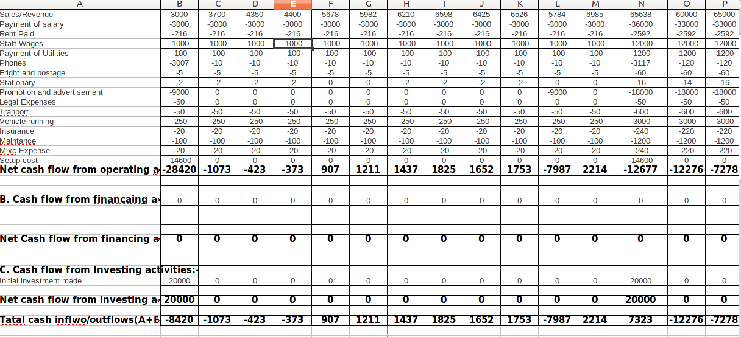

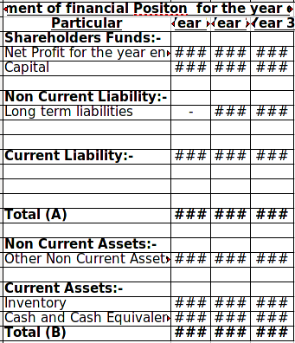

CONCLUSION
From the above formulated business plan of the cafe named Taste & Toast it can be summarised that it possess high possibilities of becoming successful in the market of food industry. The strengths can be acquired by becoming a unique product catering to the requirements of the customers in the market. But it is also required on the part of business to have the approach of mitigation of risk for the purpose of launching any new venture in the market. Also the business in order to prosper in the market must take into consideration the loopholes faced by the other competitors while having interactions with their targeted customers. Therefore, the Taste & Toast can in real manner proper the market with the help of outlining a suitable business plan.

REFERENCES
Boustras, G. and Waring, A., 2020. Towards a reconceptualization of safety and security, their interactions, and policy requirements in a 21st century context. Safety Science, 132, p.104942.
Chang, H.J. and Andreoni, A., 2020. Industrial policy in the 21st century. Development and Change, 51(2), pp.324-351.
Gunasekaran, A., Subramanian, N. and Ngai, W.T.E., 2019. Quality management in the 21st century enterprises: Research pathway towards Industry 4.0. International journal of production economics, 207, pp.125-129.
Huang, Y., Aimin, Y.A.N. and Smith, R., 2019. Methodology for the development of knowledge management on organizational performance based on employees’ professional competence. Revista de Cercetare Si Interventie Sociala, 64, pp.85-96.
O'Higgins, E. and Zsolnai, L. eds., 2018. Progressive business models: Creating sustainable and pro-social enterprise. Springer International Publishing.
Peschl, H., Deng, C. and Larson, N., 2021. Entrepreneurial thinking: A signature pedagogy for an uncertain 21st century. The International Journal of Management Education, 19(1), p.100427.
Popkova, E.G. and Gulzat, K., 2019, May. Technological revolution in the 21 st century: digital society vs. artificial intelligence. In Institute of Scientific Communications Conference (pp. 339-345). Springer, Cham.
Saini, K. and Jain, S., 2018. Women Entrepreneurship The Emerging Workforce in 21st Century: Turning Challenges into Opportunities. International Journal of Research in Management & Social Science, 101.
Salamon, K.L.G., 2020. Possessed by enterprise: Values and value-creation in Mandrake management. In Magic, culture and the new economy (pp. 47-55). Routledge.
Vanclay, F., 2020. Reflections on Social Impact Assessment in the 21st century. Impact Assessment and Project Appraisal, 38(2), pp.126-131.

