[1]
Peter Robert Kenrick (1910613)
1910613@student.uwtsd.ac.uk
Controlling a CIWS
Comparing a PID controller to the Maths

Abstract
This report is focused on comparing the simulation of a closed loop control system with its mathematical model and using the latter to validate the simulation. This has been done by modelling the simulation in MATLAB and Simulink of the Plant and then tuning a P.I.D. controller to bring the plant under control within the specifications. The values from the controller were then input into a Single Transfer Function which is representative of the whole simulation. The results of both were then compared and the Simulation model was validated.

Contents
Abstract 1
Contents 1
Introduction 3
What is a control system? 3
P.I.D. control systems 3
What is a CIWS? 3
Simulation setups 4
Requirement for the System: 4
Controller 4
Single Transfer Function 4
Modelling the Process 5
Step 5
Adder 5
PID 5
Plant 5
Results 6
Pole-Zero diagram 8
Nyquist/Bode Diagram 10
Discussion 11
Conclusion 11
References 11

Figure 1 - PID circuit 5
Figure 2 - Step Input 6
Figure 3 - Input after feedback 6
Figure 4 - Output from Controller 6
Figure 5 - Plant output minus Controller 7
Figure 6 - Output from Plant 7
Figure 7 - Single Transfer Function output 7
Figure 8 - Difference between Simulation and Single TF 8
Figure 9 - Pole-Zero - Plant TF 8
Figure 10 - Pole-Zero - Controller TF 9
Figure 11 - Pole-Zero - Single TF 9
Figure 12 - Nyquist Plot - Forward TF 10
Figure 13 - Bode Diagram - Forward TF 10

Equation 1 - Plant Transfer Function 4
Equation 2 - P.I.D. Controller Function 4
Equation 3 - Controlled Plant Equation 4
Equation 4 - Single Transfer Function 4
Equation 5 - Overall Transfer Function (Expanded) 5

Table 1 - Unique Values 4
Table 2 - P.I.D. Gain values 5
Table 3 - Plant Pole values 8
Table 4 - Controller Poles and Zeros values 9
Table 5 - Single TF Pole and Zero values 9

Introduction
This report will be looking at a control system for the angular positioning system of a Close-In-Weapon-System (CIWS) turret.
The aim is to use MATLAB and Simulink to simulate the control system (controller, plant, and feedback) and use this model to bring it under control in under two seconds and with an overshoot of less than 5%. Using this information, a Single Transfer Function can then be created. These two can then be compared to validate the Model
The Simulation and the Single Transfer Function are both modelled in MATLAB’s Simulink (see Figure 1). All screenshots and results within this report are taken from MATLAB and Simulink [1]

What is a control system?
Control systems are used in all sorts of processes and according to Karl and Richard [2], a controller utilises feedback to compare the output to the desired system behaviour and makes corrections to achieve this. There are two types of systems: Open and Closed loop systems. The difference between a closed loop and open loop system is that closed loop utilise feedback and therefore is controlled. Control systems are used in all manors of situations, both military and civilian. An example of a control system most people would be familiar with would be Central Heating used in houses. It is a closed loop system meaning it uses feedback, this comes in the form of a Thermostat. The system will heat the house up to the temperature indicated on the Thermostat and will cut off the heat when this is reached. If the temperature drops below the indicated temperature, then the heating will be turned back on.

P.I.D. control systems
P.I.D stands for Proportional, Integral and Derivative. A P.I.D. controller is a feedback controller which uses the sum of all three of these actions according to Dormindo and Visioli [3].
The Proportional aspect is as the name implies, proportional to the current value of the control error, this does mean that as the difference between the output and the input tends towards 0, the correction of the proportional aspect will also tend to 0 meaning they will never meet, also known as a steady-state error.
The Integral aspect uses the integration of previous control error values to attempt to eliminate the steady-state error. If not tuned correctly this can cause overshoot as when the signal approaches 0 the Integral of the errors will shrink which will reduce the rate of change.
The Derivative aspect uses a derivative of the change in error to predict the system behaviour. This utilises the rate of change of the error which can be used to flatten or dampen the curve and reduce overshoot.

What is a CIWS?
According to David Alexander [4] a Close-In-Weapons-System (CIWS) is a defence platform, typically naval, which is designed to engage small, fast-moving targets such as missiles, fast jets, small boats etc. which have gotten too close to the ship. CIWS usually use a gatling gun with a high fire rate but are typically quite short ranged. Speed and accuracy of target acquisition is of the utmost importance for any CIWS as the faster it can get on target the more likely it is to take the target out safely. There are several examples of CIWS currently in service around the world: Raytheon’s Phalanx and Thales’ Goalkeeper.

Simulation setups

Requirement for the System:
The control system for this report is required to bring the process under control within two seconds and with only a 5% overshoot. Table 1 shows the unique values for this specific CIWS.
a | b | c
4 | 2 | 3
Table 1 - Unique Values
The time requirement of two seconds means that the turret is required to get from wherever angle it starts at, to facing the target within that time limit. The maximum angle the turret will need to rotate though will be 180°. This considers that the turret will have inertia and will not be able to move instantaneously.
The overshoot requirement of 5% is the level of accuracy for where the turret is pointing. A CIWS needs to be accurate to shoot its target down.
The values for a, b, and c represent a multitude of factors such as the mass of the turret, its diameter, the power of the motor used to turn the turret, internal friction etc. All these factors need to be accounted for to control the system and are represented in the transfer function of the plant (Equation 1).
$$G_{\left(s\right)}=\frac{1}{as^{2}+bs+c}$$
Equation 1 - Plant Transfer Function

Controller
The P.I.D. controller is represented by Equation 2. When this is applied to the Plant (Equation 1) it becomes Equation 3. Equation 3 shows what is also known as the Forward Transfer Function which excludes the feedback in the system.
$$G_{c}\left(s\right)=k_{p}+k_{i}\frac{1}{s}+k_{d}\frac{s}{\frac{1}{N}s+1}$$
Equation 2 - P.I.D. Controller Function
$$\frac{\left(K_{p}+NK_{d}\right)s^{2}+\left(NK_{p}+K_{i}\right)s+NK_{i}}{as^{4}+\left(b+aN\right)s^{3}+\left(c+bN\right)s^{2}+cNs}$$
Equation 3 - Controlled Plant Equation

Single Transfer Function
$$TF=\frac{G}{1+GH}$$
Equation 4 - Single Transfer Function
In Equation 4, as there is no feedback function H = 1. Taking Equation 3 as G, this then expands out to Equation 5. This equation is comprised of all the components of the Controller (K_{p}, K_{i}, K_{d} & N), Plant (a, b, c), and the Feedback.
$$\frac{\left(K_{p}+NK_{d}\right)s^{2}+\left(NK_{p}+K_{i}\right)s+NK_{i}}{as^{4}+\left(b+aN\right)s^{3}+\left(c+bN+K_{p}+NK_{d}\right)s^{2}+\left(NK_{p}+K_{i}+cN\right)s+NK_{i}}$$
Equation 5 - Overall Transfer Function (Expanded)

Modelling the Process
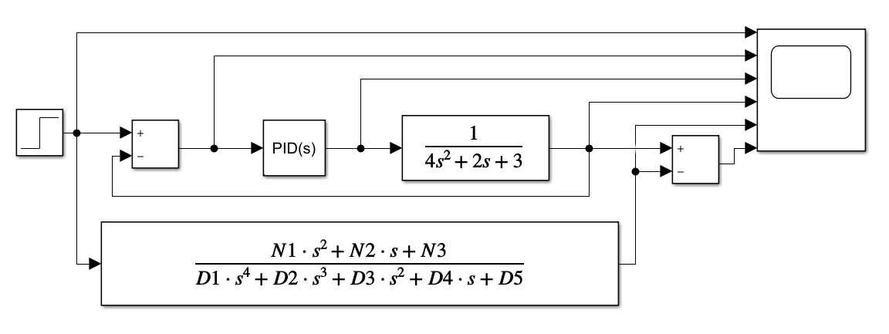
Figure 1 - PID circuit

Step
The step, or input, is simply representing an input which might be sent from the targeting system. The value will represent the angle which the turret needs to turn to.

Adder
The Adder takes the value from the Input and subtracts the feedback from this. This is how the feedback is incorporated as if the Output of the plant is greater than the Input the Input from the Adder to the System will now reflect this (this can be seen in Figure 3).

PID
This represents the Controller; this attempts to compensate for any changes to the system as described above on Page 3.
A controller needs to be “Tuned” to achieve the desired effect. For this report, Simulink has been used to tune the controller to acquire the values in Table 2.
k_{p} | 70.5889
k_{i} | 23.2987
k_{d} | 45.1512
N | 1304.7178
Table 2 - P.I.D. Gain values

Plant
The plant is represented by the Transfer Function in Equation 1. This uses the 3 values in Table 1. In this report this is representing the angular positioning system in the CIWS.

Results
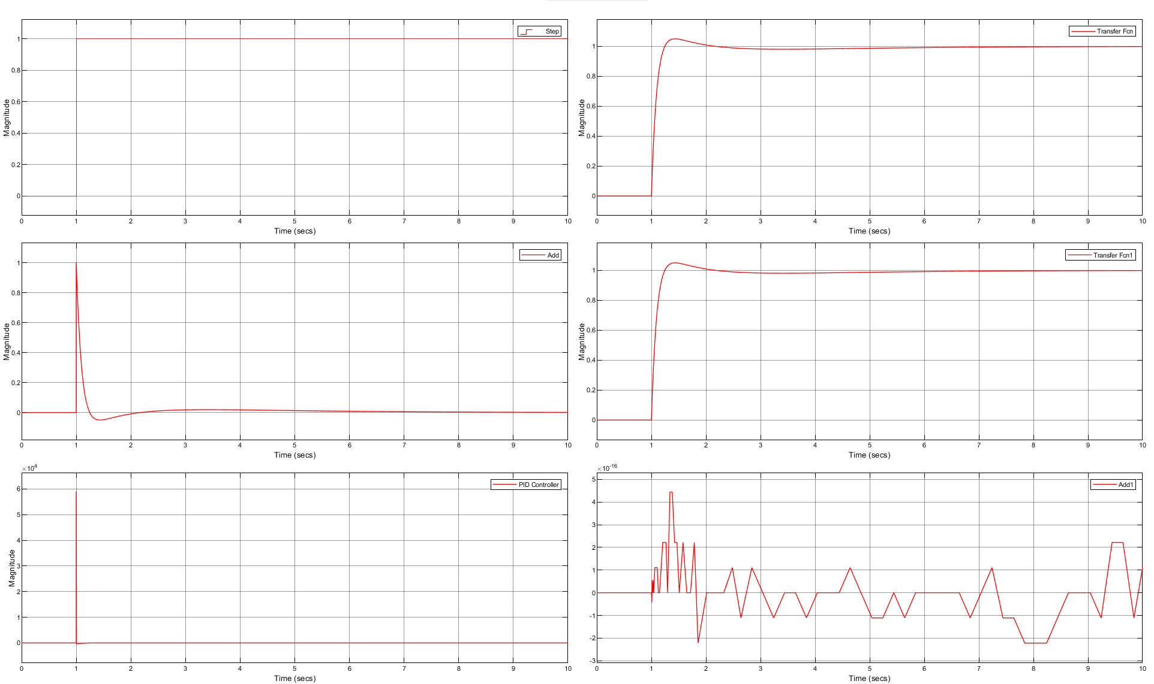
Figure 2 - Step Input
Figure 2 shows the step input, this is used for both the Simulation and the Single Transfer Function. It represents the signal which would be sent from the targeting system.
Figure 3 - Input after feedback
Figure 3 shows the input signal after being combined with the feedback signal. Between seconds 1 and 2 it can be observed to go negative; this shows the turret has overshot slightly and is then brought back to (close to) 0.
Figure 4 - Output from Controller
Figure 4 shows what the controller outputs for the given step. This signal is modified to get the Plant to act as desired, within the constraints of the specification. The maximum value for the output can be seen to be nearly 6000. The time scale is very short, from the step point to when it comes back down to 0 Magnitude is about 0.003844 seconds. Both mean the Plant will get a much faster, more powerful signal which will allow it to meet the specifications.
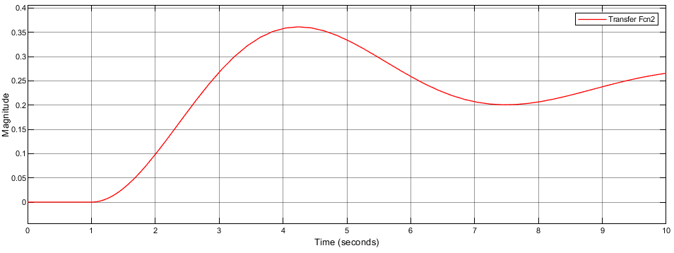
Figure 5 - Plant output minus Controller
Figure 6 - Output from Plant
Figure 5 and Figure 6 show the output of the Plant where Figure 5 shows the Plant response without the controller and Figure 6 includes the controller. The most obvious differences are that if there is no controller the Plant doesn’t even reach the right angle and the time to its highest peak is over 4 seconds. The controlled Plant can be seen to sharply move to 1 where it overshoots slightly and is brought back to near 1 within 2 seconds. This gap does shrink almost completely after about 7 seconds, but it meets the requirements.
Figure 7 - Single Transfer Function output
Figure 7 clearly looks almost identical to Figure 6 (See below). This is generated from Equation 5 which is an overall equation to represent the whole system in one. By comparing the two graphs it is possible to validate the Simulation.
Figure 8 - Difference between Simulation and Single TF
The comparison between the Simulation and the Single Transfer Function (Equation 5) can be seen in Figure 8. This is the subtraction of the Single Transfer Function from the Simulation Output, and the difference is at most 4.5*10⁻¹⁶ which is negligible.

Pole-Zero diagram
According to Karl and Richard [2], Pole-Zero diagrams are used to show if a system is stable or not, it plots all the roots for a transfer function. Poles (denoted as X on the graph) are where the graph tends towards infinity i.e., the denominator tends to zero. Zeros (denoted as O on the graph) are where the graph tends towards zero i.e., the numerator tends to zero.
The Zeros are not pertinent to this report as their location does not impact the stability of the system.
There are four quadrants to the graphs Positive and Negative in the Real Axis, and in the Imaginary Axis. A system is stable if the Poles are negative of the Real Axis, this is because the response for these values will tend to zero. If there is no Imaginary component, the response will just tend towards zero, if there is an Imaginary component the response will oscillate about the Real Axis eventually coming to 0.
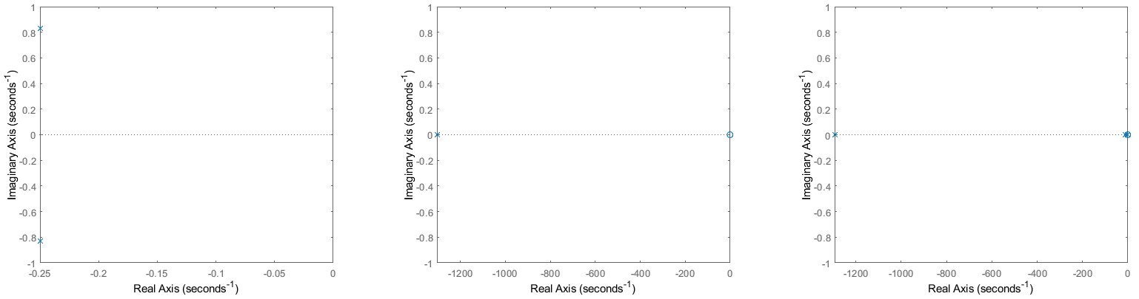
Figure 9 - Pole-Zero - Plant TF
Poles
-0.2500 + 0.8292i
-0.2500 - 0.8292i
Table 3 - Plant Pole values
Figure 10 - Pole-Zero - Controller TF
Poles | Zeros
-1304.7 | -1.0884
 | -0.4736
Table 4 - Controller Poles and Zeros values
Figure 11 - Pole-Zero - Single TF
Poles | Zeros
-1293.3 | -1.0884
-10.1 | -0.4736
-1.3
-0.4
Table 5 - Single TF Pole and Zero values
All the Pole-Zero diagrams generated for this simulation are clearly stable.
Figure 9, which shows the Plant’s TF stability, shows that while it is stable, it will oscillate due to the Imaginary component.
The Controller is shown to be more stable than the plant and has no Imaginary components.

Nyquist/Bode Diagram
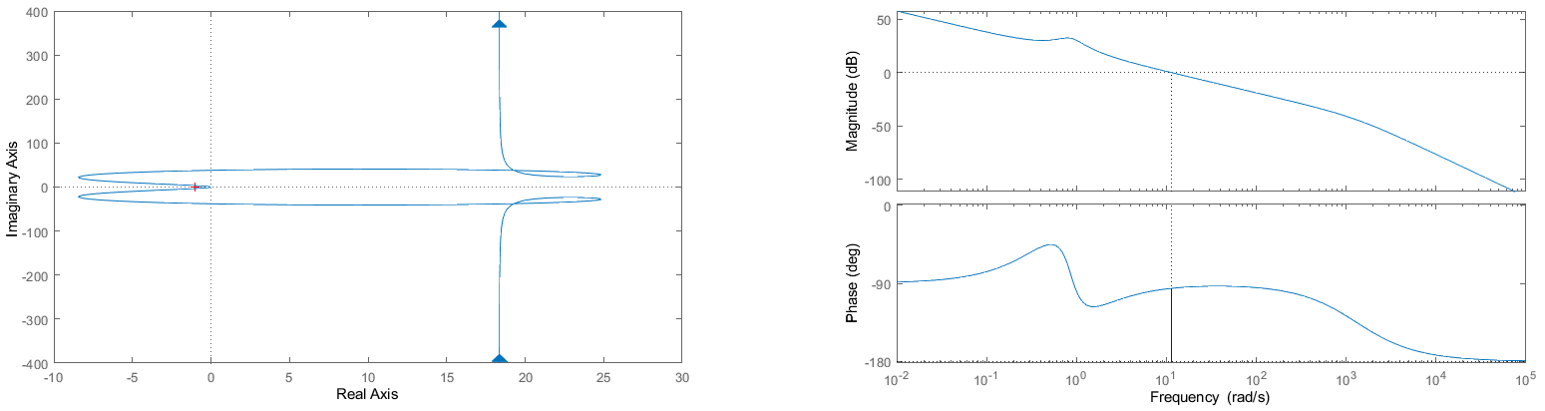
Figure 12 - Nyquist Plot - Forward TF
Figure 13 - Bode Diagram - Forward TF
Nyquist and Bode diagrams have been generated using Simulink, this can give valuable insight to a System’s properties.
According to Arturo, Luigi and Mattia [5], a Nyquist diagram’s most basic function is to determine how stable a system is. Figure 12 shows that the plot does not encircle the -1+0j point (the red point on the diagram). This indicates stability. The gain margin of the system can also be shown from this, this indicates how much change would need to occur to make the system unstable.
Karl and Richard [2] state that Bode diagrams are good for visualising the systems behaviour over a wide range of frequencies. The different segments in each of these curves shows where the Poles and Zeros start to have an effect.

Discussion
While using Simulink to tune the P.I.D. controller, the response time managed to get down to less than 4*10⁻³ seconds which would be physically impossible. This would also mean the controller would be closer to instability.
From Figure 8 it is possible to see that the difference between the Simulation and the Single Transfer Function if probably from rounding errors when taking the values for the P.I.D. controller.
When looking at the Pole-Zero diagrams and comparing the roots of the functions, the Single Transfer Function’s Zeros, and therefore the Zeros of the overall simulation, are the same as the Controller’s Zero values. Another similarity is the highest Pole value (approx. 1300), this clearly shows the influence of the Controller.

Conclusion
It can be concluded in this report that the Single Transfer Function does validate the Simulation of the Controller, Plant and Feedback system. Figure 8, showing the difference between the two to be close to 0 is evidence for this.
It can also be concluded from the Pole-Zero diagrams, Nyquist and Bode plots that the system is stable.

References
[1] “MATLAB 9.9.0.1570001 (R2020b) Update 4, [Software].” The MathWorks, Inc, Natick, Massachusetts, USA, 2021.
[2] K. J. Åström and R. M. Murray, Feedback Systems: An Introduction for Scientists and Engineers, 2nd ed. Princeton University Press, 2008. doi: 10.2307/j.ctvcm4gdk.
[3] S. Dormido and A. Visioli, “PID Control,” in Encyclopedia of Systems and Control, London: Springer London, 2015, pp. 1062–1071. doi: 10.1007/978-1-4471-5058-9_245.
[4] D. Alexander, “Close in Weapons System,” Military Technology, vol. 36, no. 4, pp. 17–20, 2012, Accessed: Jan. 03, 2022. [Online]. Available: https://web-s-ebscohost-com.ezproxy.uwtsd.ac.uk/ehost/pdfviewer/pdfviewer?vid=4&sid=4164ec72-47a0-4876-9460-34c6d51fa742%40redis
[5] A. Buscarino, L. Fortuna, and M. Frasca, “Nyquist plots under frequency transformations,” Systems & Control Letters, vol. 125, pp. 16–21, Mar. 2019, doi: 10.1016/J.SYSCONLE.2019.01.004.

