UNIVERSITY OF WALES
Trinity Saint David

Level 4
DIGITAL SKILLS and RESEARCH METHODS
Module Code/ BMSK4003

Lecturer: Balendran Kandasamy

Student: Gheorghe Albu
Student Number: 1813898

London 2019

CONTENT

INTRO

Part 1: Web Techonologie Cloud storage-definition, and compare between two clouds storage like Google Drive and dropbox.

Part 2: Social media, Facebook, Linkedin, Twitter, How we can use for business and marketing.

Part 3: Refferance

Intro

First part of this paper will contain two major chapters, in the first chapter I is de definition of web technology like cloud storage. In this way, I chose to make a brief comparison between two major web technology providers like Google Drive and Drop Box. Also at the end of the first part I will make a personal recommendation regarding the choice of the appropriate provider according to needs.
In the second part I will detail how social media can be used as a business tool. I will also share from my personal experience how I used facebook to promote services and products.

- Web Technologies Cloud storage-definition, and compare between two clouds storage like Google Drive and dropbox.

Web Technology is an all-encompassing term referring to technology that assists in the creation, maintenance and development of web-based applications. This involves the use of languages and frameworks, data storage platforms and mechanisms, and services that allow the creation of platforms and applications for the web.

One form of web technology that allows the communication and transfer of data form one server to another is cloud storage. Cloud storage has offers substantive advantages over conventional storage by allowing easy accessibility over an internet connection, reliability in terms of any defective hard disk malfunction if data is backed up on cloud at a lower cost. However, one of the major concerns with cloud storage is regarding the privacy and safety of data stored on cloud storage platforms. Moreover, accessibility might be restricted in areas with poor internet connectivity.

Realising the potential benefits of cloud storage, more and more businesses and individuals are switching to cloud storage. This increase in demand has lead many companies to provide cloud storage platforms. Dropbox and Google Drive are two of the major cloud storage providers. The positive and negative aspects of both these services would be discussed and compared below.

Google Drive and Dropbox, both, sync documents across different devices and allow the sharing of files with different receipts. In terms of pricing Google Drive is much cheaper as it offers 2 TB for the price for which Dropbox offers 1TB. Moreover, Google Drive offers 15 GB of free storage on sign up whereas Dropbox is less generous as it offers only 2 GB of free storage.

In terms of speed, Dropbox is faster as it has block-level file copying, which only copies the bits that have changed and the rest of the uploaded file remains the same. Moreover, Dropbox also uses LAN Sync technology which syncs files on the same network directly. Lack of LAN Sync and block-level file copying means that Google drive is slightly slower in terms of speed. However, it is pertinent to note that Google Drive also uses one of the fastest alternative technologies available and therefore the speed difference is not even noticeable unless the file size is large.

Although that does give Google a serious edge in this section, Dropbox offers a number of ways to increase your free storage. Basic (free) accounts can earn an additional 500MB of storage space for each friend or family member referred to the service, up to 16GB. Dropbox also recently introduced the chance to earn a further 1GB for earning the “Mighty Answer” badge for helping out a fellow Dropbox user on the forum.

While the additionally earned free storage space does lead to Dropbox offering more free space than Google Drive, referring hoards of friends isn’t a simple task, especially in today’s world, where most people who want cloud storage already have it. It’s good that Dropbox has that option, but ultimately Google Drive’s free storage is simply better.

File sharing
File sharing is of paramount importance to many cloud storage customers, as it makes it much easier to send large files or folders to groups of people. When you pit Google Drive vs. Dropbox, how do they each fair?

Google Drive lets you share files and folders using the mobile app or in the web-browser interface, with direct links, or the option to email access to your trusted share partner. It also offers the option to give view and edit permissions to those you share with, letting you customize the power they have. The only downside is that without passwords or expiry dates on those links, they do present a potential security problem if you don’t move your shared files or folders in the future.

Outside support
Google Drive can quickly save and store Gmail attachments, twin stored images with Google Photos, and makes collaboration easier through Google Docs, Sheets, and Slides. The Chrome Web Store has more than 100 compatible third-party apps for Google Drive too, giving the cloud storage solution a lot more potential than some of its competitors.

Dropbox has some service integrations of its own. Personal users can enjoy a partnership with Microsoft that sees Office documents openable and editable from within Dropbox itself, making collaboration easier.

In terms of data security, both service providers encrypt the data that is stored on the cloud. However, Google Drives offers more options to protect the user’s account form unauthorised logins and also requires two keys (one additional master key) to read data stored on its servers, compared to only one key required by Dropbox.

Conclusion
Unfortunately, it’s very hard to settle the Dropbox vs. Google Drive debate. While both products fall into the category of cloud solutions, it’s plain to see they are two very different services.

For users looking for a cloud storage solution that allows you to store a large number of files and share them quickly, we highly recommend Dropbox. Larger cloud storage plans are quite affordable, and the Dropbox interface will most likely be known.

On the other hand, if you're looking for a tool to help you edit documents in flight and allow teams to work on remote projects, Google Drive is a better choice. It may take a while before you become accustomed to all the features offered by Google Drive, but once you do, productivity will increase dramatically.
The recommendation of the specialists, Google Drive is a very affordable option for home-based users because it offers 15GB of free storage space and it's easy to uncover it with access to all Google services users.

- Social media, Facebook, Linkedin, Twitter, How we can use for business and marketing.

The Chartered Institute of Marketing defines marketing as ‘the management process for identifying, anticipating and satisfying customer requirements profitably’. [ Withey, J. and Lancaster, G., 2006]

In simple terms it relates loosely to the act of promoting and selling products/services. It is a fundamental aspect of any business and the foundation on which a business’ success or failure ultimately depends.

With the advent of social media and its rapid growth in the last decade, social media marketing has taken over a large chunk of marketing strategies of huge enterprises. Social media giants such as Facebook, Instagram and Snapchat etc. are providing great opportunities for businesses to market their products and reach out to potential customers. [Heggde, G. and Shainesh, G. 2018]. These avenues will be discussed below to highlight how Social media can be used by businesses for effective marketing.

Social media can be used attain a number of marketing goals such as increasing brand awareness and loyalty, increasing sales and leads, increasing and improving communication and interaction with customers, obtaining insight into customer interests and preferences etc. [Charlesworth, A. 2015]
After the business has decided the purpose of its online presence and social media marketing, the next step is to have an implementation strategy to achieve that purpose. In designing such a strategy the target audience must be carefully considered. Even though social media statistics show that its users come from all age groups, the majority of the frequent users are young and therefore businesses targeting older people will have to target their customers carefully in order to achieve the desired results. [Brown, E. 2012]

Businesses should be wary of the fact that an online social media presence must be handled extremely carefully and the brand image must be guarded vigilantly as it might be subject to reputation damage if the complaints of customers surface online and are not address appropriately. Having an effective strategy in place and an efficient team at work on social medial profile of the business would surely help in reducing and minimising any damage and help uplift the brand image.[ Brown, E. 2012]

Furthermore, businesses can also keep an eye on their competitors by reviewing their performance on social media; noting the products/services that the customers are appreciating and the products that customers are asking them for. In this way social media can help businesses in formulating strategies to fulfil any gaps in the market and attract customers which are disgruntled with competitors by listening to their feedback.[ Withey, J. and Lancaster, G., 2006]

Moreover, it is crucial to identify potential influencers among the target audience and seek their assistance to publicise the business and its brand image. This has proven to be highly successful in the cosmetics and technology sectors; wherein businesses have relied on influencers, who influence public opinion about certain products in terms of their utility, instead of celebrities to promote their products. Therefore, having a group of influencers from the relevant sector on its side is important to achieve the aims of any social media marketing strategy.[ Withey, J. and Lancaster, G., 2006]

Similarly, businesses can also take help of bloggers and product reviewers to publicise their products by giving them an opportunity to test their products and services. However, care must be taken to ensure that they are not offered to review substandard products/services as it might result in negative reviews and blogs, adversely affecting the brand image.

Finally, businesses can also use social media for paid advertising. Advertising is one of the oldest and successful forms of promotion to attract new customers. According to statista.com, a massive 18.3 billion US dollars were spent on social media advertising in the US alone compared with only 10.81 billion US dollars in 2015.

There are many reasons for this massive increase in social media advertising. The primary reason is the increase in social media usage all around the world. With reduced consumption of television channels and newspapers (two of the most prevalent forms of advertising), the focus is now shifting towards social media as business realise that there are more customers to be found online than by using conventional advertisement methods. [ Withey, J. and Lancaster, G., 2006]

Furthermore, advertising on social media has been proven to be more cost-effective than other methods and the advanced techniques employed by social media networks such as Facebook give businesses insights into the actual effectiveness of a campaign, allowing businesses the opportunity to obtain valuable data that could be used to improve their future campaigns.[ Heggde, G. and Shainesh, G. 2018]
The social network Facebook has become so popular that fewer people have no account open here. However, this network not only opens the way to communication, but can also turn into a real resource for companies that will know how to exploit it to attract more valuable customers. Facebook has become a way of accessing potential customers because it contains important demographic information. According to Claire Shih, the author of the book, " Facebook Era", it is necessary to be present where customers or potential customers.[Clarie Shih. 2009].

Facebook can be used as a marketing tool by creating an own page that needs to be well established. It has to be said that there are millions of Facebook pages currently gathering over 10 million fans every day, according to the site's statistical data.

Companies can set up a Facebook page to reflect their activity and name, and there may be links to the company's website or online sales pages. That's how big companies are doing. such as Coca-Cola, TUI or Amazon.

Clara Shih recommends setting an exact target for using this social network. It's a good idea to know from the beginning whether you want to accumulate more customers through the site or make your brand known.
The recommendation of the specialists is to ask friends and family members to become fans, given that, on average, every Facebook user has about 140 "friends" who are watching their work almost every day.

In conclusion, it must be said that social media provides endless opportunities for business from monitoring customer interests and competitors’ performance to gaining traction and promoting brand image; the opportunities are endless. It all depends on the business how it effectively puts in a strategy to achieve the desired aims of the business.

https://www.facebook.com/george.albu.129
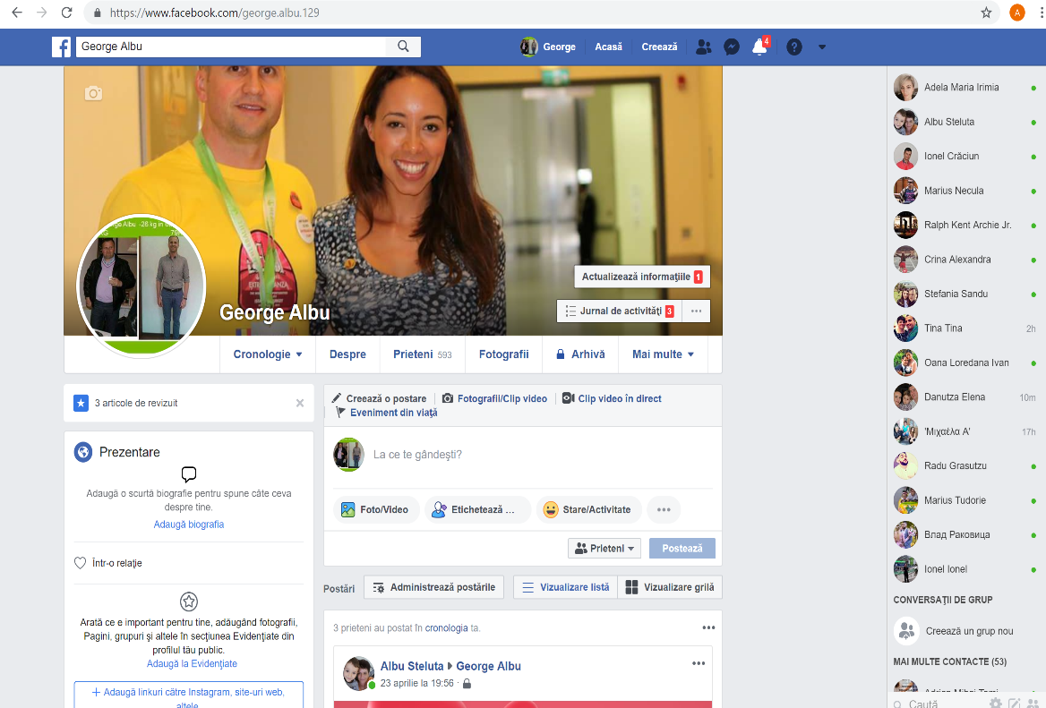
https://twitter.com/GeorgeAlbu9
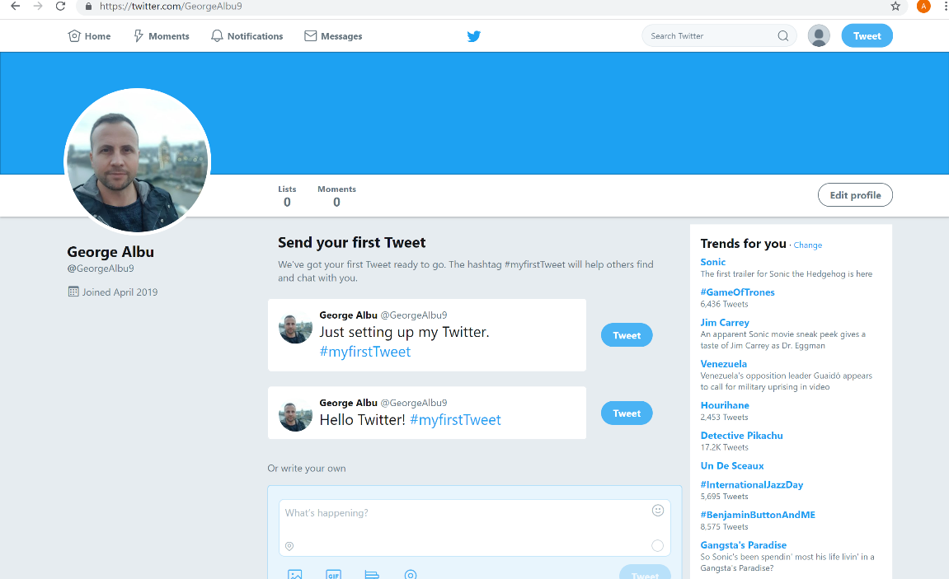

https://www.linkedin.com/in/george-albu-6814b2184/
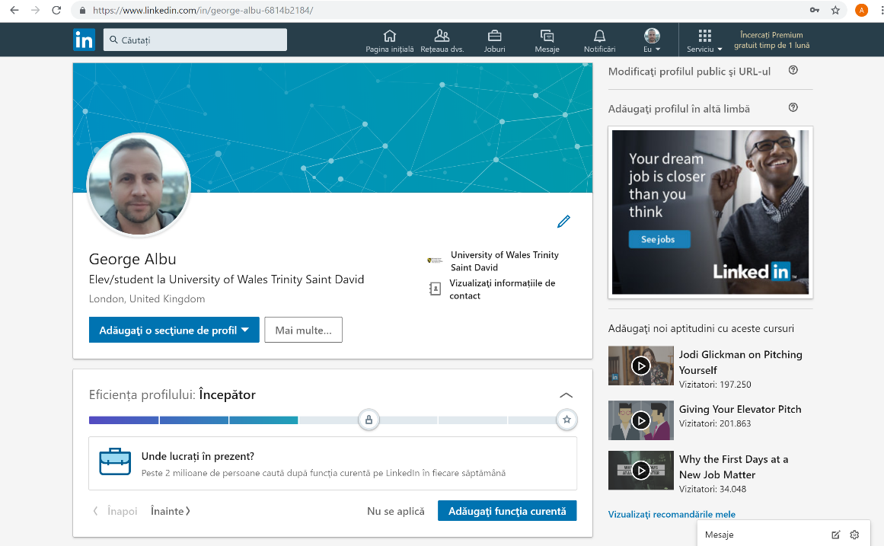

- REFERENCES

- Brown, E. (2012). Working the crowd. Swindon: British Informatics Society.
- Charlesworth, A. (2015). An Introduction to Social Media Marketing. Routledge.
- Dropbox vs. Google Drive | Cloud Storage Advice www. CloudStorageAdvice.com 30th April 2019.
- Dropbox vs Google Drive 2019: Deep Dive & Comparison www.Cloudwards.com 10th April 2019.
- In the battle of the cloud storage, which is better: Google Drive or Dropbox www.DigitalTrends.com 30th April 2019.
- Jacobsen & Foster (2011). The Wired Generation: Academic and Social Outcomes of Electronic Media Use Among University Students.
- Jeffrey Boase, John Horrigan, Barry Wellman and Lee Rainie (2006). The Strength of Internet Ties.
- Heggde, G. and Shainesh, G. (2018). Social media marketing. Palgrave Macmillan.
- The Facebook Era www.GoogleBooks.com 15th April 2019.
- Withey, J. and Lancaster, G., (2006). CIM Coursebook 06/07 Marketing Fundamentals. Routledge.

