University of Wales Trinity Saint David
Wales Institute of Science & Art



Energy in a Flywheel
Motor Vehicle Engineering Science (ACHA4036)

Bethan Lane
2502536
March 2025

Contents
1 Introduction 1
2 Experimental Procedure 2
3 Results 4
4 Analysis 5
5 Conclusion 8
6 Evaluation 9
7 Further Work 10
8 References 11

Tables and Figures
Figure 1: Bearing block and Flywheel Setup 2
Figure 2: Plastic guide aligned at 0mm 2
Figure 3: 10g mass added to weight hanger 3
Figure 4: 20g mass added to weight hanger 3
Figure 5: Graph for Potential Energy Loss against Mass 6
Figure 6: Graph for Calculated Inertia 7

Table 1: Raw Data 4
Table 2: Results Table 5
Table 3: KE Values 5
Table 4: Values Used in the Calculations 5

Introduction
The main aims of this experiment are to prove the theory for energy stored in a flywheel and validate the moment of inertia using kinetic energy calculations.
A flywheel is a large circular disc that is attached to the crankshaft of an engine and has a large moment of inertia and a potential to store kinetic energy through rotation as (Lund, 2020) explained.
The potential energy of the flywheel is the energy of the falling mass under gravity, and the kinetic energy is the potential energy converted into rotational kinetic energy stored in the flywheel.
Energy storage in a flywheel is important in real engineering applications because it smooths fluctuations in the engine power output and can provide high power and energy density as (Koohi-Fayegh & Rosen, 2020, p. 7) explains when talking about the operation of electrical machines that use flywheels for energy storage and transfer. Flywheels also store braking energy used for regenerative braking and can convert the stored kinetic energy into electricity as described by (Chauhan & Saini, 2014).
Kinetic energy in a flywheel is the energy possessed in the motion of rotation of the flywheel and the equation for this is: $KE= \frac{1}{2}Iω^{2}$
I = moment of inertia ω = angular velocity
This experiment is trying to prove that the larger the mass or speed of the flywheel, the more kinetic energy it can store. This report will show this through analysis of experimental results and graphs.

Experimental Procedure
- The ES9 Potential and Kinetic Energy Kit was used for this experiment, and the bearing block and flywheel were already pre-assembled.
- The bearing block and flywheel were fixed securely to the top of the work panel.
- The flywheel could rotate freely as the brake screw was removed from the bearing block.
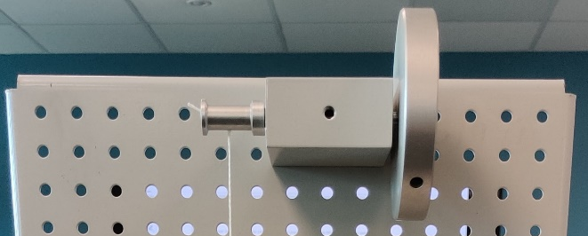
Figure 1: Bearing block and Flywheel Setup
- The string was measured and tied to the pulley and adjusted so the hanger dropped vertically just under 290mm.
- The weight hanger with the plastic guide was fitted to the loop at the bottom of the string.
- The drop height was measured after fixing a magnetic 300mm ruler to the work panel behind the weight hanger and was aligned with the plastic guide at 0mm.
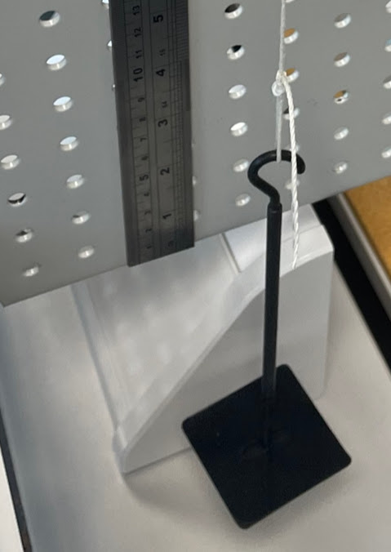
Figure 2: Plastic guide aligned at 0mm
- 10g masses were added on top of the plastic guide on the weight hanger to obtain the required masses for the experiment to get all sets of results.
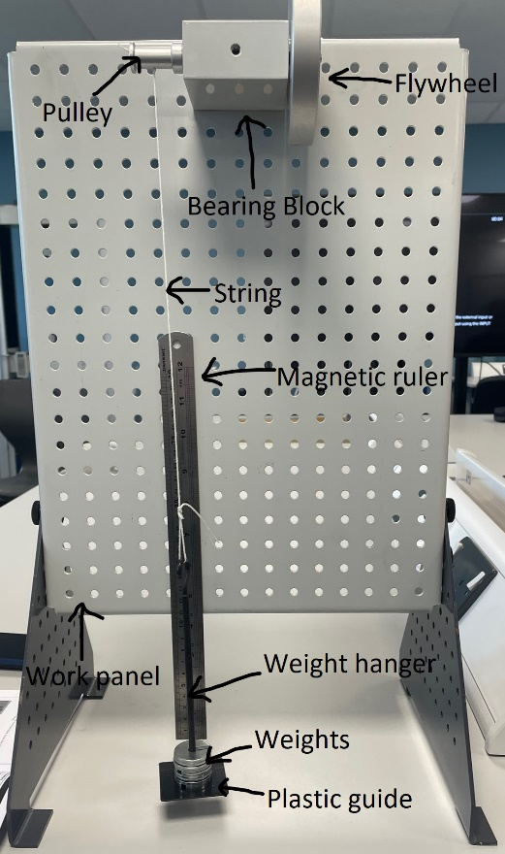
Figure 3: 10g mass added to weight hanger

Figure 4: 20g mass added to weight hanger
- For each repeat of the experiment the flywheel was turned slowly to lift the weight hanger, so the plastic guide was aligned with 280mm on the ruler. This height is the initial height (h₁).
- The mass was released from the initial height without pushing it.
- To measure the return height (h₂) a member of the group sat eye level with the ruler and watched the plastic guide to see the highest point it reached. Two other members of the group watched the plastic guide to validate the maximum height.
- Another member of the group recorded the time it took for the weight hanger to fall from its 280mm position to the 0mm position and back up to its maximum height (h₂). This was recorded with an iPhone stopwatch.
- For each different mass, the time and maximum height was recorded 3 times to calculate a mean.
- To keep the test fair and repeatable the same people did the same jobs throughout the experiment to make sure the reaction times were the same for each set of data. All the equipment including the stopwatch, ruler and flywheel were kept the same throughout the experiment. The only thing being changed was the mass on the weight hanger.
(TecQuipment , 2012)

Results
The raw data collected during the experiment is presented below.
Table 1: Raw Data
Mass (kg) | h₁ (m) | h₂ Test 1 (m) | h₂ Test 2 (m) | h₂ Test 3 (m) | Time Test 1 (s) | Time Test 2 (s) | Time Test 3 (s)
0.1 | 0.28 | 0.245 | 0.246 | 0.245 | 4.31 | 3.92 | 4.48
0.2 | 0.28 | 0.26 | 0.262 | 0.26 | 2.90 | 2.77 | 2.75
0.3 | 0.28 | 0.255 | 0.26 | 0.264 | 2.31 | 2.31 | 2.57
0.4 | 0.28 | 0.248 | 0.247 | 0.245 | 2.19 | 1.97 | 2.18
0.5 | 0.28 | 0.228 | 0.17 | 0.24 | 1.99 | 2.30 | 1.78

Analysis
Below is all the data from the experiment including calculations and a graph.
Table 2: Results Table

Table 3: KE Values
Table 4: Values Used in the Calculations

The raw results were analysed using equations to determine the energy transfer and the moment of inertia of the flywheel.
All calculations from the raw data were carried out using Microsoft Excel. The calculated results are shown in Table 2: Results Table.
To calculate the initial potential energy the equation ‘$PE=mgh$’ was used this is the mass times by gravity and times by the initial height.
The potential energy loss was calculated using the equation $PE loss=mg(h_{1-}h_{2})$. This is the total energy loss through the downward and upward movement of the weight hanger.
The PE loss adjusted stands for the potential energy loss for just the downward movement of the weight hanger so that it can be compared easily to the kinetic energy.
Figure 5: Graph for Potential Energy Loss against Mass
The acceleration of the flywheel was measured by calculating the acceleration of the falling mass using the equation $a= \frac{2h_{1}}{{t_{f}}^{2}}$ The notation t_{f} stands for the time taken for the weight hanger to fall the distance of h₁.
The maximum linear velocity was calculated using the maximum acceleration and the falling time in the equation $v=at_{f}$ .
By converting the linear velocity, angular velocity could be calculated by using the circumference of the pulley in the equation $ω= \frac{2πv}{c}$ . The circumference of the pulley for this experiment was 0.0408m, this figure is allowing for the diameter of string on the pulley.
The torque $(τ)$ is the force applied to the flywheel to make it spin. Gravity is acting on the mass pulling it down but at a slower rate because the mass is spinning the flywheel so the actual force in the string is $mg-ma$. As the string is being wrapped around the pulley, the force is rotating around the radius of the pulley $\left(r\right)$. Therefore, the simple moment theory $τ=Fr$ is used to calculate the torque in this experiment in the equation $τ=\left(mg-ma\right)r$.
Angular acceleration in the flywheel is calculated in the equation $α=\frac{a}{r}$ because it is the linear acceleration divided by the pulley radius.
Figure 6: Graph for Calculated Inertia
The graph plotted in Figure 5 was to show the torque= $\left(mg-ma\right)r$ measured in (Nm) against the angular acceleration= $\frac{a}{r}$ measured in (rad/s²). The gradient of the graph represents the total moment of inertia (I_{t}) of the flywheel from the actual results of the experiment.

Conclusion
The aim of this experiment was to investigate energy storage in a flywheel and determine the moment of inertia using kinetic energy calculations. The experimental value obtained for the moment of inertia was 3.786x10⁻⁴kgm². There is a 24.04% difference between the experimental value for inertia and the nominal value for inertia which is 4.696x10⁻⁴kgm². This shows moderate agreement with the experimental procedure used as there were some limitations.
As Table 3 show, the value of kinetic energy using the calculated inertia has fairly close numbers with PE+PE loss adjusted = KE with each mass, however, they don’t match perfectly due to frictional loss from the bearings which slows the flywheel down (Woodford, 2023)and because of the string having elastic in it which isn’t calculated for in the nominal values.
The relationship between potential energy loss and mass, as shown in Figure 6, indicates that as mass increases, the potential energy increases according to the equation $PE=mgh$. This results in greater frictional losses within the bearing block, causing a higher value of potential energy loss.
The experiment also supports the theory for energy stored in a flywheel because the results show the transfer of potential energy of the falling mass to rotational kinetic energy stored in the flywheel. The results show that the larger the mass and velocity of flywheel, more kinetic energy is being stored and released.
This experiment successfully reached its aims; however, the experimental procedure could be improved to produce better timing and height measurement accuracy.

Evaluation
The biggest sources of error were timing and height measurement. The group couldn’t have had an accurate experiment as the time on the stopwatch was dependent on the reaction time of the person and the height measurement was taken to the best of the group’s ability.
The errors affected the time and height results because they wouldn’t be completely accurate.
To improve the accuracy of the results, the group made sure a person allocated for a task stayed doing that task for the whole experiment. This meant that there was the same reaction time on the stopwatch throughout the experiment and the same judgement on the maximum height recorded etc.
This method could be improved in the lab by recording on a phone set-up on a tripod to video the height and time that the group can look back on after each repeat on each mass. This gives a more accurate visual to find the maximum height and the video could also show the accurate time to a tenth of a second if time is taken to go through each video.

Further Work
With unlimited time and money, the method for carrying out this experiment could use a high-speed camera to slow down the footage so that the maximum height the plastic guide reached and the time it took could be thoroughly assessed. However, using this sort of equipment requires lots of storage as the high-speed camera would create lots of data for each of the masses in the experiment.
To reduce as much energy loss as possible a brand-new bearing block could be used so that the friction is minimal.
Another extra experiment could be carried out to investigate the frictional torque by finding out how long the flywheel takes to stop and calculate the braking power of the friction in the bearing block.

References
Chauhan, A. & Saini, R. P., 2014. A review on Intergrated Renewable Energy System based power generation for stand-alone applications: Configurations, storage options, sizing methodologies and control. Renewable and Sustainable Energy Reviews, Volume 38, p. 104.
Koohi-Fayegh, S. & Rosen, M., 2020. A review of energy storage types, applications and recent developments. Jornal of Energy Storage, Volume 27.
Lund, D., 2020. Standard Flywheel, Vaasa: University of Vaasa.
TecQuipment , 2012. Potential and Kinetic Energy Kit ES9. 3. Energy in a flywheel ed. s.l.:Engineering Science Worksheets.
Woodford, C., 2023. Flywheels. [Online]
Available at: https://www.explainthatstuff.com/flywheels.html
[Accessed 25 March 2026].

