Programme: BA Leadership and Management Skills for the Workplace
Module: Strategic Management for Business
Module code: LCLM6001
Lecturer’s name: Faizu Edu
Student Name: Nicoleta Botnari
Student ID:2315295

Executive Summary
The report has paid attention to the set of vision, mission, goals, and objectives of the chosen company, Colourways Textile. Apart from this, the analysis of the external as well as internal environment has also become a key subject of discussion. It has used PESTLE and SWOT analysis as the key frameworks to conduct the environmental analysis in an appropriate way. The Ansoff Matrix has highlighted that product development and market development are the key strategies which help SME companies attain sustainable development in the market. Cost leadership, differentiation and focus have been outlined as other strategies. Mendelow’s framework has been used for stakeholder analysis, whereas, RACI matrix has been used to outline the roles and responsibilities of stakeholders. Investment in digital transformation and niche market specialisation has been evaluated as suggested recommendations to improve operations.

Table of Contents
Introduction 4
The current strategic direction and goals of Colourways Textile 5
Environmental Analysis of Colourways Textile 6
Internal environment analysis (SWOT Analysis) 6
External environment analysis (PESTLE Analysis) 7
Strategic Growth Choices and Proposed New Strategy to achieve a long-term sustainable future of Colourways Textiles 10
Available Strategic Growth Options for SMEs 10
Proposed Sustainable Strategy with Justification 12
Stakeholder analysis with their changing expectations 13
Stakeholder Analysis using Mendelow’s Metrix 13
Role Definition using RACI Matrix 15
Suitable Strategic Options 16
Recommendations 17
Conclusion 18
References 19

Introduction
Organisational overview: The chosen business for the task will be Colourways Textile, which is a 3rd generation British Clothing manufacturer. Through this family-owned business, premium jersey wear is being manufactured and supplied. The company has been contributing to this field since the time frame of 1972 and has developed as a high-end brand and retailer in the UK (Colourways Textiles, 2025). In this way, it has become more than a clothing brand as it contributes to the well-being of the people who make the products. Every part of the product's manufacturing has been observed by them with the purpose of contributing to the best.
Its products and services: Only the finest fabrics from different corners of the world are used to create the products of the venture. Furthermore, here the key products include polo shirts, hoodies as well and t-shirts. Considering the aspect of long-term sustainability, they develop the handmade products in an ethical way, and the mindset is developed throughout generations. Apart from this, the company contributes to making all the clothes in Leicester, and this aspect provides them with the opportunity to measure the impacts with real-world evidence (Colourways Textiles, 2025).
Uniqueness: There are many other jersey and clothing businesses operating in the UK; however, the commitment of Colourways Textile towards ethics and sustainability makes it responsible, valuable and unique enough. In order to do so, they created the clothes in Leicester with the purpose of recognising the impacts. Furthermore, the products are ethically sourced, and the creators pay attention to every minor detail (Colourways Textiles, 2025). There is a commitment to create clothes without waste, and the use of quality materials helps the garments to look good and feel great.
Report overview: The entire task will be accomplished with Colourways Textile and will conduct internal as well as external environment analysis. In this aspect, the strategic decisions of the company, its goals, strategic growth and key stakeholders will be vital topics of discussion.

The current strategic direction and goals of Colourways Textile
Mission
The key mission of Colourways Textile is to make better clothes for everyone and cause no any kind of waste on the path. Apart from this, the creation of jobs and the preservation of the community are also included in the mission statement of the company. Furthermore, the venture takes plenty of initiatives and approaches to fulfil this mission in an appropriate way (Colourways Textiles, 2025)
Vision
The vision of Colourways Textile is to play a vital role in the field of ethically and sustainability sourced jerseys and stay engaged with a huge number of audiences. Since 1972, three generations of the business have been working with this vision and contributing their best with the approaches and initiatives (Colourways Textiles, 2025).
Objectives
It is essential to mention that the key objectives of the business are developed on the basis of its vision and mission statement. Aligning with the objectives, the clothes are made in Leicester so that their impacts can be directly recognised. On the basis of the objective to protect community people, Colourways Textile ensures the well-being of the makers of the clothes and it is a highly sustainable approach (Colourways Textiles, 2025). The company also contributes to creating jobs for the local people and make it sure that they become stable economically and grow on the path.

Environmental Analysis of Colourways Textile

Internal environment analysis (SWOT Analysis)


Figure: SWOT Analysis
Source: (Peterdy, 2025a)
SWOT Analysis can be an effective framework to take an overview of the internal environment of Colourways Textile in which it operates.
Strengths
Due to the innovative and sustainable products, Colourways Textile has become to upheld a recognised position in the UK market, and it is a key strength. The company has developed a strong nd loyal customer base who have the will to stay connected with the sustainable and innovative products of the business (Colourways Textiles, 2025). It is important to mention that the company has a unique human resource which is not imitable by other rivals. The skilled and experienced workforce helps to uphold the unique position in the market, and it is a noteworthy success of the business.
Weaknesses
Apart from the strengths, there are also different types of weaknesses related to the business operations of Colourways Textile. It can be mentioned that while creating ethical and sustainable products, the overall manufacturing and operational cost of the company becomes higher than that of other textile businesses. Furthermore, the tools and systems used by the company are considered to be quite inflexible, and they fail to adapt to the changes that emerge in the textile market (Peterdy, 2025a). Due to this, it becomes quite difficult to raise the capital and investment to run the business processes.
Opportunties
Considering the key strengths of Colourways Textile, it can be stated that the company has an opportunity to expand its business in the e-commerce platforms. Through this, it can be easier to reach a wide range of customers and achieve development in the revenue generation process. Another opportunity which is present in front of the company is the collaborate with other established brands to bring growth to the business aspect (Thiele, 2024). The company can also expand the business in other destinations in the UK with the purpose of business growth.
Threats
It is a well-recognised factor that the competition in the sustainable clothing market is increasing at a rapid rate, and it is a major threat. On the other hand, the preferences and expectations of the audiences are changing, and it becomes difficult for the company to meet them in an appropriate them. Disruptions in the supply chain can also be mentioned here as one of the recognised threats.

External environment analysis (PESTLE Analysis)
PESTLE analysis will play a vital role in evaluating the external business environment of Colourways Textile.
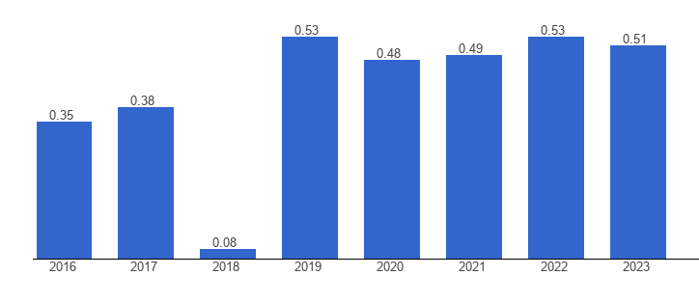
Figure: UK Political stability index
Source: (The Global Economy, 2025)
Political factors: Colourways Textile operates its business in England and due to this, the political environment, stability, trade policies, tariffs and tax regulations have the potential to affect the business in a major way. As per the data of 2023, the latest value of the political stability index of the UK was 0.51, and the average value between 1996 to 2023 has been 0.48 (The Global Economy, 2025). Therefore, it is crucial that Colourways Textile stay aware of the political changes in order to take the required steps.
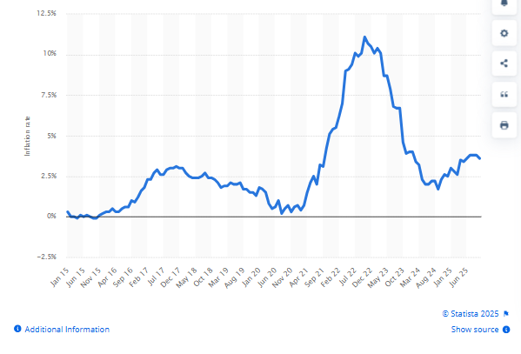
Figure: UK Inflation rate
Source: (Clark, 2025)
Economic factors: The economic factors, namely, inflation rate, growth rate, level of unemployment, employment and exchange rate, are the crucial factors that significantly affect the business of Colourways Textile. Here, it can be mentioned that the inflation rate in the UK was 3.6% as per the data of October 2025. Apart from this, the inflation rate was at its peak in 2022 with 11.1% in October 2022 (Clark, 2025). Being affected by the inflation rate, the cost of living crisis is also increasing in the UK and this aspect has the potential to affect the revenue generation process of Colourways Textile.
Sociological factors: There are plenty of sociological factors upon which the business of Colourways Textile depends to a great extent. It can be mentioned that the purchasing decisions of customers are influenced by cultural aspects, social and democratic trends. Apart from this, the attitude, lifestyle and preferences of the target audiences also play a valuable role. It can be mentioned that the concern for sustainability and ethics is increasing in the recent society of the UK (Thiele, 2024). Therefore, the business of Colourways Textile can benefit from this awareness in a positive way.
Technological factors: The advancement of technologies, changes in technical aspects and innovation are several crucial factors that influence the business of Colourways Textile. It is a well-recognised fact that the UK has been receiving much development in the digital economy after Brexit. As per the data of 2024, the UK has upheld the 18th rank in digital competitiveness, where 66 other nations also participated (Taylor, 2025). Therefore, the technical advancement can help Colourways Textile to bring innovations to the product and enrich the overall experience of customers.
Legal factors: While operating the business in the UK, it becomes crucial for Colourways Textile to stay up-to-date regarding the set of laws and regulations that the UK government has developed for businesses. These laws include, Companies Act 2006, which enables the company to maintain its structure (Legislation.gov.uk, 2025a). Apart from this, the business also maintains the Consumer Protection Act 1987 with the purpose of protecting the consumers and keeping the products safe (Legislation.gov.uk, 2025b).
Environmental factors: There is the presence of the Environmental Act 2021 in the UK that enables companies such as Colourways Textile to pay attention to their impacts on the environment and take steps accordingly (Legislation.gov.uk, 2025c). It is required to mention here that the operations and products of Colourways Textile are already sustainable and maintain the ethical standards in the manufacturing process. Due to this reason, it becomes easier for them to comply with the environmental laws and regulations in an appropriate way.

Strategic Growth Choices and Proposed New Strategy to achieve a long-term sustainable future of Colourways Textiles

Available Strategic Growth Options for SMEs
Small and medium-sized organisations in the market faced a rapid transition to achieve sustainable growth and development. In this context, the use of the Ansoff Matrix and Porter’s Five Forces strategies enables businesses to evaluate critical options which boost their strategic thinking and achieve a competitive market advantage, eliminating higher competition levels as follows.
Porter’s Generic Strategies
A company's relative position in the industry is determined by the profit ratio, which enables it to run its business long-term in the market. According to the author, low cost and differentiation are the two core factors which lead a business to achieve a competitive edge in the market (IFM, 2025). It allows them to ensure higher performance development and attain ample scope of development considering the cost, leadership and focus variants in mind, which is as follows.
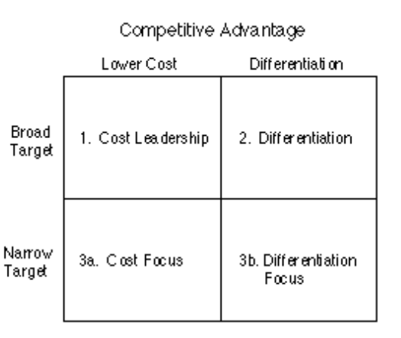
Figure: Porter’s Generic Strategies
Source: (IFM, 2025).
Cost Leadership
The main aim of the SME organisation is to be the lowest cost producer in the market, which allows them to perform with a wider consumer base to achieve profit. This guides the company to emphasise cost control strategies, boost the economies of scale and enhance efficient operations. It enables the company to achieve a higher profit margin and get a new market for business expansion (IFM, 2025). Here, the company can invest in developing an effective marketing campaign based on its niche market segment. A cost focus approach can be helpful for companies to achieve the lowest cost and maximise sales.
Brand Differentiation
A different marketing approach is the key to sustaining in the competitive market and getting a new consumer segment for market operations. The SME companies are committed to creating such a range of products and services that have perceived uniqueness in the market and across the desired industry they want to operate. In this regard, they can be attentive towards the premium pricing of their products to foster brand loyalty and awareness in the market (Chan et al., 2025). The focus of the company to offer highly different and valued items after analysing their niche segment will be helpful.
Ansoff Matrix
The management team of a company implement the Ansoff Matrix framework in their operations to be aware of the growth and development initiatives. This tool particularly helps a company to help its stakeholders conceptualise the risk level associated with different proposed strategies to achieve success. According to this framework, the growth of a business is based on its existing products and markets against the new ones (Peterdy, 2025b).
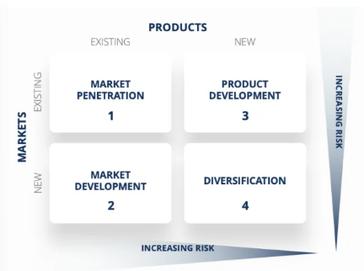
Figure: Ansoff Matrix
Source: (Peterdy, 2025b).
Product Development
The SME companies can pay attention to product development, which enables them to invest in new product development within a new market. It enables the brand to maximise its reach and business, and tailor to a new consumer base (Peterdy, 2025b). Improving the features and characteristics of the existing products and services in the market, the company can get ample scope for growth.
Market Development
Limited market reach is a potential challenge faced by SMEs in the market, which requires new market expansion. In this regard, they can invest in expanding their operations within a new geographic area with their existing products. This will be helpful for the company to boost its revenue (Peterdy, 2025b).

Proposed Sustainable Strategy with Justification
After considering the suitable strategic options for the SMEs companies, it is stated that Colourways Textiles can incorporate such elements to maximise its growth. In this context, the focus of the company on circular economy differentiation, paying attention to the hybrid of differentiation in Porter's forces and product development of the Ansoff Matrix, will be helpful. This proposed strategy will enable the company to become a leader in ethically sourced products and the eco-friendly market, which is the core business value of the brand (Dzhengiz et al., 2023). Considering this, they can make their jersey and other premium items from scratch, which they can borrow from the suppliers. The higher market demand for circular economy initiatives enables the company to align with the changing consumer needs and ensure differentiation using a dynamic pricing strategy. This approach will help the brand attain long-term sustainable development in the market.

Stakeholder analysis with their changing expectations
Stakeholders are the key pillars of a business, and they act effectively to enhance the strategic responsibilities of the company towards consumers and the environment. They guide the company with necessary and informed decision-making to maximise the overall engagement strategy of the business in the global marketplace (Bermeo-Giraldo et al., 2025). In this regard, the Mendelow’s Matrix helps to categorise the stakeholders based on their power, interests and engagement rate, whereas the RACI Matrix is used to define their roles and responsibilities as follows.

Stakeholder Analysis using Mendelow’s Metrix
Aubrey Mendelow developed the matrix to describe more details about various stakeholders' power, category and interests in decision-making. It is highly effective for organisations to categorise their stakeholders effectively to engage them with the success of a project (Weijers, 2025).
Stakeholders | Power | Interest | Category | Strategic Approach | Expectations and Power
Board of management and major investors | High | High | Manage closely | Fully engaged in decision making and make a higher effort to satisfy clients. | Power to drive and block the project and have vested interests in the success. Their expectations align with the organisational goals, which maximise the feasibility and acceptability (Weijers, 2025).
Suppliers, Government and Regulators | High | Low | Keep satisfied | Avoid excessive communication and make enough contributions to raise interests. | High power and minimal interest in reviewing the daily operations in detail. It prevents them to biasedly use their power.
Employees, Local communities | Low | High | Keep Informed | They are informed about the projects and the major issues arising, and work as valuable sources to support the company operations. | Limited direct power to make final decisions, and their collective support towards the project is beneficial.
External Parties and General People | Low | Low | Monitor | Do not use excessive communication, and monitor the general and necessary information. | The least attention ein contributing to the strategic decision-making and are unlikely to be significantly impacted by the decisions made by the SMEs businesses.

Role Definition using RACI Matrix
RACI Matrix is the strategic options highly used within the organisational context to be aware of the responsible stakeholder management. Responsible, accountable, consulted and informed are the four key dimensions of this framework, which help to segment the stakeholders based on their designations are as covered (Miranda, 2025).
Role | Description | Stakeholders | Purpose in Strategy Implementation
Responsible | Do work and complete tasks. | Project manager, web developer, manufacturer. | Ensures that the tasks are aligned with organisational annual goals to attain competitive advantages.
Accountable | Answerable for their work and decision-making. | Owner, CEO, Board members, Project manager | Clear ownership in final decision-making and played an effective role in organisational success and development.
Consulted | Involved in two-way communication and are consulted before making decisions. | Retailer, manufacturer, suppliers and consumers | Use historical knowledge, valuable inputs and expertise to enhance the quality of strategic implementation.
Informed | Kept updated information, not directly involved in a task. | Waste management company, regulators | Manage expectations of the project and avoid unnecessary engagement.

Suitable Strategic Options
The above stakeholder analysis helps to outline the feasibility, suitability and acceptance of the strategic options to attain success and development opportunities from the market. Alignment of the company with the key market players, such as water management companies and high-power suppliers, helps to secure necessary resources for business development (Chan et al., 2025). Compliance with the regulators in the market enables them to minimise risks and ensure the timely completion of the project with a high and effective project implementation plan.

Recommendations
Specialised in Niche Market: Colourways Textiles is recommended to pay higher attention to the circular economy to uphold its niche and specialised market. Delivering sustainable, premium and high-quality materials to its consumers, they can avoid direct competition from the large-scale manufacturers in the market are dependent on high volume and low-cost products (Schenkenhofer, 2022).
Investment in digital transformation: The company is recommended to invest more in digital marketing to improve its market operations and profit collection. It enables them to maximise their financial stability, manage inventory and deliver customised products to the consumer base to work with real-time data (Gazzola et al., 2024). Content marketing and the use of an informative blog within the official webpage of the company enable them to keep the consumers aware of the sustainable initiatives of the firm.

Conclusion
Strategic decision-making is highly important within the business context, and being a local SME, Colourways Textiles faced challenges in getting future development and growth potential. The company is committed to delivering handmade, ethically sourced jersey and other products to its consumers. Objectives, missions and visions of the company are covered as well. SWOT analysis helped to outline the impact of internal factors while the PESTLE analysis helps to evaluate the external factors. Ansoff Matrix and Porter's generic forces are used to evaluate various strategic options to ensure sustainable market development. The stakeholder’s analysis is highlighted here using the Mendelow and RACI Matrix, followed by a set of actionable recommendations.

References
Bermeo-Giraldo, M.C., Valencia-Arias, A., Rojas, E.M., Cardona-Acevedo, S., Rodríguez-Correa, P.A., González-Ruiz, J.D., Londoño-Celis, W. and García, R.B., (2025). Research agenda on the evolution of digital transformation in the textile sector: a bibliometric analysis and research trends. Discover Sustainability, 6(1), p.294.
Chan, H.L., Choi, T.M. and Guo, S., 2025. Systems thinking for sustainable global supply chains: coordination and power relationship. International Journal of Production Research, pp.1-27.
Clark, D., (2025). Inflation rate in the UK 2015-2025. [Online] Available at: https://www.statista.com/statistics/306648/inflation-rate-consumer-price-index-cpi-united-kingdom-uk/?srsltid=AfmBOopoNb6Irr5YUa5AcI8v_0FfRZlmeb2_jT_1ALAy-8U0mt1MIawg [Accessed 15 November 2025].
Colourways Textiles, (2025). Colourways Textiles. [Online] Available at: https://colourwaystextiles.com/ [Accessed 15 November 2025].
Dzhengiz, T., Haukkala, T. and Sahimaa, O., (2023). (Un) Sustainable transitions towards fast and ultra-fast fashion. Fashion and Textiles, 10(1), p.19.
Gazzola, P., Grechi, D., Iliashenko, I. and Pezzetti, R., (2024). The evolution of digitainability in the fashion industry: a bibliometric analysis. Kybernetes, 53(13), pp.101-126.
IFM, (2025). Porter's Generic Competitive Strategies (ways of competing). [Online] Available at: https://www.ifm.eng.cam.ac.uk/research/dstools/porters-generic-competitive-strategies/ [Accessed 17 November 2025].
Legislation.gov.uk, (2025a). Companies Act 2006. [Online] Available at: https://www.legislation.gov.uk/ukpga/2006/46/contents [Accessed 15 November 2025].
Legislation.gov.uk, (2025b). Consumer Protection Act 1987 [Online] Available at: https://www.legislation.gov.uk/ukpga/1987/43 [Accessed 15 November 2025].
Legislation.gov.uk, (2025c). Environment Act 2021. [Online] Available at: https://www.legislation.gov.uk/ukpga/2021/30/contents [Accessed 16 November 2025].
Miranda, D., (2025). What Is A RACI Chart? How This Project Management Tool Can Boost Your Productivity. [Online] Available at: https://www.forbes.com/advisor/business/raci-chart/ [Accessed 17 November 2025].
Peterdy, K., (2025a). SWOT Analysis. [Online] Available at: https://corporatefinanceinstitute.com/resources/management/swot-analysis/ [Accessed 15 Novemver 2025].
Peterdy, K., (2025b). Ansoff Matrix. [Online] Available at: https://corporatefinanceinstitute.com/resources/management/ansoff-matrix/ [Accessed 17 November 2025].
Schenkenhofer, J., (2022). Hidden champions: A review of the literature & future research avenues. Management Review Quarterly, 72(2), pp.417-482.
Taylor, P., (2025). Digital economy in the United Kingdom (UK) - statistics & facts. [Online] Available at: https://www.statista.com/topics/7208/digital-economy-in-the-uk/?srsltid=AfmBOoroJbS_Cvtwg7RpzRwrffaRQ8U1aH96pNuzbsJ-c4J82jaZIyDW [Accessed 15 November 2025].
The Global Economy, (2025). United Kingdom: Political stability. [Online] Available at: https://www.theglobaleconomy.com/United-Kingdom/wb_political_stability/ [Accessed 15 November 2025].
Thiele, L.P., (2024). Sustainability. John Wiley & Sons.
Weijers, L., (2025). Mendelow Matrix. [Online] Available at: https://www.toolshero.com/strategy/mendelow-matrix/ [Accessed 17 November 2025].

