Safe Water Africa

(Project report)

Community Engagement
(LCBB4002)

Learner Assessment Submission and Declaration

“In submitting this work, I affirm that my work adheres to the scholarly and intellectual standards of honesty and integrity. I affirm that this work is my work only and that in the preparation of this work I have not consulted any person. I affirm that I have not plagiarised or misrepresented the ideas or language of someone else as my own and that I have fully and accurately attributed any ideas or text of others to the sources and documented each source”.

Learner name: Petar Yanakiev  Student Number: 2008345 |  | Lecture: Riaz Bhatti
Hand out date: Week 2 of term | Submission dead line date:15/12/2020 |  | Submitted on:15/12/2020
Programme: BA Business Management

Unit: LCBB4002

Assignment title: Community Engagement- Assessment 1

Learner declaration

I certify that the work submitted for this assignment is my own. I have clearly referenced any sources used in the work. I understand that false declaration is a form of malpractice.

Learner signature: 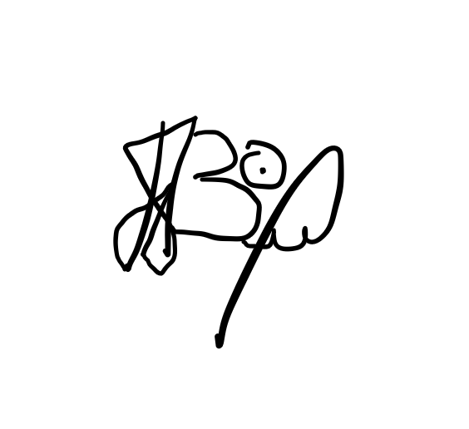 Date:15/12/2020

Introduction....................................
Analysis of the project......................
Conclusion......................................
References......................................

Introduction:
It is a good known reality that millions of individuals need get to to clean water in Africa. Individuals travel numerous hours a day in look of water on Zanzibar Island. But those who have no water on the littler islands must travel over the ocean day by day to gather water from government taps on bigger islands. Quite regularly these taps are exchanged off for a few weeks or indeed months at a time. This takes off individuals stranded without fresh drinking water. We have been penetrating for water for to assist bolster the destitute for a long time presently. There are scores of our water wells over Zanzibar’s farther towns and its neighboring islands.

Analysis of the project:

-Issue Explanation:

Over the course of the a long time 2010 & 2011, AAF field officers met with a few country communities in Kenya, particularly in ranges that have issues with clean water. At the best of the list of the issues confronting these country communities was the frantic require for more noteworthy and more effective get to to clean water.

Much of rustic Kenya regularly gets less than 800 millimeters, or 31 inches, of precipitation per year, rendering these ranges dry or semi-arid. The dry season, which happens from June to October, requires water capacity for numerous communities in rustic Kenya. However, to date, there has been small subsidizing for water help ventures, and much of the cleanest water around-that which falls from the sky within the shape of rainwater-has been cleared out unharnessed.

Whereas water is regularly taken for allowed within the worldwide North, in places such as provincial Kenya, it is regularly seen as one of the foremost important commodities. As essential because it could appear, in arrange for the community to appropriately work, it requires get to to clean water for edit generation, showering, cooking, cleaning, and drinking. Without clean water, communities, like those gone by by the AAF field groups in rustic Kenya open themselves up to flare-ups of water-borne ailments, which can influence human well-being, as well as valuable nourishment supplies. The dangers of broad flare-ups of waterborne illnesses like cholera, typhoid, hepatitis A, and loose bowels maladies are caused by insufficient water and sanitation. Drying water sources powers individuals to utilize intensely sullied water subsequently coming about in water borne infections in case ingested. Such diseases-like loose bowels, cholera, and typhoid-count for 80% of all country illnesses in Kenya.
The regular relocation of families and specialists to urban ranges amid dry seasons is additionally common in provincial Kenya. These movement designs lead to the spread of communicable illnesses such as HIV/ AIDS. Drought periods, regular dry seasons, nourishment shortage and desertification leads to extend in movement stream. Relocation has been recognized as an critical facilitator of the spread of malaria. Prolonged dry seasons may lead to overwhelming populace developments; subsequently causing the youthful and the ancient to endure push and death. The issues with get to to clean water go past wellbeing and sanitation issues, and interestingly influence ladies and girls. Children have been sometimes spotted drawing water from spilling sewages, careless of the perils they are uncovered to. The water stack carried regular is overwhelming and has caused chest complications to numerous local people particularly those with moo salaries. A few children have dropped out of school and to seek after water exchanging as a implies of survival.

Women in country Kenya spend an normal of three hours per day carrying water to their homes from far off sources.

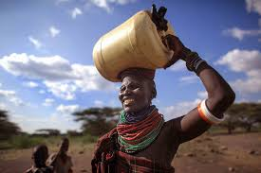

The time ladies and young ladies spend in water transportation altogether degrades from time they may spend in school or gaining a practical income. Some common issues confronted within the existing schools and communities evaluated are: No get to to secure water: They depend on regularly hindered central water supply frameworks from the government. No satisfactory squander water administration coming about to contaminated ground water. Lack of secure sanitation. The rate of school drop-outs in girls increases during feminine cycle, this is often since most of the restrooms have no water, are found distant from the school, have no protection, and no hand washing offices.

-Deduction:

The Amsha Africa Establishment field officers famous the following: Water supply is progressively constrained relative to request. Typically to a great extent due to tall populace development rates, water request for water system and civil use. The fetched of new consumable water can be Ksh. 20 - 25 per 20 liters. The costs cruel that in spite of the fact that water may be realistic, the costs are exceptionally tall and in this way cause major financial hardships. Population development is tall and wastewater collection is growing. Numerous towns are presently actualizing improvement ventures for the advancement of civil administrations and wellbeing conditions in their towns. Uncontrolled reuse is being practiced is a few areas. Farmer’s occupy untreated squander water from sewer outlets and inundate vegetables that are sold within the markets. This seem result in other nourishment borne sickness due to defilement.

With the extension of water generation and utilize, the volume of moo quality return streams into streams has expanded, particularly: Surface streams have by and large moo streams and thus generally moo acclimatized capacities. Water toxins from horticulture. Return streams from agribusiness increments the saltiness of the waterways and streams. An expanded rate of illness.

-Project Plan:

The cheapest, least complex, and most viable arrangement to the country Kenya water emergency is the development of economical water collecting systems. These water gathering frameworks will permit ladies to devote more time to income-earning assignments, diminishes the hazard of illness from sullied water, and gives more noteworthy get to to a crucial human need: water.
Unfortunately, the straightforward, cost-effective, and age-old method of water gathering has regularly been ignored by huge improvement educate and requires the collaboration of grassroots organizations and communities with a commitment for change. Rooftop water frameworks include three essential components: catchment, transport, and a collection gadget. The catchment gadget is the surface that captures the rainwater. In country Kenya the catchment is the housetop where water falls normally. Water channels down the inclined roof best to the movement disobedient, or canals, at the base of the roof.

These canals transport the water from the housetop to the collection gadget, which in this venture will be the Water Hoard. The water is at that point put away within the Water Hoard until its use. One versatile Water Hoard capacity tank holds nearly 52 gallons of water. For the 130 Water Swines Amsha Africa Establishment extraordinary to purchase and introduce, we are going be able to capture over 6,760 gallons of water from water that would something else go unused into the ground. If a lady can carry 5 gallons of water per day, at that point one Water Hoard capacity tank can hold water that would have taken her over 10 days to carry. If she spends 3 hours per day carrying this water, a capacity tank close the domestic can spare her 30 hours of water transport over 10 days which comes about in 1080 more hours a year to do other errands, such as entrepreneurial exercises, day by day cooking, cleaning, child care, and schoolwork.
In case she spends indeed half of those 1080 hours on work that wins indeed $0.50 per hour of salary, this additional time can result in over $250 of pay for this lady and her family. Ideally, each open and private building in provincial Kenya ought to have its claim water gathering framework .

This could maximize the profits of rain water and give satisfactory get to to water for all individuals of the community. With the help of benefactors, AAF will be able to cover the costs of obtaining, shipping, and introducing these water-harvesting frameworks.

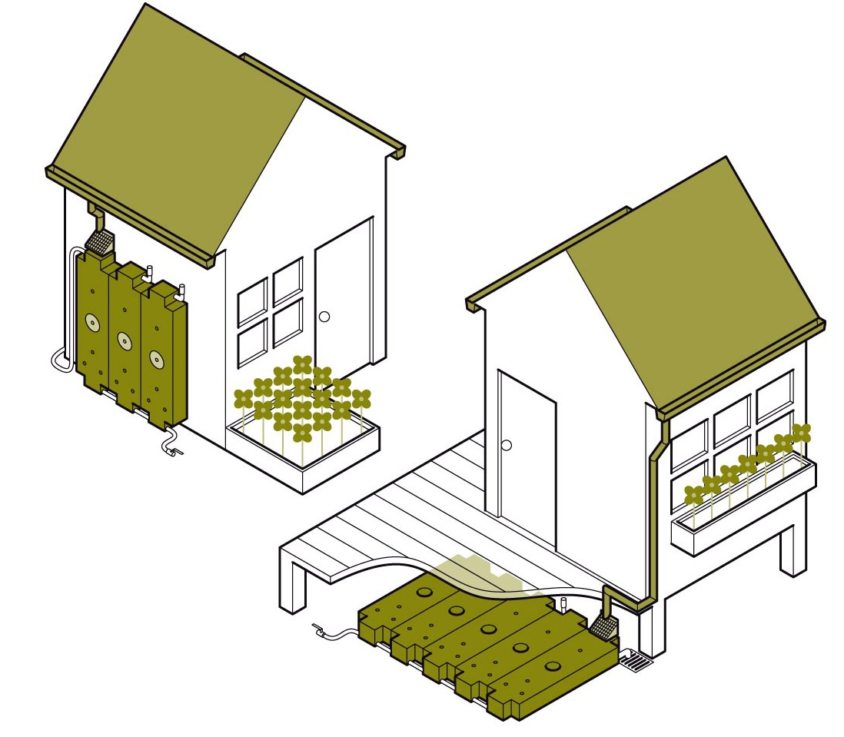

-Project Objectives:

1.Brief Term Objectives...

1.1 Education -Since it was famous that the increment in school dropout was specifically connected to water deficiency, accessibility of water will moderate this issue. Most children spend more time getting to get water, within the long run they conclusion up skipping important learning time. Water accessibility will effortlessly put a halt to this

1.2 Failed Project -Most slowed down ventures in country Kenya, for case the Modambogo Wellbeing Center in Mwatate, Tumaini Ladies Self Offer assistance gather extend in Kisumu, Bee Guardians Affiliation, in Taveta, cannot be commissioned due to need of channeled water. In case water is profited, these ventures can be effortlessly completed and commissioned to serve their fundamental work of making a difference the community.

1.3 Awareness Rising -Effective execution of the rain water collecting framework will offer assistance raise mindfulness on the benefits of water gathering by rapidly illustrating how simple and successful the arrangement of the water collecting framework can be.

2.Long Term Objectives...

2.1 To guarantee accessibility of clean drinking water to the individuals in provincial Kenya .

The foremost essential utilize of water is drinking. Water is an fundamental component to our bodies. For numerous a long time communities in country Kenya have not had get to to clean drinking water. In a few regions, boreholes that had been sunk created either saline water, were sullied and numerous have run dry. This has had a more extensive impact to generally financial exercises. With clean rain-harvested drinking water, we are going put an conclusion to issues with respect to wellbeing – waterborne maladies and guarantee that the community part get coordinate get to to clean drinking water over a long period of time.

2.2 Moving forward the wellbeing care framework

Through our investigate, we famous that numerous wellbeing centers in country Kenya are non utilitarian. With need of channeled water, these wellbeing centers cannot be able to run essential capacities such as to begin with help, wound treatment among others. With water running, most wellbeing centers such as Modambogo Wellbeing center in rustic Mwatate will be restored. The by and large affect of this will be to guarantee that the community individuals within the region enjoy great wellbeing. To attain this, AAF groups in collaboration with volunteer specialists from the Joined together States will be routinely running free treatment in endeavors to totally annihilate infections that can be maintained a strategic distance from like Intestinal sickness, Typhoid among others.

2.3 Make strides agrarian movement through water system

AAF is arranging to teach the range inhabitants on moved forward rural hones utilizing water gathering and water system as a source of water. With exceptionally rich soils, trim development utilizing rain water collecting and water system methods can be a victory and the inhabitants can put agribusiness as an financial action. Reusing of water can be utilized to inundate crops and moreover check issues with respect to nourishment security.

Target:

1.Woman
2.Children
3.Adult

1.-Ladies in provincial Kenya do lion's share of the family errands. These incorporate cooking, cleaning the house, washing dress, edit development among other assignments. Most of these errands depend exclusively on the accessibility of water. With this kind of part playing, ladies endure the foremost particularly where there's need of water. In such a situation, a lady will be forced to wake up exceptionally early within the morning, walk over long separations to induce water. Water sellers such as the nearby council’s water framework are untrustworthy and numerous times a few of these ladies travel long separations as it were to conclusion up with no water. At times where water is accessible the ladies line for long hours due unending demand. It is very disastrous that in spite of the destitution levels in most of rustic Kenya, water merchants utilize imposing business model to over cost communities. A normal case in Mwatate town is where a 5 liter jerrican is sold at a cost of 20 shillings.

2.-When the AAF group did a fast study on water deficiency in relations to instruction, much was concluded. For case, the Mzwanenyi Essential School in Mwatunge area records moo turnouts of understudies. When questioned, the students complain that their guardians don't permit them to go to school since they need to stay at domestic and offer assistance in getting water. Many ranges that have issues with water deficiency record destitute execution in national examinations which can be ascribed to low concentration by the students. Some of these students walk long separations to explore for water, relinquishing hours of schoolwork. In an occurrence in Eminent 2010, a understudy on his way to induce water on a jackass driven cart was included in an mishap where a car drove into the cart, murdering the jackass and gravely harming the child. This truly disturbed the neighborhood community and the matter was detailed to the neighborhood chief.

In case the issue of water deficiency is tended to and fathomed totally, numerous of the school going children would be able to comfortably go to school without stressing approximately planning to bring water. In general, this will offer assistance them concentrate in instruction and bring down the expanded rate of school dropouts and move forward the by and large execution.

3.-The grown-ups within the locale complain that most of their time is squandered investing long hours going in look of water. Likewise, much time is additionally went through within the long lines for water. In such a situation, most vitality is channeled to ineffective activity. Man hours that can be put in profitable exercises such as cultivating is misplaced. Most cultivating arrive within the locale lies uncovered since they are not cultivated. With the extend kicking off, AAF will sensitize the community individuals on the significance of cultivating as an financial movement. Through water system, the ranchers in country Kenya can utilize the ripe soils to develop crops such as maize, beans and indeed cash crops.

Our Order to our Donors:

Amid the advance of the venture, week after week gatherings will be set to guarantee all the members are educated of the progress. The field extend co-ordinator will be sending e-mail upgrades with photo and video connections (on the off chance that conceivable) amid and after the completion of the project. A media occasion will be held at the conclusion of the extend which is able incorporate nearby media, nearby specialists, and the community that was included in making the venture a success. After the rain water gathering framework is introduced, AAF field groups will clarify to the recipients how the framework works, how to keep the framework clean, and what to do in the event that they have any issues. AAF will work near with Water Assets Administration Specialist and National Natural Administration Specialist to guarantee that the extend meets universal measures and would be able to serve eras to come.

Project Evaluation:

With truths and figures at hand, AAF is anticipating that the venture will be a victory once implemented. Water deficiency has been a major issue in provincial Kenya over decades. This has been ascribed to subsiding precipitation amount over the years. Once this extend is actualized, key divisions such as wellbeing, sanitation, instruction, horticulture and in general advancement will benefit. The assessment period may go from 3 to 2 a long time and radical changes will be famous.

The Benefits:

Education Education is one of the columns of improvement. Instruction is synonymous to improvement. For case, the Mwatate locale gone by by AAF field groups records exceptionally moo instructive lists since most of the children stop instruction once they total their essential education. Since the tall level of school dropout is straightforwardly related to water deficiency, with water accessibility, guardians can be able to guarantee that their children go to school.

Health Major Wellbeing centers in rustic Kenya have unfavorably been influenced by need of water. A great case is the Mwatate Wellbeing Center where a quiet cannot be treated in the event that he or she cannot come with a jerrican of water. Moreover, fizzled ventures just like the Modambogo wellbeing center would be restored with accessibility of water.

Agriculture Water bolstered development (water system) in the event that sensitized as restricted to season based agribusiness can guarantee regions in provincial Kenya that have water issues encounter copious gather all year round .

Conclusion:

After the completion of each rain water collecting extend, AAF will authoritatively hand over the venture to the water administration committees within the country communities chosen for this project. The community individuals in these committees will be entrustedto miss the supportability of the project. AAF will closely screen the administration of the venture through visit visits to the location and have a changeless agent within the water administration committees shaped who will be announcing to AAF. The water administration committee will have the taking after tasks: Ensure that the hardware at the extend location is secure all the time. This could be done by enlisting a watch who will not as it were secure the border but too guarantee that the hardware is adjusted frequently on the off chance that needed. In the onset of wear and tear, AAF will guarantee the contracted design will continuously be accessible to do repair work, out of the contract assention signed.

The AAF group will work with the nearby specialists such as chiefs, locale officers, and community senior citizens through community policing to guarantee that the introduced gear are secured from vandalism. Strict activities will be taken on wrongdoers and the community will be taught on how critical it is to care for the extend through consistent barazas (meetings). Community cooperation in administration of the venture will accomplish this. To guarantee long-term supportability of the extend, private financial specialists, people, the chamber and indeed government offices will be energized to pipe and tap the water and pay month to month expenses to guarantee supportability of the water. These expenses will be able to cater for adjusting and essential repairs that could be experienced over the a long time. With time, the committee can grow the ventures depending on the request from both the local people and the clients.

References:

Donate water;2017.Water Well Charity ,Ac-Ahsari Foundation ; Amsha Africa Foundation ;2017

