

THE IMPACT OF VIRTUAL LEARNING ENVIRONMENT (VLE, AS AN EXAMPLE MOODLE OF OUR UWTSD) OF THE LEARNING EXPERIENCE OF THE STUDENTS AT UWTSD (LONDON CAMPUS)

MODULE: DIGITAL SKILLS AND RESEARCH METHOD HEALTH AND SOCIAL CARE.
COURSECODE: BMSW 4003

NAME: WINNIE NZARAMBA

STUDENT ID: 2014619

UNIVERSITY OF WALES TRINITY SAINT DAVID LONDON CAMPUS
MR. KOUSHIK MODAK

Table of Contents

1.0 Introduction 2
1.1 Rationale 3
1.2 Research aim and objectives 3
2.0 Literature review 4
2.1 What is VLE 4
2.2 Importance of VLE 5
3.0 Research methodology 5
3.1 Research design 6
3.2 Survey analysis 6
3.3 Closed ended question 7
3.4 Ethical considerations 7
3.5 Data analysis 7
4.0 Result and analysis 8
4.1 Survey questionnaire 9
4.2 Discussion of result 11
5.0 Conclusion 13
6.0 References 14

1.0 Introduction

It is evident that, the overall education system has been impacted by the COVID 19 throughout the globe where numerous schools, colleges and universities were shut down to comply with government legislation which was an attempt to minimize the spread (Andreas., 2020). However, with the help of technology and relevant tools, numerous educational institutes run their activities via integrated digital learning platforms. Like many educational institutes UWTSD also have adopted effective online learning platforms (VLE) where students are gathered to attend the class and carry out discussion as per university requirements. Hitherto, this report is based on VLE of UWTSD where the impact of it towards students will be scrutinised.

Students in a class were asked for this research to conduct surveys where students can participate to synchronous and asynchronous talks to maximise their learning. The surveys were conducted through survey questionnaire online where 21 students were chosen as a participant who are second year students of UWTSD. The surveys have been designed with ten unique questions focusing on impact of VLE towards students in UWTSD.

1.1 Rationale

VLE holds various impact towards student in numerous ways, its due to the changes in learning culture among the students as well as advanced technology used within the university (Paulo., 2016). In the middle of March 2020, the UWTSD authority and students came off the campus and started teaching and learning online along with all the professional and academic support allocated by UWTSD. The university was successful to offer and provide all the required services such as support and teaching digitally. The university is looking forward to getting back to on-campus situation from February 2021, but they are still reviewing the situation taking the current pandemic situation into consideration.

1.2 Research aim and objectives

The Aim of this study examines how the Virtual Learning Environment impact on the students learning journey.

To attain this aim, the field of study has developed three unique objectives that need to be obtained to ensure successful completion of the report.

- To identify the experiences of UWTSD students via using VLE within their learning process.
- To develop awareness through the data analysis along with its translation into the knowledge.
- To justify the soreness of VLE among undergraduate students of UWTSD - London Campus.

2.0 Literature review

2.1 What is VLE

A virtual learning environment is sort of platform that connects students, parents and teachers to share information and different learning activities. It is basically a web-based system that offers a secure space for everything that happens in educational institutions (Frog Education., 2019).

2.2 Importance of VLE

A VLE offers so much information which is more than just a digital record of institutions activities. It is considered as a resource bank that could be adopted to push data out as well as in. VLE - the Virtual Learning Program has made it clear that, it is an effective and significant way of learning in modern days. Not only broadly used in education but VLE also proved itself as a system of learning distantly without having regular face-to-face contact with the lecturer in a physical room (Paulo., 2016).

3.0 Research methodology

When it comes to research methodology; it plays a crucial role as it is something that systematically designs the study to ensure reliable and valid results which address the research aim and objectives (Franklin., 2012). In this research, the research method is based on survey where surveys have been completed and consulted towards students taking into consideration things like student’s digital competence, opinion related to VLE, experiences while using VLE along with other technical applications etc. A ten-ques-ton computer survey has been designed in prior to processing the survey and the format was structured with multiple choices. On the other hand, the survey also contained four different sections that focused over teacher, student and classroom resources and the use of VLE.

This report not only used primary sources but also secondary sources where necessary to support various theorist viewpoint regarding the importance or definition of different methods. This report is based on survey questionnaire, which is part of a quantitative research method, but author of this research has personally interviewed some participants over WhatsApp to get the deeper understanding about the thoughts. The survey questionnaire was Likert type scale structured and close ended in nature and was distributed by Email and after the completion of survey data is presented through numeric order along with discussion and analysis.

3.1 Research design

The quantitative research was developed in a form of an e-questionnaire that allowed analysis with excel and different pie-charts. The survey questions were grouped and organised into ten questions. The survey questionnaire was developed through the help of the lecturer during the class tutorial. Even though this report is largely based quantitative research, but the writer also has used qualitative methods through observation and interviewing the participant to get critical understanding. Hence, through the support of the survey questionnaire, observation and interview, the field of study has scrutinised respondent opinion regarding impact of VLE, experiences related to technological applications and so on.

3.2 Survey analysis

In this chapter, the survey questionnaire is illustrated where the outcomes of the survey are presented along with examples.

Question - Has VLE impacted your life?

To get the answer to this question, the author has explained to the participant about how VLE is impacting their studies and how effectively they can use UWTSD Moodle.
To analyse the numerical outcome of the question, the author has developed Likert scale questions such as:
- On the scale of 1 to 5 how VLE changes your understanding and learning process? Where 1 is the lowest and 5 is the highest.
- On the scale of 1 to 5 how VLE has benefit you? Where 5 is the highest and 1 is the lowest or poor.

3.3 Closed ended question

Another form of the survey questionnaire was close ended questions. Close ended questions are the sort of tactics where the researcher allows participant to answer questions with the option of yes or no (Patton., 2002). For example:

- Have online experiences helped you? – Yes or No.
- Do you consider VLE experiences is secure and safe? – Yes or No.

3.4 Ethical considerations

Ethical consideration plays an important role in any kind of research (Silverman and David., 2011). Hence, high importance was given regarding the ethical consideration to carry out this report. All the students were given consent to participate within the study and has been informed about the detail of the process. Some respondents were uncertain during the interview, due to the technology confusion amongst the students. The author also has made it clear that, this report is not intended to assess the lecturer’s performance, but rather focus on how students reacted to the use of the technology. All the information gathered within the report are followed guidelines developed by UWTSD and was referenced correctly to avoid collusion.

3.5 Data analysis

The data for this research are developed in English and distributed towards the potential respondent. The data analysis followed the Likert type scale structure and were administered towards the respondent along with some close ended questions. Total 10 questions were developed that followed the model proposed by Creswell (2009) which incorporates preparing and organizing of the data analysis, reading all the information, data coding and interpreting descriptions and theme. The outcome of the data was presented using Excel and Pie charts and discussed according to achieve aim and objectives of the report.

4.0 Result and analysis

To justify the result and analysis of the report, the field of study carried out a survey questionnaire where a set of questions were distributed and the author had done analysis with the help of excel and pie-charts, where the numerical outcome of the survey will be presented. The following table shows the impact of VLE on students of UWSTD (London Campus).

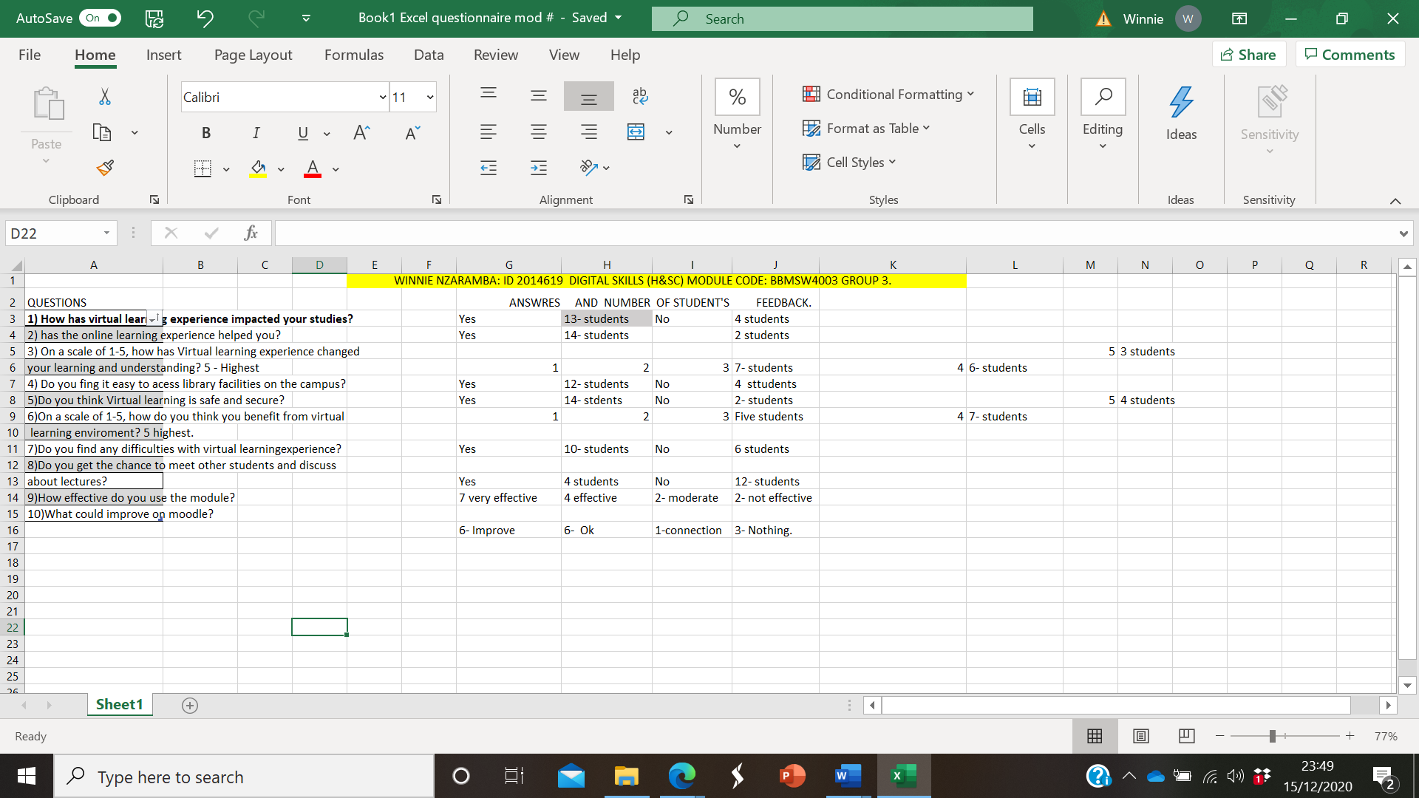

4.1 Survey questionnaire

1. Has VLE impacted your life? 76% Yes. 24% No.
2. Has the VLE helped you with your studies? 87.5% Yes. 12.5% No.
3. On a scale of 1-5, how has VLE changed your learning experiences and understanding? 53.8% Moderate. 46.1% Second highest.

4. Do you find it easy to access online library over VLE? 75% Yes. 25% No.
5. Do you think VLE is secure and safe? 87.5% Yes. 12.5% No.
6. How do you think, you are benefitted from VLE? On a scale of 1-5? 41.6% Moderate. 58.3% Second highest.
7. did you face any difficulties while using VLE? 62.5% Yes. 37.5% No.
8. Do you get the chance to meet other peers and discuss with them about an issue? 25% Yes. 75% No.
9. How effectively you use Moodle? On a scale of 1-5? 46.6% Very effective. 26.6% Effective. 13.3% Moderate. 13.3% Not effective.

10. Does VLE need any improvement? 37.5% Could improve. 37.5% answered OK. 6.25% connection could improve. 18.75% answered nothing.

4.2 Discussion of result

Researcher has developed the discussion in regard to aim and objective of the report through the statistical outcome of the above excel sheet and Pie Charts which is following.
Through the significant numerical findings, it’s evident that uses of VLE produced high improvement when it comes of learning and drive motivation towards learning which has been reported by the respondent (students). The findings stimulate teachers interest and they indicated the areas of attention to promote VLE learning. Student who used VLE can be set as a “task” that need to be finished at their own pace. VLE has effectively improved the satisfaction of students. A total number of 21 students were chosen for the survey and majority of them replied they are highly satisfied with the VLE experiences and they also complemented manifestations.

The ten-question survey which followed the Likert type scale structure and administered towards the responded. At the end of the discussion about experience, quality of VLE, lab con-dictions, lessons, further improvements and so on and after that the author of this report is highly convinced that students of USWTD are highly satisfied with the VLE system which was also been identified with their positive responses which was way higher than negative answer.

The author has also observed the respondent during the survey as well as during the first semester of the academic year. And outcomes of the survey are like the observation where students are highly satisfied with the system specially the time of Pandemic. All the respondents engaged within this survey are respected accordingly and allocated enough time to answer the questions.

5.0 Conclusion

The objectives of this report were: to identify the experiences of UWTSD students via using VLE within their learning process, to develop awareness through the data analysis along with its translation into the knowledge, to justify the soreness of VLE among undergraduate students of UWTSD - London Campus. Hence, after analysing this report with right methodologies and discussion students of UWTSD are highly satisfied with the VLE experiences where the room for improvement was mentioned is connectivity. So, relevant authority could take it into considerations for further improvements. Finally, the researcher has done this report for academic purposes and all the information gathered here are referenced correctly to avoid plagiarism and collusion.

6.0 References

Andreas Schleicher. 2020. The Impact of COVID-19 on Education. Retrieved from https://www.oecd.org/education/the-impact-of-covid-19-on-education-insights-education-at-a-glance-2020.pdf. Accessed 02.01.2021.

Paulo Alves. (2016). The Importance of Virtual Learning Environments in Higher Education. Portugal: Polytechnic Institute of Braganca.
Creswell, J. 2009. Research Design: Qualitative, Quantitative, and Mixed Methods Approaches. Thousand Oaks, California: Sage Publications.

Franklin M. 2012. Understanding Research: Coping with the Quantitative-Qualitative Divide. London: Routledge.

Frog Education. 2019. Why you need a Virtual Learning Environment. Retrieved from https://inspire.frogeducation.com/news/virtuallearningenvironment. Accessed. 03.01.2021.
Patton, M. Q. 2002. Qualitative research & evaluation methods (3rd edition). Thousand Oaks, California: Sage Publications.
Silverman J. and David F. 2011. Qualitative Research: Issues of Theory, Method and Practice, Third Edition. London, Thousand Oaks, New Delhi, Singapore: Sage Publications.

