Kai Higgins | 2104154

Research and case scenario in Data Security and Compliance
Contents
Research and case scenario in Data Security and Compliance 0
Data Security and Compliance 1
Task 1 1
Introduction 1
Physical Security 1
Intrusion Detection and Prevention Systems and Other security Tools 2
Intrusion Detection System 2
Intrusion Prevention System 3
Security Technologies 4
Task 2 – Case Scenario 6
Introduction 6
Organization Structure and chart 6
Policies 7
Compliance 7
Risk Management 8
Protection Mechanisms 8
References 9

Data Security and Compliance

Task 1

Introduction
For task 1 the main aim is to research into my chosen subjects thinking of both positives and negatives and trying to show organisations real life examples of this and why it’s important to add into their infrastructure and explain why the need to implement these into their organisation. Personally, I feel as though a organisations network being secure and being able to detect threats is critical for a successfully run business no one will want to associate with an unsecure business.

Physical Security
Physical security in an organisation is very important in an organisation when I say physical security, I don’t just mean locking doors in the office even though that does place a role in security. One of the main ways of securing an organisation that won’t allow for any unknown people entering is through bio metric scanners [1] this is quite an advanced way to do so. There are many benefits of bio metric entrance first one being that it keeps logs of who has opened what door and both at what time this will be very useful if something where to happen and you needed to see who was in the office at the time, Another advantage of this is the ability to also control who has access to what doors for example if it’s a manager’s office ideally you only want the manager to gain access to the door and are able to do that with bio metric scanners.
Another important way to secure an organisation is to make sure that certain IT privileges are correct on the system and the way to do this is to appoint one of the IT staff members to double check privileges and be very careful what certain users are allowed to do. But on the other hand, you also do not want to go too overboard with the restrictions as this could limit the user experience and certain members of staff in the organization may not be able to do their job [2]
Making sure that all staff have basic IT skills and training them is also important for an organisation as in terms of security basic knowledge will teach the staff not to click on certain hazardous links and to log out of their computers correctly preventing any data potentially corrupting. This basic training will teach an organisation about internet security. [4]
Most organisations will focus on making sure that all of the security aspects are covered but will fail to think about actual physical points that could go wrong with a network, what I mean by this is natural disasters some organisations are only 1 floor and 1 office but that will not be efficient against floods for example, and this also depends on how they are backing up there data if they are not using cloud and instead using hard drives then these could also be damaged and unusable. So, making sure that the server is elevated is important and making sure that the server room is correctly sealed if you are unable to raise the server you can also place sandbags on the doors when flood warning is made [3]. It is critical that cloud storage is used and not physical backups as these could also be damaged by the flood, setting the cloud to back up every week will solve this problem and you will only lose a week worth of data instead of potentially all of it.

Intrusion Detection and Prevention Systems and Other security Tools

Intrusion Detection System
The use of an intrusion detection system is vital in a network or something like its role, an intrusion detection system will check through the traffic going through the internet and then match it to databases of known attack signatures and then notify and or block the connection [5]
The advantages of this being that the network can still run smoothly with minor snags along the way of these risky networks, this is very useful for an organisation as this can be left alone to run in the background and if it is updated frequently so that the database is constantly being refreshed then there will be no problems.
But sadly it is not that easy any more and this is the minimum amount of security attacks to an organisation are constantly getting more and more advanced and also depending on the organisation they may receive hundreds of flagged addresses daily and that’s the issue the database will need to be constantly adding these new potential threats onto the system, but it is not possible to update it daily so some will slip through on the network due to attacks simply getting smarter and the database list just not being able to keep up.
The network will not block this it will simply report it and then will gain information and report it to the system admin who then can understand the number of threats they deal with and take appropriate action from there.

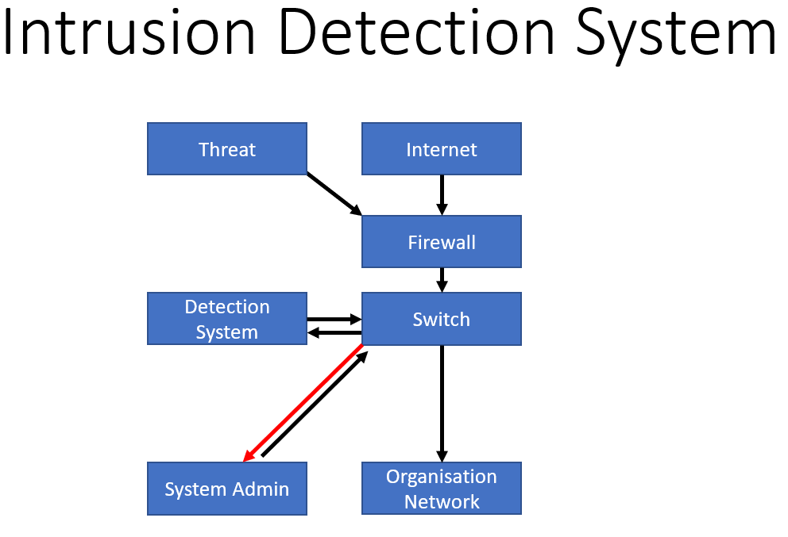

Intrusion Prevention System
An intrusion prevention system on the other hand is much more sophisticated when it comes to solving potential attackers onto the network, what an IPS will do is when an unauthorised connection enters the network it will block the traffic of that network and recognise it as a potential threat. An IPS will already have IDS installed onto it meaning it is able to understand what threats to look out for by comparing the connections to the database. This system also has the capabilities of analysing all previous attacks and using this to and storing it to understand what to block in the future [6], all these setting can be changed by the organisation admin they can also view potential patterns that the IPS has noticed and be able to change the sensitivity of the IPS whether it should block certain links or not. They may also add a whitelist of what links are okay to go through the network.
This is a much more sophisticated way of running the network and the advantages are that the network is much more safter and is constantly reading what is going on and will be able to stay up to date and understand algorithms that attackers may use to gain access to the organisation. Another benefit of the IPS system is unlike the IDS system this will block and report instead of just reporting. The IPS system will also understand potential attackers that are not in the database due to it learning the attacks.
This sadly comes with a cost this system costing around £10000 + for organisations so if it’s a starter organisation this option could be much more expensive rather than the basic firewall, another disadvantage is if something goes wrong, sadly this is not an issue a network admin can deal with this is a sophisticated system and will require a professional to work / update / problem solve it. Another issue with this
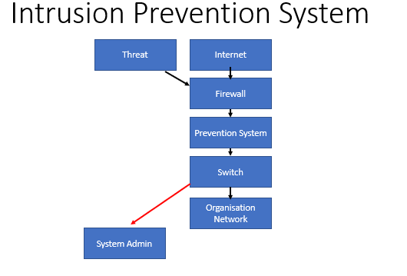

Security Technologies
There are many different types of security technologies first you have data loss prevention and from an organisation point of view it is most used to prevent any sensitive information being leaked so this will work through emails and will detect any files that seem to be sensitive and prevent it from sending. This is so that confidential information does not get out of the office. [7]
The benefits of loss prevention are that it has so much potential to save a business for mass amounts of damage and both money as information being leaked like a person’s address or name will be in breach of the data protection act and could see the company being fined and sued for up to 4% of annual turnover which may not seem like much but if a company is struggling this could be the last straw for them. [9]
The disadvantages of this are that it could be a hindrance when doing certain projects like staff sending information from one building to the other through email this will be flagged and then stopped which could cause loss of work for the company and will require downtime. Another issue with this is emailing the customers themselves if you place any personal information in the email, it will once again flag this and report it. The solution for them problems will require an IT professional to make an automatic system to add all customers to a whitelist database which can become pricey and cost quite a lot of money. [10]
Another potential security technology is a firewall all organisation systems will need a firewall this is the first layer of security these firewalls will focus on blocking suspicious attempts to get into the network [8], a firewall will constantly be running in the background and will work without the user even noticing. A firewalls sensitivity can also be controlled by a system admin to make it stricter or to make it block less traffic.
The advantage of a firewall is that they are cheap and are extremely vital to the network without one it’s like keeping your front door open, these will constantly work in the background if the server is turned on, this means less maintenance needed as its admins can allow the firewall to work away. This also means reduced costs on staff training as you do not need advanced training and can simply give them beginners training.
There are also disadvantages to a firewall this could be the cost, first the organisation needs to choose a gen of firewalls they need to pick a certain one that will achieve what they gen 5 being the best possible chose blocking out mass attacks and multiple attack attempts at once. The only issue with gen 5 is being the cost around £1.50 per deployment hour which means every hour that the firewall is running, say the firewall runs 24 hours a day that cost’s £36 a day and £144 per month, and you will also have to pay for the initial IT expert to install this onto the system. If a business is just starting up and has not much money this could be an issue, but this is also very essential and is needed to protect the business network.
An organisation will also commonly use an anti-virus, and this will be installed on all systems in the organisation the role of an anti-virus is to monitor what files have been installed onto the computer once it finds what files are on the computer it will then match the files to a database of known malicious files and will then both block and delete the file from the computer. The anti-virus will also be doing this at a constant rate with every file that is installed onto the computer, if any file that is being installed looks malicious it will then notify the user and proceed to block the attempted attack.
The good thing about an anti-virus is that it doesn’t just cover virus’s most anti-virus software now comes with spyware protection, Web protection, Spam protection, this is massive in terms of protection and is a must have with scammers getting more and more smart when it comes to website links and also by using spyware, spyware is commonly used to look at keystrokes the user makes and when it comes to an organisation an attacker could look at certain peoples bank information or even important passwords to gain access into the organisations system. [11]
As always there are disadvantages to an anti-virus one of them being the way it scans files it works off a database of key files so if something flags it will them attempt to remove the issue that being the problem, if the user is trying to download a file similar to the flag the anti-virus will then not allow this to happen thus causing the user to have to deactivate the anti-virus software just to be able to download this file onto the system. Another issue with an anti-virus is the constant maintenance required to keep everything updated even your OS and attackers will constantly be looking for insecurities and an out-of-date OS (operating system) and a weak network they can then bypass the anti-virus and get direct access into the computer. [12]

Task 2 – Case Scenario

Introduction
I have been asked to help a business called “SwanTech” to set up a new security unit. Based on the information I have received these are a computer security company who I will be tasked on working on there computer security systems and plan on teaching them how to set this up and even what they can focus on more and the risks that they may face and how to correct them issues like data protection and potential policies the company can put into place.

Organization Structure and chart
Making sure that the organisation has structure and that all departments have the correct managers and also job roles is important for many reasons first of this will allow for the most efficient possible way the organisation can run and also the most optimised way, without having structure with no leadership roles the company would simply not get anything done and people would have no idea what job to do and also what there roles are for the day, making sure that people understand what jobs and also what department they are in is vital without that then there would be no company without structure.
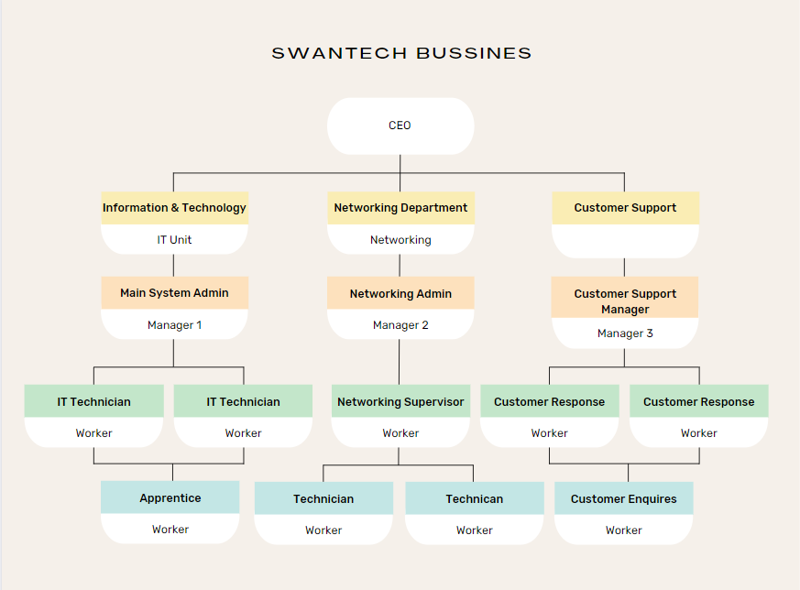
As you can see from the chart above I decided to make a structure for the company in the table above you can see I will always have a manager these people will be handing out the jobs and also keeping an eye that everything is being done correctly but there is one difference in the networking department I have added a manager and also a supervisor when it comes to networking having 2 people to go through will let much less problems slip through the cracks and also meaning that any suggestion the networking team or any products that they are ready to launch go through the supervisor and the manager and then the owner meaning there are multiple security checks for flaws / potential backdoors that an attacker could use to get into the new software. But the good thing about this company is that everything must be run through the owner meaning that problems can be checked for in any department.
There are always disadvantages and the disadvantages of having such a strict structure is potential segregation between the colleagues which can cause a clash in terms of staff relationship so making sure that staff have respect for each other is key to a happy business. Another potential disadvantage of this structure could be lack of coordination due to the fact that everything is done between mangers and owners staff will not be able to talk to one another and work stuff out between each other meaning this could be less efficiency in the company and also time consuming as the whole process needs all mangers and both owners to approve these decisions so I think maybe adding more supervisors or allowing trusted staff to be able to implement certain decisions as long as it’s approved by 1 manger should be acceptable.

Policies
There are many polices that a company has to follow especially a Tech company when setting up a new business Policies are a legal requirement there are many a company need to follow by but I will name specifics that I would recommend “SwanTech” need to use, starting off with code of conduct I recommend that “SwanTech” inform all staff off this policy as it will cover them from any staff problems and tell them how they should conduct themselves, especially when it comes to IT constant professionalism needs to be used as any miss concentration could cause problems to the network and both staff relationship.
Another policy to enforce is data protection and I highly recommend that all staff in the organisation are aware of this policy and constantly refreshed on it as they are handling private information about business and any information leaked that shouldn’t go back on the company and make SwanTech look bad. Data protection handheld incorrectly could cause the company to be fined and lose money. [13]
Another policy to make sure staff in the company are also aware off is use of social media and the internet, if staff are using social media in the office and posting videos / photos of the office and or workspace then this will breach this policy and then need to be dealt with. Another issue with this is that if they are taking videos of the server room and putting it into social media this could be inviting unwanted attention to the networks setup and potentially cause physical threat to the network.
In conclusion when setting up a new unit the staff need to understand how to follow basic policies and constantly be refreshed on these polices as a simple photo on social media could cause a potential threat to the network. Also, this will keep the staff understanding the risks that they face and make them double check before they perform certain actions that could affect both the company and compromise the network.

Compliance
Compliance in a company is extremely important this is where the staff will listen to certain rules and certain policy’s that the company send out, in terms of lawfully as well the company to prevent them getting into serious trouble need to set these rules out for the staff to save them getting sued or in result of being sued, they are able to protect themselves.
The first Compliance I would personally set for the organisation is how to use a computer correctly I would make sure to make a list on the general conduct of the computers in the office and make sure the staff both read and both agree to this, in future this will prevent any sort of insider threat to the company as any staff cause using the computer against the written agreement can then be dealt with accordingly.
Another Compliance to add to the organisation is an agreement for the organisation to follow policies & procedures these are lengthy but making sure staff are educated on them especially data protection policies as working with security and business address / information you must be careful with how they use this information so making sure staff comply with these acts is important.
Making sure staff are also complying with training and educating them on both the internet protocols and both the safest and most correct way to use a computer without potentially falling for any common scam attempt with basic training staff will be able to notice these attempts and staff will also understand how to safely use a computer [14] and be able to understand any malicious files or emails they could be receiving.
In conclusion making sure that there are certain rules and certain procedures that staff need to comply with is extremely important to an organisation to prevent certain court cases potentially happening and in terms of efficiency and both basic IT skills making sure that staff comply with the training that is set out will benefit both the staff member and both the company from any sort of simple problems in terms of attacks happening.

Risk Management
When it comes to risk management as a business this could be multiple different things but first of all I am going to talk about if there was a potential threat to enter the network how the company will need to set out risk procedures this being, if a threat enters the network to report it to one of the IT admins who then can follow certain polices and both steps to then detect where the threat has come from and remove it, and also make sure to report.
Another example of Risk management can be avoiding the risk overall and writing a risk assessment so staff know what to look out for ahead of time of the risk potentially happening this is important, and the business can learn and grow and eventually add everything they have learnt to the possible risks or even reduce possible risks.
Risk management doesn’t always have to be a massive hit to the network or business the idea of risk management it to work on how to take the blow and what actions to take if it happens to reduce the impact of the risk, risks do not always have to be a massive thing and always need to be dealt with. And example of a risk that you could lower the impact could be a potential attacker gaining access to network the risk assessment should then be used of a network admin proceeding to block this connection and run a scan on the network for the potential breach that they could have used to gain access into the network.

Protection Mechanisms
One of the types of a protection mechanism that could help the business to become a safer place and also to prevent potential threats to the network is biometrics for the lock on the server room door, this meaning that only certain people can gain access into the room this will also benefit the company if something does end up happening in that room they will be able view who was in the room at the time of incident.
Also, when it comes to physical mechanisms this can involve how the server and other technologies are stored having them in save places is important placing them into a room with no sort of protection will cause issues, making sure that the server is elevated to protect from potential nature disasters and also that it is encased in a waterproof case for 2 reasons 1 being in case of floods and another being in case of a fire in the server room all servers will be fitted with temp sensors and once it reaches to the max temp it will then trigger sprinklers to prevent any further harm / loss to the servers.
Another way a protection mechanism can be used in the company is making sure that data is backed up to the cloud this luckily can be done automatically and set to when it can be done, for this company I would recommend first of all monitoring how much customers they actually get if it’s daily then backup every 24hrs if it’s weekly then set it to be every week.
Another protection mechanism that could help the company is authentication this will require all users to have a username and password on the network so that no unauthorised access can be gained onto the computer system, for any guests onto the network or IT professionals coming to do the network they can have a guest account and there permissions can be change accordingly and they can also be given a OTP (one time password) [15]. The benefits of this are that you can track who is using the network at what time and you can also see if any other connections are being made that are not meant to be happening due to each computer of the networks having a username.

References
[1] Unknown, “How corporations are using biometric technology”, https://ievoreader.com/how-corporations-are-using-biometric-technology/#:~:text=Biometrics%20can%20be%20used%20to,day%2Dto%2Dday%20operations, 2019
[2] Chris Smith, “A guide to managing and securing privileged users”, https://delinea.com/blog/privileged-users, July 27, 2021
[3] Unknown, “8 Cost effective tips to protect your computer data from natural disasters”, https://www.datanumen.com/blogs/8-effective-tips-protect-computer-data-natural-disasters/, November 10, 2017
[4]Unknown, “The Importance of IT Training and Development in the Workplace”, https://www.custardgroup.co.uk/the-importance-of-it-training-and-development-in-the-workplace/#:~:text=Benefits%20of%20staff%20IT%20training&text=A%20few%20benefits%20include%3A,self%2Desteem%20and%20personal%20development, Unknown
[5] Muhammad Raze, “Intrusion Detection vs Intrusion Prevention Systems: What’s the Difference?”, https://www.bmc.com/blogs/ids-intrusion-detection-vs-ips-intrusion-prevention-systems/, July 26th, 2018
[6] Unknown, “What is an intrusion prevention system?”, https://www.vmware.com/topics/glossary/content/intrusion-prevention-system.html#:~:text=An%20intrusion%20prevention%20system%20(IPS,it%2C%20when%20it%20does%20occur, Unknown
[7] Priya Pedamkar, “Security Technologies”, https://www.educba.com/security-technologies/, Unknown
[8] Unknown, “What is a Firewall?”, https://www.checkpoint.com/cyber-hub/network-security/what-is-firewall/, Unknown
[9] Unknown, “GDPR penalties and fines”, https://www.itgovernance.co.uk/dpa-and-gdpr-penalties#:~:text=The%20EU%20GDPR%20sets%20a,lead%20to%20data%20protection%20fines, Unknown
[10] Unknown, “6 INSIDER DLP RISK INDICATORS”, https://managedmethods.com/blog/insider-dlp-risk-indicators/, April 15, 2021
[11] Unknown, “Anti-Virus | Its Benefits and Drawbacks”, https://www.geeksforgeeks.org/anti-virus-its-benefits-and-drawbacks/, 02 Aug, 2022
[13] Moritz Homann, “6 Must-Have Policies for Every Company”, https://www.eqs.com/compliance-blog/must-have-policies-company/, 16.03.2022
[14] Unknown, “Why is staff training important?”, https://www.citation.co.uk/news/hr-and-employment-law/why-is-staff-training-important/, Unknown
[15] Cisco Pres “Developing Network Security Strategies”, https://www.ciscopress.com/articles/article.asp?p=1626588&seqNum=2, Oct 2010

