

An Introduction to Microsoft Word 2007-2010: Creating a Table of Figures

Jamie Tavender/Rhian Pole/John Apps

Adapted from notes from Steve Hole

At the front end of some documents, you typically find a Contents Page and a Table of Figures. The Table of Figures displays information in a similar way to that of a Contents Page but in place of Headings and page numbers you will find the text associated with a Figure and a corresponding page.
To begin creating a table of figures, firstly you need to go the references tab on the ribbon

Then, when the object you wish to make a figure is selected or highlighted, simply click the “insert caption” button
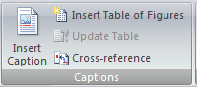
Then the below box shall appear:
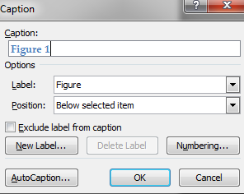
You need to make sure that the label is under figure, and for academic pieces of work, the figure position needs to be below the selected item. In the actual caption it is good practise to name the figure appropriately. This also helps with navigation when trying to find a certain figure.


Figure 1 - Penguin Image

As you can see the Figure is now in blue and appears below the image. You would complete this process for all figures in the document.

Finally, to enter the actual table of figures in your document (Should be after the table of contents), all that needs to be done is click the “insert table of figures” button in the references tab:
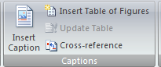
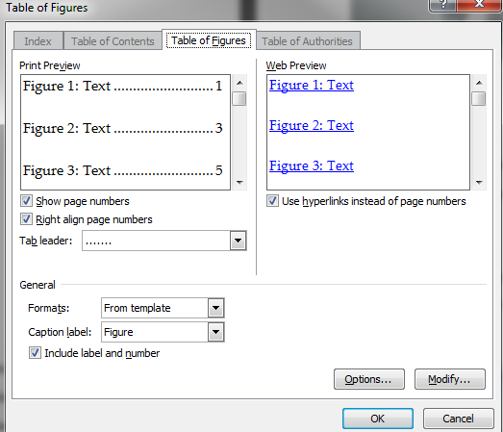
Simply press okay from this point and the table of figures will appear where you have currently selected. Just be sure to add the title above the list that appears to clarify to the reader what the list represents, as a heading doesn’t initially appear with this option.

Table of Figures
Figure 1 - Penguin Image 2



