
Business Inquiry and research
Assignment 1 – Part 1 and Part 2
Nia-Mai Hopcroft (2003405)
[Company Name]

Contents Page:

- Introduction
- Literature Research
- Procedure
- Data Analysis Techniques
- Data presentation and findings
- Conclusion/ Reflection
- References

Introduction

This qualitative study aims to understand how employee engagement affects morale in the workplace within healthcare. This data was collected from face to face semi structured interviews with three participants. Participants were picked through convenience sampling process to gather a range of demographics. The study area chosen is important to me due to personal experience within healthcare while working in a residential care home for the last five years and many family members working in the NHS. It was also chosen because healthcare is also a career, I want to progress in future by becoming a manager of a care home then hopefully one day running my very own residential care home and I refer to my responsibility of being a student studying business management.

In a study, researchers discovered that nurse engagement levels were the most important variable associated with mortality. It is unfortunate that many leaders confuse employee engagement with employee appreciation or staff satisfaction. (Stone, 2021) Staffing shortage concerns will only intensify with the retirement of a large number of baby boomer nurses and the decreasing supply of nurses available to meet the growing demand. Patients are affected directly or indirectly by every employee in healthcare. It has been found that hospital workers who are engaged listen, are helpful and conscientious about the entire patient experience and make fewer mistakes. (Reed, 2019)

During the interviews, the participants experiences of working within healthcare and their experience of employee engagement affecting morale will be examined. Results from these interviews will be analysed using a thematic framework method.

Literature Research

A qualitative approach was selected for this study instead of a quantitative one because it was essential to identify participants views on employee engagement affecting morale within the workplace in healthcare. Qualitative research methods are referred to as the study of nature of phenomena and is one of the uttermost common way of data collection for observations, interviews and focus groups. (Loraine Busetto, 2020) interviews can be an adequate of gathering data and Participants' views, experiences, beliefs, and motivations can be explored through interviews (P.GILL, 2008) . The sample groups chosen for this study were selected for purposeful sampling with non-judgemental selection of participants. The best type of sampling consists of the individuals from which the sample is drawn (Mccombes, 2019)

Positive paradigms are the basis for all quantitative research because they can explain every phenomenon in the world. A phenomenon can only be explained and understood by empirical methods and quantitative methodology, according to them. This paradigm gained popularity because it is easy to apply to standard research methods. (Articles, 2019)

A ‘phenomenology method’ is going to be used for this primary research approach. An individual is studied through the phenomenological method by analysing the phenomena that have impacted them. Phenomenological research can provide a detailed understanding of an individual situation and experiences. (Diaries, 2021) The phenomenon chosen was “participants experiences with employee engagement affecting morale in the workplace within healthcare.”

Procedure

After the phenomenon framework (thematic) and methodology were picked, a semi structured interview was chosen as the best method to collect this qualitative data. To ensure we have explanatory responses and gather their thoughts, opinions, and viewpoints on the chosen topic. We then proceeded to carried out the interviews with a specific process to make sure we gathered accurate and ethical results.
- Questions were chosen on the topic of employee engagement affecting morale in the workplace within healthcare. A range of open and closed questions were used to gather the appropriate answers needed for analysis.
- A sample group of participants were picked with different demographics to allow an assorted set of answers. This type of sampling is called convenience sampling.
- The semi structured interview technique was used due to a combination of fixed questions with the chance to receive open answers. Fixed questions allow the right analysis of data because all interviewees would answer the same question but allowing the participants to make an open answer can be convenient to expand their thoughts and views on the chosen topic which shows the participants that the interview is not very formal or restricting. Before any interview took place the participants were aware of practical arrangements and an explanation of the process of the interview was given before they signed any ethics agreement to participate in the interview.
- A semi structured interview was undertaken individually in a peaceful room with no distractions. The interviewer asked the questions in the same tone and manner and each interview took over 20 minutes to complete.
- All interviews were made into a word document for analysis. All interviews adhered to the ethical agreement and privacy rules by mentioning no names or identifiable details recorded in the interview.

Data Analysis Techniques

Any information provided from the interviewees which wasn’t useful to my chosen subject of employee engagement affecting morale in the workplace within healthcare was eliminated from the word document. A table was created from the date into three different columns. The first column had the participants comments, the middle column was what the interviewer’s thoughts of the data and the last column gathered recurring answers. Groups were organised by different themes however when a new opinion was given it would not fall into the previous group a new one was made. Conclusions and themes were created from this data.

The purpose of focus groups is to share experiences of people with similar characteristics through group dynamics. The focus here is not on the individual, as it is in an interview study. Users of focus groups may find it difficult to be in the same room at the same time. (Agency, 2020)

Data Presentation and Findings

Below is a table made to present the qualitative analysis of the grouped participants comments and within the transcript.
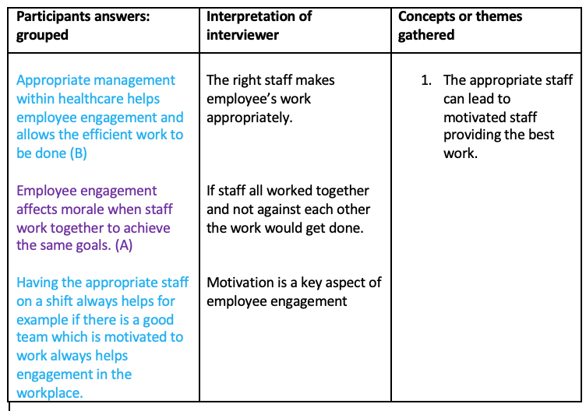
The first concept gathered was how motivated staff within the workplace provides the best employee engagement for morale within healthcare. The participants all said similar answers where motivation was a key aspect however one mentioned the factor of having the right management within healthcare shows how employee engagement improves. Another key concept was how if staff all worked together instead of against each other employee engagement wouldn’t be as bad as it is within healthcare. If healthcare practices had an appropriate workforce with great teamwork employee engagement would improve.

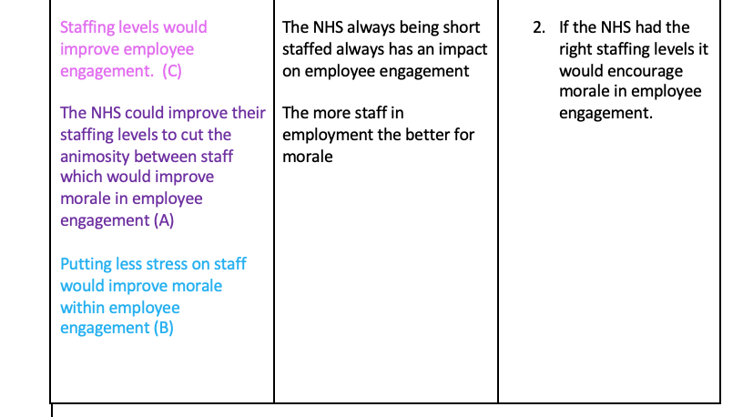
The second theme mentioned was the staffing levels within healthcare. This was the greater answer mentioned within the interview data. All interviewee’s mentioned staffing levels and how if they weren’t so short staffed it would reduce stress on staff members and increase employee engagement.
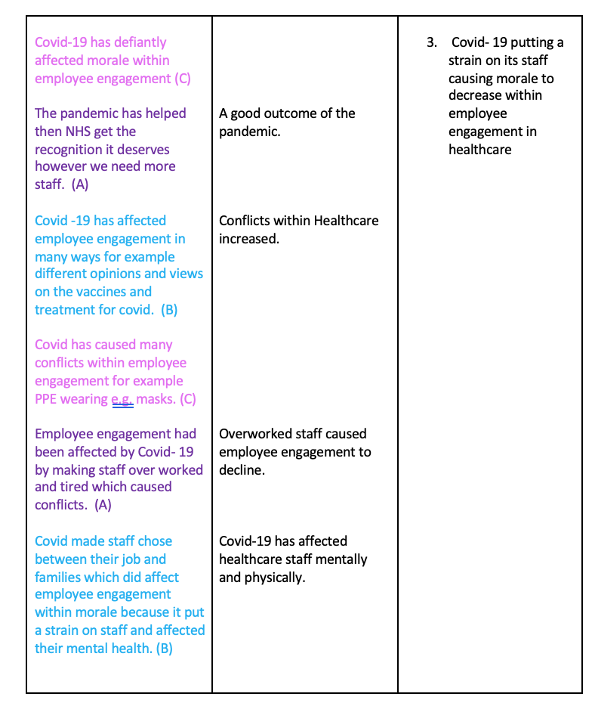
During the last couple of years of the pandemic of Covid- 19 affecting staffing levels within any employment especially healthcare has been impacted considerably with staff catching covid-19 and some sadly passing away. All participants mentioned that covid-19 hasn’t helped staffing levels within healthcare and has affected morale within employee engagement because there is a lot of controversy about the pandemic which has caused conflict within employees. Figures show that staffing levels having increased within the pandemic, all NHS hospitals and community health services staff increased by 3.1% to 1,193,666 in May 2021 which was more than 35,926 higher than May 2020. (Workforce, 2021)

The third concept definitely was the most answered and argumentative point for each interviewee and showed their opinions, thoughts and views the most in this part of the interview. This concept showed how Covid-19 has impacted healthcare and what can be done to increase morale in employee engagement. Each interviewee had different opinions within this concept of covid-19 however they all agreed that covid-19 has impacted staff considerably during the last couple of years in different ways for example Covid-19 providing the Healthcare sector with the recognition it’s needed for many years and how Covid-19 has affected staff physically and mentally from choosing to keep their families safe and moving out or catching covid and having long lasting health effects for example shortness of breath.

Conclusion/ Reflection

The collection of data was for only three individuals which meant that gathering conclusions from wider society wasn’t possible due to small size sampling. The interviewees had a similar perspective on how employee engagement affected morale in the workplace within healthcare. From the use of different date collection methods such as focus groups and merging for analysis could have produced more diverse data.

This study showed that using the semi structured interview method was reliable and valid. Any ethical issues were resolved before starting the interview process with the appropriate paperwork and participants had an explanation of what the study was. Following the appropriate qualitative techniques allowed participants to answer with their own views and thoughts for the data collecting.

From this study I found that there are many different aspects for employee engagement affecting morale in the workplace within healthcare. All participants provided strong answers between employee engagement and how affects it and how staffing levels are a major factor of morale in the workplace. The data provided has made individuals a where of how important healthcare is and how morale within employee engagement can be improved.

Word count 1,519

Reference List

Stone, Jerry (November 2021) The importance of employee engagement in healthcare. received from https://blog.medicalgps.com/the-importance-of-employee-engagement-in-healthcare

Reed, Rachel (May 2019) the importance of employee engagement in healthcare. Received
from https://blog.rewardian.com/the-importance-of-employee-engagement-in-healthcare

Lorraine Busetto et al (May 2020) How to use and assess qualitative research methods. Received from https://neurolrespract.biomedcentral.com/articles/10.1186/s42466-020-00059-z

P. Gill et al (March 2008) methods of data collection in qualitative research: interviews and focus groups. Received from https://www.nature.com/articles/bdj.2008.192

McCombes, Shona (September 2019) sampling methods – types and techniques explained. Received from https://www.scribbr.com/methodology/sampling-methods/

Research articles (June 2019) quantitative and qualitative paradigms of research. Received from http://researcharticles.com/index.php/quantitative-and-qualitative-paradigms-of-research/

Harappa Diaries (September 2021) Phenomenological research: methods and examples. Received from https://harappa.education/harappa-diaries/phenomenological-research#heading_2

UK Health Security Agency (January 2020) focus group study: qualitative studies. Received from https://www.gov.uk/guidance/focus-group-study-qualitative-studies

NHS Workforce (August 2021) NHS workforce statistics – May 2021. Received from https://digital.nhs.uk/data-and-information/publications/statistical/nhs-workforce-statistics/may-2021

Contents Page for Part 2

- Introduction
- Data collection
- Analysis approach
- Procedure
- Analytical procedure
- Data presentation and finding
- Cross tabulation of results
- Limitations of data
- Conclusion

References

Introduction

The aim of this report is to examine the treatment of healthcare workers. The service is threatened in its ability to provide people with safe, high-quality care. The increasing turnover, absenteeism, and difficult recruiting of employees in any other industry would be considered red flags, warnings of fundamental toxic cultures for the organisation. (West, 2019) medical staff have experienced a significant impact as a result of the Covid-19 pandemic, with one in six doctors reporting changes to their rotas as one of biggest changes. It is not known currently if there are any gaps in rotas, however any shortage of senior medical staff can lead to junior doctors being withdrawn from hospitals, further reducing the number of doctors on staff rotas. (Lucina Rolewicz, 2019)

The study area was selected from personal experience within the treatment of healthcare workers and the impact it has on individuals. This study also focuses the strain on healthcare workers and the risk of the future of the NHS. The aim of the questionnaire was to get individual’s views on the strain of healthcare within the NHS, participants were a mixture of NHS workers, care home staff and people who have never worked in the healthcare sector to provide a wide range of information to analyse their thoughts through a simple questionnaire.

Data Collection

Numerical data is collected and analysed in quantitative research. The method is capable of identifying patterns and averages, making predictions, testing causal relationships, and generalizing the results to broader populations. Unlike qualitative research, quantitative research collects, analyses, and interprets non-numerical information. (Bhandari, 2022)
the data collection method used was an online questionnaire. Online questionnaires can be very easy to do and don’t cost much which is great when collecting data. It’s a very quick method way to gain information due to participants doing the survey themselves and an online forum collects this data and analyses what is needed. Also, with questionnaires it allows participants to answer anonymously which means they can be more willing to give personal opinions. (Asiedu, 2019)

Analysis Approach

Qualitative data is information that can be counted or measured which gives a numerical value. It is normally structured by nature and can be used for statistical analysis. there are different types of quantitative data which are discrete, continuous interval vs. ratio data which includes counts, sensors, measurements, and calculations. (stevens, 2021)

Procedure

Using Microsoft forms and SPSS to analyse the questionnaire results increased accessibility. It allowed participants to use different devices to access the questionnaire for example mobile or laptop also it allowed different demographics to access the questionnaire for example by social media or text message with the link to the survey. Using an online survey also meant it would save a lot of time for the researcher to collect this information needed. (Sutherland, 2019)

The questions were created with the aim to gain information about the treatment of healthcare workers and the future of the NHS. The survey had a combination of closed ended questions and nominal questions such as gender selection and ordinal questions for example the chance of them wanting to work in healthcare in future. The first three questions were to provide information about the demographics of the participants which is linked to each group to analyse.

The use of closed ended questions allows a participant to choose from a list of answers which would give the researcher the answer needed for its study. The questionnaire used categorical questions which involved multiple choice questions of about three to four choices per question to allow the participant to have a fair choice. (Jovancic, 2021)

The questionnaire was shared to a range of individuals online for example across different social media sites. This method showed that time wasn’t an issue, and I gave participants a week to complete the questionnaire to gather as much information as possible and it allowed each participant to fill the questionnaire in when it suited them for example when they’d finished work. 67 participants took part in my questionnaire.

Analytical Procedure

The IBM Statistical Package for Social Sciences (SPSS) and Microsoft forms analysis for graphs were used to collect the data and analyse trends from the data. All participants remained anonymous which meant there was no breach of confidentiality. All questions had a coded frame made where labels were made for each multiple choice answer. Any variable entered was made to be either nominal, ordinal, or scale. The questionnaire results from Microsoft forms were transferred into SPSS. A few variables had been entered in numeric form to match the labels made in analysing. Each part of the data was closely looked at which meant there was no errors in the questionnaire findings.

Data Presentation and Findings

Q1. What is your gender?

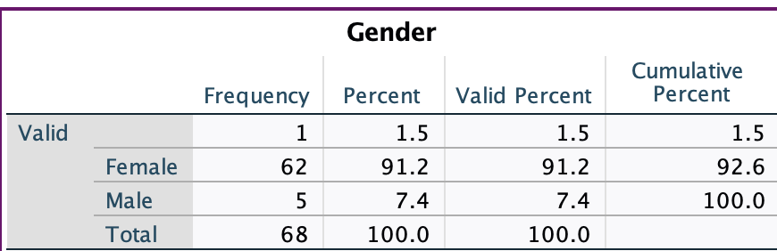

This data collected showed that there were more females than males participating in my questionnaire, I did expect this because healthcare is more female dominated compared to males e.g., nurses.

Q2. What is your age?

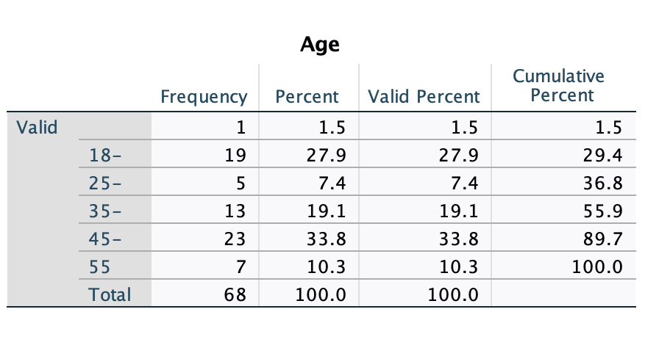

This table shows the age range of my participants. The majority are aged 45-54 however I do think I collected a range of every age sampled.

Q3. Do you think healthcare workers are treated fairly?

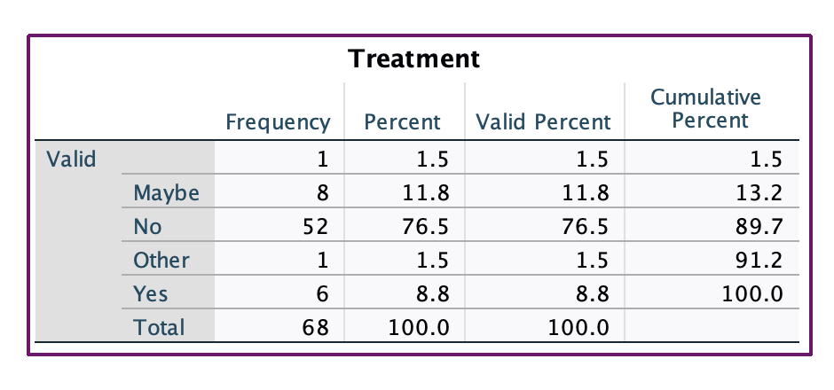

In this table the majority thought that healthcare workers are not treated fairly but I do think I had a range of answers from my participants.

Q4. Do you think healthcare workers should be paid more?

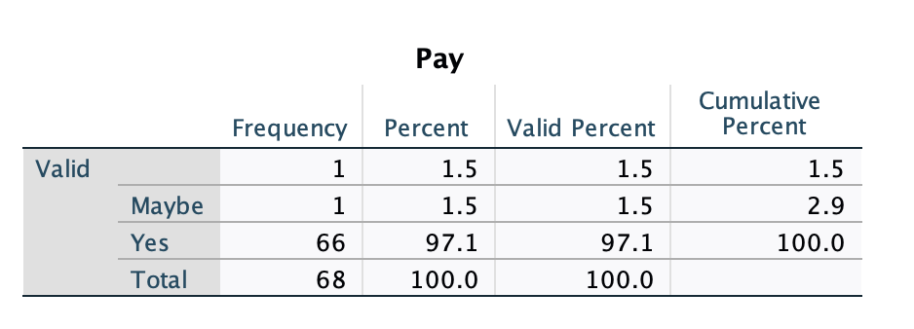

My findings in this table of my data collection showed that most thought healthcare workers should be paid more apart from 1 participant however I think it showed that healthcare workers should get paid more and need more recognition for all they do in their job role.

Q5. Prior to this survey, have you ever thought about working in healthcare?

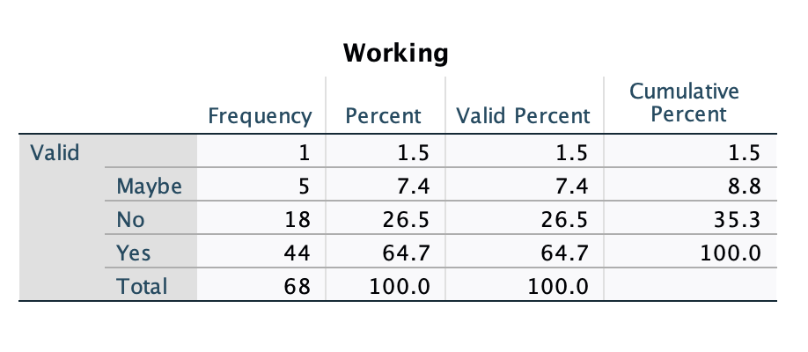

In this table it had a range of answers from participants however majority did say they have thought about working in any type of healthcare before taking my survey. There was a range that said no or maybe about working in healthcare, but I think I provided a variety of different opinions from participants.

Q6. Are you concerned about the strain on employees in healthcare?
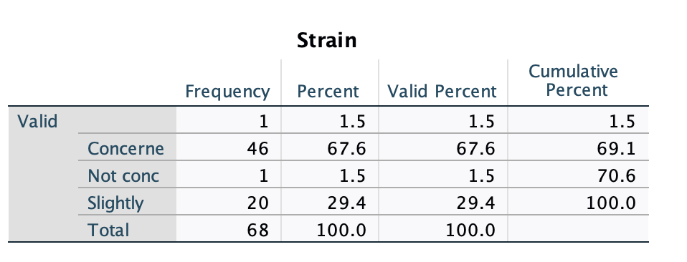
The table above showed that the majority of participants are worried or are slightly concerned about the strain on employees in healthcare.

Q7. Change in healthcare needs to be driven by:

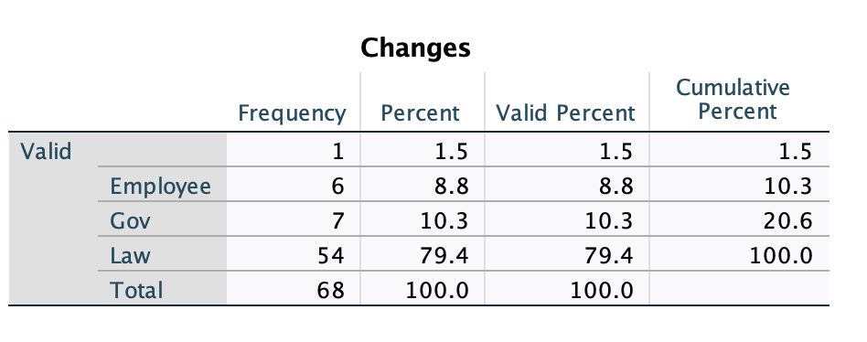
In this table most participants agree that changes in law and regulations of employment in healthcare is the change that needs to be improved for the treatment of healthcare workers however some did think either the government or employees should be the cause of change within healthcare.

Q8. Are you concerned for the future of healthcare?

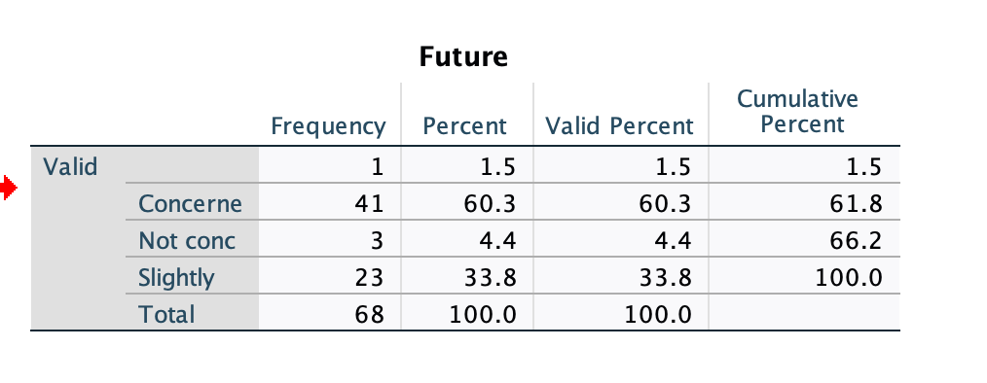

In the table above most participants did say they were concerned over the future of healthcare which I think is a real representation of the population due to not knowing what would happen to the NHS in future for example, if it went private and we paid for healthcare.

Q9. Do you think there is a risk of technology taking over the job of healthcare workers?
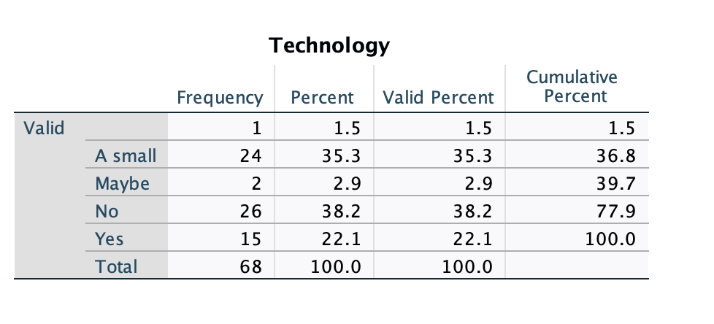
In this table we had a variety of answers from the participants in the survey, most did say there isn’t a risk of technology taking over but some did mention there is a small risk or there is a risk of technology taking over the job of healthcare workers.
Q10. What type of healthcare do you work for?
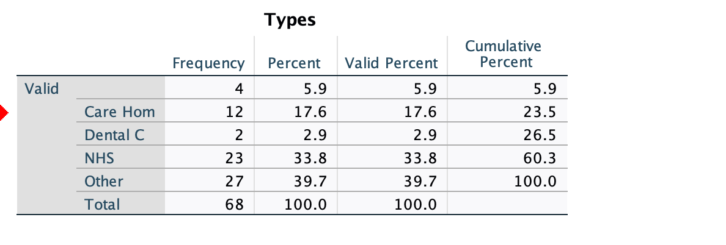
In the table above we did have a variety of answers, but majority selected other for their job role however most did say they worked for the NHS and care homes which I think provided a variety of answers from my participants for the research.

Limitations of data

One limitation of the data collected was the sample size due to only using participants within healthcare services which was my chosen topic however it didn’t generalize a wider population. My study did allow a range of different healthcare services to participate in my research. Another limitation was the number of males that participated in my questionnaire for example there was a lot more females that participated in my questionnaire compared to males which was to be expected because healthcare seems to be a more female orientated job for example nurses and carers. I think this did restrict my research.

In future if I were to further my research, I would like a large sample group and hopefully find more male participants to weight out the results. It would be interesting to further my research with how Covid-19 has changed individual’s perspective on healthcare services and see if there was a difference in my research answers from participants.

Conclusion

In conclusion, I think there is more awareness towards healthcare staff in the NHS and other healthcare services. Healthcare services need more recognition and should be treated better than what it is already, and healthcare staff should be treated fairly compared to any other job role. I think the consequences of the treatment of healthcare staff are very high, it can lead to staff leaving their job role which wouldn’t help any healthcare service because I think they are all short staffed. Covid-19 has taken a toll on staff issues in any job role however especially the NHS and other healthcare services. Another consequence of the treatment of healthcare staff would be affecting them physically and mentally which would mean they could be unhappy in their job role leading to inefficient care of its patients.

Word count: 1575

Reference List

West, Michael (March 2019) The NHS crisis of caring for staff: what do we need to do? Received from https://www.kingsfund.org.uk/blog/2019/03/nhs-crisis-caring

Lucina Rolewicz et al (May 2019) the NHS workforce in numbers. Received from https://www.nuffieldtrust.org.uk/resource/the-nhs-workforce-in-numbers

Bhandari, Pritha (April 2022) what is quantitative research? Definitions and methods. Received from https://www.scribbr.co.uk/research-methods/introduction-to-quantitative-research/

Asiedu, Felicia (April 2019) advantages and disadvantages of online surveys. Received from https://www.cvent.com/uk/blog/events/advantages-disadvantages-online-surveys

Stevens, Emily (September 2021) what is quantitative data? Received from https://careerfoundry.com/en/blog/data-analytics/what-is-quantitative-data/

Sutherland, Chanel (March 2019) 10 key advantages of using online surveys. Received https://explorance.com/blog/10-key-advantages-of-using-online-surveys-2-2/

Jovancic, Nemanja (June 2021) 8 types of survey questions to get all the data you need. https://www.leadquizzes.com/blog/types-of-survey-questions/

